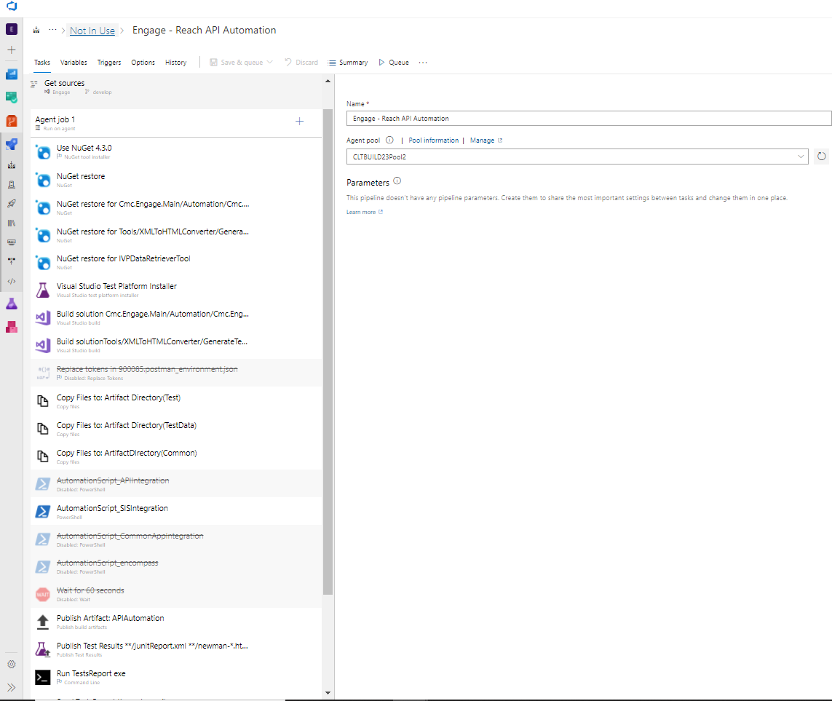

T1:

Display name:Use NuGet 4.3.0:

Version of NuGet.exe to install : 4.3.0

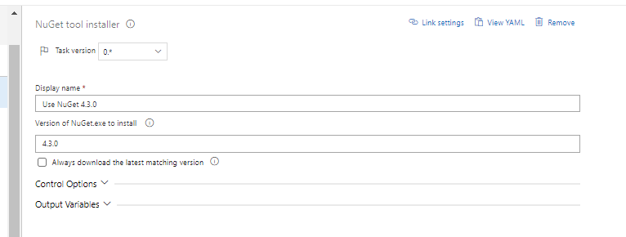

T2:

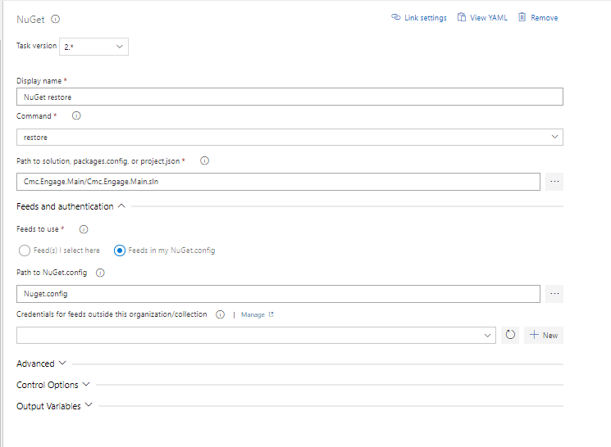

Display name : NuGet restore

Command: restore

Path to solution, packages.config, or project.json : Cmc.Engage.Main/Cmc.Engage.Main.sln

T3:

Path to solution, packages.config, or project.json : Cmc.Engage.Main/Automation/Cmc.Engage.Automation.sln

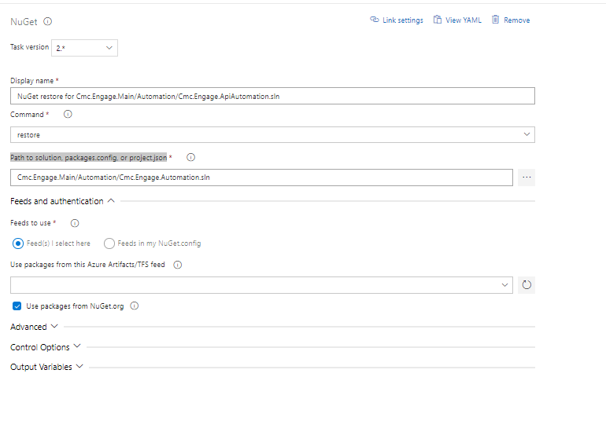

T4: Nuget

Display name: NuGet restore for Tools/XMLToHTMLConverter/GenerateTestReport

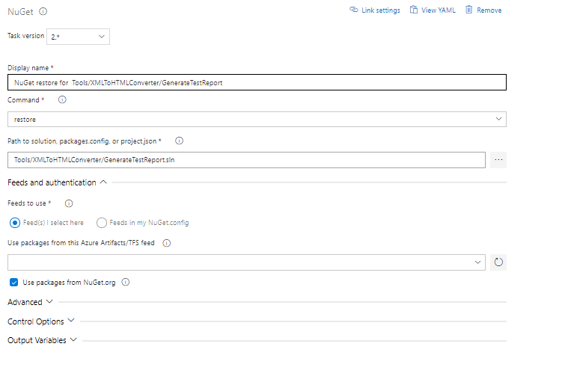

Path to solution, packages.config, or project.json : Tools/XMLToHTMLConverter/GenerateTestReport.sln

T5:

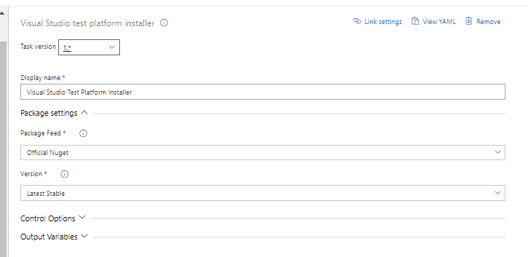

T6: Visual Studio build

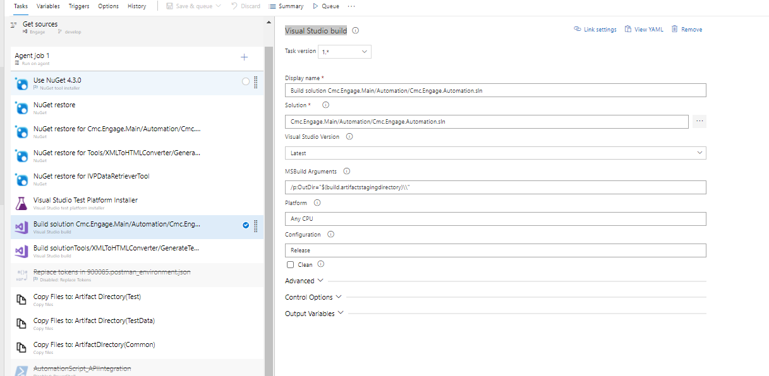

Display name: Build solution Cmc.Engage.Main/Automation/Cmc.Engage.Automation.sln

T7:

Dname: Build solutionTools/XMLToHTMLConverter/GenerateTestReport

Solution: Tools/XMLToHTMLConverter/GenerateTestReport.sln

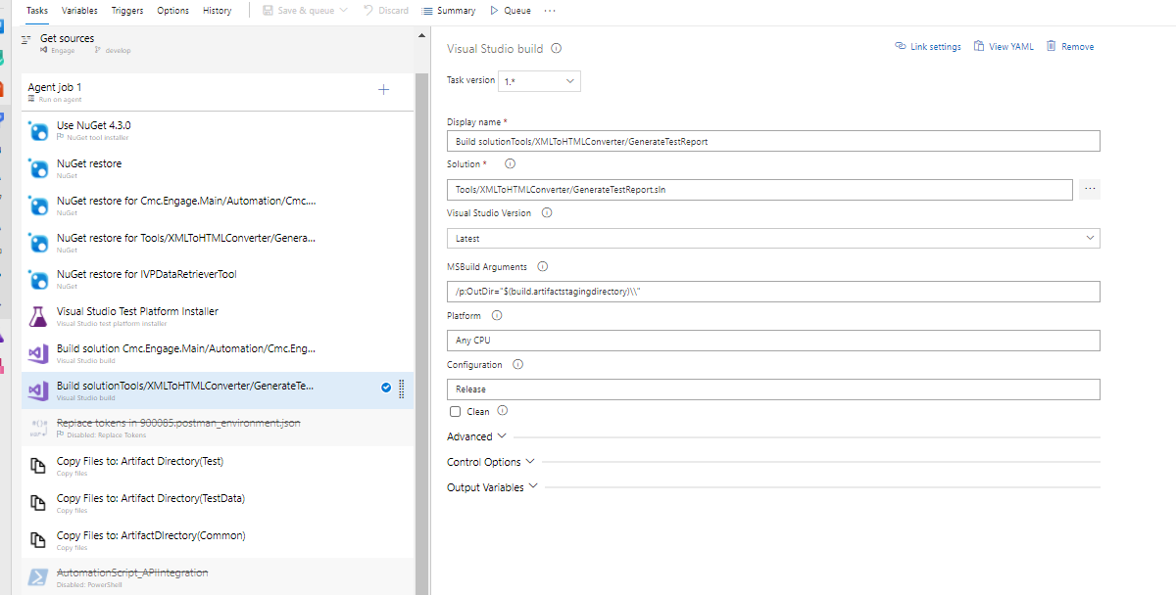

T8:

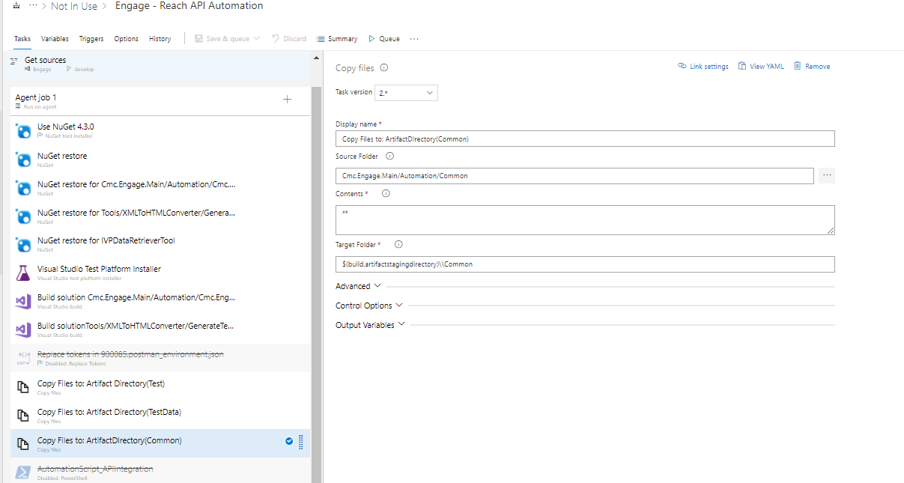

T9:Powershell:

Script:

$(Build.SourcesDirectory)\Cmc.Engage.Main\Automation\Common\Master.bat $(Build.SourcesDirectory)\Cmc.Engage.Main\Automation "Cmc.Engage.ApiAutomation"

Custom condition:

and(succeeded(), eq(variables['core'], 'true'))

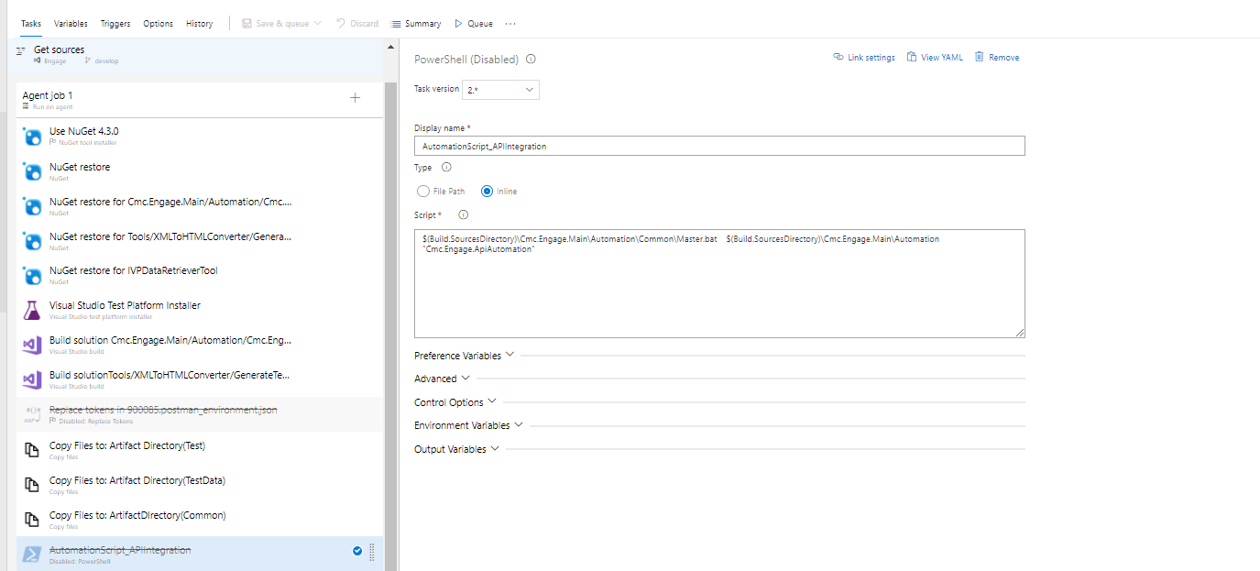

T10: Publish Artifact: APIAutomation in one folder

Path to publish : Cmc.Engage.Main/Automation

Artifact name : APIAutomation

Artifact publish location: Azure Pipelines

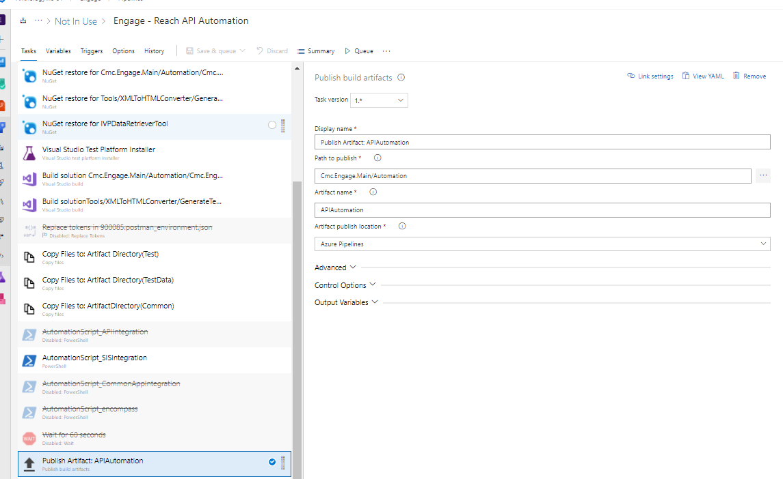

T11: Publish Test Results

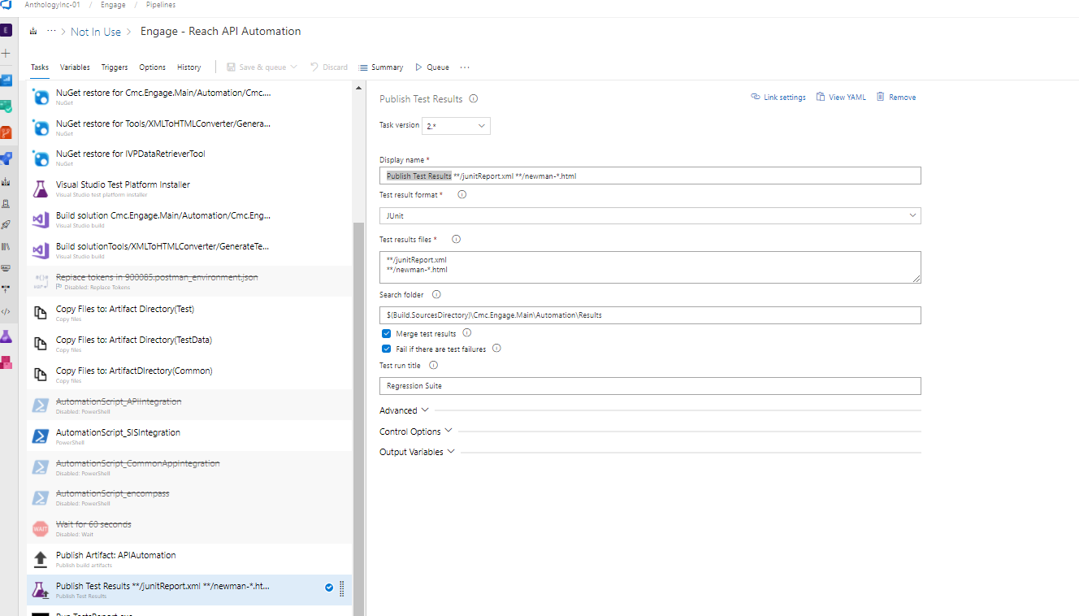

Display name : Publish Test Results **/junitReport.xml **/newman-*.html

Test result format : Junit

Test results files:

**/junitReport.xml

**/newman-*.html

Search folder: $(Build.SourcesDirectory)\Cmc.Engage.Main\Automation\Results

T12: Run TestsReport exe

Tool: "$(Build.ArtifactStagingDirectory)\ReachTestReport.exe"

Arguments:

$(Build.SourcesDirectory)\Cmc.Engage.Main\Automation\Results\ $(Build.SourcesDirectory)\Cmc.Engage.Main\Automation\Results\ "APIAutomationReport" "Runner$(Build.BuildNumber)" $(Build.SourcesDirectory)\Tools\XMLToHTMLConverter\ReachTestReport\

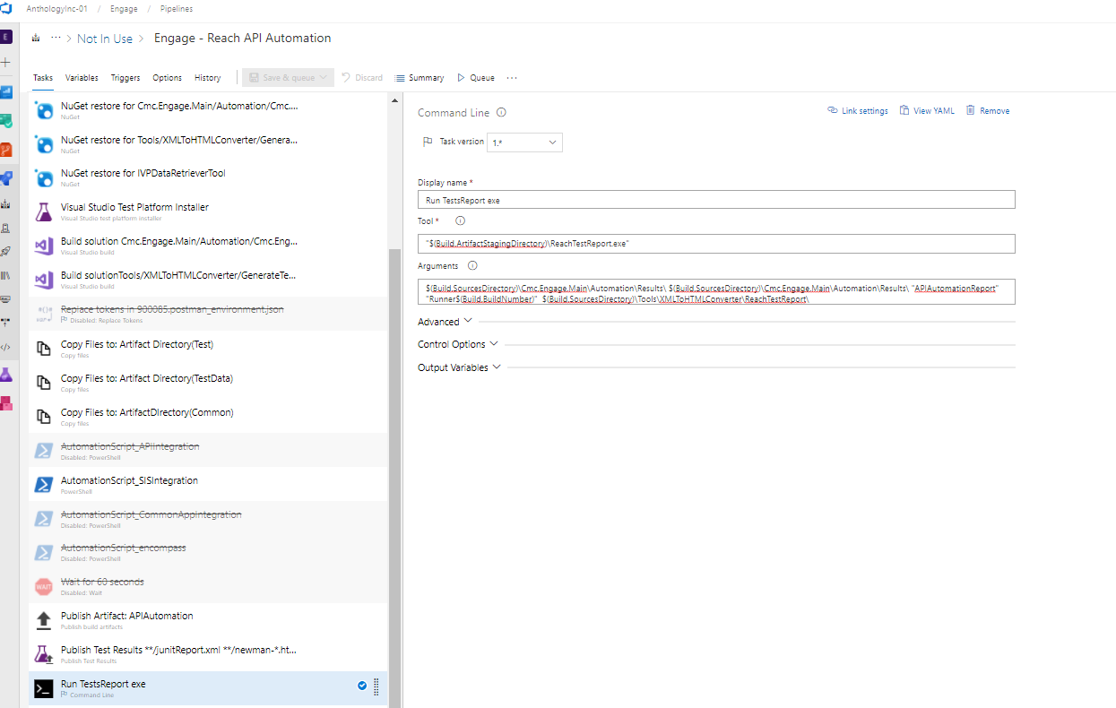

T13:Send Email

From Address: $(Build.DefinitionName)<c2kbuild@campusmgmt.com>

Mail Subject: $(Build.DefinitionName) Tests Result Report

Mail Body :

Hi,

Please find attached $(Build.DefinitionName) Tests Result Report for run $(Build.BuildNumber)

Regards,

Reach Automation

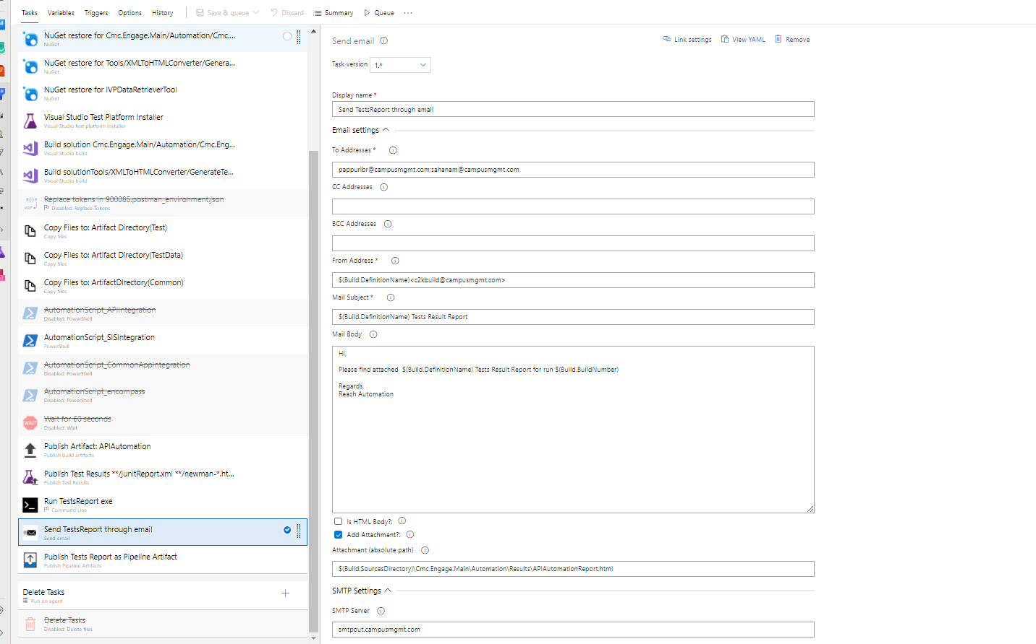

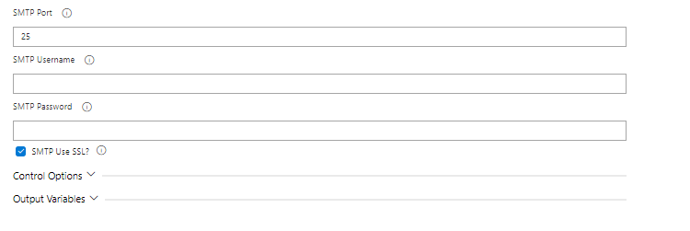

T14:Publish Tests Report as Pipeline Artifact

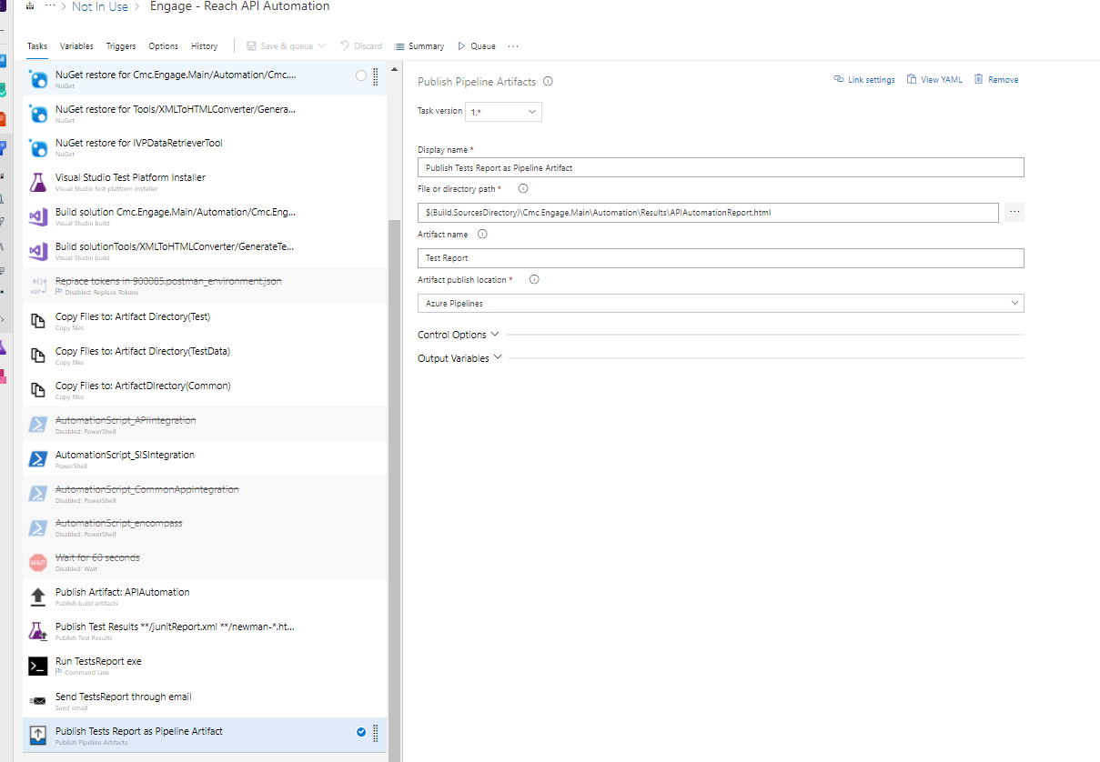

File or directory path: $(Build.SourcesDirectory)\Cmc.Engage.Main\Automation\Results\APIAutomationReport.html

Artifact name:Test Report

Artifact publish location : Azure Pipelines

T15:Delete Task (default)

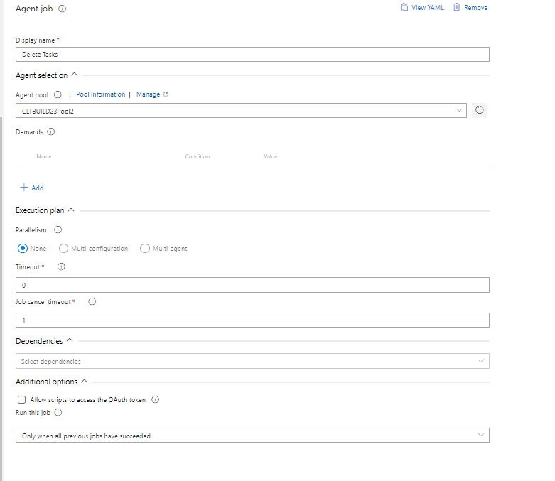

API Bat file:

old

if not defined TestLocation (set TestLocation=.)

if not EXIST "%TestLocation%\..\..\..\..\..\Common\%ApiTestConfig%.postman_environment.json" (

@echo off

setlocal

setx ApiTestConfig="default"

endlocal

@echo on

)

newman run "%TestLocation%\DuplicateDetectionrules.postman_collection.json" -d "%TestLocation%\..\..\..\TestData\DuplicateRules_UnManaged.csv" -r htmlextra --reporter-htmlextra-showOnlyFails --reporter-htmlextra-title NewmanTests --reporter-htmlextra-export newmanReport/newmantests.html --reporter-htmlextra-logs --reporter-htmlextra-darkTheme -e "%TestLocation%\..\..\..\Common\%ApiTestConfig%.postman_environment.json"

New command:

newman run "%TestLocation%\%projectname%\DuplicateDetectionrulesInt\DuplicateDetectionrulesInt.postman_collection.json" -d "%TestLocation%\Cmc.Engage.IVP\TestData\DuplicateRules_UnManaged.csv" -r htmlextra --reporters cli,junit,htmlextra --reporter-junit-export Results\DuplicateDetectionrulesInt\junitReport.xml --reporter--reporter-htmlextra-export newmanReport/newmantests.html -e "%TestLocation%\Common\%ApiTestConfig%.postman_environment.json"

Master.bat

@echo on

set agentmac=%1

echo agentmac=%agentmac%

echo %cd%

set projectname=%2

if not defined TestLocation (set TestLocation="%agentmac%")

echo TestLocation=%TestLocation%

for /f %%f in ('dir /S /B "%TestLocation%\%projectname%\*.bat"') do (

echo "%%f"

call %%~f

)

)

Old master.bat file:

@echo on

set agentmac=%1

echo agentmac=%agentmac%

echo %cd%

if not defined TestLocation (set TestLocation="%agentmac%\Cmc.Engage.Main\Automation")

pushd "%agentmac%\Cmc.Engage.Main\Automation\Cmc.Engage.ApiAutomation\"

for /f %%f in ('dir /S /B "*.bat"') do (

echo "%%f"

call %%~f

)

)

pause