Exercise-2
LangChain Agent with Groq LLM

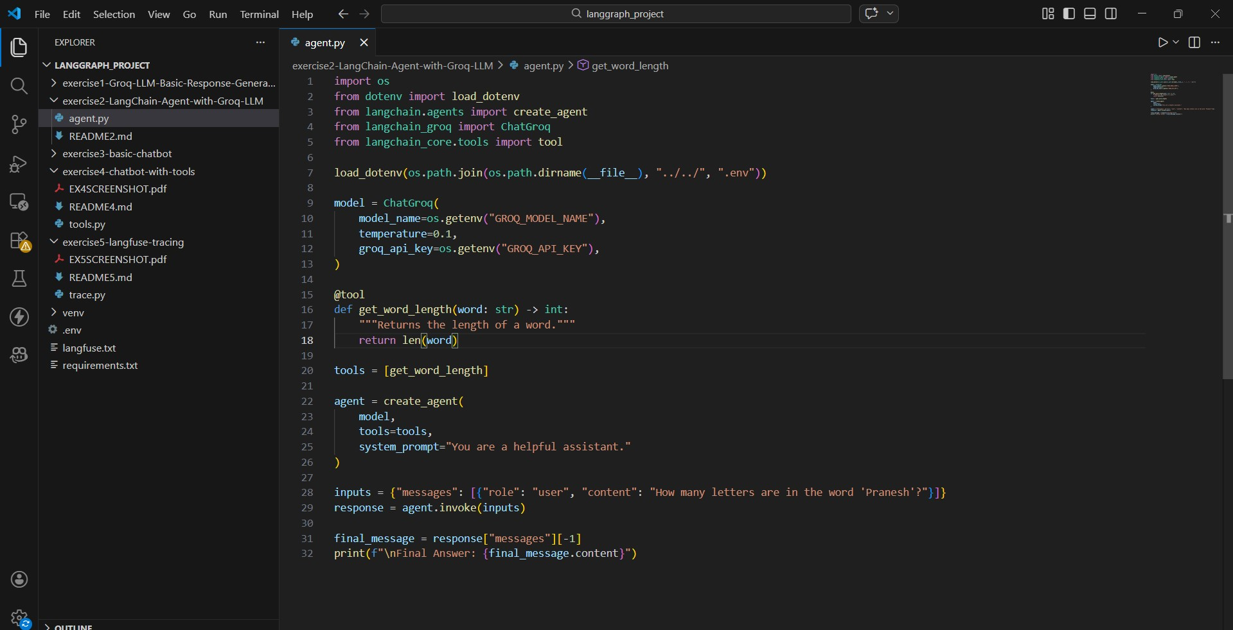

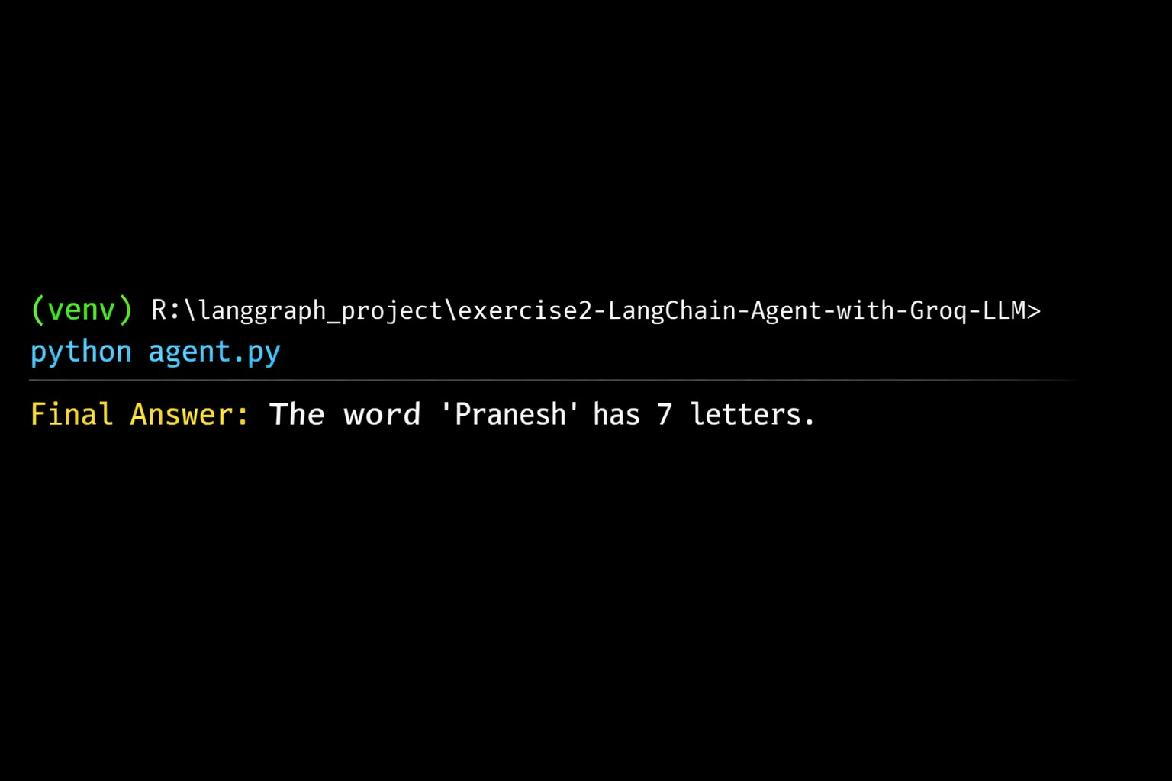 Balasai Vishalakshi B
23ISR007

