

USER INTERFACE DESIGN MANUAL

 | Submitted By
Name | P BALASAI
Roll no | AV.SC.U4CSE25224
Year/Sem | 1st year/ SEM-2
Sec | CSE-C

 | Submitted to
ASST.PROFFESSOR (Sl. Grade) | DR. RAJ KUMAR BATCHU
Designation | ASST.PROFESSOR(S1.Grade)
Department | School Of Computing

INDEX
S.no | TITLE | Page no | Remarks
1. | Week-1:  - Installing VS Code  - Creating Basic HTML Page  3.Explain About Basic HTML Tags | 5-10
2. | Week-2:  - Creating a Table | 11-14
3 | Week-3:  - School Registration form  - Combing of 2 Forms | 15-23
4. | Week-4: A.Design a registration form using only HTML tags (no CSS) with proper labels, table alignment, background color, and borders.  B.Two forms displayed side by side using iframes .one is login and another registration | 24-34
5. | Week-5: :A.creating a card layout using  tag consider three cards and a button using html and css  B.navigation using iframe (mini website) upon clicking each buttons the details about that button should be display on the same page  C.Design amrita login page by showing different campus on home page.upon clicking on each campus the details about each campus should be display on the same page use html and css to design a stylish webpage | 35-58
6. | Week-6:  B: Design a responsive e-commerce application using the grid layout. This application should contain different categories of products such as electronics, clothing, home-appliances, books. Based on the category we select corresponding products should be displayed on the sidebar | 59-74
7. | Week-7:  :create a GitHub account and create a repository in it and push all the week 6 code files in it | 75-76
8. | Week-8:  A.:create a web page that displays a square that continuously rotates 360 using css animation  B.:create a ball that moves up and down continuously using css animation  C.:create a circle that moves horizontally and rotates At the same time | 77-85
9+. | Week-9:  Create an webpage using html, CSS, java script based on the given conditions:  a)Create a button for each program, based on the button clicked the corresponding program has to be executed and should display the output.  b)The logics for each button includes finding an even numbers, odd number, prime or not, factorial of a number, amstrong or not. c)Use appropriate designs to display the output. | 86-96
10. | WEEK-10:  a) Sign of Product of Three Numbers Using Functions  b) Sort Three Numbers Using Functions  c) Find the Largest of Five Numbers Using Function and OnClick Event  d) Check Whether Numbers from 0 to 15 are Odd or Even Using For Loop  e) Calculate Student Grade from Average Marks of Six Subjects | 97-103
11 | WEEK-11:  1)Username Validation (Minimum 5 Characters)  2)Email Format Validation Before Form Submission  3)Password Strength Checker  4)Mobile Number Validation (10 Digits)  5)Registration Form Validation (Name, Email, Password) | 104-130
12 | Week-12:  Installation of Electron Framework application | 131-134
WEEK-1
Aim: Install VSCODE
Step 1: Enter Vs code in chrome Browser
Step 2:Click the first link
Step 3: Select on Download Windows or Macos(if your laptop is Mac)
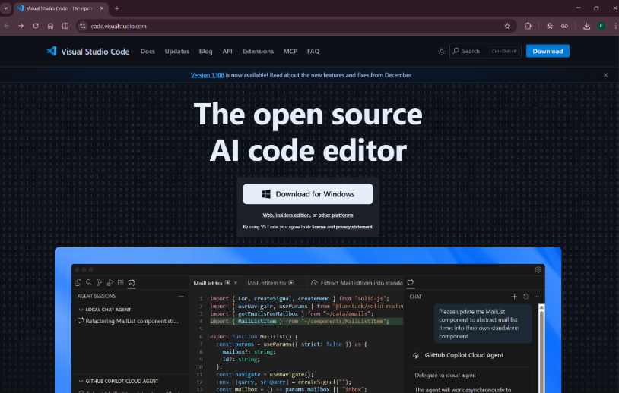
Step 4: open the Downloaded file
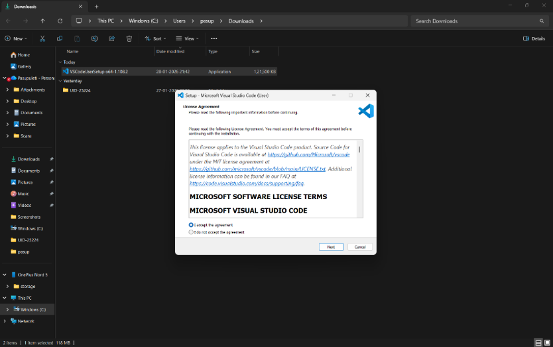
Step 5:Click next , agree their terms and condition
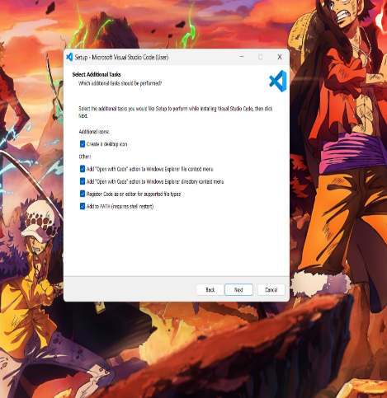
Step 6: click on install
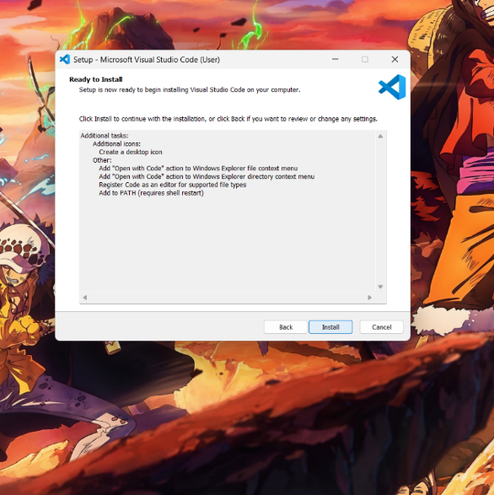

Step 7: Installation Completed
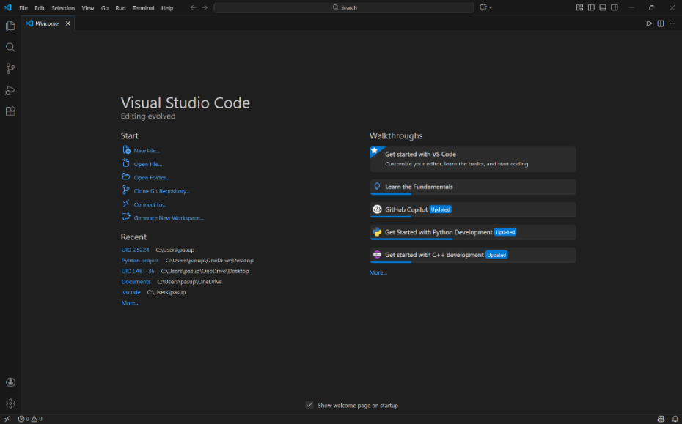

2. Aim : Basic Intro of HTML
INPUT:
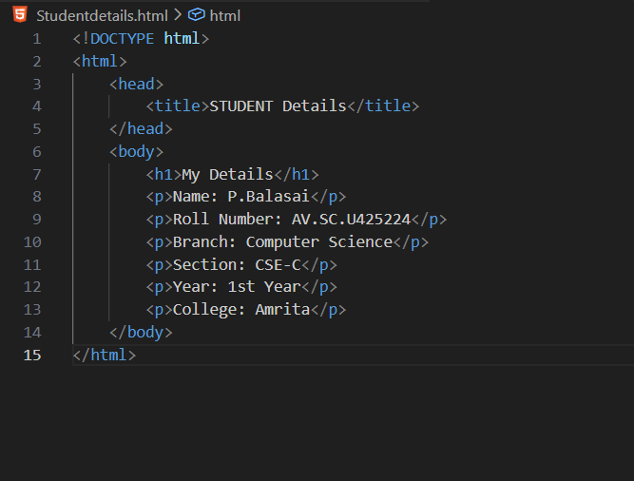
OUTPUT:
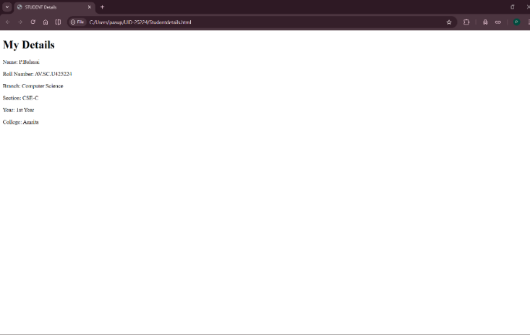
Explanation:
- <html>:Everything should be inside this tag.
- <head>: this contains title tag.
- <title> : This sets the title of the webpage.
- <body>: this contain main code (contains all visible content like text ,images ,links ,tables ,etc.).
- <h1>: this used to get headings.
- <P>: this contains para(any information).
3. Aim: Write Code Based on HTML TAGS
Input: <!DOCTYPE html>
<html>
<head>
<title>Amrita Vishwa Vidyapeetham</title>
</head>
<body>
<p>Name= Pasupuleti Balasai , Roll no =AV.SC.U4CSE25224 , Section=CSE-C</p>
<h2 style="color:rgb(239, 16, 16);"> Amrita Vishwa Vidyapeetham</h2>
<img src="https://upload.wikimedia.org/wikipedia/en/3/30/Amrita_Vishwa_Vidyapeetham_-_Logo_Icon.svg" alt="Amrita Vishwa Vidyapeetham Logo" width="300" height="200">
<p title="Amrita Amaravati Campus">Amrita Vishwa Vidyapeetham is a private deemed university in India.<br>Amrita Vishwa Vidyapeetham is a multi-disciplinary, research-intensive, private university,</p>
<a href="https://www.amrita.edu/campus/amaravati/">Visit Amrita Vishwa Vidyapeetham</a>
</body>
</html>
OUTPUT
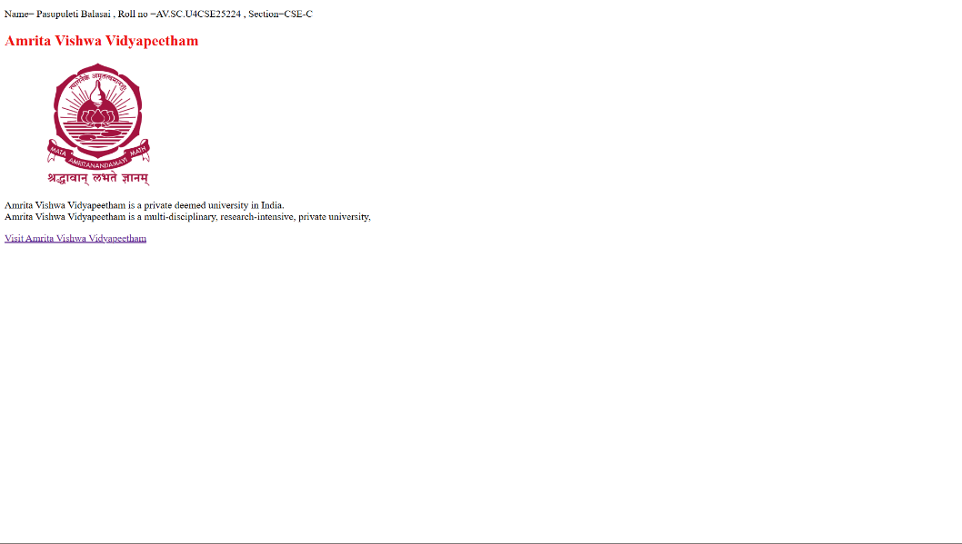

EXPLAINATION:
- <p> : it is used if we want to display any information in para format.
- <h> : Used for titles and headings
- <a href="https://www.amrita.edu/"> amrita link</a>:
<a> is used it is usable one for link ,Creates a clickable link with name amrita link ,href- specifies destination URL.
- <img src=https://webfiles.amrita.edu/2022/03/nbElb5oz-amrita-amaravati-campus-banner-2022.jpg alt="Amrita Campus Image" width="384" height="390"> :
- Displays an image on the webpage
- <img> has no closing tag
- src → image URL
- alt → text if image fails to load (important for accessibility)
- width → image width (pixels)
- height → image height (pixels)
- <br>: Moves text to the next line,No closing tag needed,
Used inside paragraphs for line breaks.
- Colour: it is a tag we used to color our text it used in <h>,<p> .main thing is the style tag should be used in that we add color as subtag.
Ex :<p style = "color:#F54927;">.

WEEK-2
1.AIM:Design a webpage which contains a Table , Paragraph
<!DOCTYPE html>
<html>
<head>
<title>ONE PIECE</title>
</head>
<body style="background-image: url('onepiece.jpg');">
<h1 style="color:rgb(43, 74, 137); text-align:center; border: 4px solid rgb(141, 196, 213); font-size:40px;">
ONE P🕴️ECE
</h1>

<pre style="color:rgb(117, 117, 190); text-align:center; font-size:20px; font-family:verdana;">
<i>
One Piece is a long-running Japanese manga and anime series created by Eiichiro Oda that tells the story of Monkey
D. Luffy, a spirited young pirate with the power to stretch like rubber after eating a mystical Devil Fruit. Driven
by his dream of becoming the King of the Pirates, Luffy sets out on an adventurous journey across the seas with his
diverse crew, the Straw Hat Pirates. Together, they face powerful enemies, uncover ancient mysteries, and explore
fantastical islands while searching for the ultimate treasure known as the “One Piece.” Renowned for its rich
world-building, emotional character arcs, and themes of friendship, freedom, and perseverance, the series has captivated
millions worldwide since its debut in 1997 and continues to be one of the most influential works in modern storytelling.
</i>
</pre>

<table width="80%" border="3" cellpadding="10" cellspacing="5" align="center" style="background-image:url('One_Piece_Anime_Logo.jpg')">
<caption style="font-size:30px; background-color:rgb(177, 21, 39); color:snow;">
<b>ONE PIECE CHARACTERS</b>
</caption>
<tr style="background-color:lightblue;">
<th>Character</th>
<th>Devil Fruit</th>
<th>Pirate Crew</th>
</tr>
<tr style="background-color:lightblue;">
<td>Monkey D. Luffy</td>
<td>Gum Gum fruit</td>
<td>Straw Hat Pirates</td>
</tr>
<tr style="background-color:lightblue;">
<td>Roronoa Zoro</td>
<td>None</td>
<td>Straw Hat Pirates</td>
</tr>
<tr style="background-color:lightblue;">
<td>Nico Robin</td>
<td>Flower Flower fruit</td>
<td>Straw Hat Pirates</td>
</tr>
<tr style="background-color:lightblue;">
<td>Sanji</td>
<td>None</td>
<td>Straw Hat Pirates</td>
</tr>
</table>
</body>
</html>

OUTPUT:
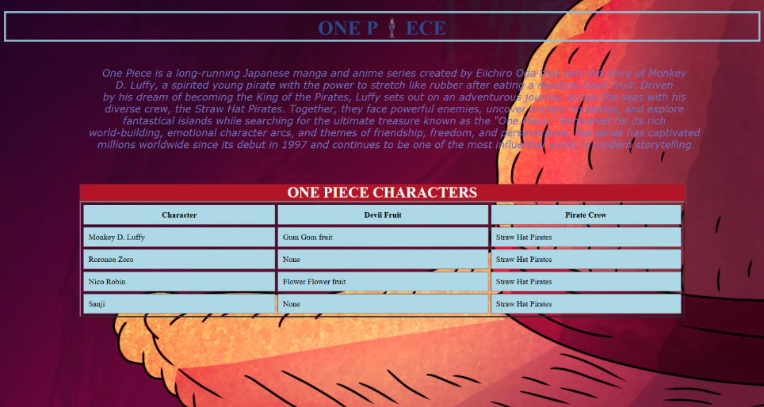
EXPLANATION
<DOCTYPE html> : the <!DOCTYPE html> element tells the web browser that this an HTML document
or this is the latest version of HTML
. <html> : the <html> element is the root element of an HTML web page
. <head> : the <head> element will contain meta data about the HTML web page
. <title> : the <title> element specifies a title for the HTML Page
. <body> : the <body> element contains all visible content all visible content like text , image , links ,
tables , etc
. <table>: the element <table> is used to create a table
. <tr>: the element <tr> creates a new row in the table
. <th>: the element <th> create a new heading inside the table
. <td>: the element <td> fill the columns in the row

WEEK-3
1. Aim: Create a Time Table
INPUT:
<!DOCTYPE html>
<html lang="en">
<head>
<style>
table { width: 100%; border-collapse: collapse; font-family: Arial, sans-serif; font-size: 12px; text-align: center; }
th, td { border: 1px solid black; padding: 5px; }
.header-info { text-align: left; background-color: #f9f9f9; }
.yellow-cell { background-color: #ffff00; font-weight: bold; width: 30px; }
.red-text { color: red; font-weight: bold; }
.merged-header { font-weight: bold; background-color: #ffffff; }
</style>
</head>
<body>
<p>Name : P Balasai</p>
<p>AV.SC.U4CSE25224</p>
<table>
<tr>
<th colspan="12" class="merged-header">Master Time Table CSE II Semester C Section</th>
</tr>
<tr class="header-info">
<td colspan="4"><b>Dept. CSE</b><br><b>Class: B. Tech. CSE-C</b><br><b>Semester-II</b></td>
<td colspan="8"><b>Class Room Venue: 512</b></td>
</tr>
<tr class="header-info">
<td colspan="4"><b>Class Advisors:</b><br>1. Mr. Budati Jaya Lakshminarayana<br>Email: bj_lakshminarayana@av.amrita.edu<br>Mobile: +91-7989795768</td>
<td colspan="8">2. Dr. Arun Kumar S<br>Email: s_arunkumar@av.amrita.edu<br>Mobile Number: +91-8940857202</td>
</tr>

<tr style="background-color: #f2f2f2;">
<td rowspan="2"><b>Time/ Day</b></td>
<td><b>Slot 1</b></td>
<td><b>Slot 2</b></td>
<td rowspan="2" class="yellow-cell">10.35am-10.45am</td>
<td><b>Slot 3</b></td>
<td><b>Slot 4</b></td>
<td><b>Slot 5</b></td>
<td rowspan="2" class="yellow-cell">01.15pm-02.05pm</td>
<td><b>Slot 6</b></td>
<td rowspan="2" class="yellow-cell">3.00pm-3.10pm</td>
<td><b>Slot 7</b></td>
<td><b>Slot 8</b></td>
</tr>
<tr style="background-color: #f2f2f2;">
<td>08.55-09.45am</td>
<td>09.45-10.35am</td>
<td>10.45-11.35am</td>
<td>11.35am-12.25pm</td>
<td>12.25am-01.15pm</td>
<td>02.10-03.00pm</td>
<td>03.10-04.00pm</td>
<td>04.00-04.50pm</td>
</tr>

<tr>
<td><b>Monday</b></td>
<td colspan="2">23MAT116 Discrete Mathematics_lab2</td>
<td rowspan="5" class="yellow-cell">S<br>h<br>o<br>r<br>t<br><br>B<br>r<br>e<br>a<br>k</td>
<td>23PHY115 Modern Physics</td>
<td>23CSE111 Object Oriented Programming</td>
<td>22ADM111 Glimpses of Glorious India</td>
<td rowspan="5" class="yellow-cell">L<br>u<br>n<br>c<br>h<br><br>B<br>r<br>e<br>a<br>k</td>
<td>22ADM111 Glimpses of Glorious India(P)</td>
<td rowspan="5" class="yellow-cell">S<br>h<br>o<br>r<br>t<br><br>B<br>r<br>e<br>a<br>k</td>
<td colspan="2">Library/Sports</td>
</tr>

<tr>
<td><b>Tuesday</b></td>
<td colspan="2">23CSE113 User Interface Design LAB(BYOD)</td>
<td>23MAT117 Linear Algebra</td>
<td>23MAT116 Discrete Mathematics</td>
<td class="red-text">COUNSELLING</td>
<td>23MEE115 Manufacturing Practice LAB</td>
<td colspan="2">23MEE115 Manufacturing Practice LAB</td>
</tr>

<tr>
<td><b>Wednesday</b></td>
<td>23PHY115 Modern Physics</td>
<td>23CSE113 User Interface Design</td>
<td>23MAT117 Linear Algebra_LAB(BYOD)</td>
<td class="red-text">COUNSELLING</td>
<td>LIBRARY</td>
<td>22ADM111 Glimpses of Glorious India</td>
<td>Library/Sports</td>
</tr>

<tr>
<td><b>Thursday</b></td>
<td>23CSE111 Object Oriented Programming</td>
<td>23MAT116 Discrete Mathematics</td>
<td>23CSE111 Object Oriented Programming_Lab2</td>
<td>23MAT117 Linear Algebra</td>
<td>LIBRARY</td>
<td colspan="2">Library/Sports</td>
</tr>

<tr>
<td><b>Friday</b></td>
<td>23CSE111 Object Oriented Programming</td>
<td>23MAT116 Discrete Mathematics</td>
<td>23PHY115 Modern Physics(T)</td>
<td>23CSE113 User Interface Design</td>
<td>23MAT117 Linear Algebra</td>
<td>LIBRARY</td>
<td colspan="2">Library/Sports</td>
</tr>
</table>

<br>

<table>
<tr style="background-color: #f2f2f2;">
<th>Course Code</th>
<th>Course Name</th>
<th>L-T-P</th>
<th>Credits</th>
<th>Faculty Name</th>
<th>Assisting Faculty</th>
</tr>
<tr><td>23MAT116</td><td>Discrete Mathematics</td><td>3-0-2</td><td>4</td><td>Dr. Srivivasa Rao Thota</td><td></td></tr>
<tr><td>23MAT117</td><td>Linear Algebra</td><td>3-0-2</td><td>4</td><td>Mr. Sapavat Bixapathi</td><td></td></tr>
<tr><td>23CSE111</td><td>Object Oriented Programming</td><td>3-0-2</td><td>4</td><td>Dr. SATYA RAJENDRA SINGH R</td><td>Dr. Balaji TK</td></tr>
<tr><td>23PHY115</td><td>Modern Physics</td><td>2-1-0</td><td>3</td><td>Dr. Soumya</td><td></td></tr>
<tr><td>23CSE113</td><td>User Interface Design</td><td>2-0-2</td><td>3</td><td>Dr. Rajkumar Batchu</td><td>Mr. Barge Bharadwaj</td></tr>
<tr><td>23MEE115</td><td>Manufacturing Practice</td><td>0-0-3</td><td>1</td><td>Dr. Sathies S.</td><td></td></tr>
<tr><td>22ADM111</td><td>Glimpses of Glorious India</td><td>2-0-1</td><td>2</td><td>Dr. Siva Panuganti</td><td></td></tr>
</table>

</body>
</html>

OUTPUT:
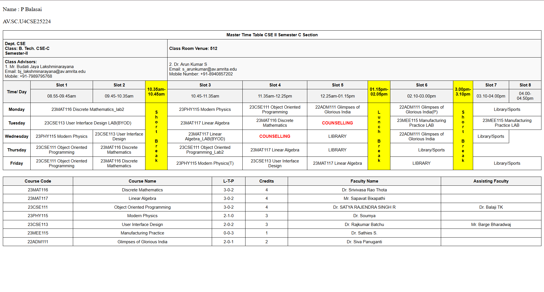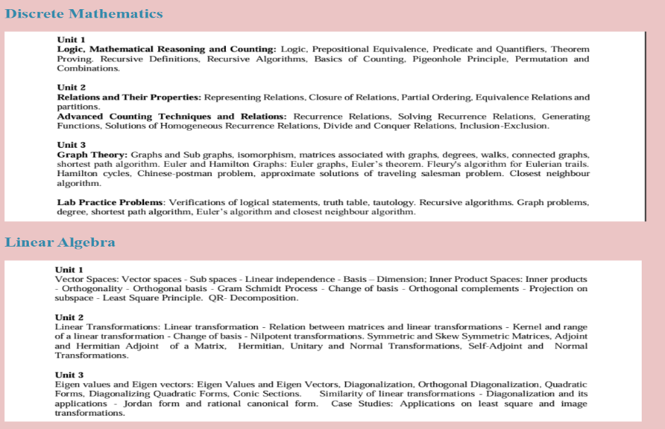
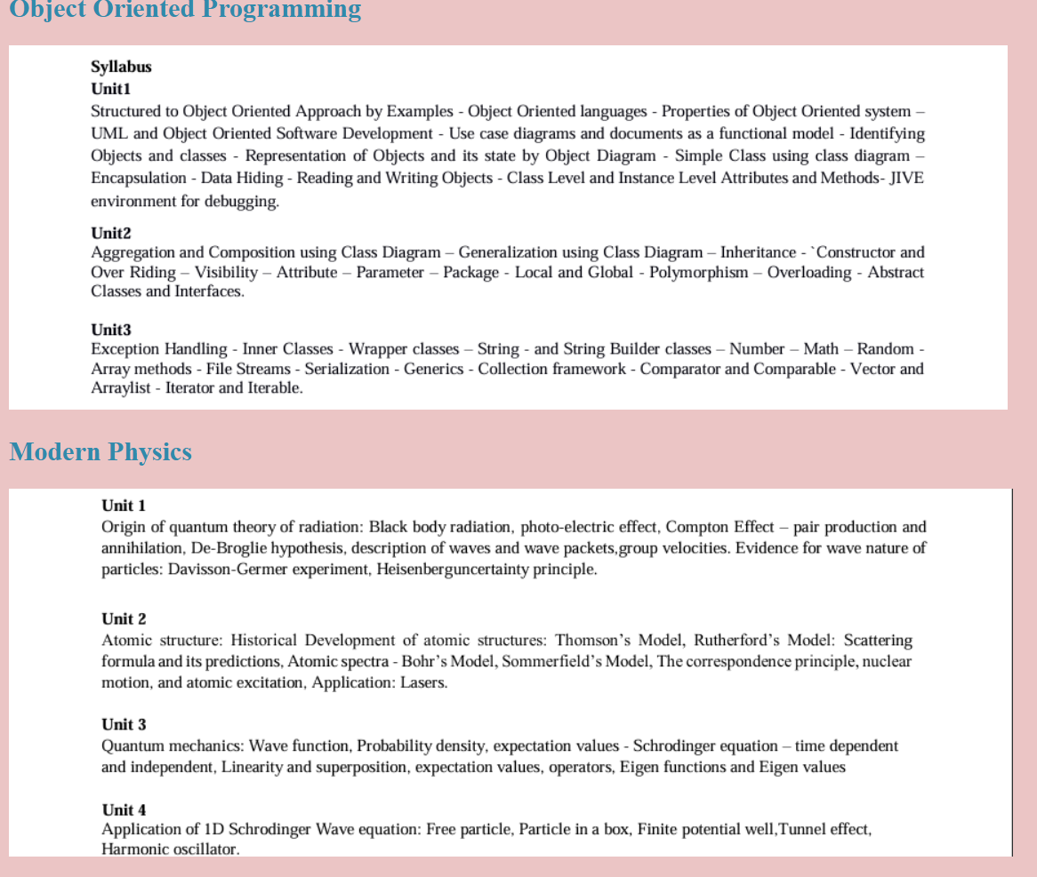
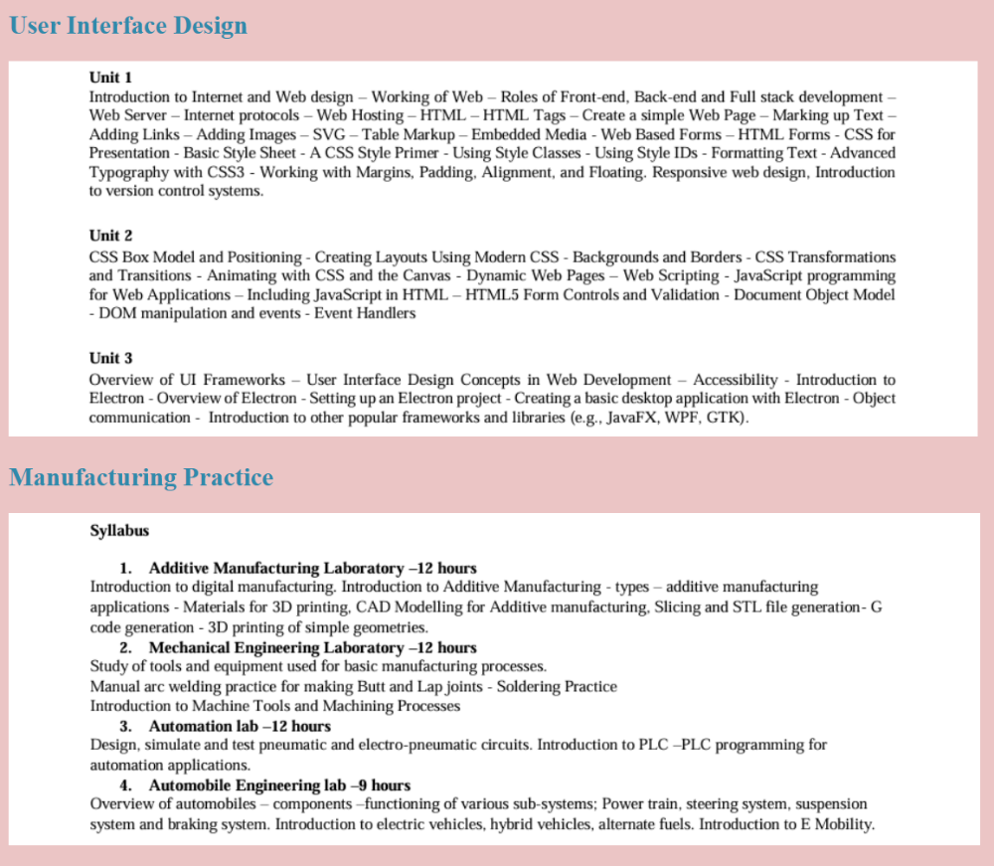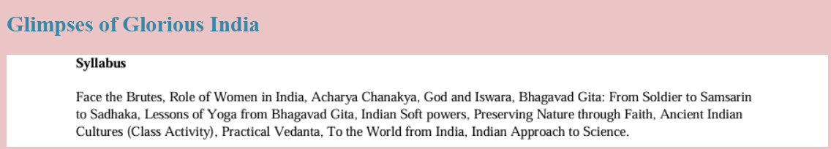

EXPLANTION:
<DOCTYPE html> : the <!DOCTYPE html> element tells the web browser that this an HTML document
or this is the latest version of HTML
<html> : the <html> element is the root element of an HTML web page
<head> : the <head> element will contain meta data about the HTML web page
<title> : the <title> element specifies a title for the HTML Page
<body> : the <body> element contains all visible content all visible content like text , image , links ,
tables , etc
<h> : we used <h> element for heading
<p> : we used <p> element for the paragraph
<table> : we used <table> element for the creation of the table
<tr> : we used <tr> element for creation of row in the table
<td> : we used <td> element for creation of table details
<th> : we used <th> element for creation of table headings
<img> : we used <img> element for adding the images into the web page

WEEK-4
1. AIM:Registration Form
INPUT:
<!DOCTYPE html>
<html>
<head>
<title>College Admission Registration</title>
</head>
<body bgcolor="lightblue">
<tr>
Pasupuleti Balasai<br></br>
SC.U4CSE25224
CSE-C
</tr>

<center>
<h2>College Admission Registration</h2>
<form>
<table border="1" cellpadding="10" cellspacing="0" bgcolor="white">

<tr>
<td><label for="fullname">Full Name:</label></td>
<td><input type="text" id="fullname" name="fullname"></td>
</tr>
<tr>
<td><label for="email">Email:</label></td>
<td><input type="email" id="email" name="email"></td>
</tr>
<tr>
<td><label for="phone">Phone Number:</label></td>
<td><input type="tel" id="phone" name="phone"></td>
</tr>
<tr>
<td><label>Gender:</label></td>
<td>
<input type="radio" id="male" name="gender" value="Male">
<label for="male">Male</label>
<input type="radio" id="female" name="gender" value="Female">
<label for="female">Female</label>
<input type="radio" id="other" name="gender" value="Other">
<label for="other">Other</label>
</td>
</tr>
<tr>
<td><label for="course">Course Applying For:</label></td>
<td>
<select id="course" name="course">
<option value="btech">B.Tech</option>
<option value="mtech">M.Tech</option>
<option value="mba">MBA</option>
</select>
</td>
</tr>
<tr>
<td><label>Hobbies:</label></td>
<td>
<input type="checkbox" id="sports" name="hobbies" value="Sports">
<label for="sports">Sports</label>
<input type="checkbox" id="music" name="hobbies" value="Music">
<label for="music">Music</label>
<input type="checkbox" id="reading" name="hobbies" value="Reading">
<label for="reading">Reading</label>
</td>
</tr>
<tr>
<td><label for="dob">Date of Birth:</label></td>
<td><input type="date" id="dob" name="dob"></td>
</tr>
<tr>
<td><label for="certificates">Upload Certificates:</label></td>
<td><input type="file" id="certificates" name="certificates"></td>
</tr>
<tr>
<td><label for="address">Address:</label></td>
<td><textarea id="address" name="address" rows="4" cols="40"></textarea></td>
</tr>
<tr>
<td colspan="2" align="center">
<input type="submit" value="Submit">
<input type="reset" value="Reset">
</td>
</tr>
</table>
</form>
</center>

</body>
</html>

OUTPUT:
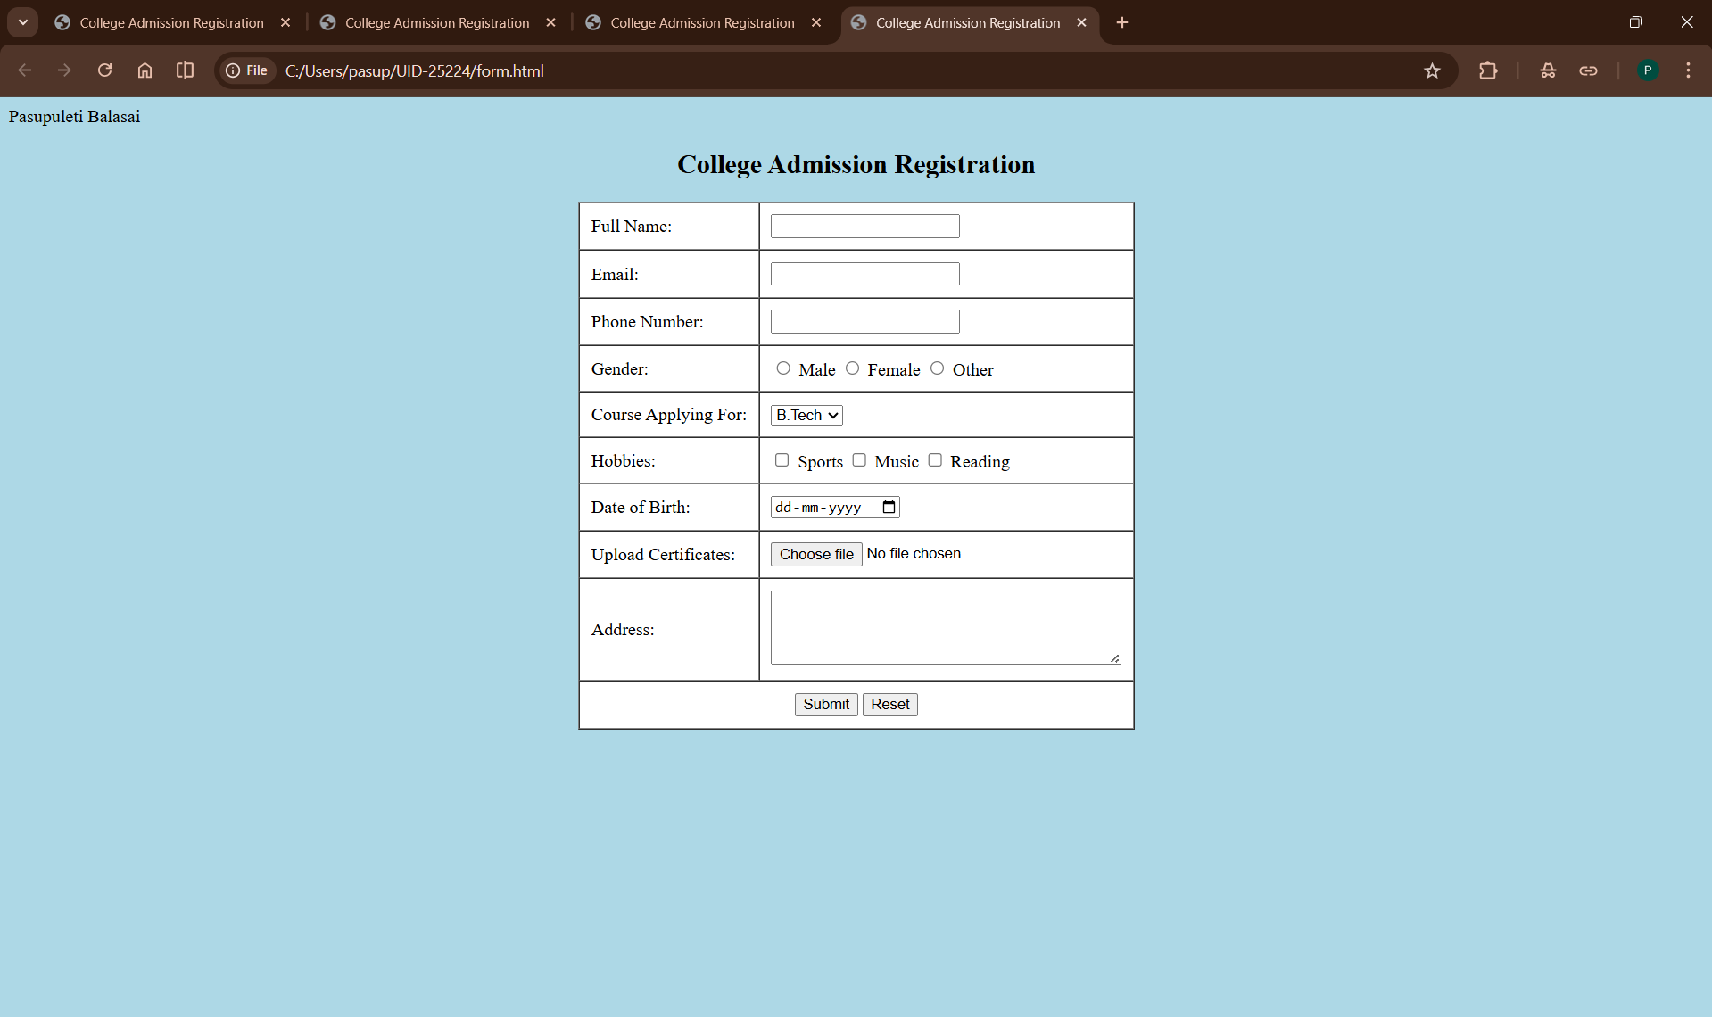
EXPLANATION:
<DOCTYPE html> : the <!DOCTYPE html> element tells the web browser that this an HTML document
or this is the latest version of HTML
<html> : the <html> element is the root element of an HTML web page
<head> : the <head> element will contain meta data about the HTML web page
<title> : the <title> element specifies a title for the HTML Page
<body> : the <body> element contains all visible content all visible content like text , image , links ,
tables , etc
<h> : we used <h> element for heading
<p> : we used <p> element for the paragraph
<table>: the element <table> is used to create a table
<tr>: the element <tr> creates a new row in the table
<th>: the element <th> create a new heading inside the table
<td>: the element <td> fill the columns in the row
<label>:we used <label> element for linking the input to specific id name and we use for attribute for it
<input>:we use <input> element for the input elements in the forms
<select>:we use <select> element for creation of drop box
<option>:we use <option> element for creating the options in the drop box

2. AIM: Two forms displayed side by side using iframes .one is login and another registration
<!DOCTYPE html>
<html>
<head>
<title>Two Forms Using Iframes</title>
</head>
<body>
<center>
<h2>Two Forms Using Iframes</h2>
<iframe src="Userlogin.html" width="600" height="500"></iframe>
<iframe src="Registration.html" width="600" height="500"></iframe>
</center>
</body>
</html>
USER LOGIN
<!DOCTYPE html>
<html>
<body>
<center>
<h2>User Login</h2>
<form>
<tr>
<table width="50" border="1" cellpadding="25" cellspacing="2" style="text-align:center;">
<tr>
<td>
<label for="fname">Username:</label>
</td>
<td>
<input type="text" id="fname" name="fname">
</td>
</tr>
<td>
<label for="password">Password:</label>
</td>
<td>
<input type="password" id="password" name="password">
</td>
<tr>
<td colspan="2" style:align="center">
<input type="Submit" id="Login" name="Login" value="Login">
</td>
</tr>
</table>
</center>
</form>
</body>
</html>
Registration:
<!DOCTYPE html>
<html>
<body>
<center>
<h2>User Registration</h2>
<form>
<table width="50" border="1" cellpadding="25" cellspacing="2" style="text-align:center;">
<tr>
<td>
<label for="fname">FullName:</label>
</td>
<td>
<input type="text" id="fname" name="fname">
</td>
</tr>
<td>
<label for="Email">Email:</label>
</td>
<td>
<input type="Email" id="Email" name="Email">
</td>
<tr>
<td>
<label for="phone number">Phone:</label>
</td>
<td>
<input type="text" id="phone number" name="phone nummber">
</td>
</tr>
<tr>
<td>
<label for="password">Password:</label>
</td>
<td>
<input type="password" id="password" name="password">
</td>
</tr>
<tr>
<td colspan="2" style:align="center">
<input type="Submit" id="Register" name="Register" value="Register">
<input type="Reset" id="Reset" name="Reset" value="Reset">
</td>
</tr>
</form>
</table>
</tr>
</center>
</body>
</html>
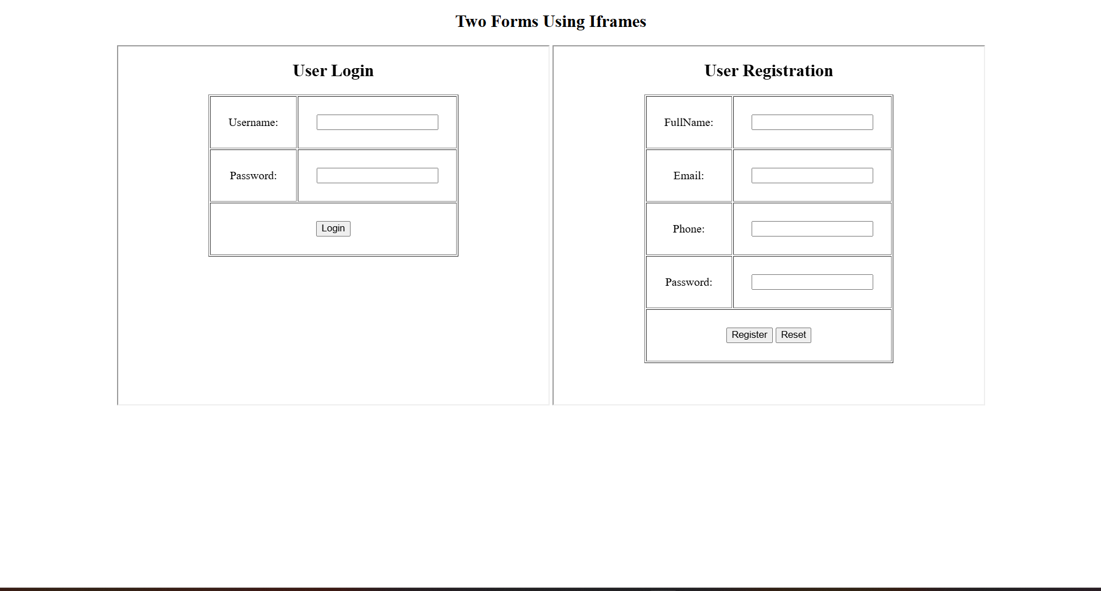

EXPLANATION:
<DOCTYPE html> : the <!DOCTYPE html> element tells the web browser that this an HTML document
or this is the latest version of HTML
<html> : the <html> element is the root element of an HTML web page
<head> : the <head> element will contain meta data about the HTML web page
<title> : the <title> element specifies a title for the HTML Page
<body> : the <body> element contains all visible content all visible content like text , image , links ,
tables , etc
<h> : we used <h> element for heading
<p> : we used <p> element for the paragraph
<table>: the element <table> is used to create a table
<tr>: the element <tr> creates a new row in the table
<th>: the element <th> create a new heading inside the table
<td>: the element <td> fill the columns in the row
<label>:we used <label> element for linking the input to specific id name and we use for attribute for it
<input>:we use <input> element for the input elements in the forms
<select>:we use <select> element for creation of drop box
<option>:we use <option> element for creating the options in the drop box
<iframes>:we use <iframes> element for adding anoter html file to main html file
WEEK-5
5.1 Aim: creating a card layout using
tag consider three cards and a button using html and css

Input
<!DOCTYPE html>
<html>
<head>
<title>Card Design </title>

<style>
body{
font-family:Arial, Helvetica, sans-serif;
background-color:rgb(190, 162, 128);
text-align:center;
margin: 2px;
padding : 20px;
}
.container{
display:flex;
justify-content: center;
flex-wrap:wrap;
align-items:center;
overflow-x:auto;
gap:50px;
}
.card{
background-color:bisque;
border-radius:10px;
box-shadow:0 4px 8px rgba(0,0,0,0.2);
width:300px;
padding:20px;
text-align:center;
transition:transform 0.3s;
}
.card:hover{
transform:translateY(-10px);
}
.card h3{
margin-bottom:10px;
color:black;
}
.card p{
font-size:15px;
color:rgb(109, 130, 149);
margin-bottom:15px;
}
.card button{
background-color:aquamarine;
color:rgb(100, 16, 16);
border:none;
padding:10px 15px;
border-radius:5px;
cursor:pointer;
font-size:16px;

}
.card button:hover{
background-color:rgb(0, 255, 255);
}
.onepiece-img{
width:150px;
height:200px;
object-fit:cover;
border-radius:8px;
}

</style>
</head>
<body>
<h1 style="color: rgb(143, 58, 58);">One Piece Characters</h1>
<div class="container">
<div class="card">
<img class="onepiece-img"
src="https://images8.alphacoders.com/133/thumb-1920-1332278.jpeg" alt="One Piece">

<h3>Monkey D. Luffy</h3>
<p>Gum-Gum Fruit</p>
<button>Learn More</button>
</div>
<div class="card">
<img class="onepiece-img"
src="https://i.pinimg.com/1200x/1a/c9/c4/1ac9c487bb6a9572595c5cd12efbbdf8.jpg" alt="One Piece">
<h3>Roronoa Zoro</h3>
<p>Swordsmanship</p>
<button>Learn More</button>
</div>
<div class="card">
<img class="onepiece-img"
src="https://images.wallpapersden.com/image/wxl-sanji-art-one-piece-2022_83882.jpg" alt="One Piece">
<h3> Sanji</h3>
<p>Black Leg</p>
<button>Learn More</button>
</div>
</div>
</body>
</html>

OUTPUT:
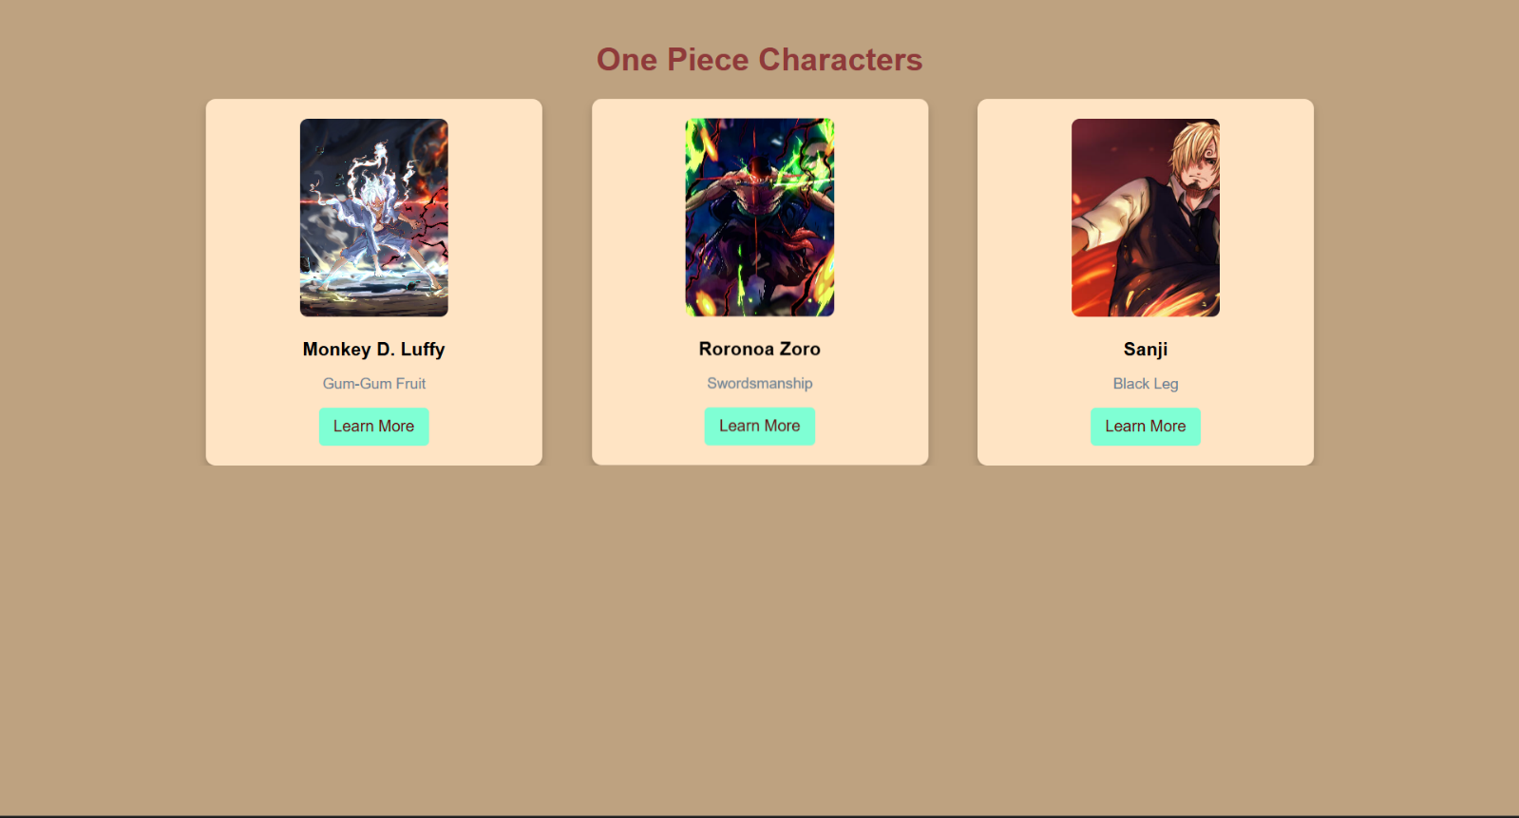
Explanation:
<!DOCTYPE html>: Tells the browser this is an HTML5 document.
<html>: The root element that wraps all your content.
<head>: Contains meta-information, the title, and CSS styles (not visible on the page).
<title>: Sets the text shown in the browser tab.
<body>: Contains all the visible content (headings, images, cards).

5.2
CODE:
MAIN.HTML:
<!DOCTYPE html>
<html>
<head>
<title>Card Design </title>

<style>
body{
font-family:Arial, Helvetica, sans-serif;
background-color:rgb(190, 162, 128);
text-align:center;
margin: 2px;
padding : 20px;
}
.container{
display:flex;
justify-content: center;
flex-wrap:wrap;
align-items:center;
overflow-x:auto;
gap:100px;
}
.card{
background-color:bisque;
border-radius:10px;
box-shadow:0 4px 8px rgba(0,0,0,0.2);
width:300px;
padding:20px;
text-align:center;
transition:transform 0.3s;
}
.card:hover{
transform:translateY(-10px);
}
.card h3{
margin-bottom:10px;
color:black;
}
.card p{
font-size:15px;
color:rgb(109, 130, 149);
margin-bottom:15px;
}
.card button{
background-color:aquamarine;
color:rgb(100, 16, 16);
border:none;
padding:10px 15px;
border-radius:5px;
cursor:pointer;
font-size:16px;

}
.card button:hover{
background-color:rgb(0, 255, 255);
}
.onepiece-img{
width:150px;
height:200px;
object-fit:cover;
border-radius:8px;
}

</style>
</head>
<body background="https://wallpaperaccess.com/full/317501.jpg"></body>
<h1 style="color: rgb(143, 58, 58);">One Piece Characters</h1>
<div class="container">
<div class="card">
<img class="onepiece-img"
src="https://images8.alphacoders.com/133/thumb-1920-1332278.jpeg" alt="One Piece">

<h3>Monkey D. Luffy</h3>
<p>Gum-Gum Fruit</p>
<button> <div class="menu">
<a href="Gears.html">
Learn More </div></button>

</div>
<div class="card">
<img class="onepiece-img"
src="https://i.pinimg.com/1200x/1a/c9/c4/1ac9c487bb6a9572595c5cd12efbbdf8.jpg" alt="One Piece">
<h3>Roronoa Zoro</h3>
<p>Swordsmanship</p>
<button>Learn More</button>
</div>
<div class="card">
<img class="onepiece-img"
src="https://images.wallpapersden.com/image/wxl-sanji-art-one-piece-2022_83882.jpg" alt="One Piece">
<h3> Sanji</h3>
<p>Black Leg</p>
<button>Learn More</button>

</div>
</body>
</html>
Gear.html:
<!DOCTYPE html>
<html>
<head>
<style>
body {
background-image: url('One_Piece_Anime_Logo.webp');
background-size: cover;
background-repeat: no-repeat;
background-attachment: fixed;
}
.container{
display:flex;
justify-content:center;
flex-wrap:wrap;
align-items:center;
}
.card{

border-radius:10px;
box-shadow:0 4px 8px rgba(0,0,0,0.2);
width:300px;
padding:20px;
text-align:center;
transition:transform 0.3s;
}
.card:hover{
transform:translateY(-10px);
}
.card h3{
margin-bottom:10px;
color:black;
}
.card p{
font-size:15px;
color:rgb(109, 130, 149);
margin-bottom:15px;
}
.card button{
background-color:aquamarine;
color:rgb(100, 16, 16);
border:none;
padding:10px 15px;
border-radius:5px;
cursor:pointer;
font-size:16px;
}
p {
max-width: 600px;

padding: 10px;
border-radius: 5px;
}
</style>
</head>
<body style="font-family:Arial, Helvetica, sans-serif; text-align:center; margin: 2px; padding: 20px; color:rgb(26, 27, 29); font-size:20px;">
<div class="container">
<div class="card">
<img src="C:\Users\pasup\OneDrive\Pictures\Screenshots\Screenshot 2026-03-10 102123.png"alt="Luffy Base Form" class="onepiece-img">
<h3>Base Form (Pre-Gear)</h3>
<p style="text-align:center ; margin-left: 20px; color:rgb(26, 27, 29); font-size:18px;">
<strong>Appearance:</strong> Episode 1 / Chapter 1.<br>
<strong>Explanation:</strong> Uses basic stretching abilities (e.g., Gum-Gum Pistol)<br>
<strong>Abilities:</strong> Immune to blunt force, bullets, and electricity. Highly creative, but lacks raw power compared to higher gears
</p>
</body>
</html>
OUTPUT:
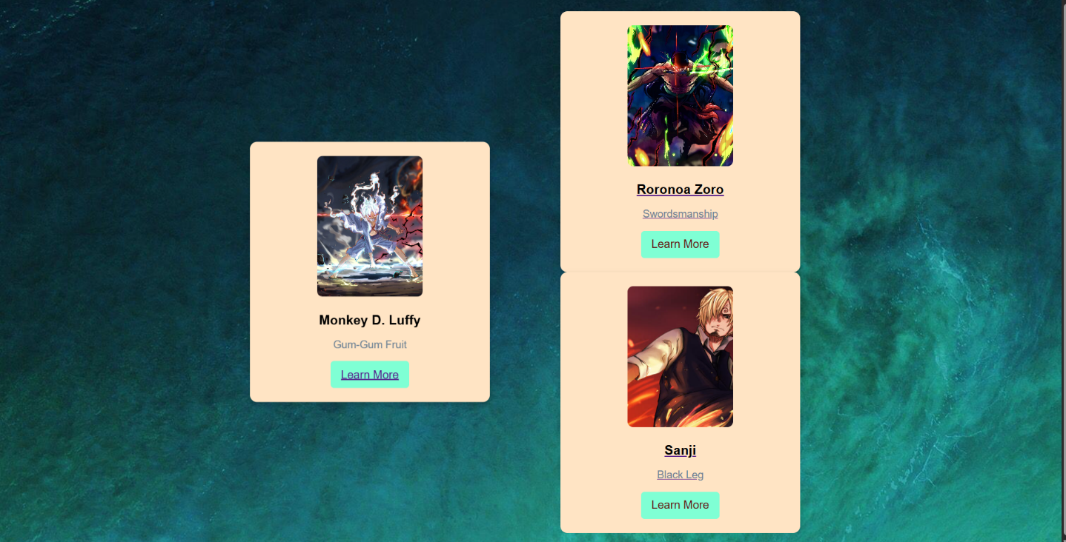

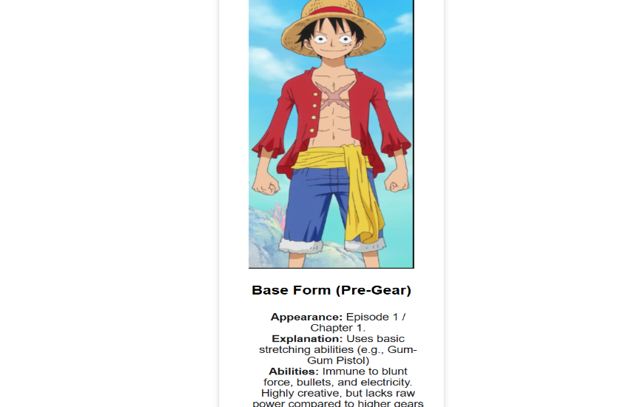

EXPLANATION
- <html> → Root element of the HTML document.
- <head> → Contains metadata, styles, and the title.
- <title> → Sets the page title (shown in browser tab).
- <style> → Internal CSS styling.
- <body> → Main content area of the webpage.
- <div> → Defines sections/containers (used for .container and .card

5.3
Aim: Design amrita login page by showcampus on home page.upon clicking on each campus the details about each campus should be display on the same page use html and css to design a stylish webpage

Program:
Main page
<!DOCTYPE html>
<html>
<head>
<title>Amrita Vishwa Vidhyapeetam</title>
<style>
body{margin:0;font-family:Arial;background:rgb(101, 101, 139);}
header{background:#a00000;color:#fff;text-align:center;
padding:20px;font-size:36px;}
nav{background:#0b5ea6;text-align:center;padding:10px;}
nav a{color:yellow;margin:12px;text-decoration:none;
font-weight:bold;padding:5px;}
nav a:hover{background:#fff;color:#0b5ea6;
border-radius:5px;}
main{display:flex;padding:20px;}
.login{
width:350px;
background-image:url("C:\\Users\\pasup\\OneDrive\\Pictures\\Screenshots\\Screenshot 2026-03-10 054819.png");
width:fit-content;
padding:15px;
border-radius:10px;
color:white;
}
.login input[type="email"],
.login input[type="password"]{
width:90%;
padding:6px;
margin:6px 0;
}
.remember{display:flex;align-items:center;gap:6px;margin:8px 0;}
iframe{
flex:1;
margin-left:20px;
height:520px;
border:none;
background-image:url("C:\\Users\\pasup\\OneDrive\\Pictures\\Screenshots\\Screenshot 2026-03-10 054819.png");
border-radius:10px;
}
</style>
</head>
<body>
<header>AMRITA VISHWA VIDHYAPEETAM</header>
<nav>
<a href="amaravati.html" target="campus">AMARAVATI</a>
<a href="amritapuri.html" target="campus">AMRITAPURI</a>
<a href="bengaluru.html" target="campus">BENGALURU</a>
<a href="chennai.html" target="campus">CHENNAI</a>
<a href="Caoimbatore.html" target="campus">COIMBATORE</a>
</nav>
<main>
<div class="login">
<h2>Login</h2>
Email
<input type="email">
Password
<input type="password">
<div class="remember">
<input type="checkbox"><label>Save me</label>
</div>
<input type="button" value="Login" style="width:100%;padding:6px;">
<br><br>
<a href="#">Forgot Password?</a><br>
No account? <a href="#">Register</a>
</div>
<iframe name="campus" src="amaravati.html"></iframe>
</main>
</body>
</html>
Amaravati:
<!DOCTYPE html>
<html>
<body style="font-family:Arial; text-align:center; padding:30px;">
<h1 style="color:#a00000;">Amaravati Campus</h1>
<p>
Amrita Amaravati campus is located near the Krishna River in Andhra Pradesh.
It provides modern classrooms, research labs, and excellent hostel facilities.
</p>
<p>
Popular Courses: CSE, AI, Data Science<br>
Facilities: Library, Smart Classrooms, Hostel<br>
Focus: Innovation and Research
</p>
<img src="C:\Users\pasup\OneDrive\Pictures\Screenshots\Screenshot 2026-03-10 053934.png" alt="Amaravati Campus"
width="450">
</body>
</html>
Amritapuri;
<!DOCTYPE html>
<html>
<body style="font-family:Arial;text-align:center;padding:30px;">
<h1 style="color:#a00000;">Amritapuri Campus</h1>
<p>
Amritapuri campus in Kerala is the main campus of Amrita University,
located near the Arabian Sea with a peaceful academic atmosphere.
</p>
<p>
Popular Courses: Engineering, Arts, Sciences<br>
Facilities: Research Labs, Beach Campus, Hostel<br>
Focus: Academic Excellence with Values
</p>
<img src="C:\Users\pasup\OneDrive\Pictures\Screenshots\Screenshot 2026-03-10 052320.png"
width="450">
</body>
</html>
BENGALURU:
<!DOCTYPE html>
<html>
<body style="font-family:Arial;text-align:center;padding:30px;">
<h1 style="color:#a00000;">Bengaluru Campus</h1>
<p>
Located in India's tech hub, Bengaluru campus offers advanced
engineering programs with strong industry connections.
</p>
<p>
Popular Courses: Robotics, CSE, ECE<br>
Facilities: Coding Labs, Innovation Centres<br>
Focus: Industry Collaboration
</p>
<img src="C:\Users\pasup\OneDrive\Pictures\Screenshots\Screenshot 2026-03-10 052725.png"
width="450">
</body>
</html>

CHENNAI:
<!DOCTYPE html>
<html>
<body style="font-family:Arial;text-align:center;padding:30px;">
<h1 style="color:#a00000;">Chennai Campus</h1>
<p>
Chennai campus provides top-quality computing and management education
with modern infrastructure and placement support.
</p>
<p>
Popular Courses: IT, MBA, Electronics<br>
Facilities: Digital Library, Placement Cell<br>
Focus: Career Development
</p>
<img src="C:\Users\pasup\OneDrive\Pictures\Screenshots\Screenshot 2026-03-10 053039.png"
width="450">
</body>
</html>
COIMBATORE:
<!DOCTYPE html>
<html>
<body style="font-family:Arial;text-align:center;padding:30px;">
<h1 style="color:#a00000;">Coimbatore Campus</h1>
<p>
Coimbatore campus is well known for its engineering excellence
and research-oriented education.
</p>
<p>
Popular Courses: Mechanical, Civil, CSE<br>
Facilities: Workshops, Labs, Hostel<br>
Focus: Core Engineering Skills
</p>
<img src="C:\Users\pasup\OneDrive\Pictures\Screenshots\Screenshot 2026-03-10 053315.png"
width="450">
</body>
</html>
Output: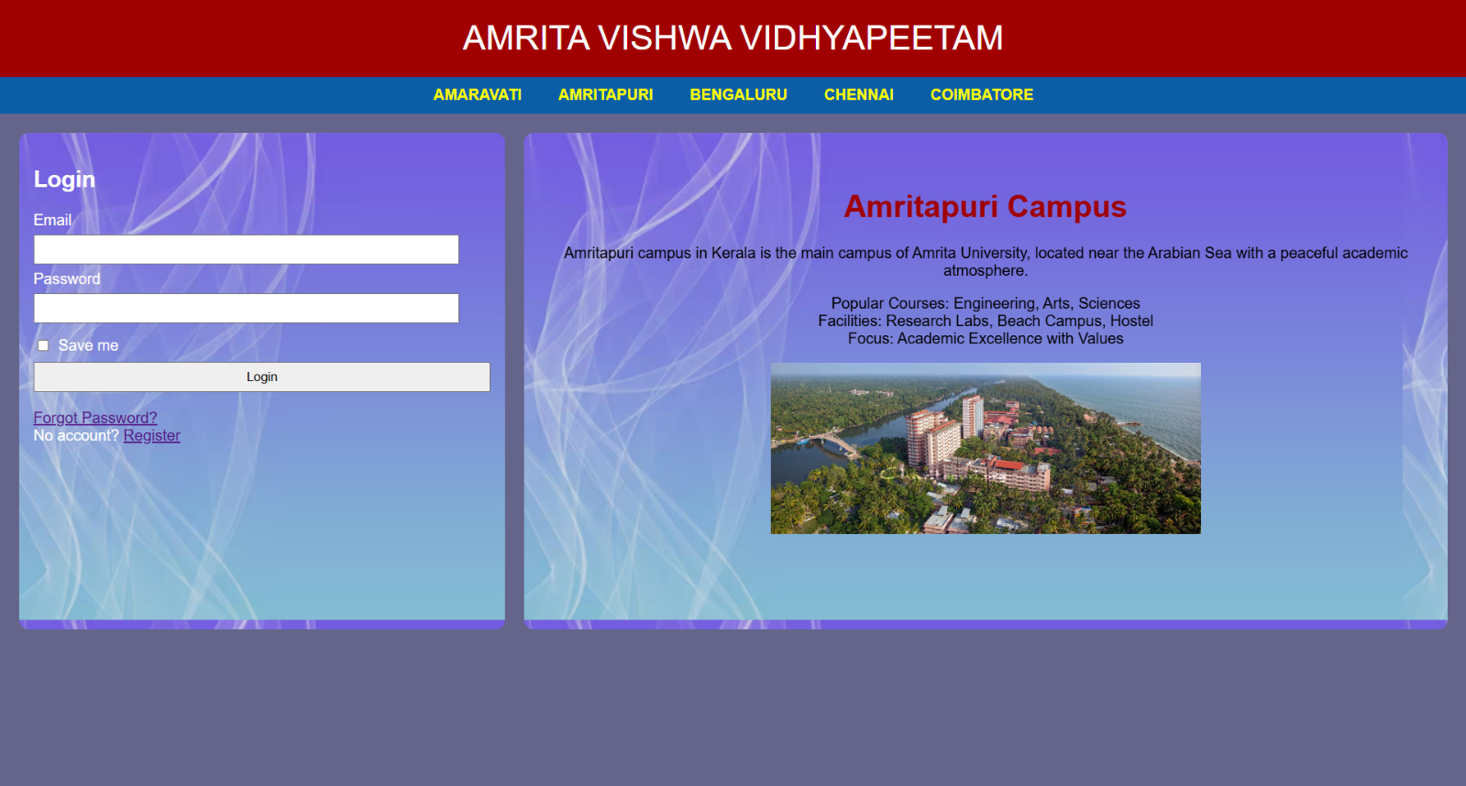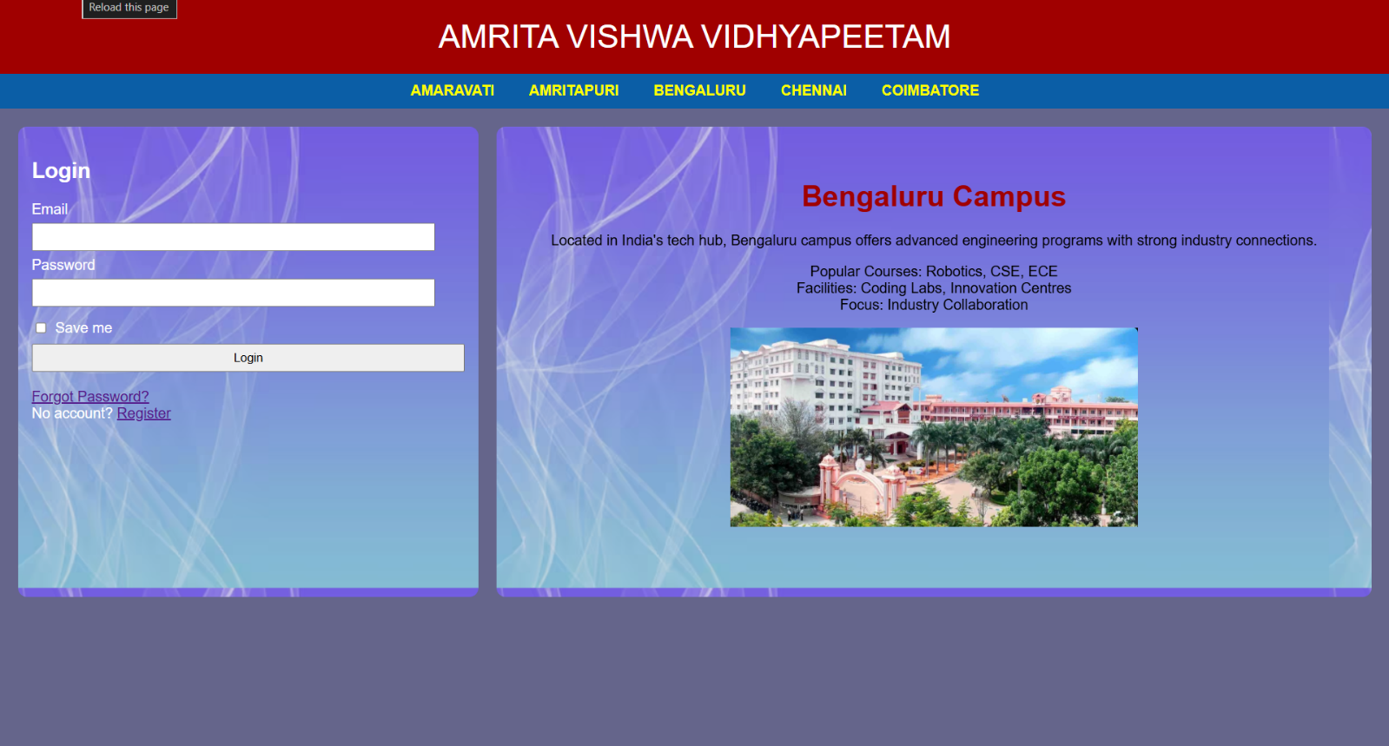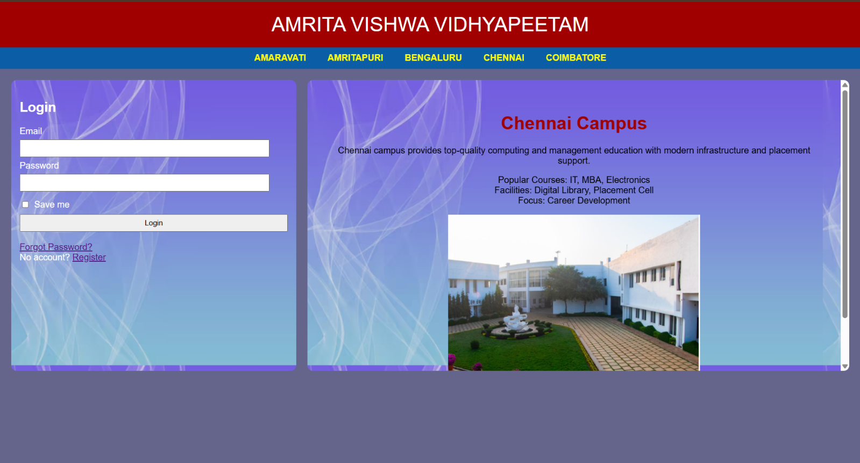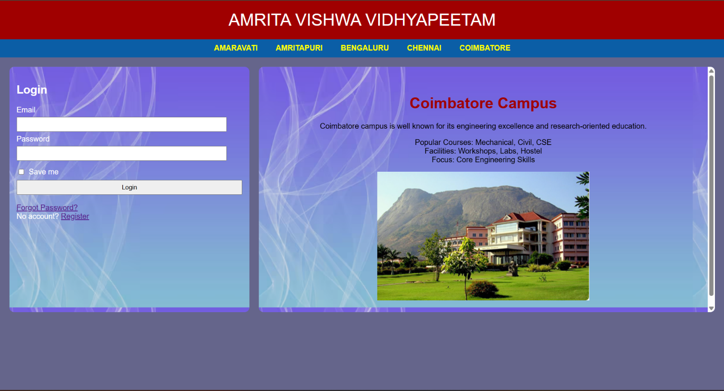

Explanation:
<DOCTYPE html> : the <!DOCTYPE html> element tells the web browser that this an HTML document
or this is the latest version of HTML
<html> : the <html> element is the root element of an HTML web page
<head> : the <head> element will contain meta data about the HTML web page
<title> : the <title> element specifies a title for the HTML Page
<body> : the <body> element contains all visible content all visible content like text , image , links ,
tables , etc
<h> : we used <h> element for heading
<p> : we used <p> element for the paragraph
<div>:we use <div> element for encapsulating the the divisions and easy to modify and
<button>: we use <button> element for button
<img>: we use <img> tag for displaying the image
<Iframes>:we use <iframe> element for creating the login block that stays left to it

WEEK-6
AIM: Design a responsive e-commerce application using the grid layout. This application should contain different categories of products such as electronics, clothing, home-appliances, books. Based on the category we select corresponding products should be displayed on the sidebar.

CODE:
Main.html
Name = P Balasai , Roll no = 25224 , Section-C
<!DOCTYPE html>
<html>
<head>
<title>E-commerce Site</title>
<style>
body {
margin: 0;
background-color: aliceblue;
font-family: sans-serif;
}

.container {
display: grid;
min-height: 100vh;
grid-template-rows: auto auto 1fr auto;
grid-template-columns: 200px 1fr;
grid-template-areas:
"header header"
"sale sale"
"sidebar products"
"footer footer";

}

.header {
grid-area: header;
background-color: blanchedalmond;
text-align: center;
padding: 10px;
margin-top: 0px;
border-radius: 8px;
}

.sale {
grid-area: sale;
background-color: tomato;
opacity: 0.9;
color: white;
border-radius: 8px;
text-align: center;
padding: 10px;
font-size: 19px;
font-weight: bold;
}

.sidebar {
grid-area: sidebar;
background-color: #e3f2fd;
padding: 20px;
border-radius: 9px;
opacity: 0.9;
border-right: 1px solid #ccc;
}
.frame {
grid-area: products;
width: 100%;
height: 100%;
border: none;
}

.sidebar a {
display: block;
color: black;
text-decoration: none;
padding: 10px 0;
border-bottom: 1px solid #d1e9ff;
}

.sidebar a:hover {
color: blue;
}

.footer {
grid-area: footer;
background-color: black;
color: white;
text-align: center;
padding: 2px;
}
</style>
</head>
<body>

<div class="container">
<div class="header">
<h1>Online store</h1>
</div>

<div class="sale">
<p>BIG SALE! 50% OFF!!</p>
</div>

<div class="sidebar">
<h3>Categories</h3>
<hr>
<a href="electronics.html" target="frame">Electronics</a>
<a href="clothes.html" target="frame">Clothes</a>
<a href="accessories.html" target="frame">Accessories</a>
</div>

<iframe class="frame" name="frame" src="electronics.html"></iframe>

<footer class="footer">
<p>2026 E-commerce Store Concept</p>
</footer>
</div>

</body>
</html>

Electronics.html
<!DOCTYPE html>
<html>
<head>
<title>Electronics</title>
<style>
body {
margin: 0;
background-color: aliceblue;
font-family: sans-serif;
}

.products {
grid-area: products;
display: grid;
grid-template-columns: repeat(2, 1fr);
gap: 10px;
padding: 20px;
}

.product-card {
background: white;
border: 1px solid #ddd;
padding: 20px;
text-align: center;
border-radius: 8px;
height: auto;
width: 600px;
width: 100%;
}
.p{
text-align: center;
background-color: tomato;
align-items: center;
}
img{
width: 120px;
height: auto;
border-radius: 8px;
}

.button {
background-color: blue;
color: white;
border: none;
padding: 10px 20px;
cursor: pointer;
border-radius: 50px;
margin-top: 10px;
}

.button:hover {
background-color: #7094ff;
}
</style>
</head>
<body>
<div class="products">
<div class="product-card">

<img src="C:\Users\pasup\OneDrive\Pictures\Screenshots\Screenshot 2026-03-17 055255.png">
<h3>Iphone 17</h3>
<p>$899</p>
<p>12GB RAM | 256GB Storage</p>
<button class="button">Add to Cart</button>
</div>
<div class="product-card">
<img src="C:\Users\pasup\OneDrive\Pictures\Screenshots\Screenshot 2026-03-17 055613.png">
<h3>Samsung Galaxy S26</h3>
<p>$1199</p>
<p>12GB RAM | 512GB Storage</p>
<button class="button">Add to Cart</button>
</div>
<div class="product-card">
<img src="C:\Users\pasup\OneDrive\Pictures\Screenshots\Screenshot 2026-03-17 060308.png">
<h3>Dell G15</h3>
<p>$799</p>
<p>16GB RAM | 1024GB Storage</p>
<button class="button">Add to Cart</button>
</div>
<div class="product-card">
<img src="C:\Users\pasup\OneDrive\Pictures\Screenshots\Screenshot 2026-03-17 061110.png">
<h3>HP victus</h3>
<p>$749</p>
<p>16GB RAM | 512GB Storage</p>
<button class="button">Add to Cart</button>
</div>
</div>
</body>
CLOTHES.HTML
<!DOCTYPE html>
<html>
<head>
<title>Electronics</title>
<style>
body {
margin: 0;
background-color: aliceblue;
font-family: sans-serif;
}

.products {
grid-area: products;
display: grid;
grid-template-columns: repeat(2, 1fr);
gap: 20px;
padding: 20px;
}

.product-card {
background: white;
border: 1px solid #ddd;
padding: 20px;
text-align: center;
border-radius: 8px;
}
img{
width: 120px;
height: auto;
border-radius: 8px;
}
.p{
text-align: center;
background-color: tomato;
align-items: center;
}

.button {
background-color: blue;
color: white;
border: none;
padding: 10px 20px;
cursor: pointer;
border-radius: 50px;
margin-top: 10px;
}

.button:hover {
background-color: #7094ff;
}
</style>
</head>
<body>
<div class="products">
<div class="product-card">
<img src="C:\Users\pasup\OneDrive\Pictures\Screenshots\Screenshot 2026-03-17 061314.png">
<h3>USPA off-white shirt</h3>
<p>$39</p>
<p>Size: S , M , XL , XXL</p>
<button class="button">Add to Cart</button>
</div>
<div class="product-card">
<img src="C:\Users\pasup\OneDrive\Pictures\Screenshots\Screenshot 2026-03-17 061446.png">
<h3>USPA blue Shirt</h3>
<p>$59</p>
<p>Size: S , M , L , XL</p>
<button class="button">Add to Cart</button>
</div>
<div class="product-card">
<img src="C:\Users\pasup\OneDrive\Pictures\Screenshots\Screenshot 2026-03-17 061544.png">
<h3>USPA black pants</h3>
<p>$49</p>
<p>Size: 28 , 30 , 32 , 34</p>
<button class="button">Add to Cart</button>
</div>
<div class="product-card">
<img src="C:\Users\pasup\OneDrive\Pictures\Screenshots\Screenshot 2026-03-17 061645.png">
<h3>USPA Green pants</h3>
<p>$52</p>
<p>Size: 28 , 30 , 32 , 34</p>
<button class="button">Add to Cart</button>
</div>
</div>
</body>
</html>
Accessories
<!DOCTYPE html>
<html>
<head>
<title>Electronics</title>
<style>
body {
margin: 0;
background-color: aliceblue;
font-family: sans-serif;
}

.products {
grid-area: products;
display: grid;
grid-template-columns: repeat(2, 1fr);
gap: 20px;
padding: 20px;
}

.product-card {
background: white;
border: 1px solid #ddd;
padding: 20px;
text-align: center;
border-radius: 8px;
}
.p{
text-align: center;
background-color: tomato;
align-items: center;
}
img{
width: 120px;
height: auto;
border-radius: 8px;
}

.button {
background-color: blue;
color: white;
border: none;
padding: 10px 20px;
cursor: pointer;
border-radius: 50px;
margin-top: 10px;
}

.button:hover {
background-color: #7094ff;
}
</style>
</head>
<body>
<div class="products">
<div class="product-card">
<img src="C:\Users\pasup\OneDrive\Pictures\Screenshots\Screenshot 2026-03-17 061826.png" alt="Samsung Galaxy Watch 6">
<h3>Samsung Galaxy Watch 6</h3>
<p>$169</p>
<button class="button">Add to Cart</button>
</div>
<div class="product-card">
<img src="C:\Users\pasup\OneDrive\Pictures\Screenshots\Screenshot 2026-03-17 062028.png" >
<h3>Samsung Galaxy Buds 4</h3>
<p>$249</p>
<button class="button">Add to Cart</button>
</div>
<div class="product-card">
<img src="C:\Users\pasup\OneDrive\Pictures\Screenshots\Screenshot 2026-03-17 062145.png">
<h3>Samsung Galaxy ring </h3>
<p>$459</p>
<button class="button">Add to Cart</button>
</div>
<div class="product-card">
<img src="C:\Users\pasup\OneDrive\Pictures\Screenshots\Screenshot 2026-03-17 062306.png">
<h3>Samsung S26 case </h3>
<p>$59</p>
<button class="button">Add to Cart</button>
</div>
</div>
</body>

OUTPUT: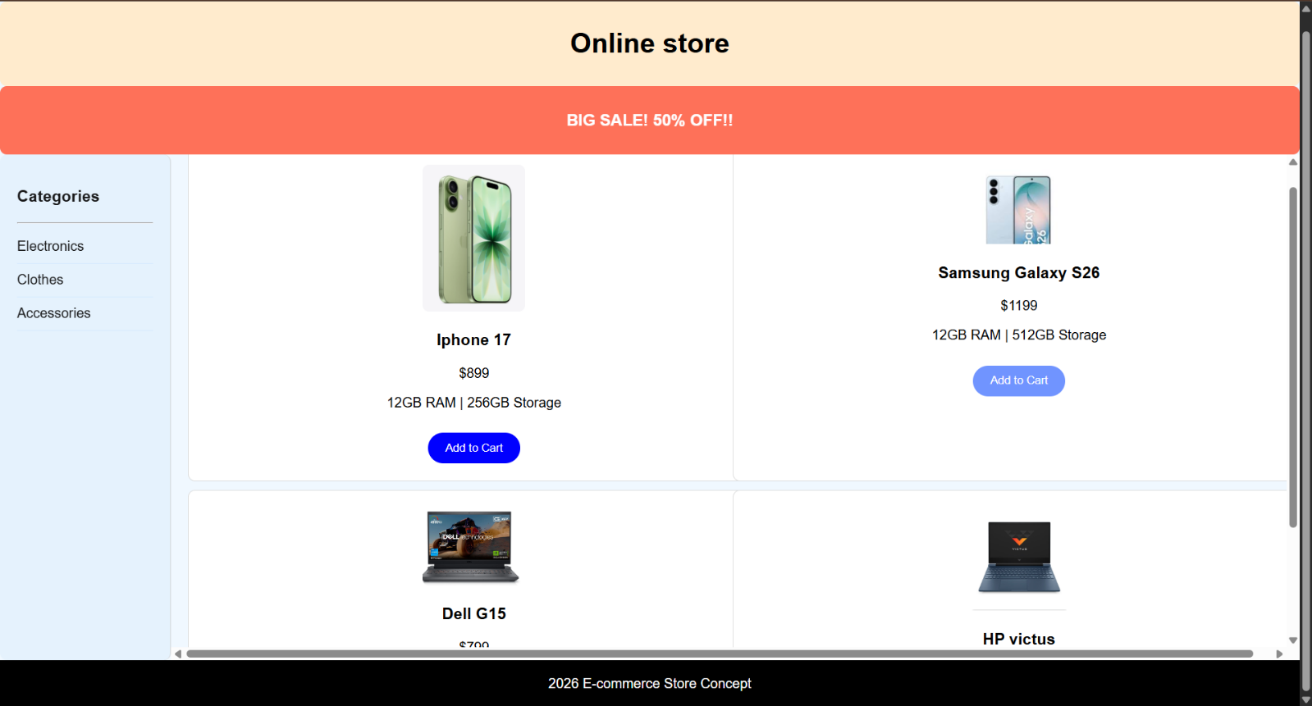
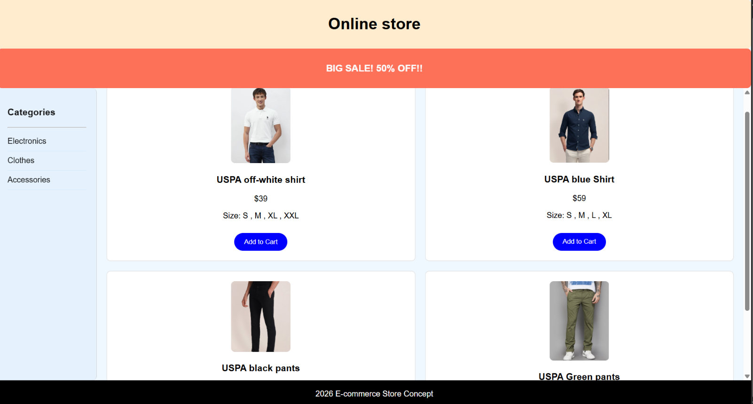

EXPLANATION:
<DOCTYPE html> : the <!DOCTYPE html> element tells the web browser that this an HTML document
or this is the latest version of HTML
<html> : the <html> element is the root element of an HTML web page
<head> : the <head> element will contain meta data about the HTML web page
<title> : the <title> element specifies a title for the HTML Page
<body> : the <body> element contains all visible content all visible content like text , image , links ,
tables , etc
<h> : we used <h> element for heading
<p> : we used <p> element for the paragraph
<div>:we use <div> element for encapsulating the the divisions and easy to modify and
<button>: we use <button> element for button
<img>: we use <img> tag for displaying the image
<I frame>:we <iframe> tag to create link other webpages into it.

WEEK-7
AIM : To create a GITHUB Account and uploading of files
STEP1:
Search for github in serach bar and open website
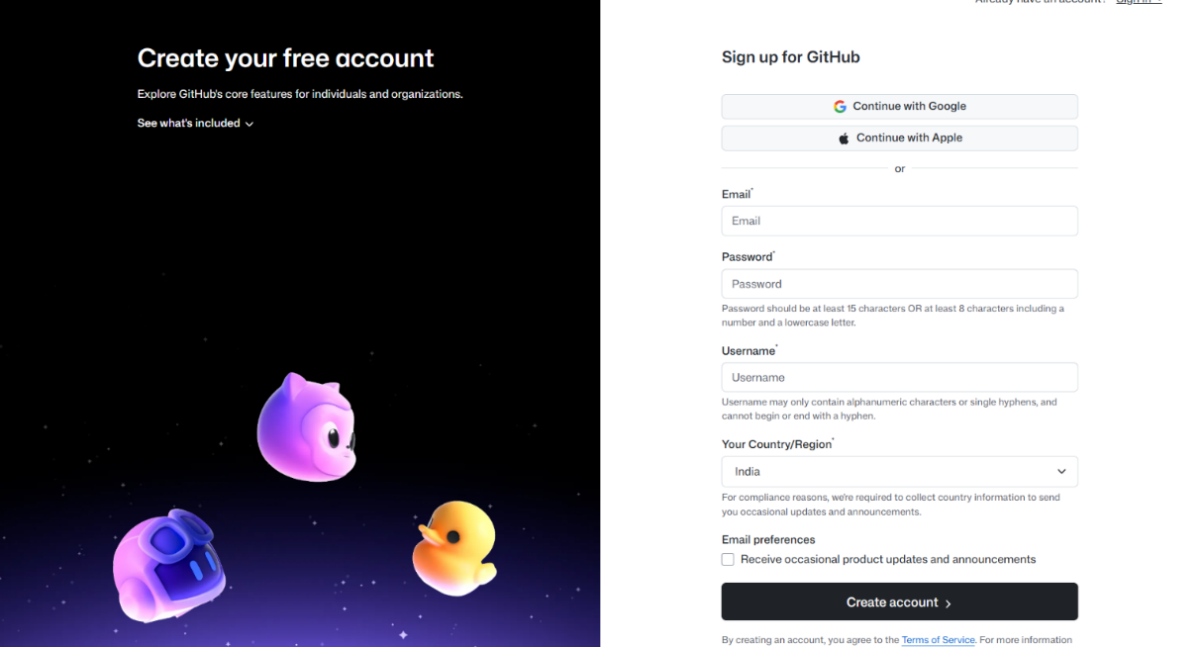
STEP 2:
Enter your respective email, username , password
Solve the given puzzles
Now sign in
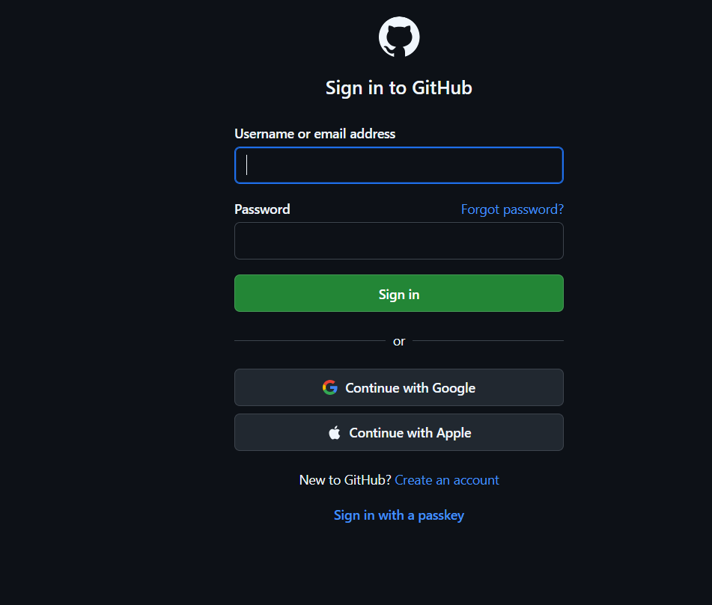

Step 3:
Create new depository for uploading your files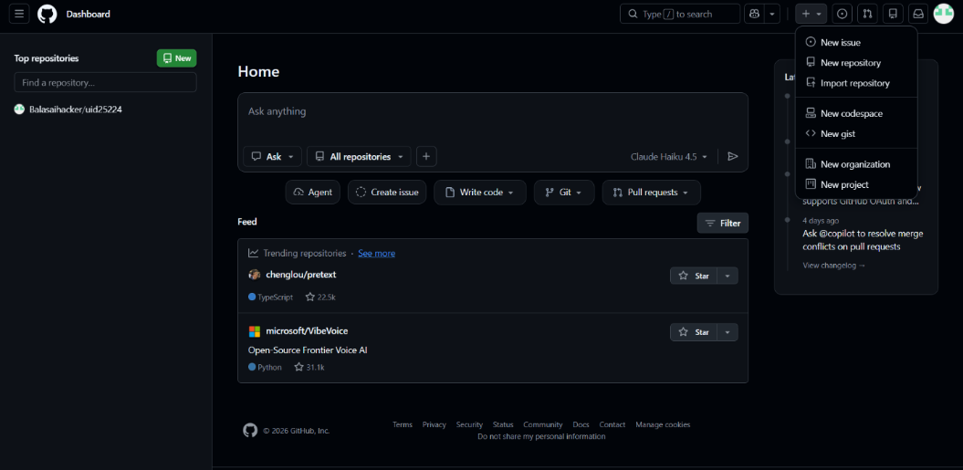
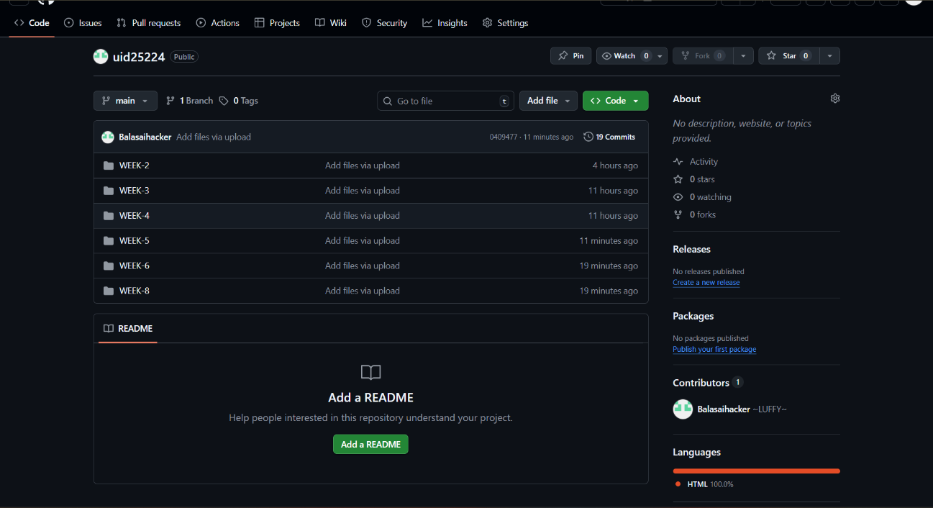
My repository link for the uid all week’s work:
https://github.com/Balasaihacker/uid25224.git
Week-8
8.1
Aim: create a web page that displays a square that continuously rotates 360 using css animation

CODE:
<!DOCTYPE html>
<html lang="en">
<head>
<meta charset="UTF-8" />
<meta name="viewport" content="width=device-width, initial-scale=1.0"/>
<title>Combined CSS Animations</title>
<style>
body {
margin: 0;
height: 100vh;
background: #f0f0f0;
display: flex;
justify-content: space-around;
align-items: center;
overflow: hidden;
}

.rotating-box {
width: 100px;
height: 100px;
background-color: #3498db;
animation: rotate 2s linear infinite;
}
@keyframes rotate {
from {
transform: rotate(0deg);
}
to {
transform: rotate(360deg);
}
}
</style>
</head>
<body>
<div class="rotating-box"></div>
</body>
</html>
OUTPUT


EXPLANATION:
<DOCTYPE html> : the <!DOCTYPE html> element tells the web browser that this an HTML document
or this is the latest version of HTML
<html> : the <html> element is the root element of an HTML web page
<head> : the <head> element will contain meta data about the HTML web page
<title> : the <title> element specifies a title for the HTML Page
<body> : the <body> element contains all visible content all visible content like text , image , links ,
tables , etc
<h> : we used <h> element for heading
<div>:we use <div> element for encapsulating the the divisions and easy to modify and
@keyframes:we use @keyframes for animation from starting to end transformation.
8.2:
Aim :create a ball that moves up and down continuously using css animation
CODE:
<!DOCTYPE html>
<html lang="en">
<head>
<meta charset="UTF-8" />
<meta name="viewport" content="width=device-width, initial-scale=1.0"/>
<title>Combined CSS Animations</title>
<style>
body {
margin: 0;
height: 100vh;
background: #f0f0f0;
display: flex;
justify-content: space-around;
align-items: center;
overflow: hidden;
}

.moving-rotating-circle {
width: 80px;
height: 80px;
background-color: #2ecc71;
border-radius: 50%;
position: absolute;
top: 80%;
animation: moveRotate 3s linear infinite;
}

@keyframes moveRotate {
0% {
left: 0;
transform: rotate(0deg);
}
50% {
left: calc(100% - 80px);
transform: rotate(180deg);
}
100% {
left: 0;
transform: rotate(360deg);
}
}
</style>
</head>
<body>

<div class="moving-rotating-circle"></div>
</body>
</html>

OUTPUT:


EXPLANATION:
<DOCTYPE html> : the <!DOCTYPE html> element tells the web browser that this an HTML document
or this is the latest version of HTML
<html> : the <html> element is the root element of an HTML web page
<head> : the <head> element will contain meta data about the HTML web page
<title> : the <title> element specifies a title for the HTML Page
<body> : the <body> element contains all visible content all visible content like text , image , links ,
tables , etc
<h> : we used <h> element for heading
<div>:we use <div> element for encapsulating the the divisions and easy to modify and
@keyframes:we use @keyframes for animation from starting to end transformation

8.3
Aim :create a circle that moves horizontally and rotates At the same time
CODE:
<!DOCTYPE html>
<html lang="en">
<head>
<meta charset="UTF-8" />
<meta name="viewport" content="width=device-width, initial-scale=1.0"/>
<title>Combined CSS Animations</title>
<style>
body {
margin: 0;
height: 100vh;
background: #f0f0f0;
display: flex;
justify-content: space-around;
align-items: center;
overflow: hidden;
}

.bouncing-ball {
width: 60px;
height: 60px;
background-color: #e74c3c;
border-radius: 50%;
position: relative;
animation: bounce 1s ease-in-out infinite alternate;
}

@keyframes bounce {
from {
top: 0;
}
to {
top: -100px;
}
}
</style>
</head>
<body>

<div class="bouncing-ball"></div>

</body>
</html>
OUTPUT:


EXPLANATION:
<DOCTYPE html> : the <!DOCTYPE html> element tells the web browser that this an HTML document
or this is the latest version of HTML
<html> : the <html> element is the root element of an HTML web page
<head> : the <head> element will contain meta data about the HTML web page
<title> : the <title> element specifies a title for the HTML Page
<body> : the <body> element contains all visible content all visible content like text , image , links ,
tables , etc
<h> : we used <h> element for heading
<div>:we use <div> element for encapsulating the the divisions and easy to modify and
@keyframes:we use @keyframes for animation from starting to end transformation.

WEEK-9
Aim: Create a webpage using html,css,js based on the give conditions, create a button for each program , based on the button, clicked the corresponding program has to be executed and should display the logics for each button includes finding an even or odd number , prime or not , factorial of a number , Armstrong or not use appropriate design to display the output.
CODE:
<!DOCTYPE html>
<html>
<head>
<title>Calculator</title>

<style>
body {
font-family: 'Segoe UI', sans-serif;
margin: 0;
height: 100vh;
display: flex;
justify-content: center;
align-items: center;

background: linear-gradient(135deg, #2585d9, #ae1d0f);
}

.container {
background: rgba(255, 255, 255, 0.1);
backdrop-filter: blur(12px);
padding: 30px;
border-radius: 15px;
text-align: center;
width: 420px;
box-shadow: 0 10px 30px rgba(0,0,0,0.3);
}

h1 {
color: white;
margin-bottom: 20px;
}

input {
padding: 12px;
width: 80%;
border-radius: 8px;
border: none;
outline: none;
font-size: 16px;
margin-bottom: 20px;
}

.btn {
padding: 10px 15px;
margin: 6px;
border: none;
border-radius: 8px;
background: white;
color: #333;
font-weight: bold;
cursor: pointer;
transition: 0.3s;
}

.btn:hover {
background: #ffcc00;
transform: scale(1.05);
}

#outputBox {
margin-top: 20px;
padding: 15px;
background: rgba(255,255,255,0.9);
border-radius: 10px;
font-size: 18px;
min-height: 50px;
}
.btn {
padding: 10px 15px;
margin: 6px;
border: none;
border-radius: 8px;
background: linear-gradient(45deg, #ffffff, #e0e0e0);
color: #333;
font-weight: bold;
cursor: pointer;
transition: all 0.2s ease;
box-shadow: 0 4px 10px rgba(0,0,0,0.2);
}
.btn:hover {
background: linear-gradient(45deg, #ffcc00, #ff9900);
transform: translateY(-3px) scale(1.05);
box-shadow: 0 8px 20px rgba(0,0,0,0.3);
}

.btn:active {
transform: scale(0.95);
box-shadow: 0 2px 5px rgba(0,0,0,0.2);
}
</style>
</head>

<body>

<div class="container">
<h1>Program Panel</h1>

<input type="number" id="numInput" placeholder="Enter a number">

<br>

<button class="btn" onclick="checkEven()">Even</button>
<button class="btn" onclick="checkOdd()">Odd</button>
<button class="btn" onclick="checkPrime()">Prime</button>
<button class="btn" onclick="findFactorial()">Factorial</button>
<button class="btn" onclick="checkArmstrong()">Armstrong</button>

<div id="outputBox">Output will appear here...</div>
</div>

<script>

function getNumber() {
var value = document.getElementById("numInput").value;
var number = parseInt(value);
return number;
}

function show(msg) {
document.getElementById("outputBox").innerHTML = msg;
}

// Even
function checkEven() {
var n = getNumber();

if (n % 2 == 0) {
show(n + " is Even");
} else {
show(n + " is Not Even");
}
}

// Odd
function checkOdd() {
var n = getNumber();

if (n % 2 != 0) {
show(n + " is Odd");
} else {
show(n + " is Not Odd");
}
}

// Prime
function checkPrime() {
var n = getNumber();
var isPrime = true;

if (n < 2) {
isPrime = false;
} else {
for (var i = 2; i < n; i++) {
if (n % i == 0) {
isPrime = false;
break;
}
}
}

if (isPrime) {
show(n + " is Prime");
} else {
show(n + " is NOT Prime");
}
}

// Factorial (fixed + simple)
function findFactorial() {
var n = getNumber();
var fact = 1;

for (var i = 1; i <= n; i++) {
fact = fact * i;
}

show("Factorial is " + fact);
}

// Armstrong
function checkArmstrong() {
var n = getNumber();
var temp = n;
var sum = 0;
var digits = n.toString().length;

while (temp > 0) {
var d = temp % 10;
sum = sum + Math.pow(d, digits);
temp = Math.floor(temp / 10);
}

if (sum == n) {
show(n + " is an Armstrong Number");
} else {
show(n + " is NOT an Armstrong Number");
}
}

</script>

</body>
</html>
OUTPUT:
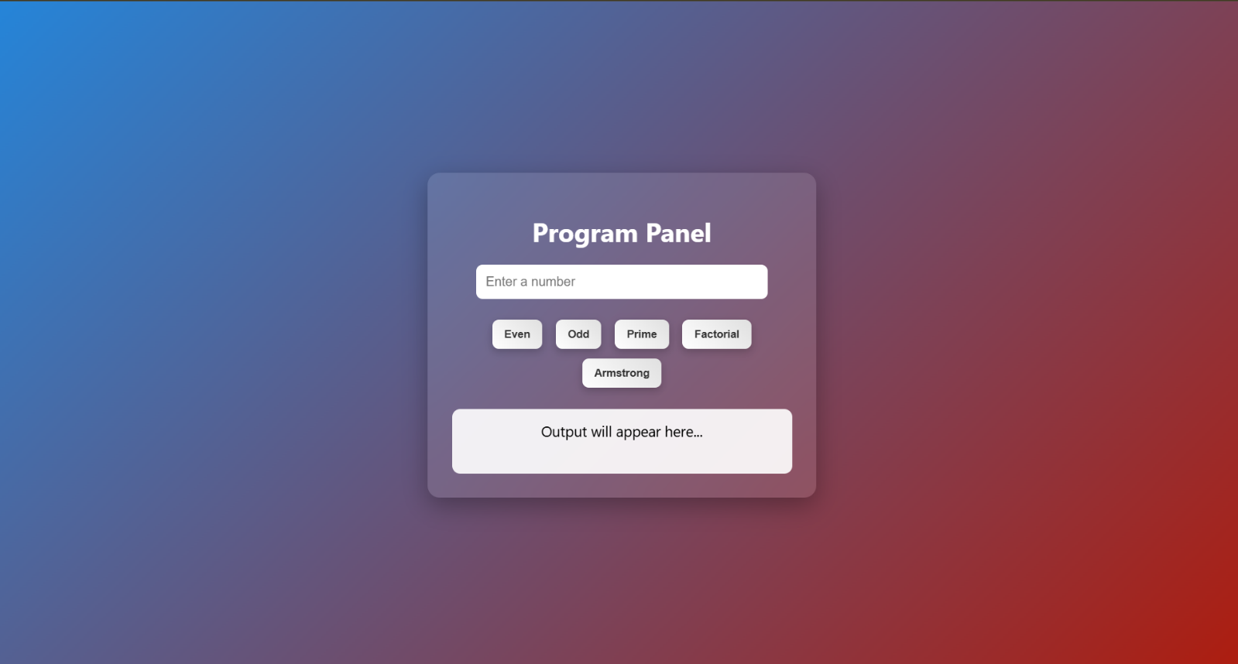

Explanation
DOCTYPE html> : the <!DOCTYPE html> element tells the web browser that this an HTML document
or this is the latest version of HTML
<html> : the <html> element is the root element of an HTML web page
<head> : the <head> element will contain meta data about the HTML web page
<title> : the <title> element specifies a title for the HTML Page
<body> : the <body> element contains all visible content all visible content like text , image , links ,
tables , etc
<h> : we used <h> element for heading
<div>:we use <div> element for encapsulating the divisions and easy to modify
<style> : the <style> element is used to write CSS (designing part) it controls colors, layout, spacing, etc
body : the body selector is used to design the whole page here it sets background color and centers the
content
.container : used to design the main box (card)gives white background, padding, shadow and rounded
corners
input : used to design the input box width, padding, border and text alignment are set
button : used to design buttons gives color, size, border and hover effect
.output : used to design output box where result will be displayed
<input> : the <input> element is used to take user input type="number" allows only numbers id is used to
access it in JavaScript
<div class="buttons"> : groups all buttons together
<button> : used to perform actions when clicked onclick calls JavaScript functions
<div id="output"> : used to display result initially shows "Result will appear here"
<script> : the <script> element is used to write JavaScript code it adds logic and functionality to the
webpage
getElementById() : used to access HTML elements using id
.value : used to get value from input box
.textContent : used to display or change text inside an element
function : used to define a block of code that performs a task
checkEvenOdd() : checks whether number is even or odd uses n % 2
checkPrime() : checks whether number is prime or not uses loop and division logic
calcFactorial() : calculates factorial of a number multiplies numbers from 1 to n
checkArmstrong() : checks Armstrong number sum of digits power equals number
Math.sqrt() : used to find square root (used in prime logic)
parseInt() : converts string to integer
isNaN() : checks if value is not a number

WEEK-10
AIM: write JavaScript conditional statement to find the sign of product of three numbers using functions .Display an alert box with specified sign .write a java script conditional statements to sort 3 numbers using functions display an alert box to show the result.write a java script conditional statement to find largest of find largest of five numbers using function and onclick event .display an alert box to show the result .write a java script for loop that will iterate from 0 to 15. For each iteration ,it will check if the current number odd or even , and display a message on screen .write a java script program to read 6 subjects marks from the student then computes the average marks of students then , this average is used to determine the corresponding grade.
CODE:
<!DOCTYPE html>
<html >
<head>
<title>WEEK-10</title>
<style>

body {
margin: 0;
font-family: 'Segoe UI', sans-serif;
background: linear-gradient(135deg, #667eea, #764ba2);
height: 100vh;
display: flex;
justify-content: center;
align-items: center;
}
.container {
background: rgba(255, 255, 255, 0.1);
backdrop-filter: blur(10px);
padding: 30px;
border-radius: 20px;
text-align: center;
box-shadow: 0 8px 30px rgba(0,0,0,0.2);
width: 350px;
}
h2 {
color: white;
margin-bottom: 20px;
}
button {
width: 100%;
padding: 12px;
margin: 8px 0;
border: none;
border-radius: 10px;
background: #ffffff;
color: #333;
font-size: 14px;
font-weight: bold;
cursor: pointer;
transition: 0.3s;
}
button:hover {
background: #ffdd57;
transform: scale(1.05);
}
.footer {
margin-top: 15px;
color: #ddd;
font-size: 12px;
}
</style>
</head>
<body>
<div class="container">
<h2> Calculator</h2>

<button onclick="findSign()">Sign of Product</button>
<button onclick="sortNumbers()">Sort 3 Numbers</button>
<button onclick="findLargest()">Largest of 5 Numbers</button>
<button onclick="checkOddEven()">Odd / Even (0–15)</button>
<button onclick="calculateGrade()">Student Grade</button>
</div>
<script>
function findSign() {
let a = parseInt(prompt("Enter first number:"));
let b = parseInt(prompt("Enter second number:"));
let c = parseInt(prompt("Enter third number:"));
let product = a * b * c;

if (product > 0) alert("Sign is +");
else if (product < 0) alert("Sign is -");
else alert("Product is zero");
}
function sortNumbers() {
let a = parseInt(prompt("Enter first number:"));
let b = parseInt(prompt("Enter second number:"));
let c = parseInt(prompt("Enter third number:"));

let nums = [a, b, c];
nums.sort((x, y) => x - y);

alert("Sorted: " + nums.join(", "));
}
function findLargest() {
let nums = [];

for (let i = 0; i < 5; i++) {
nums[i] = parseInt(prompt("Enter number " + (i + 1)));
}

let max = nums[0];

for (let i = 1; i < nums.length; i++) {
if (nums[i] > max) max = nums[i];
}

alert("Largest number: " + max);
}
function checkOddEven() {
let result = "";

for (let i = 0; i <= 15; i++) {
result += i + (i % 2 === 0 ? " is even\n" : " is odd\n");
}

alert(result);
}

function calculateGrade() {
let marks = [];
let sum = 0;

for (let i = 0; i < 6; i++) {
marks[i] = parseInt(prompt("Enter marks for subject " + (i + 1)));
sum += marks[i];
}

let avg = sum / 6;
let grade;

if (avg >= 90) grade = "A+";
else if (avg >= 80) grade = "A";
else if (avg >= 70) grade = "B";
else if (avg >= 60) grade = "C";
else if (avg >= 50) grade = "D";
else grade = "F";

alert("Average: " + avg + "\nGrade: " + grade);
}

</script>

</body>
</html>
OUTPUT:
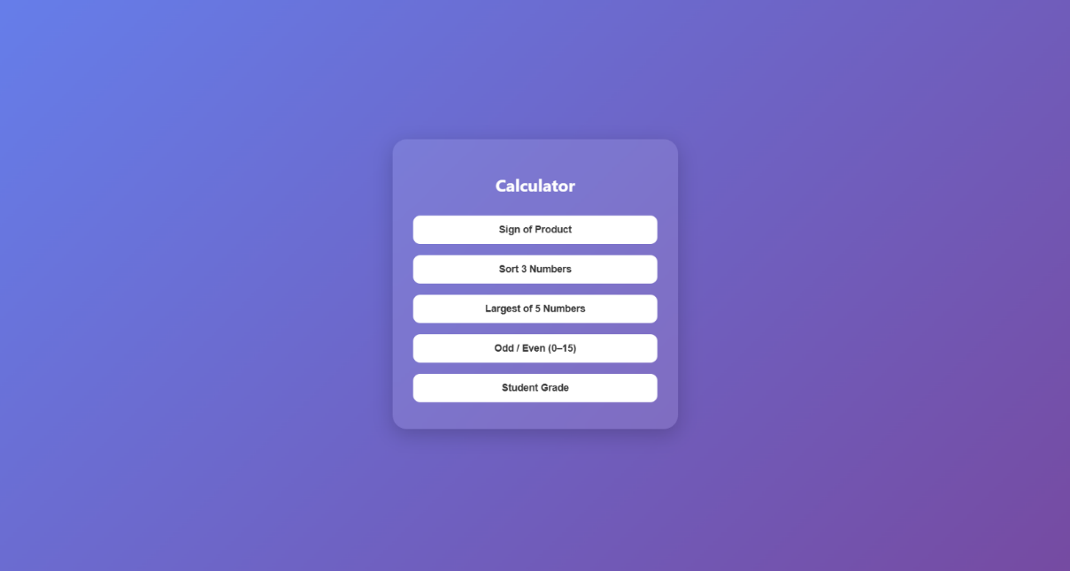
EXPLANATION:
<!DOCTYPE html> : the <!DOCTYPE html> element tells the browser that this is an HTML5 document
<html> : the <html> element is the root element of the web page all elements are written inside this
<head> : the <head> element contains meta information like title and styles
<title> : the <title> element specifies the name of the web page it appears on the browser tab
<style> : the <style> element is used to write CSS for designing the page
body : the body selector is used to style the whole page here flex is used to divide page into two sections
.left : this class is used for left side panel contains input box and buttons
.right : this class is used for right side panel used to display output
input : the <input> element is used to take user input here type="text" is used to enter numbers like 1,2,3
button : the <button> element is used to perform actions onclick is used to call JavaScript functions
<div> : the <div> element is used to group elements helps in layout design
#output : this is an id used to display result .textContent is used to change its text
<script> : the <script> element is used to write JavaScript code
function : used to define a block of code that performs a task
getElementById() : used to access HTML elements using id
.value : used to get value from input box
.split(",") : used to convert input string into array using comma
.map(Number) : converts string values into numbers
for loop : used to repeat code multiple times
if condition : used to check conditions

WEEK-11
1.
AIM : A website requires users to enter a username. The system should display a message while typing if the username is less than 5 characters.

CODE:
<!DOCTYPE html>
<html >
<head>
<title>Username Validation</title>
<style>
body {
font-family: 'Segoe UI', Tahoma, Geneva, Verdana, sans-serif;
background: linear-gradient(135deg, #74ebd5 0%, #9face6 100%);
display: flex;
justify-content: center;
align-items: center;
height: 100vh;
margin: 0;
}
.form-container {
background: #fff;
padding: 30px;
border-radius: 12px;
box-shadow: 0 6px 12px rgba(0,0,0,0.2);
width: 350px;
text-align: center;
}
h2 {
margin-bottom: 20px;
color: #333;
}
label {
display: block;
text-align: left;
margin-bottom: 8px;
font-weight: bold;
color: #444;
}
input[type="text"] {
width: 100%;
padding: 12px;
border: 1px solid #ccc;
border-radius: 6px;
font-size: 14px;
transition: border-color 0.3s;
}
input[type="text"]:focus {
border-color: #007BFF;
outline: none;
}
#userMsg {
display: block;
margin-top: 8px;
font-size: 13px;
font-weight: bold;
}
.error {
color: #d9534f;
}
.success {
color: #28a745;
}
</style>
</head>
<body>
<div class="form-container">
<h2>Username Check</h2>
<label for="username">Username:</label>
<input type="text" id="username" onkeyup="checkUsername()" placeholder="Enter username">
<span id="userMsg"></span>
</div>

<script>
function checkUsername() {
let uname = document.getElementById("username").value;
let msg = document.getElementById("userMsg");
if (uname.length < 5) {
msg.innerHTML = "Username must be at least 5 characters";
msg.className = "error";
} else {
msg.innerHTML = "Valid username";
msg.className = "success";
}
}
</script>
</body>
</html>
OUTPUT:
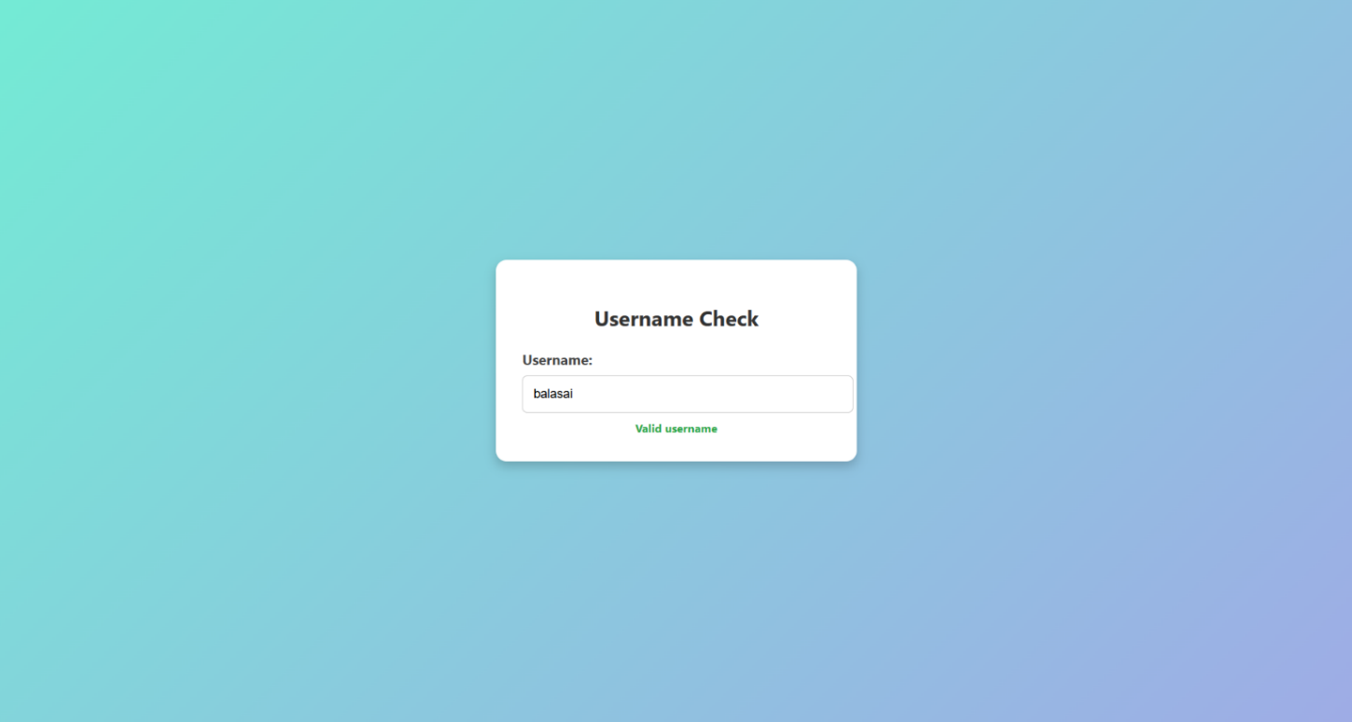

EXPLANATION:
- <!DOCTYPE html>: Declares the document type as HTML5.
- <html> … </html>: Root element of the page.
- <head> … </head>: Contains page information (not shown directly on the page).
- <title> → Sets the text in the browser tab (“Username Validation”).
- <style> → Holds all your CSS rules.
- <body> … </body>: Contains everything that will be visible on the page.
- body : Styles the whole page:
- form-container : Styles the white box
- function checkUsername() → Defines the function.
- document.getElementById("username").value → Gets what the user typed.
- document.getElementById("userMsg") → Finds the message area.

2.
AIM: A registration form should validate email format before submission. If invalid, the form should not be submitted.
CODE:
<!DOCTYPE html>
<html>
<head>
<title>Email Validation</title>
<style>
body {
font-family: Arial, sans-serif;
background: linear-gradient(135deg, #74ebd5 0%, #9face6 100%);
display: flex;
justify-content: center;
align-items: center;
height: 100vh;
margin: 0;
}
.container {
background: #fff;
padding: 25px;
border-radius: 10px;
box-shadow: 0 4px 10px rgba(0,0,0,0.2);
width: 320px;
text-align: center;
}
h2 {
margin-bottom: 20px;
color: #333;
}
input[type="text"] {
width: 100%;
padding: 10px;
margin-bottom: 12px;
border: 1px solid #ccc;
border-radius: 6px;
font-size: 14px;
transition: border-color 0.3s;
}
input[type="text"]:focus {
border-color: #007BFF;
outline: none;
}
button {
width: 100%;
padding: 10px;
background: #007BFF;
color: white;
border: none;
border-radius: 6px;
font-size: 15px;
cursor: pointer;
transition: background 0.3s;
}
button:hover {
background: #0056b3;
}
#result {
margin-top: 12px;
font-weight: bold;
font-size: 14px;
}
.valid {
color: green;
}
.invalid {
color: red;
}
</style>
</head>
<body>
<div class="container">
<h2>Email Validation</h2>
<input type="text" id="email" placeholder="Enter email">
<button onclick="checkEmail()">Check</button>
<p id="result"></p>
</div>

<script>
function checkEmail() {
let email = document.getElementById("email").value;
let pattern = /^[a-zA-Z0-9._]+@[a-zA-Z]+\.[a-zA-Z]{2,}$/;
let result = document.getElementById("result");

if (pattern.test(email)) {
result.innerHTML = "Valid Email";
result.className = "valid";
} else {
result.innerHTML = "Invalid Email";
result.className = "invalid";
}
}
</script>
</body>
</html>

OUTPUT:
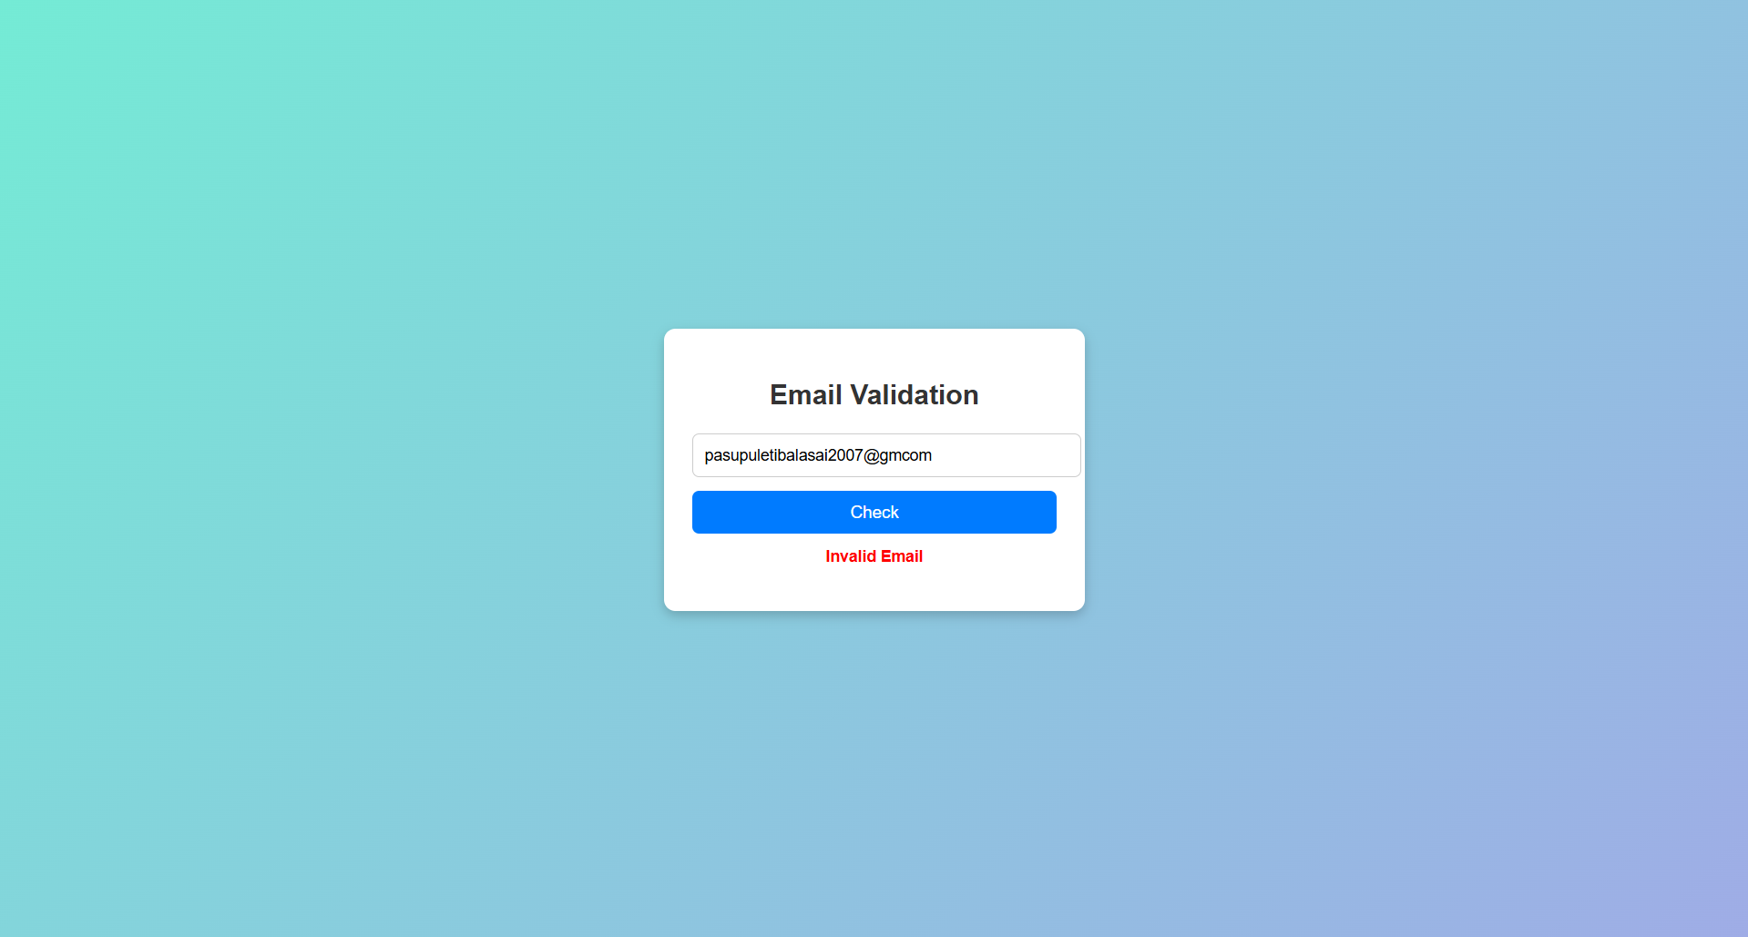
EXPLANATION:
- <!DOCTYPE html>: Declares the document type as HTML5.
- <html> … </html>: Root element of the page.
- <head> … </head>: Contains page information (not shown directly on the page).
- <title> → Sets the text in the browser tab (“Username Validation”).
- <style> → Holds all your CSS rules.
- <body> … </body>: Contains everything that will be visible on the page.
- body : Styles the whole page:
- <div class="container"> → White box styled with CSS.
- <h2> → Heading text.
- <input> → Text box for email input.
- id="email" → Unique identifier.
- placeholder="Enter email" → Hint text.
- <button> → Button that runs checkEmail() when clicked.
- <p id="result"></p> → Empty paragraph where the result message appears.

3.
AIM: A system should check password strength while typing and display whether it is weak or strong.
CODE:
<!DOCTYPE html>
<html>
<head>
<title>Password Strength Checker</title>
<style>
body {
font-family: Arial, sans-serif;
background: linear-gradient(135deg, #74ebd5 0%, #9face6 100%);
display: flex;
justify-content: center;
align-items: center;
height: 100vh;
margin: 0;
}
.container {
background: #fff;
padding: 25px;
border-radius: 10px;
box-shadow: 0 4px 10px rgba(0,0,0,0.2);
width: 320px;
text-align: center;
}
h2 {
margin-bottom: 20px;
color: #333;
}
label {
display: block;
text-align: left;
margin-bottom: 6px;
font-weight: bold;
color: #444;
}
input[type="password"] {
width: 100%;
padding: 10px;
margin-bottom: 12px;
border: 1px solid #ccc;
border-radius: 6px;
font-size: 14px;
transition: border-color 0.3s;
}
input[type="password"]:focus {
border-color: #007BFF;
outline: none;
}
#passMsg {
display: block;
margin-top: 8px;
font-size: 14px;
font-weight: bold;
}
.weak {
color: red;
}
.strong {
color: green;
}
</style>
</head>
<body>
<div class="container">
<h2>Password Strength</h2>
<label for="password">Password:</label>
<input type="password" id="password" onkeyup="checkPasswordStrength()" placeholder="Enter password">
<span id="passMsg"></span>
</div>

<script>
function checkPasswordStrength() {
let pwd = document.getElementById("password").value;
let msg = document.getElementById("passMsg");
if (pwd.length < 6) {
msg.innerHTML = "Weak password";
msg.className = "weak";
} else {
msg.innerHTML = "Strong password";
msg.className = "strong";
}
}
</script>
</body>
</html>
OUTPUT:
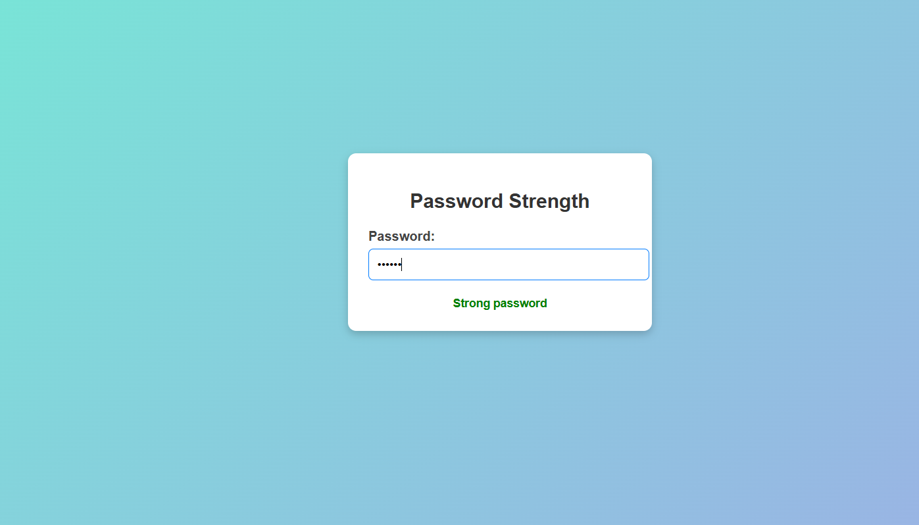
Explanation:
- <html> – Defines the HTML document.
- <head> – Contains metadata and CSS.
- <title> – Sets the webpage title.
- <style> – Adds CSS styling.
- <body> – Contains the visible content.
- <div> – Creates a container section.
- <h2> – Displays the heading.
- <label> – Displays text labels.
- <input> – Accepts password input.
- <span> – Displays password strength messages.
- <script> – Contains JavaScript code.

4.
AIM: Create form should validate a mobile number when the user leaves the input field. The number must be exactly 10 digits.
CODE:
<!DOCTYPE html>
<html lang="en">
<head>
<meta charset="UTF-8">
<title>Mobile Number Validation</title>
<style>
body {
font-family: Arial, sans-serif;
padding: 40px;
background: #f5f5f5;
}
.container {
width: 320px;
padding: 20px;
background: white;
border-radius: 8px;
box-shadow: 0 0 10px rgba(0,0,0,0.1);
}
input {
width: 100%;
padding: 10px;
font-size: 16px;
border: 2px solid #ccc;
border-radius: 5px;
outline: none;
transition: 0.3s;
}
input.valid {
border-color: green;
}
input.invalid {
border-color: red;
}
#error {
margin-top: 8px;
color: red;
font-size: 14px;
height: 18px;
}
button {
margin-top: 15px;
width: 100%;
padding: 10px;
background: #0078ff;
color: white;
border: none;
border-radius: 5px;
font-size: 16px;
cursor: pointer;
}
button:hover {
background: #005fcc;
}
</style>
</head>
<body>
<div class="container">
<h3>Mobile Number Validation</h3>

<input type="text" id="mobile" placeholder="Enter mobile number">
<p id="error"></p>

<button onclick="validate()">Validate</button>
</div>
<script>
const mobile = document.getElementById("mobile");
const error = document.getElementById("error");
mobile.addEventListener("input", () => {
const regex = /^[6-9]\d{9}$/;

if (regex.test(mobile.value)) {
mobile.classList.add("valid");
mobile.classList.remove("invalid");
error.textContent = "";
} else {
mobile.classList.add("invalid");
mobile.classList.remove("valid");
error.textContent = "Enter a valid 10-digit mobile number";
}
});
function validate() {
const regex = /^[6-9]\d{9}$/;

if (regex.test(mobile.value)) {
alert("Valid Mobile Number");
} else {
alert("Invalid Mobile Number");
}
}
</script>
</body>
</html>
OUTPUT:
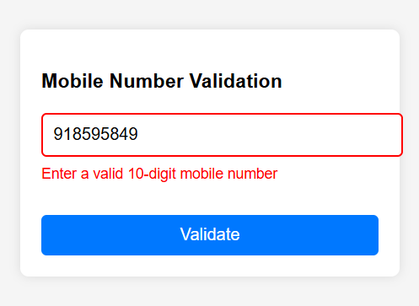
Explanation:
- <!DOCTYPE html>: Declares the document type as HTML5.
- <html> … </html>: Root element of the page.
- <head> … </head>: Contains page information (not shown directly on the page).
- <title> → Sets the text in the browser tab (“Username Validation”).
- <style> → Holds all your CSS rules.
- <body> … </body>: Contains everything that will be visible on the page.
- body : Styles the whole page:
- <div class="container"> → White box styled with CSS.
- <h2> → Heading text.
- <input> → Text box for email input.
- id="email" → Unique identifier.
- placeholder="Enter email" → Hint text.
- <button> → Button that runs checkEmail() when clicked.
- <p id="result"></p> → Empty paragraph where the result message appears.

5.
AIM: Design an HTML page, such that the registration form must validate:
Name (not empty)
Email (valid format)
Password (minimum 6 characters)

CODE:
<!DOCTYPE html>
<html>
<head>
<title>Registration Form</title>
<style>
body {
font-family: Arial, sans-serif;
background: #f4f7f8;
display: flex;
justify-content: center;
align-items: center;
height: 100vh;
}
.container {
background: #c05959;
padding: 30px;
border-radius: 8px;
box-shadow: 0 4px 8px rgba(0,0,0,0.2);
width: 350px;
}
h2 {
text-align: center;
color: #333;
margin-bottom: 20px;
}
label {
display: block;
margin-bottom: 6px;
font-weight: bold;
color: #444;
}
input[type="text"], input[type="password"] {
width: 100%;
padding: 10px;
margin-bottom: 12px;
border: 1px solid #ccc;
border-radius: 4px;
transition: border-color 0.3s;
}
input[type="text"]:focus, input[type="password"]:focus {
border-color: #007BFF;
outline: none;
}
span {
font-size: 12px;
display: block;
margin-bottom: 10px;
}
input[type="submit"] {
width: 100%;
padding: 12px;
background: #007BFF;
color: white;
border: none;
border-radius: 4px;
font-size: 16px;
cursor: pointer;
transition: background 0.3s;
}
input[type="submit"]:hover {
background: #0056b3;
}
.error {
color: red;
}
.success {
color: green;
}
</style>
</head>
<body>
<div class="container">
<h2>Registration Form</h2>
<form onsubmit="return validateForm(event)">
<label>Name:</label>
<input type="text" id="name">

<label>Surname:</label>
<input type="text" id="surname" onkeyup="checkSurname()">
<span id="surnameMsg"></span>

<label>Email:</label>
<input type="text" id="email">
<span id="emailMsg"></span>

<label>Password:</label>
<input type="password" id="password" onkeyup="checkPasswordStrength()">
<span id="passMsg"></span>

<label>Mobile:</label>
<input type="text" id="mobile" onblur="validateMobile()">
<span id="mobileMsg"></span>
<input type="submit" value="Register">
</form>
</div>
<script>
function checkUsername() {
let uname = document.getElementById("username").value;
let msg = document.getElementById("userMsg");
if (uname.length < 5) {
msg.innerHTML = "Username must be at least 5 characters";
msg.className = "error";
} else {
msg.innerHTML = "Valid username";
msg.className = "success";
}
}
function validateEmail(email) {
let pattern = /^[^ ]+@[^ ]+\.[a-z]{2,3}$/;
return pattern.test(email);
}

function checkPasswordStrength() {
let pwd = document.getElementById("password").value;
let msg = document.getElementById("passMsg");
if (pwd.length < 6) {
msg.innerHTML = "Weak password";
msg.className = "error";
} else {
msg.innerHTML = "Strong password";
msg.className = "success";
}
}
function validateMobile() {
let mob = document.getElementById("mobile").value;
let msg = document.getElementById("mobileMsg");
if (/^\d{10}$/.test(mob)) {
msg.innerHTML = "Valid mobile number";
msg.className = "success";
} else {
msg.innerHTML = "Mobile number must be 10 digits";
msg.className = "error";
}
}
function validateForm(event) {
let name = document.getElementById("name").value;
let email = document.getElementById("email").value;
let password = document.getElementById("password").value;
let mobile = document.getElementById("mobile").value;
if (name.trim() === "") {
alert("Name cannot be empty");
return false;
}
if (!validateEmail(email)) {
alert("Invalid email format");
return false;
}
if (password.length < 6) {
alert("Password must be at least 6 characters");
return false;
}
if (!/^\d{10}$/.test(mobile)) {
alert("Mobile number must be exactly 10 digits");
return false;
}
alert("Registration Successful!");
return true;
}
</script>
</body>
</html>
OUTPUT:
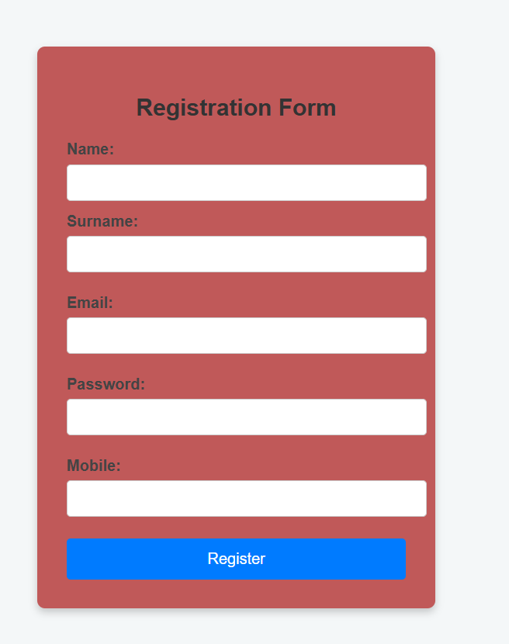
Explanation:
- <html> – Defines the HTML document.
- <head> – Contains title, CSS, and other metadata.
- <title> – Sets the webpage title.
- <style> – Adds CSS styling to the page.
- <body> – Contains the visible content of the webpage.
- <div> – Creates a container for the form.
- <h2> – Displays the heading "Registration Form".
- <form> – Creates the registration form.
- <label> – Displays labels for input fields.
- <input> – Accepts user input (text, password, submit button).
- <span> – Displays validation messages.
- <script> – Contains JavaScript code for validation.

WEEK-12

AIM: Installation of Electron
STEP1: Install Node.js
Open the Node.js website.
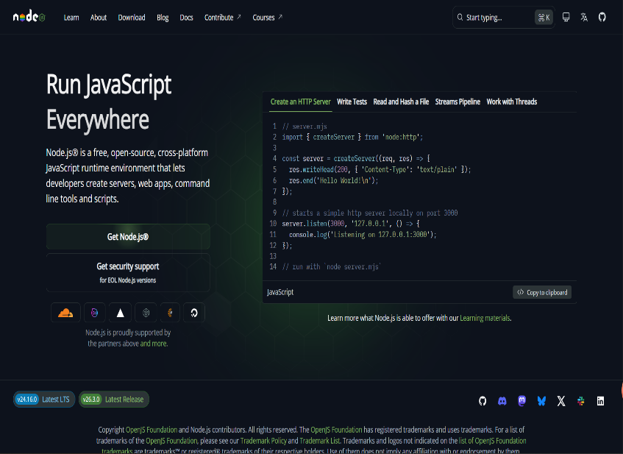
Download the Windows Installer (.msi).
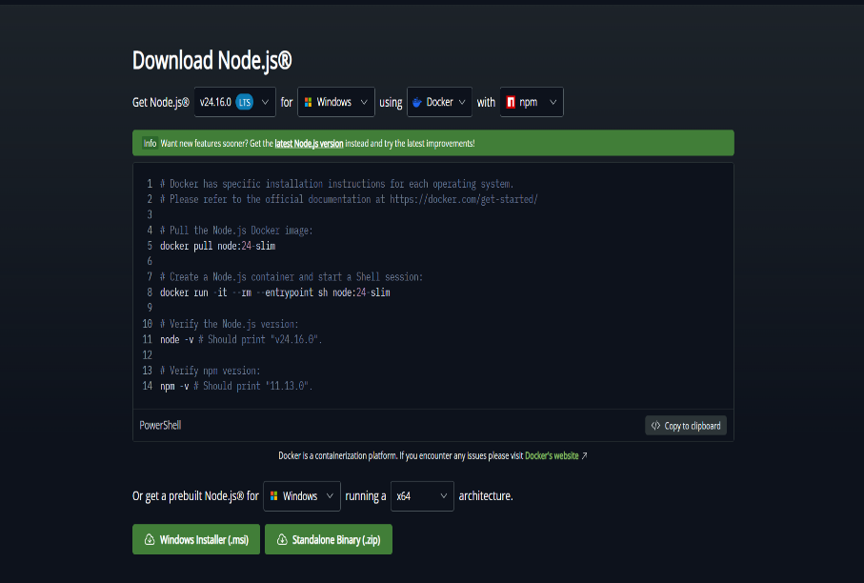

Run the installer and complete the installation.
Verify installation by opening Command Prompt and typing
“node -v”
“npm -v”
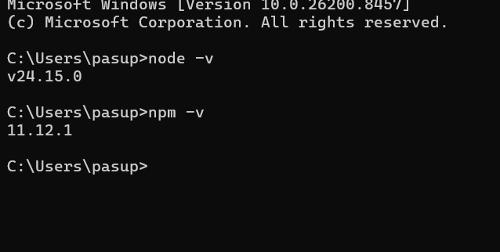

Step 2: Change PowerShell Execution Policy
Open PowerShell as Administrator. And execute the given
And Enter “Y “
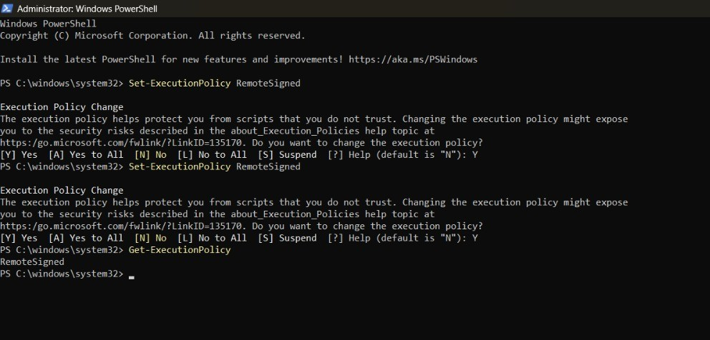
Step 3: Create Project Folder , Open VS Code Terminal and run: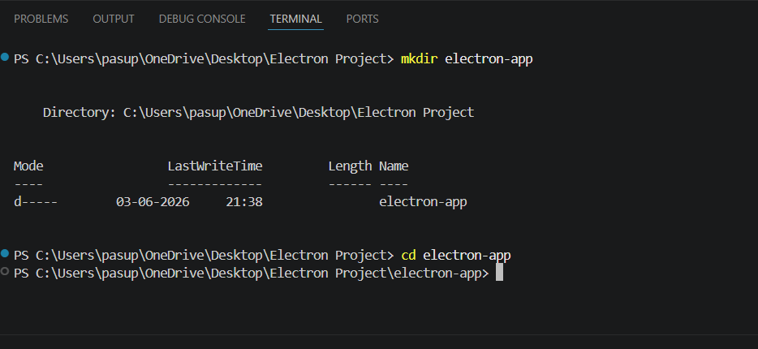
Step 4: Initialize Node Project
Enter “npm init -y”
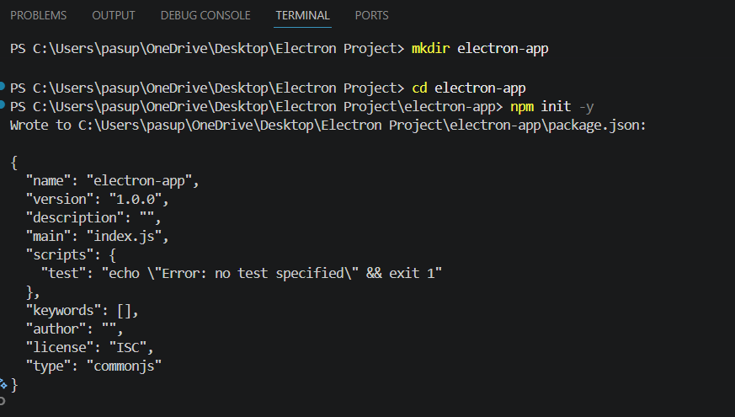
Step 5: Install Electron
This installs Electron and creates the node_modules folder.
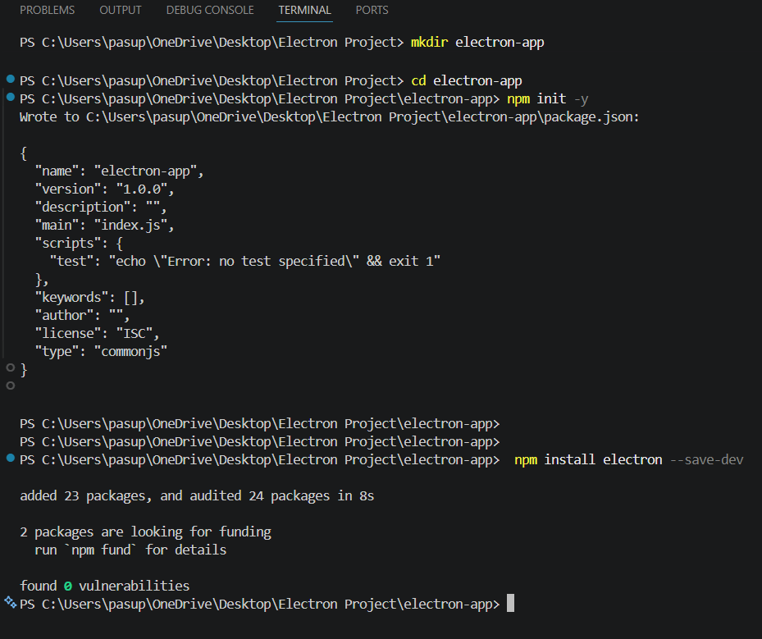
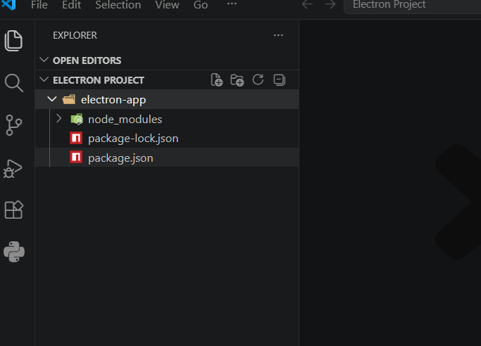
Step 6:Create Main Application Files
main.js→Controls app lifecycle and creates windows
index.html→User interface
style.css→Design and layout
renderer.js→Handles user interaction

Write main.js
• Imports Electron modules
• Creates application window
• Loads UI

Run Application:
By Entering the Command “npm Start”

