PL/SQL
Ex – 1: Control Statements
SET SERVEROUTPUT ON;
CREATE TABLE Customers (
CustomerID NUMBER PRIMARY KEY,
Name VARCHAR2(50),
Age NUMBER,
Balance NUMBER,
IsVIP VARCHAR2(5)
);
INSERT INTO Customers VALUES (1, 'Ramesh', 65, 15000, 'FALSE');
INSERT INTO Customers VALUES (2, 'Suresh', 45, 5000, 'FALSE');
INSERT INTO Customers VALUES (3, 'Mahesh', 70, 25000, 'FALSE');
CREATE TABLE Loans (
LoanID NUMBER PRIMARY KEY,
CustomerID NUMBER,
InterestRate NUMBER,
DueDate DATE
);
INSERT INTO Loans VALUES (101, 1, 10.5, SYSDATE + 10);
INSERT INTO Loans VALUES (102, 2, 9.0, SYSDATE + 45);
INSERT INTO Loans VALUES (103, 3, 11.0, SYSDATE + 20);
COMMIT;
BEGIN
FOR c IN (
SELECT CustomerID
FROM Customers
WHERE Age > 60
)
LOOP
UPDATE Loans
SET InterestRate = InterestRate - 1
WHERE CustomerID = c.CustomerID;
END LOOP;
COMMIT;
DBMS_OUTPUT.PUT_LINE('Scenario 1 Completed');
END;
/
BEGIN
UPDATE Customers
SET IsVIP = 'TRUE'
WHERE Balance > 10000;
COMMIT;
DBMS_OUTPUT.PUT_LINE('Scenario 2 Completed');
END;
/
BEGIN
FOR l IN (
SELECT LoanID,
CustomerID,
DueDate
FROM Loans
WHERE DueDate BETWEEN SYSDATE
AND SYSDATE + 30
)
LOOP
DBMS_OUTPUT.PUT_LINE(
'Reminder: Loan ID '
|| l.LoanID
|| ' is due on '
|| TO_CHAR(l.DueDate,'DD-MON-YYYY')
);
END LOOP;
END;
/
SELECT * FROM Customers;
SELECT * FROM Loans;
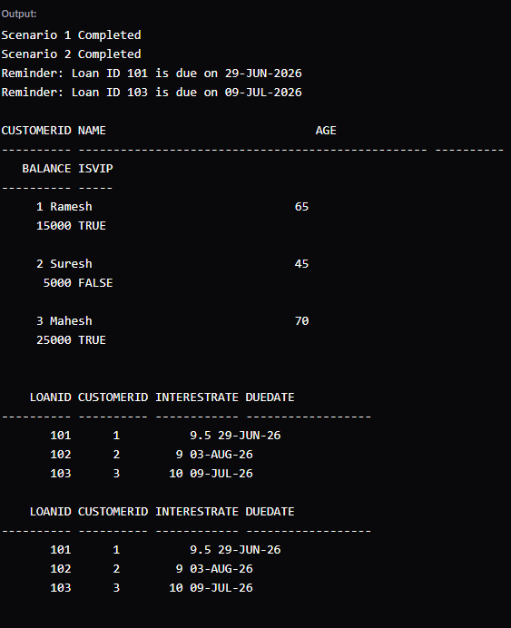

Ex – 3: Stored Procedures
SET SERVEROUTPUT ON;
CREATE TABLE SavingsAccounts (
AccountID NUMBER PRIMARY KEY,
CustomerName VARCHAR2(50),
Balance NUMBER
);
INSERT INTO SavingsAccounts VALUES (101,'Ramesh',10000);
INSERT INTO SavingsAccounts VALUES (102,'Suresh',20000);
INSERT INTO SavingsAccounts VALUES (103,'Mahesh',15000);
CREATE TABLE Employees (
EmployeeID NUMBER PRIMARY KEY,
EmployeeName VARCHAR2(50),
Department VARCHAR2(50),
Salary NUMBER
);
INSERT INTO Employees VALUES (1,'Amit','IT',50000);
INSERT INTO Employees VALUES (2,'Rahul','IT',60000);
INSERT INTO Employees VALUES (3,'Priya','HR',45000);
CREATE TABLE Accounts (
AccountID NUMBER PRIMARY KEY,
CustomerName VARCHAR2(50),
Balance NUMBER
);
INSERT INTO Accounts VALUES (1001,'Ramesh',20000);
INSERT INTO Accounts VALUES (1002,'Suresh',10000);
COMMIT;
CREATE OR REPLACE PROCEDURE ProcessMonthlyInterest
IS
BEGIN
UPDATE SavingsAccounts
SET Balance = Balance + (Balance * 0.01);
COMMIT;
DBMS_OUTPUT.PUT_LINE('Monthly Interest Processed');
END;
/
CREATE OR REPLACE PROCEDURE UpdateEmployeeBonus(
p_department IN VARCHAR2,
p_bonus_percent IN NUMBER
)
IS
BEGIN
UPDATE Employees
SET Salary = Salary + (Salary * p_bonus_percent / 100)
WHERE Department = p_department;
COMMIT;
DBMS_OUTPUT.PUT_LINE('Employee Bonus Updated');
END;
/
CREATE OR REPLACE PROCEDURE TransferFunds(
p_from_account IN NUMBER,
p_to_account IN NUMBER,
p_amount IN NUMBER
)
IS
v_balance NUMBER;
BEGIN
SELECT Balance
INTO v_balance
FROM Accounts
WHERE AccountID = p_from_account;
IF v_balance >= p_amount THEN
UPDATE Accounts
SET Balance = Balance - p_amount
WHERE AccountID = p_from_account;
UPDATE Accounts
SET Balance = Balance + p_amount
WHERE AccountID = p_to_account;
COMMIT;
DBMS_OUTPUT.PUT_LINE('Transfer Successful');
ELSE
DBMS_OUTPUT.PUT_LINE('Insufficient Balance');
END IF;
END;
/
BEGIN
ProcessMonthlyInterest;
END;
/
BEGIN
UpdateEmployeeBonus('IT',10);
END;
/
BEGIN
TransferFunds(1001,1002,5000);
END;
/
SELECT * FROM SavingsAccounts;
SELECT * FROM Employees;
SELECT * FROM Accounts;

