Data Structures and Algorithms
Ex – 2: E-commerce Platform Search Function
class Product {
int productId;
String productName;
String category;
Product(int productId, String productName, String category) {
this.productId = productId;
this.productName = productName;
this.category = category;
}
public String toString() {
return "Product ID: " + productId +
", Name: " + productName +
", Category: " + category;
}
}
public class Main {
public static Product linearSearch(Product[] products, int targetId) {
for (int i = 0; i < products.length; i++) {
if (products[i].productId == targetId) {
return products[i];
}
}
return null;
}
public static Product binarySearch(Product[] products, int targetId) {
int left = 0;
int right = products.length - 1;
while (left <= right) {
int mid = (left + right) / 2;
if (products[mid].productId == targetId) {
return products[mid];
}
if (products[mid].productId < targetId) {
left = mid + 1;
} else {
right = mid - 1;
}
}
return null;
}
public static void main(String[] args) {
Product[] products = {
new Product(101, "Laptop", "Electronics"),
new Product(102, "Mobile", "Electronics"),
new Product(103, "Shoes", "Fashion"),
new Product(104, "Watch", "Accessories"),
new Product(105, "Bag", "Fashion")
};
int targetId = 104;
Product result1 = linearSearch(products, targetId);
System.out.println("Linear Search Result:");
if (result1 != null) {
System.out.println(result1);
} else {
System.out.println("Product not found");
}
Product result2 = binarySearch(products, targetId);
System.out.println("\nBinary Search Result:");
if (result2 != null) {
System.out.println(result2);
} else {
System.out.println("Product not found");
}
}
}
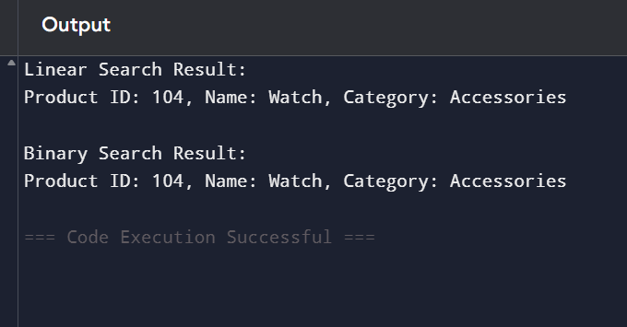

Ex – 7: Financial Forecasting
public class Main {
public static double futureValue(double presentValue,
double growthRate,
int years) {
if (years == 0) {
return presentValue;
}
return futureValue(presentValue,
growthRate,
years - 1)
* (1 + growthRate);
}
public static void main(String[] args) {
double presentValue = 10000;
double growthRate = 0.10;
int years = 5;
double result =
futureValue(presentValue,
growthRate,
years);
System.out.println("Present Value : " + presentValue);
System.out.println("Growth Rate : " + (growthRate * 100) + "%");
System.out.println("Years : " + years);
System.out.printf("Future Value : %.2f\n", result);
}
}
