**CAPSTONE PROJECT**

**APPLICATION DEPLOYMENT**

**(Deploy the given react application to a production ready state)**

**SUBMISSION:**

**GIT REPO URL:**

Kindly find my GitHub repo as below:

<https://github.com/Balasubramanian-d/My-capstone-project.git>

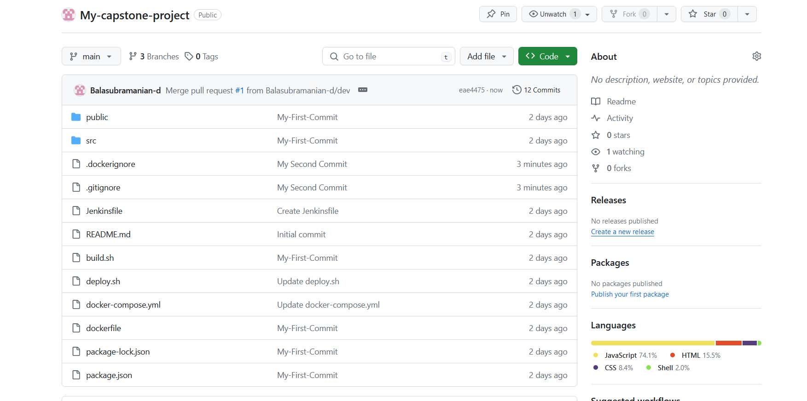

**Deployed Site Page & URL:**

Now we can able to access React JS application via our EC2 Public IP in Port 80 (HTTP) :

<http://3.145.196.219>:80

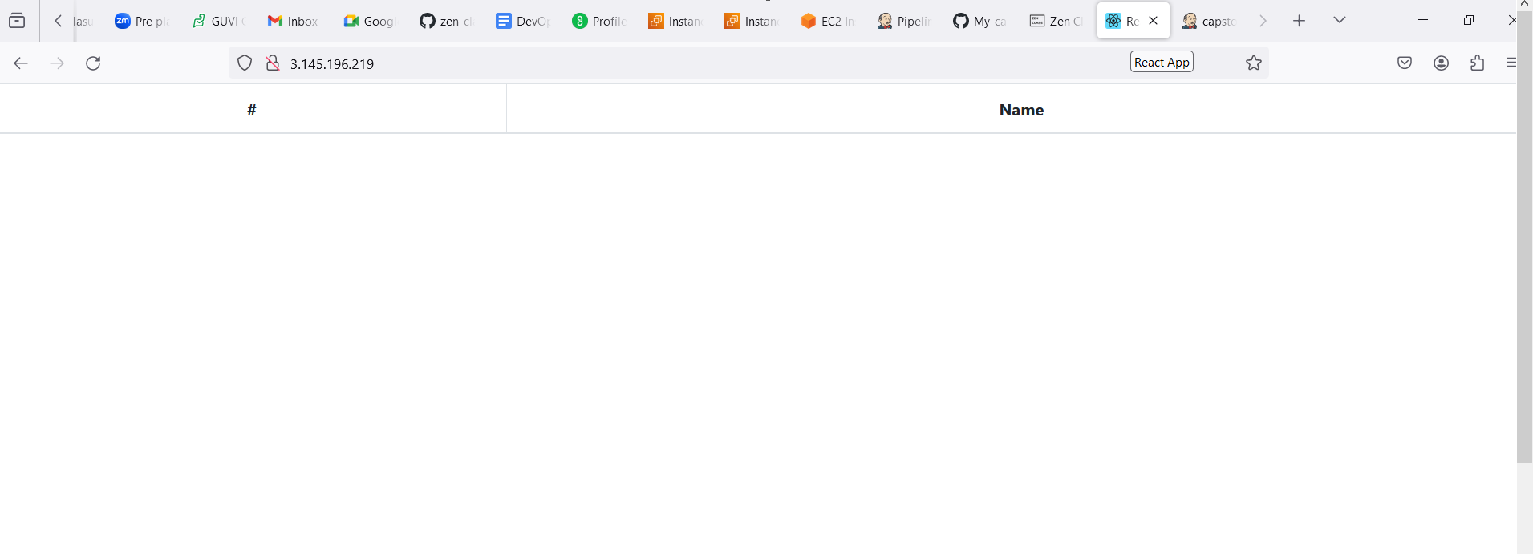

**Docker Images:**



**Jenkins Login Page:**

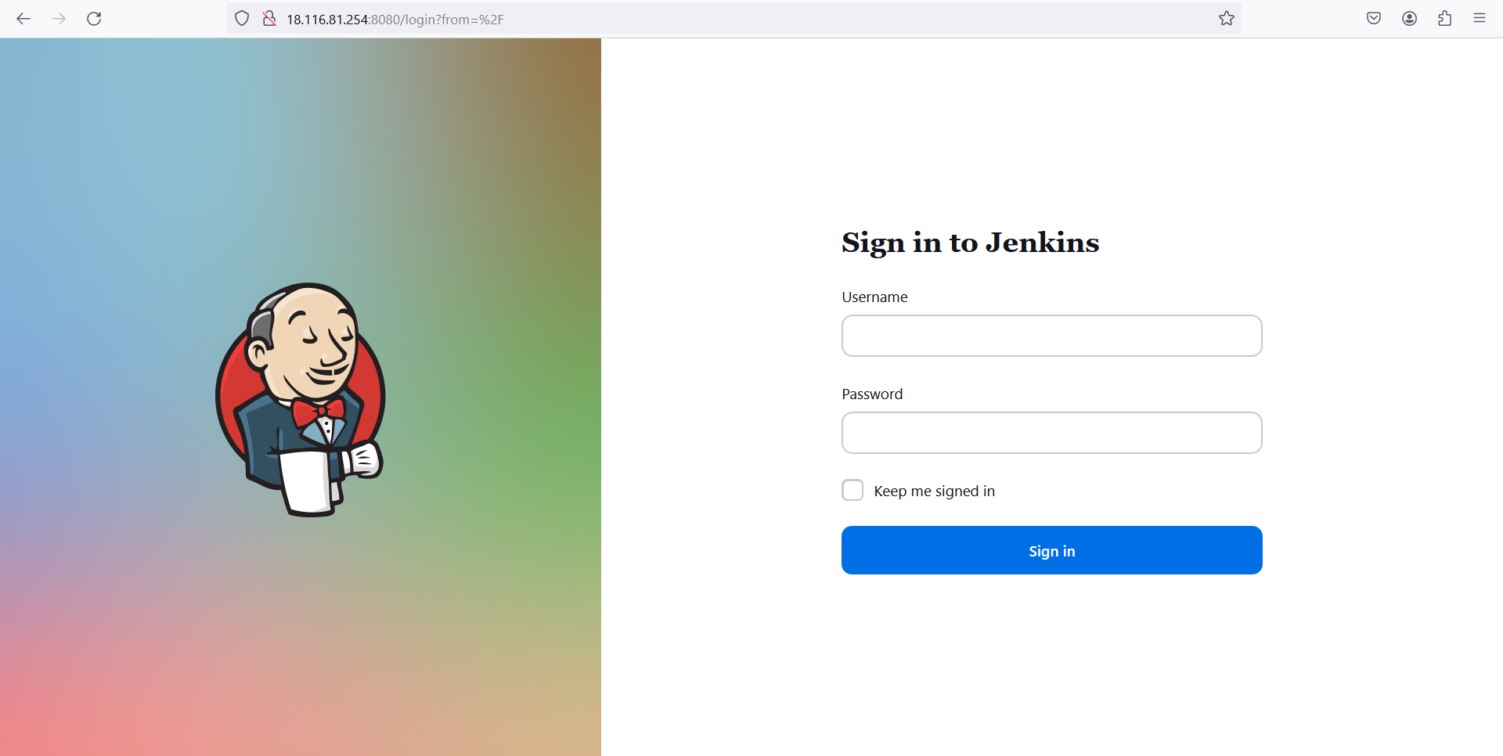

**Configuration setting in Pipeline:**

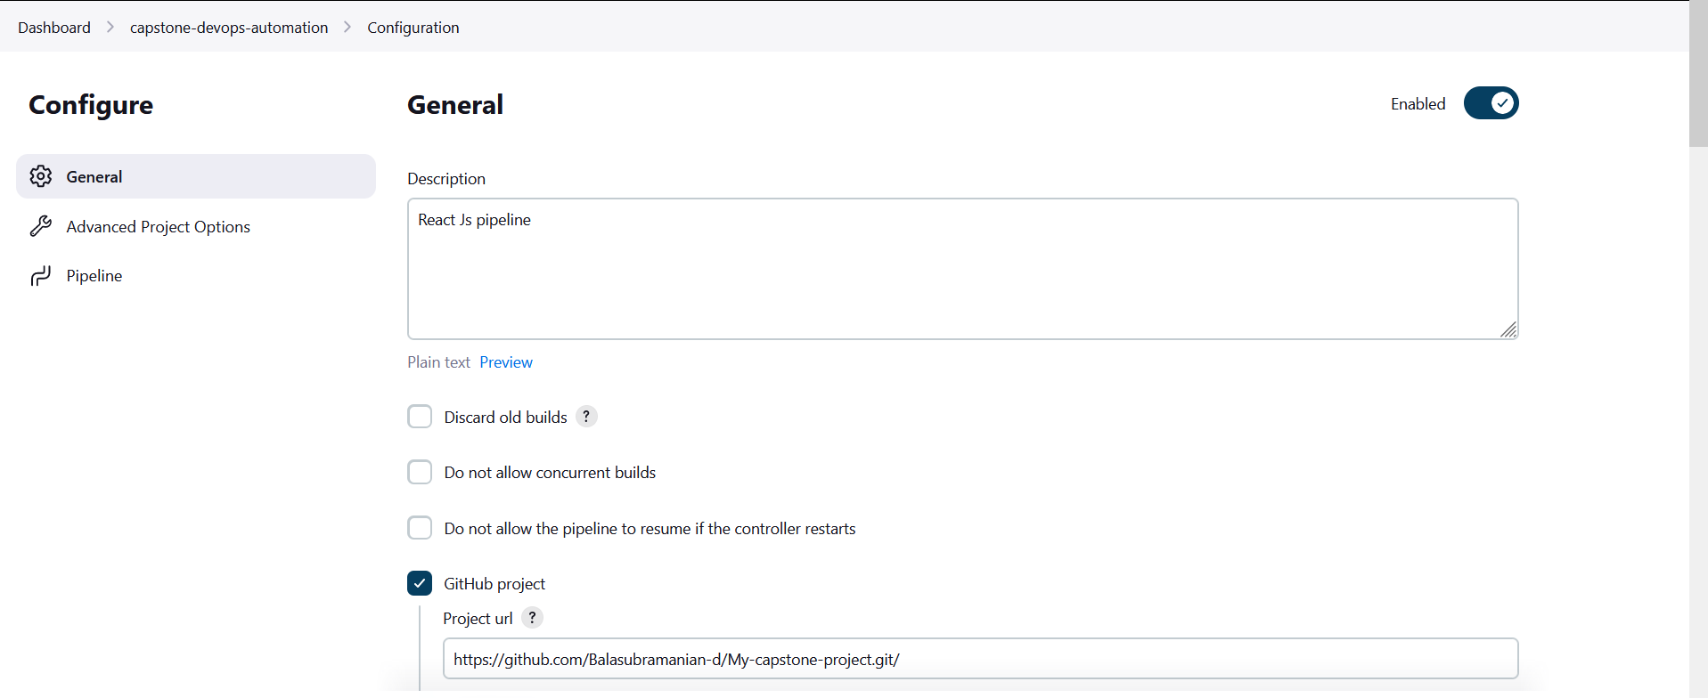

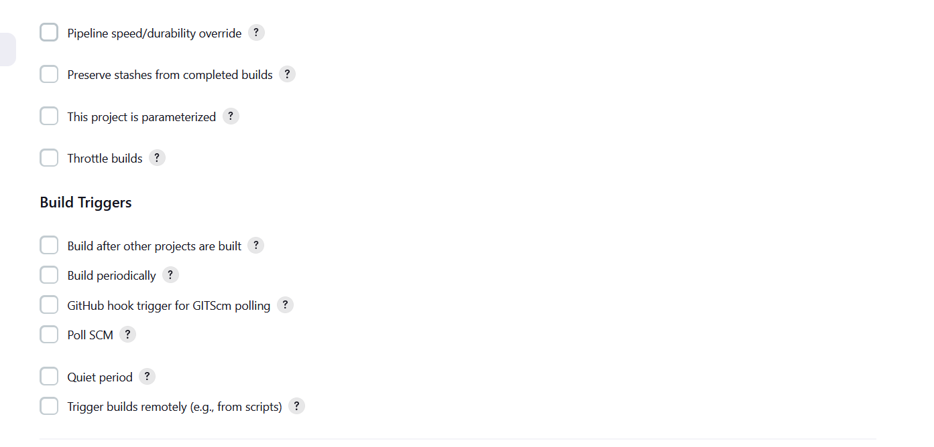

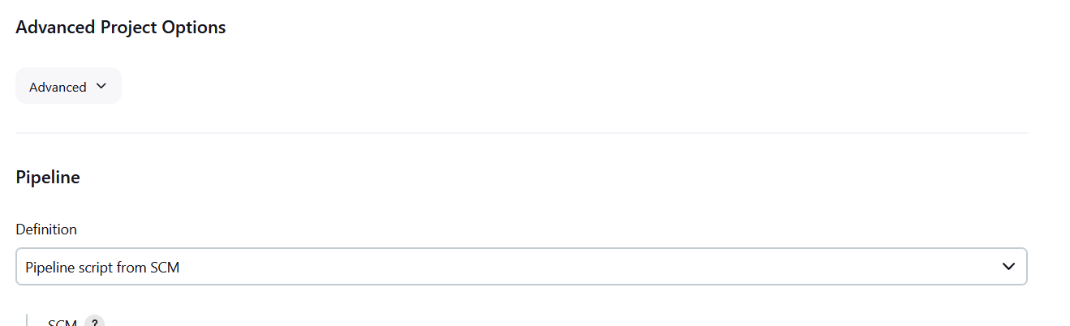

Select Pipeline Script from SCM and add GIT HUB URL and specify branch name as below:

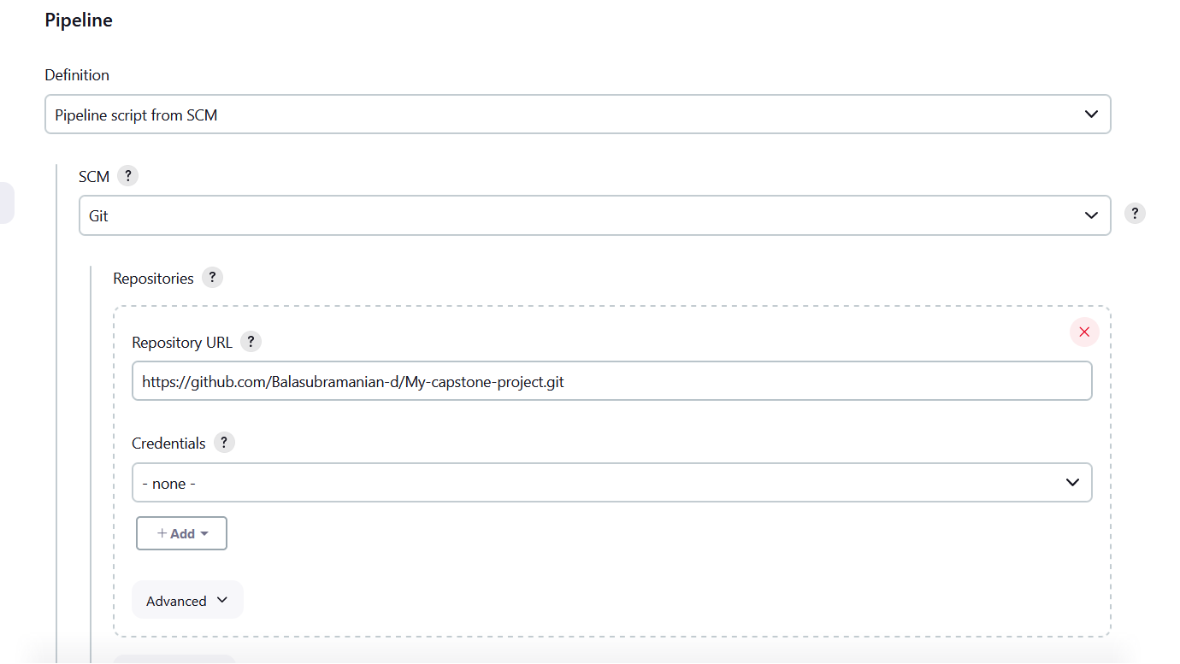

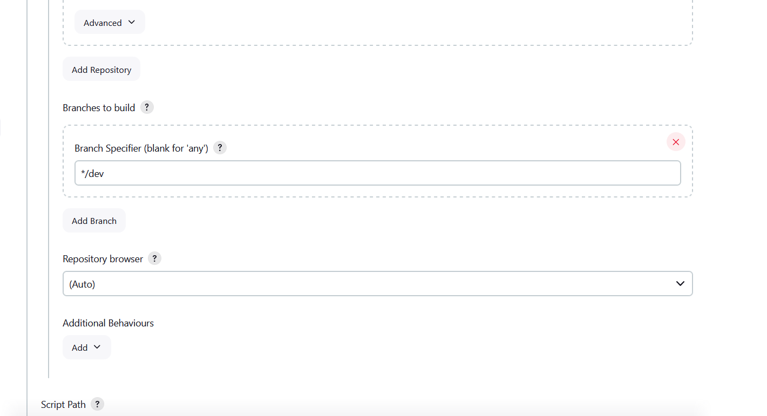

Click on save as below:

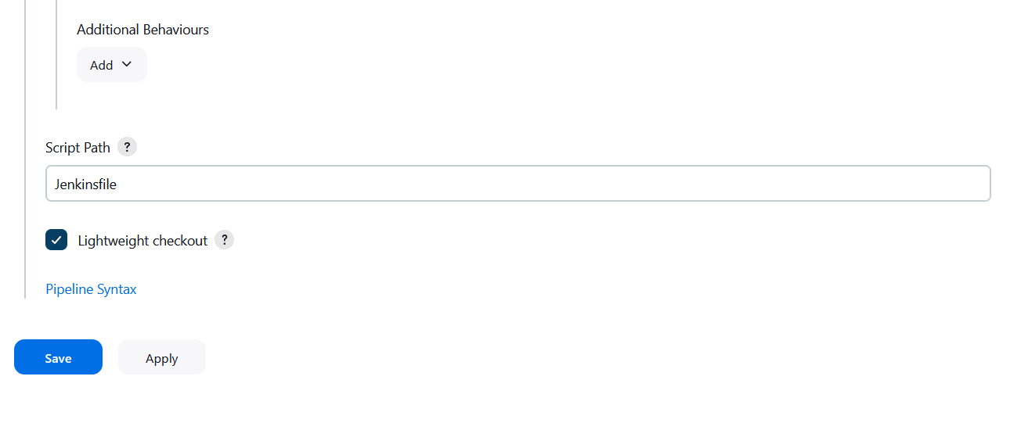

**Execute Step commands as below:**

Create Jenkins file in Git Hub Repo as below:

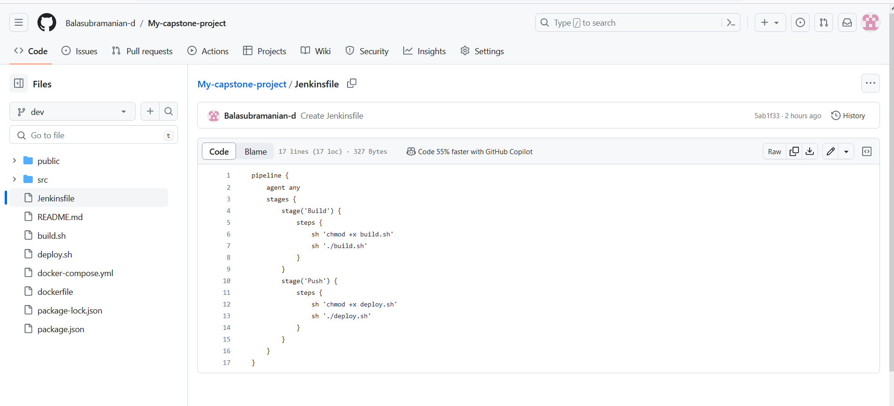

In GitHub Repo we have Build.sh ,deploy.sh ,Docker file , Docker-Compose.yml file as below:

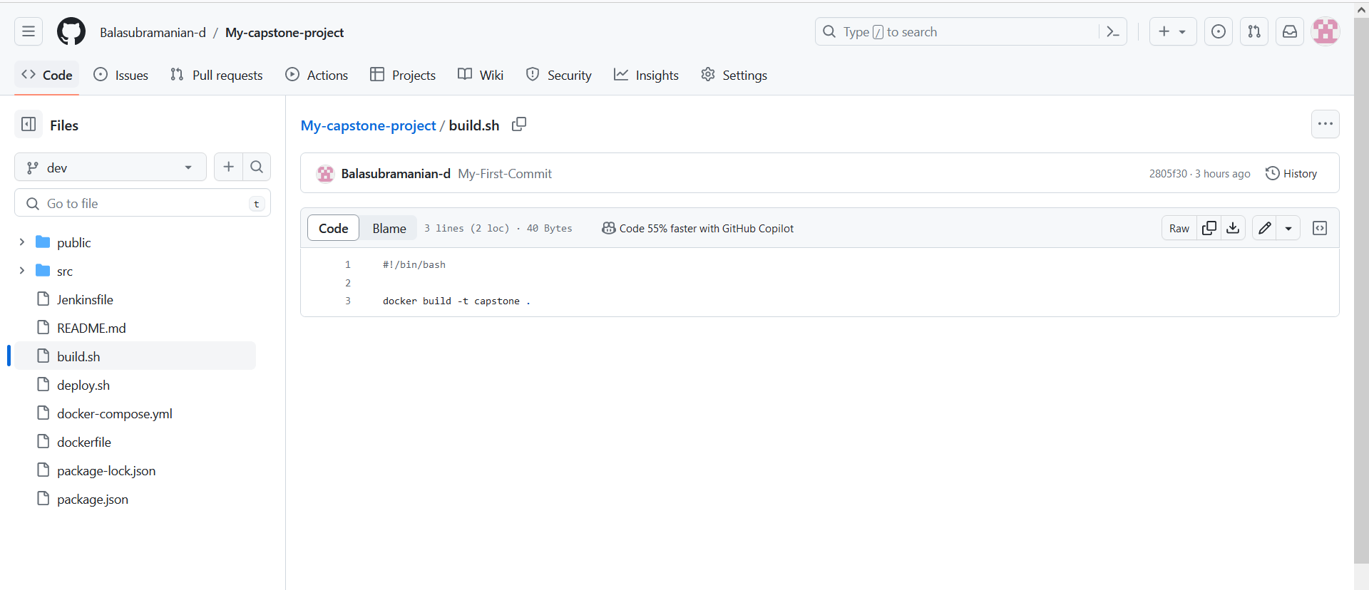

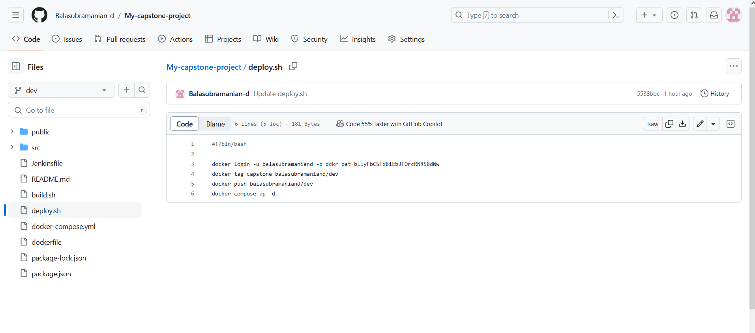

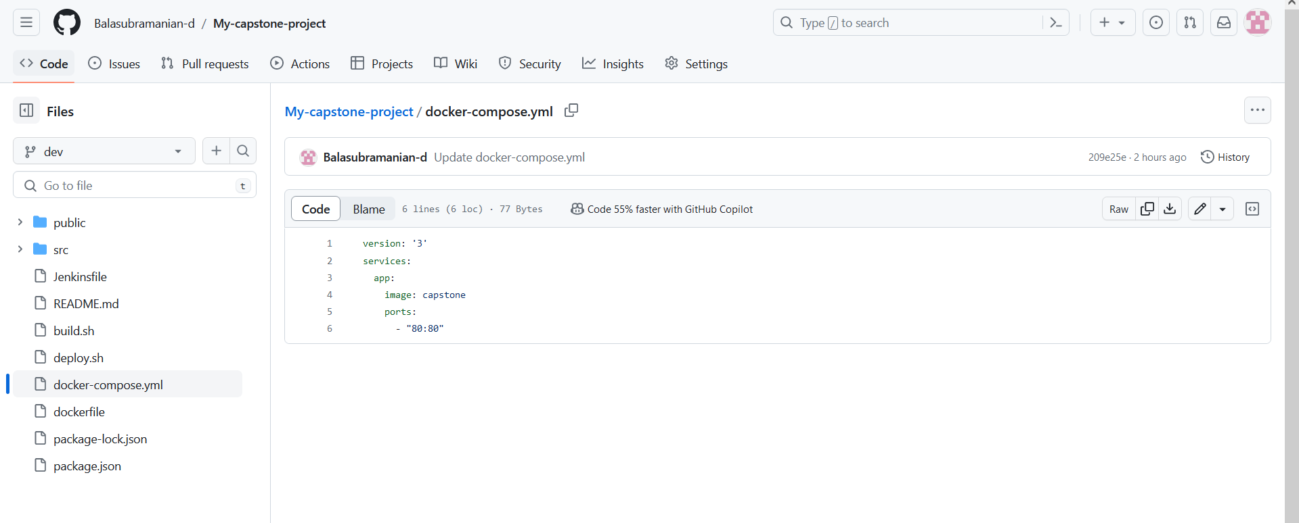

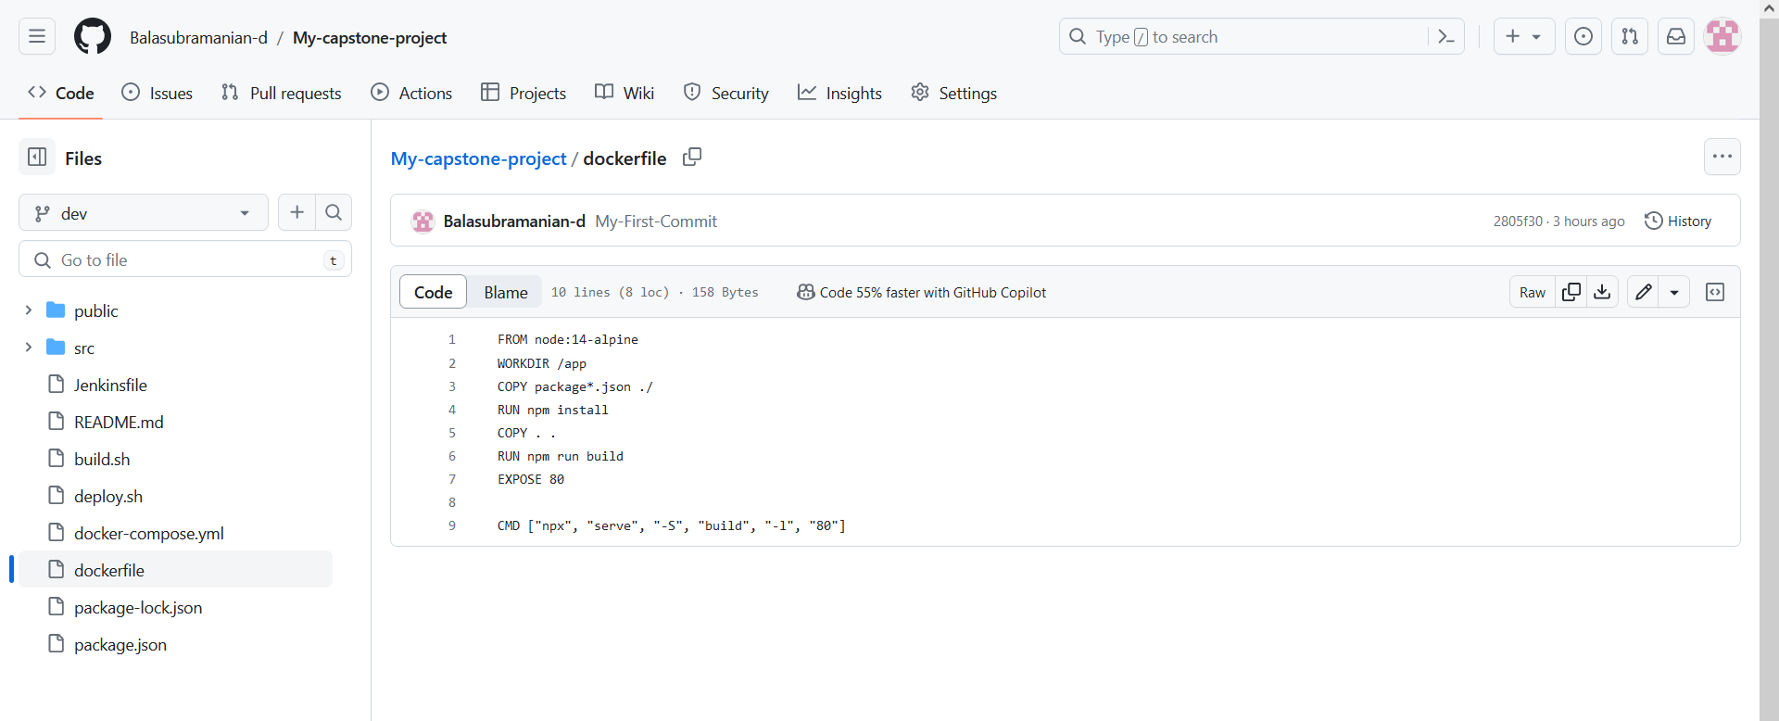

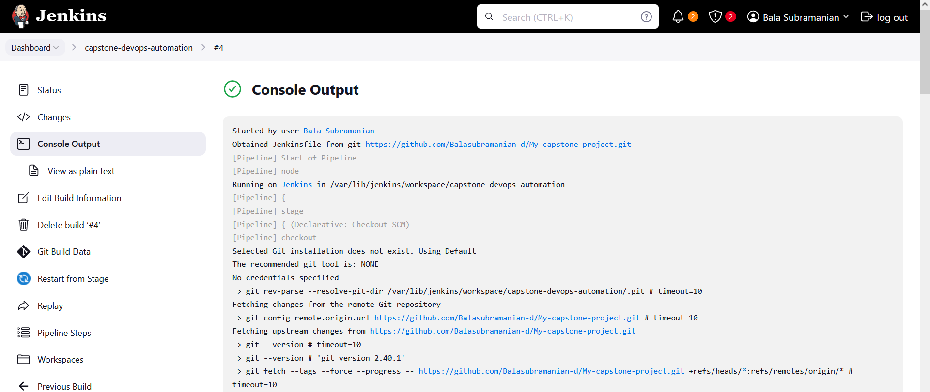

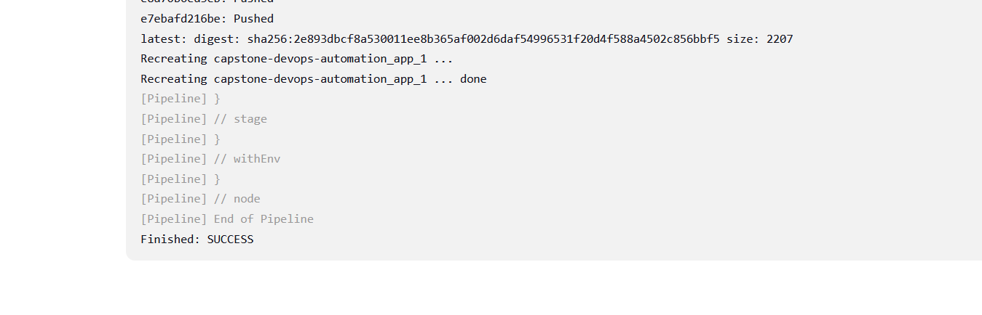

**AWS EC2 Console:**

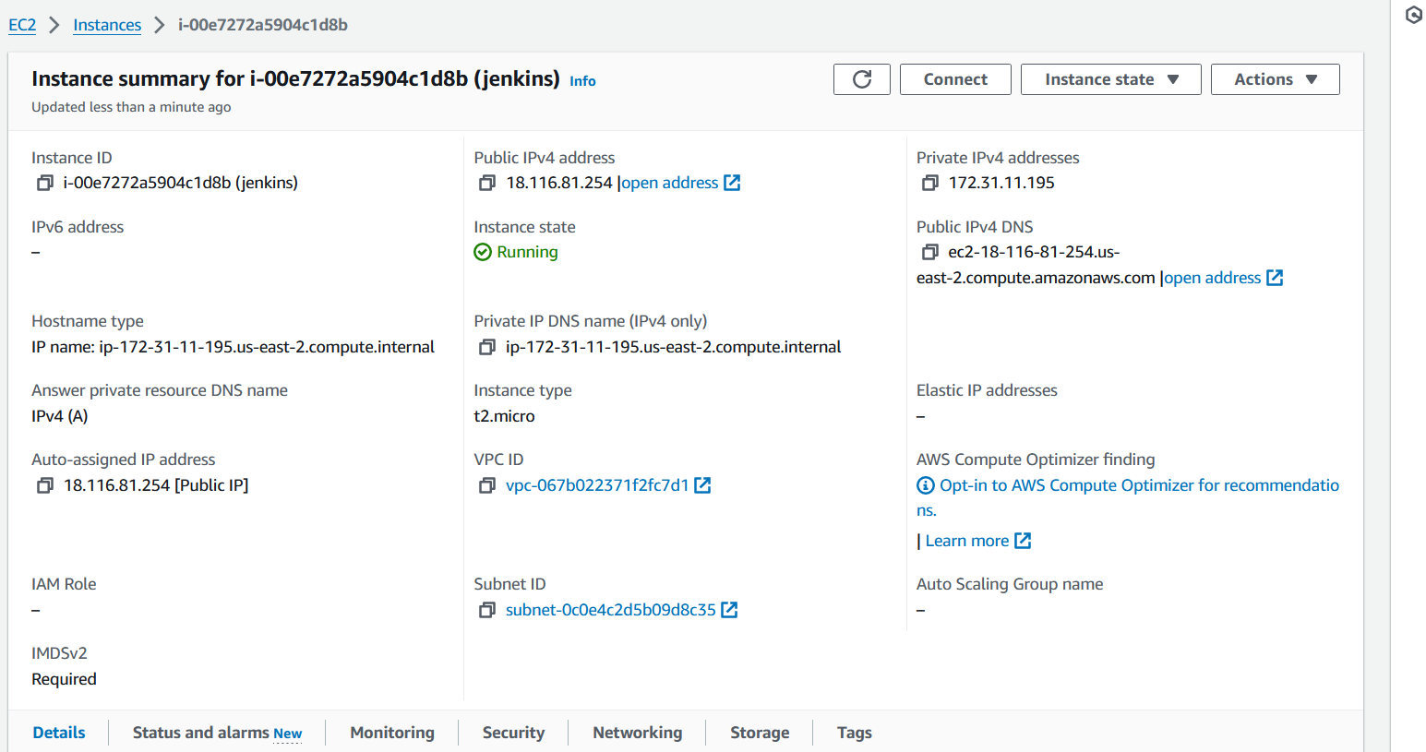

**AWS SG configs:**

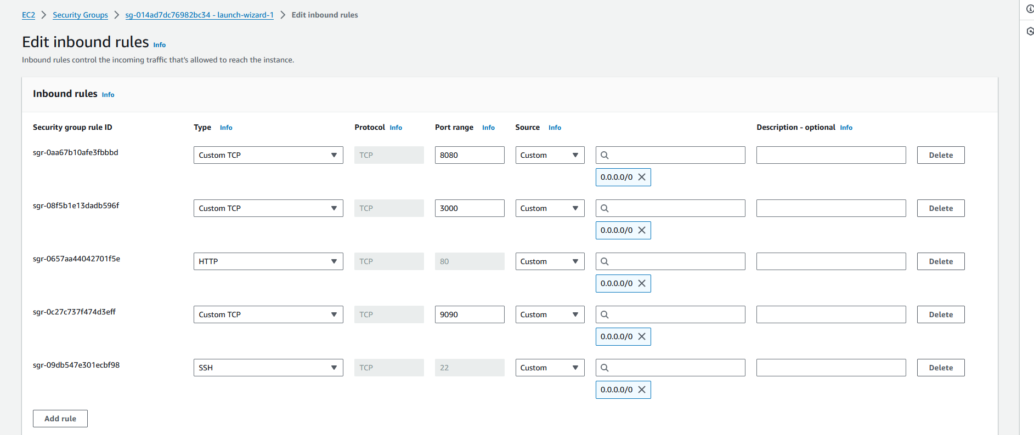

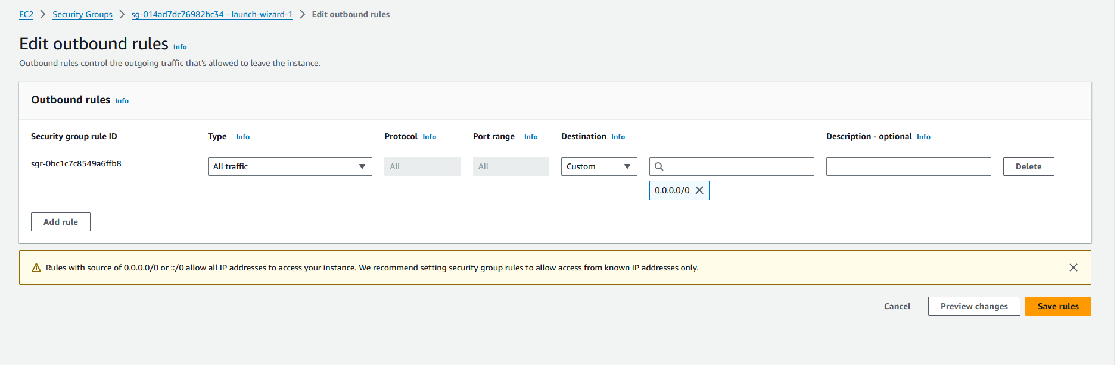

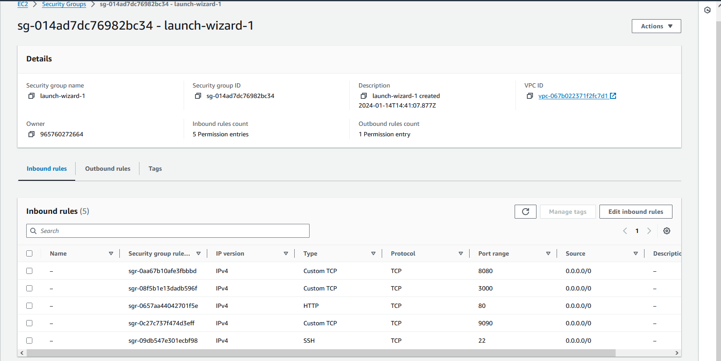

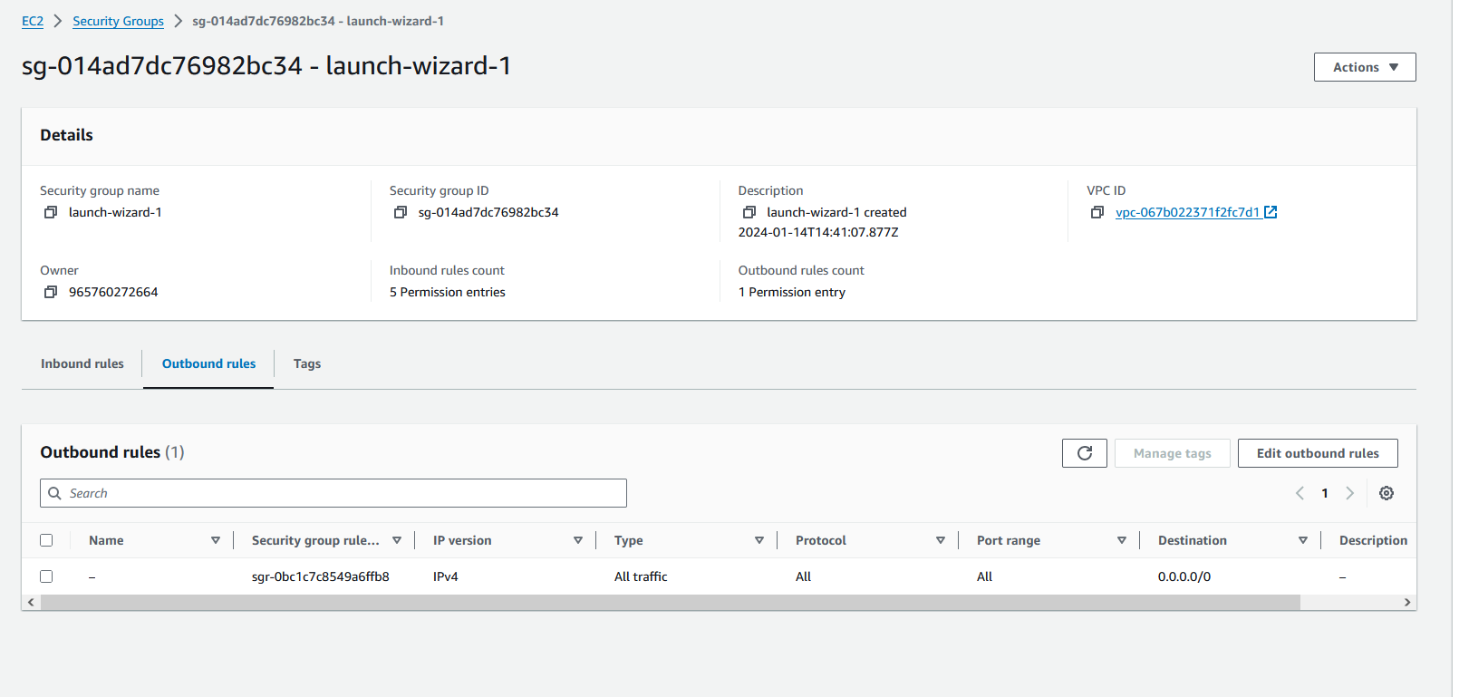

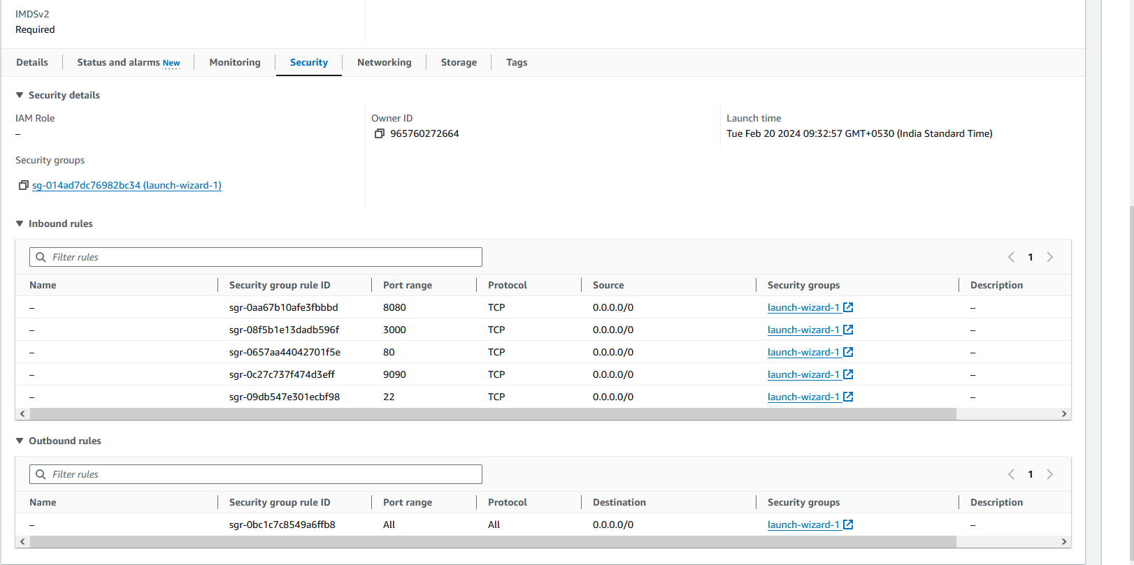

**Docker Hub repo with image Tags:**

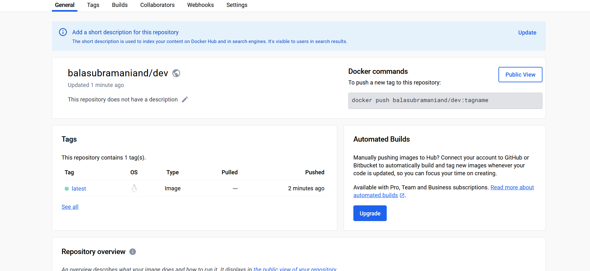

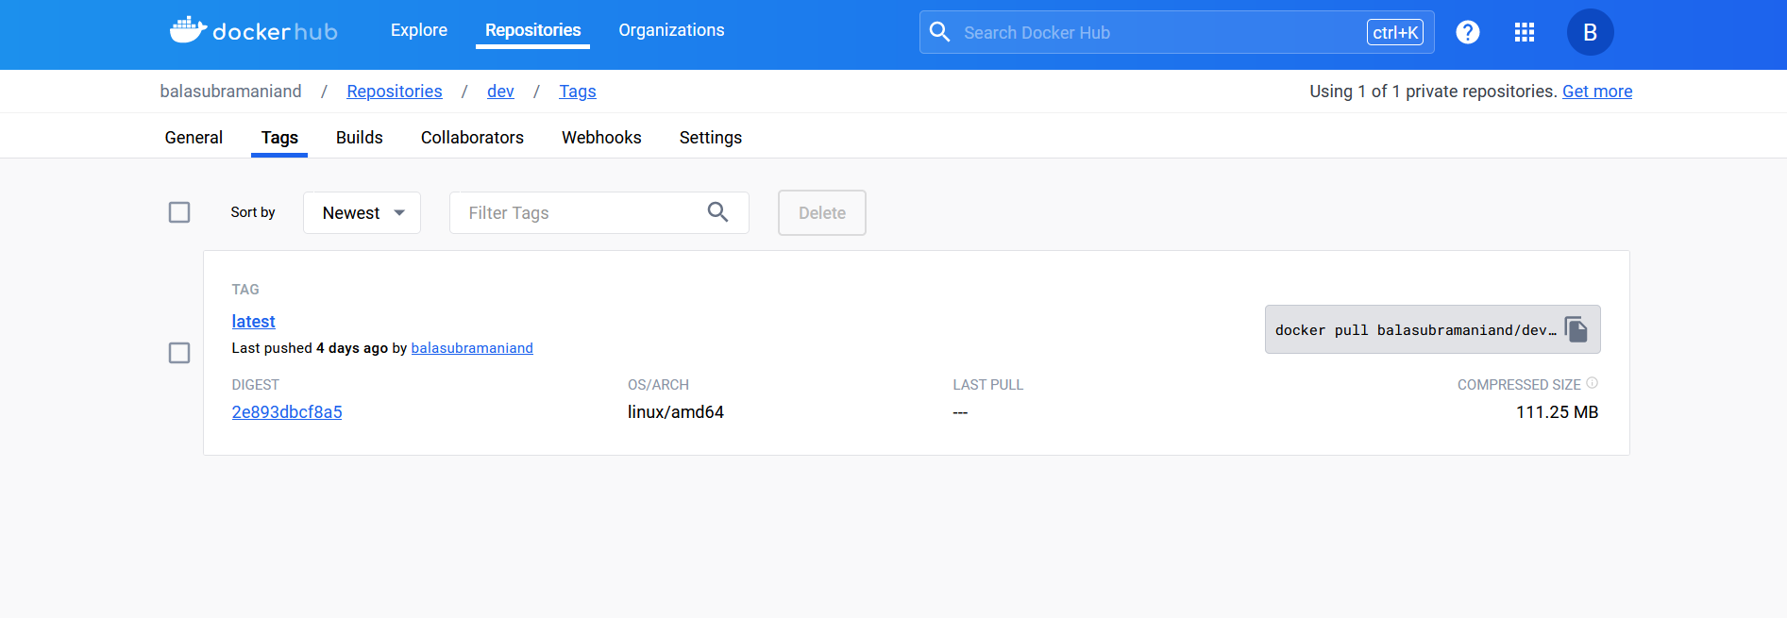

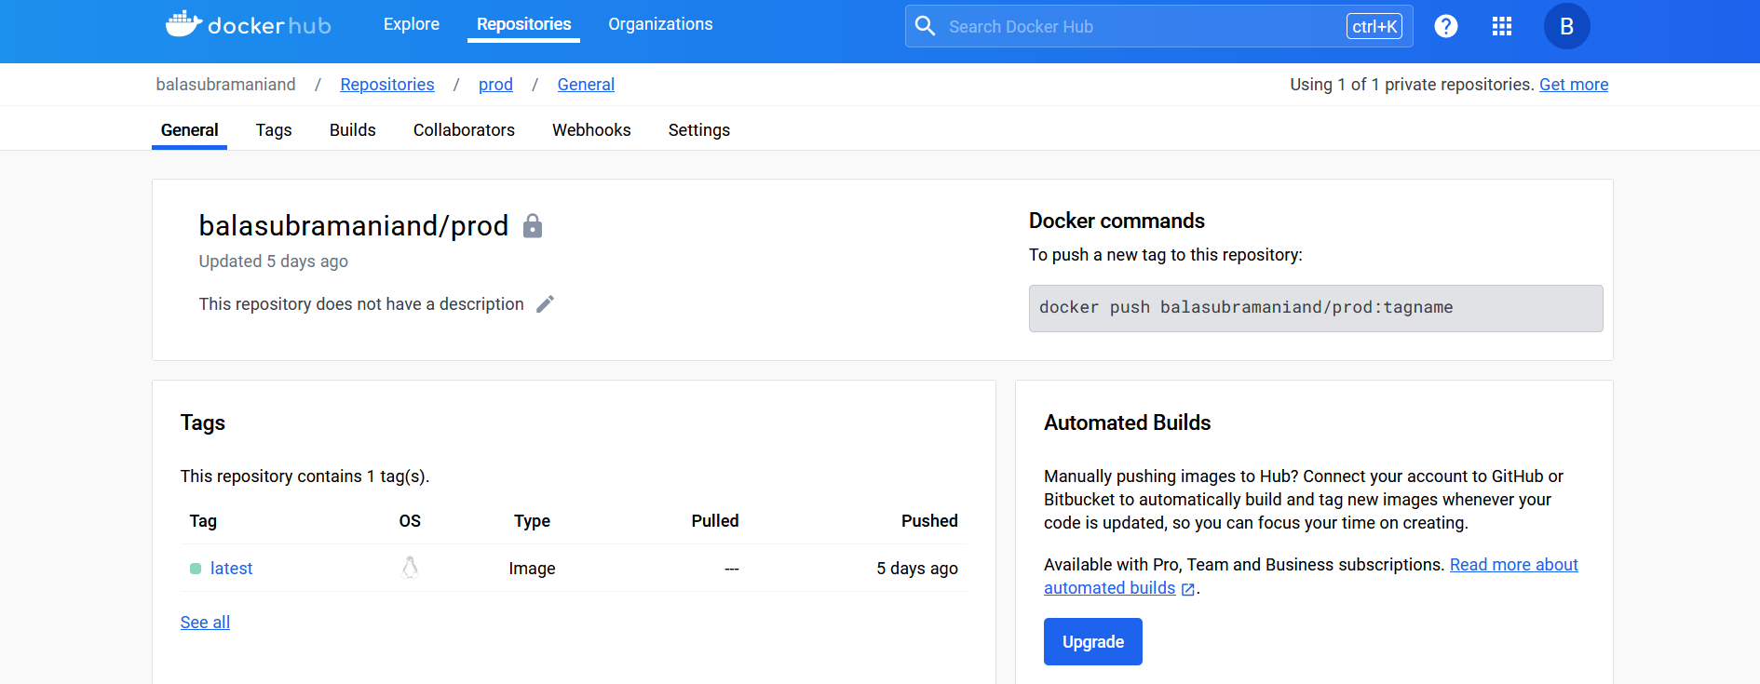

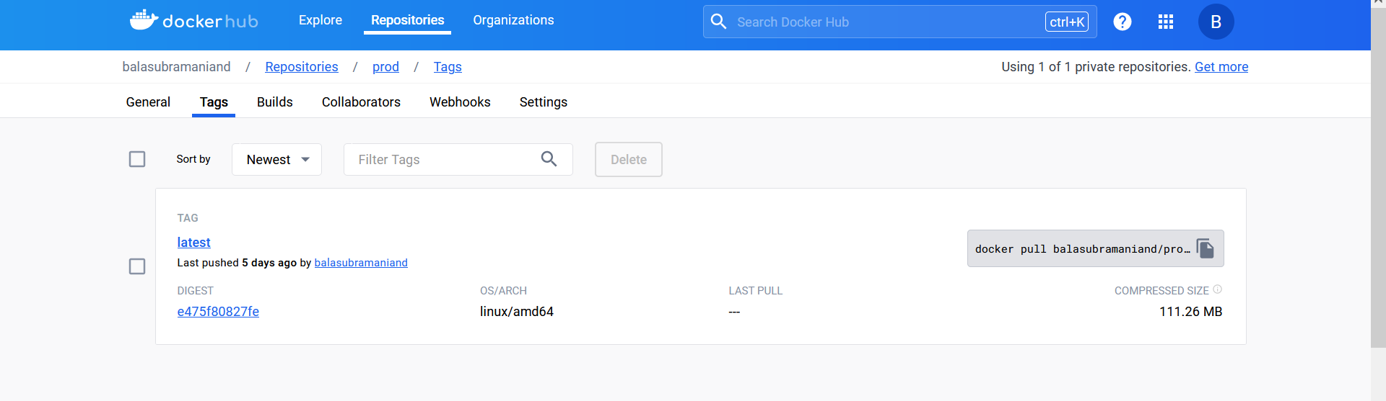

**Monitoring health status Dashboard:**

