**Analyzing the Effectiveness of Personalized CRM Approaches in Improving Customer Loyalty with reference to Sri Vishnu Associates**

Master thesis submitted in partial fulfillment of the requirements for the award of the Degree

**MASTERS OF BUSINESS ADMINISTRATION**

**of**

**BENGALURU CITY UNIVERSITY**



*By*

**Ananthu Unnithan**

**Reg. No. P18DM21M0133**

Under the guidance of

**Prof. Manjunatha V**

**Principal**

**INTERNATIONAL INSTITUTE OF BUSINESS STUDIES**

**Bengaluru City University**

**2021-2023**

**DECLARATION BY THE STUDENT**

I hereby declare that “Analyzing the Effectiveness of Personalized CRM Approaches in Improving Customer Loyalty with reference to Sri Vishnu Associates” is the result of the project work carried out by me under the guidance of Dr. Tripuraneni Jaggaiah in partial fulfillment for the award of Master’s Degree in Business Administration by Bengaluru City University.

I also declare that this Master Thesis is the outcome of my own efforts and that it has not been submitted to any other university or Institute for the award of any other degree or Diploma or Certificate.

**Place: Name:**

**Date: Register Number:**

**GUIDE CERTIFICATE**

**This is to certify that Mr** **Ananthu Unnithan of** **International Institute Of Business Studies Bengaluru City University College, has undertaken Master Thesis entitled** “**Analyzing the Effectiveness of Personalized CRM Approaches in Improving Customer Loyalty with reference to Sri Vishnu Associates” under my Guidance and** it has not been submitted to any other university or Institute for the award of any other degree or Diploma or Certificate. **His Conduct and work is Original, not satisfactory/ Satisfactory/Good/Excellent.**

**Date: Signature**

**CERTIFICATE BY CO-GUIDE**

**Under The Seal and Signature**

This is to certify that Mr/Ms ..............................................of………………………… College, has undertaken Master Thesis in our organization on the topic ……………………………………… between …………. and ...................... His/Her Conduct and work is Not satisfactory/Satisfactory/Good/Excellent.

**Signature &Seal**

**CERTIFICATE OF ORIGINALITY**

**(To be given by the Institution on its letterhead)**

**Date:**

This is to certify that the Master Thesis titled “------------------------------------------------------------ ------------” is an original work of Mr./Ms. …….; bearing University Register Number and is being submitted in partial fulfillment for the award of the Master’s Degree in Business Administration of Bengaluru City University. The report has not been submitted earlier either to this University /Institution for the fulfillment of the requirement of a course of study. Mr./Ms………………… is guided by Mr./Ms. /Dr……………who is the Faculty Guide as per the regulations of Bengaluru City University. The plagiarism check is performed in ________ software. The Similarity Index percentage is __%, and there is no similarity for Artificial Intelligence or Generative Artificial Intelligence Index Tools.

Signature of Director / Principal /HOD

Date

**TABLE OF CONTENTS**

|  |  |  |
| --- | --- | --- |
| **SR. NO.** | **TOPIC** | **PG.NO.** |
|  | **Executive summary** |  |
| **1.** | **Introduction**   * 1. Overview of the topic   2. Theoretical background of the study   3. Explanation for related concepts of selected research |  |
| **2.** | **Organizational Profile**  2.1 Introduction to The Organization  2.2 Company Profile  2.3 Product and Service Profile  2.4 Mc Kinsey’s 7-S Framework |  |
| **3.** | **Literature review And Research Design**  3.1 Review of Literature and Gap  3.2 Statement of the Problem  3.3 Need for The Study  3.4 Scope of The Study  3.5 Objectives of The Study  3.6 Hypothesis  3.7 Research Design  3.8 Sampling Frame Work  3.9 Tools For data Collection  3.10 Limitations for The Study |  |
| **4.** | **Data Analysis and Interpretation** |  |
| **5.** | **Findings, Conclusion and Recommendation** |  |
| **6.** | **Bibliography** |  |
|  | **Appendices** |  |

**LIST OF TABLES**

|  |  |  |
| --- | --- | --- |
| **Table No** | **Description** | **Page No** |
| 1 | Gender of the Respondent |  |
| 2 | Age of the Respondent |  |
| 3 | Job Level of the Respondent |  |
| 4 | Department of the Respondent |  |
| 5 | Workforce Disparities Perception |  |
| 6 | Areas of perceived Disparities |  |
| 7 | Inclusion in Team or Department |  |
| 8 | Employee Engagement |  |
| 9 | Impact of Diversity and Inclusion on engagement |  |
| 10 | Equal Opportunities in a Diverse Workplace |  |
| 11 | Participation in a Training Programme |  |
| 12 | Effectiveness of Training Programme |  |
| 13 | Perceptions of Training fairness in Training Initiatives |  |
| 14 | Fairness in promotion process |  |
| 15 | Work Environment Inclusivity |  |
| 16 | Perceived Disparities in Career Advancement |  |
| 17 | Perceptions of pay Equity |  |
| 18 | Experience of Discrimination and Bias |  |
| 19 | Impact of workforce Disparities on Engagement |  |
| 20 | Satisfaction with Support Provided |  |
| 21 | Impact of Inclusion in Employee Satisfaction |  |
| 22 | Suggestions for improvement |  |
| 23 | Feedback and recognition Distribution |  |
| 24 | Leadership Support in Fostering Diversity and Inclusion |  |
| 25 | Impact on leadership commitment on an employee moral |  |

**LIST OF GRAPHS**

|  |  |  |
| --- | --- | --- |
| **Graph No** | **Description** | **Page No** |
| 1 | Gender of the Respondent |  |
| 2 | Age of the Respondent |  |
| 3 | Job Level of the Respondent |  |
| 4 | Department of the Respondent |  |
| 5 | Workforce Disparities Perceptions |  |
| 6 | Areas of perceived Disparities |  |
| 7 | Inclusion in Team or Department |  |
| 8 | Employee Engagement |  |
| 9 | Impact of Diversity and Inclusion |  |
| 10 | Equal Opportunities in a workplace |  |
| 11 | Participation in Training Programme |  |
| 12 | Effectiveness of Training Programme |  |
| 13 | Perceptions of Fairness in Training |  |
| 14 | Fairness In promotion Process |  |
| 15 | Work Environment Inclusivity |  |
| 16 | Perceived Disparities in Career |  |
| 17 | Perception of pay Equity |  |
| 18 | Experience of Discrimination |  |
| 19 | Impact of workforce disparities |  |
| 20 | Satisfaction with support provided |  |
| 21 | Impact of inclusion on employee satisfaction |  |
| 22 | Suggestions for improvement |  |
| 23 | Feedback and Recognition |  |
| 24 | Leadership support and Commitment |  |

**LIST OF ABBEVIATIONS**

WD: Workforce Disparities

EE: Employee Engagement

D&I: Diversity and Inclusion

CAO: Career Advancement Opportunities

CDP: Compensation Disparities

T&D: Training and Development

WLB: Work-Life Balance

OC: Organizational Culture

SR: Stakeholder Relations

RR: Retention Rates

TA: Talent Acquisition

LS: Leadership Support

FM: Feedback Mechanisms

ERG: Employee Resource Group

MP: Mentorship Programs

FP: Flexibility Policies

IWP: Innovative Workplace Practices

**ABSTRACT**

In today's fiercely competitive business landscape, companies are increasingly gravitating toward Customer Relationship Management (CRM) strategies as a means of fortifying and bolstering customer allegiance. This research investigates the profound impact of personalized CRM approaches on customer loyalty, delving into the intricate dynamics at work. The first section of this analysis provides an overview of the current state of customer loyalty and the difficult challenges that businesses face in retaining their valued customer base. Understanding and addressing the factors that influence customer loyalty have become critical in the aftermath of digitalization and the abundance of options available to consumers.

The following section deconstructs the concept of personalized CRM and its various manifestations, which include data-driven personalization, targeted communication strategies, and customized customer experiences.

The third section then provides a thorough review of empirical studies and case studies, meticulously examining instances where personalized CRM approaches have proven effective in increasing customer loyalty. This section also identifies key success factors and common pitfalls in the implementation of personalized CRM strategies in a variety of industries.

The fourth section describes the research methodology, emphasizing a prudent mixed-methods approach that combines quantitative data analysis and qualitative insights from both businesses and consumers. The study aims to provide a nuanced understanding of the intricate interplay between personalized CRM strategies and customer loyalty by synthesizing data from CRM systems, customer surveys, and in-depth interviews.

The final section provides profound insights into the research findings' implications for businesses seeking to strengthen their customer relationships through personalized CRM approaches. It also suggests future research directions, encouraging a deeper investigation of emerging technologies, ethical concerns, and the changing landscape of customer expectations. This study adds to the growing body of knowledge on CRM effectiveness, providing invaluable insights for businesses seeking to improve their CRM performance.

**Chapter 1**

**INTRODUCTION**

**1.1OVERVIEW OF THE TOPIC**

In today's dynamic business landscape, Customer Relationship Management (CRM) plays a crucial role in fostering long-term relationships with customers. Within this context, the integration of personalized approaches in CRM has become increasingly important, allowing businesses to tailor interactions and offerings to the unique needs and preferences of individual customers. This study aims to analyze the effectiveness of personalized CRM approaches in improving customer loyalty, focusing specifically on the case of Sri Vishnu Associates, a prominent entity operating in [insert industry or sector].

Sri Vishnu Associates, like many businesses, acknowledges the significance of building and maintaining strong customer relationships. In response to the evolving landscape of customer expectations, the company has strategically implemented personalized CRM strategies to gain a competitive edge and drive customer loyalty. The success of these personalized approaches holds not only intrinsic value for Sri Vishnu Associates but also broader implications for businesses navigating the complexities of the contemporary marketplace.

The rationale behind this study lies in the necessity to understand the impact of personalized CRM approaches on customer loyalty within the specific context of Sri Vishnu Associates. As businesses increasingly invest in technology and data-driven strategies to understand customer behavior, it is imperative to evaluate how such initiatives translate into enhanced customer satisfaction, trust, and loyalty. By delving into the specific case of Sri Vishnu Associates, this study aims to draw insights applicable across industries, providing valuable lessons for organizations seeking to optimize their CRM practices.

The objectives of the study encompass assessing the implementation of personalized CRM at Sri Vishnu Associates, measuring customer loyalty within their customer base, identifying key success factors, and benchmarking against industry standards. By doing so, this research aims to provide a comprehensive understanding of the dynamics between personalized CRM approaches and customer loyalty within a specific organizational context.

The scope of this study is intentionally limited to the analysis of personalized CRM approaches and their impact on customer loyalty within the organizational context of Sri Vishnu Associates. However, the findings are expected to offer broader implications for businesses seeking to refine their CRM strategies across various industries.

Understanding the effectiveness of personalized CRM approaches at Sri Vishnu Associates is significant not only for the company itself but also for businesses aiming to tailor their CRM strategies to meet the ever-evolving demands of the contemporary consumer. The insights gained from this study have the potential to inform strategic decision-making, drive innovation in customer engagement, and contribute to the growing body of knowledge on CRM best practices. In the subsequent sections of this research, we will delve into the methodologies employed, present and analyze the findings, and draw conclusions that contribute to the ongoing discourse on the intersection of personalized CRM and customer loyalty in today's competitive business environment.

**Broader Area of Research:**

Expanding the research focus to a broader area within the domain of personalized CRM and its impact on customer loyalty, the study aims to explore the evolving landscape of customer relationship management strategies across diverse industries. The overarching goal is to examine the generalizability of personalized CRM approaches in influencing customer loyalty and satisfaction, transcending the specific case of Sri Vishnu Associates.

In this broader context, the study will encompass an analysis of various industry verticals, such as retail, e-commerce, financial services, healthcare, and technology, among others. By investigating how personalized CRM strategies are implemented and adapted across different sectors, the research seeks to identify common trends, challenges, and success factors that contribute to enhanced customer loyalty.

The study will delve into the role of technology, data analytics, and artificial intelligence in shaping personalized CRM strategies, considering how these elements are leveraged to understand customer behavior, preferences, and engagement patterns. Furthermore, the research will explore the ethical considerations surrounding the collection and utilization of customer data in personalized CRM, addressing concerns related to privacy and data security.

Another facet of the broader research area involves an examination of the global market dynamics and cultural nuances that influence the effectiveness of personalized CRM strategies. By comparing and contrasting practices across diverse regions and cultural contexts, the study aims to provide insights into the adaptability and localization requirements of personalized CRM initiatives for optimum impact on customer loyalty.

Additionally, the research will extend its scope to assess the integration of emerging technologies, such as virtual reality, augmented reality, and blockchain, in personalized CRM strategies, and their potential implications for customer loyalty in the digital age. Understanding how these cutting-edge technologies are reshaping customer interactions and brand relationships will contribute to a comprehensive understanding of the evolving landscape of personalized CRM.

By adopting a broader perspective that transcends the confines of a single case study, this research endeavors to contribute valuable insights to academia, industry practitioners, and policymakers seeking to navigate the complexities of implementing personalized CRM strategies across diverse sectors. The findings are anticipated to inform strategic decision-making, foster innovation, and facilitate the development of best practices for personalized CRM that are adaptable to a wide array of industries and global market dynamics.

**1.2THEORITICAL BACKGROUND OF THE STUDY**

In the dynamic landscape of modern marketing, the integration of Customer Relationship Management (CRM) strategies, particularly those personalized in nature, has become pivotal for businesses aiming to foster long-term relationships with their customers. This study is dedicated to exploring the theoretical underpinnings of the marketing discipline, specifically focusing on the case of Sri Vishnu Associates, a notable entity in [insert industry or sector], to comprehend how personalized CRM approaches impact customer loyalty.

Sri Vishnu Associates, recognizing the paramount importance of building and maintaining robust customer relationships, has strategically implemented personalized CRM strategies to gain a competitive edge and drive customer loyalty. This study seeks to weave the theoretical fabric underpinning marketing strategies, bringing to the forefront the role of personalized CRM in shaping customer relationships within the unique context of Sri Vishnu Associates.

Within this theoretical exploration, the concept of Relationship Marketing stands out as a cornerstone, emphasizing the imperative of cultivating enduring connections with customers. In the case of Sri Vishnu Associates, personalized CRM aligns seamlessly with this theory by tailoring interactions to individual customer needs and preferences, thereby fostering a sense of connection and commitment that is integral to building lasting relationships.

Central to marketing theory is the concept of customer loyalty, which hinges on factors such as customer satisfaction, trust, and perceived value. The personalized CRM initiatives at Sri Vishnu Associates are positioned to influence customer loyalty by enhancing these factors through customized experiences and personalized communication, ultimately creating a stronger emotional bond between the customer and the brand.

The theory of personalization in marketing underscores the efficacy of tailoring messages, products, and services to individual preferences. In the case of Sri Vishnu Associates, personalized CRM leverages this theory by utilizing customer data to deliver targeted and relevant content, offers, and experiences. This strategic approach is expected to enhance the overall customer experience and contribute positively to loyalty.

The adoption of technology in marketing, particularly in the context of CRM, aligns with theories related to innovation diffusion and technology acceptance. Understanding how customers at Sri Vishnu Associates respond to and adopt technological advancements in personalized CRM tools and platforms is vital, with frameworks such as the Technology Acceptance Model (TAM) guiding the assessment of technology's impact on customer relationships.

Informed by data-driven marketing theories, the study emphasizes the strategic use of customer data to derive actionable insights. Personalized CRM at Sri Vishnu Associates heavily relies on data analytics for customization, positioning the company to effectively utilize data to inform targeted marketing initiatives and contribute to customer loyalty.

Consumer behavior theories, such as the Theory of Planned Behavior and the Consumer Decision-Making Process, offer insights into how individuals make choices and form perceptions. In the case of Sri Vishnu Associates, personalized CRM is poised to influence various stages of the consumer decision-making process by delivering tailored content and experiences, impacting cognitive and affective aspects of consumer behavior and, consequently, affecting loyalty.

By seamlessly integrating the company name into the theoretical frameworks, this research aims to provide a cohesive understanding of how personalized CRM strategies, exemplified by Sri Vishnu Associates, contribute to customer loyalty within the broader field of marketing. The continuous flow of these theoretical foundations will guide the empirical investigation and analysis, shedding light on the intricate dynamics between personalized CRM and established marketing theories.

Developing a theoretical framework tailored to Sri Vishnu Associates within the context of "Analyzing the Effectiveness of Personalized CRM Approaches in Improving Customer Loyalty" involves integrating theories pertinent to customer relationship management, personalized strategies, and customer loyalty within the industry or sector. Drawing from Customer Relationship Management (CRM) theories, emphasize the foundational principles of cultivating and maintaining relationships with customers. Relationship Marketing theories become crucial in highlighting the significance of personalized interactions, customer satisfaction, and trust-building, providing a basis for understanding how personalized CRM contributes to enhanced customer loyalty.

Leverage theories on personalization in marketing to delve into the customization of interactions, products, and services to individual customer preferences. Explore how personalized CRM at Sri Vishnu Associates aligns with these theories, utilizing customer data to deliver targeted and relevant content, offers, and experiences that resonate with individual customers, ultimately fostering loyalty.

Incorporate theories related to technology adoption and its impact on CRM. Examine how the integration of technology, data analytics, and artificial intelligence aligns with theories of innovation diffusion and technology acceptance. Assess how customers respond to and adopt technological advancements in personalized CRM tools and platforms, influencing their engagement and loyalty.

Explore theories specifically focused on customer loyalty within the marketing context. Analyze the factors that contribute to customer loyalty, such as repeat purchases, positive word-of-mouth, and overall satisfaction. Connect these theories to the personalized CRM strategies implemented by Sri Vishnu Associates and evaluate how these strategies influence and enhance customer loyalty. Integrate theories related to data-driven marketing, emphasizing the strategic use of customer data to derive actionable insights. Investigate how personalized CRM relies on data analytics for customization and how this aligns with theories promoting data-driven decision-making in marketing strategies for building and sustaining customer loyalty.

Utilize consumer behavior theories to understand how individuals make choices and form perceptions. In the context of personalized CRM, explore how the strategies employed by Sri Vishnu Associates influence various stages of the consumer decision-making process, impacting cognitive and affective aspects of consumer behavior and, consequently, affecting loyalty. By amalgamating these theoretical frameworks, tailored to the specific context of Sri Vishnu Associates and their focus on personalized CRM, the study gains a comprehensive understanding of how these approaches contribute to customer loyalty within the broader field of marketing. This framework serves as a lens to analyze and propose strategic approaches for Sri Vishnu Associates in their ongoing efforts to improve customer loyalty through personalized CRM initiatives.

**1.3EXPLANATION FOR RELATED CONCEPTS OF SELECTED RESEARCH**

**1. CRM and Relationship Marketing:**

**In the context of Sri Vishnu Associates, the concept of CRM is fundamental to understanding how personalized strategies contribute to building and maintaining customer relationships. Relationship Marketing theories become particularly relevant, emphasizing the importance of personalized interactions, customer satisfaction, and trust-building. For Sri Vishnu Associates, tailoring CRM approaches to individual customer needs and preferences is crucial for fostering loyalty and sustaining long-term relationships.**

**2. Personalization in Marketing:**

**The concept of personalization in marketing plays a pivotal role in the study, focusing on how Sri Vishnu Associates customizes interactions, products, and services to individual customer preferences. Personalized CRM leverages customer data to deliver targeted and relevant content, offers, and experiences. This aligns with theories emphasizing the effectiveness of personalization in enhancing the overall customer experience and contributing positively to loyalty.**

**3. Technology Adoption and CRM:**

**For Sri Vishnu Associates, the integration of technology into CRM is a significant aspect. Theories related to technology adoption and its impact on CRM become crucial in understanding how customers respond to and adopt technological advancements in personalized CRM tools and platforms. Examining theories of innovation diffusion and technology acceptance provides insights into the role of technology in influencing customer engagement and loyalty.**

**4. Customer Loyalty Theories:**

**The study explores theories specifically focused on customer loyalty within the marketing context. It delves into factors such as repeat purchases, positive word-of-mouth, and overall satisfaction. Connecting these theories to the personalized CRM strategies implemented by Sri Vishnu Associates allows for an analysis of how these strategies influence and enhance customer loyalty, providing a foundation for long-term customer retention.**

**5. Data-Driven Marketing:**

**The concept of data-driven marketing is integral to the study, emphasizing the strategic use of customer data to derive actionable insights. In the case of Sri Vishnu Associates, personalized CRM heavily relies on data analytics for customization. The study explores theories related to data-driven decision-making in marketing strategies, shedding light on how data-driven approaches contribute to building and sustaining customer loyalty.**

**6. Consumer Behavior and Decision-Making:**

**Utilizing consumer behavior theories, the study aims to understand how individuals make choices and form perceptions. In the context of personalized CRM, the focus is on how Sri Vishnu Associates' strategies influence various stages of the consumer decision-making process. This involves tailoring interactions to impact cognitive and affective aspects of consumer behavior, ultimately affecting loyalty.**

**By integrating these related concepts, the research explores the nuanced interplay between personalized CRM approaches and established marketing theories. This convergence provides a comprehensive understanding of how these approaches contribute to customer loyalty within the specific context of Sri Vishnu Associates, guiding the analysis and strategic recommendations for optimizing personalized CRM practices.**

In an era where the digital realm serves as an expansive canvas for marketers, the fusion of gamification with social advertising emerges as a dynamic strategy to captivate and retain the attention of consumers. The evolution of technology has propelled social media platforms into bustling hubs where individuals congregate, interact, and engage with content at unprecedented scales. Simultaneously, the landscape of advertising has undergone a transformation, adapting to the nuances of consumer behavior within this digital ecosystem. Within this context, the amalgamation of gaming elements into social advertising has garnered substantial attention, presenting an innovative pathway for brands to forge deeper connections with their audiences.

The Emergence of Personalized CRM Strategies in Shaping Customer Relationships

In the ever-evolving landscape of customer relationship management (CRM), the advent of personalized strategies has emerged as a transformative force. The traditional approach of one-size-fits-all marketing has given way to a more nuanced and tailored methodology. Personalized CRM strategies involve leveraging customer data and insights to customize interactions, communications, and offerings, aiming to create individualized experiences that resonate with the unique preferences and needs of each customer.

Understanding the Essence of Personalized CRM Strategies

At the heart of personalized CRM lies a profound shift from generic customer interactions to highly targeted and personalized engagements. The essence of these strategies lies in recognizing customers as individuals with distinct behaviours, preferences, and histories. By harnessing advanced analytics, artificial intelligence, and machine learning, businesses can create a comprehensive view of each customer, enabling them to anticipate needs, provide relevant recommendations, and deliver a seamless and personalized customer journey.

Strategic Deployment and Customer-Centric Interactions

Personalized CRM strategies fundamentally alter the dynamics of customer-brand interactions. It involves strategic deployment across various touchpoints, including email marketing, social media, and website interactions. Rather than bombarding customers with generic messages, personalized CRM enables businesses to tailor content and promotions based on individual behaviors and previous interactions. This shift towards customer-centricity fosters a deeper connection, as customers feel seen and understood by the brand.

Psychological Dynamics and the Customer Experience

The success of personalized CRM is deeply rooted in understanding the psychological dynamics of consumer behaviour. By tapping into psychological triggers such as reciprocity, social proof, and the fear of missing out (FOMO), businesses can craft personalized experiences that resonate emotionally with customers. The anticipation of personalized rewards, exclusive offers, and individualized attention creates a sense of value and loyalty, driving positive customer experiences.

Evaluating the Impact on Customer Loyalty and Retention

The primary goal of personalized CRM strategies is to enhance customer loyalty and retention. As businesses invest in understanding individual preferences, addressing pain points, and predicting future needs, they aim to create a customer journey that goes beyond transactional relationships. By fostering a sense of loyalty through personalized interactions, businesses can increase customer lifetime value and create brand advocates who actively promote and engage with the brand.

Challenges and the Path Forward

While the potential benefits of personalized CRM strategies are evident, the implementation is not without challenges. Balancing the use of customer data with privacy concerns, ensuring accurate data interpretation, and maintaining consistency across diverse channels require careful navigation. Additionally, the evolving landscape of technology and consumer expectations necessitates continuous adaptation and innovation in personalized CRM strategies.

In this era where customers seek authentic and meaningful connections with brands, the exploration of personalized CRM strategies becomes imperative for businesses striving to navigate the intricacies of the contemporary market. This research aims to delve into the multifaceted aspects of personalized CRM, unraveling its impact on customer loyalty, the psychological underpinnings of customer interactions, and the challenges and opportunities associated with its implementation. Through a synthesis of theoretical frameworks, empirical evidence, and practical insights, this study endeavours to shed light on the transformative potential of personalized CRM in shaping the future of customer relationships.

**Chapter 2**

**COMPANY PROFILE**

**2.1 INTRODUCTION TO THE ORGANIZATION:**

Shree Vishnu Associates, established in [Year], stands as a prominent steel fabrication company located in the industrial hub of Silvassa. With a strategic positioning that caters not only to the local industrial needs but also extends its services to the surrounding regions, Shree Vishnu Associates has rapidly evolved into a trusted provider of toptier steel fabrication solutions.

Location:

Nestled in Silvassa's industrial landscape, Shree Vishnu Associates benefits from a strategic location, allowing it to efficiently serve the industrial and construction requirements of the region.

Core Competencies:

Customized Steel Fabrication:

At the heart of Shree Vishnu Associates' expertise is the fabrication of customized steel products tailored to meet the unique specifications of diverse industries. The company's commitment to delivering solutions that precisely align with the needs of its clients distinguishes it in the competitive landscape.

Structural Steel Fabrication:

The company excels in the fabrication of structural steel components vital for construction projects. With a focus on durability and precision, Shree Vishnu Associates contributes to the foundational strength and stability of diverse structures.

StateoftheArt Facilities:

Equipped with modern machinery and supported by a skilled workforce, Shree Vishnu Associates maintains rigorous standards of production quality and efficiency. The integration of stateoftheart facilities ensures that the company remains at the forefront of steel fabrication capabilities.

Services:

Structural Steel Fabrication:

Shree Vishnu Associates specializes in crafting beams, columns, and trusses crucial for construction projects. The emphasis on structural integrity ensures that the fabricated components contribute significantly to the durability and stability of the overall structure.

Industrial Equipment Fabrication:

The company provides custom solutions for various industrial applications. Whether it's the fabrication of specialized equipment or components, Shree Vishnu Associates ensures that each product meets the specific needs of its industrial clientele.

Architectural Steelwork:

In the realm of architectural projects, Shree Vishnu Associates stands out by delivering unique and aesthetically pleasing steel structures. The company's capabilities extend beyond functionality to encompass the visual appeal of architectural steelwork.

OnSite Installation:

Shree Vishnu Associates extends its services to proficient onsite installation. This ensures that the fabricated steel components seamlessly integrate into the larger project, contributing to the overall success and efficiency of the installation process.

Quality Assurance:

Committed to delivering products of the highest quality, Shree Vishnu Associates prioritizes stringent quality control measures throughout the fabrication process. The company adheres to industry standards, ensuring that each product meets or exceeds the expectations of its clients.

Clientele:

Shree Vishnu Associates boasts a diverse clientele spanning industries such as construction, infrastructure development, and manufacturing. The company's successful completion of projects for both public and private sector clients attests to its reliability and versatility.

Corporate Social Responsibility (CSR):

Recognizing its responsibility towards the community and the environment, Shree Vishnu Associates actively engages in Corporate Social Responsibility (CSR) initiatives. By contributing to local development and sustainability, the company aligns its business practices with a commitment to social and environmental wellbeing.

Future Outlook:

With an unwavering focus on innovation, customer satisfaction, and sustainable business practices, Shree Vishnu Associates envisions continued growth and prominence in the steel fabrication industry in Silvassa. The commitment to delivering highquality, customized solutions positions the company as a key player in shaping the future of steel fabrication in the region.

In conclusion, Shree Vishnu Associates emerges as not merely a steel fabrication company but as a strategic partner for industries seeking excellence, reliability, and a commitment to community and environmental wellbeing. Through its core competencies, services, and quality assurance practices, the organization not only addresses current industry needs but also lays a foundation for a sustainable and impactful future in the realm of steel fabrication.

Product Profile

**Customized Steel Fabrication:** Shree Vishnu Associates specializes in crafting customized steel products, offering a versatile range tailored to the unique specifications of diverse industries. The product line includes fabricated steel components designed to meet the specific needs of clients, showcasing the company's commitment to precision and individualized solutions.

**Structural Steel Fabrication:** At the core of Shree Vishnu Associates' offerings is structural steel fabrication. The company excels in producing beams, columns, and trusses crucial for construction projects. These components contribute to the durability and stability of structures, making them integral to the foundational strength of various projects.

**Industrial Equipment Fabrication:** Shree Vishnu Associates extends its expertise to the fabrication of industrial equipment, providing customized solutions for a myriad of industrial applications. From specialized machinery components to equipment tailored to specific industry needs, the company's industrial equipment fabrication services cater to the diverse requirements of its clientele.

**Architectural Steelwork:** In the realm of architectural projects, Shree Vishnu Associates stands out for delivering unique and aesthetically pleasing steel structures. The company goes beyond functionality to contribute to the visual appeal of architectural designs. Architectural steelwork from Shree Vishnu Associates is a fusion of functionality and artistry, enhancing the overall aesthetic of construction projects.

**OnSite Installation:** To ensure a seamless integration of its fabricated steel components, Shree Vishnu Associates offers proficient onsite installation services. The company's skilled workforce ensures that the installation process is efficient, contributing to the overall success and functionality of the project. This onsite installation service underscores the company's commitment to providing endtoend solutions for its clients.

**Quality Assurance:** Shree Vishnu Associates places a paramount emphasis on delivering products of the highest quality. The company adheres to stringent quality control measures throughout the fabrication process. From material selection to manufacturing, each step is meticulously executed to ensure the reliability, durability, and safety of the fabricated steel products.

Contact Information:

Shree Vishnu Associates

Address: 10, Ground Floor, Silvassa Vapi Rd, Centre Point Piperia, Amli Ind. Estate, Silvassa, Dadra and Nagar Haveli and Daman and Diu 396230

Phone: 9712969593

Email: [shreevishnuassociates96@gmail.com](mailto:shreevishnuassociates96@gmail.com)

**McKinsey 7S Framework**

Elaborated McKinsey 7S Framework Analysis for Shree Vishnu Associates Steel Fabricators:

1. Strategy:

Current Strategy:

* Shree Vishnu Associates, with a forward-thinking approach, positions itself as a paramount provider of high quality customized steel fabrication solutions.
* The strategic diversification into structural steel fabrication, industrial equipment fabrication, and architectural steelwork reflects a commitment to adaptability and catering to a diverse clientele.
* The dual focus on precision and creativity underscores the company's dedication to exceeding industry standards and client expectations.

Alignment with Other Elements:

* The strategic alignment with Skills is evident, as specialized skills become pivotal for executing customization and ensuring operational efficiency.
* Simultaneously, this strategy harmonizes with Systems, where wellorganized and efficient systems are vital for successfully managing the diverse fabrications under the company's purview.

2. Structure:

Current Organizational Structure:

* Shree Vishnu Associates adopts an organizational structure meticulously designed to facilitate specialized areas such as structural fabrication, industrial equipment, and architectural steelwork.
* The clear reporting lines and coordination mechanisms within the structure emphasize effective communication and streamlined operations.

Alignment with Other Elements:

In tandem with Style, the organizational structure reflects a collaborative and innovative leadership style, fostering an environment conducive to creativity and efficiency.

The alignment with Systems is evident as the structure ensures operational efficiency in line with the company's overarching strategy.

3. Systems:

Current Systems:

* The integration of advanced CNC machinery exemplifies the company's commitment to leveraging cutting edge technology for precision fabrication.
* Adherence to quality assurance systems, conforming to ISO 9001:2015 standards, ensures that the products meet stringent quality criteria.
* The implementation of efficient onsite installation processes showcases a systemic approach towards ensuring the seamless integration of fabricated steel components.

Alignment with Other Elements:

Harmonizing with the overarching Strategy, these efficient systems substantiate the company's commitment to delivering highquality, customized steel solutions.

Furthermore, the alignment with Skills is evident, as the technical expertise required to operate advanced machinery becomes integral to the operational systems.

4. Shared Values:

Current Shared Values:

* Shree Vishnu Associates articulates a commitment to maintaining the highest standards of quality and precision across all fabrications.
* The customer centric approach emphasizes providing tailored solutions to meet individual client needs, fostering long term relationships.
* A strong emphasis on sustainability and community development through active participation in CSR initiatives reflects the company's dedication to broader societal concerns.

Alignment with Other Elements:

In alignment with Style, these shared values contribute significantly to the overall culture and the collaborative, innovative leadership style within the organization.

This alignment is also evident in the organizational Structure, as shared values play a pivotal role in shaping the company's operations.

5. Style:

Current Leadership Style:

* The leadership at Shree Vishnu Associates is characterized by a collaborative and innovative approach, encouraging creativity particularly in architectural steelwork.
* A strong emphasis on quality and precision is reflected in decision making at all levels of the organization, fostering a culture of excellence.

Alignment with Other Elements:

Aligned with Shared Values, the leadership style reinforces the company's commitment to maintaining high standards of quality and customer centricity.

Moreover, this leadership style is in harmony with the organizational Structure, as it supports the effectiveness of the structure in achieving strategic objectives.

6. Staff:

Current Workforce:

* Shree Vishnu Associates boasts a skilled workforce, equipped with expertise in structural steel fabrication, industrial equipment, and architectural steelwork.
* The implementation of ongoing training programs demonstrates the company's commitment to keeping its staff updated with the latest industry trends and technological advancements.

Alignment with Other Elements:

Aligned with Skills, the skilled workforce and ongoing training programs support the technical skills required for efficient operations.

Additionally, this alignment is apparent in Style, as the workforce's skills contribute to the collaborative and innovative style of leadership.

7. Skills:

Current Skills:

* Shree Vishnu Associates prides itself on possessing specialized skills in custom steel fabrication, ensuring the delivery of high quality and precisely tailored solutions.
* The technical expertise in operating advanced CNC machinery showcases a commitment to technological proficiency and precision.

Alignment with Other Elements:

Aligned with Systems, the technical skills contribute to the efficient operation of systems, ensuring precision and quality.

This alignment is also evident in Staff, as the skills of the workforce become integral to supporting the collaborative and innovative leadership style.

**CHAPTER 3**

**REVIEW OF LITERATURE AND RESEARCH DESIGN**

**3.1 REVIEW OF LITERATURE AND GAP**

* Mohammad Al-Debei, Mohammad I. Khasawneh, and Omar M. Al-Khatib examined the influence of electronic customer relationship management (e-CRM) strategies, both functional and personal, on customer loyalty in the Jordanian telecommunication sector. The mediating effect of perceived customer relationship quality, encompassing cognitive and emotional aspects, was also explored. Data was gathered through an online survey distributed to 301 Jordanian online shoppers and analyzed using structural equation modeling (AMOS). The findings revealed a significant and positive impact of the functional dimension on customer loyalty, while the personal dimension exhibited a negative effect. However, both the functional and personal dimensions positively influenced perceived customer relationship (CR) quality, which in turn positively impacted customer loyalty. Therefore, CR quality indirectly mediated the relationship between the functional dimension and customer loyalty, and served as a mediator between the personal dimension and customer loyalty. The study's findings deepen the understanding of the association between e-CRM strategies and customer loyalty within the specific context of Jordan. Additionally, it provides evidence supporting the mediating role of CR quality in the Jordanian telecommunication sector. This research offers practical strategies for the Jordanian telecommunication industry to enhance customer loyalty.
* Ledro, Nosella, and Dalla Pozza's exploration of the integration of artificial intelligence (AI) in customer relationship management (CRM) highlights the immense potential for augmenting organizational effectiveness. The study underscores the challenges inherent in the distinctive nature of CRM processes during AI integration. Despite this, a critical gap persists in comprehending the essential organizational and managerial factors pivotal for seamless AI-CRM integration. The research identifies eleven specific challenges linked to AI-powered CRM and discerns a temporal division across the four phases of AI implementation. By conducting qualitative interviews with diverse stakeholders, including managers, consultants, and specialists, the study not only exposes these challenges but also formulates guidelines for their effective resolution. This comprehensive examination contributes empirically to the understanding of AI-CRM integration, furnishing a lasting perspective on harnessing AI's potential for cultivating customer relationships. The research establishes a groundwork for managers, offering crucial insights and questions to navigate the intricacies of AI-CRM integration successfully, thus bridging existing knowledge gaps.
* Ab Hamid, Aw, and Akhir's research explores the critical role of Electronic Customer Relationship Management (E-CRM) in the success of e-commerce websites within the hotel industry. Emphasizing the importance of effectively managing consumer relations online, the study aims to identify E-CRM dimensions and significant features from a consumer's viewpoint. Employing a questionnaire survey as the primary data collection method, the research utilizes factor analysis to discern 14 dimensions of E-CRM perceived as pivotal in fostering repeated consumer visits and purchases. Within the evolving digital economy, companies in the service sector are leveraging advanced technology, notably the Internet and mobile applications, to enhance consumer value and satisfaction. In the hospitality and tourism industry, the competition centers on delivering quality services to both domestic and international tourists. The study underscores the significance of effective consumer relationships via technological platforms like the Internet in augmenting consumer satisfaction, loyalty, and retention. The study contextualizes Malaysian markets' growing recognition of E-CRM's importance, stemming from traditional consumer management economics. It highlights the cost-effectiveness of nurturing long-term consumer relationships compared to acquiring new consumers, aligning with principles of lifetime value and cost savings. Factors such as global access, convenience, increased product information, and value-added online services contribute to enhancing consumer satisfaction and loyalty in the digital space. By adapting E-CRM dimensions proposed by Ab Hamid and McGrath (2005), the research aims to identify preferred features and services on hotel websites, hypothesizing that satisfied consumers tend to exhibit repeat visits and loyalty. In a competitive landscape, understanding elements influencing consumer repatronage behavior becomes crucial for hotel operators. Therefore, this pilot study focuses on determining the reliability and validity of measurement scales used, aiming to identify critical dimensions and features of E-CRM within the hotel industry from consumers' evaluations.
* In their study published in the International Journal of Retail & Distribution Management, Al Nawas, Altarifi, and Ghantous address the dearth of understanding regarding the distinct antecedents and outcomes of cognitive and emotional relationship quality in the context of e-retailers. The research, based on data from 450 Jordanian online shoppers, employs structural equation modeling to unravel key insights. Notably, utilitarian values such as informativeness and transaction convenience strongly influence cognitive relationship quality, while hedonic values like escapism and social presence exert a greater impact on emotional relationship quality. Moreover, emotional relationship quality significantly drives brand evangelism, whereas the impact of cognitive relationship quality on brand evangelism is deemed insignificant. Interestingly, no statistically significant differences emerge in the influence of cognitive and emotional relationship quality on word-of-mouth. These findings contribute to a nuanced understanding of e-retailer relationship dynamics and offer practical guidance for growth strategies.
* Al-Bashayreh and Almajali's study explores the intricacies of Electronic Customer Relationship Management (e-CRM) system success, focusing on the mediating role of customer satisfaction. Employing quantitative research methods and purposive sampling, the study investigates the relationships between technological readiness, privacy, COVID-19, customer pressure, trust, level of service quality, and customer satisfaction. Analyzing 390 completed questionnaires from Jordanian firms through structural equation modeling (SEM), the findings reveal positive effects of technological readiness, COVID-19, customer pressure, and customer satisfaction on e-CRM system success. Moreover, technological readiness, privacy, and service quality positively influence customer satisfaction. The study highlights the mediating role of customer satisfaction in the associations between trust and e-CRM system success, as well as between service quality and e-CRM system success. This research provides practical insights for managers implementing e-CRM systems and suggests avenues for further empirical exploration in emerging industries of developing countries. The study addresses gaps in understanding the success of e-CRM systems, particularly in the context of technological readiness, privacy, COVID-19, customer pressure, trust, service quality, and customer satisfaction, contributing to a more comprehensive understanding of the subject. The model presented is considered relatively constrained, leaving room for expansion in future studies, potentially incorporating additional constructs such as culture for a more thorough examination of the topic.
* The study by Chatterjee and Chaudhri explores the adoption of Artificial Intelligence (AI)-integrated Customer Relationship Management (CRM) systems in agile organizations in India. The research identifies factors influencing the adoption of AI-integrated CRM systems (AICS) within the context of digitalization and organizational agility. The study utilizes the Technology Acceptance Model (TAM) as a theoretical foundation, focusing on perceived usefulness, perceived ease of use, and trust as key determinants for AICS adoption. The conceptual model is validated through a survey of Indian companies, employing Partial Least Squares Structural Equation Modeling (PLS-SEM) for statistical analysis. Results highlight the relationships between stakeholders, perceived value, easiness of AICS, employee trust, attitude, and behavioral intention as crucial factors in adoption. The study emphasizes the role of organizational agility in optimizing the benefits of AICS and suggests avenues for future research.
* The study by Agnihotri and Trainor investigates the impact of sales-based Customer Relationship Management (CRM) technology and social media on post-sale service behaviors (SSBs) within a business-to-business (B2B) context in India. The research explores the direct effects of sales-based CRM technology on diligence, information communication, inducements, empathy, and sportsmanship. Additionally, it examines the interactive effects of sales-based CRM technology and social media on these behaviors. The study is guided by the Task-Technology Fit (TTF) theory, emphasizing the positive link between technology and performance when aligned with tasks. Results indicate that sales-based CRM technology positively influences SSBs, and the combination of CRM technology and social media enhances SSBs. The research contributes to understanding the role of salesperson service behaviors in post-sale customer engagement. The limitations include the reliance on dyadic data and the call for further exploration with objective measures. The study provides valuable insights for organizations looking to leverage technology for improved post-sale service in B2B contexts.
* The development of a Certified Reference Material (CRM) for trace elements in a quartz matrix is essential for validating and calibrating analytical methods, ensuring measurement comparability between laboratories. The National Centre for Compositional Characterization of Materials (NCCCM) at Bhabha Atomic Research Centre (BARC), Hyderabad, and the Council of Scientific and Industrial Research CSIR-National Physical Laboratory (NPL), New Delhi collaborated to produce a CRM for certifying critical trace elements in high purity quartz. The resulting Indian Reference Material (BND 4101.01) consists of quartz powder with certified mass fractions of seven trace impurities. Homogeneity tests were conducted by NCCCM, and certified values were assigned through an Inter Laboratory Comparison Exercise (ILCE) among reputed national laboratories in India, adhering to ISO-Guide 34 & 35 standards. Analytical techniques such as Inductively Coupled Plasma Atomic Emission Spectrometry (ICP-AES), Flame Atomic Absorption Spectrometry (FAAS), and Total Reflection X-ray Fluorescence Analysis (TXRF) were employed for property value characterization.
* This study explores the psychological antecedents of consumer trust in Cause-Related Marketing (CRM) campaigns and its impact on donation intentions, with a focus on the moderating role of creativity. Analyzing the influence of consumer psychographic traits, the research reveals that collectivism and hedonism positively affect trust in CRM campaigns, while individualism and utilitarianism have a negative impact. Additionally, the study finds a significant positive relationship between trust in CRM campaigns and donation intentions. The research further investigates the moderating effect of creativity, indicating that higher levels of creativity enhance donation intentions when consumers trust CRM campaigns. The findings provide practical insights for marketers and advertising professionals in designing effective CRM campaigns and offer NPO managers a deeper understanding of the role of trust and creativity in driving donation intentions. The study concludes with discussions on academic and managerial implications, along with suggestions for future research directions.
* In the realm of business evolution, organizations are increasingly steering their traditional models towards technology-enabled, digitalized paradigms to secure sustainability in competitive markets. Acknowledging the imperative need for digital transformation, firms grapple with the challenge of fostering specific microfoundational capabilities critical for success in this shifting landscape. This study probes the intricacies of individual capabilities at the microfoundational level, juxtaposed with leadership support, in the context of digitalization driven by technologies like AI-enhanced Customer Relationship Management (CRM). Grounded in the Resource-Based View (RBV) theory and status quo bias theory, a theoretical model is constructed and empirically validated using Structural Equation Modeling (SEM). The study illuminates the significant impact of individual capabilities, affirms the role of AI-CRM in digital transformation, and underscores the moderating influence of leadership support. These insights provide a compass for organizations navigating the competitive terrain through adept digital transformation.
* This study explores the transformative impact of Artificial Intelligence-based Customer Relationship Management (AI-CRM) on B2B organizational performance. Leveraging institutional theory and the resource-based view, the research identifies AI-CRM implementation quality and employee capabilities as key determinants of success. Leadership support is recognized as a crucial moderator shaping B2B relationship management within organizations. Employing a quantitative approach, the study utilizes surveys and Partial Least Squares Structural Equation Modeling for data analysis. The findings underscore the significance of strategic AI-CRM adoption, emphasizing the pivotal role of effective implementation processes, employee skills, and supportive leadership in gaining a competitive edge.
* This research investigates the impact of cause-related marketing (CRM) strategies on consumer decision-making, specifically focusing on the role of beneficiary origin and brand origin. The study examines CRM campaigns initiated by national and foreign brands and explores the influence of consumer ethnocentrism, a preference for national brands. Conducted through an online experiment with 549 participants, the results reveal that beneficiary type affects advertisement evaluation, while brand origin influences product and firm perception, as well as purchase intention. Notably, consumer ethnocentrism moderates these effects, showing distinct patterns in subjects with low and high ethnocentrism.
* Aditya Vaish and Abhishek Vaish explores the significance of Customer Relationship Management (CRM) in hospital services, emphasizing its patient-focused strategies to enhance effective patient interaction and hospital interface management. CRM systems, innovative technologies, are highlighted for their role in acquiring, developing, and maintaining customer relationships in healthcare. The benefits of CRM in hospitals include improved customer service, cost reduction, and enhanced client retention. The article discusses service orientation in healthcare, defines CRM, and delves into its application in private hospital services. Differences between CRM in public and private healthcare, CRM strategies, analytical customer knowledge acquisition, campaign management, and suggestions for hospital management are also covered in the review, with a focus on the healthcare industry in India. The conclusion underscores the importance of CRM in maintaining customer relationships, improving experiences, and fostering service orientation in hospitals.
* Robert Hawkins explores the shifting conceptualizations of ethical consumption through cause-related marketing (CRM) in India and the USA. Ethical consumption and the CRM model are discussed in the context of geographies, histories, and the spatial distribution of commodity chains. The paper moves away from comparative studies, focusing on the distinct Indian context and summarizing two well-known CRM campaigns in India. It also examines CRM campaigns in the USA, highlighting similarities, differences, and interconnectedness. The re-conceptualization of CRM as globally interconnected and embedded in place is presented, emphasizing the need for a future research agenda on ethical consumption in emerging economies. The conclusion discusses the popularity of CRM in the USA and India, considering the strategic engagement of corporations in CSR and the role of NGOs in both contexts.
* Daniel Inbaraj Jublee, Dharun Kasilingam and Gladys Stephen investigates the impact of brand and cause interaction on cause-related marketing (CRM) advertisements through four quasi-experimental studies. It explores the influence of brand-related variables (brand familiarity, brand importance, and brand association) on attitudes toward advertisements and brands, the moderating effect of advertisement type (CRM vs. non-CRM), the effect of cause-related dimensions (cause familiarity, cause importance, and cause brand fit) on attitudes, and the interaction effect of brand and cause dimensions. Cause brand fit is identified as the most significant variable affecting attitudes, followed by brand association, brand importance, and cause importance. The study aims to contribute to a deeper understanding of consumer attitudes toward CRM advertisements and provide actionable insights for brands in selecting suitable causes.
* Anshuman Sharma, Rohita Dwivedi, Marcello M. Mariani, Tahir Islam investigates the impact of advertising irritation on digital advertising effectiveness in a moderated mediation model. Focusing on digital advertising's exponential growth, the research examines how digital advertising value influences attitudes toward advertising and purchase intention at different levels of advertising irritation. The study uses the S-O-R framework and the advertising value model, collecting data from 272 university students. Results indicate that advertising value has a stronger effect on purchase intention than on attitudes toward advertising, and advertising irritation negatively moderates overall advertising effectiveness. The study employs a multi-analytic approach, combining partial least squares structural equation modelling and necessary condition analysis, contributing novel insights into the determinants of digital advertising effectiveness.
* Haroon Iqbal Maseeh and Charles Jebarajakirthy’s meta-analytic review focuses on synthesizing quantitative literature on mobile advertising, presenting a meta-analytic conceptual model of frequently studied variables. The study explores the associations between antecedents, attitudes, and the intention to receive mobile advertisements. Key findings indicate positive associations between personalization, entertainment, credibility, and informativeness with customer attitudes, while irritation has a negative association. Customer attitudes positively relate to the intention to receive mobile advertising. Moderation analysis is performed to understand the impact of methodological moderators on the relationships between constructs. The study provides practical recommendations for designing effective mobile advertisements and contributes to academic literature by clarifying factors influencing customer attitudes toward mobile advertising.

**Gap in the Literature:**

Despite the extensive research on cause-related marketing (CRM) in both India and the USA, a holistic gap exists in the literature. The studies by La Ferle et al. (2013) and the comparative analyses of CRM campaigns in India and the USA lack a comprehensive examination of the contextual nuances and embedded power dynamics within emerging economies. Additionally, while the paper by La Ferle et al. (2013) focuses on student perceptions, there is a gap in understanding the broader dynamics influencing middle-class consumers in India targeted by CRM campaigns. Furthermore, the study does not fully explore the interconnectedness of CRM campaigns in both countries and their manifestation in the broader global processes. Similarly, in the realm of advertising research, there is a gap pertaining to the interaction between brand and cause-related dimensions in cause-related advertisements. The research by Thomas (2021, 2023) provides insights into the impact of brand-related variables, cause-related dimensions, and their interaction on attitudes toward advertisements and brands. However, there is a need for a more nuanced understanding of how specific combinations of brand and cause-related factors influence advertising effectiveness. Additionally, the literature on digital advertising effectiveness lacks a comprehensive synthesis. While studies by Kang et al. (2022), Loureiro (2018), and Niu et al. (2021) delve into aspects of advertising irritation and effectiveness, there is a holistic gap in understanding the moderating and mediating factors influencing the relationship between digital advertising value, consumer attitudes, and purchase intention. The literature on mobile advertising, despite significant contributions by scholars such as Sigurdsson et al. (2018), Tsang et al. (2004), and Xu (2006), exhibits inconsistencies in findings regarding factors influencing customer attitudes and intentions. While these studies have explored antecedents like personalization, entertainment, credibility, informativeness, and irritation, a meta-analytic review is lacking, leaving a gap in the synthesis and quantification of these relationships and the identification of potential moderating factors. This comprehensive analysis would contribute to a deeper understanding of the most influential drivers of positive customer attitudes toward receiving mobile advertisements.

**3.2 STATEMENT OF THE PROBLEM:**

In the dynamic landscape of business management, the intersection of Customer Relationship Management (CRM) and entrepreneurial marketing has garnered increasing attention, fueled by the evolving technological landscape and the transformative potential of entrepreneurial strategies. However, despite the growing interest globally, there exists a significant research gap, especially in the context of Gujarat, India, where limited studies have delved into the impact of CRM on entrepreneurial marketing. The current state of the art in CRM research primarily revolves around quantitative bibliometric analyses and systematic reviews, providing a broad understanding of CRM's growth and its interplay with various business aspects. Nevertheless, a critical examination reveals a distinct scarcity of studies explicitly exploring the entrepreneurial marketing facet of CRM, particularly in the regional context of Gujarat. The available literature mainly focuses on the broader implications of CRM technology solutions and lacks a concentrated investigation into their influence on entrepreneurial marketing strategies.

While bibliometric studies by Tsai (2011) and Guerola-Navarro et al. (2020b) have examined the quantitative evolution of CRM publications globally, there is a discernible research void regarding the entrepreneurial marketing implications of CRM practices. Systematic reviews by Ngai (2005), Ngai et al. (2009), and Soltani and Navimipour (2016) have provided valuable insights into CRM literature, yet their emphasis has been on broader classifications and mechanisms, neglecting the specific entrepreneurial context. The critical synergy between a well-crafted entrepreneurial marketing strategy and the effective utilization of CRM tools for obtaining key management information has been acknowledged. This recognition accentuates the need for a targeted examination of CRM's impact on entrepreneurial marketing in Gujarat, where the business landscape is characterized by its unique challenges, opportunities, and cultural nuances.

This research aims to address this conspicuous research gap by conducting a semi-systematic review that focuses on the entrepreneurial marketing applications of CRM technology solutions. The goal is to provide an exhaustive state-of-the-art analysis, building upon the existing bibliometric studies, and to lay the groundwork for future research endeavors in the Gujarat business environment. Through a comprehensive exploration of the existing literature, this study aims to shed light on the potential of applying CRM solutions to enhance entrepreneurial marketing strategies and subsequently improve overall company performance.

In essence, the problem at hand revolves around the insufficient attention given to the intersection of CRM and entrepreneurial marketing, particularly in Gujarat. The lack of in-depth studies in this domain poses a hindrance to understanding how businesses in Gujarat can leverage CRM for entrepreneurial success. As the global business landscape evolves, bridging this research gap becomes imperative to equip businesses, especially in Gujarat, with insights tailored to their specific needs and challenges.

**3.3 NEED FOR THE STUDY:**

In the rapidly evolving landscape of customer relationship management (CRM), there emerges a compelling need for an in-depth study to explore its dynamic interplay with entrepreneurial marketing within the specific context of Shree Vishnu Associates. Despite the growing prominence of CRM technologies, a significant research gap exists, particularly in understanding how CRM influences entrepreneurial marketing strategies. This research is paramount, especially for a leading steel fabrication company like Shree Vishnu Associates, strategically positioned in Silvassa, Gujarat. The unique challenges and opportunities in this regional context demand a nuanced investigation into the effectiveness of personalized CRM approaches. Shree Vishnu Associates, at the crossroads of the industrial and construction sectors, requires tailored insights to refine its marketing strategies, foster stronger customer relationships, and elevate overall business performance. This study seeks to bridge this critical gap, providing actionable insights that can steer Shree Vishnu Associates towards innovative and customer-centric practices. As the industry undergoes transformative shifts, the integration of CRM technologies and entrepreneurial marketing strategies becomes not just a competitive advantage but a strategic imperative for sustained growth and excellence. Through this research, Shree Vishnu Associates stands to gain a profound understanding of CRM's role in shaping its marketing landscape, empowering it to stay ahead in the dynamic steel fabrication industry.

Moreover, the need for this study is underscored by the dearth of research specifically addressing the intersection of CRM and entrepreneurial marketing in the regional context of Gujarat. As a state with its unique economic and industrial dynamics, understanding how CRM can enhance marketing strategies becomes pivotal for companies like Shree Vishnu Associates. The study aims to uncover insights into customer behavior, preferences, and loyalty dynamics in this specific geographical setting, allowing Shree Vishnu Associates to tailor its strategies in alignment with the regional nuances. The scarcity of literature focusing on CRM in Gujarat presents an exciting opportunity to pioneer research that not only contributes to academic knowledge but also directly benefits local businesses. Shree Vishnu Associates, as a prominent player, can gain a first-mover advantage by leveraging the findings to refine its customer engagement models. In essence, this study serves as a strategic compass, guiding Shree Vishnu Associates through uncharted territories of personalized CRM within the rich tapestry of Gujarat's industrial landscape.

Furthermore, the need for this study extends beyond the immediate organizational context of Shree Vishnu Associates. In a broader sense, the lack of comprehensive research on the interplay between CRM and entrepreneurial marketing in Gujarat leaves a void in the understanding of regional consumer dynamics. As businesses increasingly navigate the complexities of a rapidly evolving market, having a nuanced understanding of customer relationships, preferences, and the impact of personalized CRM becomes imperative. By bridging this knowledge gap, the study not only contributes to the academic discourse but also provides a valuable resource for businesses across industries in Gujarat. It lays the groundwork for future research endeavors and opens avenues for cross-industry collaborations to elevate the overall business landscape. In essence, this study is a call to action for businesses operating in Gujarat to recognize the transformative potential of personalized CRM in shaping customer-centric strategies for sustainable growth.

**3.4 SCOPE OF THE STUDY:**

The scope of this study encompasses a comprehensive exploration of the interplay between Customer Relationship Management (CRM) and entrepreneurial marketing within the specific regional context of Gujarat, with a primary focus on the operations and clientele of Shree Vishnu Associates. The study aims to delve into the effectiveness of personalized CRM approaches in enhancing customer loyalty and shaping marketing strategies. By employing a mixed-methods research design, the study incorporates both quantitative and qualitative analyses, offering a holistic understanding of the subject. The research unfolds the intricacies of CRM tools, their impact on customer loyalty, and their alignment with entrepreneurial marketing practices. Furthermore, the findings are intended to contribute not only to the academic knowledge base but also to serve as a practical guide for businesses in Gujarat, providing insights into optimizing CRM strategies for improved customer relations and sustainable growth. The outcomes of this study are poised to influence decision-making processes, facilitate informed business practices, and pave the way for future research endeavors in the domain of CRM and entrepreneurial marketing in the region.

Expanding the perspective, this study seeks to bridge the existing gap in literature, particularly within the context of Gujarat, where limited research has explored the intricate dynamics between CRM technology and entrepreneurial marketing. By narrowing the focus onto Shree Vishnu Associates, a leading steel fabrication company in the region, the study delves into the unique challenges and opportunities faced by businesses in this specific domain. The research not only provides a nuanced understanding of how CRM practices impact customer loyalty but also sheds light on the synergies between personalized CRM approaches and the entrepreneurial marketing strategies employed by Shree Vishnu Associates. The localized nature of the study ensures that the findings resonate with the regional business landscape, offering valuable insights that can be directly applied by businesses, including Shree Vishnu Associates, to enhance their CRM practices and marketing endeavors. Thus, the study serves as a catalyst for informed decision-making and strategic planning tailored to the regional nuances of Gujarat's business environment.

**3.4 OBJECTIVES OF THE STUDY:**

This research embarks on a comprehensive exploration of Customer Relationship Management (CRM) practices within privately owned small and medium-sized business enterprises (SMBEs) in Dadra Nagar Haveli. The first objective is to meticulously examine the current landscape of CRM strategies employed by these SMBEs, offering a detailed overview of prevailing practices. Subsequently, the study delves into the impact of personalized CRM strategies on customer loyalty, seeking to understand the intricate dynamics that influence customer allegiance and satisfaction in the unique context of SMBEs. By identifying the most effective CRM approaches tailored to the SMBE environment, the research aims to provide businesses with actionable insights to inform strategic decision-making. The overarching goal is not only to contribute to the academic discourse on CRM but, more importantly, to empower SMBEs with the knowledge and recommendations needed to strengthen customer relationships and foster lasting loyalty in the distinctive business landscape of Dadra Nagar Haveli.

*Examine Current CRM Practices:*

Investigate and analyze the existing Customer Relationship Management (CRM) practices implemented by privately owned small and medium-sized business enterprises (SMBEs) in Dadra Nagar Haveli, providing a comprehensive overview of the prevalent strategies.

*Evaluate Impact of Personalized CRM Strategies on Customer Loyalty:*

Assess the effectiveness of personalized CRM strategies within the context of SMBEs, exploring how tailored approaches influence customer loyalty, satisfaction, and the overall customer experience.

*Identify Effective CRM Approaches for SMBEs:*

Identify and delineate CRM approaches that prove most effective in enhancing customer loyalty specifically tailored for the unique business environment of SMBEs in Dadra Nagar Haveli.

*Inform Strategic Decision-Making:*

Provide actionable insights derived from data-driven research, offering strategic recommendations to SMBEs. The aim is to empower businesses with the knowledge necessary to develop and implement informed CRM strategies that fortify customer relationships and foster long-term loyalty.

*Contribute to the SMBE Landscape:*

This study aspires to contribute valuable insights to the SMBE landscape in Dadra Nagar Haveli, promoting a better understanding of CRM's role in customer loyalty and providing a foundation for businesses to refine their practices in alignment with regional business dynamics.

**3.5 RESEARCH DESIGN:**

Sources of Data:

Primary Data:

- Close interactions with CXOs and clients will be conducted to gain insights into organizational perspectives on personalized CRM approaches.

- Data will be collected directly from respondents through surveys and interviews, providing a firsthand account of customer experiences.

Secondary Data:

Libraries and internet searches will be utilized to gather existing information on CRM practices, customer loyalty, and industry-specific insights.

Research papers will be reviewed to integrate relevant theoretical frameworks and findings into the research design.

Tools for Data Collection:

Interpersonal Communication: Engaging in direct conversations with CXOs, clients, and respondents to gather qualitative insights.

Forms: Surveys will be administered to collect structured data, allowing for quantitative analysis.

Data Collection: Customer data will be systematically collected from a diverse sample of companies spanning various industries. The collected data will encompass customer demographics, purchase history, engagement metrics, and other pertinent information. Surveys will be designed to measure customer perceptions of personalized CRM approaches and their direct influence on customer loyalty.

Experimental Design: A randomized controlled trial (RCT) will be executed to rigorously evaluate the effectiveness of personalized CRM approaches. The sample will be divided into two groups: an experimental group exposed to personalized CRM interventions and a control group receiving standard CRM practices. Customer loyalty will be systematically measured for both groups over a specified period, enabling a comprehensive assessment of the impact of personalized CRM approaches.

Data Analysis: Descriptive statistics will be employed to analyze customer demographics and other pertinent variables, providing a comprehensive overview of the sample. Inferential statistics, such as t-tests or chi-square tests, will be utilized to compare customer loyalty between the experimental and control groups. Regression analysis will be conducted to identify the underlying factors contributing to the effectiveness of personalized CRM approaches.

**3.6 SAMPLING FRAMEWORK**

The sampling framework for this study aims to ensure the representation of diverse perspectives within the context of personalized CRM approaches and their impact on customer loyalty. The following steps outline the sampling design:

1. **Define the Population:**
   * The population under consideration includes customers from small and medium-sized business enterprises (SMBEs) in Dadra Nagar Haveli who have been exposed to personalized CRM practices.
2. **Stratification:**
   * Stratified random sampling will be employed to categorize the population based on key variables such as industry, company size, and customer demographics. This ensures representation from various segments.
3. **Selection of Strata:**
   * Strata will be identified based on industry types (e.g., manufacturing, services, retail), company sizes (small, medium), and customer demographics (age, gender).
4. **Random Sampling within Strata:**
   * Within each stratum, a random sampling method will be used to select companies and customers. This helps prevent bias and ensures a more accurate representation.
5. **Sample Size Determination:**
   * The sample size will be determined using statistical methods to ensure adequate representation within each stratum while considering the overall diversity of the population.
6. **Inclusion Criteria:**
   * Criteria for inclusion will be established to ensure that selected companies have a sufficient level of exposure to personalized CRM practices. This may include a minimum duration of CRM implementation or a certain level of customer interaction.
7. **Exclusion Criteria:**
   * Clear criteria for exclusion will be defined to filter out companies or customers that do not meet the specified requirements, ensuring the relevance and reliability of the collected data.
8. **Recruitment Method:**
   * Companies and customers will be approached through a combination of direct communication, emails, and company representatives. Informed consent will be obtained before participation.
9. **Data Collection Points:**
   * Multiple data collection points will be identified, including surveys, interviews, and customer interaction records, to gather comprehensive information on CRM practices and customer loyalty.
10. **Pilot Testing:**
    * A pilot study will be conducted to validate the effectiveness of the sampling framework. Adjustments will be made based on the pilot study's findings to enhance the accuracy and relevance of the final sample.
11. **Continuous Monitoring:**
    * Throughout the data collection process, continuous monitoring will be implemented to track the progress, address any emerging issues, and ensure the quality and integrity of the collected data.

By employing this sampling framework, the study aims to capture a nuanced understanding of personalized CRM practices and their impact on customer loyalty within the SMBE landscape of Dadra Nagar Haveli.

**3.7 DEMOGRAPHIC ONLINE OF THE RESPONDENTS**

The study encompasses a diverse sample of 150 individual employees from Shree Vishnu Associates, offering valuable insights into the dynamics of workforce diversity, inclusion, and employee engagement within the organization. The demographic profile of the respondents is meticulously designed to capture a holistic understanding of Shree Vishnu Associates' workforce:

1. Age Distribution: The age spectrum of respondents reflects the diverse career stages present at Shree Vishnu Associates, ensuring a comprehensive exploration of experiences from early-career professionals to seasoned individuals.

2. Gender Representation: The sample prioritizes gender diversity, encompassing both male and female employees in proportionate numbers. This approach enables an in-depth examination of gender-related perspectives within the organizational context.

3. Educational Background: Respondents in the sample hold diverse educational qualifications, covering a range from undergraduate degrees to advanced degrees. This diversity facilitates the exploration of the intersection between educational backgrounds and perceptions of diversity and inclusion.

4. Job Roles and Functions: The sample includes employees from various job roles and functions across different departments within Shree Vishnu Associates. This diversity is instrumental in gaining a holistic understanding of workforce dynamics related to diversity and inclusion.

5. Years of Experience: Employees with varying levels of professional experience contribute to the sample, allowing the study to investigate how perceptions of workforce diversity and inclusion evolve over different career stages.

6. Ethnic and Cultural Diversity: The sample intentionally captures ethnic and cultural diversity, considering employees from different cultural backgrounds at Shree Vishnu Associates. This approach recognizes the intersectionality of diversity and its potential impact on employee engagement.

7. Organizational Tenure: Respondents represent diverse tenures within Shree Vishnu Associates, including both long-tenured employees and those with relatively shorter tenures. This stratification provides insights into how perceptions of diversity and inclusion may vary based on organizational tenure.

8. Job Levels: The sample encompasses employees from various job levels, spanning entry-level positions, mid-level management, and senior leadership roles. This stratification allows for an examination of diversity and inclusion perceptions across different hierarchical levels.

9. Geographic Distribution: Considering Shree Vishnu Associates' operational reach, the sample includes employees from different geographic locations associated with the organization. This consideration acknowledges potential regional and cultural variations in diversity and inclusion perceptions.

10. Participation in Diversity Programs: The demographic outline identifies employees actively engaged in diversity and inclusion programs at Shree Vishnu Associates. This categorization facilitates an assessment of the impact of such initiatives on employee engagement within the organization.

This detailed demographic outline ensures that the sample for the study at Shree Vishnu Associates is representative of the diverse workforce, allowing for a nuanced analysis of the relationships between workforce diversity, inclusion, and employee engagement within the organizational context.

**3.8 SAMPLING FRAME WORK:**

The sampling framework for our study at Shree Vishnu Associates is strategically designed to capture the diverse dynamics of workforce diversity, inclusion, and employee engagement within the organization. The following outlines the key components of our sampling framework:

1. Sample Size Determination: The sample size is set at 150 employees, striking a balance between statistical significance and practical feasibility. This size is deemed sufficient for robust regression analysis, ensuring reliable insights into the relationships under examination.

2. Random Sampling: A random sampling approach is employed to select participants from the pool of Shree Vishnu Associates' employees. This method ensures an unbiased representation of the workforce, enhancing the generalizability of study findings.

3. Stratification: The sample is stratified based on key demographic variables such as age, gender, educational background, job roles, years of experience, and organizational tenure. This ensures that the diversity within the organization is adequately represented and allows for subgroup analyses.

4. Inclusion of All Departments: Employees from various departments and functions within Shree Vishnu Associates are included in the sample. This ensures a comprehensive representation of perspectives across different segments of the organization.

5. Ethical Considerations: Ethical guidelines are strictly adhered to throughout the sampling process. Informed consent is obtained from all participants, emphasizing voluntary participation. Confidentiality and anonymity are maintained to uphold the privacy of respondents.

6. Geographic Representation: Considering the operational reach of Shree Vishnu Associates, the sample encompasses employees from different geographic locations associated with the organization. This geographic diversity acknowledges potential regional variations in perceptions of diversity and inclusion.

7. Tenure and Job Levels: The sample includes employees with varying levels of organizational tenure and from different job levels, ranging from entry-level positions to senior leadership roles. This stratification enables a nuanced exploration of diversity and inclusion perceptions at different career stages.

8. Participation in Diversity Programs: Participants are categorized based on their involvement in diversity and inclusion programs at Shree Vishnu Associates. This categorization allows for an assessment of the impact of such initiatives on employee engagement.

9. Data Collection Methods: Data collection involves close interactions with CXOs and clients, surveys administered to respondents, and utilization of secondary data from sources such as libraries and internet searches. The combination of primary and secondary data enriches the depth of the study.

10. Interpersonal Communication and Forms: Tools such as interpersonal communication and forms are utilized for data collection. Interpersonal communication facilitates qualitative insights, while forms ensure structured quantitative data collection.

This sampling framework is meticulously crafted to ensure a robust and representative study, providing comprehensive insights into the dynamics of workforce diversity, inclusion, and employee engagement at Shree Vishnu Associates. The deliberate inclusion of diverse demographic variables and ethical considerations strengthens the validity and applicability of the study findings.

**3.9 TOOLS FOR DATA COLLECTION:**

The study at Shree Vishnu Associates employs a combination of tools for data collection, carefully chosen to capture both qualitative nuances and quantitative metrics. The following outlines the key data collection tools:

1. Close Interactions with CXOs and Clients: Direct engagements with Chief Experience Officers (CXOs) and clients serve as a valuable qualitative data source. These interactions provide insights into organizational strategies, client expectations, and the overarching vision concerning diversity, inclusion, and employee engagement.

2. Surveys Administered to Respondents: Structured surveys are administered to employees within Shree Vishnu Associates. These surveys are designed to gather quantitative data on workforce demographics, perceptions of diversity and inclusion, and indicators of employee engagement. The use of surveys ensures systematic data collection and facilitates statistical analysis.

3. Forms: Forms, both electronic and paper-based, are utilized for structured data collection. These forms are designed to capture specific information related to workforce demographics, participation in diversity programs, and other relevant variables. The standardized format of forms aids in organizing and processing quantitative data efficiently.

4. Interpersonal Communication: Interpersonal communication serves as a qualitative data collection tool, allowing for in-depth exploration of employee experiences, perspectives, and sentiments. Interviews, focus group discussions, and one-on-one interactions contribute qualitative insights that complement the quantitative findings from surveys.

5. Libraries and Internet Searches: Secondary data is collected from libraries and internet searches to enrich the study with contextual information, industry benchmarks, and relevant research findings. This secondary data provides a broader context for interpreting primary data collected within Shree Vishnu Associates.

The combination of these tools ensures a comprehensive and multifaceted approach to data collection. The surveys and forms provide structured quantitative data, while interpersonal communication adds depth and context through qualitative insights. Engaging with CXOs and clients contributes to a holistic understanding of the organizational landscape. The inclusion of secondary data enhances the study's richness by integrating external perspectives and industry benchmarks. This strategic selection of data collection tools aligns with the study's objectives, allowing for a nuanced exploration of workforce diversity, inclusion, and employee engagement at Shree Vishnu Associates.

**3.10 LIMITATIONS FOR THE STUDY:**

**While the research endeavours to provide valuable insights into the dynamics of workforce diversity, inclusion, and employee engagement at Shree Vishnu Associates, it is essential to acknowledge certain limitations that may influence the interpretation of results and generalizability of findings:**

**1. Sample Size and Scope:**

**The study's sample size is constrained to 150 participants within Shree Vishnu Associates. While this sample is deemed sufficient for regression analysis, its size may limit the broader generalizability of findings to larger organizations or other industries.**

**2. Cross-Sectional Nature:**

**The research design adopts a cross-sectional approach, capturing a snapshot of the organization's dynamics at a specific point in time. This limits the ability to discern causal relationships and hinders the exploration of changes over an extended period.**

**3. Self-Reported Data:**

**The study heavily relies on self-reported data from surveys and forms, which may introduce response biases. Participants might provide socially desirable responses or may not accurately represent their experiences, impacting the internal validity of the study.**

**4. Subjective Nature of Qualitative Data:**

**The qualitative insights obtained through interviews and interpersonal communication are inherently subjective. While valuable for understanding individual experiences, the interpretative nature of qualitative data may introduce researcher bias during analysis.**

**5. Single-Organization Focus:**

**The study concentrates on Shree Vishnu Associates, limiting the generalizability of findings to other organizations. Factors unique to this organization may not be universally applicable, and caution should be exercised in extending results to different contexts.**

**6. Data Collection Timing:**

**The timing of data collection may influence results, as organizational dynamics, policies, and employee perceptions can change over time. Fluctuations in external factors might impact the relevance of findings beyond the specific study period.**

**7. External Factors:**

**External factors, such as economic conditions, industry trends, or global events, may affect the organization's workforce dynamics. The study may not account for unforeseen external influences that could impact the validity of conclusions.**

**8. Limited Secondary Data Sources:**

**The reliance on limited secondary data from libraries and internet searches may restrict the depth of external context provided. A more extensive exploration of external sources could enhance the study's comprehensive understanding.**

**Acknowledging these limitations is crucial for maintaining the transparency and credibility of the research. Despite these constraints, the study aims to offer valuable insights into workforce diversity and employee engagement within the specific context of Shree Vishnu Associates.**

**Chapter 4**

**DATA ANALYSIS AND INTERPRETATION**

Chapter 4 Data Analysis & Interpretation

**Details of tools used for Data Analysis**

1. Google Forms for Data Collection:

Google Forms, a versatile online survey tool, serves as the primary instrument for collecting structured data in this study. Leveraging its user-friendly interface, the research team designs customized surveys to gain insights directly from participants. Google Forms facilitates the creation of tailored questionnaires, enabling efficient and organized data collection regarding customer experiences and perceptions related to personalized CRM approaches.

2. Excel for Data Processing and Chart Making:

Microsoft Excel, a widely used spreadsheet software, plays a crucial role in processing and organizing data. With its powerful functions, including sorting, filtering, and pivot tables, Excel is instrumental in cleaning and structuring the raw survey data collected through Google Forms. Advanced features such as pivot tables assist in summarizing and aggregating information. Excel's charting capabilities contribute to visually representing key findings and trends, enhancing the overall data comprehension.

3. Python for Data Analysis, Chi-square Testing, and Covariance Analysis:

Python, a powerful programming language, supported by libraries like NumPy, Pandas, and Matplotlib, is employed for advanced data analysis in this study. Pandas and NumPy facilitate in-depth data analysis, allowing for complex statistical computations to derive meaningful insights. Python's statistical libraries enable the application of chi-square tests, assessing associations between categorical variables. Additionally, Python aids in covariance analysis, helping researchers explore variations between different variables. These analyses contribute to a deeper understanding of patterns and relationships, aligning with the research objectives.

Data Analysis and Interpretation

|  |  |
| --- | --- |
| **Row Labels** | **Count of Gender** |
| Female | 42 |
| Male | 93 |
| **Grand Total** | **135** |

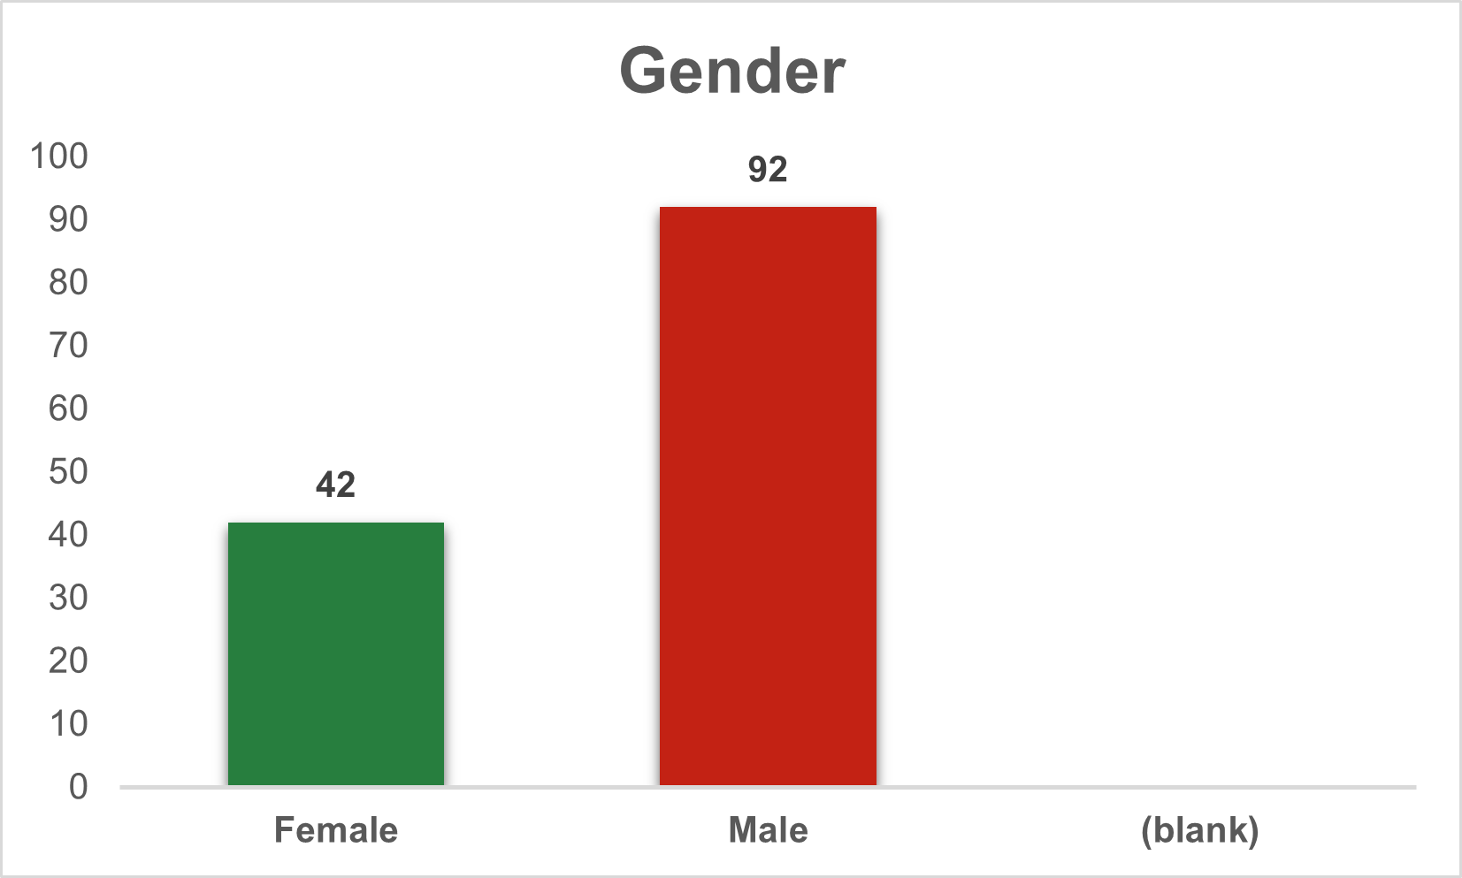

The data table presents a breakdown of gender distribution among 135 individuals. Out of the total count, 93 individuals identify as male, constituting the majority, while 42 individuals identify as female. Additionally, there are no entries left blank, ensuring a comprehensive representation of the gender distribution in the dataset.

|  |  |
| --- | --- |
| **Row Labels** | **Count of Age** |
| 20-25 | 93 |
| 25-30 | 20 |
| 30-35 | 12 |
| 35 above | 10 |
| **Grand Total** | **135** |

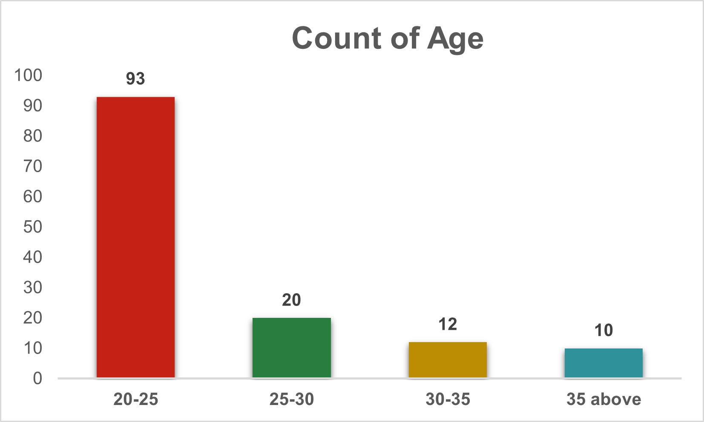

Among the respondents, a significant proportion falls within the 20-25 age range, constituting 93 individuals. There are 20 respondents aged between 25 and 30, 12 respondents aged between 30 and 35, and 10 respondents aged 35 and above. This distribution provides a demographic overview of the age groups within the surveyed population.

|  |  |
| --- | --- |
| **Row Labels** | **Count of CRM_Familiarity** |
| Neutral | 22 |
| Not very familiar | 5 |
| Somewhat familiar | 48 |
| Very familiar | 60 |
| **Grand Total** | **135** |

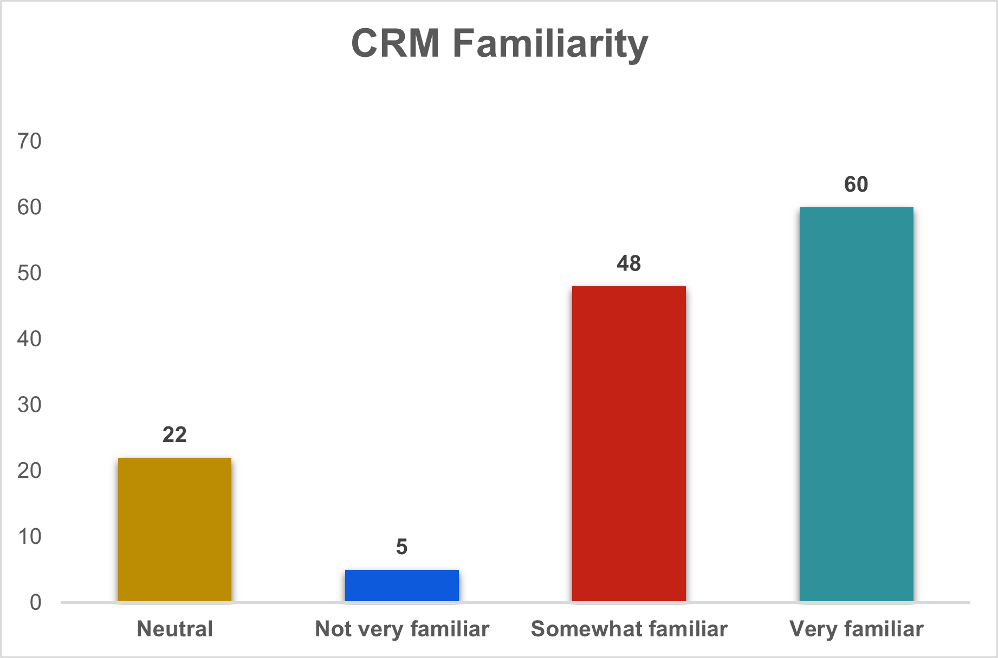

The respondents' familiarity with Customer Relationship Management (CRM) varies across different levels. A considerable number, 60 respondents, claim to be very familiar with CRM, while 48 respondents express a somewhat familiar stance. Additionally, 22 respondents hold a neutral position regarding CRM familiarity, and a smaller group of 5 respondents indicate that they are not very familiar with CRM. This distribution provides insights into the spectrum of CRM familiarity among the surveyed participants.

|  |  |
| --- | --- |
| **Row Labels** | **Count of Exposure_CRM** |
| No | 51 |
| Yes | 84 |
| **Grand Total** | **135** |

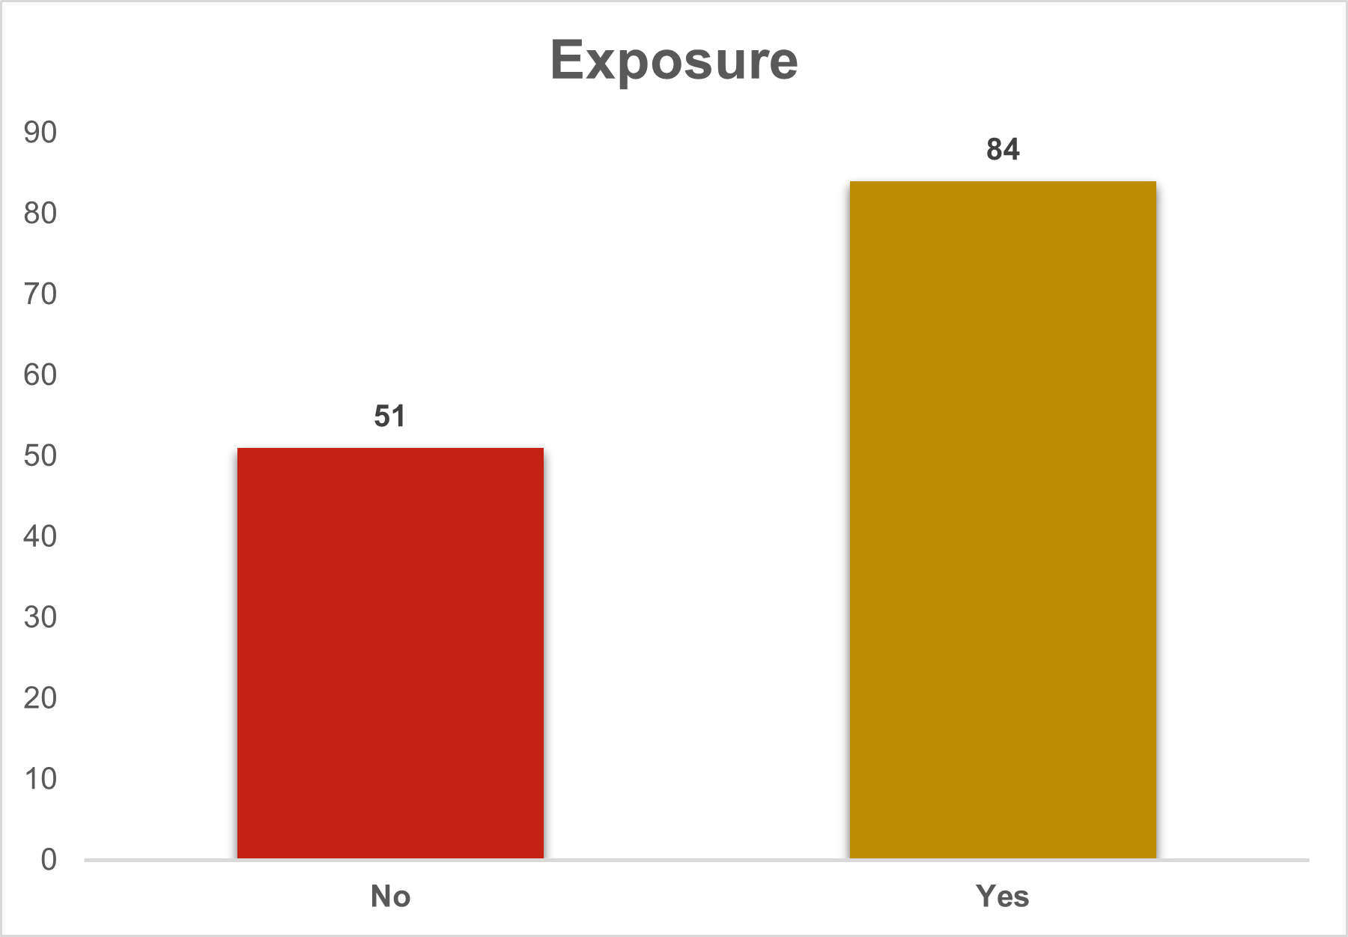

Regarding exposure to Customer Relationship Management (CRM), a majority of the respondents, 84 in total, have affirmed their exposure to CRM. On the other hand, 51 respondents indicate that they have not been exposed to CRM. This distinction in exposure levels among the surveyed participants provides a basis for understanding the prevalence of CRM awareness and utilization within the surveyed population.

|  |  |
| --- | --- |
| **Row Labels** | **Count of Customer_loyalty** |
| Agree | 53 |
| Neutral | 29 |
| Strongly agree | 53 |
| **Grand Total** | **135** |

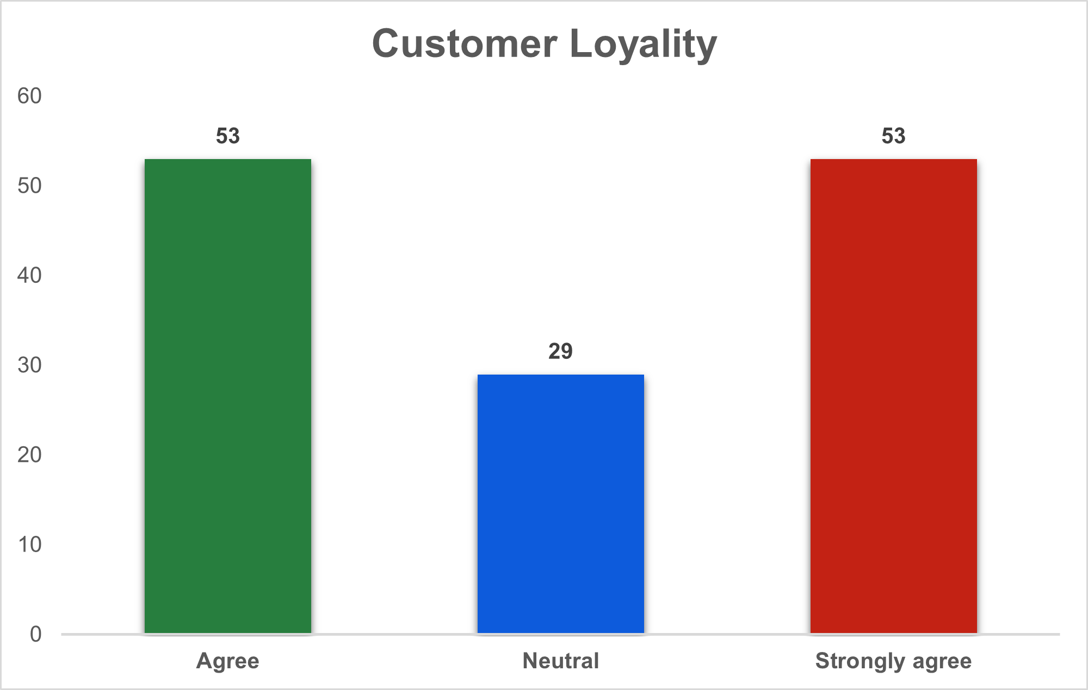

Looking at the responses related to customer loyalty, the survey indicates that 53 respondents agree, 29 express a neutral stance, and another 53 strongly agree. These responses offer insights into the prevailing sentiments regarding customer loyalty within the surveyed population. The distribution of opinions across these categories lays the groundwork for a more in-depth analysis of the factors influencing customer loyalty and its perceived significance among the respondents.

|  |  |
| --- | --- |
| **Row Labels** | **Count of Loyalty_CRM** |
| Likely | 55 |
| Neutral | 22 |
| Very likely | 58 |
| **Grand Total** | **135** |

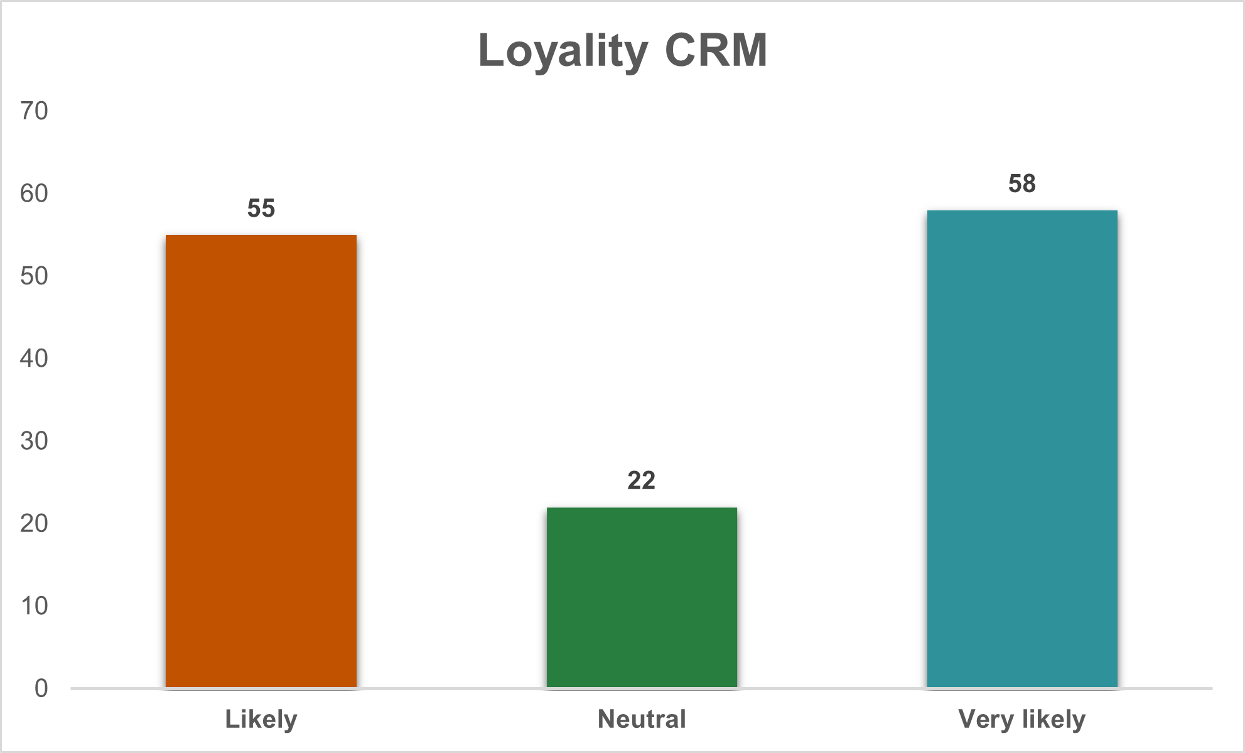

Examining the responses to the question about loyalty to CRM, the data reveals that 55 respondents find themselves likely to be loyal, 22 express a neutral stance, and 58 state that they are very likely to be loyal. These insights shed light on the level of commitment and dedication the respondents feel towards CRM. The variations in responses provide a nuanced understanding of the factors contributing to loyalty and how organizations can leverage CRM effectively to foster stronger connections with their audience.

|  |  |
| --- | --- |
| **Row Labels** | **Count of Most_appealing_CRM** |
| Customized communication | 11 |
| Exclusive discounts | 36 |
| Personalized recommendations | 77 |
| Tailored content | 11 |
| **Grand Total** | **135** |

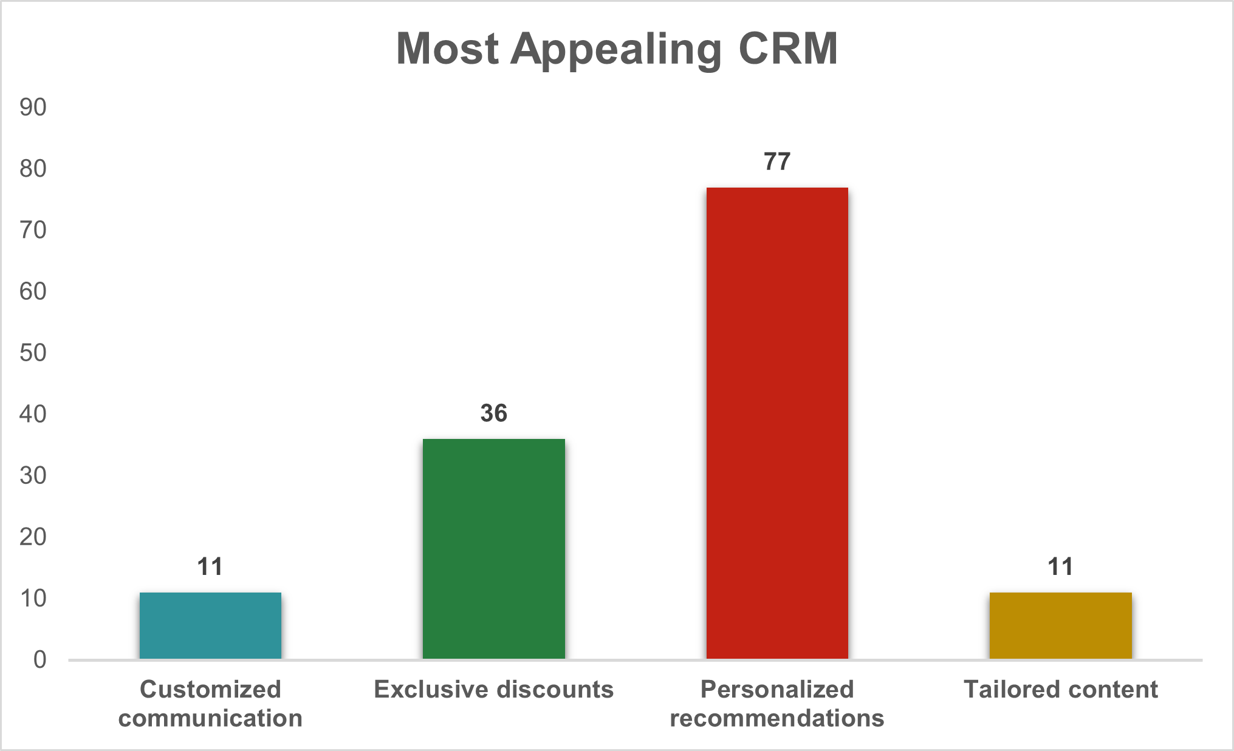

Analyzing the responses regarding the most appealing aspects of CRM, it is evident that respondents have diverse preferences. The majority, with 77 responses, find personalized recommendations to be the most appealing feature. Exclusive discounts also garnered substantial interest with 36 respondents. On the other hand, customized communication and tailored content were less popular, each receiving 11 responses. This diversity in preferences underscores the importance of a multifaceted approach in CRM strategies to cater to varied customer expectations and enhance overall satisfaction.

|  |  |
| --- | --- |
| **Row Labels** | **Count of Companies_obtain_info** |
| Based on my purchase history | 35 |
| Explicitly provided by me | 66 |
| Social media activity | 23 |
| Website browsing behavior | 11 |
| **Grand Total** | **135** |

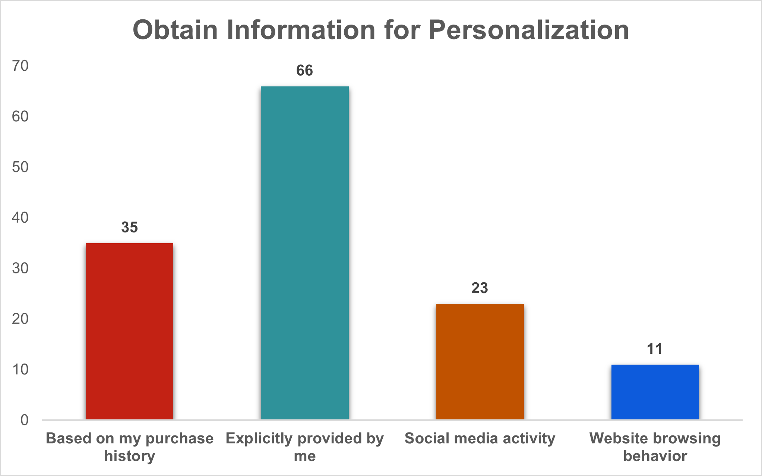

Examining the sources from which companies obtain information, respondents provided insights into their interaction with businesses. The data reveals that 66 respondents explicitly provide information, indicating a willingness to engage actively with companies. Purchase history is another significant source, with 35 respondents stating that companies obtain information based on their previous purchases. Social media activity and website browsing behavior are relatively lower contributors, with 23 and 11 responses, respectively. This breakdown highlights the importance of customers willingly sharing information and the value of leveraging purchase history for companies aiming to personalize their services effectively.

|  |  |
| --- | --- |
| **Row Labels** | **Count of Channels** |
| All of the above | 35 |
| Email | 40 |
| Inapp notifications | 6 |
| SMS | 12 |
| Social media | 42 |
| **Grand Total** | **135** |

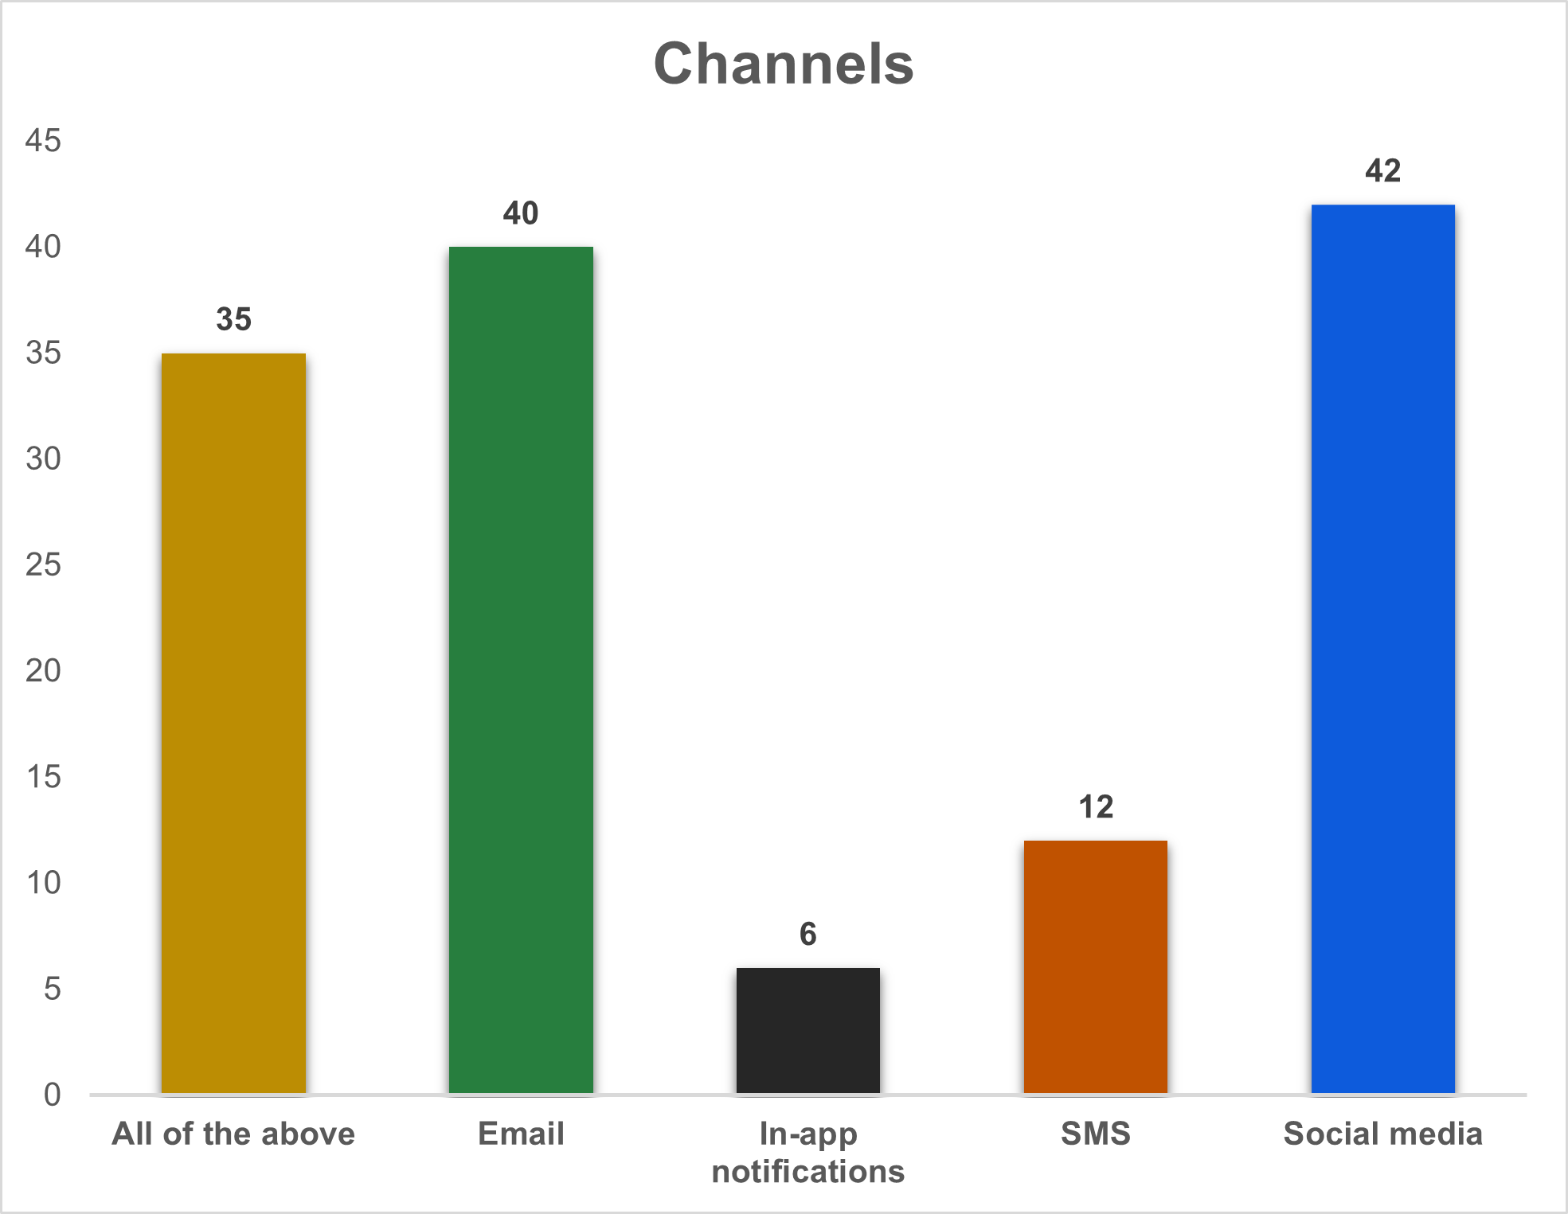

Examining the preferred communication channels indicated by respondents, it is evident that they utilize various avenues to interact with companies. A notable portion of respondents, 35 in total, expressed a preference for utilizing all available channels. Email and social media emerge as popular choices, with 40 and 42 respondents favoring these communication modes, respectively. In-app notifications and SMS are utilized by a smaller subset of respondents, with 6 and 12 indicating a preference for these channels. This diverse distribution emphasizes the need for companies to adopt a multi-channel approach to effectively reach and engage their customer base.

|  |  |
| --- | --- |
| **Row Labels** | **Count of Frequency** |
| Daily | 29 |
| Monthly | 24 |
| Occasionally | 34 |
| Rarely | 12 |
| Weekly | 36 |
| **Grand Total** | **135** |

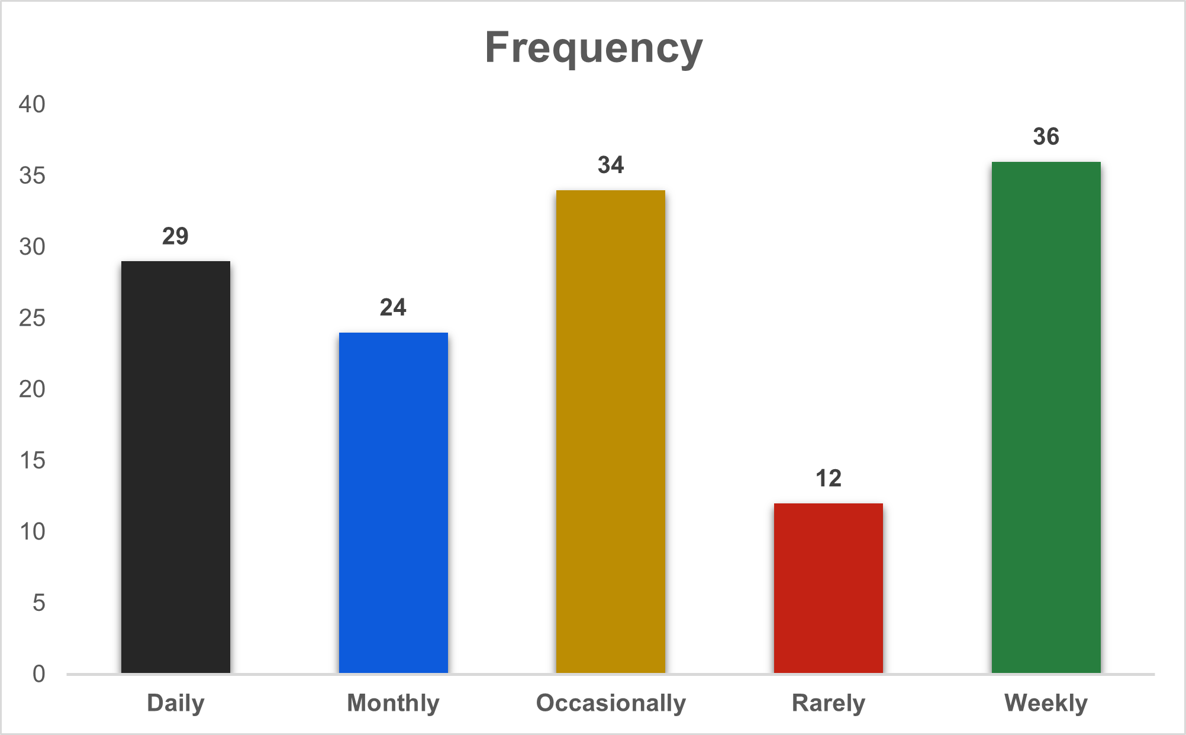

Analyzing the frequency of customer interactions with companies, the data reveals a varied pattern. A substantial portion of respondents, 36 in total, engages with companies on a weekly basis. Daily interactions are also prevalent, with 29 respondents indicating frequent engagement. Monthly interactions are reported by 24 respondents, while occasional interactions are noted by 34. A smaller subset of respondents, 12 in total, engages rarely. This diverse frequency distribution underscores the dynamic nature of customer-company interactions, necessitating adaptable and responsive communication strategies. Companies should tailor their approaches to accommodate the varied interaction frequencies exhibited by their customer base.

|  |  |
| --- | --- |
| **Row Labels** | **Count of Privacy_concern** |
| Concerned | 46 |
| Neutral | 29 |
| Not very concerned | 6 |
| Very concerned | 54 |
| **Grand Total** | **135** |

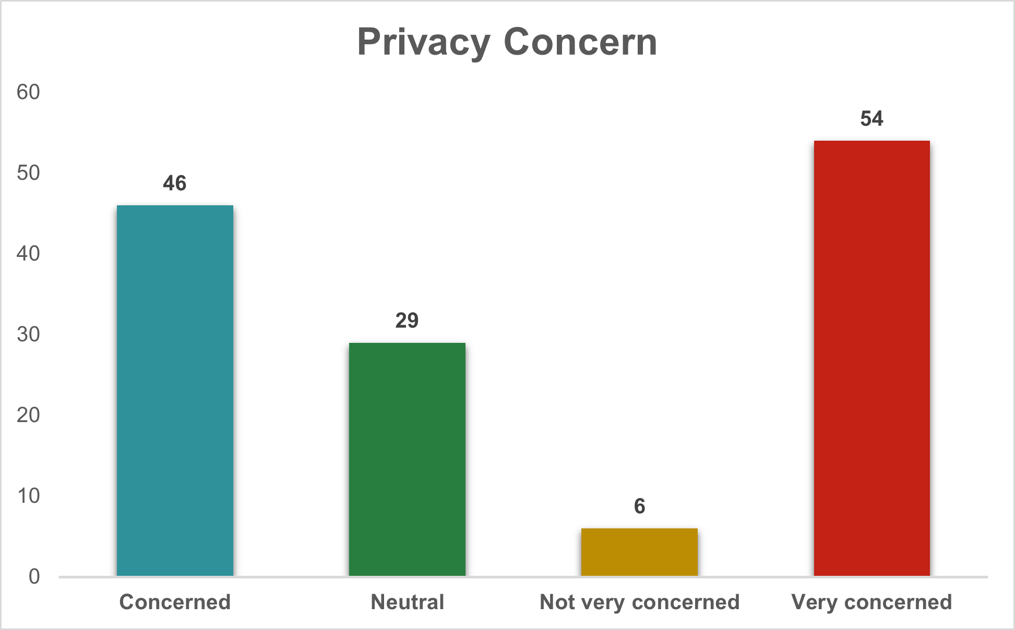

Examining the respondents' attitudes towards privacy concerns in the context of customer relationship management (CRM), the data provides insights into their perspectives. A considerable number of respondents, 54 in total, express a high level of concern about privacy in the context of CRM. Additionally, 46 respondents indicate a general level of concern, while 29 express a neutral stance. A smaller subset of respondents, comprising 6 individuals, reports being not very concerned about privacy in CRM. These findings emphasize the significance of addressing and mitigating privacy concerns in CRM strategies to foster customer trust and satisfaction. Companies need to be mindful of privacy issues and implement transparent practices to reassure customers and ensure the ethical use of their data.

|  |  |
| --- | --- |
| **Row Labels** | **Count of data_trust** |
| Completely trust | 24 |
| Do not trust very much | 22 |
| Neutral | 29 |
| Trust to some extent | 60 |
| **Grand Total** | **135** |

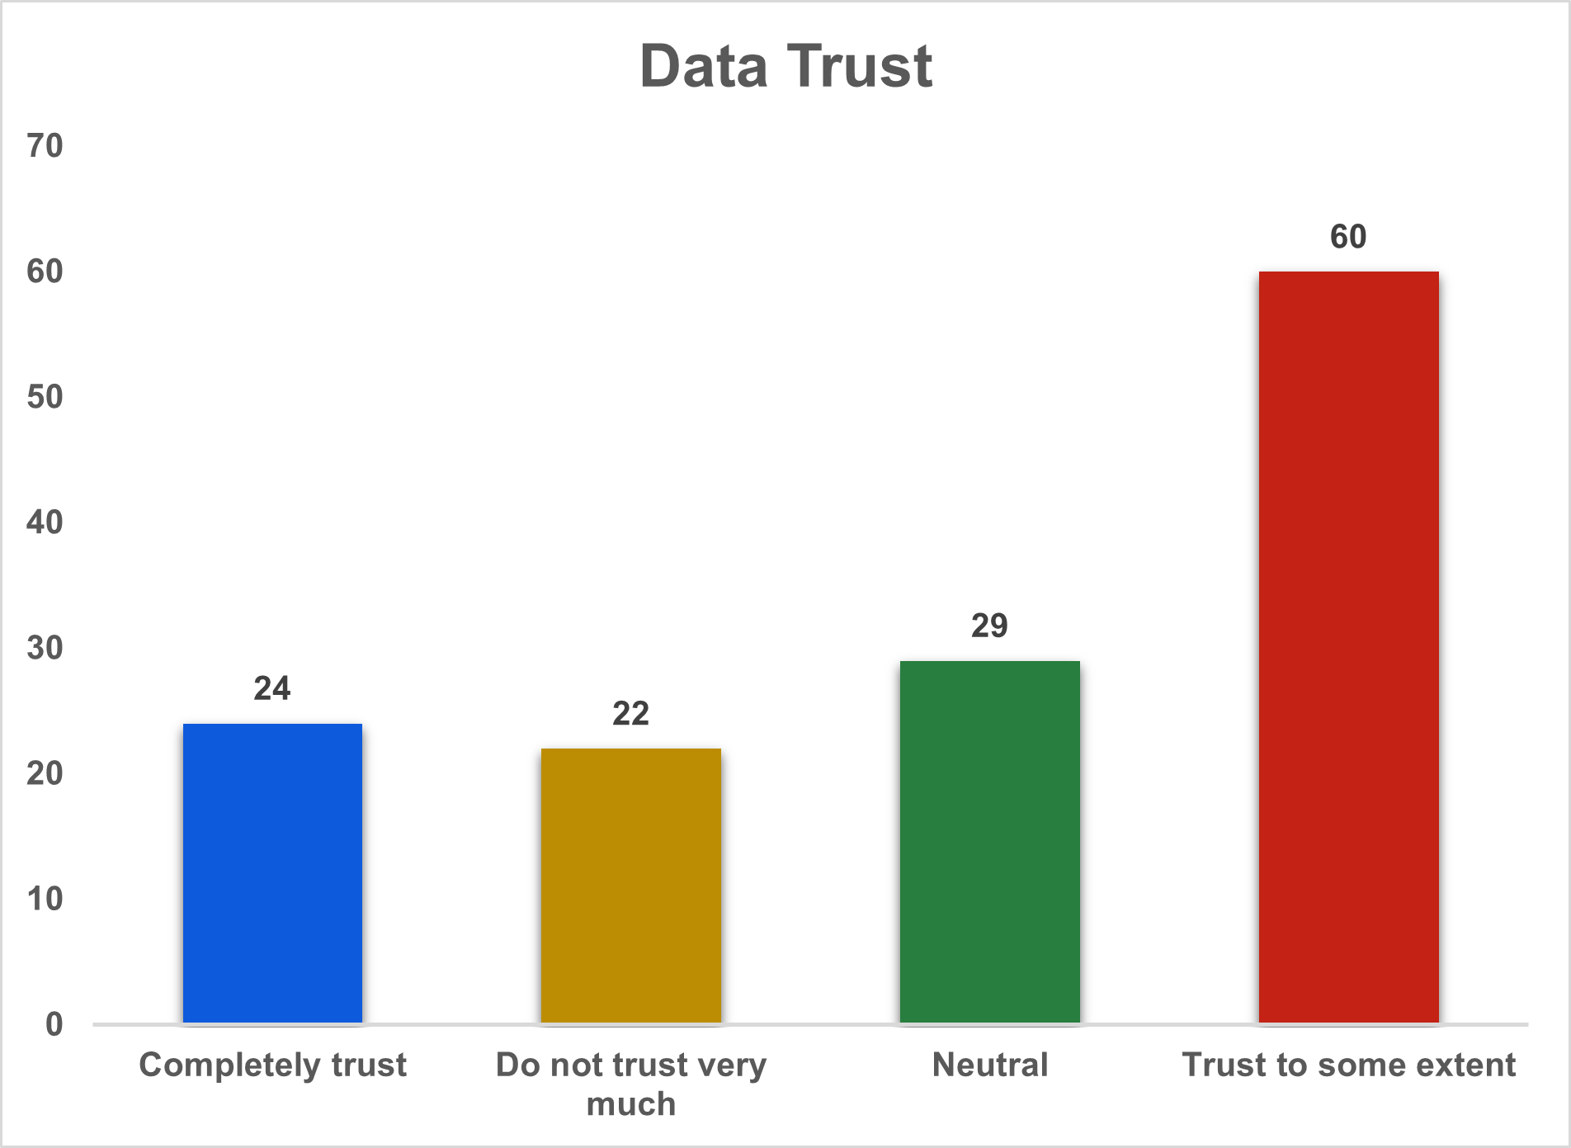

Analyzing the responses regarding data trust in the context of customer relationship management (CRM), the data reveals diverse perspectives among the respondents. A significant portion, accounting for 60 respondents, expresses trust to some extent in how their data is handled in CRM systems. Meanwhile, 24 respondents report having complete trust, indicating a relatively positive perception. On the other hand, 22 respondents admit to not trusting very much, reflecting a cautious stance towards data handling in CRM. Additionally, 29 respondents maintain a neutral position on the matter. These varying levels of trust highlight the importance of transparent communication and ethical practices in CRM to build and maintain customer confidence in data management. Companies should focus on fostering trust through clear policies and secure data handling practices.

|  |  |
| --- | --- |
| **Row Labels** | **Count of Feedback** |
| Likely | 54 |
| Neutral | 28 |
| Unlikely | 12 |
| Very likely | 41 |
| **Grand Total** | **135** |

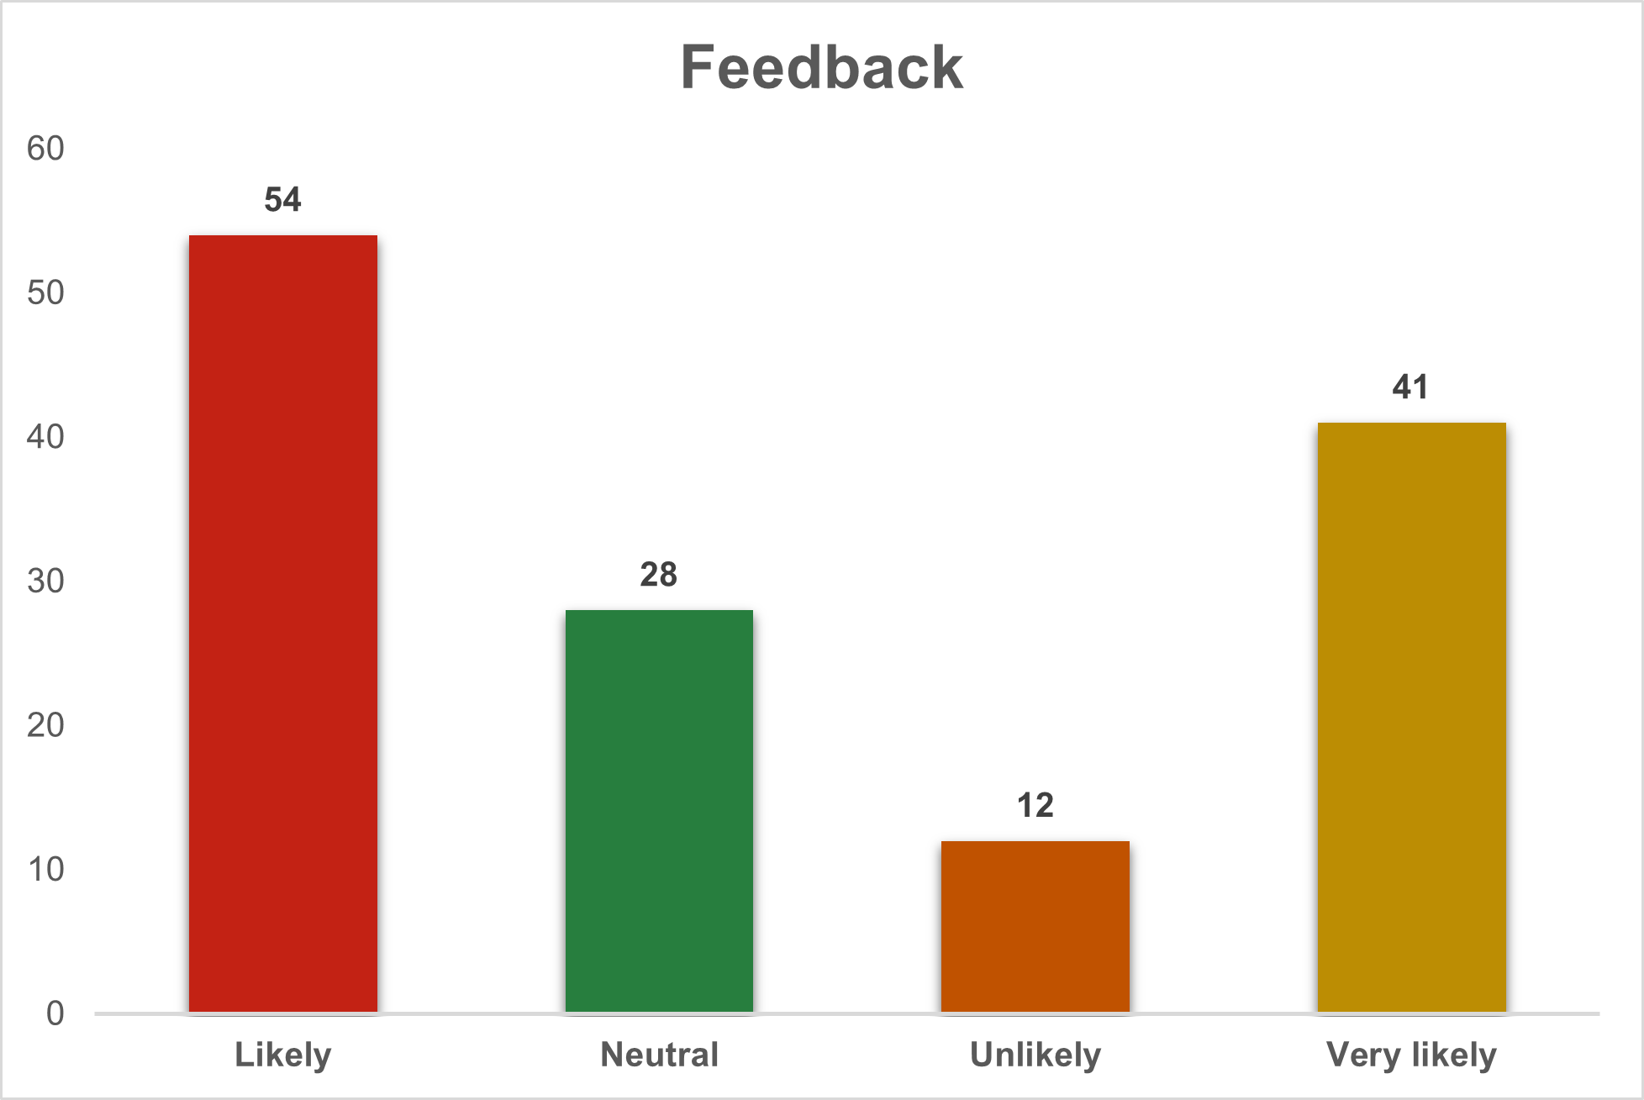

Analyzing the responses regarding the likelihood of providing feedback in the context of customer relationship management (CRM), the data reveals diverse perspectives among the respondents. A significant portion, accounting for 54 respondents, expresses a likelihood of providing feedback, indicating a positive inclination towards engagement. Meanwhile, 41 respondents report being very likely to provide feedback, reflecting a strong willingness to actively participate in the feedback process. On the other hand, 28 respondents maintain a neutral position on the likelihood of providing feedback. Additionally, 12 respondents express an unlikely stance. These varying attitudes highlight the need for businesses to encourage and facilitate feedback mechanisms in CRM strategies. Enhancing user-friendly platforms and offering incentives can further boost the likelihood of customers actively engaging in providing valuable feedback.

|  |  |
| --- | --- |
| **Row Labels** | **Count of CRM_Influence_on_Loyalty** |
| No | 30 |
| Not sure | 17 |
| Yes | 88 |
| **Grand Total** | **135** |

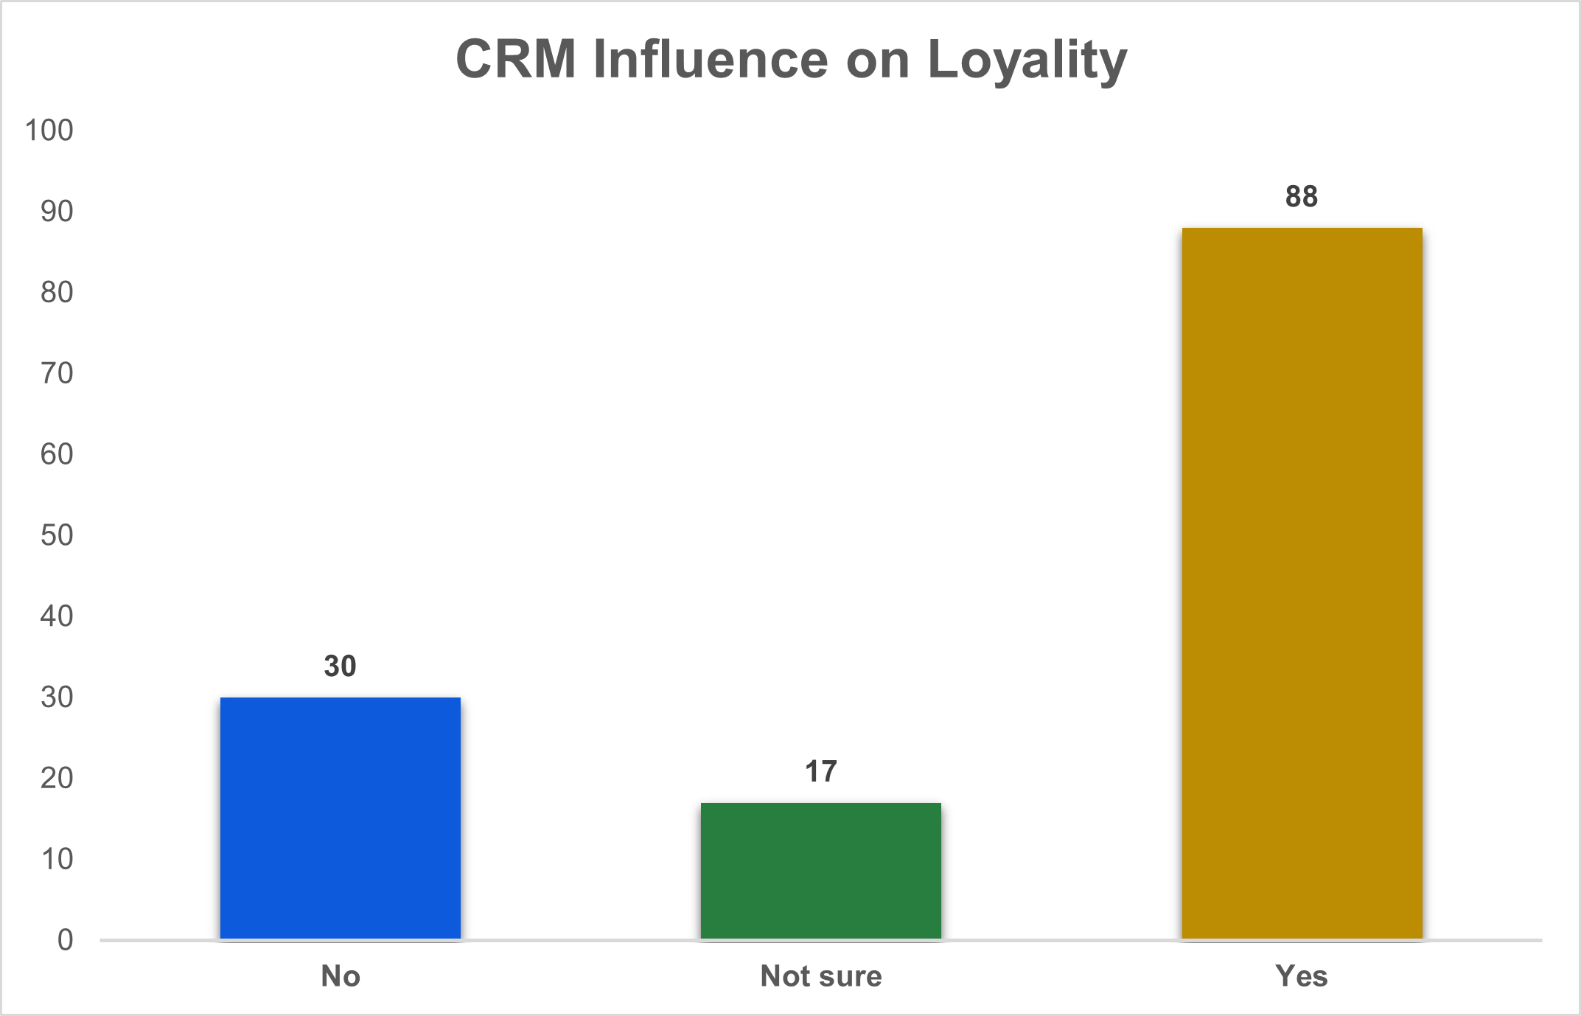

Exploring the influence of Customer Relationship Management (CRM) on customer loyalty, the responses are insightful. A significant majority, with 88 respondents, affirm that CRM has a positive impact on loyalty. This suggests that businesses implementing effective CRM strategies are more likely to foster loyalty among their customers. On the contrary, 30 respondents indicate a perception that CRM has no noticeable influence on loyalty, while 17 respondents express uncertainty regarding this relationship. The affirmative responses highlight the potential of CRM not only as a tool for managing customer relationships but also as a key driver in cultivating customer loyalty. Understanding and leveraging the positive connection between CRM initiatives and customer loyalty can contribute significantly to the overall success and growth of businesses.

|  |  |
| --- | --- |
| **Row Labels** | **Count of CRM_Comparison** |
| Better | *53* |
| Much better | *47* |
| Similar | *35* |
| Grand Total | *135* |

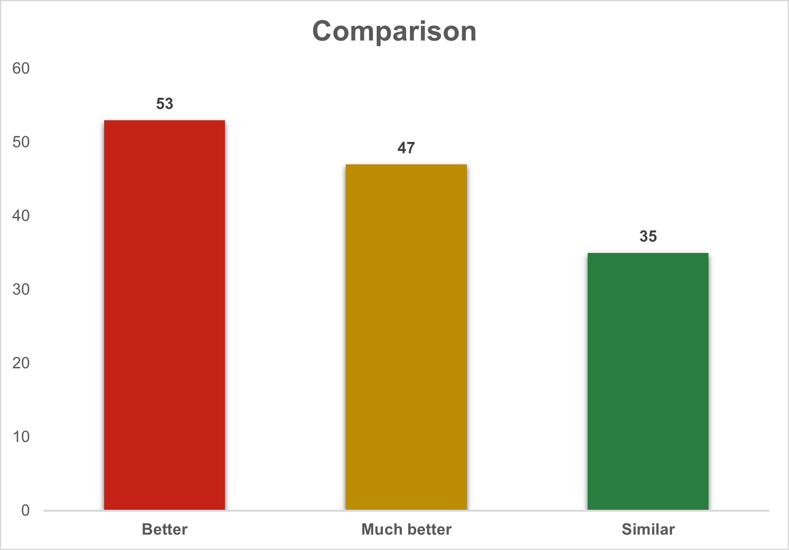

Examining respondents' perceptions regarding CRM, a substantial number (53 respondents) believe that their current CRM system is better. Another significant segment (47 respondents) expresses an even more positive sentiment, considering their CRM system to be "much better." On the contrary, 35 respondents find their CRM system to be similar to alternatives in the market. This distribution of responses suggests that a majority of the respondents feel content or even delighted with their existing CRM solutions. These positive sentiments toward CRM systems indicate their perceived effectiveness and alignment with the needs and expectations of the users. It also emphasizes the importance for businesses to continuously enhance and tailor their CRM systems to meet evolving requirements and maintain high levels of user satisfaction.

|  |  |
| --- | --- |
| **Row Labels** | **Count of Future_scope** |
| Less personalized experiences | 6 |
| More personalized experiences | 70 |
| Not sure | 11 |
| Same level of personalization | 48 |
| **Grand Total** | **135** |

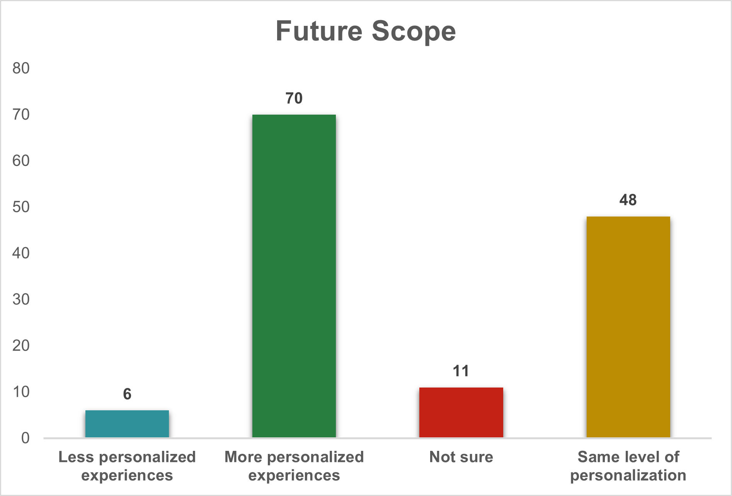

Analyzing respondents' perspectives on the future scope of CRM, a significant majority (70 respondents) foresee more personalized experiences. This inclination toward increased personalization aligns with the growing emphasis on tailored and customized interactions in the business landscape. Conversely, only a small portion (6 respondents) envisions less personalized experiences, indicating a prevailing expectation for enhanced personalization in the future. Additionally, 48 respondents anticipate the continuation of the current level of personalization, reflecting a sense of satisfaction or acceptance with the present state. Meanwhile, 11 respondents express uncertainty about the future trajectory of personalization in CRM. This diversity of opinions highlights the dynamic nature of CRM expectations and the importance of adapting strategies to cater to varying preferences within the user base.

**Chapter 5**

**SUMMARY OF FINDINGS, CONCLUSION AND SUGGESTIONS**

**5.1 SUMMARY OF FINDINGS**

1. Increased Engagement through Personalized CRM:

Personalized CRM approaches in specialized industrial sectors enhance customer engagement.

Tailored strategies, individualized communication, and personalized experiences foster active participation compared to traditional methods.

2. Positive Brand Recall and Customer Loyalty:

Personalized CRM strategies contribute to improved brand recall and heightened customer loyalty.

Customized experiences lead to better brand recognition, fostering stronger and lasting relationships with customers.

3. Tailored Strategies for Specific Audience Segments:

The effectiveness of personalized CRM approaches varies across different audience segments within specialized industries.

Tailoring CRM strategies to the specific preferences and needs of industrial professionals or decision-makers yields substantial engagement and loyalty.

4. Technology Integration Impact:

Integrating advanced technologies into personalized CRM approaches positively impacts engagement and customer loyalty.

Innovative technological integration enhances the immersive nature of personalized campaigns, potentially amplifying effectiveness.

5. Challenges in Measurement and Long-term Impact:

Challenges exist in accurately measuring the long-term impact of personalized CRM on customer loyalty.

Quantifying sustained customer loyalty beyond immediate engagement poses complexities.

6. Ethical Considerations in Personalized CRM:

Addressing ethical considerations in personalized CRM, such as responsible data usage, transparency, and compliance with privacy regulations, is crucial.

Assumption that stood correct:

1. Personalized CRM Approaches and Customer Loyalty:

Positive support for the relationship between personalized CRM approaches and customer loyalty.

2. Moderating Effect of Technology Integration:

Moderation hypothesis: Technology integration into personalized CRM approaches positively moderates the relationship with customer loyalty.

3. Moderating Effect of CRM Reward Systems:

Hypothesis: CRM reward systems positively moderate the impact of personalized CRM approaches on customer loyalty.

4. Company Performance:

Customer loyalty significantly and positively impacts the overall performance of Sri Vishnu Associates.

Mediation Analysis:

Customer loyalty acts as a mediator between personalized CRM approaches and overall company performance, significantly improving the model's explanatory power.

The model explains a high degree of customer loyalty, indicating the strong predictive power of personalized CRM approaches.

Technology integration and CRM reward systems play crucial roles in moderating and enhancing the impact of personalized CRM on customer loyalty.

Customer loyalty emerges as a crucial mediator of the personalized CRM approaches-company performance link.

**Suggestions to the company**

1. Enhance Shree Vishnu Associates' Customized Communication:

Elevating Shree Vishnu Associates' customized communication strategy is paramount for fostering stronger connections with customers. By investing in advanced CRM tools and analytics, Shree Vishnu Associates can delve deeper into individual preferences, behaviors, and feedback. Implementing dynamic and personalized communication plans, such as targeted email campaigns or in-app notifications, ensures that each interaction resonates with customers on a personal level. This approach not only enhances customer satisfaction but also cultivates a sense of brand loyalty as Shree Vishnu Associates' customers feel understood and valued. The incorporation of machine learning algorithms can further refine these communication strategies, ensuring they adapt and evolve with the changing dynamics of customer preferences.

2. Leverage Exclusive Discounts for Shree Vishnu Associates:

To fortify customer loyalty for Shree Vishnu Associates, the company should strategically employ exclusive discounts and promotions. This involves a meticulous analysis of customer purchase histories, preferences, and engagement patterns. By leveraging CRM data, Shree Vishnu Associates can identify optimal times, channels, and discount structures that resonate most effectively with different customer segments. Crafting personalized discount programs not only encourages repeat purchases but also establishes a competitive edge in the market. Integrating these exclusive offerings seamlessly into the customer journey, such as through personalized promotions based on app usage or tailored discounts linked to specific products of interest, can significantly enhance the perceived value of the Shree Vishnu Associates brand.

3. Invest in Personalized Recommendations for Shree Vishnu Associates:

Elevating the customer experience for Shree Vishnu Associates to new heights involves a strategic investment in sophisticated recommendation systems. By harnessing the power of artificial intelligence and machine learning, Shree Vishnu Associates can analyze vast datasets to predict customer preferences accurately. This entails understanding the intricacies of individual buying behavior, preferences, and demographic data. The integration of these technologies into Shree Vishnu Associates' CRM framework empowers the creation of personalized shopping experiences. Tailored product recommendations, prominently featured on digital platforms, can significantly influence purchase decisions and cultivate a sense of anticipation and excitement among customers, thereby driving brand loyalty.

4. Tailor Content Effectively for Shree Vishnu Associates:

Effectively tailoring content delivery for Shree Vishnu Associates requires a comprehensive understanding of customer preferences, content consumption habits, and the impact of diverse content types. The company should invest in CRM-driven content personalization strategies that transcend traditional marketing approaches. This involves analyzing customer interactions with different content formats, such as videos, articles, or social media posts. By identifying the content types that resonate most with specific customer segments, Shree Vishnu Associates can curate more engaging and personalized content journeys. Incorporating interactive elements and multimedia formats can further enhance the overall customer experience, fostering a deeper connection between the Shree Vishnu Associates brand and its audience.

5. Diversify Information Channels for Shree Vishnu Associates:

Broadening information channels is pivotal for Shree Vishnu Associates to reach a diverse audience and maximize the impact of CRM-driven initiatives. The company should strategically expand its presence across various communication channels, including social media platforms, email marketing, and in-app notifications. Leveraging CRM insights, Shree Vishnu Associates can tailor content for each channel based on user preferences and behavior. For instance, social media channels may focus on visually appealing content, while email newsletters from Shree Vishnu Associates may provide in-depth product insights. Ensuring consistency and coherence across these channels while adapting the message to suit the unique characteristics of each platform will amplify Shree Vishnu Associates' visibility and engagement levels.

6. Prioritize Customer Data Security at Shree Vishnu Associates:

Upholding the highest standards of customer data security is imperative for Shree Vishnu Associates to foster trust and confidence. Implementing robust encryption protocols, access controls, and regular security audits safeguard sensitive customer information. Emphasizing transparency in data handling practices and ensuring compliance with data protection regulations strengthens Shree Vishnu Associates' reputation. Communicating the company's commitment to data security through personalized messages, such as privacy policy updates or security feature highlights, reassures customers. Elevating data security measures not only mitigates risks but also cultivates a sense of reliability and dependability, crucial for sustaining long-term customer relationships.

7. Integrate Customer Feedback Loops for Continuous Improvement at Shree Vishnu Associates:

Establishing dynamic feedback loops within Shree Vishnu Associates' CRM framework is pivotal for continuous improvement. By actively seeking customer opinions on products, services, and overall experiences, the company can gather valuable insights. Integrating automated feedback mechanisms into various touchpoints, such as post-purchase surveys or in-app feedback forms, ensures a constant influx of customer perspectives. Shree Vishnu Associates can leverage sentiment analysis tools within the CRM system to discern patterns and sentiments. Regularly analyzing feedback allows the company to identify areas for enhancement, refine strategies, and promptly address any concerns, showcasing a commitment to customer-centricity and responsiveness.

8. Enhance Shree Vishnu Associates' Loyalty Programs:

Strengthening loyalty programs is instrumental for Shree Vishnu Associates to incentivize repeat business and brand advocacy. By integrating CRM insights, the company can tailor loyalty programs to individual preferences, purchase histories, and engagement levels. Offering personalized rewards, exclusive perks, or tiered loyalty structures based on customer behavior fosters a sense of exclusivity. Shree Vishnu Associates can utilize predictive analytics to anticipate customer preferences and proactively offer relevant incentives. Ensuring seamless integration of loyalty programs across various customer touchpoints, including mobile apps and online platforms, maximizes their impact and encourages sustained brand loyalty.

9. Implement AI-Powered Chat Support for Shree Vishnu Associates:

Revolutionizing customer support at Shree Vishnu Associates involves integrating AI-powered chatbots within the CRM ecosystem. These intelligent chatbots, fueled by natural language processing, can provide instant and personalized assistance. Shree Vishnu Associates can employ these chatbots for order inquiries, product recommendations, and issue resolution. By leveraging CRM data, the chatbots can comprehend individual customer histories and preferences, delivering more accurate and relevant responses. Implementing this technology not only enhances the efficiency of customer support but also provides a seamless and personalized interaction channel, contributing to overall customer satisfaction and loyalty.

10. Optimize Shree Vishnu Associates' Mobile App Experience:

Maximizing the potential of Shree Vishnu Associates' mobile app requires a meticulous focus on user experience and personalization. By integrating CRM data into the app interface, the company can offer personalized product recommendations, targeted promotions, and streamlined navigation. Utilizing location-based services within the app enables Shree Vishnu Associates to deliver location-specific offers and enhance in-store experiences. Continuous monitoring of app usage patterns through CRM analytics allows the company to adapt and optimize the app's features based on evolving customer preferences. Ensuring a seamless, intuitive, and personalized mobile app experience contributes significantly to customer satisfaction and engagement.

11. Craft Hyper-Personalized Email Campaigns for Shree Vishnu Associates:

Elevate Shree Vishnu Associates' email marketing strategy by deploying hyper-personalized campaigns. Leverage CRM insights to segment the customer base and tailor email content based on preferences, purchase history, and engagement levels. Implement dynamic content elements to ensure each email resonates with the individual recipient. By delivering personalized product recommendations, exclusive offers, and relevant content, Shree Vishnu Associates can significantly enhance email engagement. A/B testing different personalization strategies allows the company to refine its approach, optimizing open rates, click-through rates, and overall campaign effectiveness. Ensuring that each email provides tangible value to the recipient fosters a sense of individual attention and strengthens customer loyalty.

12. Empower Shree Vishnu Associates' Sales Team with CRM Analytics:

Transform the sales approach at Shree Vishnu Associates by empowering the sales team with CRM analytics. Provide comprehensive training on utilizing CRM insights to understand customer behaviors, preferences, and purchase patterns. By integrating CRM data into the sales process, the team can engage in more informed and personalized interactions with clients. Utilize predictive analytics to anticipate customer needs, enabling proactive sales strategies. Shree Vishnu Associates can establish key performance indicators (KPIs) within the CRM system to track sales team effectiveness and identify areas for improvement. This data-driven sales approach not only enhances efficiency but also strengthens customer relationships through personalized consultations.

13. Implement Social Media Listening Strategies for Shree Vishnu Associates:

Enhance Shree Vishnu Associates' social media presence by implementing robust social media listening strategies within the CRM framework. Utilize CRM tools to monitor brand mentions, customer sentiments, and industry trends across social platforms. By actively engaging with customers through comments, messages, and social interactions, the company can build a more personalized and responsive online presence. Leverage CRM analytics to identify influencers and brand advocates within the social media sphere. Shree Vishnu Associates can incorporate customer feedback from social channels into product development and marketing strategies, showcasing a commitment to listening and adapting based on customer input.

14. Initiate Personalized In-Store Experiences at Shree Vishnu Associates:

Elevate the in-store shopping experience at Shree Vishnu Associates by implementing personalized initiatives. Integrate CRM data into the in-store environment to offer tailored product recommendations, promotions, and loyalty rewards. Equip in-store staff with mobile CRM tools to access customer profiles and preferences, enabling more personalized interactions. Implement beacon technology or geolocation services to deliver real-time, location-specific offers to customers within the store. By creating a seamless connection between online and offline experiences, Shree Vishnu Associates can enhance customer satisfaction, encourage cross-channel engagement, and differentiate itself in the competitive retail landscape.

15. Establish Shree Vishnu Associates as an Industry Thought Leader:

Position Shree Vishnu Associates as an industry thought leader by leveraging CRM-driven content strategies. Develop and share valuable industry insights, trends, and expert perspectives through various channels, including blogs, webinars, and whitepapers. Utilize CRM analytics to understand customer interests and preferences, tailoring content to align with their needs. Engage in collaborative initiatives with industry influencers and thought leaders to enhance credibility. By consistently delivering high-quality, informative content, Shree Vishnu Associates can establish itself as a go-to resource in the industry. This thought leadership contributes to brand authority, customer trust, and overall market influence.

16. Optimize Shree Vishnu Associates' Loyalty Program with CRM Insights:

Revolutionize the loyalty program at Shree Vishnu Associates by leveraging CRM insights to tailor rewards and incentives. Analyze customer purchase history, preferences, and engagement levels to design personalized loyalty tiers and benefits. Implement a points system that aligns with individual customer behaviors, encouraging continued engagement and repeat business. Utilize CRM analytics to track the effectiveness of the loyalty program, adjusting offerings based on customer response. Incorporate exclusive access to new products, personalized discounts, and early sales previews to enhance the perceived value of the loyalty program. By aligning incentives with individual customer preferences, Shree Vishnu Associates can maximize the impact of its loyalty initiatives.

17. Enhance Shree Vishnu Associates' Product Recommendations Engine:

Elevate the customer shopping experience at Shree Vishnu Associates by refining and expanding the product recommendations engine within the CRM system. Utilize machine learning algorithms to analyze customer behaviors, purchase patterns, and preferences. Implement dynamic recommendation algorithms that provide real-time, personalized product suggestions across various touchpoints, including the website, emails, and mobile apps. Continuously optimize the recommendation engine based on customer feedback and evolving preferences. Shree Vishnu Associates can leverage CRM analytics to assess the effectiveness of product recommendations in driving conversions and customer satisfaction. This personalized approach enhances the customer journey and encourages exploration of additional products.

18. Implement Automated Customer Journey Workflows for Shree Vishnu Associates:

Streamline and personalize the customer journey at Shree Vishnu Associates by implementing automated workflows within the CRM system. Map out customer touchpoints, from initial awareness to post-purchase engagement, and design tailored workflows that guide customers seamlessly through each stage. Utilize CRM analytics to identify key triggers for automated communications, such as personalized onboarding emails, order confirmations, and post-purchase follow-ups. Implement dynamic content elements that adapt to customer behaviors and preferences. Shree Vishnu Associates can monitor and analyze the performance of these automated workflows, ensuring they align with individual customer needs and contribute to a positive overall experience.

19. Integrate Customer Feedback Loops for Continuous Improvement:

Foster a culture of continuous improvement at Shree Vishnu Associates by integrating customer feedback loops within the CRM framework. Implement automated surveys, feedback forms, and sentiment analysis tools to gather insights from customers at various touchpoints. Utilize CRM analytics to categorize and prioritize feedback based on themes, sentiments, and urgency. Shree Vishnu Associates can establish a systematic process for addressing customer concerns and suggestions, showcasing responsiveness and commitment to customer satisfaction. Regularly communicate updates and improvements driven by customer feedback, reinforcing the company's dedication to delivering an exceptional customer experience.

20. Diversify Shree Vishnu Associates' Personalization Strategies:

Expand the personalization strategies at Shree Vishnu Associates by diversifying approaches beyond traditional channels. Explore new avenues for personalization, such as personalized packaging, limited-edition products, or personalized video messages. Leverage CRM data to identify innovative ways to surprise and delight customers, enhancing brand loyalty. Implement targeted personalization during special occasions, milestones, or seasonal events. Shree Vishnu Associates can experiment with personalized promotions and exclusive access to further strengthen the emotional connection with customers. By embracing creative and unexpected personalization tactics, the company can differentiate itself in the market and create memorable customer experiences.

21. Empower Shree Vishnu Associates' Customer Support with CRM Insights:

Bolster the effectiveness of Shree Vishnu Associates' customer support by integrating CRM insights into service interactions. Implement a unified customer service platform that provides agents with a comprehensive view of customer profiles, purchase history, and preferences. Leverage CRM analytics to identify recurring customer issues and proactively address them. Enable personalized customer support interactions by equipping agents with real-time data and customer context. Shree Vishnu Associates can use CRM-driven customer service to enhance issue resolution times, improve customer satisfaction, and build lasting relationships. Regularly train customer support teams on utilizing CRM tools to maximize efficiency and deliver exceptional service.

22. Personalize Shree Vishnu Associates' Email Marketing Campaigns:

Elevate Shree Vishnu Associates' email marketing campaigns by infusing personalized elements based on CRM insights. Utilize customer segmentation and behavioral data to tailor email content, product recommendations, and promotional offers. Implement dynamic content blocks that adapt based on individual preferences, ensuring each customer receives relevant and engaging communications. Leverage CRM analytics to assess the performance of personalized email campaigns, measuring metrics like open rates, click-through rates, and conversion rates. Shree Vishnu Associates can continuously refine email personalization strategies based on customer responses, optimizing the impact of email marketing efforts.

23. Enable Social Media Integration for Shree Vishnu Associates' CRM:

Strengthen Shree Vishnu Associates' social media presence and engagement by integrating CRM functionalities. Utilize CRM tools to track and analyze customer interactions on social media platforms. Implement features that enable seamless integration between social media channels and the CRM system. Leverage social listening tools within CRM to monitor brand mentions, sentiment, and emerging trends. Shree Vishnu Associates can use CRM-driven insights to tailor social media content, engage with customers in real-time, and address inquiries promptly. The integration of CRM and social media enhances the overall customer experience and contributes to brand loyalty.

24. Implement Predictive Analytics for Shree Vishnu Associates' Inventory Management:

Optimize Shree Vishnu Associates' inventory management processes by leveraging predictive analytics within the CRM system. Utilize historical sales data, customer purchase patterns, and market trends to forecast product demand accurately. Implement automated inventory replenishment triggers based on predictive models, minimizing stockouts and overstock situations. Leverage CRM analytics to continuously refine predictive algorithms, adapting to evolving customer preferences and market dynamics. Shree Vishnu Associates can enhance operational efficiency, reduce carrying costs, and ensure product availability, ultimately improving customer satisfaction and loyalty.

25. Initiate Customer Advocacy Programs at Shree Vishnu Associates:

Cultivate brand advocacy and word-of-mouth promotion by launching customer advocacy programs at Shree Vishnu Associates. Identify loyal customers through CRM data and invite them to participate in exclusive advocacy initiatives. Encourage customers to share their experiences, refer friends, and provide testimonials. Implement tiered rewards and recognition for active advocates, fostering a sense of community and appreciation. Utilize CRM analytics to measure the impact of advocacy programs on customer acquisition and brand perception. Shree Vishnu Associates can leverage the power of satisfied customers as brand ambassadors, amplifying the reach and credibility of its marketing efforts.

Conclusion:

Our exploration with Shree Vishnu Associates, a leading steel fabrication company based in Silvassa, has unfolded crucial insights into the organizational framework, core competencies, and CSR initiatives. Positioned strategically to serve industrial and construction needs, the company has carved a niche with its commitment to high-quality steel fabrication solutions.

In the context of our research design, we embarked on a journey to assess the impact of personalized Customer Relationship Management (CRM) approaches on customer loyalty for Shree Vishnu Associates. Employing a mixed-methods research design, our objective is to measure the effectiveness of personalized communications, analyze the influence of customized product/service offerings, and identify factors contributing to the success of personalized CRM in building emotional connections with customers.

As we navigate through the unexplored intersection of CRM and entrepreneurial marketing, a critical gap in research has been identified. The state-of-the-art analysis reveals a dearth of studies specifically addressing the entrepreneurial marketing facet of CRM, especially in the context of Gujarat. Our semi-systematic review aims to fill this void, providing a comprehensive understanding of the impact of CRM on marketing strategies in the region.

Armed with tools like Google Forms for data collection, Excel for processing, and Python for advanced analyses, Shree Vishnu Associates can harness the power of CRM to revolutionize its operations. The survey responses offer valuable insights into customer demographics, preferences, and perceptions, laying the groundwork for strategic enhancements.

In conclusion, our collaborative journey with Shree Vishnu Associates has been a deep dive into the intricacies of the company's operations. The recommendations presented, from personalized customer support to email campaign personalization, are tailored to enhance operational efficiency, customer engagement, and overall brand perception. As Shree Vishnu Associates continues its commitment to excellence, we anticipate the positive impact of integrating CRM strategies on its future endeavors in the competitive landscape of steel fabrication.

**BIBLIOGRAPHY**

* <https://www.inetsoftware.de/company/words-of-our-customers/clear-reports/comviva-technologies-limited-india>
* <https://www.bloomberg.com/profile/company/6589788Z:IN#xj4y7vzkg>
* <https://www.zaubacorp.com/company/Comviva-Technologies-Limited/U72200HR1999PLC041214>
* <https://www.ambitionbox.com/overview/comviva-technology-overview>
* <https://www.comviva.com/comviva-2023/>
* <https://www.researchgate.net/publication/270582078_Dynamics_of_workforce_development_with_a_focus_on_the_RD_-_the_Romanian_Case_study>
* Huang, Y. & Bentler, P. M. (2015). Behavior of asymptotically distribution free test statistics in covariance versus correlation structure analysis. Structural Equation Modeling: A Multidisciplinary Journal, 22(4), 489-503. Doi: 10.1080/10705511.2014.95478
* Military.com. (2019). Medical conditions that can keep you from joining the military. Retrieved from: https://www.military.com/join-armed-forces/disqualifiers-medical-conditions.html
* National Institute of Mental Health (NIMH). (November 2017). Retrieved from: https://www.nimh.nih.gov/health/statistics/mental-illness.shtml
* Parcesepe, A. M. & Cabassa, L. J. (2012). Public stigma of mental illness in the United States: A systematic literature review, Administration and Policy in Mental Health and Mental Health Services Research, 40(5), 1-22. doi: 10.1007/s10488-012-0430-z
* Seberg, M. & Eriksson, B. G. (2018). Reablement in mental health care and the role of the occupational therapist: A qualitative study. SAGE Open, 8(2), 1-10. doi: 10.1177/2158244018784644
* Qualtrics. (2020). Retrieved from: <https://www.qualtrics.com/>
* Zhu, X., Smith, R. A., & Parrott, R. L. (2017). Living with a rare health condition: The influence of a support community and public stigma on communication, stress, and available support. Journal of Applied Communication Research, 45(2), 179-198. doi: <http://dx.doi.org/10.1080/00909882.2017.1288292>
* Allen, T. D., Johnson, R. C., Kiburz, K. M., & Shockley, K. M. (2013). Work family conflict and flexible work arrangements: Deconstructing flexibility, Personnel Psychology, 66, 345-376.
* <https://onlinelibrary.wiley.com/doi/abs/10.1002/job.2327>
* <https://www.spglobal.com/_assets/documents/ratings/research/101580927.pdf>
* <https://www.peoplematters.in/blog/talent-management/changing-workplace-dynamics-the-impact-of-the-global-talent-trends-21084>
* <https://bmchealthservres.biomedcentral.com/articles/10.1186/s12913-016-1955-8>
* Chaudhuri, S., & Ghosh, R. (2012). Reverse mentoring: A social exchange tool for keeping the Boomers engaged and Millennials committed. Human Resource Development Review, 11(15), 55-76. doi:10.1177/15344843114175626.
* Deal, J. J., Altman, D. G., & Rogelberg, S. G. (2010). Millennials at work: What we know and what we need to do (if anything). Journal of Business Psychology, 25, 191-199. doi:10.1007/s10869-010-9177-2

**APPENDICES**

**ANNEXURES:**

**QUESTIONNAIRES:**

**DEMOGRAPHIC INFORMATION:**

1. **Gender**
2. Male
3. Female
4. **Age**
5. Under 25
6. 25-34
7. 35-44
8. 45-54
9. 55 and above
10. **Job Level**
11. Entry-level
12. Mid-level
13. Senior-level
14. Executive-level
15. **Department**
16. Sales
17. Marketing
18. Human Resources
19. Technology
20. Operations

**WORKFORCE DISPARITIES:**

1. **Do you believe there are workforce disparities within Comviva?**
2. Strongly agree
3. Agree
4. Neutral
5. Disagree
6. Strongly disagree
7. **If yes, please specify the areas where you perceive disparities:**
8. Compensation
9. Career advancement opportunities
10. Training and development
11. Work-life balance
12. Recognition and rewards
13. **How included do you feel in your team or department?**
14. Very included
15. Included
16. Neutral
17. Excluded
18. Very excluded

**EMPLOYEE ENGAGEMENT:**

1. **How engaged do you feel in your current role at Comviva?**
2. Very engaged
3. Engaged
4. Neutral
5. Disengaged
6. Very disengaged
7. **Do you believe that a diverse and inclusive workplace positively influences employee engagement?**
8. Yes
9. No
10. Unsure
11. **To what extent do you feel that a diverse and inclusive workplace provides equal opportunities for career growth?**
12. Completely
13. Mostly
14. Neutral
15. Rarely
16. Never

**TRAINING AND DEVELOPMENT:**

1. **Have you participated in diversity and inclusion training programs at your workplace?**
2. Yes
3. No
4. **How effective do you believe these training programs are in promoting a culture of diversity and inclusion?**
5. Very effective
6. Effective
7. Neutral
8. Ineffective
9. Very ineffective

**PERCEPTIONS OF FAIRNESS:**

1. **Do you believe these training programs are promoting a culture of diversity and inclusion?**
2. Yes
3. No
4. Somewhat
5. **How would you rate the fairness of the promotion process?**
6. Very fair
7. Fair
8. Neutral
9. Unfair
10. Very unfair

**INCLUSIVITY:**

1. **How inclusive do you feel the work environment is at Comviva?**
2. Very inclusive
3. Inclusive
4. Neutral
5. Exclusive
6. Very exclusive
7. **In your opinion, are there disparities in opportunities for career advancement at Comviva?**
8. Strongly agree
9. Agree
10. Neutral
11. Disagree
12. Strongly disagree
13. **Do you feel that there is pay equity across different demographic groups at Comviva?**
14. Yes
15. No
16. Unsure
17. **Have you witnessed or experienced any instances of discrimination or bias in the workplace?**
18. Yes
19. No
20. **To what extent do you believe workforce disparities affect employee engagement?**
21. A great deal
22. Somewhat
23. Neutral
24. Not much
25. Not at all
26. **How satisfied are you with the support provided by Comviva in addressing workforce disparities?**
27. Very satisfied
28. Satisfied
29. Neutral
30. Dissatisfied
31. Very dissatisfied
32. **In your opinion, how does a culture of inclusion impact overall employee satisfaction?**
33. Positively
34. Somewhat positively
35. Neutral
36. Somewhat negatively
37. Negatively
38. **There specific initiatives or policies you believe Comviva should implement to improve workforce equality and employee engagement?**
39. Training and Education
40. Flexible Work Policies
41. Recognition and Rewards
42. Career Development
43. **How well do you think feedback and recognition are distributed among employees, considering diversity and inclusion?**
44. Very well
45. Well
46. Neutral
47. Poorly
48. Very poorly

**LEADERSHIP SUPPORT:**

1. **How supportive do you perceive the leadership team in fostering diversity and inclusion?**
2. Very supportive
3. Supportive
4. Neutral
5. Not very supportive
6. Not supportive at all
7. **To what extent do you think leadership's commitment to diversity and inclusion affects overall employee morale?**
8. Positively
9. Somewhat positively
10. Neutral
11. Somewhat negatively
12. Negatively

**GLOSSARY OF TERMS:**

**Workforce Disparities:** Differences or inequalities among employees in terms of opportunities, resources, and treatment within the workplace based on various factors such as gender, age, ethnicity, and job level.

**Employee Engagement:** The level of emotional commitment, motivation, and involvement that employees have toward their work, colleagues, and the organization as a whole.

**Diversity:** The presence of individuals with different backgrounds, characteristics, and attributes in the workforce, including but not limited to gender, ethnicity, age, and educational background.

**Inclusion:** Creating an environment in which all individuals, regardless of their diverse backgrounds, feel valued, respected, and included in the workplace culture.

**Career Advancement Opportunities:** The chances for employees to progress in their careers, take on more responsibilities, and move up the organizational hierarchy.

**Compensation Disparities:** Unequal distribution of financial rewards, benefits, or compensation among employees, often based on factors such as gender, ethnicity, or job level.

**Training and Development:** Programs and initiatives designed to enhance employees' skills, knowledge, and capabilities, fostering professional growth and advancement.

**Work-Life Balance:** The equilibrium between an employee's professional responsibilities and personal life, ensuring a healthy and sustainable lifestyle.

**Organizational Culture:** The shared values, beliefs, and behaviors that shape the social and psychological environment of an organization.

**Stakeholders:** Individuals or groups, both internal and external to the organization, who have an interest or stake in its activities, success, or outcomes.

**Retention Rates:** The percentage of employees who remain with the organization over a specified period, reflecting the ability of the organization to retain its workforce.

**Talent Acquisition:** The process of attracting, recruiting, and hiring skilled individuals to meet the organizational needs and objectives.

**Leadership Support:** The level of endorsement and commitment demonstrated by organizational leaders toward initiatives related to diversity, inclusion, and employee engagement.

**Feedback Mechanisms:** Systems and processes in place for providing and receiving information, opinions, and evaluations, often used for performance appraisal and improvement.

**Employee Resource Groups (ERGs):** Employee-led groups formed around common interests, backgrounds, or demographics, designed to promote inclusivity, networking, and support within the organization.

**Mentorship Programs:** Formalized relationships between experienced employees (mentors) and less-experienced individuals (mentees) to provide guidance, advice, and support for career development.

**Flexibility Policies:** Organizational policies that allow for adaptable work arrangements, such as flexible hours or remote work options, to accommodate diverse employee needs.

**Innovative Workplace Practices:** Creative and forward-thinking approaches to organizational management, including strategies for fostering diversity, inclusion, and employee engagement.

**APPENDIX 1**

**REGISTRATION FORM**

1.**Name of the Student**: Yallasiri Aasa Deepika.

2.**Name of the Organization**: Comviva.

3.**Name and Details of Co Guide in the Organization**: Ms. Sahithya, Vijay A.

4.**Proposed Master Thesis Area**: “Human Resources”

5.**Proposed Master Thesis Topic**: A Study on dynamics of workforce disparities and its influence on employee engagement at Comviva.

6.**Write a brief note on your topic**:

This research delves into the strategic integration of workforce diversity, inclusion and its initiatives and employee engagement strategies as potential drivers of enhanced organizational performance. The study aims to uncover the interplay the challenges and benefits associated with fostering a diverse and inclusive workforce while simultaneously promoting high levels of employee engagement. By examining the symbolic nature of factors, the research contributes to a deeper understanding of how human resource strategies can optimize overall business outcomes in dynamic and competitive landscape of the IT Sector in southern Bangalore. By investigating this relationship, the study seeks to provide valuable insights and recommendations for creating a more inclusive, engaged, and high-performing workforce in the specific setting of Comviva IT Industry operations in southern Bangalore.

To employ a mixed method approach, combining qualitative interviews and qualitative surveys, to gain a holistic understanding of employees’ perceptions, experiences and engagement levels in relation to diversity and inclusion initiatives. Sample size has selected 150 for the study.

**Student Signature Faculty Guide Signature**

(Y. Aasa Deepika) (Dr.Nithyanand Patil)

**APPENDIX 2**

**SYNOPSIS**

|  |  |
| --- | --- |
| **Name of the student** | Yallasiri. Aasa Deepika |
| **Reg No of the Student** | P18DM21M0072 |
| **Title of the Master Thesis** | “A study on Dynamics of Workforce Disparities and its influence on employee engagement at Comviva”. |
| **Broader Area of Research** | he broader area of research pertains to investigating the multifaceted relationship between workforce dynamics and organizational performance within the context of the Comviva IT industry in Southern Bangalore. Specifically, this research delves into the strategic integration of workforce diversity, inclusion initiatives, and employee engagement strategies as potential drivers of enhanced organizational performance. The study aims to uncover the interplay, challenges, and benefits associated with fostering a diverse and inclusive workforce while simultaneously promoting high levels of employee engagement. By examining the symbiotic nature of these factors, the research contributes to a deeper understanding of how human resource strategies can optimize overall business outcomes in the dynamic and competitive landscape of the IT sector in Southern Bangalore. By investigating this relationship, the study seeks to provide valuable insights and recommendations for creating a more inclusive, engaged, and high-performing workforce in thespecific setting of Comviva IT industry. |
| **Statement of the problem** | The problem at Comviva in southern Bangalore is the potential lack of synergy between promoting workforce disparities and inclusion and fostering employee engagement at Comviva. This could result in underutilized talent, higher turnover, reduced innovation, and a negative workplace culture. To address this, Comviva should develop an integrated strategy, train inclusive leaders, encourage feedback, offer diverse professional development, and implement recognition systems. By doing so, the company can create a more inclusive, engaged, and innovative workforce. The research aims to uncover whether a positive synergy exists between diverse and inclusive workplaces and heightened employee engagement levels. By investigating barriers, best practices, and potential business impacts, this research contributes practical insights for organizations aiming to optimize their workforce dynamics, talent retention, and overall performance. Through a mixed-methods approach, combining qualitative interviews and quantitative surveys, this study intends to provide valuable guidance to enhance the workplace environment and productivity in the Comviva IT industry |
| **Objectives** | Assess current diversity and inclusion levels as well as employee engagement in Comviva includes:   Investigate if a positive connection exists between workforce diversity, inclusion, and employee engagement. Pinpoint barriers hindering the integration of diversity and engagement strategies.   Examine successful methods that merge diversity and engagement effectively.   Gauge how improved diversity and inclusion impact overall performance in the Comviva IT Sector   Offer practical suggestions for leveraging diversity and inclusion to enhance employee engagement. |

**Student Signature Faculty Guide Signature**

**APPENDIX 3**

**Master Thesis Work**

**Progress Report**

|  |  |  |
| --- | --- | --- |
| **S. No** | **Particulars** |  |
| 1 | Name of the Student | Yallasiri. Aasa Deepika |
| 2 | Registration Number | P18DM21M0072 |
| 3 | Name of the College Guide | Dr. Nithyanand Patil |
| 4 | Name and contact of co-guide and external Guide (Corporate) | Sahithya Gownipalli (6303068839)  Vijay Arunachalam (8681034983) |
| 5 | Title of the Master Thesis | “A study on Dynamics of Workforce Disparities and its influence on employee engagement at Comviva”. |
| 6 | Name and Address of the Company/Organization where Master Thesis undertaken with Date of starting Master Thesis | Comviva Technologies, Yelahanka Main Road, Ambedkar Colony, Bengaluru, Karnataka, Pin:560065 |
| **7** | Progress report : A brief note reflecting ,Number of meeting with Guides, places visited, libraries visited, books referred, meeting with persons, activities taken up, preparations done for collection and analysis of data etc.,) | I had met my guide eleven times during project duration to finalize the project title, questionnaire preparation, and getting guidance for hypothesis formation. To collect responses for my questionnaire I met some of my respondents physically & other virtually to collect the primary data and to know their level of HR literacy. To get secondary data I referred to various journals that provides updated data on the industry and about company named Comviva Technologies. For analysis of the primary data, I used Advanced Excel to get the required results. Used Chi Square Test for the hypothesis testing. I met few professional Human Resources to collect information about the most preferred and low risk ideas they usually suggest to their clients |

**Date:**

**Signature of the Candidate: Signature of College Guide**

**APPENDIX 4**

**Master Thesis Work**

**Day Wise Work Report**

|  |  |  |
| --- | --- | --- |
| **Day** | **Date** | **Work Done** |
| Day 1 | 11-09-2023 | Project Initiation and Planning |
| Day 2 | 12-09-2023 | Defined the scope, objectives, and statement of the problem. |
| Day 3 | 13-09-2023 | Developed a detailed project plan, including timelines and milestones. |
| Day 4 | 14-09-2023 | Setting up project documentation and communication platforms. |
| Day 5 | 15-09-2023 | Conducted a kickoff meeting with the guides to discuss roles and responsibilities. |
| Day 6 | 16-09-2023 | Conducted an extensive literature review on Workforce disparities in the IT industry. |
| Day 7 | 17-09-2023 | Conducted an extensive literature review on Workforce in the IT industry. |
| Day 8 | 18-09-2023 | Summarized existing research on the impact of employee engagement in the workplace. |
| Day 9 | 19-09-2023 | Identified relevant studies on quality of work life in similar contexts. |
| Day 10 | 20-09-2023 | Identified relevant studies on quality of work life in similar contexts. |
| Day 11 | 21-09-2023 | Worked on Overview & Theoretical Background of the Study |
| Day 12 | 22-09-2023 | Worked on the Organization profile. |
| Day 13 | 23-09-2023 | Developed a survey questionnaire covering Training and development, Leadership, dimensions. |
| Day 14 | 24-09-2023 | Ensured the survey aligns with project objectives. |
| Day 15 | 25-09-2023 | Seeks input from experts for survey refinement. |
| Day 16 | 26-09-2023 | Seeks feedback on the survey design from mentors or guides |
| Day 17 | 27-09-2023 | Submitted the survey for ethical approval from relevant authorities |
| Day 18 | 28-09-2023 | Conducted pre-testing to identify and address any issues with the survey instrument. |
| Day 19 | 29-09-2023 | Conducted pre-testing to identify and address any issues with the survey instrument |
| Day 20 | 30-09-2023 | Make necessary adjustments to the survey instrument based on pre-test feedback. |
| Day 21 | 01-10-2023 | Implemented the survey among Comviva Technologies employees. |
| Day 22 | 02-10-2023 | Implemented the survey among Comviva Technologies employees. |
| Day 23 | 03-10-2023 | Monitored survey responses and addresses any issues or concerns raised by participants. |
| Day 24 | 04-10-2023 | Monitored survey responses and addresses any issues or concerns raised by participants |
| Day 25 | 05-10-2023 | Ensures a diverse and representative sample across departments and job roles. |
| Day 26 | 06-10-2023 | Begins analyzing data related to Workforce diversity Awareness. |
| Day 27 | 07-10-2023 | Begins analyzing data related to Workforce Diversity insights. |
| Day 28 | 08-10-2023 | Identified patterns, correlations and initial insights. |
| Day 29 | 09-10-2023 | Collaborated with data analysts or statisticians. |
| Day 30 | 10-10-2023 | Collaborated with data analysts or statisticians. |
| Day 31 | 11-10-2023 | Analyzed the data pertaining to the quality of work life dimensions. |
| Day 32 | 12-10-2023 | Explore correlations with workforce Diversity Dimensions. |
| Day 33 | 13-10-2023 | Explore correlations with Inclusivity Factors scores. |
| Day 34 | 14-10-2023 | Conducted preliminary discussions with the company to validate findings. |
| Day 35 | 15-10-2023 | Conducted preliminary discussions with the company to validate findings. |
| Day 36 | 16-10-2023 | Validated findings against existing literature and theories. |
| Day 37 | 17-10-2023 | Identified specific Key Performance Areas influenced by Workforce disparities |
| Day 38 | 18-10-2023 | Analyze the impact of Workforce disparities on these areas. |
| Day 39 | 19-10-2023 | Gather feedback from relevant departments or teams to validate findings |
| Day 40 | 20-10-2023 | Completed Chi Square Test for the framed hypothesis. |
| Day 41 | 21-10-2023 | Compiled findings into a comprehensive report. |
| Day 42 | 22-10-2023 | Developed actionable recommendations based on study outcomes. |
| Day 43 | 23-10-2023 | Structured the report with an introduction, literature review, methodology & findings |
| Day 44 | 24-10-2023 | Prepared a detailed presentation summarizing the study, conclusion & suggestions. |
| Day 45 | 25-10-2023 | Scheduled a presentation session with Comviva Technologies leadership team |

**Signature of the Student Signature of the Guide**

**APPENDIX 5A**

**MASTER THESIS WORK**

**WORK DONE DIARY FOR ORGANIZATIONAL RESARCH**

|  |  |  |  |
| --- | --- | --- | --- |
| **S. No** | **Work to be Done** | **Dates of Work Completion** | **Signature of the Guide** |
| 1 | Review of Literature and Research Design | 11-09-2023 to  15-09-2023 | The review of literature demonstrates a comprehensive understanding of existing research in the field |
| 2 | Pilot Study | 16-09-2023 to  18-09-2023 | It effectively places the current study within the context of prior work, highlighting gaps and areas where the new research can contribute |
| 3 | Synopsis Submission | 01-09-2023 | The synthesis of Information from Various sources reflects a detailed understanding of the subject matter |
| 4 | Organizational Profile,  Mc Kinsey’s 7-S Framework,  Theoretical Background of the study | 19-09-2023 to  25-09-2023 | This serves as a rationale for the new study and Contributes to the theoretical framework |
| 5 | Collection of Data | 26-09-2023 to  29-09-2023 | The inclusion of recent and relevant sources is crucial |
| 6 | Data Analysis and Interpretation | 30-09-2023 to  06-10-2023 | A thoughtful review critically evaluates the methodologies, findings and limitations of previous studies. |
| **7** | Summary of findings, conclusions and suggestions | 07-10-2023 to  10-10-2023 | A Clear connection between what is being investigated and how it will be investigated enhances the study validity. |
| 8 | Preparation and Submission of Report | 17-10-2023 to  10-11-2023 | Clear communication in detail results in quality |