DOCKER

1. It is a tool for running the application in the isolated environment.
2. Like a Visual machine.
3. App will run on the same environment.
4. Software Deployment

|  |  |
| --- | --- |
| Container | VM |
| 1. Containers are abstraction app layer which package the code and dependencies together. 2. Each container runs as an isolated process. 3. Multiple containers can run on the same machine. 4. Less space memory | 1. It is a abstraction layer of physical hardware turning the one server in to the multiple server. 2. Hypervisor will run the multiple VMs in the same machine. 3. Each VM will have full copy of the operating system (OS), application, needed binaries and libraries. 4. It is very slow to boot. 5. I will use tens of GBs space memory |

1. Window server 2016 containers
   1. It will share the kernel (means LINUX OS) with the container host and all container running on the host.
2. Kernal:
   1. The kernel is the theme manages the CPU resource, memory resource, processes of any computers. It has device drivers in it so when you want to do any networking that goes to kernel, we want to talk about Bluetooth that goes though the kernel, we want to goes to the file system, that will goes though to the kernel. Thus it is lower layer about the CPU.
   2. Two type kernel is designed are
      1. Monolithic kernel ex: LINUX is a monolithic kernel.
      2. Micro kernel ex: Unix is a micro kernel.

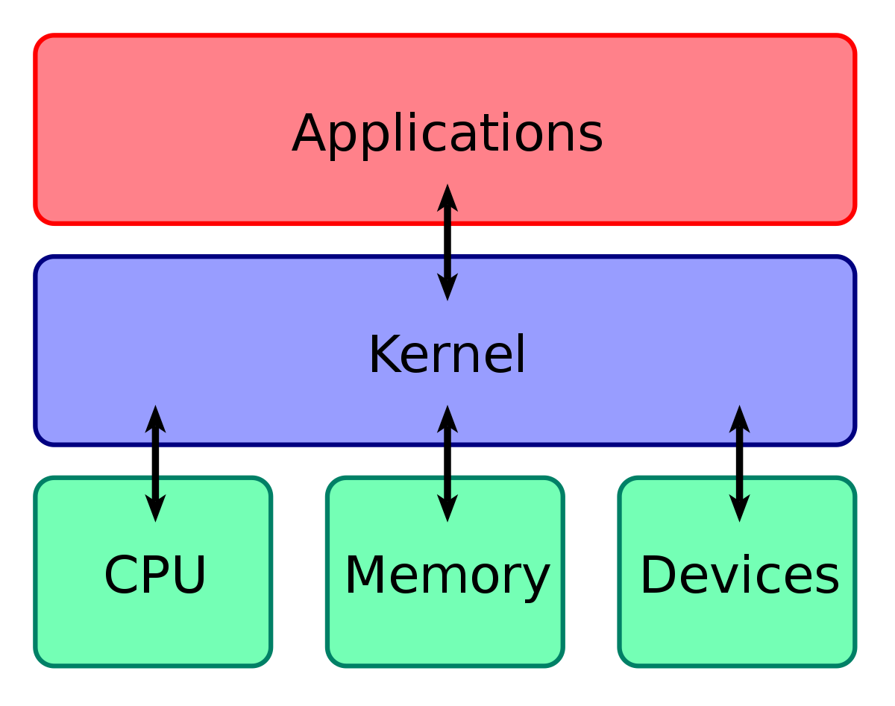

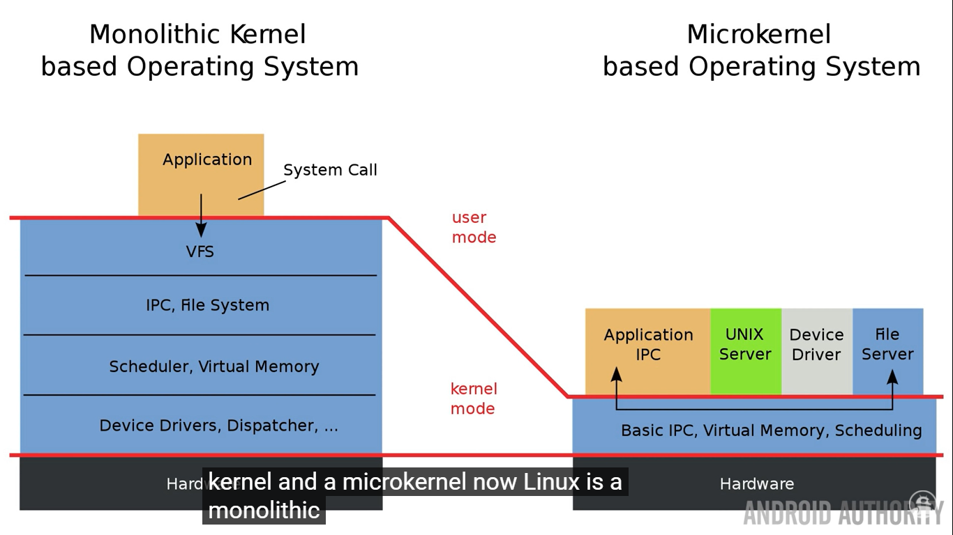

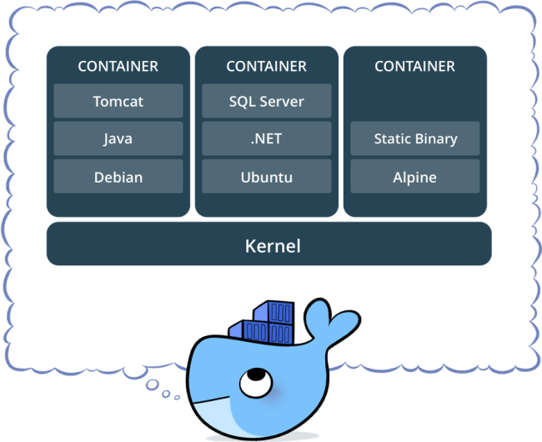

* + 1. Kernel is the lowest level of the any operating system. It is a response for CPU resources, Memory resources, file system, device divers of networking, it is lower piece of software that just come about the hardware

1. Hyper-V:
   1. Hyper-v is containers does not share the Kernal of the host and the kernel will not share with the others Hyper-V container as well.
   2. Image kernel build based on the Windows server 2016 should be equal to the host operating system kernel. But in the windows, kernel is going to be windows 10 kernal and image will pull from the docker is a server kernel thus, both are not equal thus, it is using the HYPER-V.

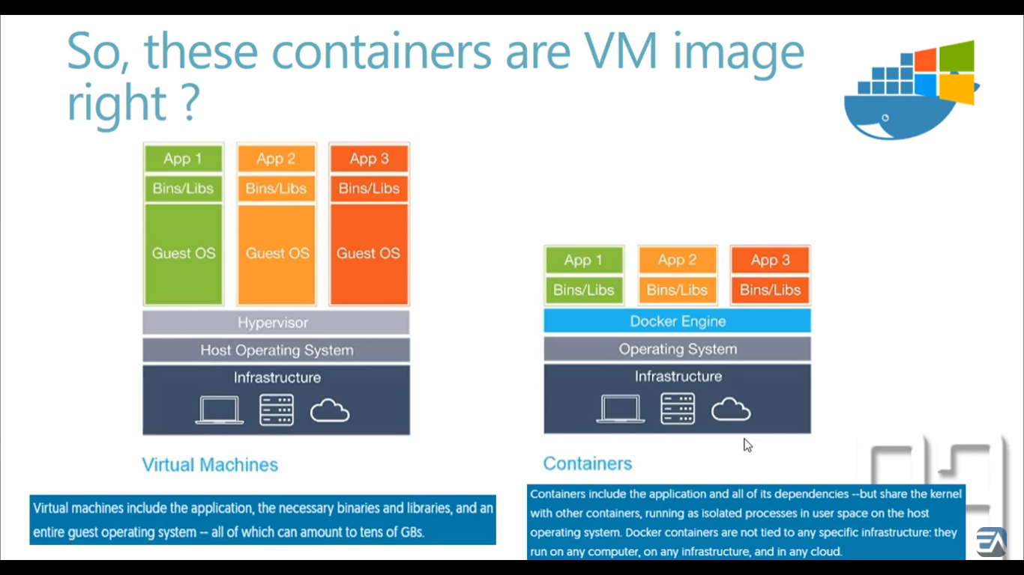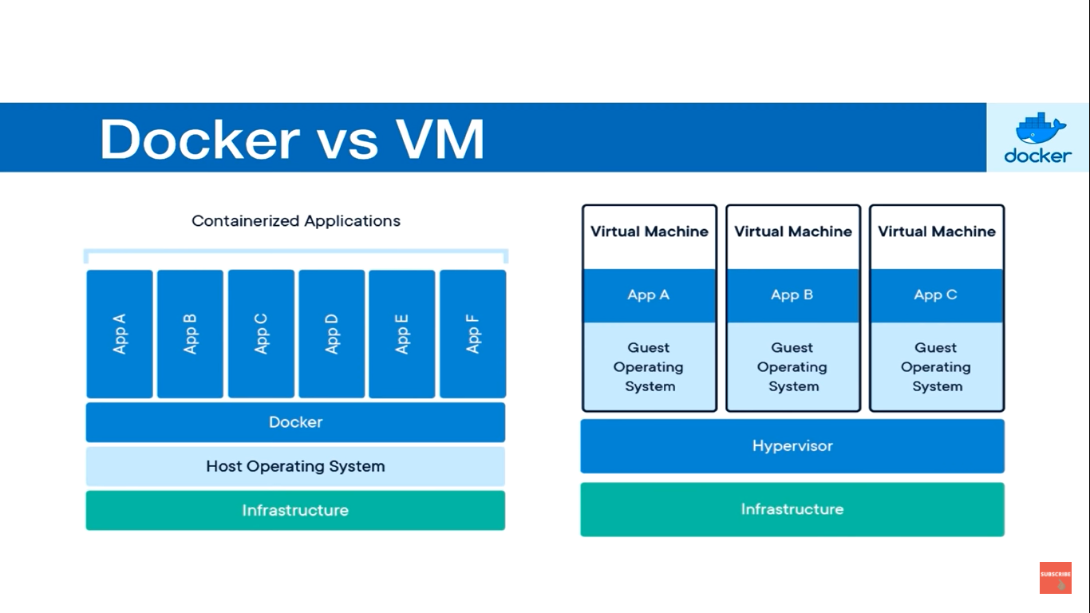

Benefits:

1. Run container in seconds instead of the minutes.
2. Less resource
3. Less memory
4. Does not need full OS
5. Deployment
6. Testing

Installing process:

Prerequisite:

* Windows 10 64-bit: Pro, Enterprise, or Education (Build 17134 or later).

For Windows 10 Home, see [Install Docker Desktop on Windows Home](https://docs.docker.com/docker-for-windows/install-windows-home/).

* Hyper-V and Containers Windows features must be enabled.
  + 1. Enable Hyper-V ,
       - go to Programs and feature.
       - go to turn window feature on or off.
       - Select Hyper-v
       - Click ok and restart
* The following hardware prerequisites are required to successfully run Client Hyper-V on Windows 10:
  + 64 bit processor with [Second Level Address Translation (SLAT)](https://en.wikipedia.org/wiki/Second_Level_Address_Translation)
  + 4GB system RAM
  + BIOS-level hardware virtualization support must be enabled in the BIOS settings. For more information, see [Virtualization](https://docs.docker.com/docker-for-windows/troubleshoot/#virtualization-must-be-enabled).

