Smart Guardian: An AI-Driven Women Safety Monitoring and Emergency Assistance System with a Two-Stage Alert Architecture
Sai Rakhesh K K¹, Nikilesh S², A. Ramya³
¹,² UG Scholars ³ Assistant Professor
Department of Computer Science and Engineering, Karpagam Academy of Higher Education, Coimbatore, India
Corresponding Author: ramya12.eng@gmail.com
Abstract—Personal safety applications for women often rely on manually triggered SOS alerts and static, threshold-based rules, which provide limited contextual assessment of risk. This paper presents Smart Guardian, an emergency-assistance platform that combines a conventional SOS and live-location pipeline with a lightweight machine-learning module for contextual threat scoring. The system uses a React frontend, a Spring Boot and PostgreSQL backend, and a Python microservice for scoring movement, location, and device-context features. Its proposed two-stage alert design uses a user-confirmable check-in before notifying emergency contacts when the predicted risk is elevated. Logistic Regression and Histogram-based Gradient Boosting were evaluated using 8,000 domain-informed synthetic samples; Logistic Regression achieved a ROC-AUC of 0.7445 on the held-out synthetic test set. Because the labels were generated from specified assumptions rather than observed incidents, these results assess the modeling pipeline on synthetic data and do not establish real-world threat-detection performance or a reduction in false alarms. The paper describes the architecture, feature design, evaluation, limitations, and steps required for validation with real outcome data.
Index Terms—women safety, emergency assistance system, machine learning, threat detection, false-positive reduction, SOS alert

I. INTRODUCTION
Personal safety technology for women had converged on a familiar set of features: a manually triggered SOS button, GPS-based live location sharing, and notification of pre-registered emergency contacts. While effective as a baseline, this class of system placed the entire burden of threat recognition on the user, who had to consciously recognize danger and physically act to trigger help — a requirement that was frequently unmet in exactly the situations these systems were designed for, such as when a user was incapacitated, restrained, or otherwise unable to interact with a device [1].
A. Motivation: Scale of the Problem
The scale of the underlying problem justified moving beyond a purely manual system. The latest global estimate of the World Health Organization placed the number of women alive who had been subjected to intimate-partner or non-partner sexual violence at some point in their lives at 840 million [7].
TABLE I
STATISTICAL CONTEXT (SOURCES: WHO 2025, UNODC/UN WOMEN 2025, NCRB 2022)
Statistic | Value
Women worldwide with lifetime IPV/sexual violence exposure | 840 million
Women/girls killed by partner or family, 2024 (global) | ∼50,000
Share of female homicides that were domestic, 2024 | 60%
Reported crimes against women, India, 2022 (NCRB) | 445,256
National crime rate against women, India, 2022 | 66.4 / lakh
Average reported complaints per hour, India, 2022 | 51

Separately, the UNODC/UN Women estimates for 2024 put the number of women and girls killed by a partner or family member in that year at roughly 50,000 [8], accounting for about 60% of all female homicides recorded in 2024. The risk was not spread evenly: UN Women data showed that women in low-income, conflict-affected, and climate-vulnerable regions bore a disproportionate share of this burden [8].
Closer to the deployment context of this project, the National Crime Records Bureau of India logged 445,256 crimes against women in 2022 alone, which corresponded to a national rate of 66.4 incidents per 100,000 women and roughly 51 complaints filed every hour of every day [9], with the count rising further in 2023. These figures covered only the incidents that were reported; independent survey work, including the National Family Health Survey of India, consistently pointed to real prevalence being considerably higher than official crime figures alone suggested. Table I compiled the figures that motivated this work.
These figures underscored two points directly relevant to system design. First, the scale of the problem was large enough that even modest reductions in response latency or false-negative rate corresponded to meaningful real-world impact. Second, and equally important given this scale, a system deployed to a large user base that generated frequent false alarms carried a real social cost — both in eroded trust and in desensitizing users and contacts to genuine alerts — which was precisely why false-positive control was treated as a structural design constraint (Section IV-C4) rather than a secondary tuning concern.
A growing body of work had explored automating threat detection using sensor fusion and machine learning, ranging from wearable physiological monitoring [1], [3] to mobile-only systems that inferred risk from location and behavioral patterns without additional hardware [2]. These systems reported high raw accuracy, but a recurring and under-addressed weakness was the treatment of false positives: a system that paged the family of a user every time a benign anomaly occurred (a dropped phone, an unusual but harmless route, a battery running low at night) was quickly disabled or ignored by its users [1]. High offline accuracy was therefore a necessary but not sufficient condition for a deployable safety system.
This paper presented Smart Guardian, a software-only (no dedicated wearable hardware) women’s safety platform that combined a mobile/web client, a conventional application backend, and a decoupled AI threat-scoring microservice. The contributions of this work were as follows:
1) A system architecture that isolated AI threat scoring as an independently deployable and independently evaluable microservice, separate from the transactional SOS/location backend, and that required no dedicated hardware, unlike the majority of prior systems (Section IV-A1).
2) A two-stage alert design in which an elevated model score prompts a bounded, user-confirmable check-in before emergency contacts are notified. This is intended to help manage false-positive notifications, but its effect on false-alarm rates and emergency-response delay has not yet been empirically established.
3) A baseline threat-scoring model trained and evaluated on a domain-informed synthetic dataset with a documented data-generating process, together with a rationale for the selected model family in the context of the system’s deployment constraints.
4) An evaluation reporting precision, recall, F1, and ROC-AUC on a held-out synthetic test set, alongside a discussion of the limits of interpreting these metrics when labels are generated from assumptions rather than observed incidents.
The rest of the paper was organized as follows. Section II surveyed related systems. Section III refined the problem statement into four concrete gaps. Section IV described the proposed architecture, contrasted it with the patterns identified in Section II, and detailed the threat-scoring methodology. Section V covered implementation specifics, and Section VI presented the evaluation results. Section VII discussed the market relevance of the design, Section VIII discussed its limitations, and Section IX presented conclusions and directions for future work.
II. RELATED WORK
Wearable-centric approaches integrated physiological sensors (heart rate, temperature, galvanic skin response) with GPS and GSM modules to detect distress autonomously. Wagh et al. [1] proposed a hybrid Support Vector Machine and Naive Bayes framework over physiological and motion sensor data, reported an SVM accuracy of 99.7% under 10-fold cross-validation, and explicitly identified the risk of oversimplified, single-signal threshold detection producing high false-positive rates during ordinary activity such as exercise. Their earlier work [3] established the underlying wearable IoT architecture that the 2026 study evaluated. Along the same lines, Senthilrajan [15] described a wearable built around GPS and GSM connectivity, geofenced zones, and voice-triggered activation; notably, threat classification in that system remained entirely manual (panic-button driven), with no learned model in the loop. All of these wearable-first designs shared a dependence on purpose-built hardware, which added cost and friction to adoption that a purely software-based approach avoided.
Mobile-application-centric systems avoided dedicated hardware by relying on the sensors and connectivity of the smartphone itself. Chand et al. [11] presented WoSApp, an early and widely cited example that triggered an emergency call via a shake gesture or panic-button press and transmitted the location of the user to the police; this established the baseline single-trigger, no-ML pattern that later systems built on. Kavya et al. [13] presented a more recent IoT-and-GPS panic-button system with a similar single-trigger design. Pawar et al. [2] presented RescueNow, which combined multi-trigger SOS activation (manual, voice, and shake-based), silent audio-video evidence capture, SMS-based alerting through Twilio for offline resilience, and a machine learning component that predicted crime-prone zones from historical incident data to warn users proactively. That system emphasized usability features such as a discreet “panic word” and confirmation prompts to reduce accidental activation, but its machine learning component was oriented toward zone-level risk prediction rather than per-session, per-user threat scoring from live behavioral signals. This pattern was echoed at a broader scale by Farooq et al. [14], whose survey of the IoT-based women’s-safety literature concluded that manual or single-signal triggering dominated the field and that genuinely learned, automated threat detection remained the exception.
A third line of work targeted automated detection directly from live sensor data rather than manual triggers. Oh and Yoo [12] trained and compared five classifiers (SVM, kNN, Random Forest, SGD, and a 1D convolutional neural network) on smartwatch accelerometer data to distinguish at-risk movements from walking, running, and desk work, and found that the 1D-CNN achieved the highest accuracy (97.98% in the frequency domain), although it required a purpose-built, continuously sampled motion dataset and non-trivial on-device inference. Jothi [10] proposed a complementary audio-based approach that continuously listened for distress phrases and escalated to full alerting only when audio detection was corroborated by motion or biometric signals from a paired wearable, explicitly to control the false-positive rate through multi-modal confirmation rather than a single-signal threshold. This work confirmed, from an independent design direction, the same core insight that motivated the two-stage alert architecture of Smart Guardian: single-signal automated detection was not reliable enough to alert third parties without a confirmation step.
The proposed system differed from all of these lines of work in three respects. First, it required no dedicated wearable hardware or continuous audio/motion capture and relied entirely on standard smartphone location, motion, and device-state sensors sampled at a low, battery-friendly rate, which lowered both the cost and the privacy footprint of adoption relative to [1], [3], [10], [12], [15]. Second, unlike the single-trigger systems [11], [13], threat scoring was continuous and model-driven rather than purely manual. Third, rather than reporting a single headline accuracy figure, false-positive control was treated as a first-class, structurally enforced design constraint (Section IV-C4), and evaluation metrics were reported on a dataset explicitly constructed to avoid trivial separability. Table II summarized these distinctions.

TABLE II
COMPARISON WITH RELATED SYSTEMS
System | Dedicated Hardware | Trigger Type | Primary Detection Signal | False-Positive Mitigation | Reported Metric
WoSApp [11] | None (smartphone only) | Manual (shake/button) | None (manual only) | None reported | Not quantified
Senthilrajan [15] | Wearable + GSM/GPS | Manual (panic button / voice) | None (manual only) | None reported | Not quantified
Wagh et al. [1] | Wearable (Arduino/Pi) | Automated | Physiological + motion sensors | Two-sensor agreement + temporal persistence | 99.7% accuracy (SVM, 10-fold CV)
RescueNow [2] | None (smartphone only) | Manual (button, voice, shake) | None for live threat; ML predicts crime-prone zones | Confirmation popup on trigger | Not quantified
Oh & Yoo [12] | Smartwatch | Automated | Accelerometer (IMU) time series | None (single-model threshold) | 97.98% accuracy (1D-CNN)
Jothi [10] | Optional wearable | Automated | Audio keyword spotting | Multi-modal (audio + motion) | 95.8% keyword accuracy
Smart Guardian (this work) | None (smartphone only) | Manual SOS + automated risk score | Location, motion, device context | Two-stage user check-in (not yet validated) | 0.7445 ROC-AUC (synthetic data)
Note: Reported metrics are taken from each study and were obtained on different datasets, tasks, and evaluation protocols; they are therefore not directly comparable.

III. PROBLEM STATEMENT
Building on the gaps identified in Section II, four specific problems that motivated the proposed design were identified:
1) Reliance on manual activation. Existing lightweight safety applications provided alerting functionality but little to no automated, contextual threat analysis, so protection was contingent on the ability of the user to act [1], [11], [15].
2) False-positive fragility. Systems that incorporated automated detection commonly used static thresholds on a small number of signals, which did not generalize across the natural variability of everyday movement and device state and led to false alarms that eroded user trust [1].
3) Communication delay. Where automated detection existed, the time between anomaly detection and emergency-contact notification was rarely treated as an explicit design variable, even though it directly determined the practical value of the system during an active incident.
4) Absence of an evaluable, incrementally improvable ML pipeline. Many published systems reported only final accuracy figures without a documented, reproducible training and evaluation methodology, which made it difficult to iterate as real usage data became available.
Smart Guardian addressed problems (1) and (3) through its SOS and live-location subsystem (Section IV-B), and addressed problems (2) and (4) through the threat-scoring microservice and its two-stage alert design (Section IV-C).
IV. PROPOSED SYSTEM
A. System Architecture
Smart Guardian followed a layered client-server architecture (Fig. 1). A React-based client (web, with a React Native mobile client following the same API contract) communicated with a Spring Boot backend over REST and WebSocket connections. The backend was responsible for authentication, user and emergency-contact management, SOS event lifecycle management, and notification dispatch (SMS via Twilio, push notifications via Firebase Cloud Messaging, and email as a fallback channel). A PostgreSQL database persisted user, contact, SOS event, location trail, and incident data.
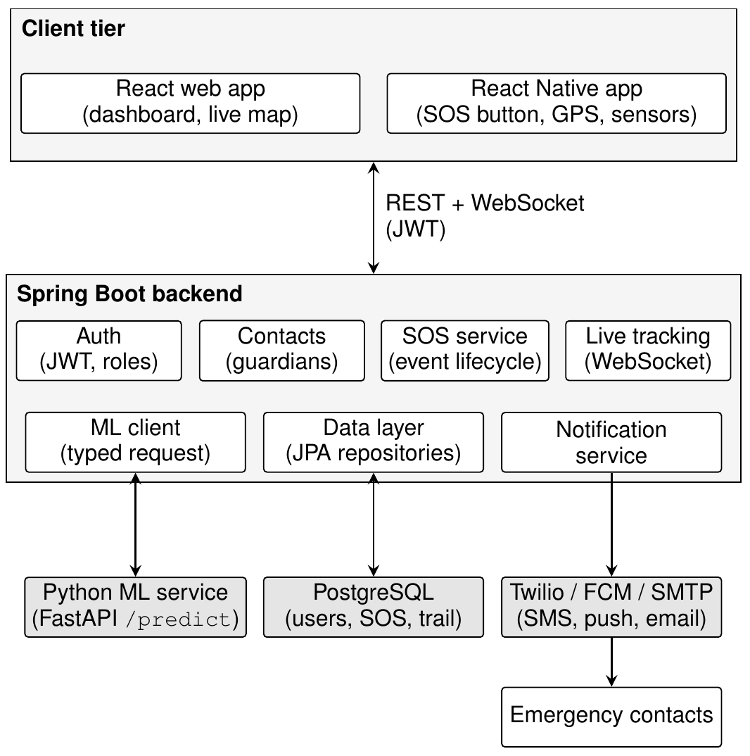
Fig. 1. Smart Guardian system architecture. The AI threat-scoring service was deployed as an independent microservice, decoupled from the transactional backend.
The AI threat-scoring logic was placed in its own Python microservice, deliberately kept outside the Spring Boot application rather than embedded inside it. This split was made for three concrete reasons. First, it allowed the model to be retrained, versioned, and redeployed on its own timeline without touching the transactional backend. Second, it forced everything that passed between the learning component and the surrounding platform through a single, strongly typed request/response boundary, which made the model far easier to test and evaluate in isolation. Third, it mirrored how such services were typically run in practice once they left the prototype stage, so the architecture reflected real deployment conditions rather than the shortcuts that a scoring function embedded directly in the backend would have represented.
As shown in Fig. 1, the client communicated with the Spring Boot backend over REST for standard operations and over WebSocket for the live-location stream during an active SOS event. The backend queried the ML service synchronously on each scoring tick and persisted both the request features and the returned score for later retraining, as described in Section VIII.
1) Comparison with Existing System Architectures: To make the architectural contribution concrete, Fig. 2 contrasted the Smart Guardian architecture with the three architectural patterns identified in Section II: (a) the wearable-centric pattern of [1], [3], [15], in which sensing hardware, inference, and alerting were tightly coupled on a single embedded device;
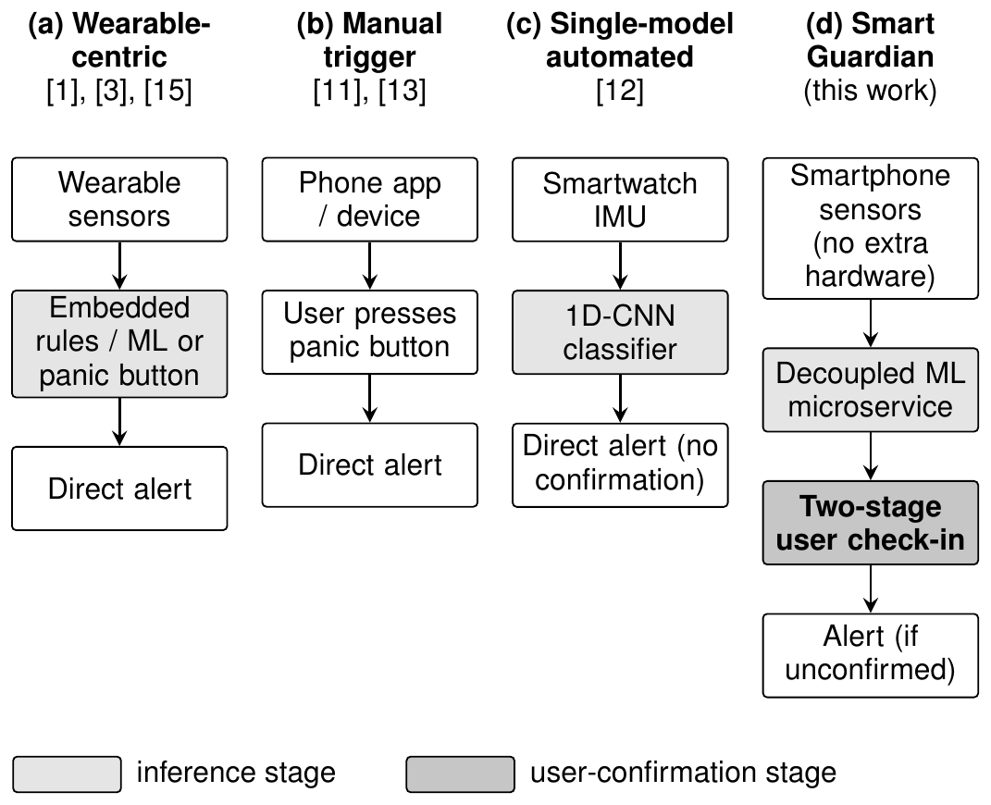
Fig. 2. Architectural comparison: (a)–(c) prior patterns from related work versus (d) Smart Guardian. Only (d) combined a network-decoupled inference stage with an interposed user-confirmation stage before third parties were alerted.
(b) the manual-trigger smartphone pattern of [11], [13], in which no inference stage existed at all; and (c) the single-model automated pattern of [12], in which an on-device classifier alerted directly without a confirmation stage. The Smart Guardian architecture (d) was distinguished by two structural properties that were absent from all three prior patterns: the inference stage was a network-decoupled service rather than on-device or absent, and a confirmation stage was interposed between inference and alerting rather than alerts firing directly from a model score.
The practical consequence of this difference was visible in Table II: every prior system either omitted automated detection entirely (the manual variants of pattern (a), and pattern (b)) or, where automated detection existed (the automated variant of pattern (a), and pattern (c)), fired alerts directly from a model score with no interposed confirmation step. Smart Guardian was the only architecture in the comparison in which a positive detection did not, by itself, notify a third party.
B. SOS and Live Location Subsystem
When a user manually triggered an SOS event, or when the threat-scoring subsystem recommended escalation (Section IV-C4), the backend created an SOS event record, began accepting a stream of location updates over a WebSocket connection at a five-to-ten-second interval, and dispatched notifications with a live-location link to the registered emergency contacts of the user. Every location update was persisted, which allowed a full GPS trail to be reconstructed for post-incident review.
C. AI Threat-Scoring Module
1) Feature Design: On a regular cadence, the client computed a set of context signals that a stock smartphone could already provide, with no extra hardware required: the local hour of day, the current battery level of the device, the instantaneous speed, a short-window variance in accelerometer readings (standing in for erratic or struggle-like movement), the distance of the user from home, the deviation of the current path from where the user usually was at that hour, a historical risk score attached to the present location, and a flag for a sharp stop immediately after sustained motion. Two additional binary signals were derived from the raw hour and battery fields: is night (21:00–05:00) and low battery (below 20%). Table III listed all ten features.
TABLE III
THREAT-SCORING FEATURE SET
Feature | Description
hour of day | Local hour, 0–23
is night | Binary, derived: hour ∈ [21, 24) ∪ [0, 5)
battery level | Device battery percentage
low battery | Binary, derived: battery level < 20%
speed kmh | Current movement speed (km/h)
accel variance | Variance of recent accelerometer samples
distance from home km | Distance from registered home location (km)
deviation from usual route km | Deviation from typical route cluster (km)
location risk score | Historical incident density, [0, 1]
sudden stop | Binary: sharp deceleration after sustained motion

2) Model Training: Because no labeled incident dataset was available at the time of this study, a domain-informed synthetic dataset of 8,000 samples was constructed. Feature values were drawn from distributions chosen to approximate plausible marginal distributions (e.g., an exponential distribution for speed and route deviation, and a right-skewed Beta distribution for location risk). Binary labels were generated by combining features through a weighted linear function reflecting the risk assumptions described in Section IV-C1, applying a logistic sigmoid, and sampling a Bernoulli outcome. This procedure produced overlapping classes. The resulting evaluation therefore measures how well the models recover patterns in this assumed synthetic label-generation process; it does not demonstrate real-world detection performance.
Two classifiers were trained and compared, chosen deliberately to contrast an explainable linear model with a heavier nonlinear one: (i) Logistic Regression with L2 regularization and balanced class weights [6], [19], and (ii) Histogram-based Gradient Boosting [5], both via the scikit-learn implementation [4]. In each case, 20% of the data was held out for testing, stratified by class, with the random seed fixed so that the split was reproducible across runs. The two models were compared using ROC-AUC [20], a metric that remained meaningful regardless of the decision threshold and tolerated the mild class imbalance present in the data.
3) Algorithm Formulation and Justification: This subsection formulated the two candidate algorithms mathematically and explained, with reference to the accuracy figures reported in prior work (Table II), why this model family was chosen over the alternatives used by related systems.
a) Logistic Regression: Given a standardized feature vector x = (x₁, x₂, …, x_{d})^{T} (Table III), the model computes the threat probability p(y = 1 | x) as
p(y = 1 | x) = σ(w^{T}x + b) = 1 / (1 + exp(−(w^{T}x + b))) (1)
where σ(z) = 1/(1 + exp(−z)), w is the learned coefficient vector, and b is the intercept. The parameters are learned by minimizing the L2-regularized log-loss over n training samples:
L(w, b) = −(1/n) Σ_{i=1}^{n} [y_{i} log p_{i} + (1 − y_{i}) log(1 − p_{i})]
+ (λ/2)‖w‖² (2)
where p_{i} is the predicted probability for sample i, y_{i} is its binary label, and λ controls regularization strength. Class weights were scaled inversely to class frequency to address moderate class imbalance. Each coefficient in w corresponds to a feature’s contribution to the model’s log-odds.
b) Histogram-based Gradient Boosting: For the nonlinear comparison, an ensemble of M shallow regression trees was built sequentially, with each tree added to improve the current predictions. After boosting round m, the running raw prediction for sample x is
F_{m}(x) = F_{m−1}(x) + η h_{m}(x), m = 1, 2, …, M (3)
where h_{m} is the tree fitted to the negative gradient of the log-loss with respect to the current ensemble output F_{m−1}, and η is the learning rate. Continuous feature values are bucketed into histogram bins when searching for splits. The raw ensemble output is converted to a probability with the sigmoid function, p(y = 1 | x) = σ(F_{M}(x)).
c) Choice of model family over the alternatives used in prior work: Table II showed that related systems reported higher raw accuracy than the ROC-AUC of 0.7445 obtained here: the SVM of Wagh et al. reached 99.7% [1], and the 1D-CNN of Oh and Yoo reached 97.98% [12]. Those model families were not selected, for reasons specific to the deployment constraints of this system rather than a general claim that they were inferior classifiers:
- Support Vector Machines [16], as used in [1], required a fixed, hand-tuned kernel and did not natively output calibrated probabilities, on which the two-stage design depended for setting τ_{low} and τ_{high} in (4); post-hoc calibration (e.g., Platt scaling) added complexity without closing the fundamental interpretability gap. The comparison of Wagh et al. also used Naive Bayes [21] as a secondary model, which assumed conditional independence of the features given the class — an assumption that this feature set violated directly, since is night and location risk score were correlated by construction (higher-risk areas were more often flagged as risky specifically at night in the incident data from which such scores were typically derived).
- 1D convolutional neural networks, as used in [12], required a purpose-collected, continuously sampled time-series dataset (5,534 labeled windows collected from 12 participants under supervision in that study) and meaningful on-device compute for real-time inference. The Smart Guardian feature set was a low-rate, heterogeneous tabular vector (Table III) rather than a uniform time series, which made a 1D-CNN architecturally mismatched to the input; reframing the problem as time-series classification would have required the continuous raw sensor streaming that this design explicitly avoided for battery and privacy reasons.
- Random Forest [17] and other non-boosted tree ensembles, as compared in [12], offered interpretability trade-offs similar to Histogram-based Gradient Boosting but lacked the sequential error-correction property in (3), which allowed boosting to reach a given accuracy with fewer, shallower trees — a relevant property when the model had to run per prediction at low latency on modest server infrastructure.
In short, the alternatives achieved higher accuracy on their own tasks and data, which were not directly comparable to this setting: they assumed wearable hardware, continuous high-frequency sensor streams, or a hand-labeled dataset an order of magnitude larger than what a pre-launch, software-only system could collect. Given the actual constraints of this deployment — a smartphone-only, low-frequency, tabular feature vector and a hard requirement for calibrated, explainable probabilities to drive the two-stage alert thresholds — Logistic Regression and Histogram-based Gradient Boosting formed the model family that was both effective and transparently evaluable, as confirmed empirically in Section VI-A.
4) Two-Stage Alert Design: The model score p was mapped to three levels using two fixed thresholds, τ_{low} = 0.35 and τ_{high} = 0.70:
level(p) = { LOW, if p < 0.35;
CHECK-IN, if 0.35 ≤ p < 0.70; (4)
HIGH, if p ≥ 0.70.
These thresholds are prototype design settings, not validated operating points for real-world emergencies.
For a score at or above τ_{low}, the client presents a check-in prompt with a nominal 15-second response window. If the user does not respond, the system is designed to escalate to SOS notification. This workflow is intended to give the user an opportunity to cancel an unnecessary alert; however, this study did not experimentally measure whether it reduces false alarms, nor did it quantify the effect of the check-in window on missed or delayed assistance. These trade-offs require end-to-end testing before deployment.
V. IMPLEMENTATION
The client applications were implemented in React (web) and React Native (mobile) and shared a common typed API client. The application backend was implemented in Java with Spring Boot and Spring Security for JWT-based authentication, backed by a PostgreSQL relational schema covering users, emergency contacts, SOS events, location pings, threat predictions, and incidents. The threat-scoring microservice was implemented in Python using FastAPI, with Pydantic request/response schemas shared between the training and serving code paths to prevent training/serving feature skew. The trained model artifact, together with its feature names, version identifier, and evaluation metrics, was serialized with joblib and loaded once at service startup. The service was containerized with Docker for deployment independent of the main backend.
VI. RESULTS
A. Model Evaluation
Table IV reported the performance of each candidate model on the 1,600-sample held-out split (the 20% of the synthetic dataset reserved for testing) in terms of precision, recall, F1, and ROC-AUC. Logistic Regression achieved the higher ROC-AUC and was carried forward as the selected model.
TABLE IV
BASELINE MODEL EVALUATION ON HELD-OUT TEST SPLIT
Model | Precision | Recall | F1 | ROC-AUC
Logistic Regression | 0.636 | 0.653 | 0.644 | 0.7445
Hist. Gradient Boosting | 0.660 | 0.540 | 0.594 | 0.7151

On the test split, the selected Logistic Regression model produced 626 true negatives, 265 false positives, 246 false negatives, and 463 true positives (Fig. 4), corresponding to 891 negative and 709 positive test samples. Fig. 3 presented the corresponding ROC curve.
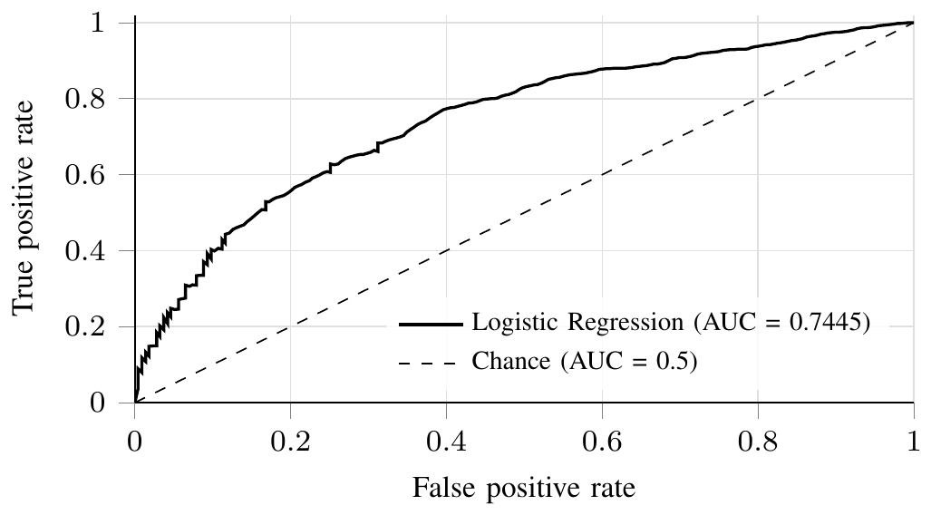
Fig. 3. ROC curve for the selected Logistic Regression model, measured on the held-out test split (AUC = 0.7445).
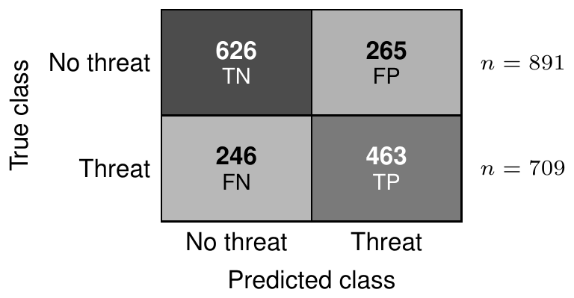
Fig. 4. Confusion matrix for the held-out test split (1,600 samples). Rows: true class; columns: predicted class.
The Logistic Regression model achieved a ROC-AUC of 0.7445 on the held-out synthetic dataset. This indicates that the model learned a degree of ranking signal relative to the synthetic labels, but it should not be interpreted as evidence of real-world threat-detection accuracy. The purpose of this initial experiment was to exercise the modeling and evaluation pipeline on overlapping synthetic classes; validation against independently labeled scenarios or real outcome data remains necessary.
B. Feature Importance
Fig. 5 presented the standardized Logistic Regression coefficients for all ten input features, which provided a direct, human-readable explanation of the decision process of the model — an explicit advantage of the explainable-baseline approach described in Section IV-C3. The is_night indicator carried the largest positive coefficient, followed by sudden_stop and location_risk_score, consistent with the causal structure used to generate the training labels (Section IV-C2) and with the qualitative risk factors identified in prior work [1]. Notably, hour_of_day and the raw battery_level carried negligible weight once their derived binary counterparts (is_night, low_battery) were included, which indicated that the derived features successfully captured the relevant nonlinearity and that the raw features were largely redundant given them — a useful finding for feature-set simplification in future iterations.
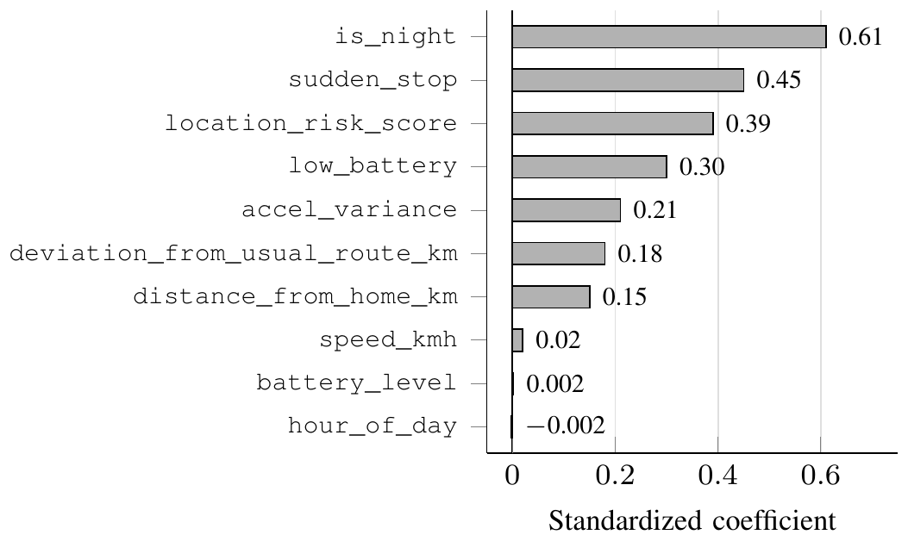
Fig. 5. Standardized coefficients from the selected Logistic Regression model, ordered by magnitude.
C. Additional Diagnostic Evaluation
ROC-AUC and a single confusion matrix at a threshold of 0.5 did not, on their own, establish whether the model output was trustworthy enough to drive the two-stage alert design of Section IV-C4, which depended on the risk score behaving as a genuine probability rather than an arbitrary ranking score. Four further diagnostics aimed specifically at this question were therefore examined.
Precision–recall curve. Fig. 6 plotted precision against recall across all thresholds, with average precision (AP) summarizing the curve as a single number. AP reached 0.7019 against a positive-class prevalence of 0.443 in the test split; because precision–recall curves were far less forgiving than ROC curves under class imbalance, this was arguably a stricter check on the model than the ROC-AUC figure in Table IV alone.
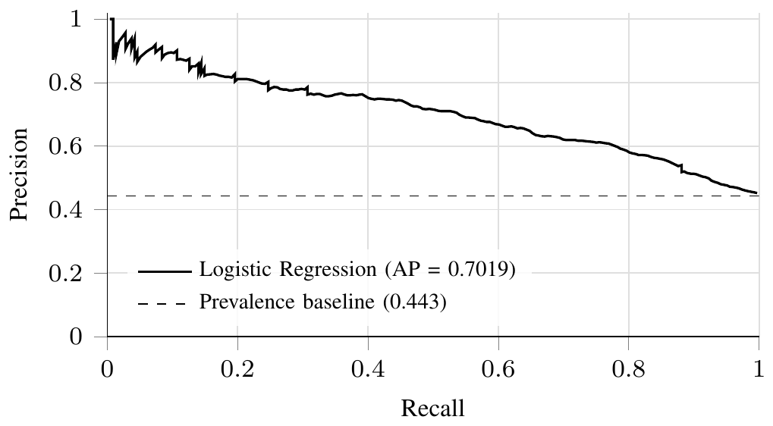
Fig. 6. Precision–recall curve on the held-out test split (AP = 0.7019), against the prevalence baseline that a random classifier would achieve.
Calibration. The two-stage design in (4) uses the model score as a probability, so calibration is relevant to the threshold decisions. Fig. 7 bins test predictions into ten quantile groups and compares the mean predicted score with the observed positive rate in the synthetic test labels. Any apparent agreement reflects those synthetic labels only and does not establish calibration for real-world incidents. The thresholds should be reassessed if the model is retrained on real outcome data.
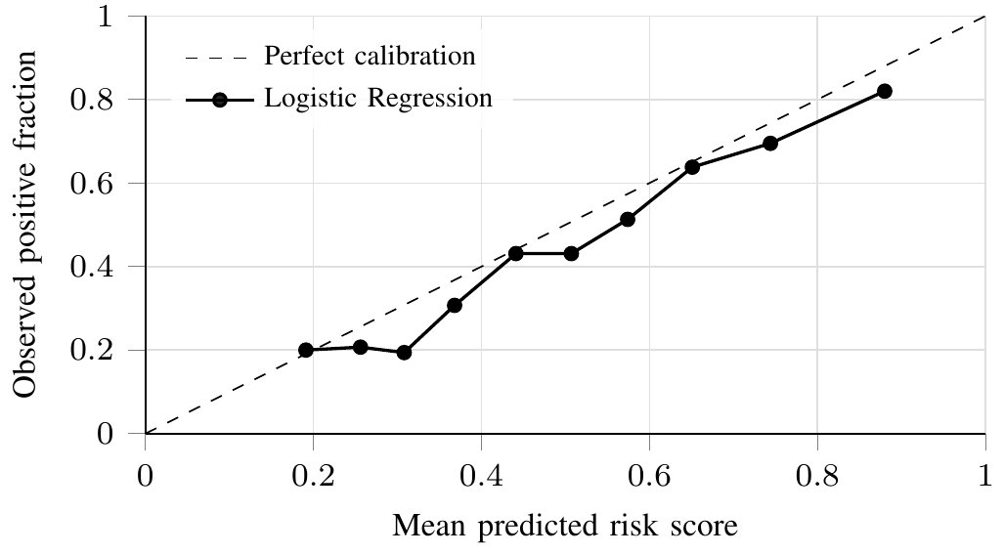
Fig. 7. Calibration (reliability) curve on the synthetic test labels, 10 quantile bins.
Threshold sensitivity. Fig. 8 sweeps the decision threshold from 0 to 1 and plots precision, recall, and F1 for the synthetic test labels, with τ_{low} = 0.35 and τ_{high} = 0.70 marked. This analysis makes the prototype’s threshold settings visible for inspection, but does not establish that these settings are appropriate for operational emergency escalation. They should be selected and validated using a suitable risk-based evaluation before deployment.
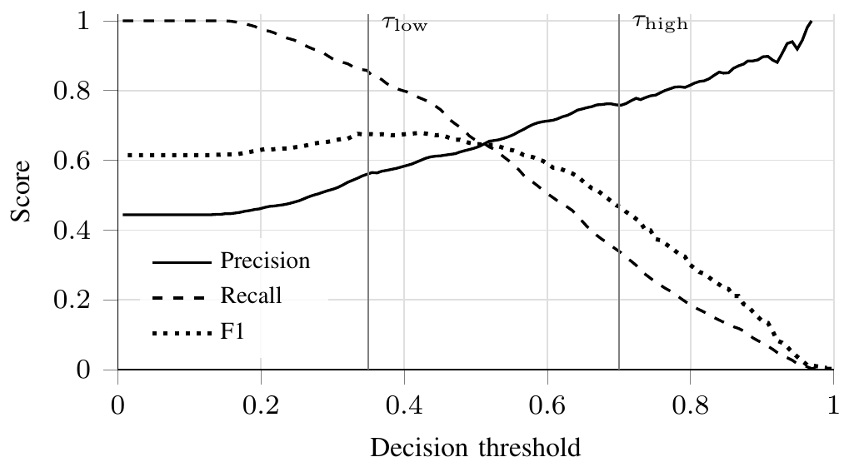
Fig. 8. Precision, recall, and F1 as a function of the decision threshold, with the two operating thresholds from (4) marked.
Class separation. Fig. 9 shows the predicted-score distributions for the two classes in the synthetic test set. The distributions overlap, consistent with the reported ROC-AUC and average precision. Because the classes were generated from an assumed process, this separation is evidence about the synthetic experiment only, not evidence that the model distinguishes real incidents from ordinary activity.
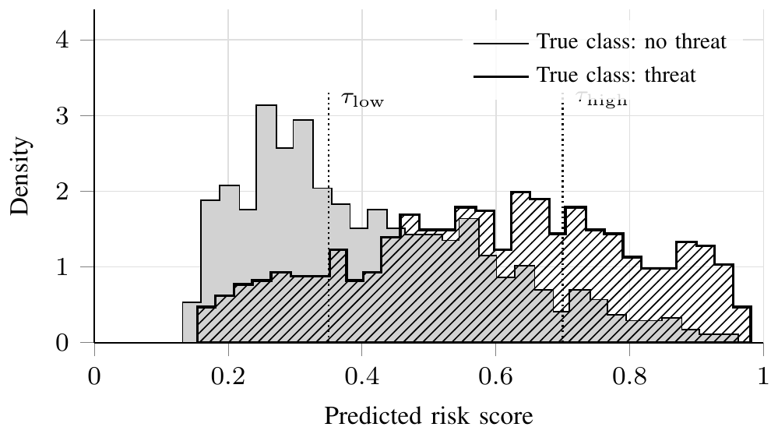
Fig. 9. Distribution of predicted risk scores, split by true class, with τ_{low} and τ_{high} marked (synthetic test set).
D. System-Level Evaluation
The end-to-end threat-scoring API was evaluated for functional correctness with a suite of contract tests, including a directional sanity check confirming that a constructed high-risk scenario (late night, low battery, high location-risk score, sudden stop) produced a materially higher score than a constructed low-risk daytime scenario. All tests passed, and the service was verified to serve predictions correctly when run as a standalone container, matching its behavior under the test harness.
VII. MARKET RELEVANCE AND COMPETITIVE ADVANTAGES
Beyond the architectural and algorithmic contributions of Sections IV and VI, several properties of the Smart Guardian design translated directly into practical advantages for real-world deployment and adoption — factors that mattered as much as raw model accuracy when such a system had to compete for and retain users. Table V summarized these properties.
TABLE V
DESIGN PROPERTIES AND INTENDED PRACTICAL BENEFITS
Design property | Intended benefit (not yet evaluated)
Zero dedicated hardware | No bill-of-materials, manufacturing, or supply-chain cost, unlike [1], [3], [15]; installed like any other app, lowering a key adoption barrier
Decoupled ML microservice | Threat-scoring model retrainable and redeployable independently of app releases, with no app-store review cycle needed to ship a model update
Two-stage alert design | Intended to reduce false-alarm fatigue, a risk noted for automated safety alerts [1], by letting the user cancel an unnecessary alert before contacts are notified
Interpretable linear model | Each score can be explained through per-feature coefficients, which is more transparent than deep-learning alternatives [12]
Low-frequency, on-phone sensing | No continuous audio or video capture (cf. [10]), reducing both battery drain and the privacy concerns that led some users to decline always-listening safety apps
Shared React / React Native codebase | Web and mobile clients shipped from one codebase, reducing time-to-market and ongoing maintenance cost relative to separate native builds
Retraining support | Schema designed to log predictions with eventual outcomes (Section VIII), enabling future retraining on real data

These design choices distinguish the proposed architecture from the patterns discussed in the related-work section, particularly through the separation of SOS handling from a dedicated inference service and the addition of a user-confirmation stage. The present study does not establish commercial viability, sustained user trust, a reduction in false alarms, or real-world detection effectiveness. Those outcomes require implementation-level and user-centered evaluation.
VIII. DISCUSSION AND LIMITATIONS
The primary limitation of this study is its reliance on a synthetic, causally constructed dataset in the absence of real incident data. Although the data-generating process is documented, it encodes the authors’ assumptions about which features matter and how they interact rather than empirically observed relationships. The reported metrics should therefore be interpreted as a validation of the modeling pipeline against synthetic labels, not as estimates of real-world detection accuracy.
The system design includes a threat_predictions table intended to log predictions alongside eventual outcomes, such as user confirmation, non-response and escalation, or a manually filed incident report. This could support future analysis and retraining if the system is deployed with appropriate consent, privacy protections, and reliable outcome-labeling procedures. The availability and quality of such real-world data have not yet been established in this study.
A second limitation is the reliance on a location-risk feature, which requires suitable historical incident data or a defensible proxy; regions with sparse or biased records may receive less informative scores. The system also depends on successful notification delivery under potentially degraded network conditions. SMS fallback is described as an operational design measure, but end-to-end delivery latency and reliability were not evaluated empirically.
IX. CONCLUSION AND FUTURE WORK
This paper presented Smart Guardian, a proposed software-oriented women’s safety system that separates SOS handling from a dedicated machine-learning threat-scoring service and introduces a user-confirmable stage before escalation. On a domain-informed synthetic dataset, the Logistic Regression baseline achieved a ROC-AUC of 0.7445. This result is preliminary and characterizes performance against the synthetic label-generation process; it does not establish real-world detection effectiveness or demonstrate that the two-stage design reduces false alarms. The principal contribution is the architecture and its explicit evaluation plan, which now requires validation using independently labeled scenarios, end-to-end tests, and—when feasible—real outcome data.
Future work includes evaluating the model on independently labeled scenarios and, if ethically and practically feasible, real outcome data; testing end-to-end notification latency and failure handling; and conducting a user study to assess the two-stage alert design’s effects on false alarms, response delay, and user trust. Optional audio-based distress detection may also be explored, subject to explicit consent and privacy safeguards.
REFERENCES
[1] N. R. Wagh, S. R. Sutar, V. J. Kadam, S. M. Jadhav, A. S. Yadav, and V. S. Pawar, “Evaluation of IoT based smart safety systems for women and children using machine learning techniques,” Scientific Reports, vol. 16, p. 87, 2026, doi: 10.1038/s41598-025-29146-4.
[2] S. S. Pawar, R. Roy, K. V. Sawant, R. B. Singh, and M. Navale, “RescueNow: Real-time SOS and Predictive Women’s Safety System,” International Journal for Research in Applied Science and Engineering Technology (IJRASET), vol. 13, no. 5, 2025, doi: 10.22214/ijraset.2025.70070.
[3] N. R. Wagh, S. R. Sutar, and A. S. Yadav, “Smart security solution for women and children using wearable IoT systems,” Wireless Personal Communications, vol. 138, pp. 701–715, 2024, doi: 10.1007/s11277-024-11429-0.
[4] F. Pedregosa et al., “Scikit-learn: Machine Learning in Python,” Journal of Machine Learning Research, vol. 12, pp. 2825–2830, 2011.
[5] J. H. Friedman, “Greedy function approximation: A gradient boosting machine,” Annals of Statistics, vol. 29, no. 5, pp. 1189–1232, 2001.
[6] D. W. Hosmer, S. Lemeshow, and R. X. Sturdivant, Applied Logistic Regression, 3rd ed. Wiley, 2013.
[7] World Health Organization, “Violence against women,” Fact Sheet, 2025. [Online]. Available: https://www.who.int/news-room/fact-sheets/detail/violence-against-women
[8] UNODC and UN Women, “Femicides in 2024: Global estimates of intimate partner/family member femicides,” Nov. 2025. [Online]. Available: https://www.unwomen.org/en/digital-library/publications/2025/11/femicides-in-2024-global-estimates-of-intimate-partner-family-member-femicides
[9] National Crime Records Bureau, Ministry of Home Affairs, Government of India, “Crime in India 2022,” 2022.
[10] I. V. P. Jothi, “AI-Powered Woman Safety Application with Real-Time Audio-Based Trigger and Emergency Alert System,” International Journal for Multidisciplinary Research (IJFMR), vol. 7, no. 4, 2025.
[11] D. Chand, S. Nayak, K. S. Bhat, S. Parikh, Y. Singh, and A. A. Kamath, “A mobile application for Women’s Safety: WoSApp,” in TENCON 2015 – 2015 IEEE Region 10 Conference, Macao, 2015, pp. 1–5, doi: 10.1109/TENCON.2015.7373171.
[12] H. Oh and J. Yoo, “Real-Time Detection of At-Risk Movements Using Smartwatch IMU Sensors,” Applied Sciences, vol. 15, no. 4, p. 1842, 2025, doi: 10.3390/app15041842.
[13] K. B. Kavya, D. Sajankar, A. Pandey, and R. Koranga, “Panic Button for Women Safety Using IoT and GPS,” International Journal of Creative and Open Research in Engineering and Management (IJCOPE), vol. 2, no. 5, 2026, doi: 10.55041/ijcope.v2i5.640.
[14] M. S. Farooq, A. Masooma, U. Omer, R. Tehseen, S. A. M. Gilani, and Z. Atal, “The Role of IoT in Woman’s Safety: A Systematic Literature Review,” IEEE Access, vol. 11, pp. 69807–69825, 2023, doi: 10.1109/ACCESS.2023.3252903.
[15] A. Senthilrajan, “A Smart Device for Women’s Security Using IoT, GSM and GPS,” in Intelligent and Fuzzy Systems (INFUS 2025), Lecture Notes in Networks and Systems, vol. 1529, Springer, Cham, 2025, pp. 429–435, doi: 10.1007/978-3-031-97992-7_48.
[16] C. Cortes and V. Vapnik, “Support-vector networks,” Machine Learning, vol. 20, no. 3, pp. 273–297, 1995, doi: 10.1007/BF00994018.
[17] L. Breiman, “Random Forests,” Machine Learning, vol. 45, no. 1, pp. 5–32, 2001, doi: 10.1023/A:1010933404324.
[18] T. Chen and C. Guestrin, “XGBoost: A Scalable Tree Boosting System,” in Proc. 22nd ACM SIGKDD Int. Conf. Knowledge Discovery and Data Mining (KDD), 2016, pp. 785–794, doi: 10.1145/2939672.2939785.
[19] D. R. Cox, “The regression analysis of binary sequences,” Journal of the Royal Statistical Society: Series B, vol. 20, no. 2, pp. 215–242, 1958.
[20] T. Fawcett, “An introduction to ROC analysis,” Pattern Recognition Letters, vol. 27, no. 8, pp. 861–874, 2006, doi: 10.1016/j.patrec.2005.10.010.
[21] I. Rish, “An empirical study of the naive Bayes classifier,” in IJCAI Workshop on Empirical Methods in Artificial Intelligence, vol. 3, no. 22, 2001, pp. 41–46.

