AI Course
Chapter 8. Quiz

For students

ⓒ2023 SAMSUNG. All rights reserved.
Samsung Electronics Corporate Citizenship Office holds the copyright of this document.
This document is a literary property protected by copyright law so reprint and reproduction without permission are prohibited.
To use this document other than the curriculum of Samsung Innovation Campus, you must receive written consent from copyright holder.
- What is the problem that occurs when the number of nodes is small when analyzing artificial neural networks?
- If the number of nodes is small, the number of operations to be processed is small, so it is performed quickly.
- Complex decision-making boundaries cannot be created when performing an analysis model.
- Backpropagation algorithm that adjusts weights and thresholds cannot be performed.
- The number of nodes has nothing to do with the analysis model.
Answer: Complex decision-making boundaries cannot be created when performing an analysis model.
- What is the concept described below?
Answer: Tensor
Multidimensional matrix with 3 components: Rank, Shape, Type

- What happens if the verification error is constantly rising when we graph the verification error for each epoch using the batch slope descent method? Also, how can you solve this problem?
Answer: If the verification error is constantly rising, it indicates overfitting. The training loss decreases but validation error increases. To solve this: (1) Reduce model complexity, (2) Add regularization (L1/L2), (3) Use dropout, (4) Get more training data, (5) Use early stopping.
- The figure on the next page is data with a three-dimensional structure.
- Present the convolution equations for (a).
Answer: For a 3D convolution with input of shape (height, width, channels), the equation is: Output[i,j,k] = Σ(Input[i+m, j+n, l] × Kernel[m, n, l, k]) + Bias[k], where the summation is over the kernel dimensions.
- Present the convolution equations for (b).
Answer: For the second convolution operation, the equation follows the same pattern: Output[i,j,k] = Σ(Input[i+m, j+n, l] × Kernel[m, n, l, k]) + Bias[k], applied to the output from the previous layer.
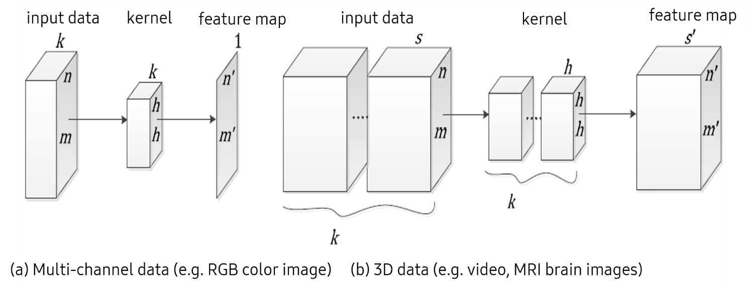

- Apply the softmax function when the output of the neural network is ${(0.4,2.0,0.001,0.32)}^{T}$ and write the result.
Answer: The softmax function is: softmax(x_i) = exp(x_i) / Σ(exp(x_j)) for all j. This converts raw outputs into probabilities that sum to 1. For example, if the output is [2.0, 1.0, 0.1], the softmax result would be approximately [0.659, 0.242, 0.099].
- Train an RNN-based time series prediction model with reference to the following code.
Answer: To complete the RNN model:
model.add(tf.keras.layers.SimpleRNN(units=50, activation='tanh', return_sequences=False))
model.add(tf.keras.layers.Dense(1))
model.compile(optimizer=tf.keras.optimizers.Adam(learning_rate=learn_rate), loss='mse')
model.fit(ts_scaled_2, ts_scaled_2, batch_size=batch_size, epochs=n_epochs, verbose=0)

import pandas as pd
import numpy as np
from sklearn.model_selection import train_test_split
from sklearn.preprocessing import MinMaxScaler
import tensorflow as tf
import matplotlib.pyplot as plt

# read data
df = pd.read_csv('data_boston.csv', header='infer', encoding='latin1')
df = df[['PRICE']]

# scale input & X, y
scaler = MinMaxScaler()
ts_scaled = scaler.fit_transform(df)

# sacle
ts_scaled_2 = ts_scaled.reshape(1, -1, 1)

# training parameters
batch_size = 1
n_epochs = 1000
learn_rate = 0.0001

# model
model = tf.keras.Sequential()
model.add(tf.keras.Input(shape=(None, 1)))

# please complete rnn based model and train

