SYNAPSE '26 | 24-HOUR HACKATHON
Vindex
AI Grievance Redressal Prioritization System
Multilingual complaint triage that runs entirely on local hardware: language, department, urgency and evidence from a local model, rules a human can edit, a reviewer for every uncertain case, and the citizen informed at every step.
Complete project report
Team Logic Makers (team ID 148372)
V.S.B. Engineering College
Final jury review: 16 October 2026
Source: github.com/Balavigneshcse/AI_Grievance_Redressal_Prioritization_System

Contents
1. Executive summary 4
1.1 Headline numbers 4
2. The problem 4
2.1 Assigned statement 4
2.2 What goes wrong today 5
2.3 Who uses it 5
2.4 Constraints the statement sets 6
2.5 Scope chosen for the hackathon 6
3. Objectives and how they were met 6
4. The solution at a glance 7
4.1 Design principles 7
4.2 End-to-end workflow 8
5. Features by role 9
5.1 Citizen 9
5.2 Department admin 9
5.3 District admin 9
5.4 Super admin 9
6. System architecture 10
6.1 Components 10
6.2 Analysis pipeline, stage by stage 11
6.3 Decision logic 11
6.4 Technology stack 12
7. The AI layer in detail 13
7.1 Models 13
7.2 Prompt and output 13
7.3 Urgency scale 13
7.4 Rules 13
7.5 Duplicates, nearby complaints and support 14
7.6 District offices and SLAs 14
8. Data model 14
8.1 Complaint status machine 15
8.2 Integrity rules 15
9. Security and privacy 15
10. User interface 16
10.1 Citizen screens 16
10.2 Staff screens 18
11. Testing and results 20
11.1 End-to-end suite 20
11.2 Gold-set replay 20
11.3 Second-opinion classifier 21
11.4 Defects found and fixed 21
11.5 Performance 21
11.6 Browser walk-through and recorded demo 22
12. Training data and evaluation data 22
13. Running the project 22
13.1 Prerequisites 22
13.2 Start 23
13.3 Accounts 23
13.4 Documents in the repository 23
14. The demo story 24
15. Limitations and roadmap 25
15.1 Known limits 25
15.2 Roadmap 25
Appendix A. API routes 26
Appendix B. How the 24 hours were spent 26

1. Executive summary
Vindex is a grievance-triage system built in the 24 hours of SYNAPSE '26 for government and corporate complaint portals. A citizen writes a complaint in Tamil, Hindi, English or a mix of them, attaches photos or a video, and shares a location. Within a second the complaint has a tracking ID and an acknowledgement email. In the background a local language model reads the text and the photos and returns the language, the department, the urgency, the exact phrases that justify them and an English summary. A rules layer, a second independent classifier and a duplicate check cross-examine that answer; anything uncertain, critical or contradictory goes to a human reviewer, and nothing is ever closed by software. The complaint is routed to the right district office with a due time from the office's service-level agreement, and every change of status reaches the citizen by email in their own language.
Everything runs on one laptop with a 4 GB graphics card: Gemma 3 4B and bge-m3 through Ollama, PostgreSQL with pgvector, a FastAPI backend and a React front end. No cloud AI service sees a single complaint. The whole system is measured rather than assumed: a 118-check end-to-end suite passes, the gold set replays at 100% department accuracy with rules, every Critical case reaches a human, and the second-opinion classifier was retrained four times on 1,644 locally generated complaints.
What the jury can see in five minutes: register with an email code, file a Tanglish complaint with an in-app video and GPS, watch it analysed on the laptop, follow it through the district admin, the water department, the citizen's reply, the resolution photo and the rating, support a neighbour's complaint instead of duplicating it, and open the map, the staff page, the metrics and the rule tester. A recorded walkthrough with subtitles ships with the repository.

1.1 Headline numbers
Measure | Result | Where it comes from
Acknowledgement with tracking ID | under 1 s | intake returns 202 before any model runs
Full analysis of text and photos | 12 to 20 s | Gemma 3 4B on an RTX 3050, 4 GB, GPU free
Department accuracy, gold set, model + rules | 100% | 12 hand-labelled complaints, model alone 83%
Critical cases that reach a human | 100% | gold set, 4 of 4; rules force review
Language identification | 92% | Tamil, Hindi, English, Tanglish, Hinglish
End-to-end checks | 118 of 118 | scripts/test_api_e2e.py, 16 Oct 2026
Second-opinion classifier, held-out department accuracy | 85 to 88% | four training rounds, 1,644 synthetic rows
Complaints auto-closed by software | 0 | by design; every decision carries a reason
Districts and offices covered | 38 districts, 760 offices | Tamil Nadu office mapping with SLA hours

2. The problem

2.1 Assigned statement
Design a multilingual natural-language-processing system for government or corporate grievance portals that reads complaints submitted in free text, identifies the subject and urgency, categorises the issue, and routes it to the appropriate department. The system should help organisations respond more quickly while keeping complainants informed about the status of their cases.

2.2 What goes wrong today
Grievance portals such as CPGRAMS, state and municipal portals and customer-support desks receive thousands of complaints a day as free text. A person reads each one, guesses the department and forwards it. Subject, urgency and routing are decided by whoever happens to read the complaint first, so outcomes are slow and inconsistent.
Symptom | Underlying cause
Serious cases wait behind routine ones | Urgency is judged first-in-first-out, not by content
Complaints bounce between departments | Routing depends on the individual reader; no shared rules
The same issue is filed three or four times | No duplicate check at intake; no acknowledgement, so the complainant resubmits
Complainants cannot be contacted | Contact details missing or malformed; nobody flags it at intake
Non-English and informal writers get worse service | Staff fluency varies; informal text is read as less serious
The complainant has no idea what happened | Status lives in internal tools; no outbound updates

A buried Critical case, a gas leak, an exposed wire or a patient on home oxygen during a power cut, costs lives, not just time. Misrouting adds days per hop and erodes trust in the portal. Staff time goes to reading and forwarding instead of resolving.
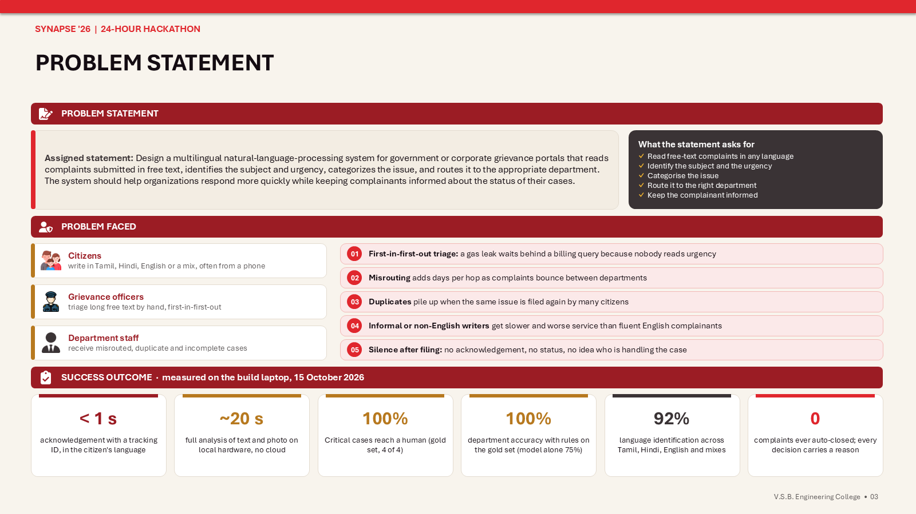
Figure 1. Problem statement, the people affected and the outcomes measured on the build laptop (from the submission deck).

2.3 Who uses it
User | Who they are | What they need
Complainant | Citizen or customer; any language, any literacy level, often on a phone | Register once, submit in their own words with photo or video and location, get an ID, know what is happening
Department admin | Engineer, inspector or support agent in one department of one district | Only relevant, de-duplicated, complete complaints with due times; a way to ask the citizen for details
District admin | Nodal officer for one Tamil Nadu district | A review queue of the uncertain and critical cases, a map, and control over the department accounts of the district
Super admin | Portal owner | Every district, staff accounts, routing rules, metrics, model reload
Auditor | RTI, ombudsman, internal audit | A full trail of who decided what and why

2.4 Constraints the statement sets
- The original text is always preserved; normalisation is additive.
- Every recommendation is explainable: evidence spans, matched rules, confidence.
- Uncertain and potentially urgent cases go to a human.
- Staff can reassign and correct; corrections are recorded.
- The model never rejects or closes a complaint on its own.
- Personal data is protected; accounts are verified; media and location are visible only to the complainant and authorised staff.
- Performance is measured per language and per complaint type.
- All models run on the organisation's own hardware. No cloud AI APIs.

2.5 Scope chosen for the hackathon
- Domain: civic and municipal grievances in Tamil Nadu. The architecture is domain-agnostic; only the taxonomy and the routing configuration change for a corporate deployment.
- Languages: English, Tamil, Hindi, and the code-mixed forms Tanglish (Tamil in Latin letters mixed with English) and Hinglish.
- Channel: email only for OTP, acknowledgement and status updates. No SMS. WhatsApp stays on the roadmap.
- Evidence: photos or a video from the in-app camera or the gallery; location from the camera, the photo's EXIF data, the device's current location, or a typed address.

3. Objectives and how they were met
The twelve measurable objectives set in the first hour, with the result at the end of the build.
ID | Objective | Target | Result
O1 | Detect the language, including code-mixed text | >= 95% | 92% on the gold set (one Hinglish row); a script hint feeds the model
O2 | Classify the category with an explanation | >= 85%, evidence on every prediction | 100% with rules on the gold set; evidence spans quoted verbatim in every analysis
O3 | Score urgency on a four-level scale | >= 85%; 100% of Critical reach review | 92% exact with rules; 100% of Critical cases reach a human
O4 | Route by configurable rules plus the model | Rules editable without redeploy; rule wins | YAML rules, hot-reloaded, editor and tester in the admin UI; rules override the model
O5 | Flag uncertain cases for human review | Confidence threshold and disagreement | Threshold 0.70, rule or second-opinion disagreement, Critical, duplicate: all go to review
O6 | Detect duplicates | >= 80% of planted duplicates | Repeat filings flagged at similarity 1.00; nearby list and me-too support stop duplicates before filing
O7 | Keep the complainant informed | Acknowledgement and every status change | Emails in the citizen's language at every step; tracking page updates itself
O8 | Measure fairness | Accuracy per language on a dashboard | Metrics page: live accuracy per language from officer corrections, eval runs, classifier report
O9 | Protect personal data | PII masked before any model call | Regex masking, map visible to staff only, name and Aadhaar digits never sent to the model
O10 | Human authority | Zero auto-closures; overrides recorded | No code path closes a complaint; every decision stores who, when and why
O11 | Verified identity | Email OTP, strong password, OTP expiry | Argon2 hashes, 6-digit OTP, 10-minute expiry, 5 attempts, rate limits
O12 | Evidence and location capture | Camera, EXIF, current location, manual | All four sources work; offline reverse geocoding to a locality and district

4. The solution at a glance
Vindex is a triage layer in front of a grievance portal: text, photos and a location go in; department, urgency, office, due time and a status email come out, with a human reviewer in the loop for every case the system is not sure about.
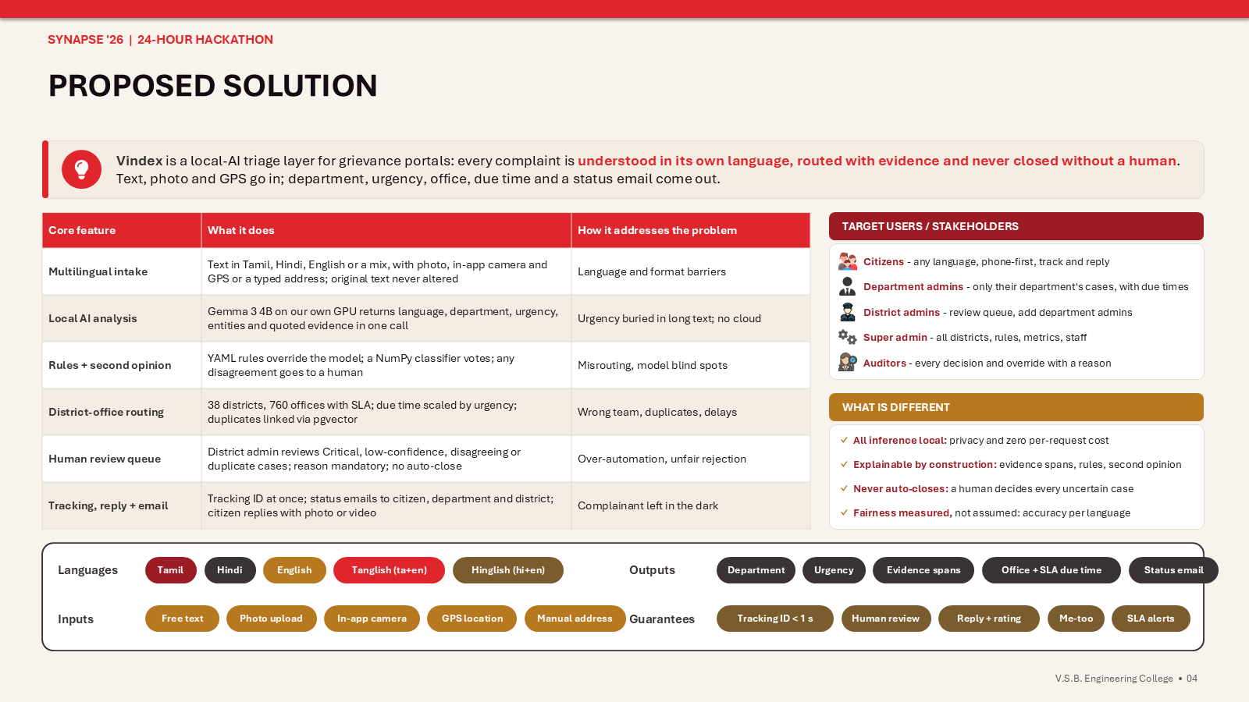
Figure 2. Core features, target users and what makes Vindex different (from the submission deck).

4.1 Design principles
- Local-first. Every model runs on the organisation's own machine through Ollama. Complaint text, photos and location never leave it; there is no per-request cost and it works without internet.
- Human authority. The system recommends, a person decides. Uncertain, Critical, disagreeing and duplicate cases pass through a reviewer. Nothing is auto-closed.
- Explainable by construction. Every recommendation carries evidence spans, matched rules, image findings, the second opinion and a confidence score.
- Configuration over code. Departments, the urgency scale, routing rules and the district-office mapping are files an administrator edits; rules reload without a restart.
- Asynchronous analysis. The citizen gets an ID instantly; the model works in the background and the page updates when it finishes.
- Fail safe, not fail silent. A model timeout or error sends the case to the review queue as awaiting analysis; an email that cannot be sent is retried from an outbox, never lost.
- Fairness measured, not assumed. Formality, length and language are never urgency signals; accuracy is tracked per language.

4.2 End-to-end workflow
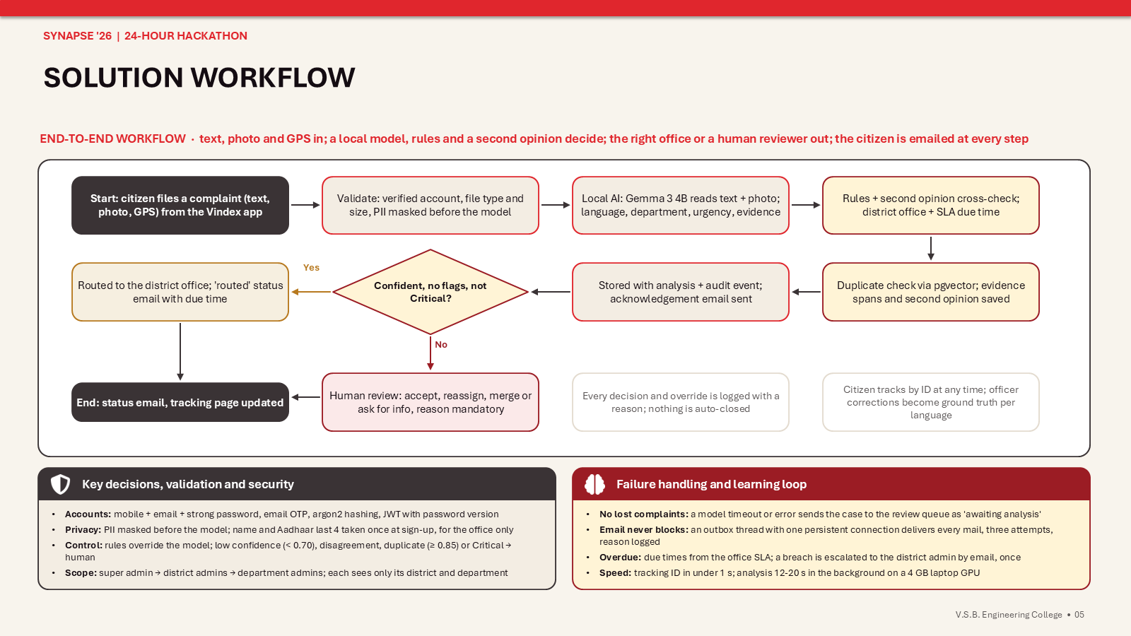
Figure 3. Solution workflow: from filing to the status email, with the human review branch (from the submission deck).
- Account: register with name, mobile, email, the last four Aadhaar digits and a strong password; the account activates after an email OTP.
- Intake: the raw text, media files and location are stored untouched; a tracking ID is issued and the acknowledgement is queued; the analysis job is enqueued.
- Language hint: Unicode script detection and a function-word detector label the text as Tamil, Hindi, English, Tanglish or Hinglish for the model prompt.
- PII masking: phone numbers, Aadhaar, PAN, email addresses and PIN codes are replaced by placeholders before the text reaches the model; the map is kept for staff.
- Location: camera GPS, photo EXIF, the device's position or a typed address is resolved offline to a locality and district.
- Local AI: Gemma 3 4B reads the masked text and up to three photos and returns a JSON object with language, department, urgency, confidence, entities, evidence spans, image findings and an English summary.
- Cross-checks: bge-m3 embeddings feed a pgvector duplicate search and a NumPy second-opinion classifier; the YAML rules can override the department, raise the urgency floor or force a review.
- Decision: confident, not Critical, no disagreement and no duplicate: routed straight to the district office with a due time. Otherwise: the district admin's review queue.
- Review and work: district admins accept, reassign, merge or ask for information; department admins accept, request details, attach proof and resolve; every action needs a reason.
- Closing the loop: the citizen replies, rates the resolution or reopens it; neighbours support an open complaint instead of filing again; overdue cases escalate by email.

5. Features by role

5.1 Citizen
- Registration with name, mobile, email, Aadhaar last four digits, strong password and preferred language; email OTP; password reset by OTP.
- Complaint in any language or script; the script badge updates while typing; the "Filing as" line shows the name and Aadhaar digits from the account, never retyped.
- Evidence: in-app camera for photos or a video of up to five minutes with the location captured, or uploads from the gallery; photos up to 25 MB, videos up to 100 MB.
- Location: map pin, "Use current location", or a typed address; the resolved locality is shown.
- Nearby open complaints are listed once a location is set; one tap supports one instead of filing a duplicate.
- Tracking page: status, department, urgency, language, summary, why this department, matched rules, attachments, timeline; updates itself every three seconds.
- Reply to a request for information with text, photos or a video; the office is notified and the case continues.
- After resolution: see the office's proof photo, rate one to five stars with a note, or reopen within seven days.
- Emails in the chosen language at every step: OTP, acknowledgement, under review, routed, in progress, awaiting your reply, resolved; officer notes translated into Tamil or Hindi.
- The whole interface in English, Tamil or Hindi.

5.2 Department admin
- Sees only the complaints of its department in its district: routed, in progress and awaiting information, with due times and overdue flags.
- Accept starts the work; Request info asks the citizen a question; Reassign, Merge, Resolve and Close are available with a mandatory reason.
- Full detail: masked text with the PII map, evidence spans, image findings, the model's confidence, the rules that matched, the second opinion, duplicate candidates, the office and the SLA.
- Attaches resolution photos or videos as proof; the citizen sees them on the tracking page.
- Is emailed when a case is routed, reassigned, replied to, reopened or overdue.

5.3 District admin
- Review queue of its district: Critical, low-confidence, disagreeing and duplicate cases; nothing in it closes without a person.
- Accept, reassign to another department or urgency, merge duplicates, request information, resolve or close, each with a reason that becomes part of the audit trail.
- District map with markers by urgency, a red ring for overdue cases and marker size growing with supporters.
- Creates and disables the department admin accounts of its district; changes a staff email so mails reach a real inbox.
- Is emailed when a case needs review and when a case passes its due time.

5.4 Super admin
- Every district: queue with four views (needs review, active work, resolved, all), search by tracking ID, name or words, filters by department, urgency, language and district.
- Staff and districts page: complaints per district, staff accounts per district, creation of district and department admins with a one-time generated password.
- Rules page: the routing rules with their keywords in three languages, a YAML editor with a change log, a tester that shows which rules match a text, and a one-click reload of the retrained classifier.
- Metrics page: totals, by status and department, live accuracy per language from officer corrections, the second-opinion report, the gold-set evaluation runs, average rating, reopen rate, supporters, model latency and outbox health.

6. System architecture
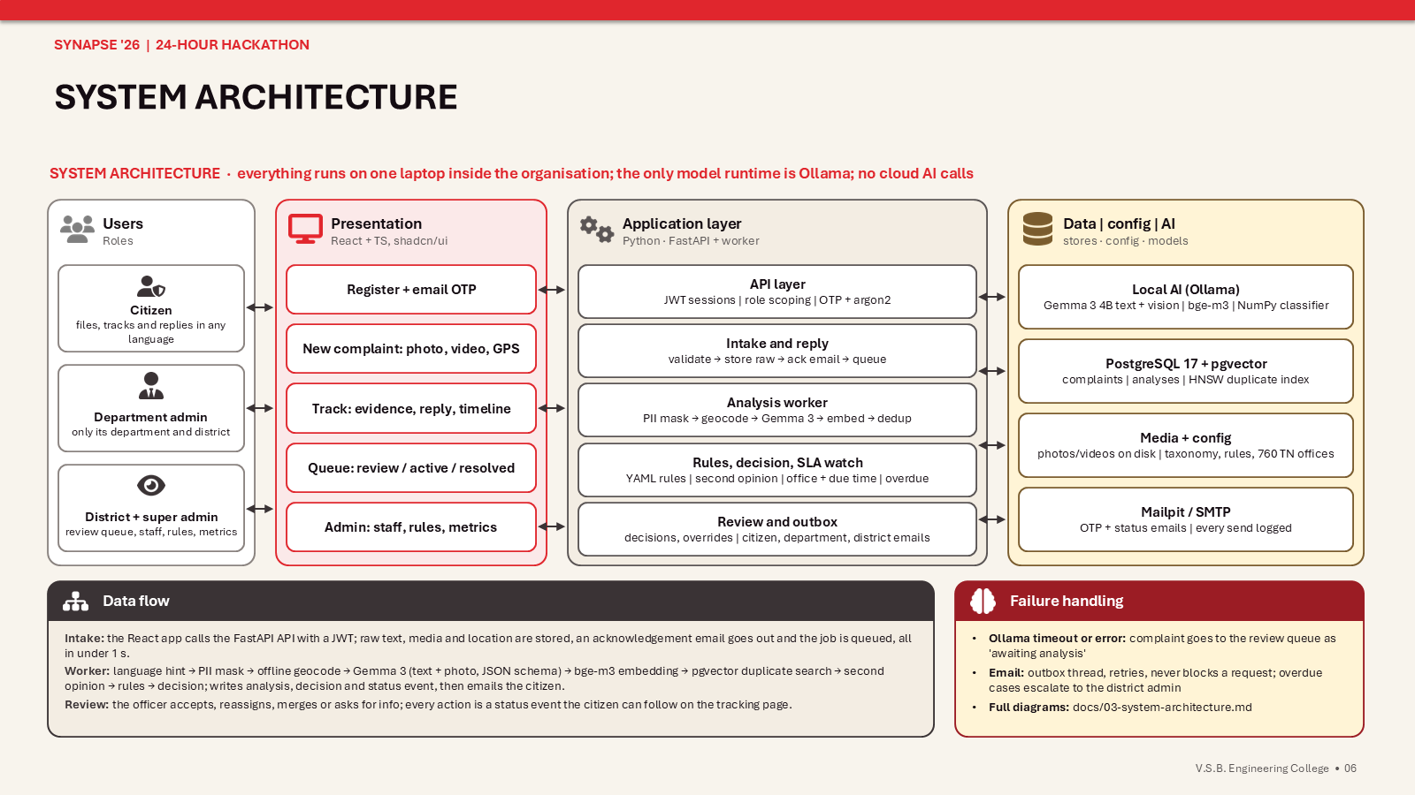
Figure 4. System architecture: users, presentation, application layer, data and AI, with the data flow and failure handling (from the submission deck).

6.1 Components
Component | Responsibility | Where
Web client | Citizen portal, officer console and admin pages in one responsive React app; camera, geolocation and map through browser APIs; three interface languages | frontend/ (React 18, Vite, Tailwind v4, shadcn/ui, lucide-react, react-leaflet, i18next)
API server | Authentication, intake, tracking, review, staff, rules, metrics, map; OpenAPI documentation at /docs | backend/app/main.py and backend/app/api/
Analysis worker | One background thread per process runs the pipeline stage by stage and never blocks a request; a second thread watches SLAs every minute | backend/app/services/worker.py, pipeline.py, sla.py
Rules engine | Loads config/rules.yaml, matches keywords in three languages and romanised forms, returns forced department, urgency floor and force-review; hot reload | backend/app/services/rules.py
Notifier | Outbox: every mail is a queued row delivered by one persistent SMTP connection with three attempts; staff routing; translation of officer notes; demo-domain skip on real mail servers | backend/app/services/notifier.py, translate.py
Ollama runtime | Serves Gemma 3 4B (text and vision, JSON-schema output) and bge-m3 embeddings; one request at a time on the 4 GB card | localhost:11434
Storage | PostgreSQL 17 with pgvector (Docker Compose, port 5434), media files on disk, YAML and JSON configuration, Mailpit for local mail | docker-compose.yml, media/, config/

6.2 Analysis pipeline, stage by stage
Stage | Input | Output | Time
1 Language hint | raw text | script and function-word based label: ta, hi, en, ta-en, hi-en | 1 ms
2 PII mask | raw text | masked text and an entity map kept for staff | 1 ms
3 Geo resolve | GPS, EXIF or address | locality, district, source tag (offline table of Tamil Nadu places) | 10 ms
4 LLM analysis | masked text, up to three photos, taxonomy, urgency scale | JSON: language, department, urgency, confidence, entities, evidence spans, image findings, summary | 10 to 20 s
5 Embedding | English summary | 1024-dimension vector from bge-m3 (CPU) | about 2 s
6 Duplicate search | vector, location, user | open complaints above similarity 0.85 near the same place | 5 ms
7 Second opinion | vector | department and probability from the NumPy classifier | 1 ms
8 Rules | text, language, model output | forced department, urgency floor, force review, matched rule IDs | 1 ms
9 District office | district, department, keywords | office name, department code, due time from the SLA scaled by urgency | 1 ms
10 Decision | everything above | department queue or review queue with the list of reasons; status event; emails | 1 ms

6.3 Decision logic
urgency = max(model.urgency, rules.urgency_floor)
department = rules.department or model.department

route to REVIEW if any of:
rules.force_review
urgency == Critical
model.confidence < 0.70
rules.department set and different from the model's (disagreement)
second_opinion.department differs and its probability > 0.6 (disagreement)
duplicate.score >= 0.85 (merge candidate)
analysis failed or timed out (awaiting analysis)
else route to the DEPARTMENT queue of the district office
Never: auto-close, auto-reject.
Every reason that fired is stored with the decision and shown to the reviewer. The due time is the office's SLA in hours multiplied by 0.25 for Critical, 0.5 for High, 1 for Medium and 3 for Low.

6.4 Technology stack
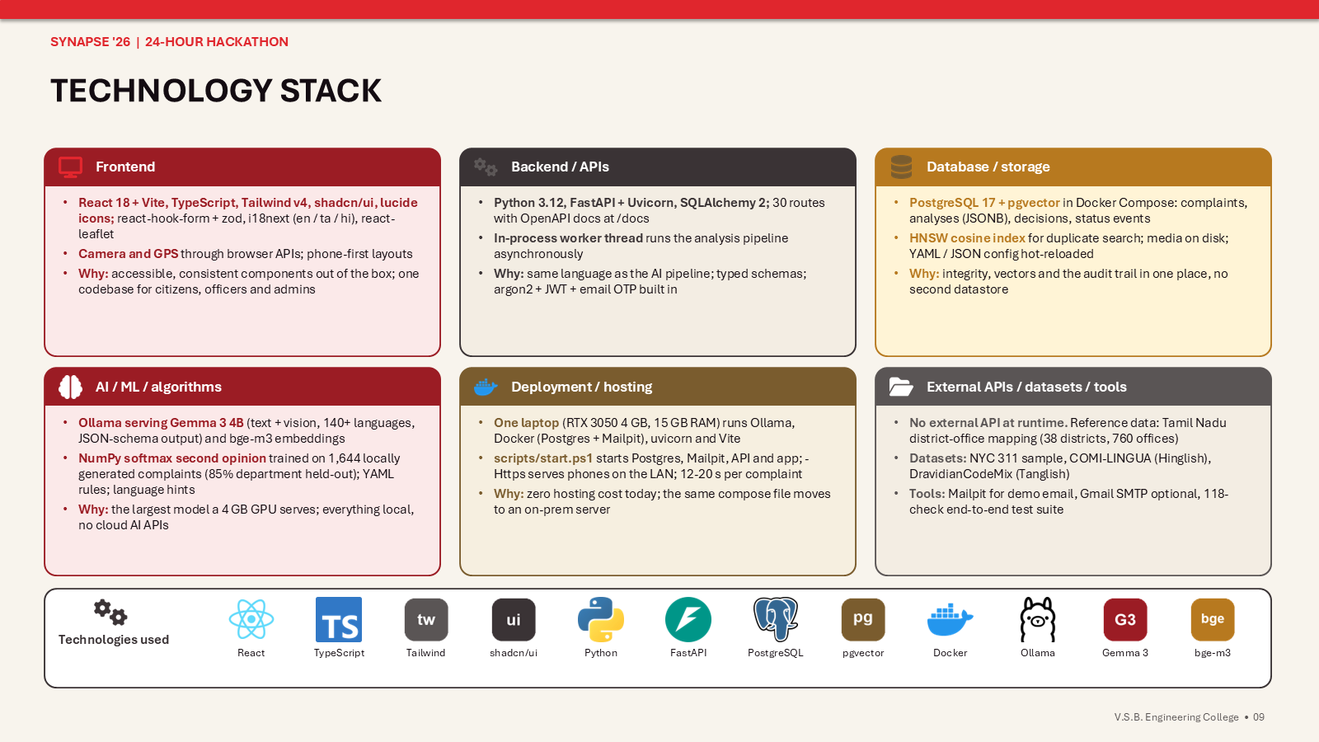
Figure 5. Technology stack and the reasons for each choice (from the submission deck).
Layer | Choice | Why
Front end | React 18 + Vite, TypeScript, Tailwind v4, shadcn/ui on Base UI, lucide-react, react-hook-form + zod, i18next, react-leaflet | Accessible components out of the box, one code base for citizens and staff, browser camera and GPS, three languages from JSON dictionaries
Back end | Python 3.12, FastAPI, Uvicorn, SQLAlchemy 2, Pydantic | Same language as the AI pipeline, typed schemas that double as the model's JSON schema, OpenAPI docs
Database | PostgreSQL 17 + pgvector, psycopg 3, Docker Compose | Relational integrity for an audit-heavy system, jsonb for explanations, HNSW vector index beside the complaint rows
AI | Ollama serving gemma3:4b and bge-m3; NumPy softmax regression | Largest vision-capable model a 4 GB card serves; strongest open multilingual embeddings; a classifier that trains in seconds without scipy
Security | argon2-cffi, PyJWT with a password version, hashed OTPs, in-memory rate limiter | Standard primitives, no third-party identity provider, every session invalidated on reset or disable
Email | smtplib to Mailpit locally or Gmail SMTP with an app password | OTP and status mails visible in a local inbox for the demo, a real server by environment variable
Config | YAML rules, taxonomy and urgency scale; JSON district-office mapping; CSV places | Editable without a redeploy, diffable in git, hot-reloaded

Two constraints shaped the stack: the build laptop has an RTX 3050 with 4 GB of VRAM and 15 GB of RAM, and its Windows Application Control blocks unsigned native libraries, so torch, scipy and fastText do not load. Every model therefore runs inside Ollama, a signed binary, and the Python service uses only NumPy, pandas and Pillow on the native side.

7. The AI layer in detail

7.1 Models
Job | Model | Notes
Text and vision analysis | Gemma 3 4B, instruction-tuned, through Ollama | 140+ languages, image input, 128K context; the largest model that sits on the 4 GB card; JSON-schema constrained output so the answer always parses; kept loaded with a two-hour keep-alive
Embeddings | bge-m3 (567M parameters, 1024 dimensions) through Ollama | Strongest open multilingual embedding model; runs on the CPU so Gemma keeps the GPU; used for duplicates and the second opinion
Second opinion | Softmax regression written in NumPy on bge-m3 embeddings | Trained on the locally generated set; votes on the department only; disagreement with the model sends the case to a human
Language hint | Unicode script detection plus a romanised function-word detector | Tamil script, Devanagari, or Latin letters classified as English, Tanglish or Hinglish; the model makes the final call
Translation of officer notes | Gemma 3 4B | An English resolve or request note is translated into the citizen's Tamil or Hindi for the status mail; the answer is checked for the right script and cached

Measured on the build laptop: Gemma 3 4B answers a complaint in 12 to 20 seconds with the GPU free (10 to 11 tokens per second, 15 of 35 layers on the card after the desktop's share); the cold load adds 14 to 28 seconds once. Ollama runs one request at a time on this card, so the analysis worker, the translation step and any training script share one queue; the demo runbook therefore forbids running the data generator during a demo.

7.2 Prompt and output
The system prompt fixes the department taxonomy, the four-level urgency scale and the instruction that formality, grammar and language are never urgency signals. The language hint and the masked text follow, with the photos attached. Ollama's format parameter receives the JSON schema in config/analysis_schema.json, so the model returns exactly: language (primary and secondary), department, urgency, confidence from 0 to 1, entities, evidence spans copied verbatim from the original text, image findings with a flag for whether the picture matches the text, and a one-sentence English summary. The output stays under 200 tokens because output length is latency.

7.3 Urgency scale
Level | Criteria
Critical | Immediate risk to life or safety; medical dependency; a vulnerable person (child, elderly, disabled) affected now
High | Essential service fully down (no water, no power, sewage overflow); time-bound deadline; repeat complaint
Medium | Service degraded or partial; property damage; billing dispute with financial impact
Low | Information request, suggestion, cosmetic issue, general feedback

7.4 Rules
Rules live in config/rules.yaml and win over the model: a matched department replaces the model's, an urgency floor raises but never lowers urgency, and force review sends the case to a human whatever the confidence. Keywords are matched case-insensitively and as whole words against the original text in Tamil script, Devanagari, English and romanised spellings. The super admin edits the file in the browser with a change note; every save is logged and applied at once.
Rule | Trigger (examples of the keywords) | Action
R1 Gas leak | gas leak, கேஸ் லீக், எரிவாயு கசிவு, gas ki badbu, गैस लीक | Fire and Safety, Critical, forced review
R2 Medical dependency on power | oxygen, dialysis, ventilator, insulin in three scripts | Critical, forced review
R3 Exposed or hanging wire | hanging wire, live wire, மின் கம்பி, नंगा तार, electric pole leaning | Fire and Safety, Critical, forced review
R4 Fire or collapse | fire, தீ, आग, collapse, இடிந்து, building crack | Fire and Safety, Critical, forced review
R5 Water supply | thanni, thanneer, தண்ணீர், paani, पानी, no water | Water Supply
R5b Street light | street light, தெருவிளக்கு, स्ट्रीट लाइट, light eriyala | Roads and Infrastructure
R6 Sewage into homes | sewage inside, drainage water inside, கழிவுநீர் வீட்டுக்குள் | Sanitation, floor High
R7 Disease cluster | dengue, malaria, cholera, typhoid, many people sick | Public Health, floor High
R8 Repeat complaint | repeat, again, already complained, மீண்டும், फिर से | floor High
R10 Children affected | kids sick, child, குழந்தை, बच्चे with illness words | floor Critical, forced review

7.5 Duplicates, nearby complaints and support
The English summary of every complaint is embedded with bge-m3 and stored in a pgvector column with an HNSW index. A new complaint is compared with the open complaints near the same location; a cosine similarity of 0.85 or more flags it as a possible duplicate and sends it to review, where the officer can merge it into the original (the merged complaint keeps receiving the original's updates). Duplicates are also prevented before they exist: once a citizen sets a location on the form, open complaints within two kilometres are listed with a Support button. Supporting raises a counter shown in the queue and on the map; five supporters raise the urgency one level, once, and three mark the case as popular.

7.6 District offices and SLAs
A Tamil Nadu reference sheet supplied by the team (38 districts, 20 departments, 760 district-office rows with SLA hours and 41 keyword hints) is imported into config/tn_mapping.json. The locality resolved from the location gives the district; the department and the keyword hints pick the office (for example Street Lighting under Roads), and the due time is the office SLA scaled by urgency. The SLA watcher escalates an open complaint that passes its due time exactly once: a timeline note, an overdue flag in the queue and on the map, and an email to the district and department admins.

8. Data model
PostgreSQL 17 with the pgvector extension, accessed through SQLAlchemy 2. Native types are used where they pay off: uuid primary keys, jsonb for evidence spans, entities, reasons and duplicate candidates, vector(1024) for the embedding, timestamptz everywhere. Media files live on disk under media/ and are referenced by path. Three rules shape the schema: the raw complaint text is immutable, every automated decision and every human action is its own row, and closing is a human act.
Table | One row per | Key columns
users | registered person | mobile, email, argon2 password hash and version, role (complainant, dept_admin, district_admin, super_admin), department, district, full name, Aadhaar last 4, preferred language, verified, active
otps | code issued | purpose (register, reset), hashed code, 10-minute expiry, attempts, consumed
departments | department | id and names in English, Tamil and Hindi, seeded from config/taxonomy.yaml
complaints | complaint, current state | tracking ID, raw text, language hint, status, department, urgency, location and its source, resolved place, district, office, due time, duplicate_of, complainant name and Aadhaar last 4, escalated_at, rating, reopen count, supporters
media | photo or video | kind, path, mime, size, EXIF GPS, captured in app, role (evidence or resolution), uploaded by
analyses | pipeline run | models used, languages, predicted department and urgency, confidence, English summary, evidence spans, entities, image findings, masked text, PII map, embedding, second opinion, matched rules, duplicate candidates, latency
decisions | automated routing decision | queue, department, urgency, reasons
overrides | staff action | action, from and to department or urgency, merged into, reason (required), actor
status_events | status change | from, to, actor type, note; the citizen's timeline
notifications | mail | template, language, subject, body, English note awaiting translation, status (queued, sent, failed, skipped)
supports | me-too | complaint and supporter, unique per pair
rule_changes | edit to rules.yaml | YAML before and after, note, admin

8.1 Complaint status machine
received -> analysing -> routed (confident, not Critical, no flags)
-> under_review (low confidence, Critical, disagreement, duplicate, model failure)
under_review -> routed | merged | awaiting_info | resolved | closed (staff decision with a reason)
routed -> in_progress (department admin accepts) -> awaiting_info -> in_progress (citizen replies)
in_progress -> resolved -> closed ; resolved or closed -> in_progress (citizen reopens within 7 days)
Only the analysing transitions are made by software, and analysing never leads to resolved, closed or a rejection. under_review is the safety net; awaiting_info keeps the complaint open, so nothing is dropped for being incomplete. Every transition writes a status_events row in the same transaction.

8.2 Integrity rules
- raw_text has no update path; masked text, translations and summaries live in analyses.
- Every override needs a non-empty reason; the confirm button stays disabled until one is typed.
- duplicate_of may only point at a complaint that is not itself a duplicate.
- Media and complaint detail routes check that the requester is the owner or staff inside scope; the PII map and the second opinion are removed from every citizen response.
- Deletes are not exposed; records are retained for audit.

9. Security and privacy
Concern | How it is met
Accounts | Mobile, email, name and Aadhaar last 4 at registration; passwords need 8+ characters with upper, lower, digit and symbol and are hashed with argon2; the account activates only after a 6-digit email OTP that expires in 10 minutes and allows 5 attempts
Sessions | JWT carrying the user's password version; a password reset or a disabled account invalidates every open session
Rate limits | Login 30 per minute per address and 10 per minute per email, registration 20 per 10 minutes, OTP resend and forgot-password 3 per 10 minutes per email, OTP verify 10 per 10 minutes; 429 with Retry-After
Personal data in text | Phone numbers, Aadhaar, PAN, emails and PIN codes are masked before the model sees the text; the map is stored and shown only to staff
Identity | Only the last four Aadhaar digits are ever stored; name and digits are copied onto each complaint for the office and never reach the model
Media and location | Served through authenticated routes to the owner and staff inside scope; file type and size checked; uploads streamed to disk in 1 MB pieces
Scope | Department admins see one department of one district, district admins one district, super admins everything; the API enforces it on every route (403 otherwise)
Audit | Every automated decision, override, status change, mail and rule edit is a row with actor, time and reason
Locality of data | All inference runs on the organisation's hardware; no cloud AI API; map tiles are the only external request and carry no complaint data

10. User interface
One responsive React application serves citizens on phones and staff on desktops. Components come from shadcn/ui with lucide icons; every string passes through i18next with English, Tamil and Hindi dictionaries, and the language switcher sits in the header of every screen. Urgency and status are always badges with an icon as well as a colour. The screens below are frames from the recorded demo.

10.1 Citizen screens
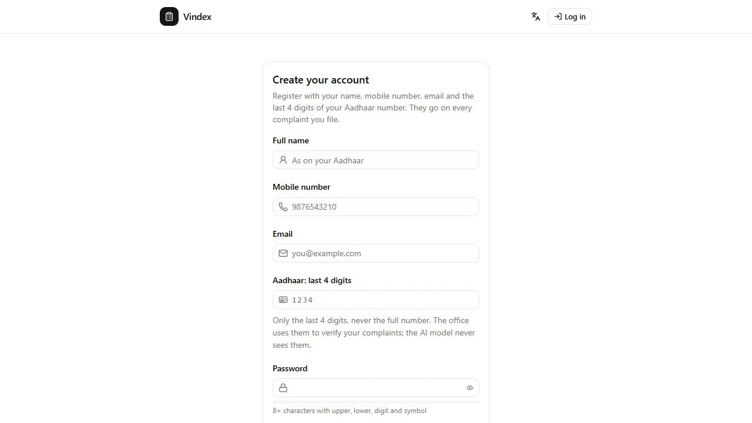  Figure 6. Registration: name, mobile, email, Aadhaar last 4, password strength, language. | 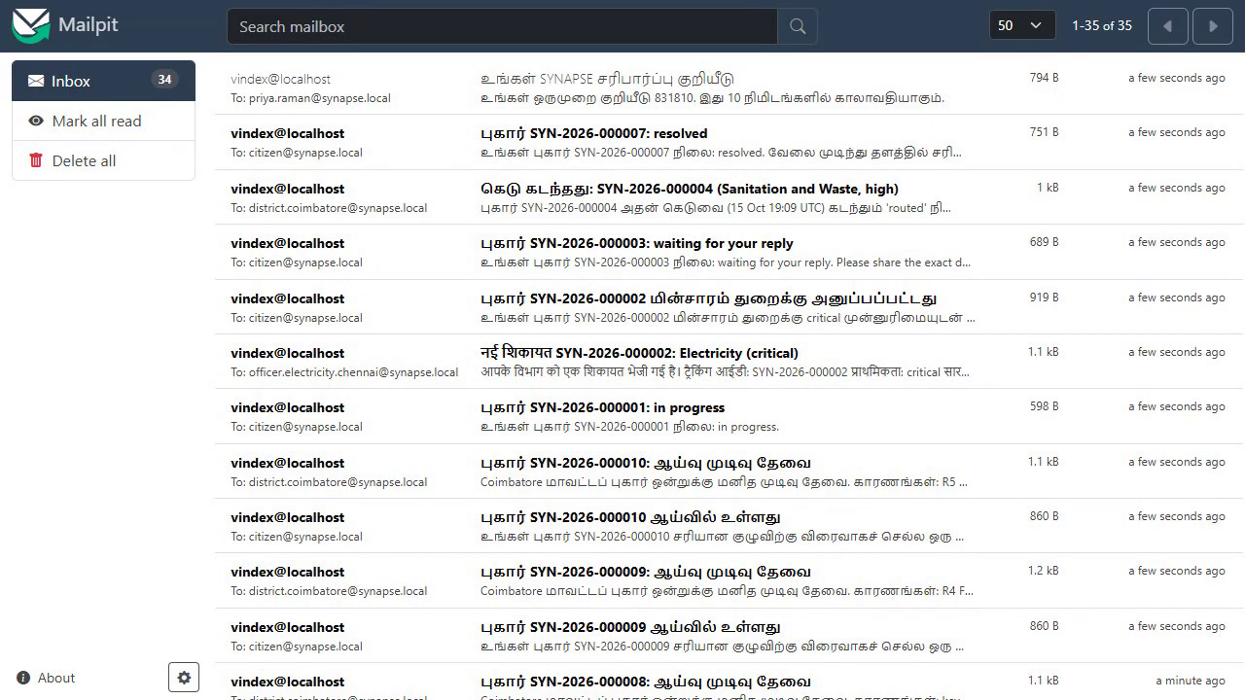  Figure 7. The OTP mail in Tamil in the local Mailpit inbox.
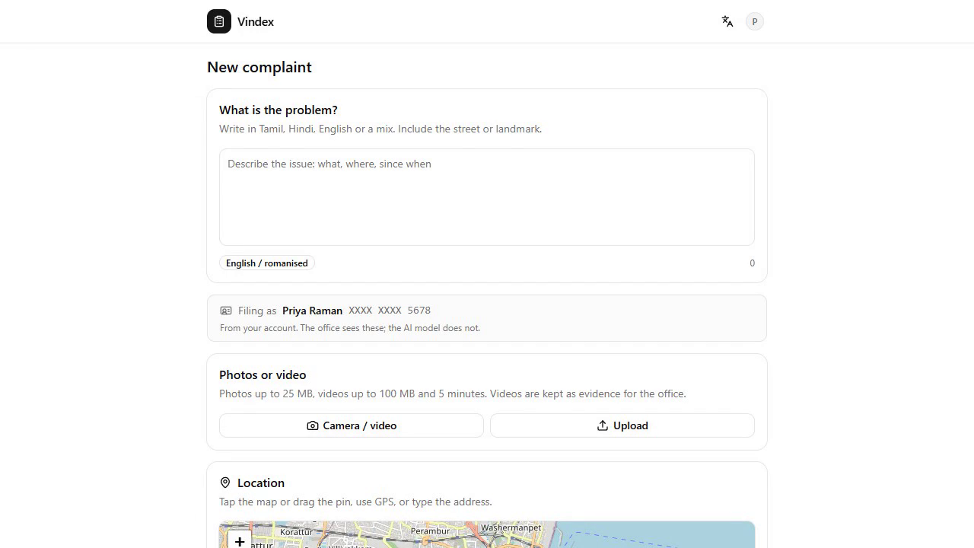  Figure 8. New complaint: free text with the script badge and the 'Filing as' line from the account. | 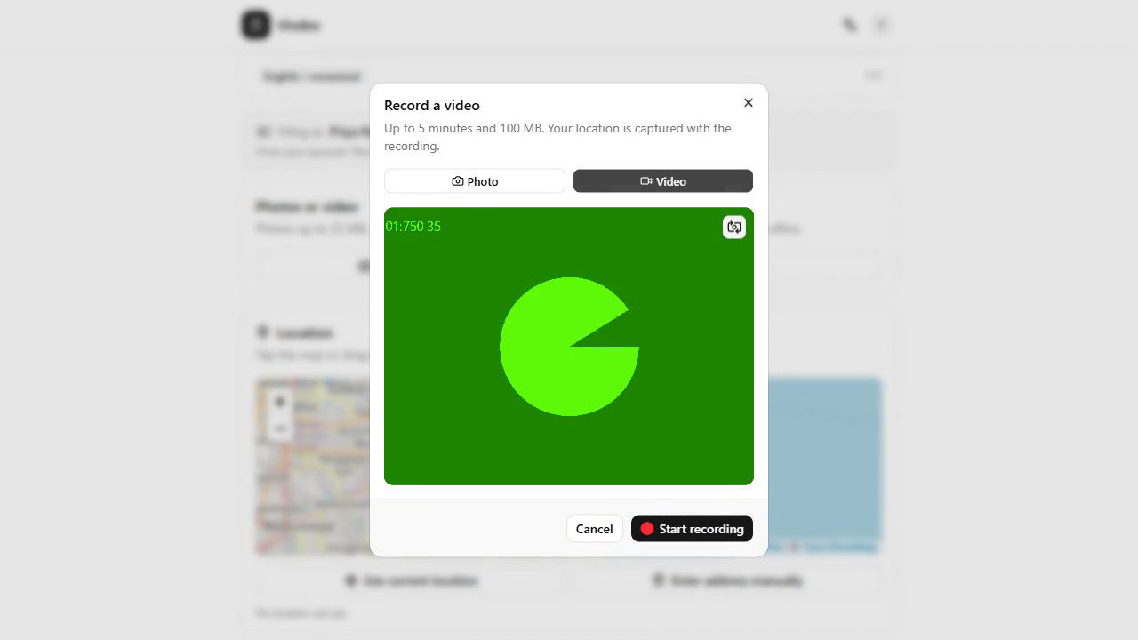  Figure 9. In-app camera in video mode with the running clock.
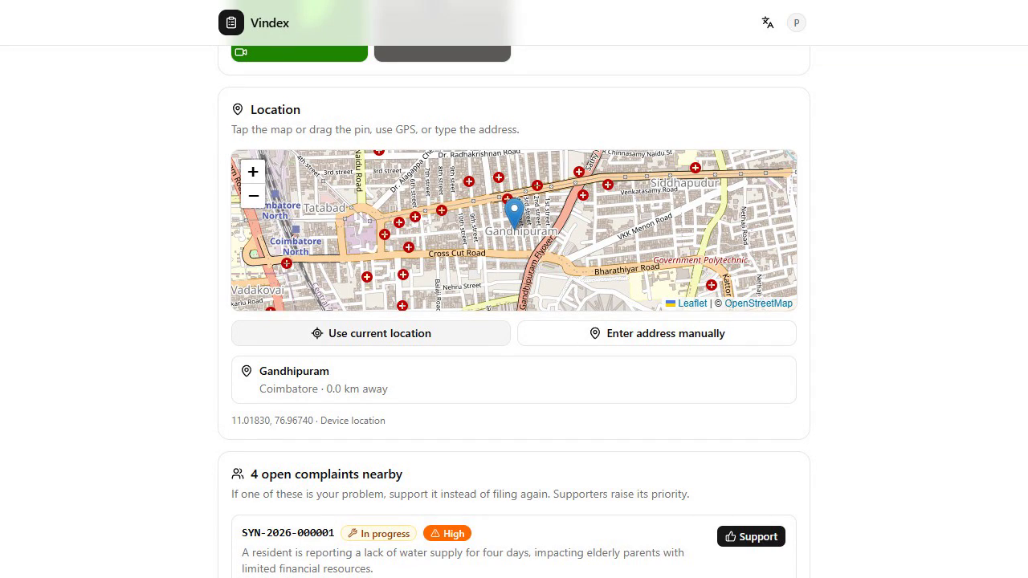  Figure 10. Location card: map pin, current location, typed address; resolved to Gandhipuram, Coimbatore. | 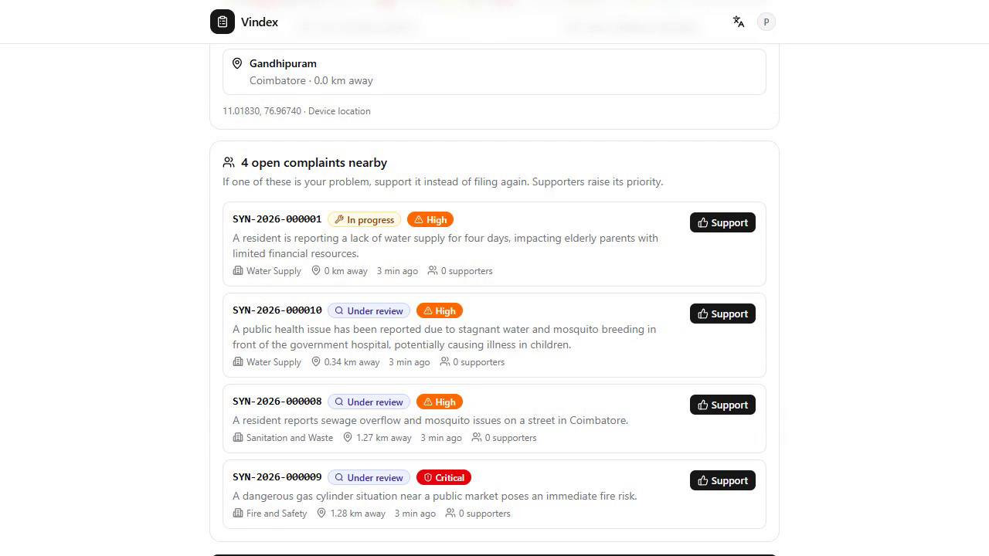  Figure 11. Open complaints nearby with a Support button.
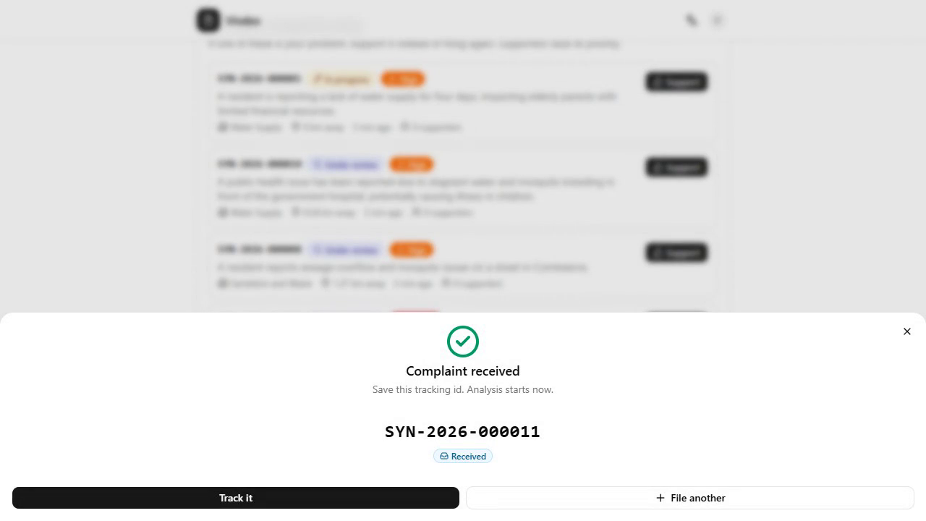  Figure 12. Complaint received: tracking ID in under a second. | 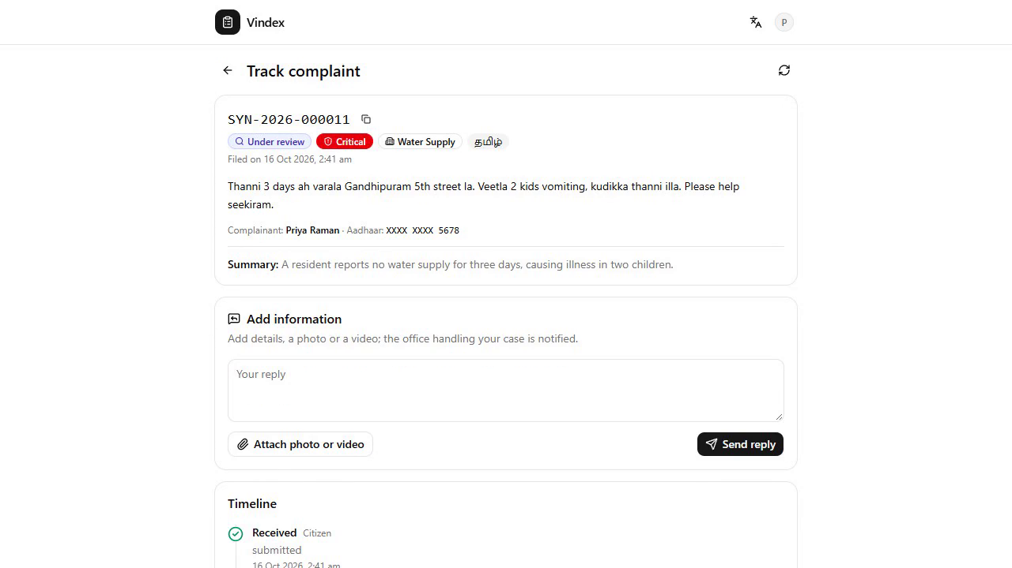  Figure 13. Tracking page after analysis: Water Supply, Critical, Tamil-English, summary and reply box.
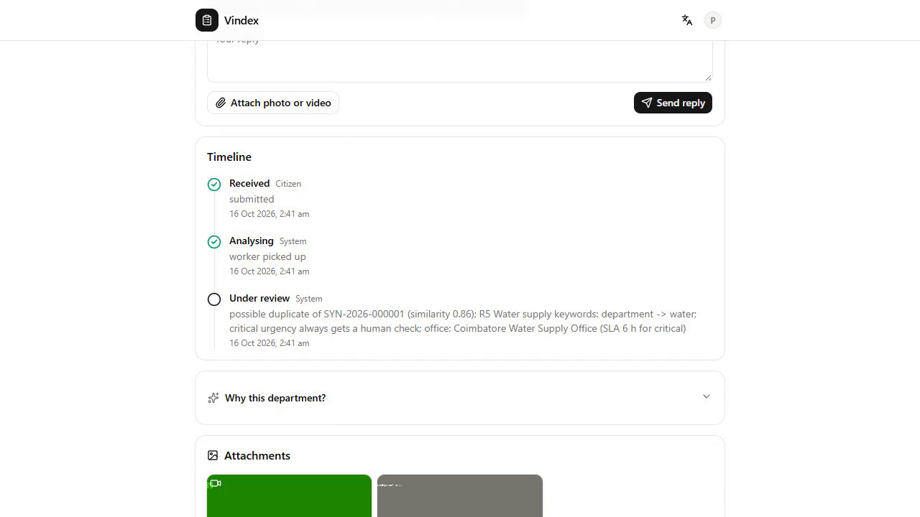  Figure 14. Why this department: evidence spans, rules, second opinion, office and due time. | 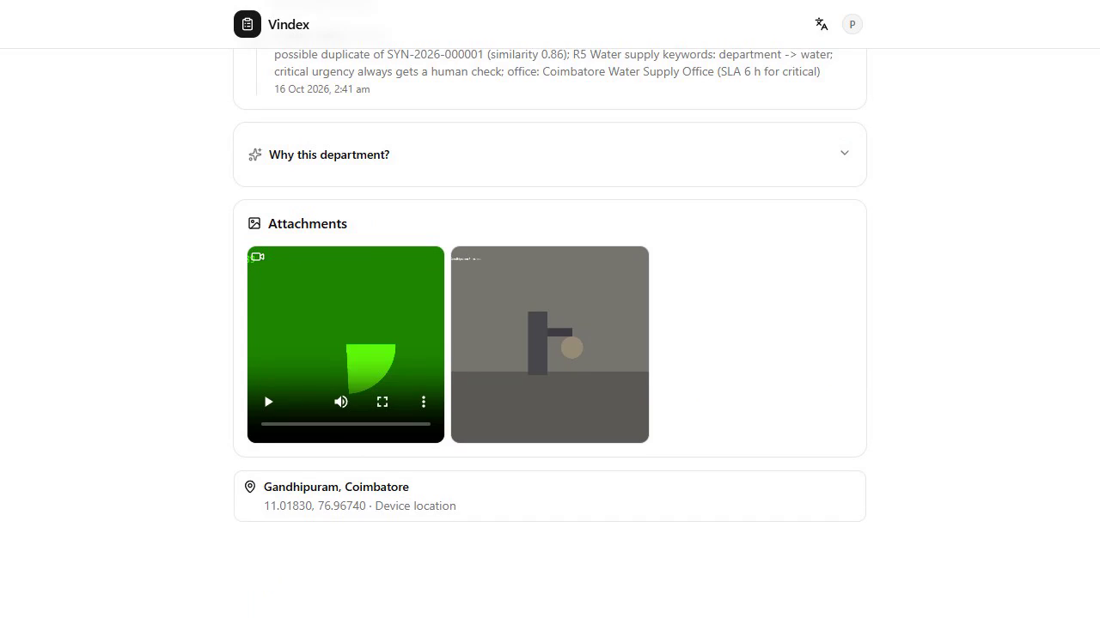  Figure 15. Timeline of status events including the citizen's reply.
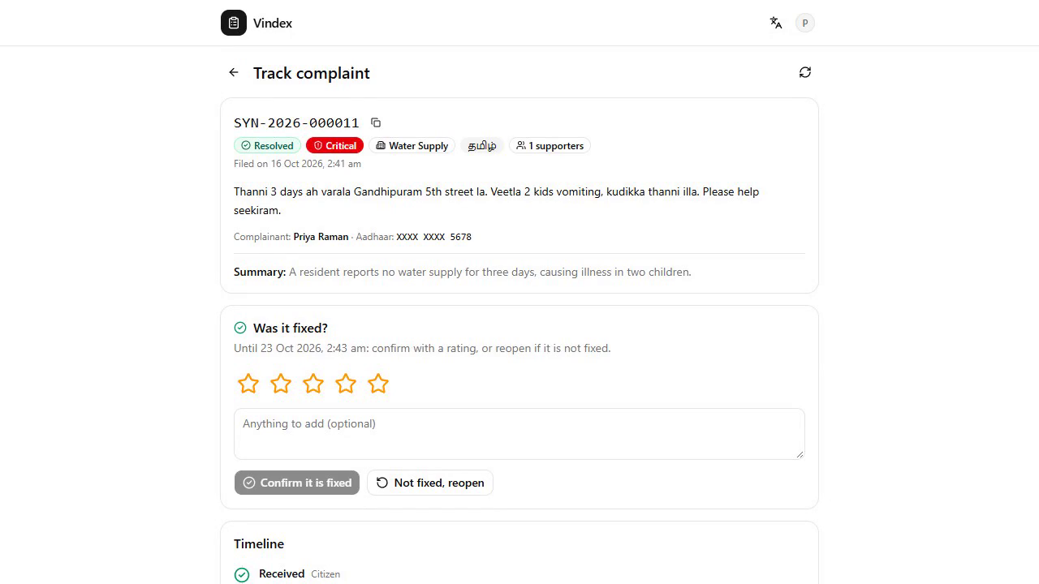  Figure 16. After resolution: proof photo, rating and the reopen option. | 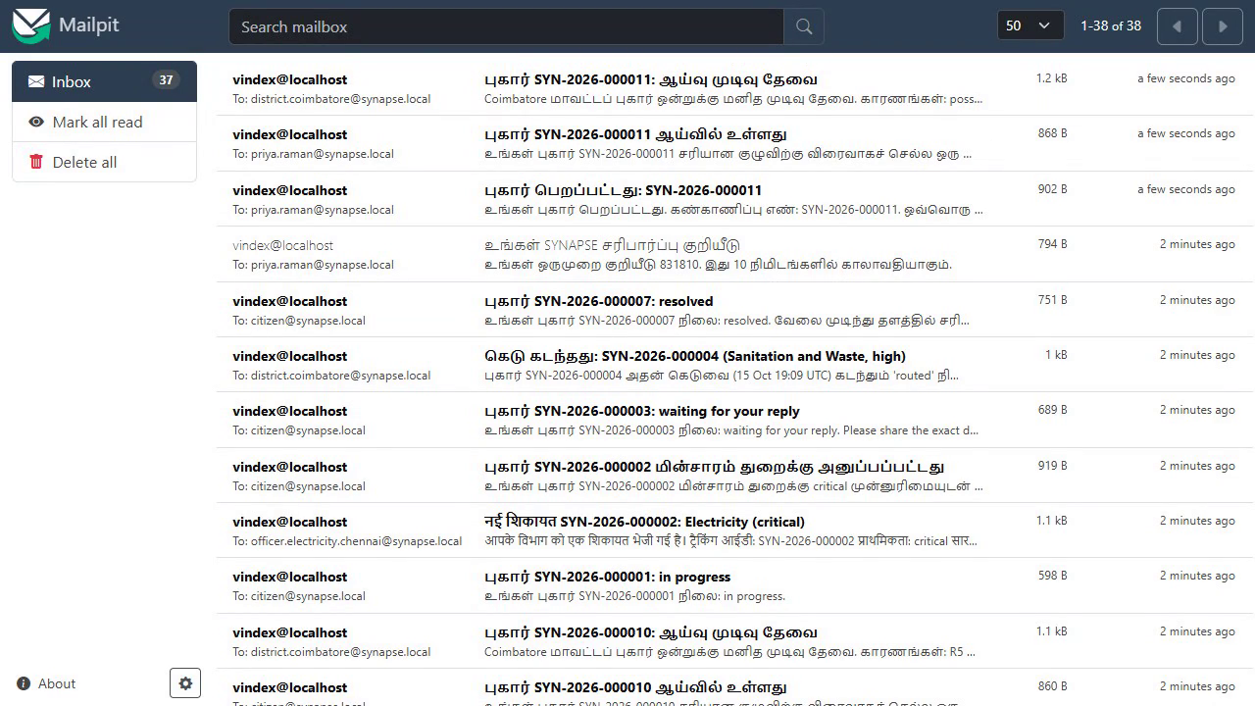  Figure 17. Acknowledgement and under-review mails in Tamil.

10.2 Staff screens
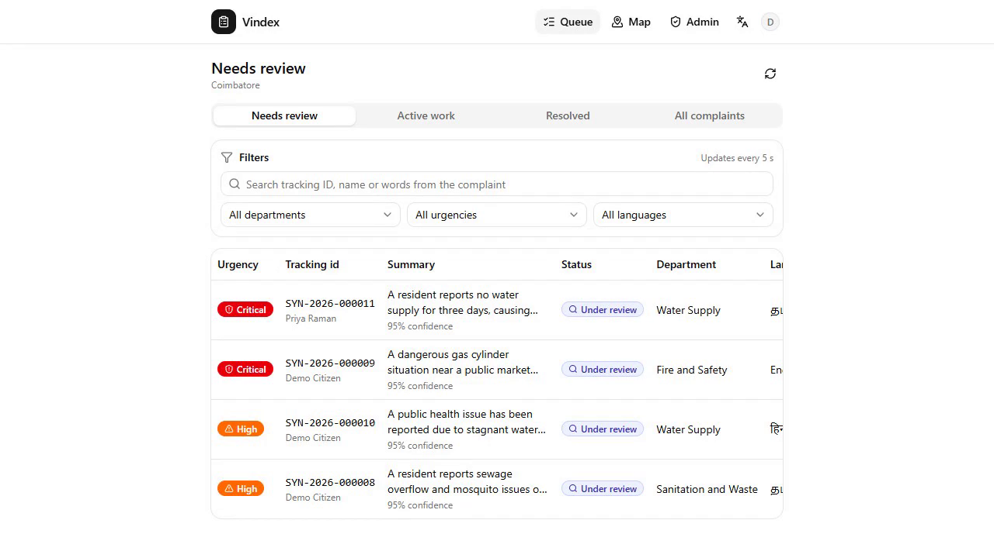  Figure 18. District admin's review queue with urgency, confidence and flags. | 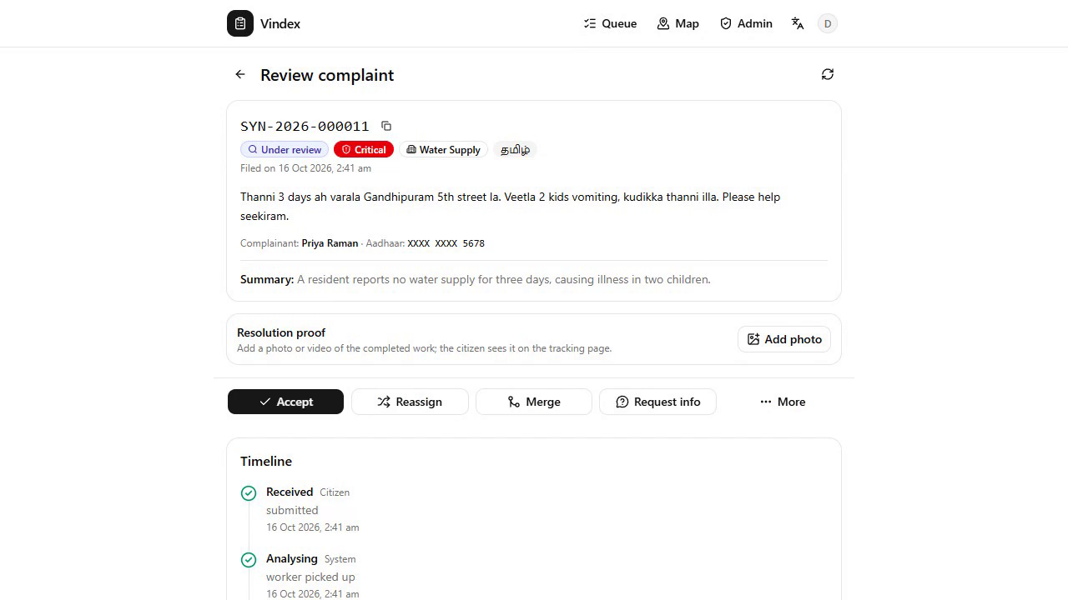  Figure 19. Staff detail: masked text, PII map, model reasoning, decision bar.
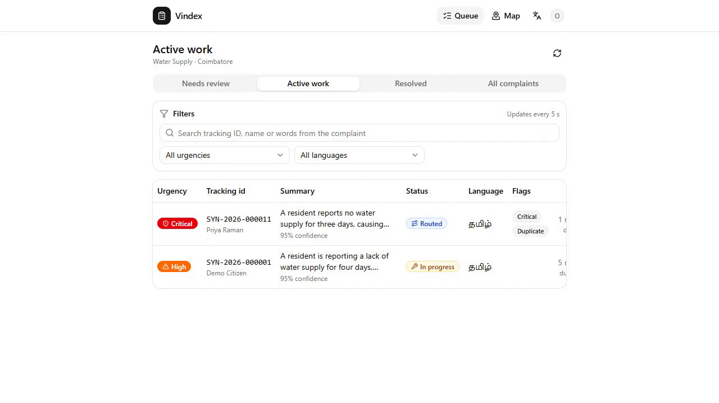  Figure 20. Department admin's active work: only water, only Coimbatore, with due times. | 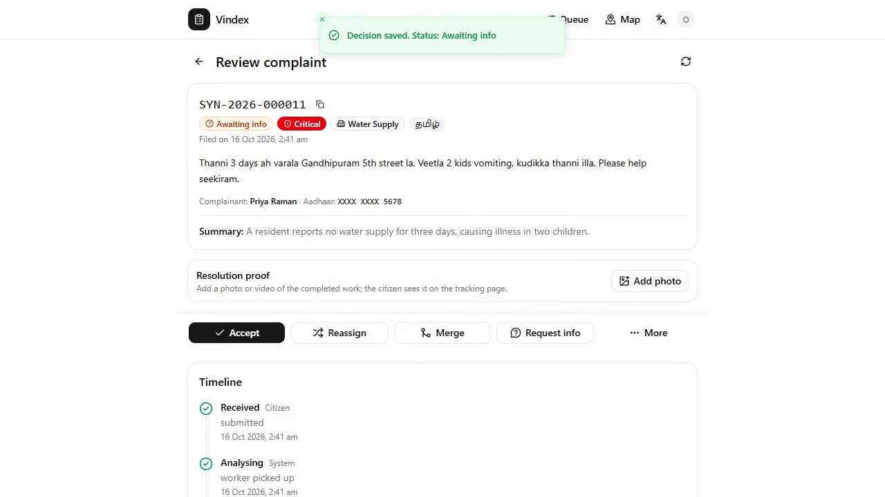  Figure 21. Request info dialog with the mandatory reason.
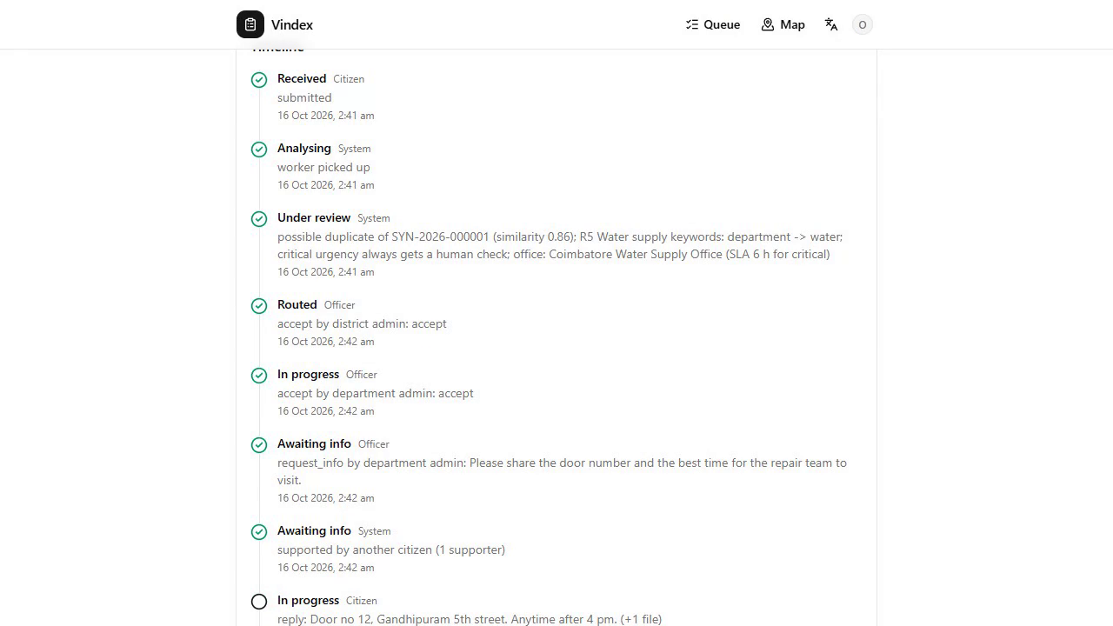  Figure 22. Resolution proof upload before resolving. | 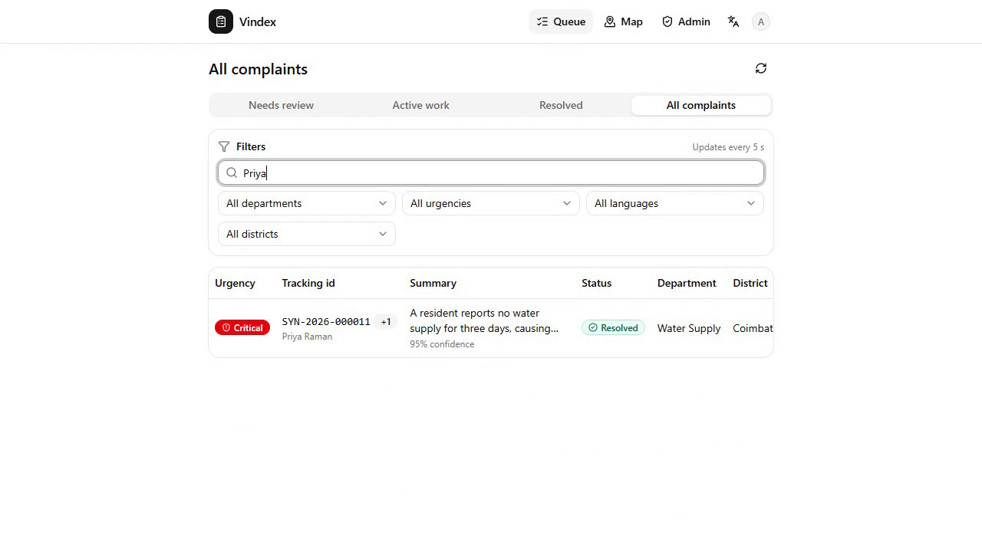  Figure 23. Super admin queue: all complaints, search by name.
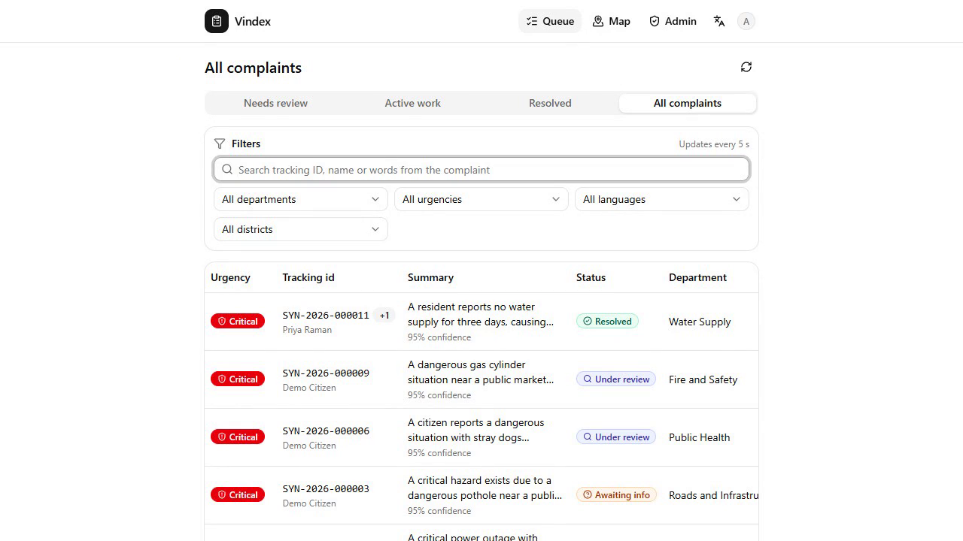  Figure 24. Overdue badge on an escalated case. | 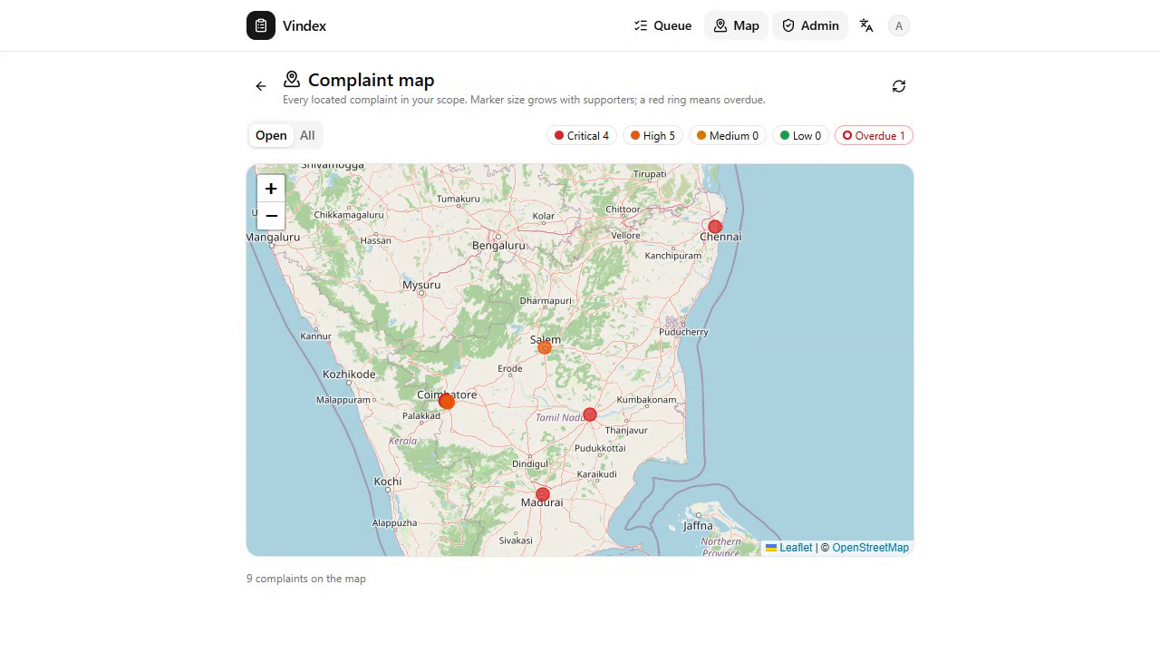  Figure 25. District map: markers by urgency, red ring for overdue.
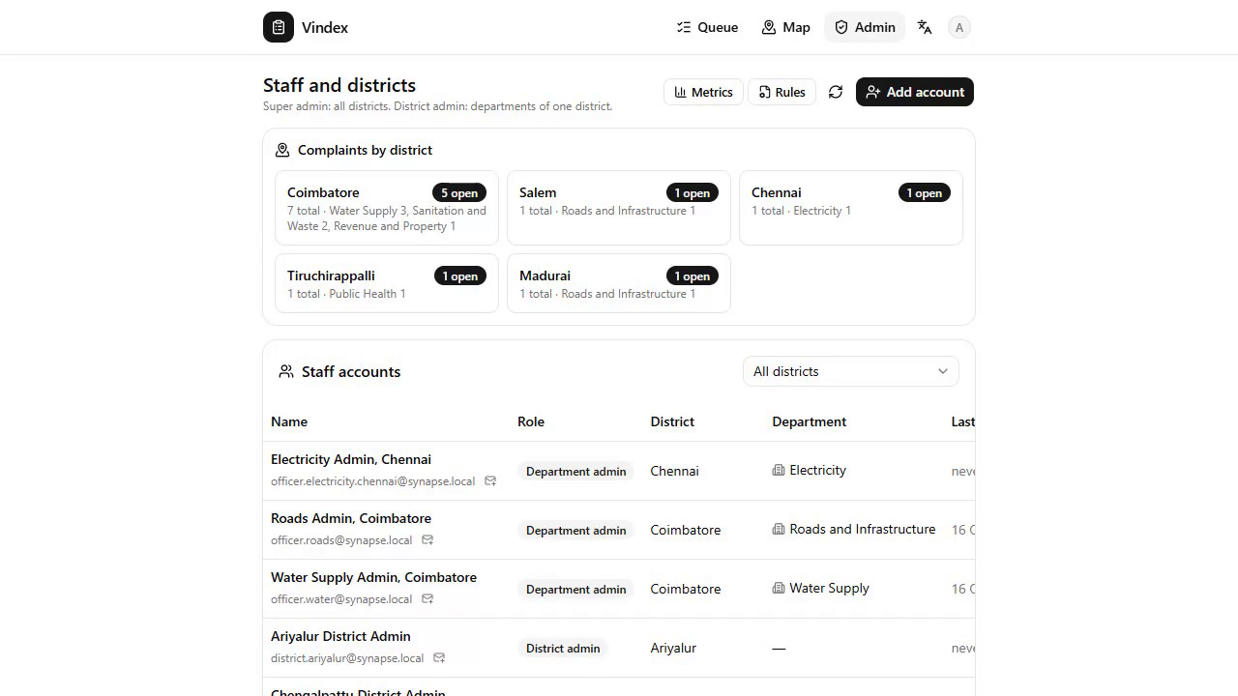  Figure 26. Staff and districts: counts per district and the 38 district admins. | 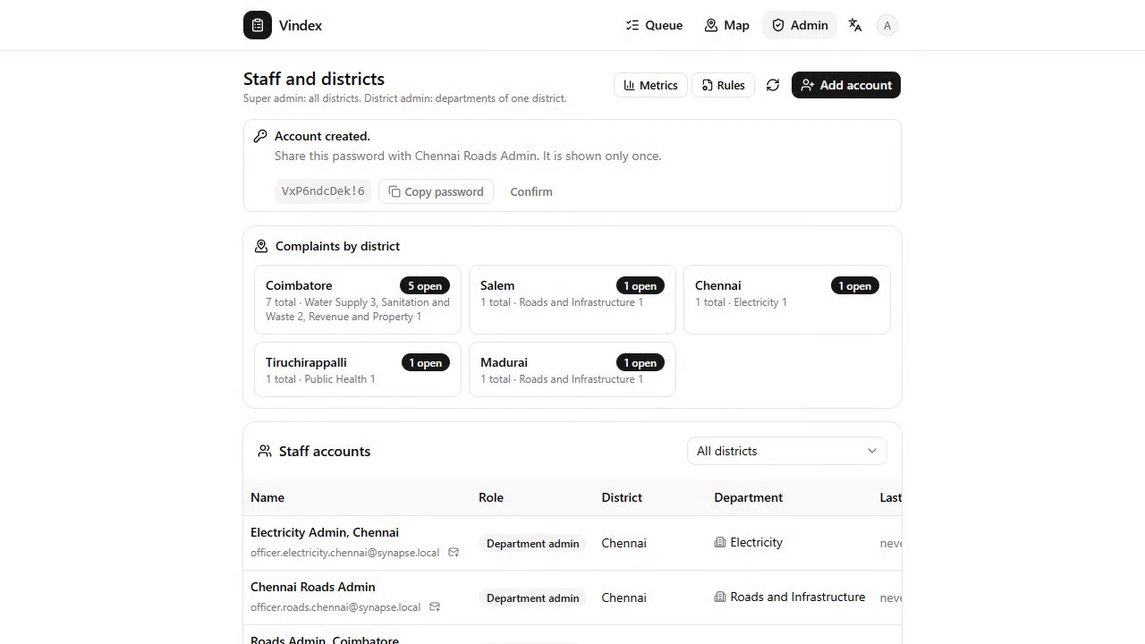  Figure 27. A new department admin created; the password is shown once.
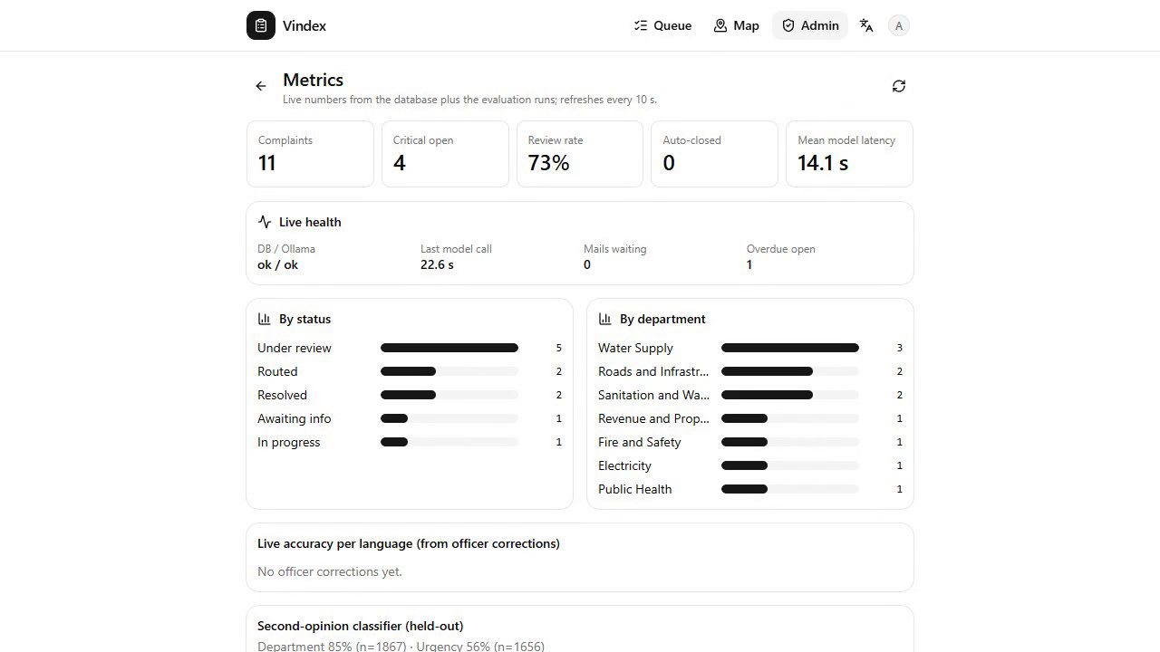  Figure 28. Metrics: live health, accuracy per language, ratings and reopen rate. | 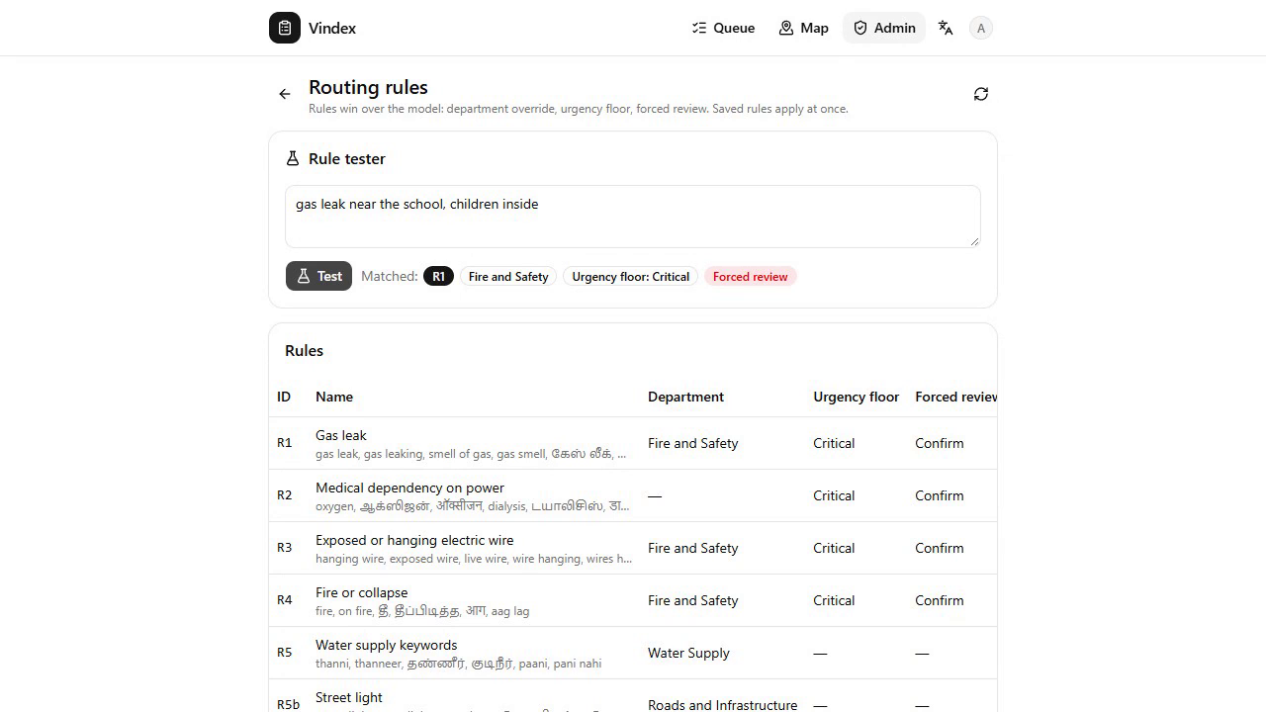  Figure 29. Rule tester: a gas-leak text matches R1 with a Critical floor and forced review.
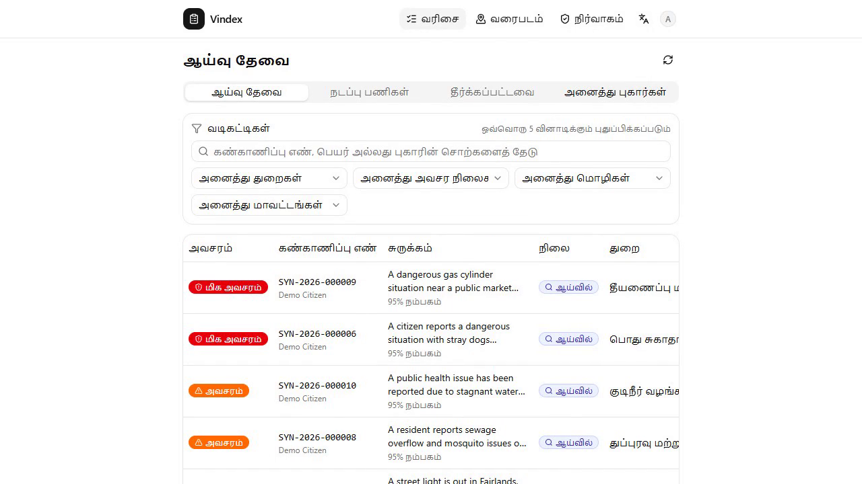  Figure 30. The queue in Tamil after one switch. | 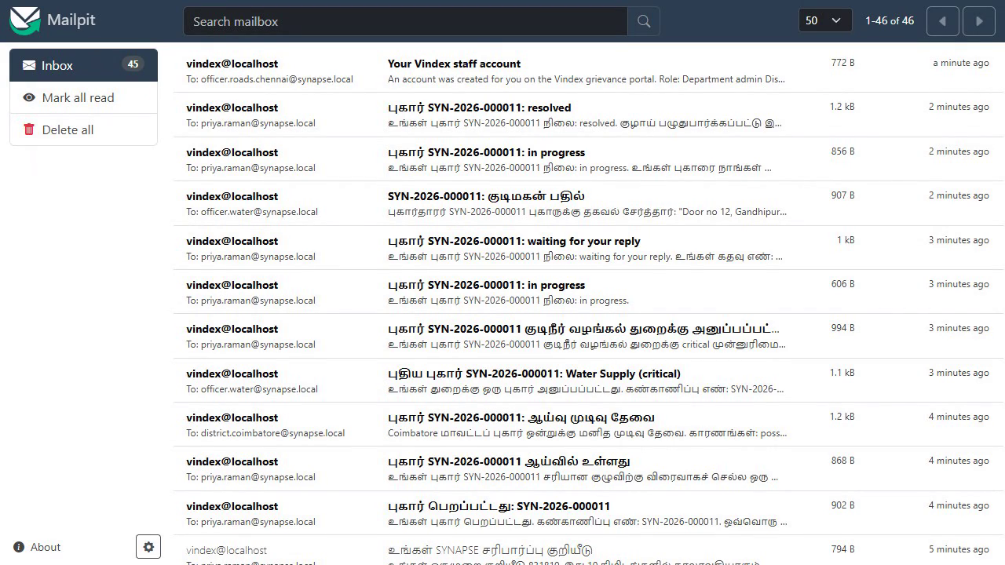  Figure 31. The mail trail: citizen, department admin and district admin.

11. Testing and results
Everything was measured on the build laptop against the live stack: PostgreSQL with pgvector, Ollama with Gemma 3 4B and bge-m3, Mailpit, the API and the Vite app. The full history of every run is in docs/06-test-report.md.

11.1 End-to-end suite
scripts/test_api_e2e.py drives the real API and the real models and checks the outcome of every feature. It grew with the product, from 61 checks on the first afternoon to 77, 91, 114 and finally 118. The last run, on 16 October 2026 at 02:40 after a full reset, passed 118 of 118 checks.
Area | What the checks prove
Accounts | weak password, wrong OTP, unverified login and bad Aadhaar digits rejected; OTP verify, password reset, old tokens invalidated; name and Aadhaar last 4 taken at registration and carried by every complaint; twelve failed logins end in 429
AI pipeline, five languages | Tamil script water outage with sick children, Devanagari power cut with oxygen, English suggestion, Hinglish gas smell, Tanglish pothole with a repeat: the right department, urgency, rules and review decision in every case; evidence spans quoted verbatim; English summary; district office and due time; second opinion stored
Evidence | a JPEG with GPS EXIF resolved to Gandhipuram; the vision model describes the pothole; two photos reach the model; media served only to the owner and staff
Duplicates and PII | the same Tamil complaint filed twice is flagged at similarity 1.00 and reviewed; phone and Aadhaar-like numbers masked, the map visible to staff only
Roles | department admin sees only its department and district; district admin creates department admins for its district only and cannot create another district admin; disabled accounts are locked out; 38 districts listed
Decisions | accept, reassign, merge into the original, request info, resolve, close, with mandatory reasons; a citizen reply resumes an awaiting-info case and reaches the department; resolution proof visible to the citizen; rating stored, reopen returns the case to work; me-too support counted once with the priority boost; queue search; map scoped per role
Mail and SLA | citizen, department admin and district admin mails for routing, review, reply, resolution and overdue; an English resolve note reaches a Tamil citizen translated into Tamil script; an overdue case escalates exactly once and shows the flag, the timestamp and the timeline note
Operations | health reports the models, queue depth, outbox backlog and model latency; rules tester, invalid YAML rejected, classifier reload

11.2 Gold-set replay
Twelve hand-labelled complaints across the five languages are replayed through the pipeline after every change (scripts/run_eval.py). The model alone is compared with the whole system, model plus rules.
Metric | Gemma 3 4B alone | System: model + rules
Department accuracy | 0.83 | 1.00
Urgency, exact | 0.83 | 0.92 (every miss within one level)
Critical recall | 0.75 | 1.00 (4 of 4)
Language identification | 0.92 | 0.92
Mean time per complaint | 12.4 s | same

The model's misses are the judgement calls the rules exist for: a Tanglish water outage with sick children read as a health matter, a leaning pole with hanging wires near a school read as electricity rather than safety, and a dark street where women feel unsafe read as safety rather than roads. In every case the rule corrected the department and the case still reached a human.

11.3 Second-opinion classifier
The NumPy softmax classifier on bge-m3 embeddings was trained four times as the locally generated set grew. The held-out split of each round:
Round | Synthetic rows | Department accuracy | Per language | Urgency
1 | 460 | 0.869 (137 rows) | en 0.93, ta 0.95, hi 0.83, hi-en 0.80, ta-en 0.74 | 0.479
2 | 940 | 0.846 (234 rows) | en 0.91, hi 0.89, ta-en 0.85, hi-en 0.78, ta 0.73 | 0.550
3 | 1,169 | 0.875 (279 rows) | en 0.93, hi-en 0.93, hi 0.84, ta-en 0.84, ta 0.78 | 0.555
4 | 1,644 | 0.845 (1,867 rows with gold and NYC) | en 0.89, hi-en 0.88, ta-en 0.87, hi 0.80, ta 0.76 | 0.563

Department accuracy has settled between 85 and 88 percent: more synthetic data from the same generator does not move it, so officer corrections, which the metrics page already collects as ground truth, are the next source of labels. Urgency from embeddings alone is weak (chance is 0.25); by design the model and the rules own urgency and the classifier only votes on the department.

11.4 Defects found and fixed
Found | Fix
Romanised Hindi labelled as Tamil by the model | A function-word detector labels Latin-script text as Hinglish, Tanglish or English and passes it to the model as a hint
The office keyword "bus" matched "bus stand" and forced a review of a clear roads complaint | Keywords and rules match whole words; a hint into the General catch-all no longer counts as a disagreement
Every send failed when TLS was on against the local mail server | The mailer upgrades to TLS only when the server offers STARTTLS
Gmail bounced mails to the demo staff addresses on a domain that does not exist | On a real mail server the outbox marks demo-domain recipients skipped; staff emails can be changed from the Admin page
Static routes /complaints/nearby and /supported were swallowed by /complaints/{id} | Registered before the parameterised route
A translation in the outbox delayed the plain staff mails behind it | Plain mails are delivered before translated ones
A cancelled data-generator run left Ollama replaying timed-out requests, every call took a minute | Every model call carries a timeout; the runbook forbids the generator during a demo
The demo reset failed on the new me-too table | The reset clears supports before complaints
The suite counted mails inside Mailpit's newest-200 window, which stops growing once the inbox is full | Counts use Mailpit's search endpoint across the whole inbox

11.5 Performance
- Tracking ID and acknowledgement in under one second; the model never sits in the request path.
- Full analysis of text and photos in 12 to 20 seconds with the GPU free; 50 seconds while the data generator held the card.
- 70 mails through one outbox connection in a single suite run, none failed; mail never blocks a request.
- Duplicate search is one indexed SQL query; the queue page refreshes every five seconds without a reload.

11.6 Browser walk-through and recorded demo
Every screen was exercised by hand in Chrome at phone and desktop widths in all three interface languages, and the final walkthrough was recorded by scripts/record_demo.py, which drives the real application through Playwright: registration with the OTP mail, a Tanglish complaint with in-app video, photo and GPS, the analysis result and timeline, district review, department work with a request for information and the citizen's reply, resolution proof, rating, me-too support, search, the overdue badge, the map, staff creation, metrics, the rule tester, the classifier reload, the Tamil interface and the mail trail. The result is docs/demo/vindex_demo_subtitled.mp4 (captions burned in), docs/demo/vindex_demo.mp4 and docs/demo/vindex_demo.srt, six minutes long.

12. Training data and evaluation data
No public dataset matches the task (multilingual civic complaints with urgency and evidence), so the team built its own and used public corpora for realism and language tests.
Dataset | What it is | Used for
Gold set, data/eval/complaints.jsonl | 12 hand-labelled complaints across the five languages with department and urgency | Replayed after every change; the fairness numbers per language
Synthetic set, data/synthetic/ | 1,644 complaints generated locally by Gemma 3 4B over every department, urgency, language and formality combination, with Devanagari and Tamil script enforced | Training the second-opinion classifier; smoke-testing the pipeline
Tamil Nadu district and department mapping, data/reference/ | 38 districts, 20 departments, 760 district-office rows with SLA hours, 41 keyword hints (team-provided spreadsheet) | District office routing and due times
NYC 311 sample | 3,000 civic requests with complaint type and agency | Extra English department rows for the classifier
COMI-LINGUA | Expert-annotated Hindi-English code-mixed sentences | Hinglish language-identification tests and examples
DravidianCodeMix Tamil-English | Tamil-English code-mixed comments in Tamil script and romanised | Tanglish language-detection and normalisation tests

Generation and training run as scripts: make_synthetic.py writes complaints in every combination with one retry at lower temperature, train_second_opinion.py embeds them with bge-m3 and fits the softmax classifier (saved as models/second_opinion_*.npz, reloadable from the admin page), run_eval.py replays the gold set and writes data/eval/summary_gemma3_4b.json, which the metrics page shows.

13. Running the project

13.1 Prerequisites
- Windows or Linux with Python 3.12, Node 20+, Docker (for PostgreSQL + pgvector and Mailpit) and Ollama.
- Models: ollama pull gemma3:4b and ollama pull bge-m3 (about 4.5 GB in all).
- A GPU with 4 GB or more makes analysis take 12 to 20 seconds; on CPU alone expect 20 to 40 seconds.
- Copy .env.example to .env: database URL, mail server (Mailpit locally or Gmail SMTP with an app password), model names, limits.

13.2 Start
docker compose up -d # PostgreSQL 17 + pgvector on 5434, Mailpit on 1025/8025
pip install -r requirements.txt
cd backend && python seed.py # departments, demo accounts
python -m uvicorn app.main:app --app-dir backend --port 8000
cd frontend && npm install && npm run dev # app on http://localhost:5173

powershell -ExecutionPolicy Bypass -File scripts\start.ps1 # or all of the above in one command (-Https for phones)
python scripts\demo_data.py --reset --districts --staff --seed # fresh demo data through the real pipeline
SMTP_HOST=localhost python scripts\test_api_e2e.py # the 118-check suite against a Mailpit-backed API
python scripts\record_demo.py # re-record the demo videos

13.3 Accounts
Role | Scope | Seed account
Super admin | everything; creates district admins; rules, metrics, map, classifier reload | admin@synapse.local
District admin | one district: review queue, map, adds department admins | district.coimbatore@synapse.local, plus one per district from demo_data.py --districts
Department admin | one department in one district | officer.water@synapse.local, officer.roads@synapse.local
Citizen | own complaints | citizen@synapse.local, or register in the app

All seed accounts share the SEED_PASSWORD value from .env. Staff accounts created from the Admin page receive a generated password shown once. The local credentials workbook is excluded from the repository.

13.4 Documents in the repository
File | Content
docs/01-problem-understanding.md | Problem analysis, users, failure modes, objectives, pipeline, features, scope
docs/02-models-and-datasets.md | Model choices with measurements, small models, datasets, download checklist
docs/03-system-architecture.md | Design principles, architecture, components, stack, data flow, decision logic, API, risks
docs/04-database-and-ui.md | ER diagram, tables, indexes, state machine, data flow per table, wireframes, component map
docs/05-implementation.md | What is built, how it runs, the API table, evidence runs, roles, identity, video, loops, demo tooling
docs/06-test-report.md | Every test run: suite growth, defects and fixes, gold set, training rounds, pre-jury run
docs/07-demo-runbook.md | The five-minute click path, numbers to quote, recovery steps, jury questions, demo video
docs/sample.pptx | The eight-slide submission deck; docs/demo/ holds the videos and the subtitle track

14. The demo story
The runbook (docs/07-demo-runbook.md) walks the jury through one complaint end to end in about five minutes, with four browser tabs logged in as the citizen, the water department admin, the Coimbatore district admin and the super admin.
Step | Who | Does | Point made
1 | Citizen | Files a Tanglish complaint: no water for three days, two children vomiting, Gandhipuram 5th street; records a short video; uses the current location; submits | Any language, any script, photo or video evidence, GPS; identity taken once at registration; tracking ID in under a second
2 | Citizen | Opens the tracking page; Analysing turns into Under review with department, urgency, highlighted evidence, office and due time | One local model call on this laptop; rules overrode the model's health label to Water Supply and forced a human because children are ill
3 | District admin | Needs review queue; opens the case; accepts with a reason | A human decides every uncertain or critical case; the reason joins the audit trail
4 | Department admin | Active work: the case is there (only water, only Coimbatore); accepts; requests the door number | Each department sees only its own cases; the citizen is emailed in Tamil
5 | Citizen | Sees the office's question; replies with a line and a photo | The reply goes straight to the department; the case continues
6 | Department admin | Attaches a resolution photo; resolves with a note | The citizen gets the note translated into Tamil and sees the proof photo
7 | Citizen | Rates with stars, or presses Not fixed, reopen; a second account supports the complaint from the nearby list | The loop closes with the citizen; duplicates become support; five supporters raise priority
8 | Super admin | Map; staff per district; metrics; rule tester with a gas-leak text; the Overdue badge and the escalation note on a seeded case | Configuration, not code; rules hot-reload; SLA breaches escalate by email

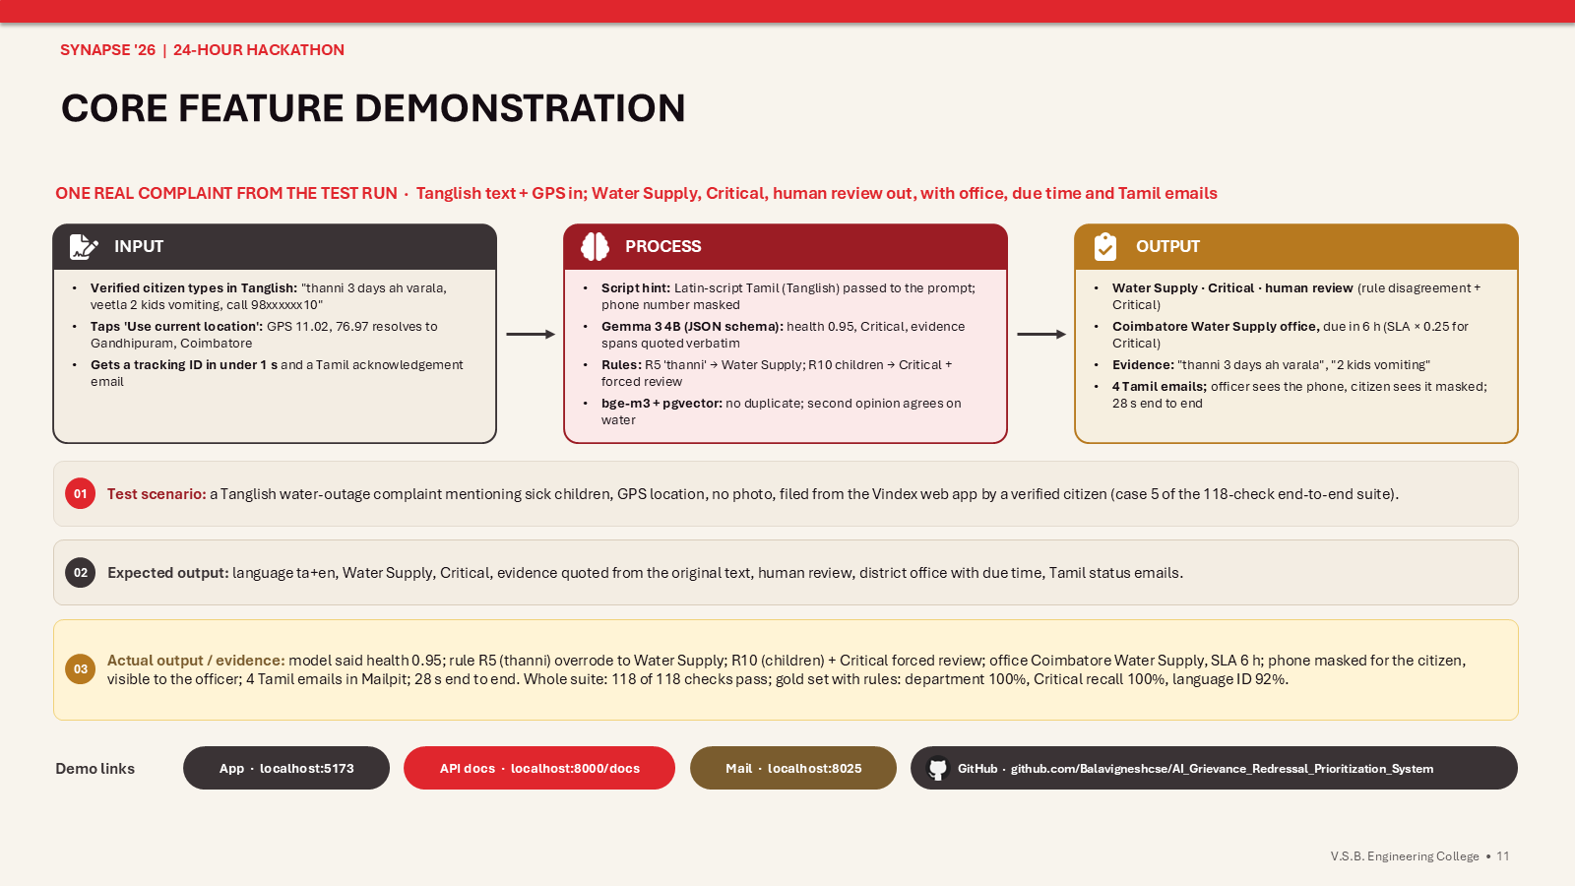
Figure 32. Core feature demonstration: one real complaint from the test run, input, process and output (from the submission deck).

15. Limitations and roadmap

15.1 Known limits
- The raw 4B model alone reaches 83% department accuracy on the gold set; the rules and the review queue carry it to 100%, and a larger model on a bigger card (Gemma 3 12B on 12 GB) would raise the raw number.
- Urgency from embeddings is weak; it stays with the model and the rules.
- Twelve gold rows are a smoke test; the planned 60-row team gold set is the real benchmark.
- Only photos reach the vision model; a video is stored as evidence for the office.
- The district-office mapping is marked as demo data by its spreadsheet and must be verified with the municipality.
- One worker and one model request at a time on a 4 GB card: throughput is about three complaints a minute; a server GPU or more workers scale it.
- Email is the only channel; map tiles come from OpenStreetMap over the internet (the fallback is coordinates).

15.2 Roadmap
- WhatsApp intake and status updates on a WhatsApp Business number (designed, not built).
- Video key frames to the vision model.
- Fine-tuning the classifier on officer corrections, which the system already records as ground truth per language.
- Ward polygons for sub-district routing; verified office data from the municipality.
- Officer analytics: SLA breaches, reopen rates and accuracy trends per language on the dashboard.
- Integration with an existing portal's database and single sign-on for staff.
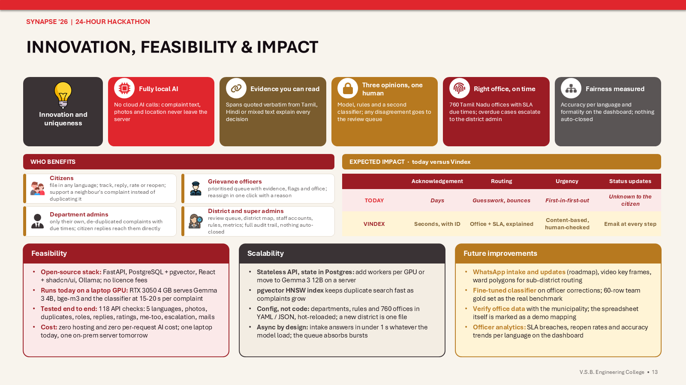
Figure 33. Innovation, feasibility and impact: who benefits, today versus Vindex, scalability and future improvements (from the submission deck).

Appendix A. API routes
Interactive documentation is generated by FastAPI at /docs.
Method | Path | Role | Purpose
POST | /auth/register | public | name, Aadhaar last 4, mobile, email, password, language; sends OTP
POST | /auth/verify-otp, /auth/resend-otp | public | activate the account and return a JWT; new code
POST | /auth/login, /auth/forgot, /auth/reset | public | JWT (403 if unverified); password reset by OTP, old sessions invalidated
GET, PATCH | /auth/me | any | current user; change name, Aadhaar last 4 or mail language
GET | /departments | public | ids and names in three languages
POST | /complaints | complainant | multipart intake; 202 with the tracking ID; analysis queued
GET | /complaints/mine, /complaints/{id}, /complaints/track/{tracking_id}, /complaints/{id}/timeline | owner or staff | detail with analysis, decision and timeline; PII map and second opinion for staff only
POST | /complaints/{id}/reply | owner | answer a request for information with text and media; the office is emailed
POST | /complaints/{id}/feedback | owner | rating 1 to 5 with a note, or reopen within the feedback window
POST | /complaints/{id}/support | citizen, not the owner | me-too on an open complaint; supporters raise urgency
GET | /complaints/nearby, /complaints/supported | citizen | open complaints within 2 km without personal data; complaints the caller supports
GET | /media/{id} | owner or staff | photo or video file
POST | /geo/reverse | public | coordinates to the nearest locality and district
GET | /review/queue | staff | complaints in scope; views review, active, resolved, all; filters and text search
GET | /review/{id} | staff in scope | full detail including masked text and PII map
POST | /review/{id}/decision | staff in scope | accept, reassign, merge, request_info, resolve, close, reopen; reason required
POST | /review/{id}/attachments | staff in scope | resolution proof photos or videos
GET, POST, PATCH | /admin/users, /admin/users/{id} | super admin, district admin | list, create (password returned once), enable or disable, change email, department or password
GET | /admin/districts, /admin/overview, /admin/map | staff | the 38 districts with staff counts; counts per district; located complaints for the map
GET, PUT, POST | /admin/rules, /admin/rules/test | super admin (read: staff) | YAML rules with change log; run the rules against a text
POST | /admin/models/reload, /admin/sla/check | super admin | pick up a retrained classifier; escalate overdue complaints now
GET | /admin/metrics, /health | staff; public | dashboard data; database, Ollama, models, queue depth, outbox, latency

Appendix B. How the 24 hours were spent
When (15-16 Oct 2026) | Delivered
10:30, checkpoint 1 | Problem understanding: analysis, users, failure modes, twelve objectives, pipeline design, scope
11:45, checkpoint 2 | Models and datasets measured on the laptop; architecture, stack, data flow, decision logic
13:30, checkpoint 3 | Data model with ER diagram, state machine, wireframes with the shadcn component map; Docker Compose for the database and mail
14:45, checkpoint 4 | Backend with 30 routes, worker pipeline, rules, notifier; Tamil Nadu office mapping; frontend with register, OTP, complaint, tracking, officer queue
15:00 to 15:45 | First test pass: 61-check suite, gold-set replay, defects fixed, test report; submission deck rebuilt in the organiser's template
16:30 | Real mail through Gmail SMTP configured from .env
18:00 to 19:40 | Role hierarchy (super, district, department admins), identity fields, video evidence with limits, asynchronous mail outbox, model warm-up; 77 checks
20:00 to 21:30 | Citizen reply loop, staff emails, SLA watch and overdue escalation, admin rules and metrics pages, demo tooling, HTTPS start for phones; 91 checks
22:00 to 23:05 | Training round 2; outbox skip rule for demo addresses; staff email change
23:30 to 00:50 | Rating and reopen, resolution proof, me-too support, district map, translated officer notes, queue search, rate limiting; 114 checks
01:00 to 02:20 | Training rounds 3 and 4; deck re-coloured to the template palette; identity moved from the complaint form to registration; 118 checks
02:15 to 02:55 | District admins for all 38 districts, clean reset and reseed, two full test passes with fixes, the recorded demo in two versions, this report

