NIP Project — Submission Template
Pega Platform project · This document is your complete submission
Read this before you start:
1. Fill in Section 1 completely. The Pega application name must follow the format NIP-[Project]-[YourName].
2. Create a new Operator in Pega with your full name and log in as that operator before taking any screenshot.
3. When you create your test case, enter YOUR FULL NAME in the Issue Description (Vehicle) or Movie Name (Movie) field.
4. Complete only the section for your chosen project. Delete the other project section.
5. Paste one screenshot per user story (10 total). Follow the screenshot rules in your selected project section.
6. Answer every question in Sections 3 and 4 in your own words.
7. Save the file using this format: ProjectName_FirstName_LastName.docx. Use VehicleService or MovieTicket as the ProjectName. Examples: VehicleService_Ravi_Kumar.docx or MovieTicket_Ravi_Kumar.docx.

Section 1 — Your Details
Full Name | Balavignesh K
Email ID (registered on NIP) | balavigneshcse@gmail.com
Phone Number | 7339464165
College Name | V.S.B Engineering College
Course (e.g. IT, CS) | CSE
State | Tamil Nadu
Project Chosen (Vehicle Service OR Movie Ticket Booking) | Movie Ticket Booking
Pega Application Name (e.g. NIP-VehicleService-YourName) | NIP_Movie_Ticket_Booking_Balavignesh_K
Case Type Name (exact) | Ticket Booking
Pega Instance URL | https://8jgijx09.pegaacademy.net/prweb/app/movie-ticket-booking/1O3kfChUoyqPj2zmFwqFq7C8uA6oWcaK*/!STANDARD?pzuiactionzzz=CXtycX1iZDExYjk3N2UwZTI3MDBkNzhkOGUzMzNmZWJiOGExOGNmZTBmZmVmOWIxMDg1ZTZkMTY5YjhiY2M4NWVmNDBhZThkYzBkZmM0ZGU2YjIyZTY3Zjg1Nzc3ZWI1MjE1ZmU=*
Operator Name (created in Pega with your full name) | balavignesh@mb

Section 2B — Movie Ticket Booking Management Application
Complete this section only if you selected this project. Delete the other project section before submitting.

Screenshot rules — IMPORTANT before you start:
1. Name your Pega application as: NIP-VehicleService-YourName OR NIP-MovieTicket-YourName
2. Create a new Operator in Pega with your full name (Security → Operators) and log in as that operator.
3. When you create your test case, enter YOUR FULL NAME in the Issue Description (Vehicle) or Movie Name (Movie) field.
4. The logged-in operator name must be visible in every screenshot wherever the Pega interface displays it.
5. The student's full name must be visible in all running-case screenshots.
6. Configuration screenshots must clearly show the relevant application or rule name.
Screenshots that do not show these will not be accepted.

US-001 — Submit Movie Ticket Request
What is expected:
Case created, customer submits Movie Name, Show Date, Show Time, Number of Tickets. Validation applied.
Screenshot — paste your screenshot below this line:
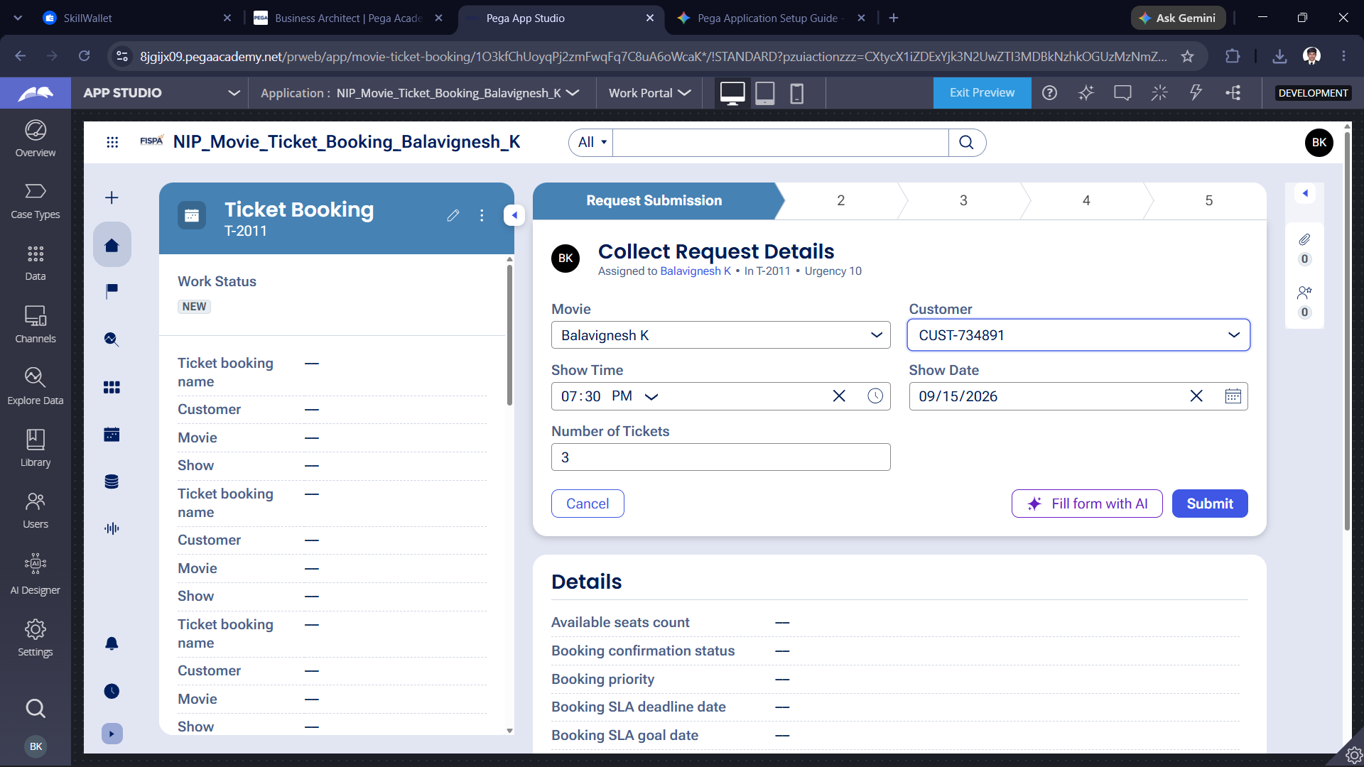

What I built for this (1–2 lines in your own words):
I built the initial request submission form for a movie ticket booking application . It captures essential customer details including the selected movie, show date, time, and ticket quantity.

US-002 — Check Show Availability
What is expected:
Availability stage. Seat Availability Status and Available Seats Count captured. Booking proceeds only if available.
Screenshot — paste your screenshot below this line:
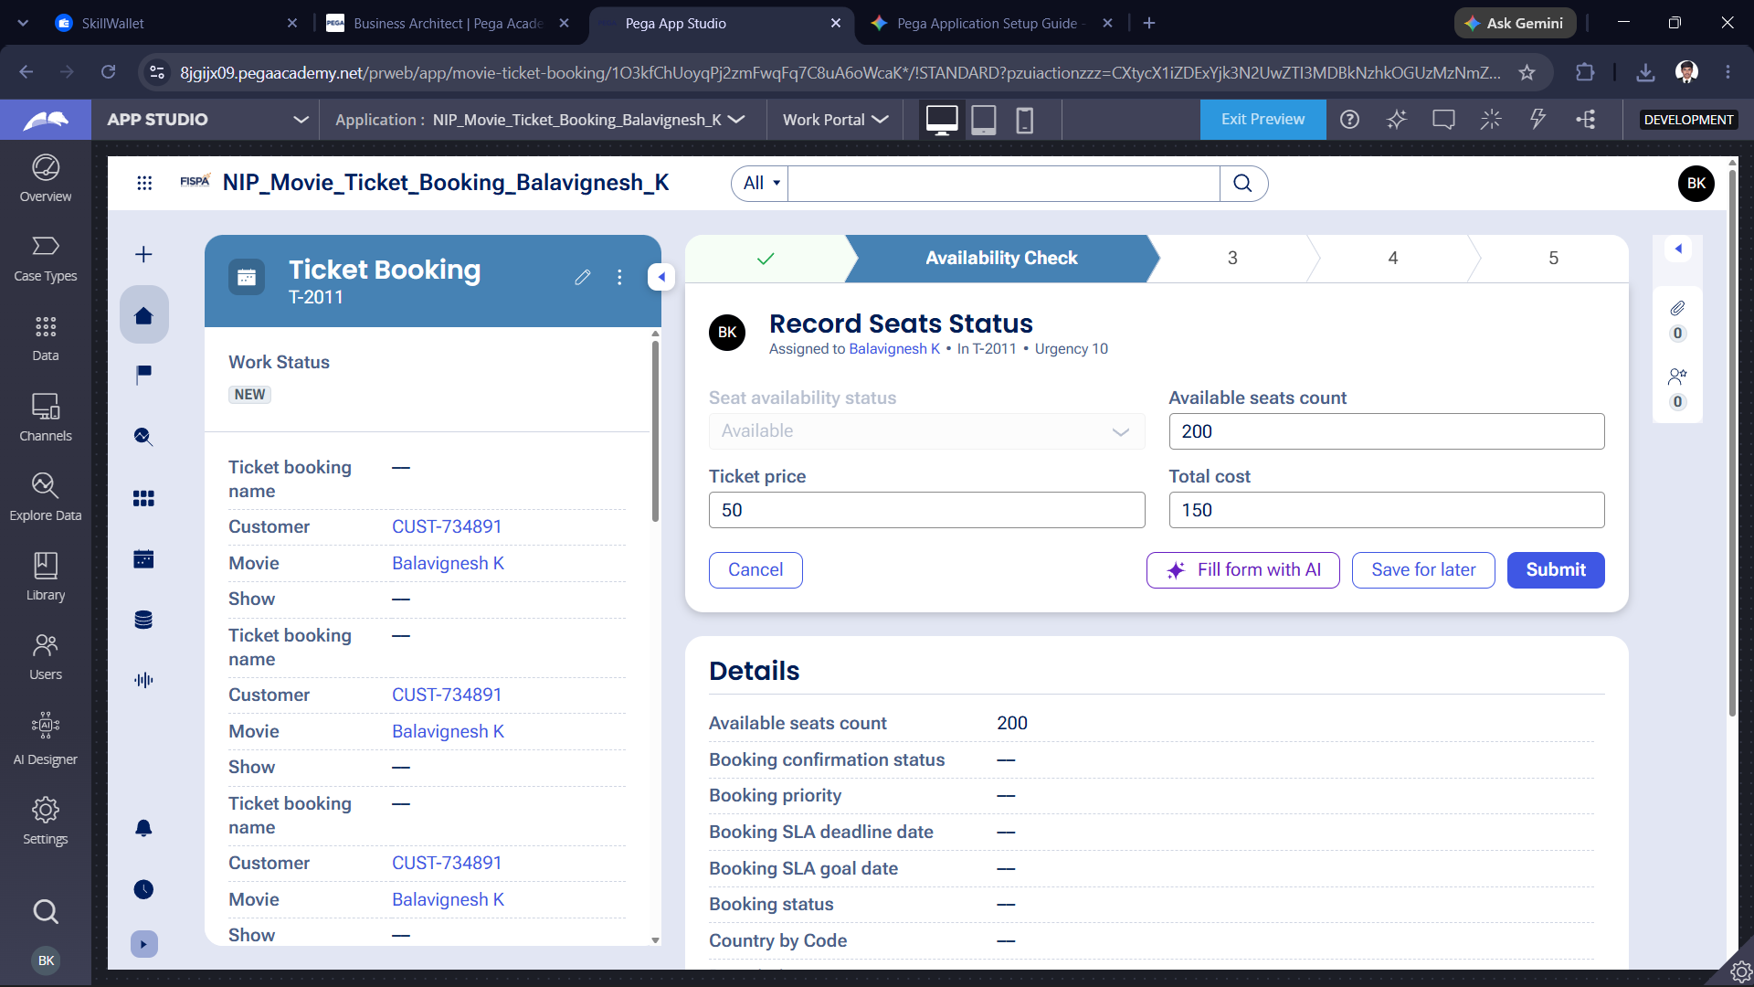

What I built for this (1–2 lines in your own words):
I create the "Record Seats Status" form in the Availability Check stage to handle inventory and pricing. It automatically calculates and displays the available seats count, individual ticket price, and total cost for the booking.

US-003 — Calculate Booking Cost
What is expected:
Total Cost calculated automatically from Ticket Price and Number of Tickets using a business rule.
Screenshot — paste your screenshot below this line:
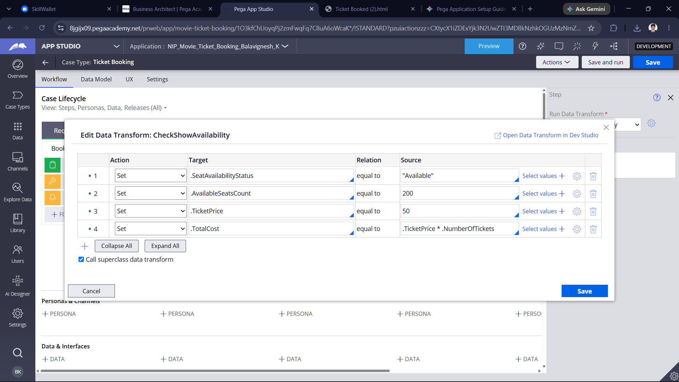

What I built for this (1–2 lines in your own words):
I configured the "CheckShowAvailability" Data Transform to automate background business logic for seat inventory and pricing. It automatically initializes the seat status, sets the base ticket price, and dynamically calculates the total cost based on the tickets requested.

US-004 — Confirm Booking Request
What is expected:
Approval stage assigned to Customer. Booking Status captured. Flow branches on confirm/cancel.
Screenshot — paste your screenshot below this line:
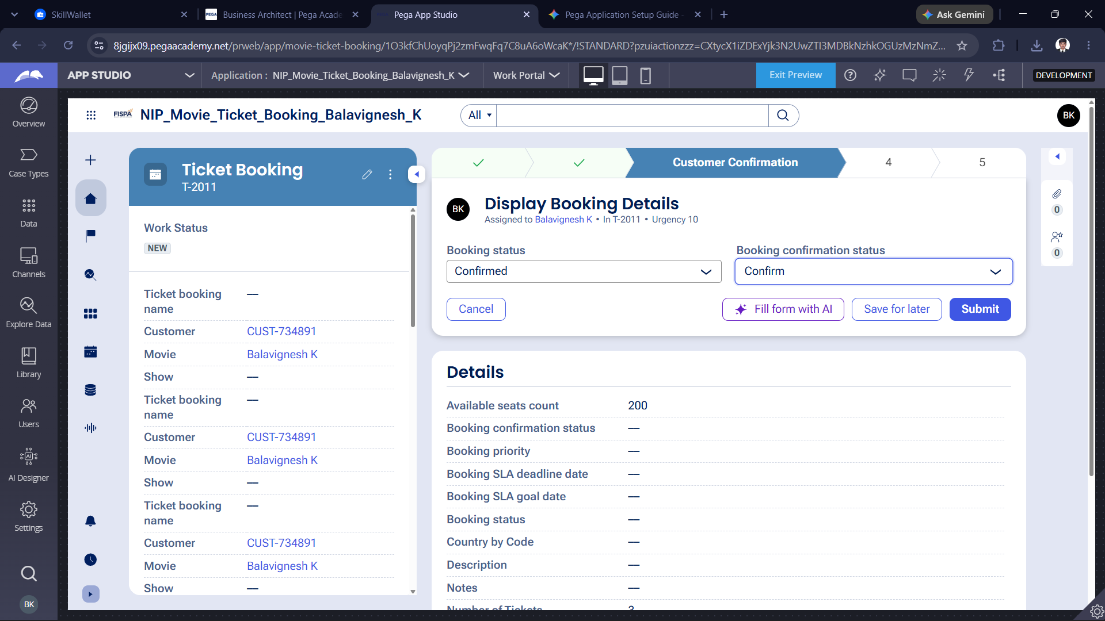

What I built for this (1–2 lines in your own words):
I made the "Display Booking Details" view in the Customer Confirmation stage to finalize the ticket reservation. It allows the user to review their information and officially submit their final booking confirmation before execution.

US-005 — Maintain Movie and Show Data
What is expected:
Reusable Movie and Show data objects created with Movie Name, Genre, Show Date, Show Time, Seat Capacity — linked to case.
Screenshot — paste your screenshot below this line:
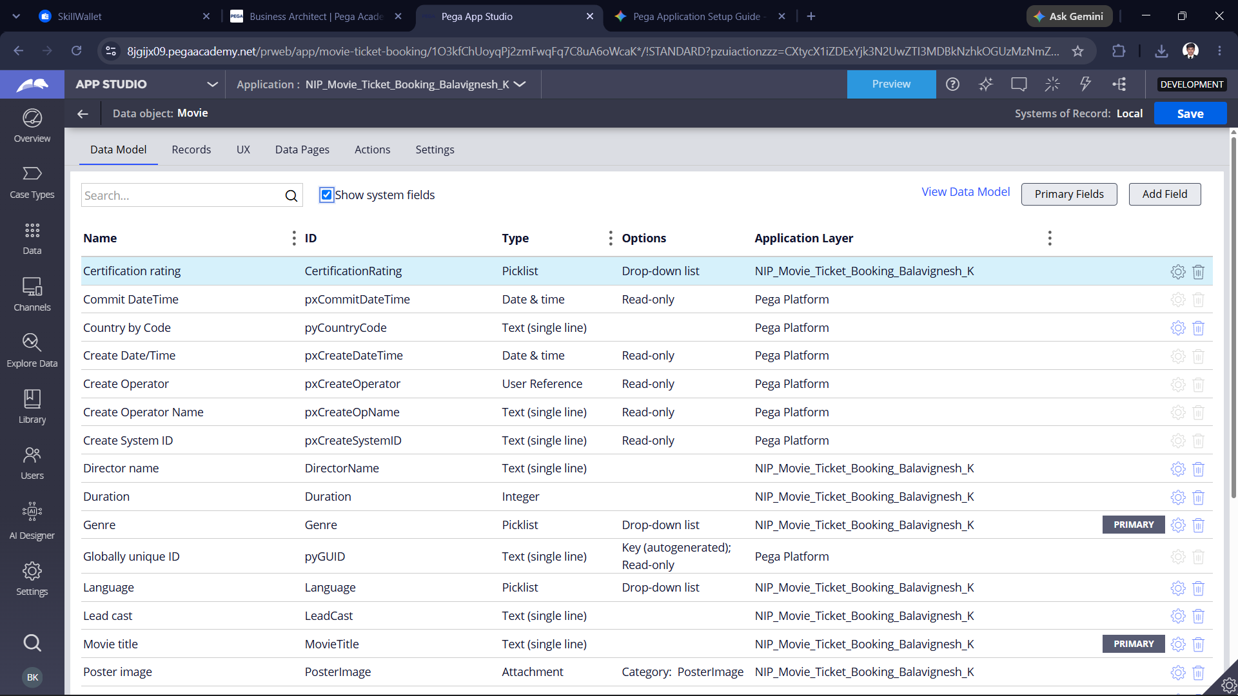

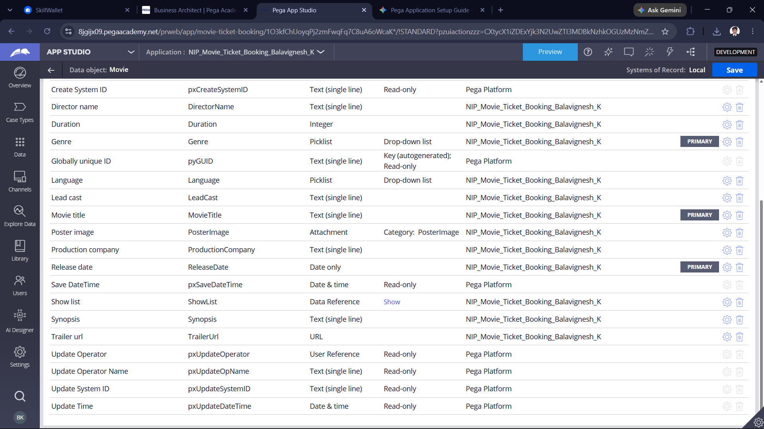

What I built for this (1–2 lines in your own words):
I configured the Movie Data Object model in Pega App Studio, defining the data structure including title, genre, and associated show details for the ticket booking application.

US-006 — Review Booking Details
What is expected:
Confirmation screen shows Movie Name, Show Timing, Number of Tickets and Total Cost clearly.
Screenshot — paste your screenshot below this line:
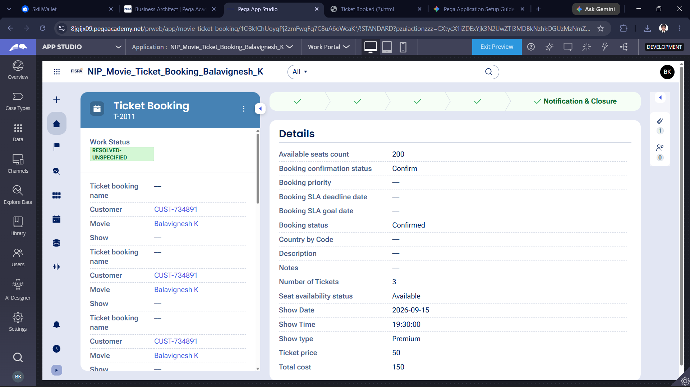

What I built for this (1–2 lines in your own words):
I made a summary screen that clearly displays the movie name, show time, number of tickets, and total cost for the customer to review

US-007 — Process Ticket Booking
What is expected:
Booking Execution stage. Seat Numbers, Ticket ID and Booking Confirmation Status maintained.
Screenshot — paste your screenshot below this line:
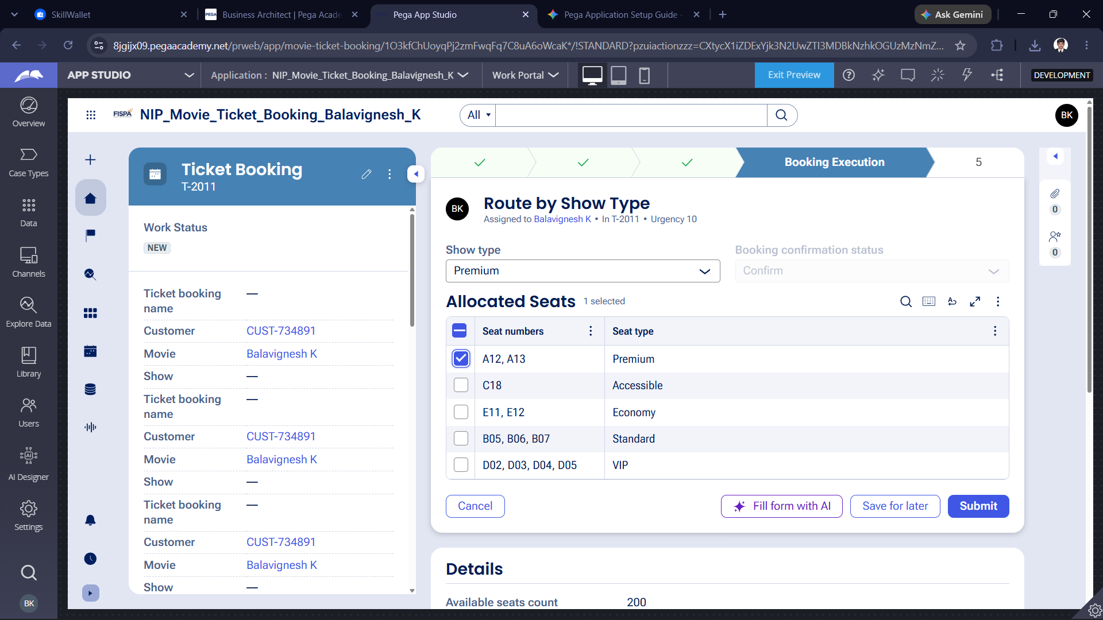

What I built for this (1–2 lines in your own words):
I configured the "Route by Show Type" step in the Booking Execution stage, implementing a selectable table view with checkboxes for seat allocation and type management.

US-008 — Notify Booking Confirmation
What is expected:
Correspondence rule triggered on case resolution. Email includes movie, show, seat and cost details.
Screenshot — paste your screenshot below this line:
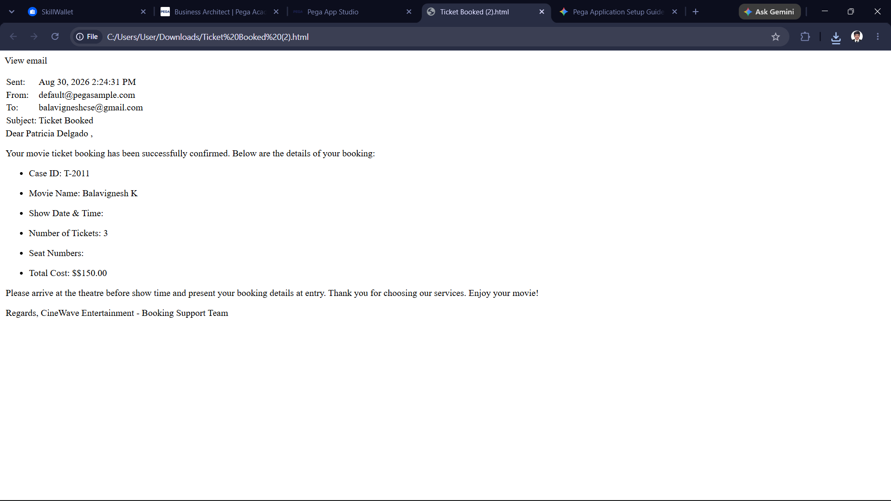

What I built for this (1–2 lines in your own words):
I created and tested the email notification step, successfully generating a booking confirmation message populated with the case details, customer information, and final pricing.

US-009 — Define Booking SLA
What is expected:
SLA configured on the case type. Goal: 1 day. Deadline: 2 days. Priority increases on breach.
Screenshot — paste your screenshot below this line:
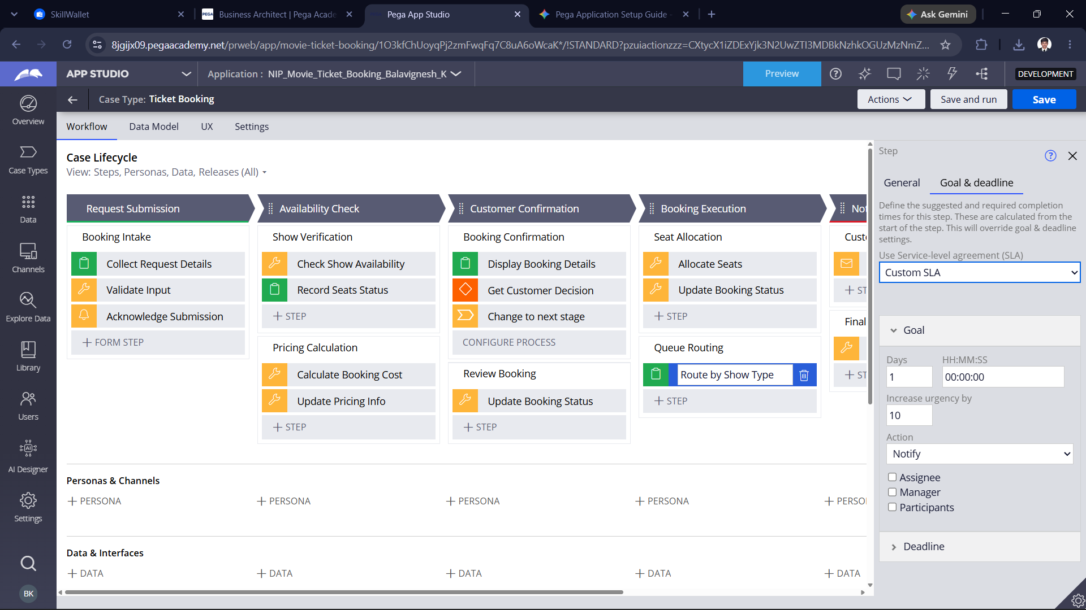

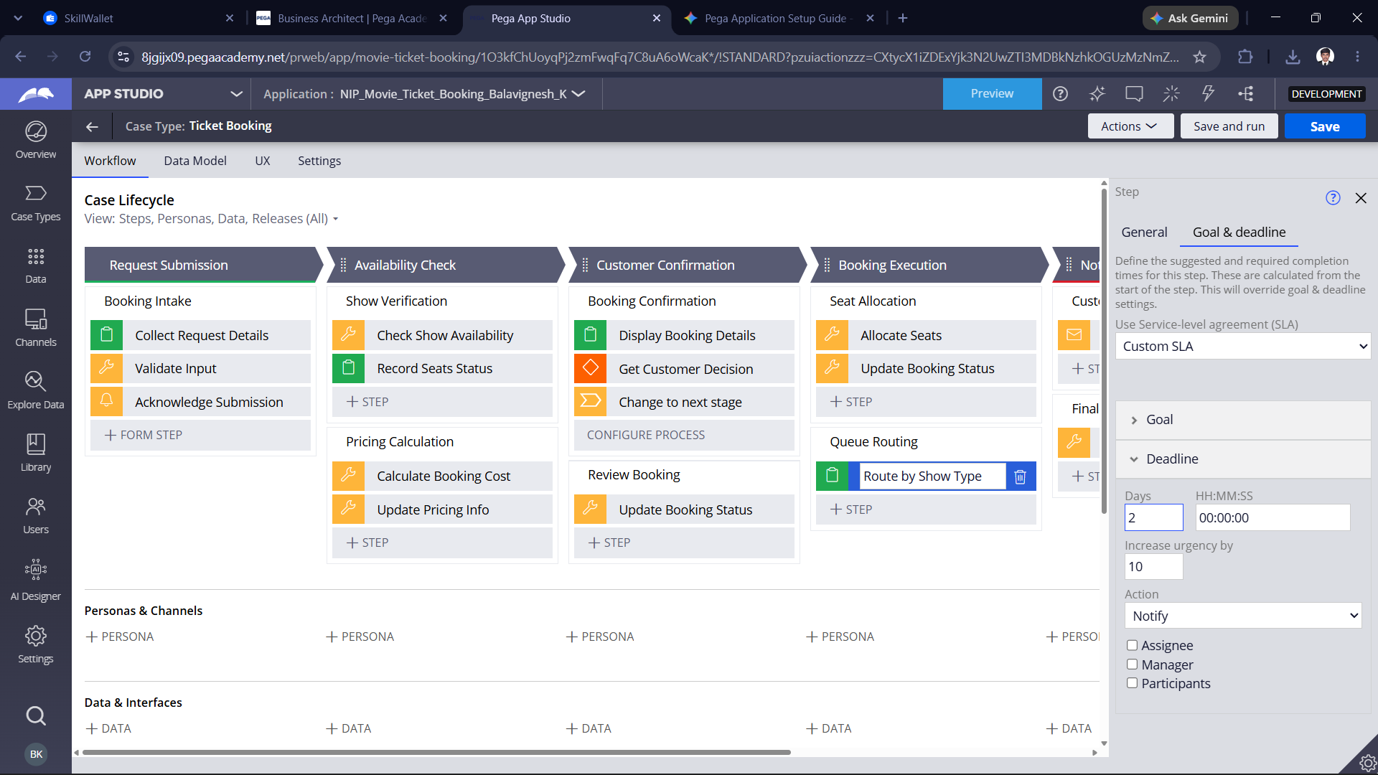

What I built for this (1–2 lines in your own words):
I configured custom Service-Level Agreements (SLAs) with specific goal and deadline configurations to manage task urgency and notifications within the Ticket Booking case lifecycle.

US-010 — Route by Show Type
What is expected:
Routing rule or Decision Table routes to PremiumShowQueue or StandardShowQueue based on Show Type property.
Screenshot — paste your screenshot below this line:
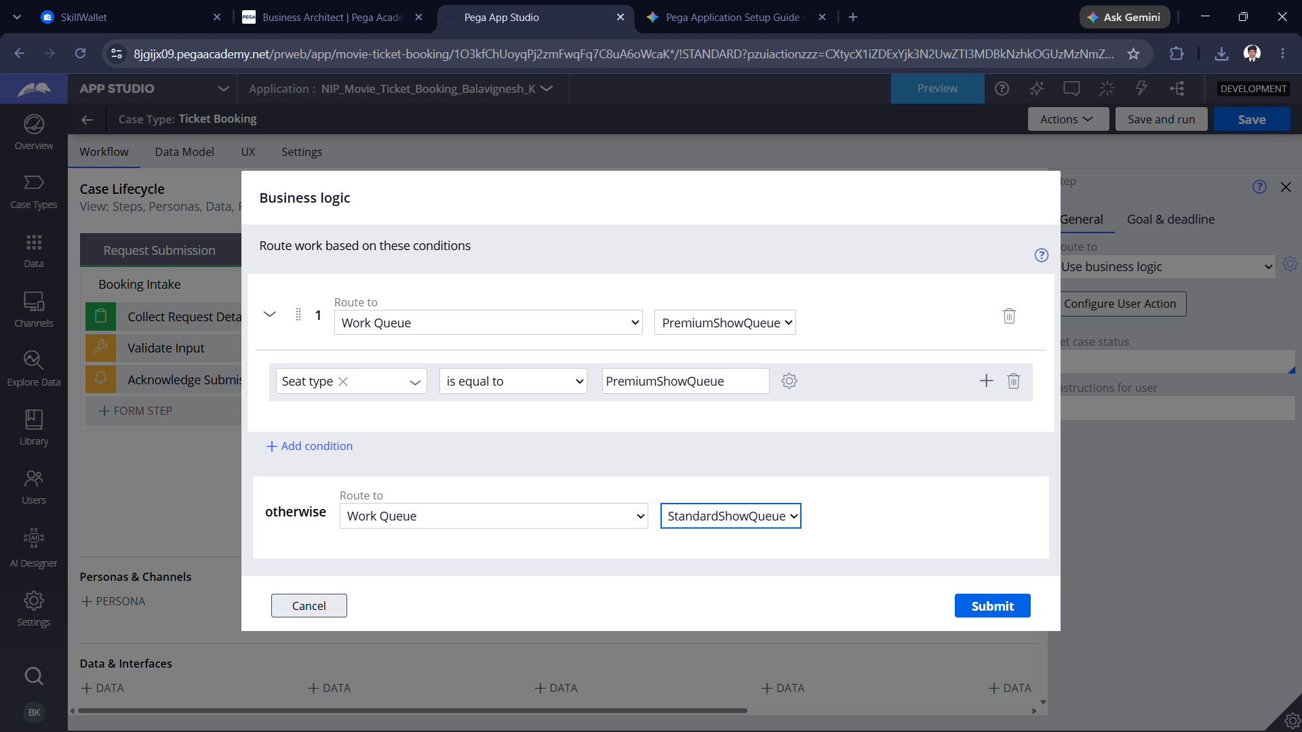

What I built for this (1–2 lines in your own words):
I configured the business logic for the "Route by Show Type" step to dynamically direct cases to the PremiumShowQueue when the seat type matches, with an alternate fallback routing to the StandardShowQueue .

Section 3 — About Your Application
These answers are checked against your screenshots. Write exactly what is in your application.

Q1. List your stages in the order they appear in your case lifecycle.
Stage names in order, separated by commas.
Request Submission, Availability, Check Customer, Confirmation, Booking Execution, Notification & Closure.

Q2. Name the data object(s) you created and the properties inside them.
Data object name and its properties.
The data objects created in the application include the Movie object with properties such as certification rating, director name, duration, genre, language, lead cast, movie title, poster image, production company, release date, show list, synopsis, and trailer URL. Additionally, the application utilizes Customer data for records like CUST-734891, Show details for schedules, Seat Allocation data for seat numbers and types, Theatre information for venues, and Booking Notification objects for managing email confirmations.

Q3. What is the exact name and type of the rule you used to calculate Total Cost?
Provide:
• Rule Name
• Rule Type
• Properties used in the calculation
• Formula used
Rule Name: CheckShowAvailability
Rule Type: Data Transform
Properties used in the calculation: .TicketPrice and .NumberOfTickets
Formula used: .TicketPrice * .NumberOfTickets

Section 4 — Your Understanding
Short, honest and specific answers score well.

Q4. What did Blueprint generate for you, and what did you add or change yourself afterwards?
Be specific about what was already there and what you built or modified on top.
Pega Blueprint generated the foundational application architecture and workflow framework, including suggested Case Types, multi-stage Case Lifecycles, core data object definitions, and initial user personas based on best practices.
Afterwards, I customized and built upon that baseline by configuring specific case steps, setting up data transforms for calculations (like the total ticket cost), defining routing business logic for work queues, and establishing custom SLAs and notification templates.

Q5. Was there anything Blueprint created that you had to correct or configure further? Describe one example.
A real example from your own work.
Pega Blueprint generated the initial case lifecycle and structure, but I had to configure further by defining the business logic and routing conditions for steps like Route by Show Type, where I explicitly set up the conditional rules to route cases to either the PremiumShowQueue or StandardShowQueue based on the seat type.

Q6. Explain your case flow from creation to resolution, in order.
What happens first, who does what, when the case closes.
The case flow begins at Request Submission, where users start the process by completing the initial request details, validating their input, and acknowledging the submission. Next, the case moves to Availability Check, which handles show verification by running availability checks, recording seat status, calculating booking costs, and updating the pricing information. After that, the case enters Customer Confirmation, where system views display booking details, capture the customer's decision, and transition the case forward to review the booking and update the status. In Booking Execution, the case goes through seat allocation, updates booking statuses, and routes work through specific queues like the premium or standard show queues based on seat types. Finally, the case reaches Notification & Closure, which triggers the confirmation email notification and completes the remaining steps until the case lifecycle is fully resolved.

Q7. Pick two design choices you made in your application and explain why you made them.
For each design choice, provide:
• What you implemented
• Why you chose that approach
• What benefit it provides to the application
Design Choice 1: Conditional Routing Based on Seat Type
- What you implemented: Configured business logic in the "Route by Show Type" step to dynamically route cases to either the PremiumShowQueue or the StandardShowQueue depending on the selected seat type.
- Why you chose that approach: To automate the distribution of work so that specialized or premium bookings are handled by the appropriate staff or queues without manual intervention.
- What benefit it provides to the application: It streamlines operational efficiency, ensures proper segregation of duties for handling different service tiers, and accelerates processing times for customers.
Design Choice 2: Automated Cost Calculation via Data Transform
- What you implemented: Created a data transform rule (CheckShowAvailability) that automatically calculates the TotalCost by multiplying .TicketPrice by .NumberOfTickets.
- Why you chose that approach: To eliminate manual math errors and ensure consistent, real-time pricing updates as soon as the user selects their ticket quantities.
- What benefit it provides to the application: It improves data accuracy, provides immediate financial transparency to the customer during review stages, and reduces administrative overhead.

Q8. What was the hardest part, and how exactly did you fix it?
Specific and honest. A real challenge scores much better than a generic answer.
The trickiest part was configuring the dynamic routing logic in the "Route by Show Type" step to make sure bookings cleanly split between the PremiumShowQueue and StandardShowQueue without overlapping. I fixed it by opening the business logic configuration for that step, setting up a precise condition where the seat type matches the premium criteria to route correctly, and configuring the otherwise fallback path to catch all standard bookings seamlessly.

Q9. If the approval step was only needed when Total Cost is above a certain amount, what would you change in your application?
Explain what you would change and where. You do not need to build this.
Configure a Routing Condition:
Set a condition on the connector leading to the approval step—such as evaluating if .TotalCost is greater than a specific threshold amount (e.g., $100).
Establish a Bypass Path:
Create an alternate path or leave the default path to skip the approval step entirely when the total cost falls below or equals that threshold, allowing those cases to proceed directly to the next stage without manager intervention.

Q10. List three exact rule names from your application that you personally created or modified.
Include the rule name and rule type for each one (for example: CalculateTotalCost - Declare Expression).
CheckShowAvailability, Route by Show Type, Ticket Booking
Q11. List all personas used in your application.
List the persona names exactly as they appear in your application.
Customer, Admin (or Ticket Agent), Users
Q12. List all work queues used in your application and explain when each one is used.
For each work queue, provide its exact name and the condition or type of work routed to it.
PremiumShowQueue:
Used during the routing step to handle bookings where the selected seat type meets the premium criteria.
StandardShowQueue:
Used as the fallback route in the business logic to handle standard ticket bookings when the premium condition is not met.
Before You Submit — Check These
Read through once before uploading.
1. Section 1 filled in. Application named as NIP-[Project]-[YourName]. Names match the actual application.
2. New Operator created in Pega with my full name. I logged in as that operator for all screenshots.
3. Only my chosen project section remains — the other project section is deleted.
4. All 10 user story screenshots are pasted and follow the operator, running-case, application, and rule-name evidence requirements.
5. Every question in Sections 3 and 4, including Q10, Q11, and Q12, is answered in my own words.
6. This file is named using the required format: ProjectName_FirstName_LastName.docx (for example, VehicleService_Ravi_Kumar.docx or MovieTicket_Ravi_Kumar.docx) and uploaded as required.

