**NATIONAL ENGINEERING COLLEGE**

(An Autonomous Institution Affiliated to Anna University Chennai & Accredited by

NAAC) K.R.NAGAR, KOVILPATTI – 628 503

**JAVA PROGRAMMING**

**19CS51C**

**CO-5 Mini Project**

**REPORT**

**Team Members**

2012045 - Balavishnu.B

2012048 - Dhanush Krishna k

1 **Title:** Canteen Management System **Problem Statement:**

To develop a canteen management system to make it easier for the

Canteen manager (or) Owner.,Instead of Making a manual Writing in note or something else..it is the easiest way to ordering all those things in database..

Our canteen management system provides a easiest user interfaces for the owner and it also takes a less time for the calculations.There is a Login Page for verification security purposes.once they signed in they have to use the billing system

**Tools Used:**

1. SWING
2. Postgresql for Database

**Module Description:**

1.Login Module

2.Menu List

LOGIN PAGE:

import javax.swing.*; import java.awt.*; import java.awt.Color; import java.awt.event.ActionEvent; import java.awt.event.ActionListener;

import java.awt.event.*;

class Loginn implements ActionListener{

JFrame f;

JLabel l1,l2,l3;

JTextField un;

JPasswordField pw;

JButton s; Loginn(){ f=new JFrame();

l1=new JLabel("CANTEEN MANAGEMENT SYSTEM");

l1.setBounds(100,10,200,20); l2=new JLabel("UserName"); l2.setBounds(10,50,200,20); l3=new JLabel("Password"); l3.setBounds(10,80,200,20); un=new JTextField(); un.setBounds(100,50,200,20); pw=new JPasswordField(); pw.setBounds(100,80,200,20); s=new JButton("Submit");

s.setBounds(150,125,100,20);

f.add(l1);f.add(l2);f.add(un);f.add(l3);f.add(pw);f.add(s);

f.setLayout(null);

f.setVisible(true);

f.getContentPane().setBackground(Color.lightGray);

f.setSize(350,200);

f.setDefaultCloseOperation(JFrame.EXIT_ON_CLOSE);

f.setResizable(false);

f.setTitle("Login");

s.addActionListener(this);

}

public void actionPerformed(ActionEvent e){ if(e.getSource()==s){

String userValue = un.getText();

String passValue = pw.getText();

if (userValue.equals("admin1") &&

passValue.equals("itsme") || userValue.equals("admin2") && passValue.equals("ucantcme")) {

CanteenManagement rr=new CanteenManagement();

}

}

}

public static void main(String ars[]){

Loginn t=new Loginn();

}

}

//MENU LIST PAGE

import javax.swing.*; import java.awt.*; import java.awt.event.*; import java.awt.event.ActionEvent; import java.awt.event.ActionListener;

class CanteenManagement implements ActionListener{

JFrame f=new JFrame("MENU");

JButton b1,b2,b3,b4,b5,b6,b7,b8,b9,b10,b11,b12,b13,s; JTextField t1,t2,t3,t4,t5,t6,t7,t8,t9,t10,t11,t12,t13; JTextArea a1,a2,a3,a4,a5,a6,a7,a8,a9,a10,a11,a12;

Int o=1,o1=0,o2=1,o3=0,o4=1,o5=0,o6=1,o7=0,o8=1,o9=0,o10=1,o11

=0,o12=1,o13=0,o14=1,o15=0,o16=1,o17=0,o18=1,o19=0,o20=1,o

21=0,o22=1,o23=0,o24=1,o25=0;

Container c;

JLabel l1,l2,l3,l4,l5,l6,l7,l8,l9,l10,l11,l12,l13;

CanteenManagement(){

f.setSize(600,700);

f.setLocation(0, 0);

f.setLayout(null);

f.setDefaultCloseOperation(f.EXIT_ON_CLOSE );

f.setResizable(false);

l13=new JLabel("CANTEEN MANAGEMENT SYSTEM");

l13.setBounds(200, 10, 600,30);

f.add(l13); l1 = new JLabel("Tea"); l1.setFont(new Font("Arial", Font.PLAIN, 20)); l1.setSize(100, 89); l1.setLocation(50, 50);

f.add(l1); l2 = new JLabel("Coffee"); l2.setFont(new Font("Arial", Font.PLAIN, 20)); l2.setSize(100, 130); l2.setLocation(50, 70);

f.add(l2); l3 = new JLabel("Juice item"); l3.setFont(new Font("Arial", Font.PLAIN, 20)); l3.setSize(100, 130); l3.setLocation(50, 105);

f.add(l3);

l4 = new JLabel("Samsa/vada"); l4.setFont(new Font("Arial", Font.PLAIN, 20)); l4.setSize(150, 150); l4.setLocation(50, 132);

f.add(l4); l5 = new JLabel("Veg buffs"); l5.setFont(new Font("Arial", Font.PLAIN, 20)); l5.setSize(150, 150); l5.setLocation(50, 165);

f.add(l5); l6 = new JLabel("Egg buffs"); l6.setFont(new Font("Arial", Font.PLAIN, 20)); l6.setSize(150, 150); l6.setLocation(50, 200);

f.add(l6);

l7 = new JLabel("Dosa"); l7.setFont(new Font("Arial", Font.PLAIN, 20)); l7.setSize(150, 150); l7.setLocation(50, 237);

f.add(l7); l8 = new JLabel("Parota"); l8.setFont(new Font("Arial", Font.PLAIN, 20)); l8.setSize(150, 150); l8.setLocation(50, 269);

f.add(l8); l8 = new JLabel("poori"); l8.setFont(new Font("Arial", Font.PLAIN, 20)); l8.setSize(150, 150); l8.setLocation(50, 300);

f.add(l8);

l9 = new JLabel("Veg Meals"); l9.setFont(new Font("Arial", Font.PLAIN, 20)); l9.setSize(150, 150); l9.setLocation(50, 335);

f.add(l9);

l10 = new JLabel("NonVeg Meals"); l10.setFont(new Font("Arial", Font.PLAIN, 20)); l10.setSize(150, 150); l10.setLocation(50, 372);

f.add(l10); l11 = new JLabel("Chapathi"); l11.setFont(new Font("Arial", Font.PLAIN, 20)); l11.setSize(150, 150); l11.setLocation(50, 407);

f.add(l11); l12 = new JLabel("Idli"); l12.setFont(new Font("Arial", Font.PLAIN, 20)); l12.setSize(150, 150); l12.setLocation(50, 440);

f.add(l12); b1 = new JButton("+"); b1.setFont(new Font("Arial", Font.BOLD, 10)); b1.setBounds(220, 80,40,20 );

f.add(b1); b2 = new JButton("+"); b2.setFont(new Font("Arial", Font.BOLD, 10)); b2.setBounds(220, 118,40,20 );

f.add(b2); b3 = new JButton("+"); b3.setFont(new Font("Arial", Font.BOLD, 10)); b3.setBounds(220, 156 ,40,20);

f.add(b3); b4 = new JButton("+"); b4.setFont(new Font("Arial", Font.BOLD, 10)); b4.setBounds(220, 194 ,40,20);

f.add(b4); b5 = new JButton("+"); b5.setFont(new Font("Arial", Font.BOLD, 10)); b5.setBounds(220, 230 ,40,20);

f.add(b5); b6 = new JButton("+"); b6.setFont(new Font("Arial", Font.BOLD, 10)); b6.setBounds(220, 263,40,20 );

f.add(b6); b7 = new JButton("+"); b7.setFont(new Font("Arial", Font.BOLD, 10)); b7.setBounds(220, 299,40,20 );

f.add(b7); b8 = new JButton("+"); b8.setFont(new Font("Arial", Font.BOLD, 10)); b8.setBounds(220, 333,40,20 );

f.add(b8); b9 = new JButton("+"); b9.setFont(new Font("Arial", Font.BOLD, 10)); b9.setBounds(220, 367,40,20);

f.add(b9); b10 = new JButton("+"); b10.setFont(new Font("Arial", Font.BOLD, 10)); b10.setBounds(220, 400,40,20 );

f.add(b10); b11 = new JButton("+"); b11.setFont(new Font("Arial", Font.BOLD, 10)); b11.setBounds(220, 435,40,20);

f.add(b11);

b12 = new JButton("+"); b12.setFont(new Font("Arial", Font.BOLD, 10)); b12.setBounds(220, 472,40,20);

f.add(b12); b13 = new JButton("+"); b13.setFont(new Font("Arial", Font.BOLD, 10)); b13.setBounds(220, 508,40,20);

f.add(b13); t1 = new JTextField(""); t1.setFont(new Font("Arial", Font.PLAIN, 20)); t1.setSize(35, 20); t1.setLocation(280, 80); t1.setEditable(false);

f.add(t1); t2 = new JTextField(""); t2.setFont(new Font("Arial", Font.PLAIN, 20)); t2.setSize(35, 20); t2.setLocation(280, 118); t2.setEditable(false);

f.add(t2); t3 = new JTextField(""); t3.setFont(new Font("Arial", Font.PLAIN, 20)); t3.setSize(35, 20); t3.setLocation(280, 156); t3.setEditable(false);

f.add(t3);

t4 = new JTextField(""); t4.setFont(new Font("Arial", Font.PLAIN, 20)); t4.setSize(35, 20); t4.setLocation(280, 195); t4.setEditable(false);

f.add(t4);

t5 = new JTextField(""); t5.setFont(new Font("Arial", Font.PLAIN, 20)); t5.setSize(35, 20); t5.setLocation(280, 230); t5.setEditable(false);

f.add(t5);

t6 = new JTextField(""); t6.setFont(new Font("Arial", Font.PLAIN, 20)); t6.setSize(35, 20); t6.setLocation(280, 264); t6.setEditable(false);

f.add(t6);

t7 = new JTextField(""); t7.setFont(new Font("Arial", Font.PLAIN, 20)); t7.setSize(35, 20); t7.setLocation(280, 300); t7.setEditable(false);

f.add(t7); t8 = new JTextField(""); t8.setFont(new Font("Arial", Font.PLAIN, 20)); t8.setSize(35, 20); t8.setLocation(280, 333); t8.setEditable(false);

f.add(t8); t9 = new JTextField(""); t9.setFont(new Font("Arial", Font.PLAIN, 20)); t9.setSize(35, 20); t9.setLocation(280, 367); t9.setEditable(false);

f.add(t9); t10 = new JTextField(""); t10.setFont(new Font("Arial", Font.PLAIN, 20)); t10.setSize(35, 20); t10.setLocation(280, 400); t10.setEditable(false);

f.add(t10); t11 = new JTextField(""); t11.setFont(new Font("Arial", Font.PLAIN, 20)); t11.setSize(35, 20); t11.setLocation(280, 435); t11.setEditable(false);

f.add(t11); t12 = new JTextField(""); t12.setFont(new Font("Arial", Font.PLAIN, 20)); t12.setSize(35, 20); t12.setLocation(280, 472); t12.setEditable(false);

f.add(t12);

t13 = new JTextField(""); t13.setFont(new Font("Arial", Font.PLAIN, 20)); t13.setSize(35, 20); t13.setLocation(280, 508); t13.setEditable(false);

f.add(t13);

s = new JButton("Buy the items");

s.setFont(new Font("Arial", Font.PLAIN, 20));

s.setSize(170, 40);

s.setLocation(200, 580 );

f.add(s);

f.setVisible(true); b1.addActionListener(this); b2.addActionListener(this); b3.addActionListener(this); b4.addActionListener(this); b5.addActionListener(this); b6.addActionListener(this); b7.addActionListener(this); b8.addActionListener(this); b9.addActionListener(this); b10.addActionListener(this); b11.addActionListener(this); b12.addActionListener(this); b13.addActionListener(this);

s.addActionListener(this); a1 = new JTextArea(); a1.setFont(new Font("Arial", Font.PLAIN, 15)); a1.setSize(150,70); a1.setLocation(400, 300); a1.setLineWrap(true);

f.add(a1);

}

public void actionPerformed(ActionEvent e){ if(e.getSource()==b1){ t1.setText(String.valueOf(o));

o++;

}o1=(o-1)*5; if(e.getSource()==b2){ t2.setText(String.valueOf(o2));

o2++;

} o3=(o2-1)*10; if(e.getSource()==b3){ t3.setText(String.valueOf(o4));

o4++;

}o5=(o4-1)*15; if(e.getSource()==b4){ t4.setText(String.valueOf(o6));

o6++;

} o7=(o6-1)*8; if(e.getSource()==b5){ t5.setText(String.valueOf(o8));

o8++; } o9=(o8-1)*12; if(e.getSource()==b6){ t6.setText(String.valueOf(o10));

o10++; } o11=(o10-1)*20; if(e.getSource()==b7){ t7.setText(String.valueOf(o12));

o12++;

} o13=(o12-1)*40; if(e.getSource()==b8){ t8.setText(String.valueOf(o14));

o14++; }o15=(o14-1)*15;

if(e.getSource()==b9){ t9.setText(String.valueOf(o16));

o16++;

}o17=(o16-1)*12; if(e.getSource()==b10){ t10.setText(String.valueOf(o18)); o18++;

}o19=(o18-1)*60; if(e.getSource()==b11){ t11.setText(String.valueOf(o20));

o20++;

}o21=(o20-1)*80; if(e.getSource()==b12){ t12.setText(String.valueOf(o22));

o22++;

}o23=(o22-1)*18; if(e.getSource()==b13){ t13.setText(String.valueOf(o24));

o16++;

}o25=(o24-1)*8; if(e.getSource()==s){

int

sum=o1+o3+o5+o7+o9+o11+o13+o15+o17+o19+o21+o23+o25;

a1.setText("Total Ammount: "+String.valueOf(sum)); a1.setEditable(false);

}

}

public static void main(String args[]){

new CanteenManagement();

}

}

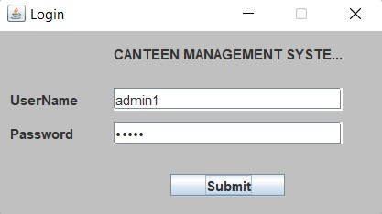

//MENU LIST

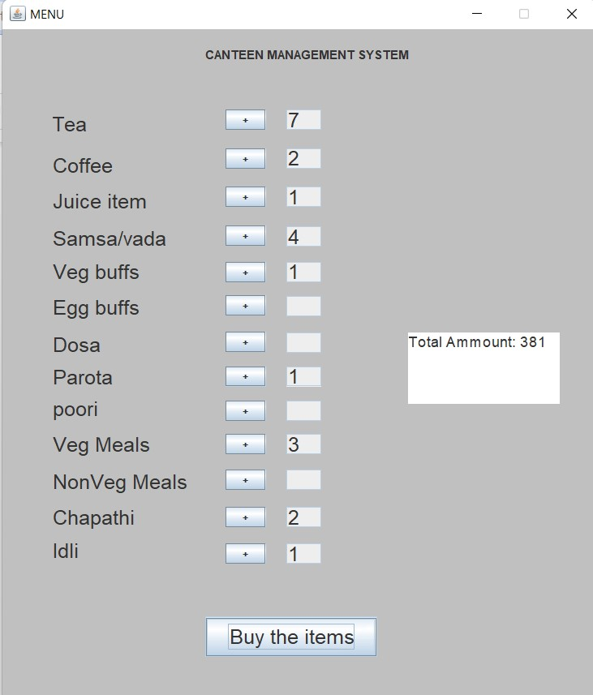

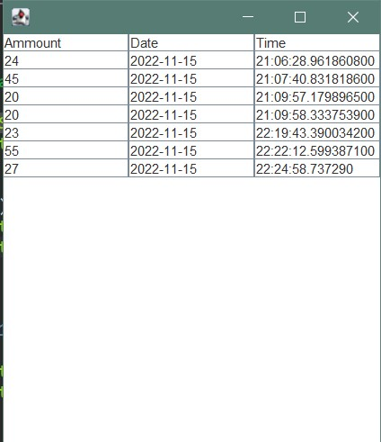



|  |  |
| --- | --- |
|  |  |
|  |  |

import javax.swing.*;

//import org.json.JSONObject;

import java.awt.*; import java.awt.event.*; import java.awt.event.ActionEvent; import java.awt.event.ActionListener; import java.time.LocalDateTime; import java.time.format.DateTimeFormatter; import java.time.LocalTime; import javax.swing.table.*;

import java.sql.Connection; import java.sql.DriverManager; import java.sql.PreparedStatement; import java.sql.ResultSet; import java.sql.SQLException; import java.sql.Statement; class CanteenManagement extends JFrame implements ActionListener{

JFrame f=new JFrame();

// dtm.addColumn("Amount");

DefaultTableModel dtm;

JButton b1,b2,b3,b4,b5,b6,b7,b8,b9,b10,b11,b12,b13,s,s1;

JTextField t1,t2,t3,t4,t5,t6,t7,t8,t9,t10,t11,t12,t13;

JTextArea a1,a2,a3,a4,a5,a6,a7,a8,a9,a10,a11,a12;

int

o=1,o1=0,o2=1,o3=0,o4=1,o5=0,o6=1,o7=0,o8=1,o9=0,o10=1,o11=0,o12=1,o13=0,o14=1,o

15=0,o16=1,o17=0,o18=1,o19=0,o20=1,o21=0,o22=1,o23=0,o24=1,o25=0;

JTable k;

Container c;

JScrollPane sh;

JLabel l1,l2,l3,l4,l5,l6,l7,l8,l9,l10,l11,l12;

public CanteenManagement(){

f.setSize(500,500);

f.setBounds(300, 100, 730, 860);

f.setLayout(null);

l1.setFont(new Font("Arial", Font.PLAIN, 20)); l1.setSize(100, 89); l1.setLocation(50, 50);

f.add(l1);

l2 = new JLabel("Coffee"); l2.setFont(new Font("Arial", Font.PLAIN, 20)); l2.setSize(100, 130); l2.setLocation(50, 70);

f.add(l2);

l3 = new JLabel("Juice item"); l3.setFont(new Font("Arial", Font.PLAIN, 20)); l3.setSize(100, 130); l3.setLocation(50, 105);

f.add(l3);

l4 = new JLabel("Samsa/vada"); l4.setFont(new Font("Arial", Font.PLAIN, 20)); l4.setSize(150, 150); l4.setLocation(50, 132);

f.add(l4);

l5 = new JLabel("Veg buffs"); l5.setFont(new Font("Arial", Font.PLAIN, 20)); l5.setSize(150, 150); l5.setLocation(50, 165);

f.add(l5); l6 = new JLabel("Egg buffs"); l6.setFont(new Font("Arial", Font.PLAIN, 20)); l6.setSize(150, 150); l6.setLocation(50, 200);

f.add(l6);

l7 = new JLabel("Dosa"); l7.setFont(new Font("Arial", Font.PLAIN, 20)); l7.setSize(150, 150);

l7.setLocation(50, 237);

f.add(l7);

l8 = new JLabel("Parota"); l8.setFont(new Font("Arial", Font.PLAIN, 20)); l8.setSize(150, 150); l8.setLocation(50, 269);

f.add(l8);

l8 = new JLabel("poori"); l8.setFont(new Font("Arial", Font.PLAIN, 20)); l8.setSize(150, 150); l8.setLocation(50, 300);

f.add(l8);

l9 = new JLabel("Veg Meals"); l9.setFont(new Font("Arial", Font.PLAIN, 20)); l9.setSize(150, 150); l9.setLocation(50, 335);

f.add(l9);

l10 = new JLabel("NonVeg Meals"); l10.setFont(new Font("Arial", Font.PLAIN, 20)); l10.setSize(150, 150); l10.setLocation(50, 372);

f.add(l10);

l11 = new JLabel("Chapathi"); l11.setFont(new Font("Arial", Font.PLAIN, 20)); l11.setSize(150, 150); l11.setLocation(50, 407);

f.add(l11);

l12 = new JLabel("Idli"); l12.setFont(new Font("Arial", Font.PLAIN, 20)); l12.setSize(150, 150); l12.setLocation(50, 440);

f.add(l12); b1 = new JButton("+"); b1.setFont(new Font("Arial", Font.PLAIN, 20)); b1.setSize(100, 20); b1.setLocation(240, 80 );

f.add(b1);

b2 = new JButton("+"); b2.setFont(new Font("Arial", Font.PLAIN, 20)); b2.setSize(100, 20); b2.setLocation(240, 118 );

f.add(b2);

b3 = new JButton("+"); b3.setFont(new Font("Arial", Font.PLAIN, 20)); b3.setSize(100, 20);

b3.setLocation(240, 156 );

f.add(b3);

b4 = new JButton("+"); b4.setFont(new Font("Arial", Font.PLAIN, 20)); b4.setSize(100, 20); b4.setLocation(240, 194 );

f.add(b4);

b5 = new JButton("+"); b5.setFont(new Font("Arial", Font.PLAIN, 20)); b5.setSize(100, 20); b5.setLocation(240, 230 );

f.add(b5);

b6 = new JButton("+"); b6.setFont(new Font("Arial", Font.PLAIN, 20)); b6.setSize(100, 20); b6.setLocation(240, 263 );

f.add(b6); b7 = new JButton("+"); b7.setFont(new Font("Arial", Font.PLAIN, 20)); b7.setSize(100, 20); b7.setLocation(240, 299 );

f.add(b7);

b8 = new JButton("+"); b8.setFont(new Font("Arial", Font.PLAIN, 20)); b8.setSize(100, 20); b8.setLocation(240, 333 );

f.add(b8);

b9 = new JButton("+"); b9.setFont(new Font("Arial", Font.PLAIN, 20)); b9.setSize(100, 20); b9.setLocation(240, 367);

f.add(b9); b10 = new JButton("+"); b10.setFont(new Font("Arial", Font.PLAIN, 20)); b10.setSize(100, 20); b10.setLocation(240, 400 );

f.add(b10); b11 = new JButton("+"); b11.setFont(new Font("Arial", Font.PLAIN, 20)); b11.setSize(100, 20); b11.setLocation(240, 435);

f.add(b11);

b12 = new JButton("+"); b12.setFont(new Font("Arial", Font.PLAIN, 20)); b12.setSize(100, 20); b12.setLocation(240, 472);

f.add(b12);

b13 = new JButton("+"); b13.setFont(new Font("Arial", Font.PLAIN, 20)); b13.setSize(100, 20); b13.setLocation(240, 508);

f.add(b13);

t1 = new JTextField(""); t1.setFont(new Font("Arial", Font.PLAIN, 20)); t1.setSize(100, 20); t1.setLocation(339, 80);

f.add(t1);

t2 = new JTextField(""); t2.setFont(new Font("Arial", Font.PLAIN, 20)); t2.setSize(100, 20); t2.setLocation(339, 118);

f.add(t2);

t3 = new JTextField(""); t3.setFont(new Font("Arial", Font.PLAIN, 20)); t3.setSize(100, 20); t3.setLocation(339, 156);

f.add(t3);

t4 = new JTextField(""); t4.setFont(new Font("Arial", Font.PLAIN, 20)); t4.setSize(100, 20); t4.setLocation(339, 195);

f.add(t4);

t5 = new JTextField(""); t5.setFont(new Font("Arial", Font.PLAIN, 20)); t5.setSize(100, 20); t5.setLocation(339, 230);

f.add(t5);

t6 = new JTextField(""); t6.setFont(new Font("Arial", Font.PLAIN, 20)); t6.setSize(100, 20); t6.setLocation(339, 264);

f.add(t6);

t7 = new JTextField(""); t7.setFont(new Font("Arial", Font.PLAIN, 20)); t7.setSize(100, 20); t7.setLocation(339, 300);

f.add(t7);

t8 = new JTextField(""); t8.setFont(new Font("Arial", Font.PLAIN, 20)); t8.setSize(100, 20); t8.setLocation(339, 333);

f.add(t8);

t9 = new JTextField(""); t9.setFont(new Font("Arial", Font.PLAIN, 20)); t9.setSize(100, 20); t9.setLocation(339, 367);

f.add(t9); t10 = new JTextField(""); t10.setFont(new Font("Arial", Font.PLAIN, 20)); t10.setSize(100, 20); t10.setLocation(339, 400);

f.add(t10); t11 = new JTextField(""); t11.setFont(new Font("Arial", Font.PLAIN, 20)); t11.setSize(100, 20); t11.setLocation(339, 435);

f.add(t11);

t12 = new JTextField(""); t12.setFont(new Font("Arial", Font.PLAIN, 20)); t12.setSize(100, 20); t12.setLocation(339, 472);

f.add(t12);

t13 = new JTextField(""); t13.setFont(new Font("Arial", Font.PLAIN, 20)); t13.setSize(100, 20); t13.setLocation(339, 508);

f.add(t13);

s = new JButton("Buy the items");

s.setFont(new Font("Arial", Font.PLAIN, 20));

s.setSize(170, 40);

s.setLocation(200, 580 );

f.add(s);

s1 = new JButton("view price"); s1.setFont(new Font("Arial", Font.PLAIN, 20)); s1.setSize(170, 40); s1.setLocation(500, 580 );

f.add(s1);

f.setVisible(true); b1.addActionListener(this); b2.addActionListener(this); b3.addActionListener(this); b4.addActionListener(this); b5.addActionListener(this); b6.addActionListener(this); b7.addActionListener(this); b8.addActionListener(this); b9.addActionListener(this); b10.addActionListener(this); b11.addActionListener(this); b12.addActionListener(this); b13.addActionListener(this); s1.addActionListener(this);

s.addActionListener(this); a1 = new JTextArea(); a1.setFont(new Font("Arial", Font.PLAIN, 15)); a1.setSize(150,150); a1.setLocation(500, 300); a1.setLineWrap(true);

f.add(a1);

}

public void actionPerformed(ActionEvent e){

if(e.getSource()==b1){ t1.setText(String.valueOf(o)); o++;

}o1=(o-1)*5; if(e.getSource()==b2){ t2.setText(String.valueOf(o2)); o2++;

}

o3=(o2-1)*10;

if(e.getSource()==b3){

t3.setText(String.valueOf(o4)); o4++;

}o5=(o4-1)*15; if(e.getSource()==b4){ t4.setText(String.valueOf(o6)); o6++;

}

o7=(o6-1)*8; if(e.getSource()==b5){ t5.setText(String.valueOf(o8)); o8++;

}

o9=(o8-1)*12;

if(e.getSource()==b6){ t6.setText(String.valueOf(o10)); o10++;

}

o11=(o10-1)*20;

if(e.getSource()==b7){ t7.setText(String.valueOf(o12)); o12++;

}

o13=(o12-1)*40;

if(e.getSource()==b8){ t8.setText(String.valueOf(o14)); o14++; }o15=(o14-1)*15;

if(e.getSource()==b9){ t9.setText(String.valueOf(o16)); o16++; }o17=(o16-1)*12;

if(e.getSource()==b10){ t10.setText(String.valueOf(o18)); o18++;

}o19=(o18-1)*60; if(e.getSource()==b11){ t11.setText(String.valueOf(o20)); o20++;

}o21=(o20-1)*80; if(e.getSource()==b12){ t12.setText(String.valueOf(o22)); o22++;

}o23=(o22-1)*18; if(e.getSource()==b13){ t13.setText(String.valueOf(o24)); o16++;

}o25=(o24-1)*8; if(e.getSource()==s){ int sum=o1+o3+o5+o7+o9+o11+o13+o15+o17+o19+o21+o23+o25;

String h1=java.time.LocalDate.now().toString();

String h3=Integer.toString(sum);

String h2=LocalTime.now().toString(); a1.setText("Total Ammount: "+String.valueOf(sum) +"\n"+ h1+"\n"+h2);

System.out.print("hbfc");

String ju="jdbc:postgresql://localhost:5432/canteendb";

String un="Admin"; String Pa="1234";

try {

// String sql="INSERT INTO weatherhistory VALUES

('"+formattedDate+"','"+r1+"','"+cit +"')" ;

Connection con=DriverManager.getConnection(ju,un,Pa);

String sql="INSERT INTO info(amount, date,

time)"+"VALUES('"+h3+"','"+h1+"','"+h2+"')"; Statement st=con.createStatement(); st.executeUpdate(sql);

}

catch(Exception nh) {

System.out.print("fhefb");

}

}

if(e.getSource()==s1) { poda pp=new poda();

}

}

public static void main(String args[]){

new CanteenManagement();

}

RESULT:

Thus the java GUI applications for Canteen Management

is designed and provide appropriate with event handling