

Project laboratory reporterrier
Department of Telecommunications and Artificial Intelligence

Name: | Bognár Balázs László
Neptun code: | RA7X78
Specialization: | Information Systems
Email: | bognarbalazslaszlo2007@gmail.com
Supervisor(s): | Toka László, Szmida Patrik
Email(s): | toka@tmit.bme.hu szmida.patrikpeter@edu.bme.hu

Title: League of Legends Analytics

Task description
Esports and competitive gaming have experienced explosive growth in recent years, now attracting a global audience of tens of millions. While data analysis and artificial intelligence methods are already established practices for developing players and teams in traditional sports, their application in gaming is currently emerging. This is particularly true for League of Legends (LoL), which is one of the most popular titles today.
In this project, the student's task is to familiarize themselves with the methodology of collecting and processing data generated during matches, focusing specifically on Korean Challenger ranked players rather than professional esports matches. The student will analyze player and team performances using machine learning techniques. The emphasis is on building a complete AI-based analysis pipeline, from data scraping and preparation via the Riot Games API to exploratory data analysis (EDA) and predictive modeling, with a special focus on calculating win probabilities based on sequential in-game events.

2025/2026. 2nd semester

Introduction and Background

1.1 Introduction
Esports has experienced significant growth in recent years, creating an environment where large volumes of match data are continuously generated. While data analytics is already a standard tool in traditional sports, its application in esports is still developing, despite the availability of detailed and structured in-game data.
League of Legends provides a particularly suitable context for analytical approaches due to its complexity and the wide range of measurable gameplay features. Among possible analytical tasks, estimating win probability is of particular interest, as it captures how in-game events and game state influence the likelihood of victory over time. This requires modeling both temporal progression and the interaction of multiple gameplay factors.
This project focuses on matches played by Challenger-level players on the Korean server. This dataset represents the highest level of ranked gameplay, where players consistently demonstrate optimized strategies and strong mechanical execution. As a result, the data is less affected by random or suboptimal decisions, allowing more reliable patterns to be identified. Additionally, the Korean server is widely recognized as one of the most competitive environments, making it especially valuable for analytical purposes.
The motivation for this work originates from personal experience with the game and a long-standing interest in professional-level gameplay. Although not participating competitively, familiarity with the game’s mechanics and strategies motivated a deeper, data-driven investigation. The goal of this project is therefore to develop a machine learning-based framework for estimating win probability, providing insight into how different factors contribute to match outcomes.

1.2 Theoretical Background
League of Legends is a multiplayer online battle arena (MOBA) game in which two teams of five players compete with the objective of destroying the opposing team’s main structure, the Nexus. Each player controls a single character assigned to a specific role, typically including top, jungle, mid, attack damage carry (ADC), and support. The game is played on a structured map with three primary lanes, defensive towers, and neutral objectives. Most analytical datasets are derived from solo queue matches, where players are matched based on skill level, resulting in competitive but non-coordinated team environments.
From a data analysis perspective, match outcome prediction can be formulated as a supervised machine learning problem. In this setting, models are trained on historical match data to learn the relationship between in-game features and the final outcome. Depending on the formulation, this task can be approached as a classification problem, where the goal is to predict the winning team, or as a probabilistic estimation problem, where the model outputs the likelihood of victory for a given game state. Common approaches include statistical models and tree-based methods, which are capable of capturing nonlinear relationships between features.
Win probability can therefore be formally interpreted as the conditional probability of a team winning given the current game state. Unlike static prediction tasks, this probability evolves throughout the match as new information becomes available. The input to such models typically consists of aggregated in-game metrics, such as resource differences, objective control, and other state descriptors.
A defining characteristic of League of Legends data is its temporal structure. The relevance of individual features varies across different stages of the game. Early-game advantages, such as initial gold leads, may not directly determine the outcome but can influence later developments.

1.3 Initial State of the Project
At the beginning of the project, no preprocessed or directly usable dataset was available for the intended analysis. In particular, access to detailed professional esports data is limited, and publicly available datasets often lack the granularity or consistency required for reliable modeling. As a result, it was necessary to collect and construct a suitable dataset independently.
Due to these limitations, the focus was shifted from professional esports matches to high-level ranked gameplay. Data collection was therefore based on matches played by Challenger-level players, which provide a comparable level of gameplay quality while being more accessible through public data sources. At the initial stage, no data processing pipeline or predictive model was implemented, and the project started with the design of a data acquisition and preprocessing workflow.

Methodology and Results

2.1 Data Scraping and Preparation
The dataset used in this project was constructed using the Riot Games API, which provides access to detailed match and player data. Due to strict rate limiting constraints imposed by the API, data collection had to be performed in a controlled and incremental manner. Requests were organized in batches, with intermediate results stored locally to ensure robustness and to avoid data loss during long-running scraping processes.
The data collection process began with retrieving Challenger-level ranked ladders from the Korean server. From these ladders, individual player identifiers were extracted, which were then used to obtain match histories. For each match, both general match data and detailed timeline data were collected. The timeline data is particularly important, as it provides fine-grained information about in-game events and state changes over time.
Pipelineábra??
During the initial phase of development, a prototype dataset was constructed using a simplified representation, where match states were sampled at fixed one-minute intervals. While this approach allowed for a basic temporal analysis, it resulted in a loss of important information between sampling points. To address this limitation, the final dataset was built using an event-driven approach, where each recorded row corresponds to a specific in-game event or timestamp. This method preserves the full temporal resolution of the match and enables more accurate modeling of game dynamics.
The final dataset structure includes the match identifier, temporal information (both minute-based and exact timestamps), and detailed player statistics for all ten participants. In addition to raw features, cumulative statistics and difference-based features were also computed, such as team-level aggregates and inter-team differences. These derived features play a key role in capturing relative advantages between teams.
Data collection was performed in multiple batches, which were later merged into a unified dataset. The final dataset consists of 10,223 matches and several million rows due to the event-driven representation. Initially, approximately 704 features were generated from match and timeline data. In a later stage, additional champion-specific features were incorporated, increasing the total number of features by 344 and further enriching the dataset.
Due to the high dimensionality of the final dataset (1,048 features), representing every single column is impractical. Instead, the event-driven feature architecture is systematically categorized into five core groups:
- Identifiers & Temporal Data: Contextual information defining the match, exact timestamp, and the trigger event (e.g., matchId, timestamp, type).
- Individual Player Statistics: Real-time metrics for all 10 participants at the exact moment of the event (e.g., currentGold_p1, positionX_p1).
- Team Differential Metrics: The computed numerical difference between the Blue and Red teams (e.g., totalGold_diff, xp_diff, level_diff).
- Cumulative Events: Running differential totals of significant game events up to the current timestamp (e.g., cum_CHAMPION_KILL_diff).
- Champion Features: One-hot encoded representations of the specific champions selected by each team.

2.2 Exploratory Data Analysis (EDA)
Exploratory data analysis was performed on a representative subset of the collected data, consisting of approximately 2.6 million rows, 704 features, and 2,475 matches. This reduced dataset enabled efficient analysis while preserving the statistical properties of the full dataset.
The distribution of match durations reveals a noticeable concentration around the 15-minute mark, which corresponds to early surrender conditions in ranked matches. This confirms that a non-negligible portion of games ends prematurely, which has implications for both feature interpretation and model training.
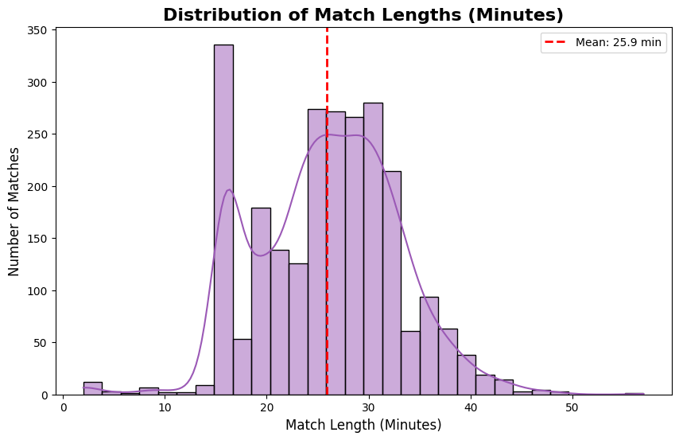
1. Figure Distribution of match durations showing the 15-minute surrender spike

Key gameplay-related features, such as gold difference and experience (XP) difference between teams, were analyzed in detail. These variables show strong correlation with match outcomes and exhibit clear distributional differences between winning and losing teams. In particular, gold advantage emerges as one of the most informative indicators of game state, supporting its use as a primary feature in predictive modeling.
To further investigate feature relationships, correlation analysis was conducted on a selected subset of relevant variables. The resulting heatmaps highlight strong dependencies between resource-based and objective-based features, while also revealing redundancies among certain derived metrics. This analysis informed later feature selection and engineering steps.
Furthermore, the data confirms a persistent statistical phenomenon known as the "Blue Side Advantage." Analyzing the global win rates in the sample, the Blue team exhibited a slight but statistically significant higher win probability compared to the Red team. This is historically attributed to map asymmetry, camera angle perspectives, and the pick/ban phase drafting order.
Objective control, particularly in the early stages of the game, also shows a meaningful relationship with match outcomes. Early acquisition of objectives such as dragons or towers is associated with increased win probability, although their impact is typically mediated through resource advantages gained over time.
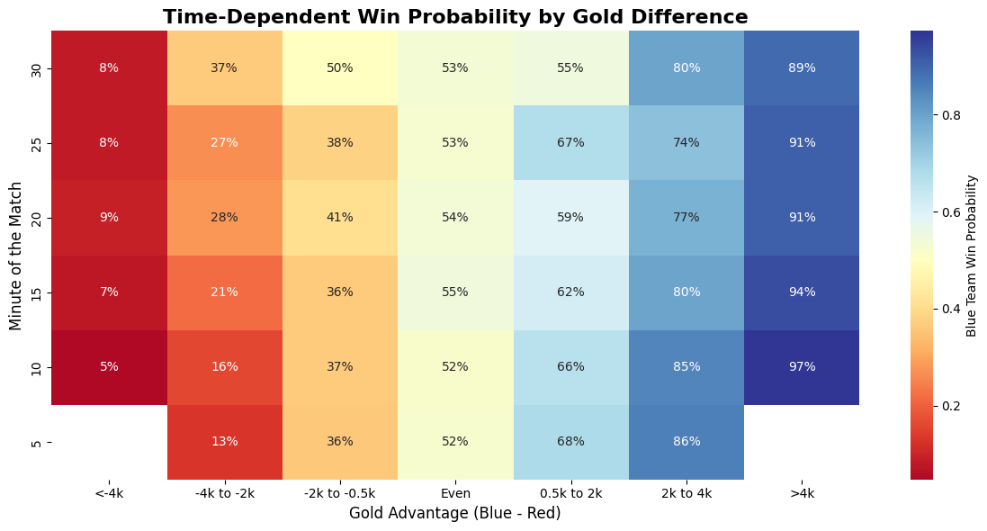
Finally, the temporal aspect of the data was examined by analyzing how the relationship between gold difference and win probability evolves throughout the match. The results indicate that the predictive power of gold advantage increases as the game progresses, reinforcing the importance of time-dependent modeling approaches.
2. Figure Heatmap of time-dependent win probability based on gold difference

2.3 Predictive Modeling for Win Probability
To estimate win probability based on in-game features, several machine learning approaches were implemented and evaluated. The modeling process was designed to compare both simple baseline methods and more advanced techniques capable of capturing nonlinear relationships and temporal dependencies.
As an initial baseline, logistic regression was applied to a reduced subset of the dataset, consisting of approximately 1 million rows and 921 matches. This model provides a straightforward probabilistic interpretation and serves as a reference point for more complex approaches. However, due to its linear nature, its ability to capture interactions between features is limited.
To address these limitations, gradient boosting methods were introduced, specifically using XGBoost. This approach is well-suited for tabular data and can effectively model nonlinear relationships between features. Two variants were implemented: one using only gameplay-derived features, and another extended with champion-specific features. The inclusion of champion information increased the feature space significantly and allowed the model to capture composition-related effects.
Hyperparameter optimization was performed using grid search to improve model performance. In addition to standard evaluation metrics, calibration of predicted probabilities was also examined. Calibration plots were used to assess how well the predicted probabilities correspond to actual observed outcomes, which is particularly important in the context of win probability estimation.

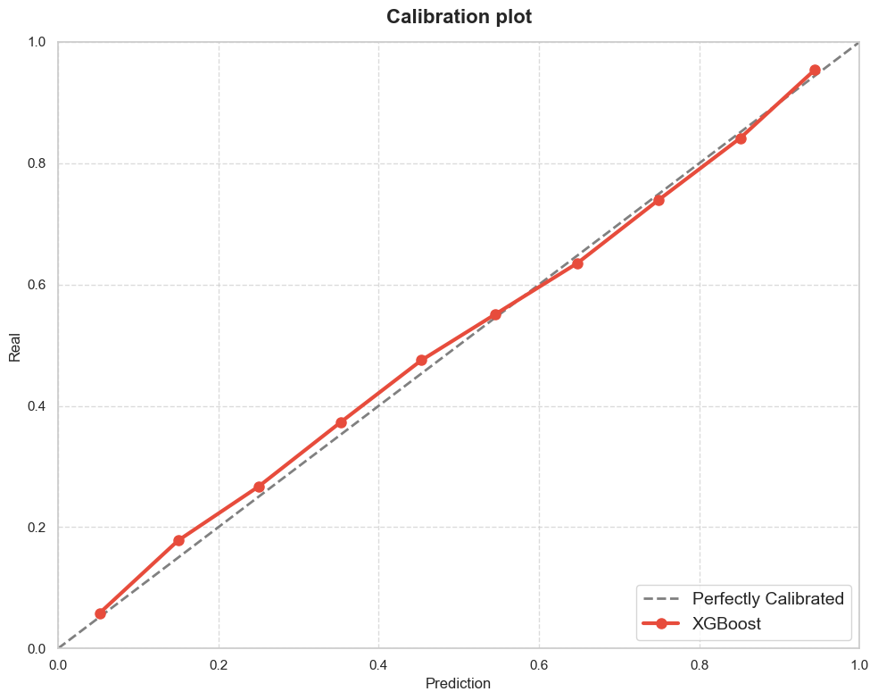
3. Figure Calibration Plot of the XGBoost model showing the reliability of predicted probabilities)
To further incorporate the temporal nature of the data, a sequence-based model using Long Short-Term Memory (LSTM) networks was implemented. This model was trained on approximately 2 million rows and is capable of learning patterns from sequences of game states rather than independent observations. By modeling temporal dependencies explicitly, the LSTM approach aims to improve prediction quality, especially in earlier stages of the game where static features may be less informative.
The performance of the models was evaluated using standard classification metrics, with particular emphasis on probabilistic interpretation and temporal consistency. The results demonstrate that tree-based methods outperform linear models in terms of predictive accuracy, while the inclusion of temporal modeling provides additional improvements in capturing game dynamics.

2.4 Results and Evaluation

Summary and Conclusions

Ebben a részben az adott félévre vonatkozó, az Önálló laboratórium tárgy keretében elvégzett munka során elért új eredmények ismételt, vázlatos, tömör összefoglalását várjuk, lehetőleg nem felsorolásként. Itt még egyszer ki lehet térni a leglényegesebb eredményekre, valamint a félév során felmerülő nehézségekre, de meg lehet említeni a továbbfejlesztési irányokat, lehetőségeket is.
Ezt a részt tagolható a következő pontok megválaszolásával:
- Mi volt az aktuális kérdés, probléma, amivel a félév során foglalkoztál?
- Mi a dolgozat célja, miért érdekes egyáltalán ezzel a problémával foglalkozni?
- Milyen módszereket használtál a probléma megoldása érdekében?
- Mik a legfontosabb eredmények?
- Milyen következtetéseket lehet levonni?
Ha valaki elolvassa ezt a részt, képet kell kapnia az egész dolgozatról!

Fontos, hogy az itt megadott sablontól el lehet térni, használata nem kötelező, csak segítséget jelenthet, viszont a fedőlap lehetőleg maradjon ugyanez és tartalmilag egyezzen meg a sablon irányelveivel. A beszámoló felépítésében nem érdemes eltérni a Bevezető - Féléves munka és eredmények bemutatása - Összefoglaló hármastól.

References

A tanulmányozott irodalom jegyzéke:
[1] | Umberto Eco, Hogyan írjunk szakdolgozatot?, Kairosz Kiadó, 2000, ISBN: 9639137537.
[2] | Esterházy Péter, Termelési-regény (Kisssregény), Magvető Könyvkiadó, 2004, ISBN: 9631423948.
[3] | Tájékoztató a Műszaki Informatika Szak önálló laboratórium tantárgyainak 2008/9. tanév I. félévi lezárásáról a BME TMIT-en (VITMA367, VITMA380, VITT4353, VITT4330), http://inflab.tmit.bme.hu/08o/lezar.shtml, szerk.: Németh Felicián, 2008. november 5. Utolsó letöltés ideje: 2010-10-12

A tanulmányozott irodalmat hivatkozni kell a szövegben! Szükség esetén többször is! Az irodalomjegyzék célja ugyanis kettős:
1. Az olvasó tájékoztatása, hogy a dokumentumban ki nem fejtett dolgoknak, a tudottnak vélt ismereteknek hol lehet bővebben utánanézni. Következésképpen ott kell meghivatkozni az irodalmat, ahová az irodalom kapcsolódik.
2. Megmutatni a tárgyfelelősnek/konzulensnek az elolvasott irodalom mennyiségét.
Javasoljuk, hogy a hallgatók tanulmányozzák, hogyan néznek ki a hivatkozások a villamosmérnöki/informatikai szakma vezető szakmai folyóirataiban megjelenő cikkekben. Ebben a témavezető is biztosan tud segíteni.
A hivatkozás teljességére és egyértelműségére tessék ügyelni! Például, ha egy könyvnek több, eltérő kiadása is van, akkor azt is meg kell jelölni, hogy melyik kiadásra hivatkozunk.
A webes hivatkozások problémásak szoktak lenni, de manapság egyre több az olyan dokumentum, ami csak weben lelhető fel, ezért használatuk nem zárható ki. Itt is törekedni kell azonban a pontosságra és a visszakereshetőségre. A weben található dokumentumoknak is van címe, szerzője, illetve meg kell adni a letöltés/olvasás időpontját is, hiszen ezek a dokumentumok idővel megváltozhatnak.
A wikipédiás hivatkozások használata nem javasolt.
Nem publikus dokumentumok hivatkozása nem javasolt és csak kivételes helyzetben elfogadható!

Csatlakozó egyéb elkészült dokumentációk / fájlok / stb. jegyzéke:
<A munka ezen beszámolóba be nem fért eredményeinek (pl. forrás fájlok, mindenképpen csatolni akart forráskód részlet, felhasználói leírások, programozói leírások (API), stb.) megnevezése, fellelhetőségi helyének pontos definíciója, mely alapján a az erőforrás előkereshető – értelemszerűen nem nyilvános dokumentumok hivatkozása nem elfogadható.>

