15. SharePoint Designer Forms and Purchase Request System Completion

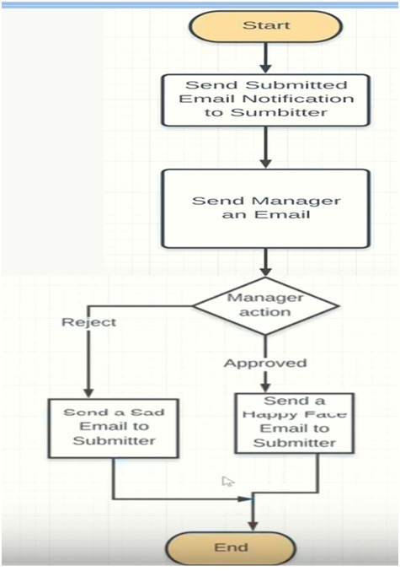

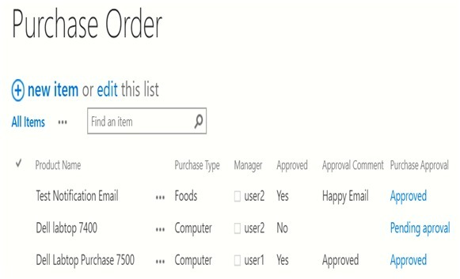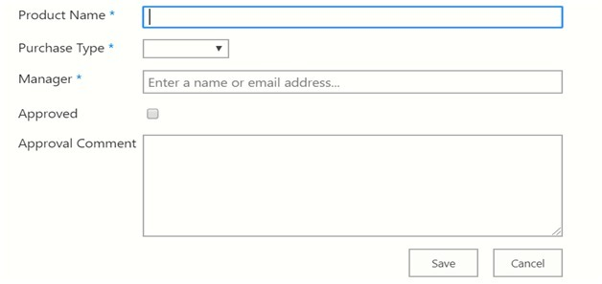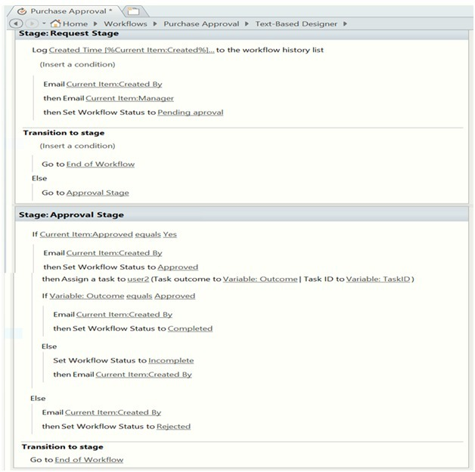

1. **Test The following**

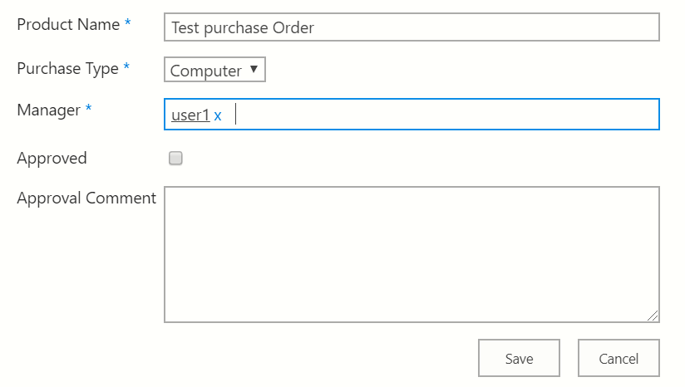

Open User1 on new browser.

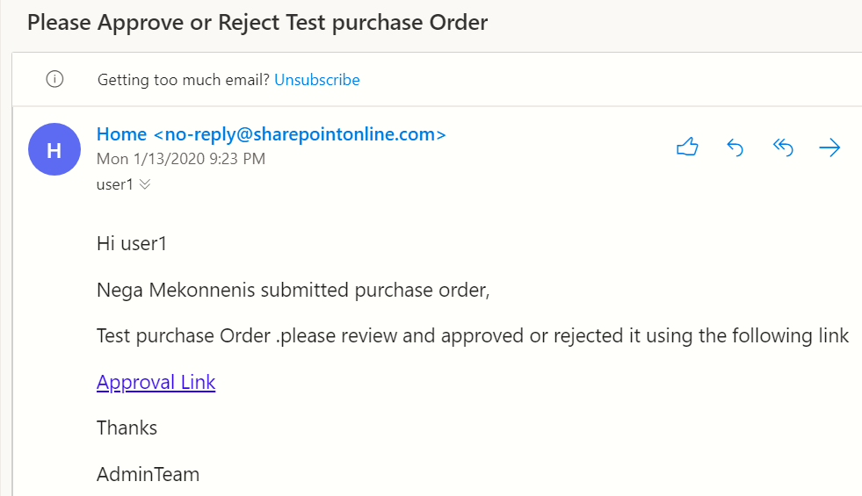

**HTML**

Browsers can’t open any file rather than html. Sometimes it opens pdf because it understands adobe acrobat.

**Source of web app**

**Eg1. Yahoo.com**

**Open it => right click on screen => view page** source then we get html source 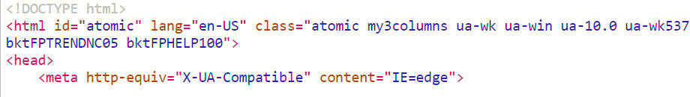

**Eg2. SharePoint**

**Open it => right click on screen => view page** source then we get html source

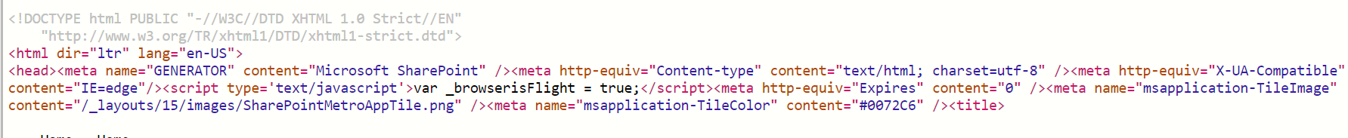

**Bases of any kind of web application**

* CSS
* JavaScript
* HTML

They are used to front end developer

**Elements of HTML**

* Links
* Text
* Textbox
* Button …

**Examples representation of element**

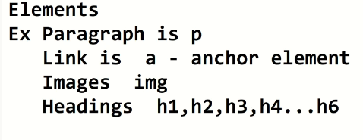

**Elements are represented by less than and greater than as follows**

Egs

1. Paragraph: **<p>**some paragraph **</p>**

* <p> start tag
* </p> end tag

Attribute: x = <p x>

1. **Heading: <h1>** **This is header <a href = ”url”> Click Me</a**>**</h1>**

**This is header <a> Click Me</a** is child note/child element

1. Link:<a>Click Me </a>

**Eg1.Empty html:**

<html>

<header>

</header>

<body>

</body>

</html>

**Eg2.Empty html:**

<html>

<header>

</header>

<body>

<h1>This is heading 1</h1>

<h2>This is heading 2</h2>

<h3>This is heading 3</h3><a href = "https://google.com" Click Me</a>

<p> This is the paragraph</p>

</body>

</html>

Save it with file Name: HTML.html

a/Then if we open it with Note pad it opens as it is

b/ if we open it with chrome we get

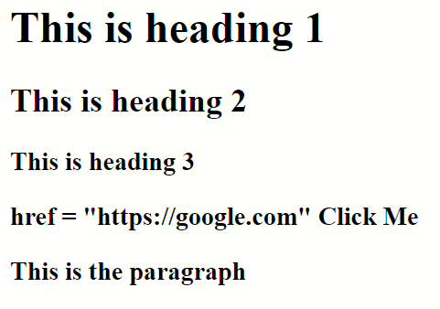

As we now There are 3 types of forms

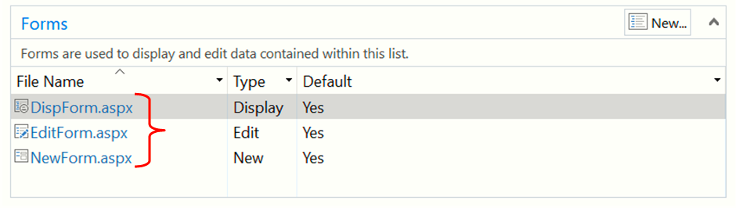

**To play with Form we need create our custom forms like**

* CustomNew
* CustomDisplay
* CustomEdit

1. CustomDisplay:

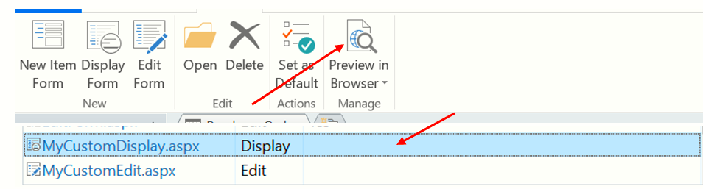

1. Custom
2. Custom

