**Final Class Novemnber 2019**

1.Interview questions and answers

* jquery interview questions
* Sharepoint interview questions

2.practice on modern Sharepoint

3.SPFx-SharePoint Framwork

Users different techinology

* + typescript-language
  + Node JS
  + Youman
  + Gulp are the tools to create SPFx solution

Spfx:

### [Overview of the SharePoint Framework (SPFx) | Microsoft Docs](https://docs.microsoft.com/en-us/sharepoint/dev/spfx/sharepoint-framework-overview)

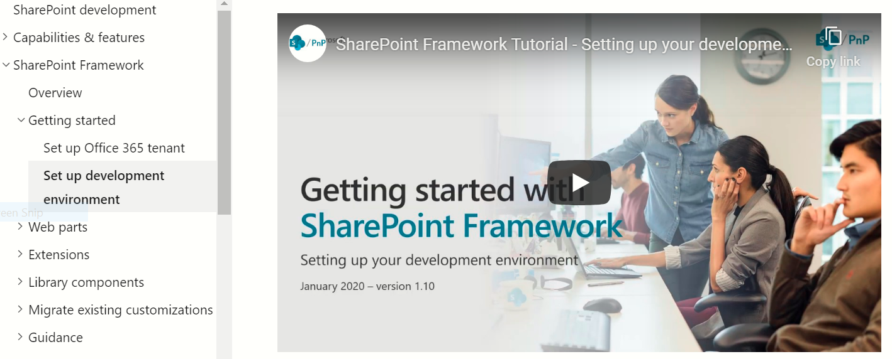

We get video and steps by text.

Install [NodeJS LTS version 10](https://nodejs.org/dist/latest-v10.x/).

Download: [node-v10.19.0-x64.msi](https://nodejs.org/dist/latest-v10.x/node-v10.19.0-x64.msi)

Then install it simply by clicking next.

Create a folder in our workspace.

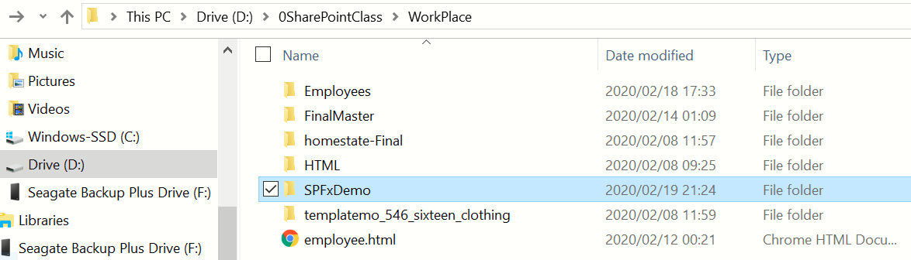

And then open it on visual studio code.

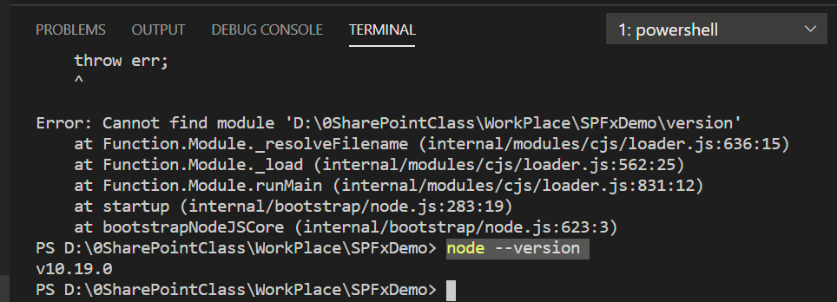

Enter the following command to install Yeoman and gulp:

npm install -g yo gulp and enter

To install the SharePoint Framework Yeoman generator globally, enter the following command:

npm install -g @microsoft/generator-sharepoint and enter

but we don’t need install the third one.

Clear and enter minimize

And go to:SPFx=>webpart=>build & deploy your first webpart

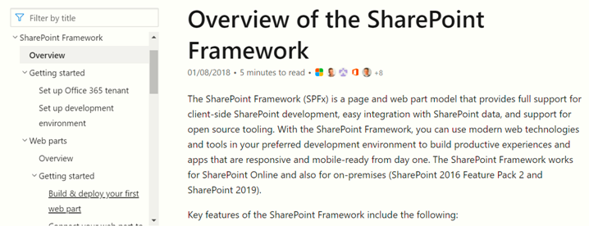

Yo @microsoft/sharepoint and enter

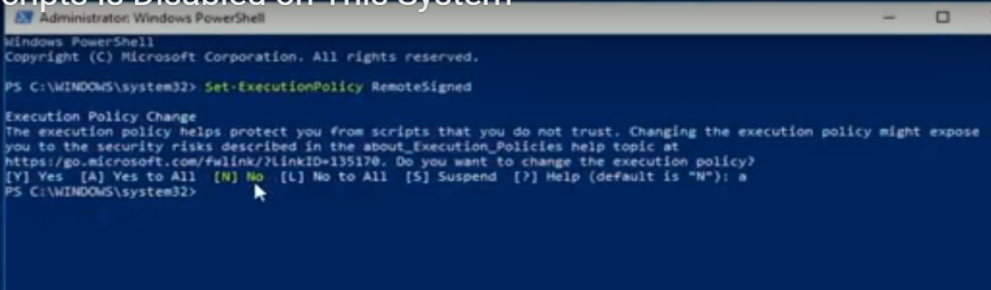

Yo @microsoft/sharepoint and enter

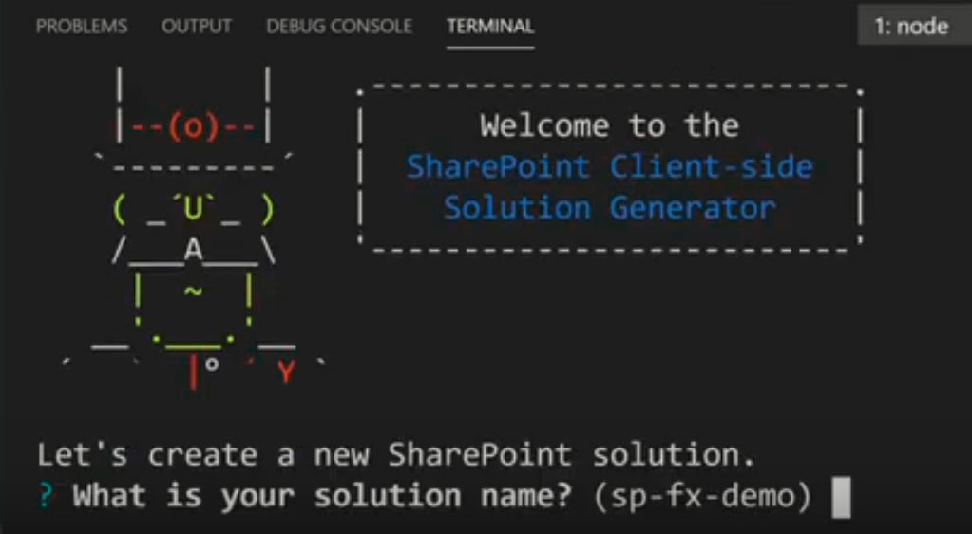

**Change**: (SP-Fx-demo) by Nov2020SPFx

By using the following keboard arrows

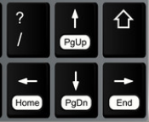

* Selest: SharePoint Online only (latest) =>enter
* Selest: Use the current folder=>enter
* Write: No=>enter
* Write: No=>enter
* Selest: WebPart=>enter
* What is your Web part name? (HelloWorld): SPFxDemoNov instead of (HelloWorld) =>enter
* What is your Web part description? (SPFxDemoNov description): SPFxDemoNov description as it is enter
* No JavaScript framework =>enter
* PS D:\0SharePointClass\WorkPlace\SPFxDemo> gulp trust-dev-cert =>enter
* Yes
* PS D:\0SharePointClass\WorkPlace\SPFxDemo> gulp serve=>enter

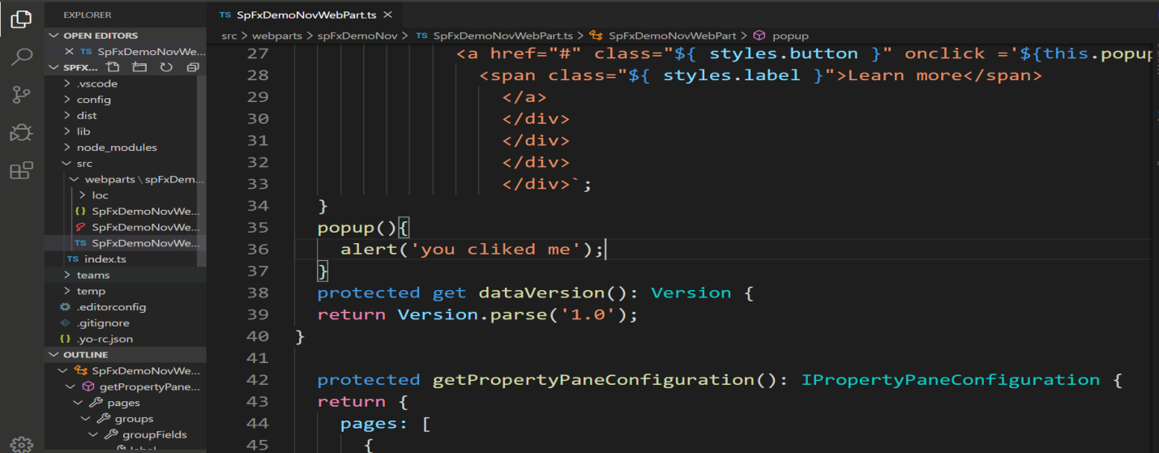

**Change:**

<a href="https://aka.ms/spfx" class="${ styles.button }">

**To:**

 <a href="#" class="${ styles.button }" onclick ='popup()'>

**Add:**

 popup(){

    alert('you cliked me');

  }

When we doing on SPFx gulp server is should be always opened.

Compare and contrast gulp serve page and modern SharePoint page.

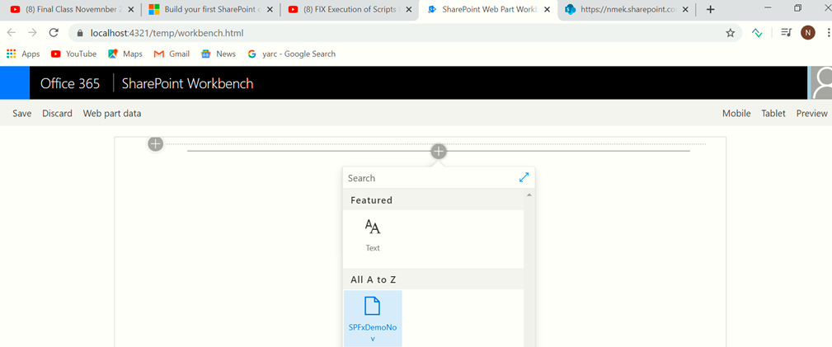

[https://nmek.sharepoint.com/sites/Demo](https://nmek.sharepoint.com/sites/Demo/%20SitePages/Home.aspx) =>[Add a page](javascript:SuiteOnClick(%22GoToCreateNewPage\u0028\u0029%22))

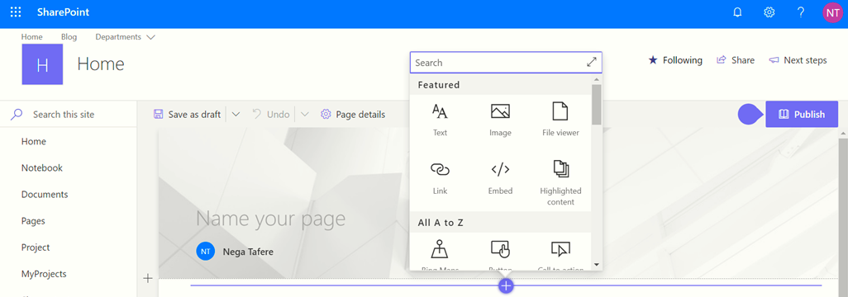

**Changing gulp to sharepoint:yourSite /_layouts/workbench.aspx**

**Eg: yourSite=**<https://nmek.sharepoint.com/sites/Demo/SitePages/m1h8zalq.aspx?Mode=Edit>

**From the above two links we get:**

<https://nmek.sharepoint.com/sites/Demo/_layouts/workbench.aspx>

**Then search it at the browser then we get**

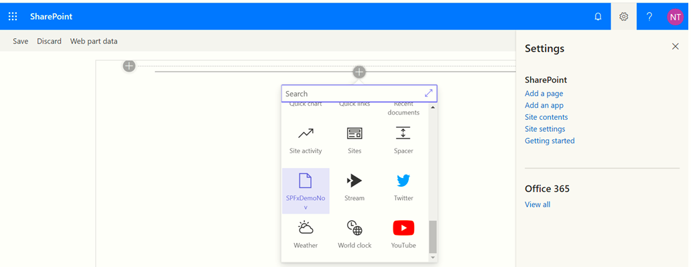

To stop the gulp from running: ctrl + C

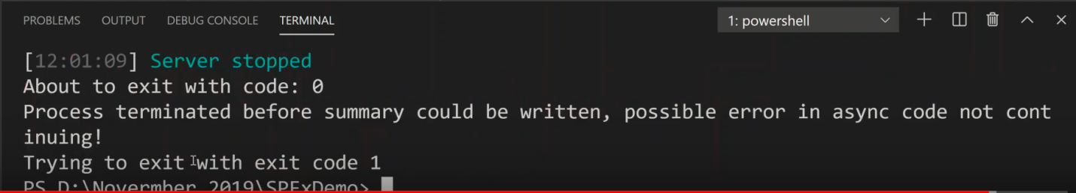

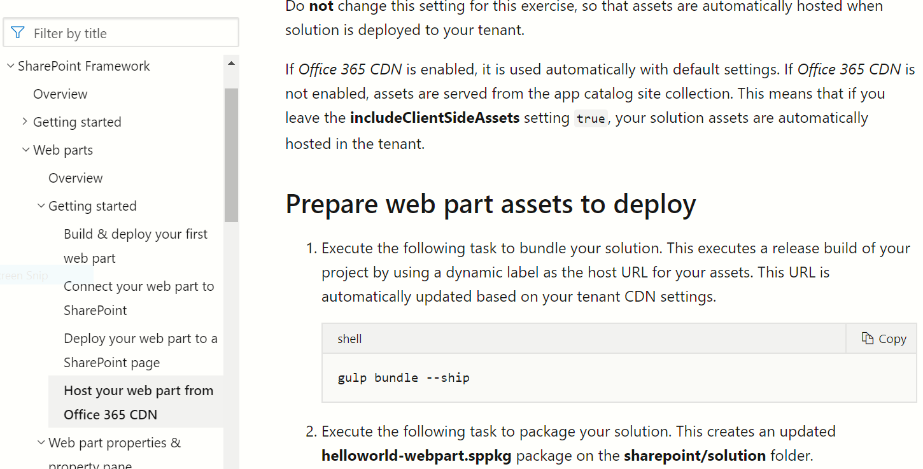

**Sharepoint Framework**

**Getstarted**

**Host your web part from office 365 CDN**

**gulp bundle –ship**

gulp package-solution –ship

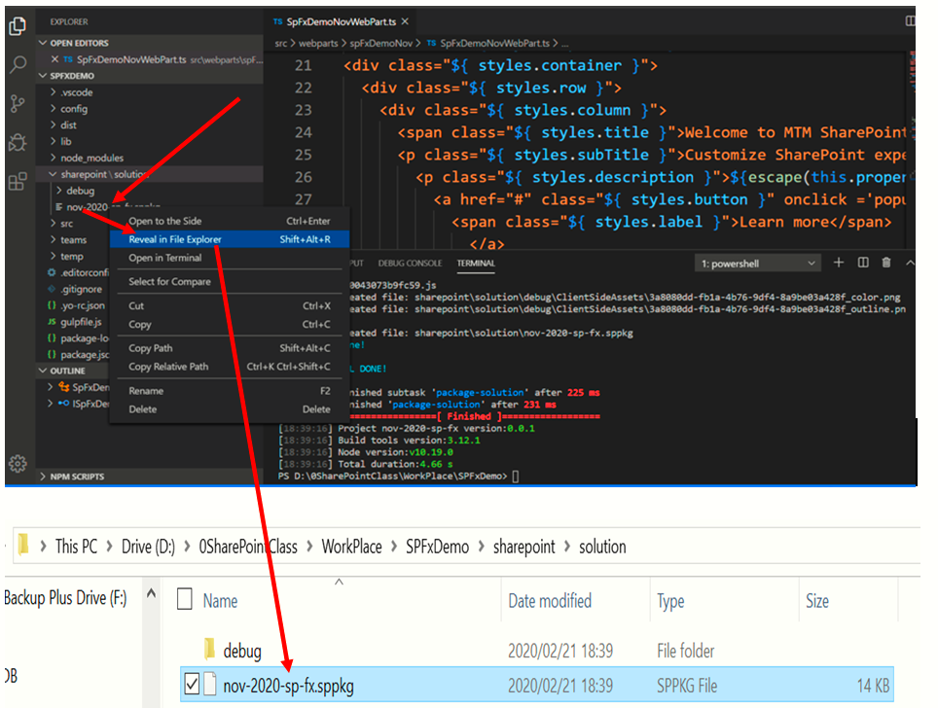

**Go to SP Classic**

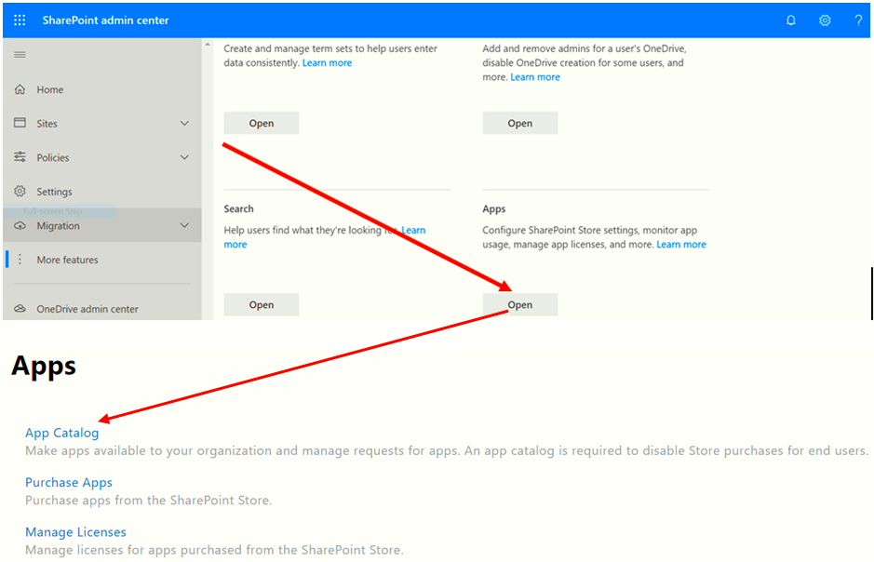

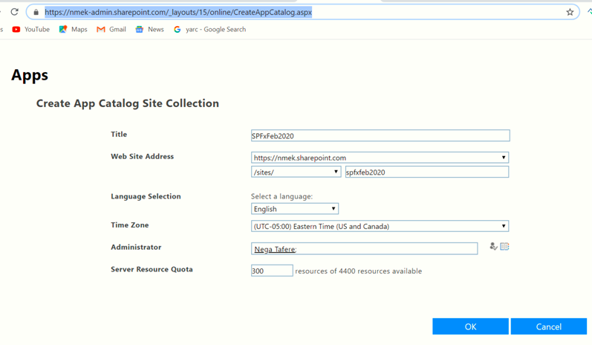

App catalog

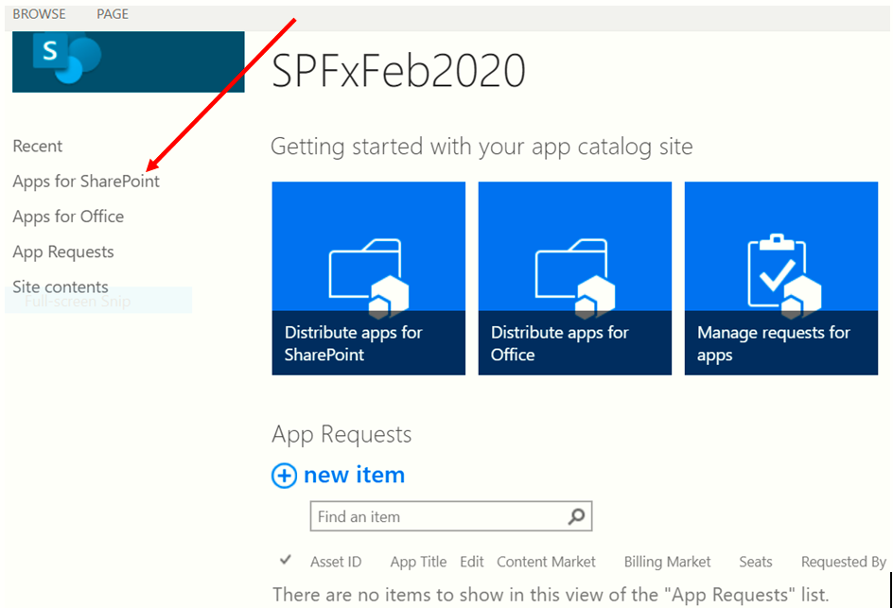

Drag and drop

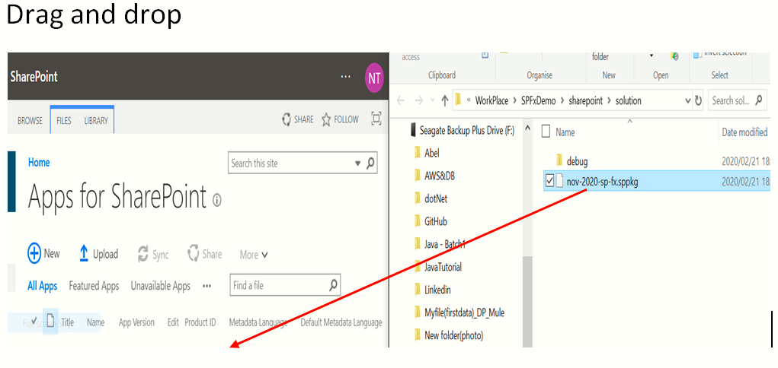

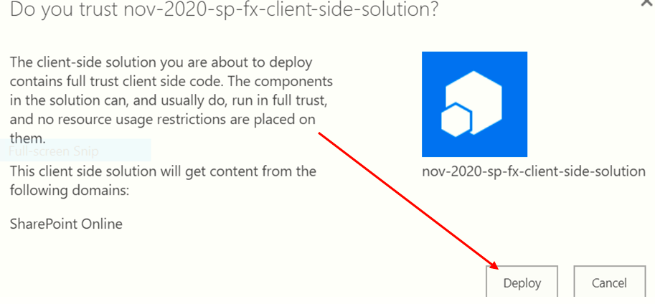

Go to our Demo=>add an app

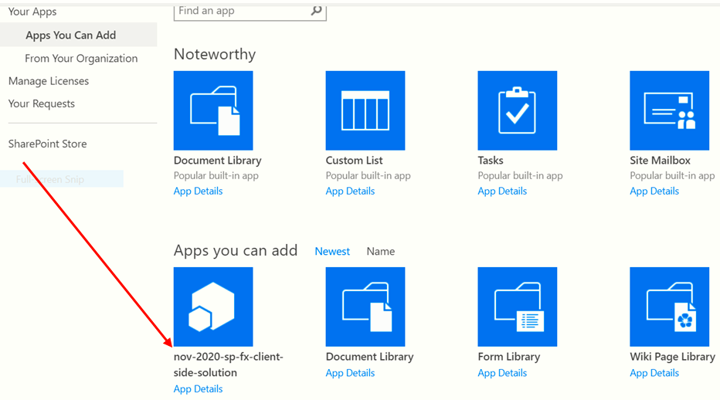

Turn classic:

Go to Edit page=>web part=>other=>SPFxDemo=>Add=>Edit it …Stop. Then we get

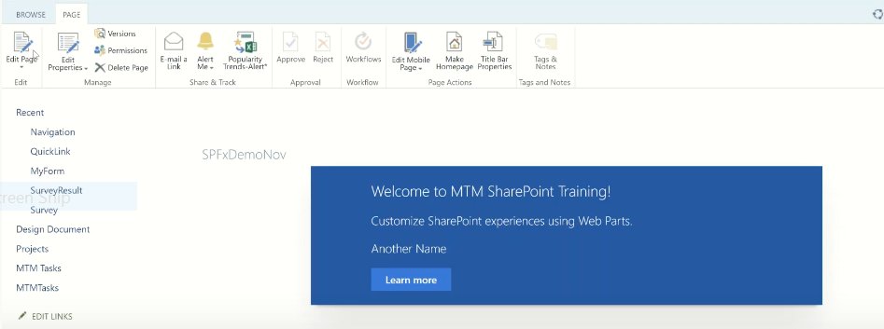

**reading:**

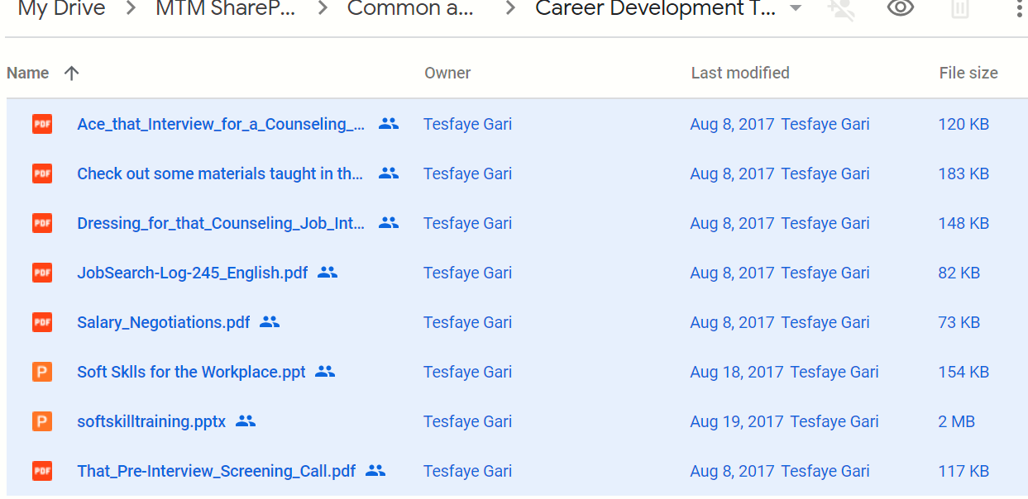

<https://drive.google.com/drive/folders/0B9hp0Y3P9_VnZnJ0S2ppdFhsT3M> openthis link on browser to get the hole reading notes.

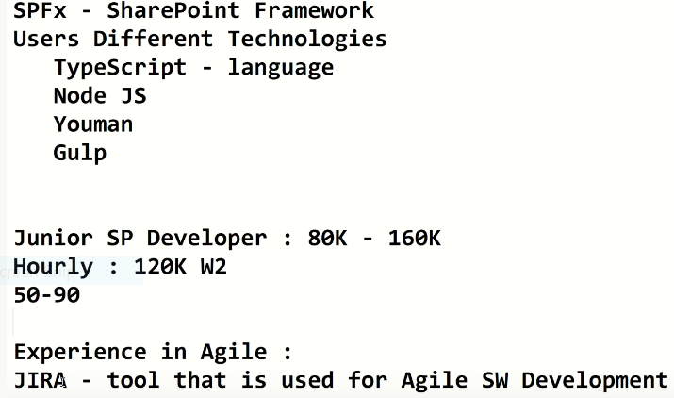

Link for scrum: <https://drive.google.com/drive/folders/0B9hp0Y3P9_VnS1V2T2IzT29ZR2M>

Vedio: <https://www.youtube.com/watch?v=GnG6RPSRLCs>

**Certification exam:** =>77-419 =>for Sharepoint

=>70-480=> for html,css,js

Searching job:

Indeed.com

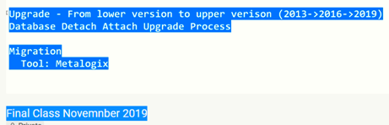

When we added resume thech the requirements that either it asks:

* US **citizen/DOD** or no.
* Active TS/CSL clearance

=================================///==========================================