Contents

To Create List/Lib 1

Document 2

Upload 3

Check in Check out 3

1.To check in the file 3

2. Check out 6

3. RelationShipe 6

filter 8

Group 9

Unique Id 10

Editing Project 11

Add page 13

1.Insert Text/top page text 13

2.Share any files 14

# To Create List/Lib

Setting=>add an app/Site content=>add an app

* Doc Library=>the most popular Library
* Picture Library=> For picture,image,photos
* Asset Library=>audio,Vedio…
* Site pages Created from wiki pages
* We create Library =>to store a doc

|  |  |  |  |  |
| --- | --- | --- | --- | --- |
| |  |  | | --- | --- | | https://eyos2011.sharepoint.com/_layouts/15/images/setrect.gif?rev=47 | [List name, description and navigatio](https://eyos2011.sharepoint.com/sites/Demo/_layouts/15/ListGeneralSettings.aspx?List=%7B3C6F8B95%2D34CA%2D4079%2DBB2F%2D613E57C69A38%7D)=>To Edit the Name of the List/Library  [Versioning settings](https://eyos2011.sharepoint.com/sites/Demo/_layouts/15/LstSetng.aspx?List=%7B3C6F8B95%2D34CA%2D4079%2DBB2F%2D613E57C69A38%7D)=>Check in Check out is not more commen for List.it is popular for Library.  It is used to get draft version(500) that mean we can find 500 copys to the back. If we do 501 copy the oldest one file is deleted,check out,take the version except the last check out.   * In Library: to get versioning * Click Edited row=>Item=>Versioning History   [Advanced settings](https://eyos2011.sharepoint.com/sites/Demo/_layouts/15/advsetng.aspx?List=%7B3C6F8B95%2D34CA%2D4079%2DBB2F%2D613E57C69A38%7D)=>Dialogs box.   * Content Type=yes/no to display before column * Doc. Template=For header and footer=>Edit Template=>open * In this time the system/sharePoint does not know chrome, it knows Ie(internet Explorer) so we use that instead of chrome   [Rating settings](https://eyos2011.sharepoint.com/sites/Demo/_layouts/RatingsSettings.aspx?List=%7b3c6f8b95-34ca-4079-bb2f-613e57c69a38%7d)=>like dislike. Either posted picture or some thing else.  [Delete this document library](javascript:DeleteList())=to delete The List/Library  [Save document library as template](https://eyos2011.sharepoint.com/sites/Demo/_layouts/15/savetmpl.aspx?List=%7B3C6F8B95%2D34CA%2D4079%2DBB2F%2D613E57C69A38%7D)=to save created template.  [Manage files which have no checked in version](https://eyos2011.sharepoint.com/sites/Demo/_layouts/15/ManageCheckedOutFiles.aspx?List=%7B3C6F8B95%2D34CA%2D4079%2DBB2F%2D613E57C69A38%7D)=>only for Library,there is no check out check in the List.  [Information management policy settings](https://eyos2011.sharepoint.com/sites/Demo/_layouts/15/policycts.aspx?List=%7b3c6f8b95-34ca-4079-bb2f-613e57c69a38%7d) => to restricte the time of doc. To delete (for 90 days,3 years,5 years..) otherwise permanently delete.  For List: Item and Folder=>use Item => retention  For Library: Doc and Folder=>use Document=> retention  Headers and footers   * From our browser=>at IE * Check out and edit=chek in and put the design icon some where in the screen. * Give the link for the people by email. * Upload the file by drag and drop from the folder * To check in the uploaded file =>   Document**:**  Is not created in the movement of seconds.  Ater created the doc. We gave them the link(library setting)  If we need to put the link at the top we can put it by editing  The place where they select upto them, we can put either the top,quick launch or in the page.  Upload**:**  Open the doc. Then drag and drop the file.  When we put the file by drag and drop the required column is skip Check in Check out1.To check in the file Select row=>File=>check in  **Log in defferent User: To be very clear**  May first of all we need create New site content (user1/user2..)  **1.1.First user: in the IE**  **1.2.Second user: in chrome by using the same URL**  **Eg:** our Design Document URL is <https://eyos2011.sharepoint.com/sites/Demo/DesignDocumnts/Forms/AllItems.aspx>   * 1. **Internet Explorer**   **Open the owner at IE: by using the above URL then**  Setting=>site setting=>Site Permission=>Grant Permission=>New: Put the user (User1 or user2..)=>show=>un active email check box: then open the doc.   * 1. **Chrome** | | Update | Update google chrome (3 dotsat the right top side) => New incognito window=>put design document link at the top(<https://eyos2011.sharepoint.com/sites/Demo/DesignDocumnts/Forms/AllItems.aspx>) =>sing in by using the owner address (but change Addmin by User1/user2 which are create before at the site content or …Before @ sign)🡺that is different user in the same library.  **Then this is the site from IE which is controlled by by the owner.**  C:\Users\Nega\Desktop\SampleFile\f1.png  **The next is the second User**   * **Before Check in: We see**   C:\Users\Nega\Desktop\SampleFile\f2.png   * **After Chck in: We see**   C:\Users\Nega\Desktop\SampleFile\f3.png | |

Because the owner did check in

**The other way**

if he/some body else who have full control: they can add them selves.

|  |  |
| --- | --- |
| Setting=>Site setting=>[Manage files which have no checked in version](https://eyos2011.sharepoint.com/sites/Demo/_layouts/15/ManageCheckedOutFiles.aspx?List=%7B3C6F8B95%2D34CA%2D4079%2DBB2F%2D613E57C69A38%7D) |  |

2. Check out**:**

Select row=>File=>check out: No one can see your check out doc.

Edit:

**Q1.** When I tryied edit by checking out , the second user can’t protected.

**2.1.Why we Check out:**

**b/se I don’t want to show my changes before I finish**

**2.2.How to turn off Check in check out Request**

Library=>Library setting=>Versioning=>make **NO**  at **“Require Check Out”**

**How to make permanent Classic:**

[Advanced settings](https://eyos2011.sharepoint.com/sites/Demo/_layouts/15/advsetng.aspx?List=%7B78FDAF9E%2DF95E%2D46BF%2D8A8D%2D50B3F672BB2B%7D)=>List experience=>Classic

3. RelationShipe**:**

**Look Up**

Used to connect two lists

(eg. **Design Document** and **project**)

**Create project List**

Setting=>Site content=>**add an app**=>Custom List (Projects)

**Add Column**

* Budjet=Curency
* Project Manager=person/group
* Start Date=date and time
* End date= date and time
* Status=Choice=Not started, inprogress,Completed

Project 1🡪N Documents ; remember u work/create table in the N side

* + - 1 project has 1/N document=> we create the table in doc. Side
    - 1 father has 1/N children=> we create the table in child Side
    - 1 professor 1/N students=> we create the table in student Side
* Documents in the project

Go to the project List

* Project=>Edit=>put the list

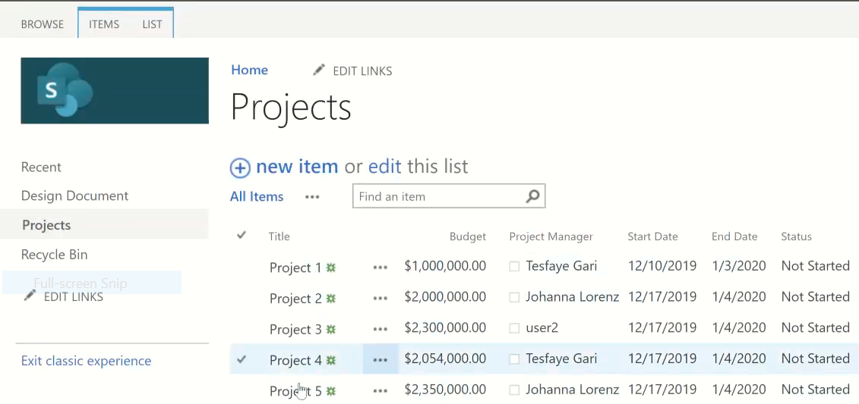

* The best to create the column in the design document

design document=>Library=>Library setting=>column

* Project = Look up,require columns contain information=>expand “information from”=>select “projects” the upload the document
* 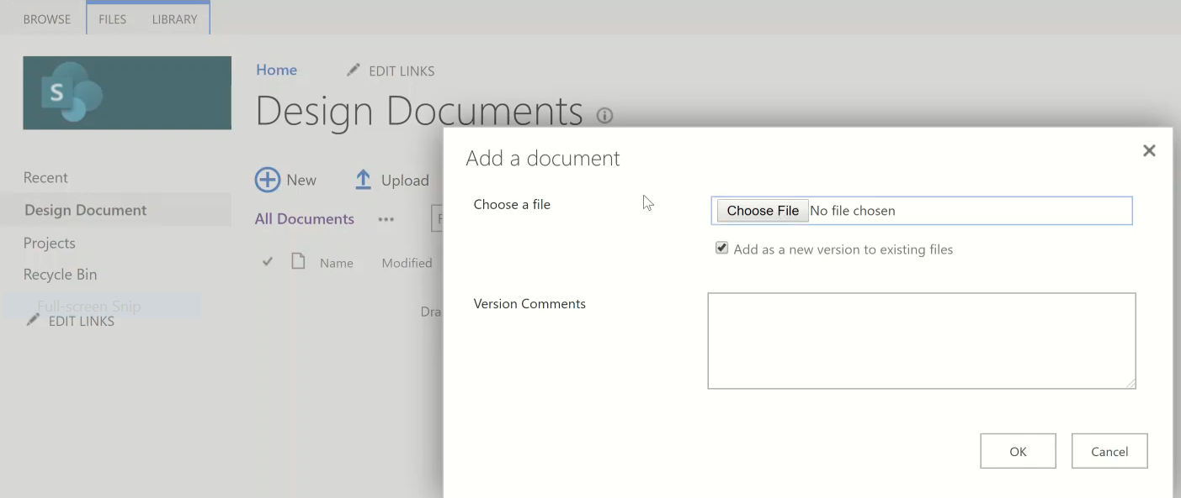

Fill the follying

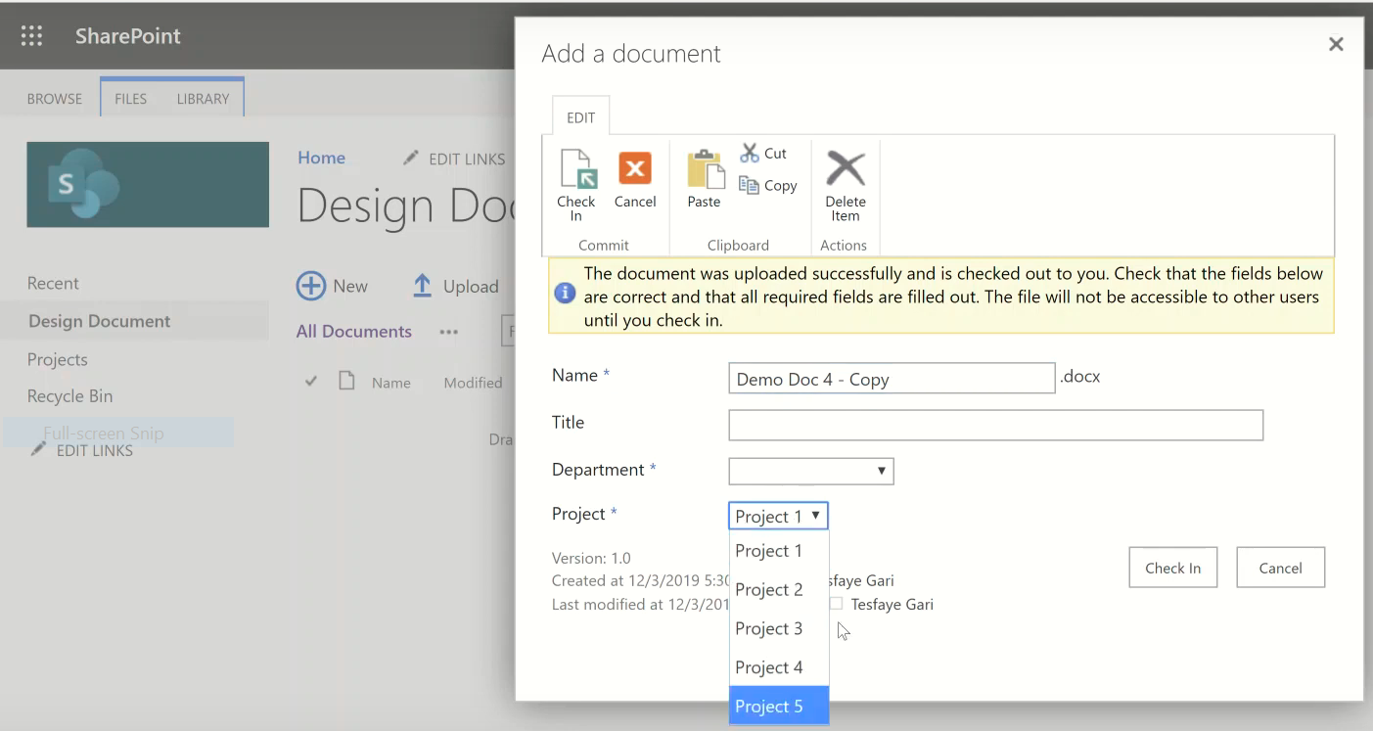

Then Check in

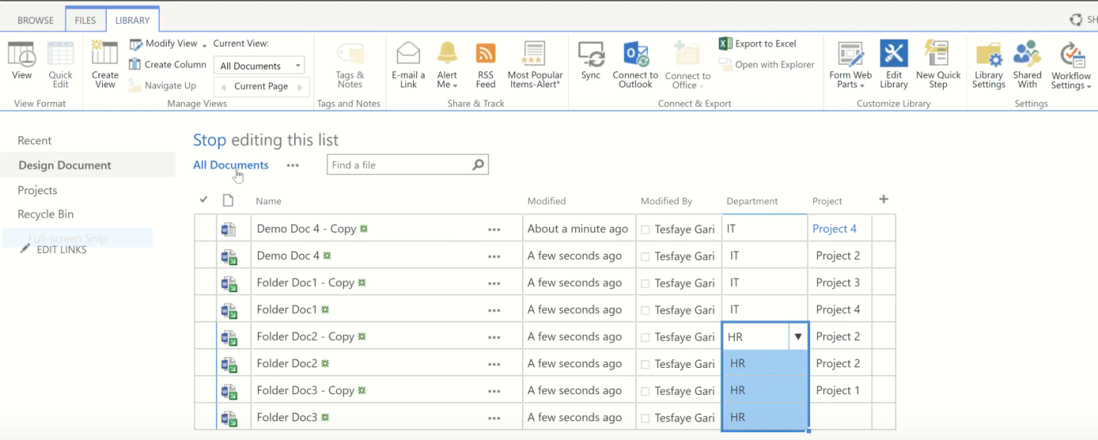

Then and check in select all

# filter

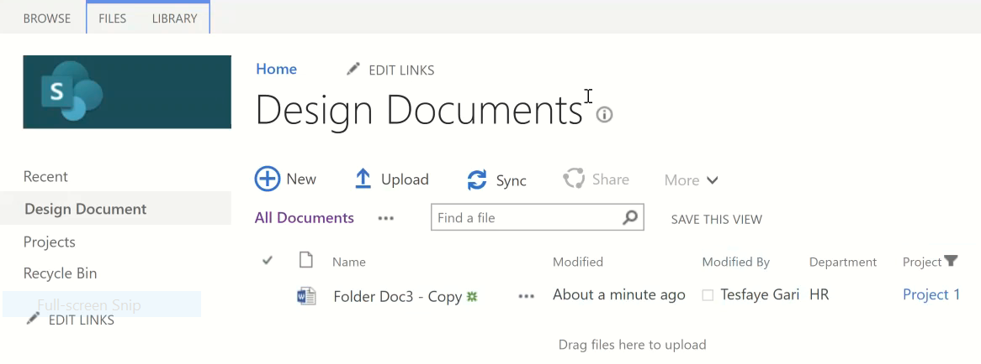

**We can see the detail of project by clicking on project**

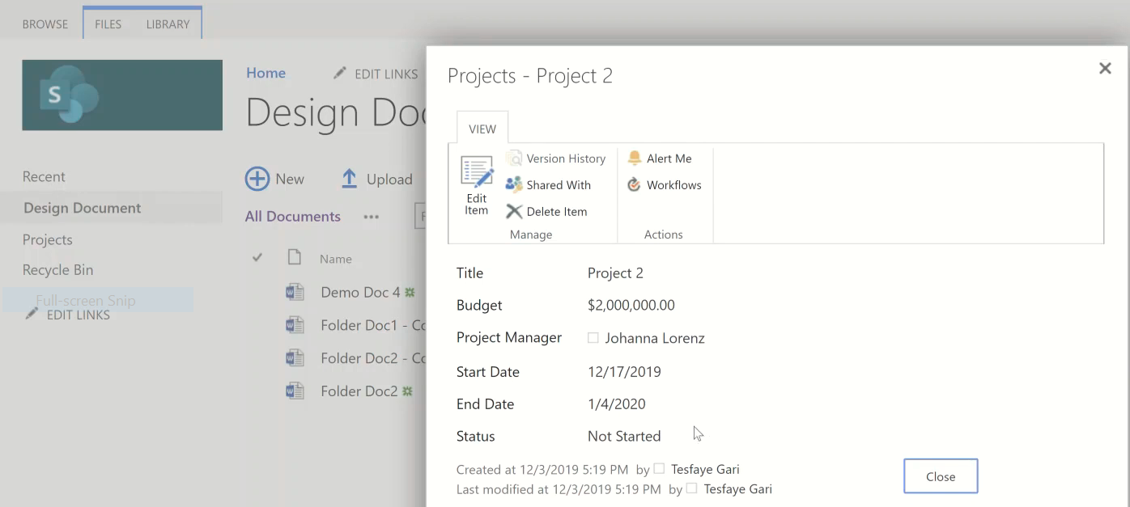

We can add the other columns by following : Library=>Library settings=>under column select we want.

# Group

Ellipse next to all document=>modify=>group by=>drop down arrow (project)

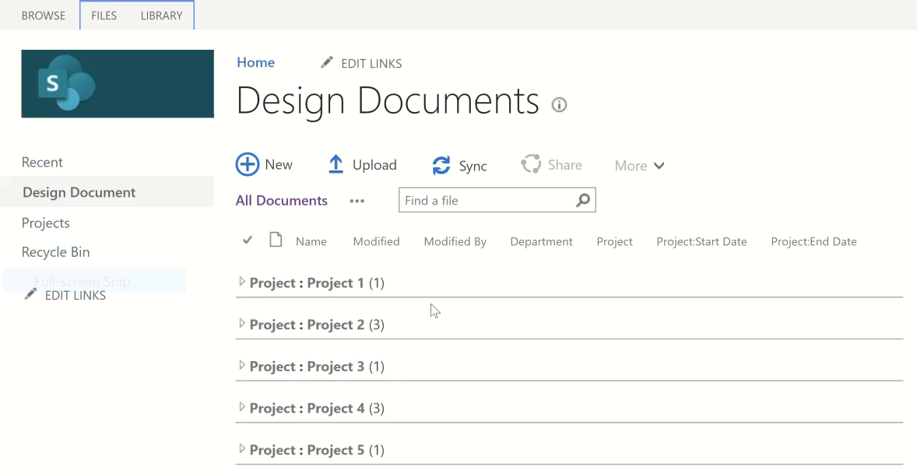

Every single project must have a unique Name

# Unique Id

If we do copy past it accepted b/se each project has a unique ID

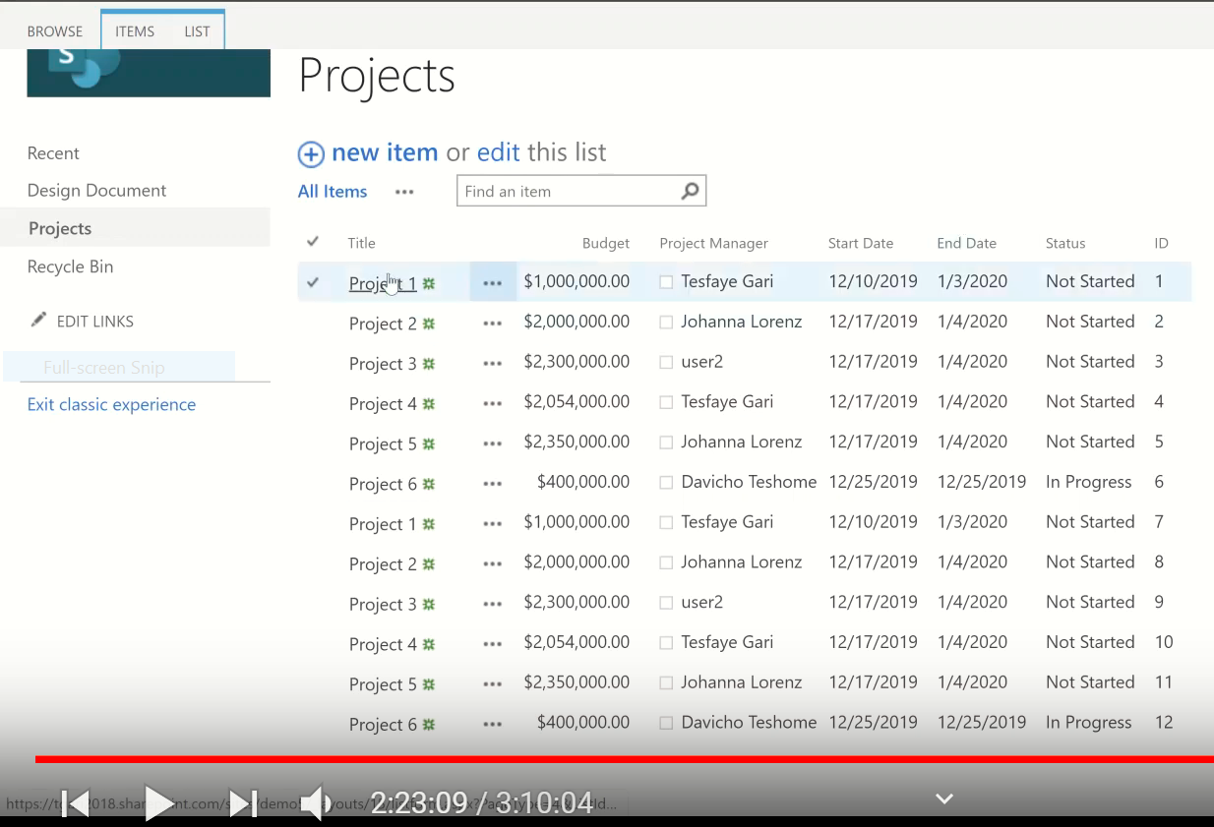

ID column is not Edit able. b/se it is unique.

## Editing Project

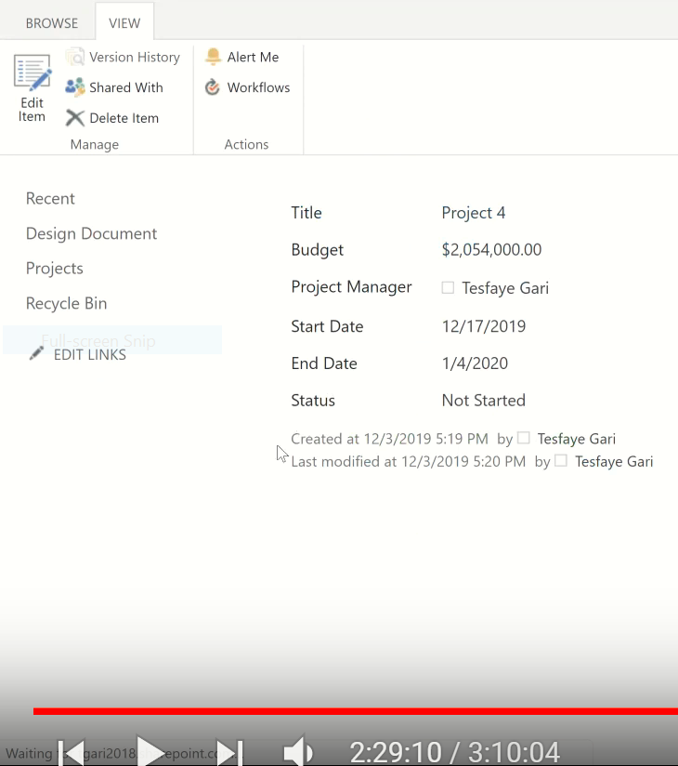

Stil we are working on doc. Library

We see on project

1. How can we see all projects doc from project list

Look

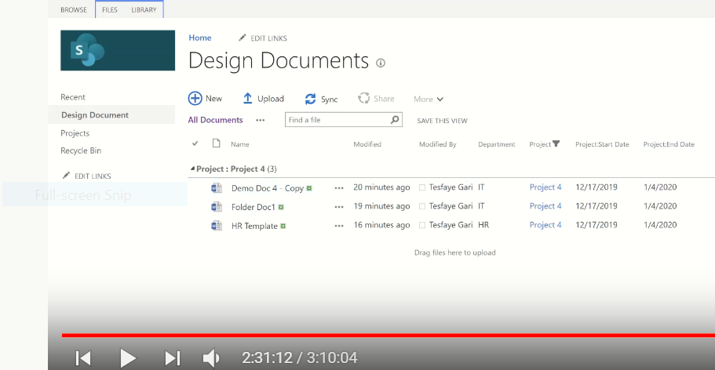

This is from document, like this

I wans to see all documents from project form. For this purpose I need create web part.

Eg. Take project 4:

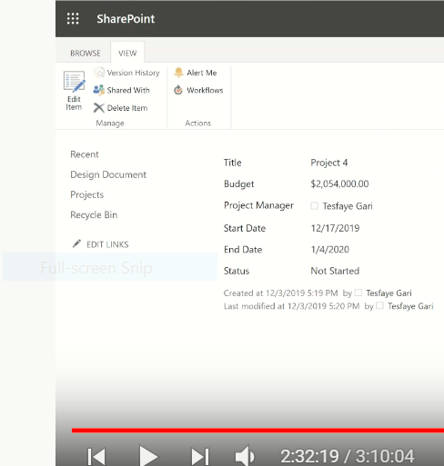

To do this

**Case 1:From the visible page**

Setting=>Edit page=>add aweb part=>Design Doc.=> add aweb part

**Case 2: Home page**

=Document=

Setthing=>site content=>site page=>then we get two pages

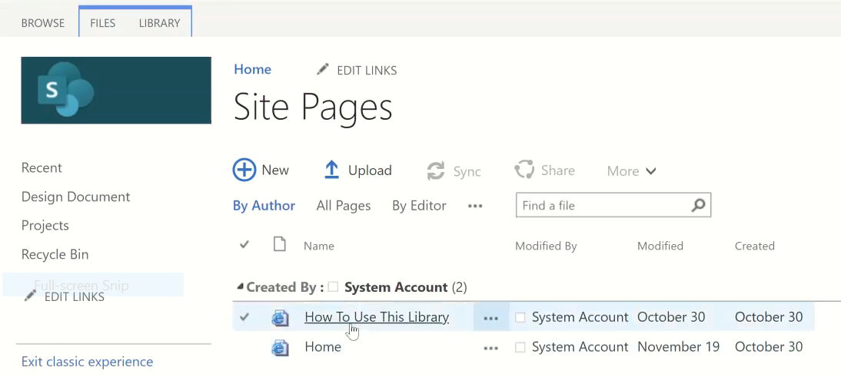

* **First page: Home**

# Add page

File=>New=>web part page

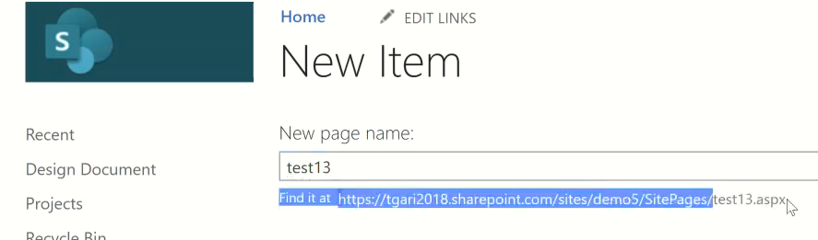

**Edit the page**

## 1.Insert Text/top page text

Edit,at the top of right corner

Then save it and we can check in

## 2.Share any files

Insert then select any one we want

**Eg. Share video**

Go to “video u want”=> C:\Users\Nega\Desktop\paybill\peco\yyy3.png at the bottom of our video=> embed(<>)=>copy=>goto sharePoint insert=>embed=>past=>insert=>save

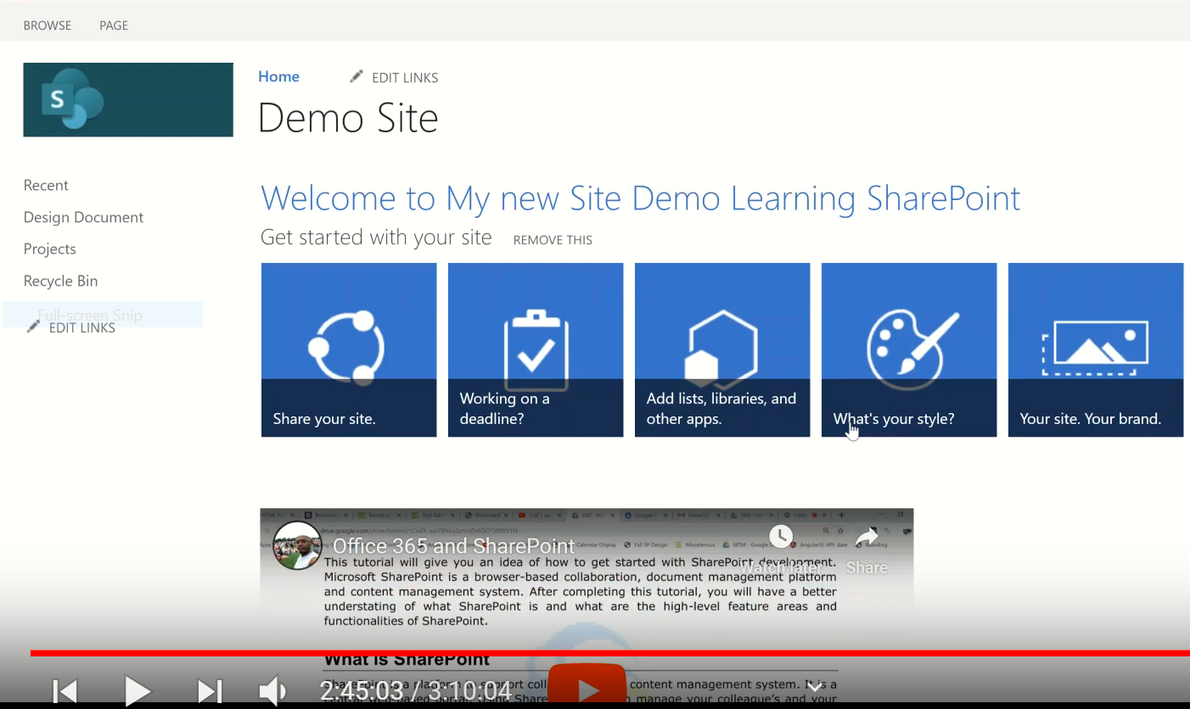

Site opend only browsers. Site page created from wiki page

* We differenciated files by looking file extension
* To display file extension at the top of the computer

View=>File Name extension examples

|  |  |
| --- | --- |
| Doc | File extension |
| Excel | xlsx |
| Word | docx |
| Pdf | pdf |
| Image | jpg |
| SharePoint | aspx |
| Java | jsp |

Some files can’t open at sharepoint b/se they may have bigger size, they are may dangerious..

Eg. Html file

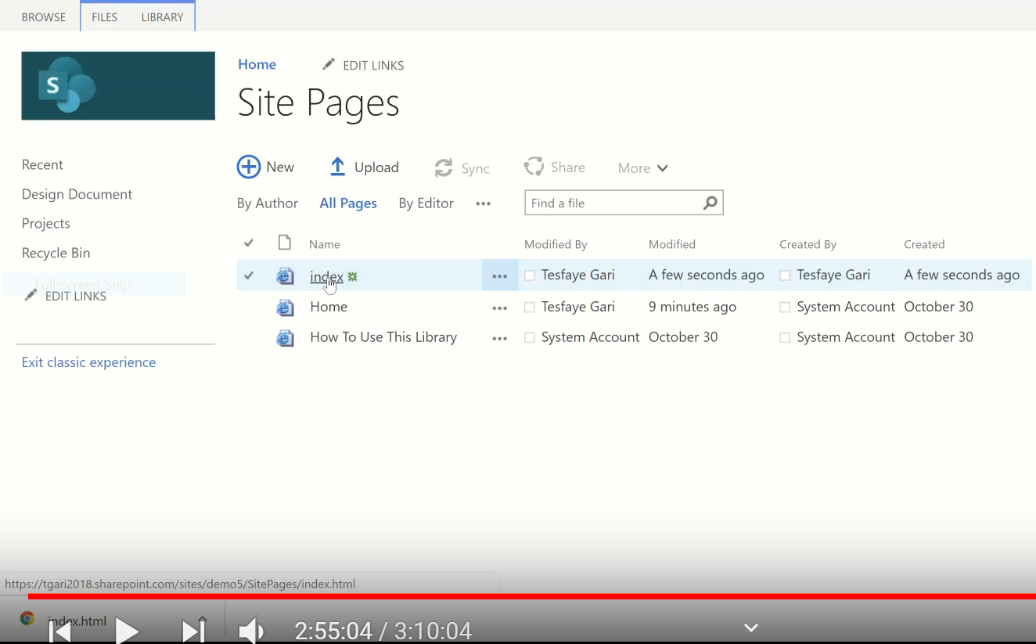

Setting=>site content=>site pages=>wiki page

Or

File=>New=>wiki page

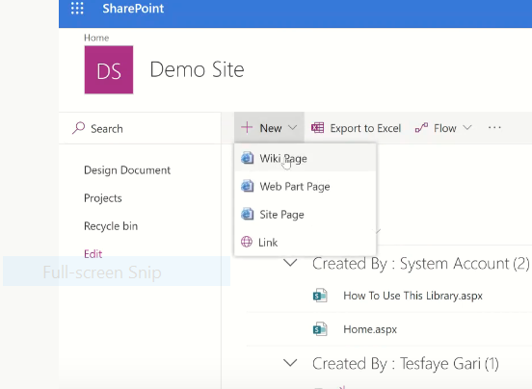

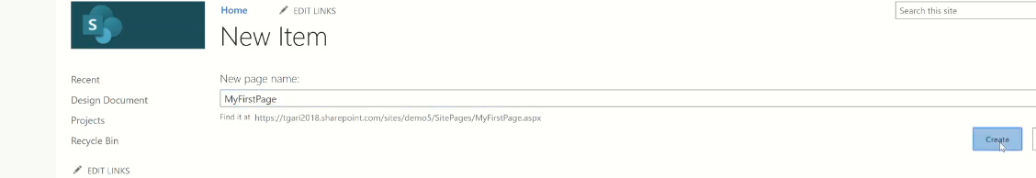

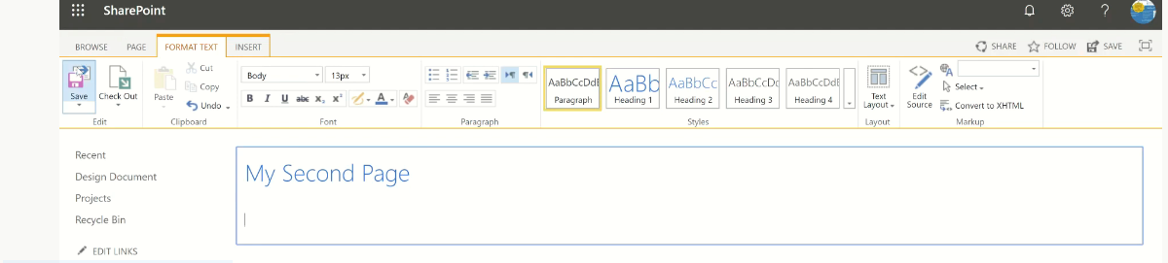

* **Second page How to use this library**

**We get important notes under it.**

* **Third page: Our New page (MyFirstPage)**

**….**

**Like the same to the above we can do any thing in this page**

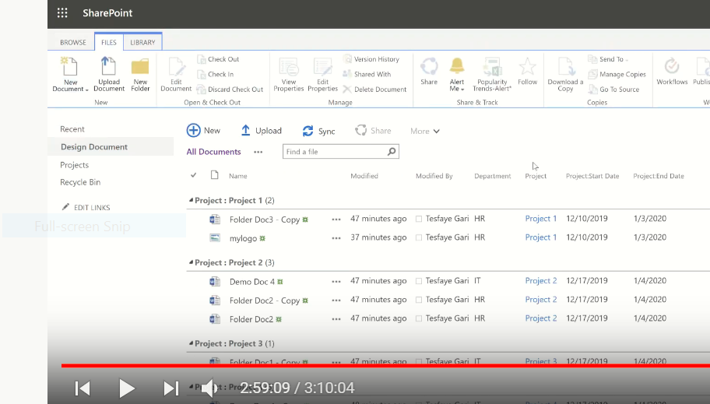

**To know anypage**

**Open the browser=>right click on the screen=>inspect=>Network=>headers=>**

**Eg. Peco.com**

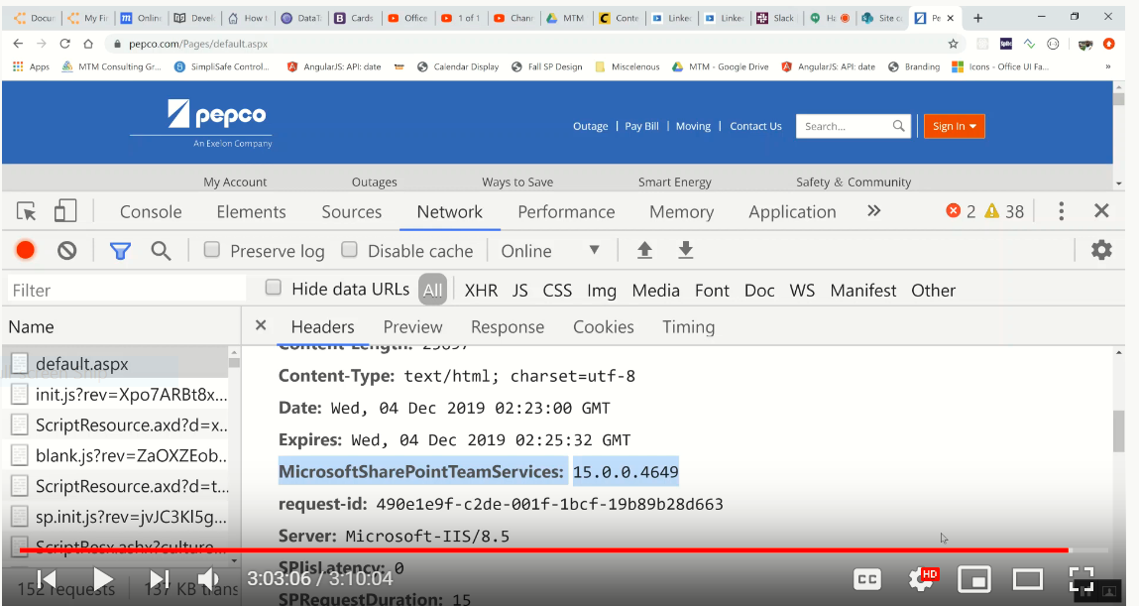

**URL indicatore**

<https://eyos2011.sharepoint.com/sites/Demo/DesignDocumnts/Forms/AllItems.aspx>

from this url:

* AllItems: shows a view
* Page: shows a library

**End of the chapter**