24/03/2025
מעבדה 2:

תוכן עניינים:

מספר מעבדה ותאריך................................................................................................ 1
תוכן עניינים............................................................................................................ 1
משתתפים............................................................................................................... 1
תרגילים.............................................................................................................. 2-6
שאלה 1) ........................................................................................................... 2
שאלה 2) ........................................................................................................... 3
שאלה 3) ........................................................................................................... 4
שאלה 4) ........................................................................................................... 5
שאלה 5) ........................................................................................................... 6

משתתפים:
- איתי רוזן - 207931437
- דימה צ'יביסוב - 342744869
שאלה 1)
#define _CRT_SECURE_NO_WARNINGS
#include <stdio.h>
#include <math.h>

// Defines the function Main.
int main()
{
// These request and assign user value to num.
printf("Enter number: ");
int num;
scanf("%d", &num);
// These print out a table of following numbers with their power varients up to 3.
printf("\nNumber Square Cube\n");
printf("%4d %8d %8d\n", num, (int)pow(num, 2), (int)pow(num, 3));
printf("%4d %8d %8d\n", num + 1, (int)pow(num + 1, 2), (int)pow(num + 1, 3));
printf("%4d %8d %8d\n", num + 2, (int)pow(num + 2, 2), (int)pow(num + 2, 3));
printf("%4d %8d %8d\n", num + 3, (int)pow(num + 3, 2), (int)pow(num + 3, 3));
printf("%4d %8d %8d\n", num + 4, (int)pow(num + 4, 2), (int)pow(num + 4, 3));
return 0;
}

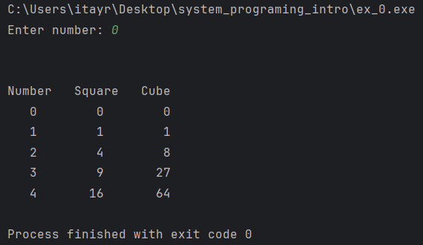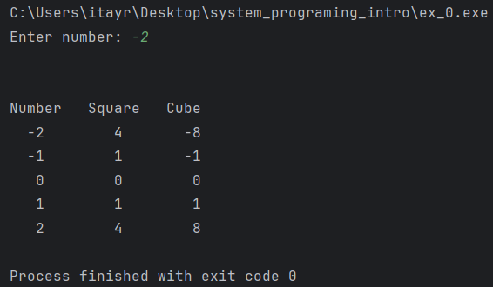
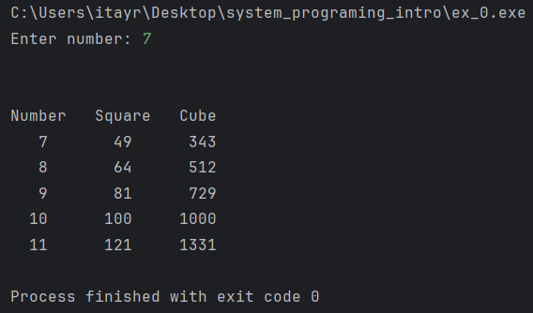

שאלה 2)
#define _CRT_SECURE_NO_WARNINGS
#include <stdio.h>
// This function calculates and prints the area of a triangle.
int main()
{
// These request and assign user values to l & d.
printf("Enter a triangle edge and it's height respectively, please: ");
float l,d;
scanf("%f %f",&l,&d);
// Prints the area of said triangle.
printf("\nThe triangle area is %.3f", (l*d)/2);
return 0;
}

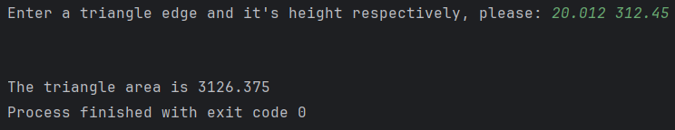

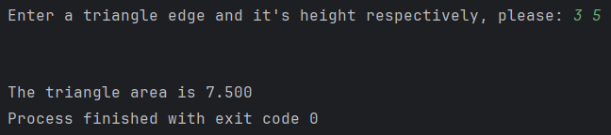

שאלה 3)
#define _CRT_SECURE_NO_WARNINGS
#include <stdio.h>

// This function prints the ascii value of 'ch' and it's uppercase varient.
int main()
{
// These request and assign user value to 'ch'.
char ch;
printf("Enter an English lower case letter, please: ");
scanf("%c", &ch);
// This assigns the uppercase version of 'ch'.
char n_ch = (char)(ch - 32);
printf("The ascii code of '%c' is %d",ch, ch);
printf("\nThe ascii code of '%c' is %d",n_ch, n_ch);
return 0;
}

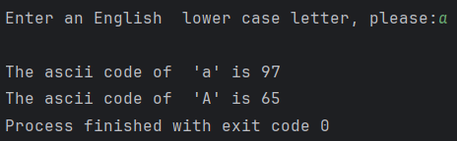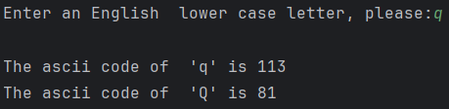

שאלה 4)
#define _CRT_SECURE_NO_WARNINGS
#include <stdio.h>
#include <math.h>
// This function solves for 'x' in 'a^x=b'.
int main()
{
// This requests and assigns user values for 'a' & 'b'.
printf("Given the equation a^x=b"
"\nEnter a and b, respectively please:");
float a,b;
scanf("%f%f",&a,&b);
// Solves for 'x' and prints it.
printf("x is: %g",log(b)/log(a));
return 0;
}

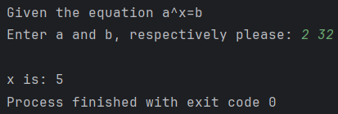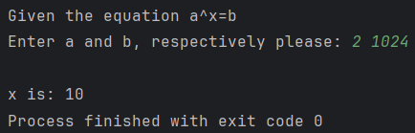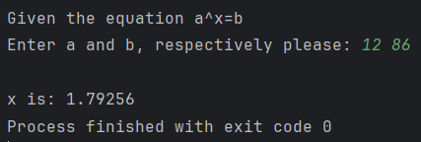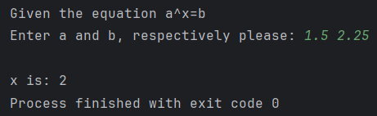

שאלה 5)
#define _CRT_SECURE_NO_WARNINGS
#include <stdio.h>
#include <math.h>

// This function calculates a certain equation based on user value 'x'.
int main()
{
// These request and assign user value for 'x'.
printf("Enter x please: ");
float x;
scanf("%f", &x);
// This assigns user value for the solved equation.
double y = x+pow((1.0/3.0)*pow(x,4)+2*pow(x,0.5),(0.2));
// These print out the same equation using a different numbering format.
printf("Output using %%lf format with 2 digits after dot.");
printf("\n x+(1/3x^3+2x^(1/2))^(1/5) = %.2lf+(1/3*%.2lf^3+2*%.2lf^(1/2))^(1/5) = %.2lf",x,x,x,y);
printf("\n\nOutput using %%g format: ");
printf("\n x+(1/3x^3+2x^(1/2))^(1/5) = %g+(1/3*%g^3+2*%g^(1/2))^(1/5) = %g",x,x,x,y);
return 0;
}

