26/03/2025
מעבדה 3:

תוכן עניינים:

מספר מעבדה ותאריך................................................................................................ 1
תוכן עניינים............................................................................................................ 1
משתתפים............................................................................................................... 1
תרגילים.............................................................................................................. 2-6
שאלה 1) ........................................................................................................... 2
שאלה 2) ........................................................................................................... 3
שאלה 3) ........................................................................................................... 4
שאלה 4) ........................................................................................................... 5

משתתפים:
- איתי רוזן - 207931437
- דימה צ'יביסוב - 342744869
שאלה 1)
#define _CRT_SECURE_NO_WARNINGS
#include <stdio.h>
#include <math.h>

// This function calculates BMI.
int main()
{
// Requests and assigns user values for 'w' & 'h' as integers
printf("Please enter weight (in kg) and height (in cm), respectively: ");
int w, h;
double r;
scanf("%d %d", &w, &h);
// Convert height from cm to meters and calculate BMI correctly
r = w / pow(h / 100.0, 2);
// These print different messages in relation to 'r'.
if (r < 18.5)
printf("Underweight\n");
else if (r < 25)
printf("Normal weight\n");
else if (r < 30)
printf("Increased weight\n");
else if (r < 40)
printf("Obese\n");
else
printf("Very high obese\n");
return 0;
}

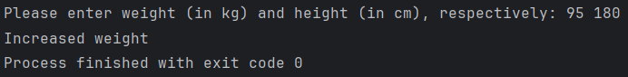

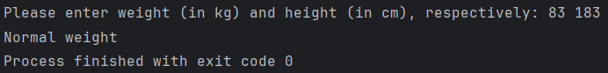

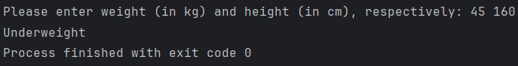

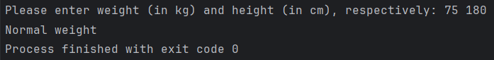

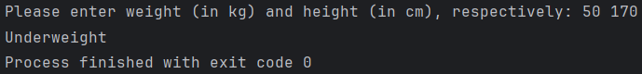
שאלה 2)
#define _CRT_SECURE_NO_WARNINGS
#include <stdio.h>
#include <math.h>
int main()
{
int i, num, res, count = 0;
// Assigns user values to 'num', while defining 'i', 'count' & 'res'.
printf("Enter an integer number, please: ");
scanf("%d", &num);
res = abs(num);
// This checks for an edge case where 'num' equate to 0.
if (num == 0)
{
printf("Infinity");
return 0;
}
// This loop prints all of 'num''s dividers while counting them.
for (i = 1; i < res; i++)
{
if ((res % i) == 0)
{
count++;
printf("%d ", i);
}
}
// This handles a negative 'num'.
if (num < 0)
{
count++;
printf("%d", res);
}
printf("\ncount=%d", count);
return 0;
}

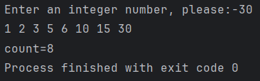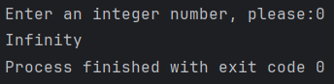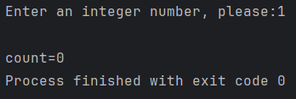
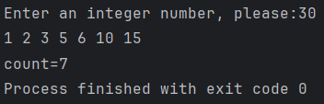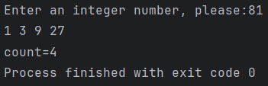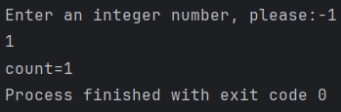
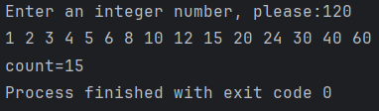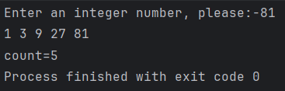

שאלה 3)

#define _CRT_SECURE_NO_WARNINGS
#include <stdio.h>
void triangle(char, int);
int main()
{
// Request and assign user values to 'ch' & 'n'.
int n;
char ch;
printf("Enter a character an integer, please: ");
scanf("%c %d", &ch, &n);
// Sends said values to "triangle".
triangle(ch, n);
return 0;
}
// This function prints a triangle using 'tav' at 'num' height.
void triangle(char tav, int num)
{
int k;
for (; num > 0; num--)
{
for (k = num ; k > 0; k--)
{
putchar(tav);
}
printf("\n");
}
}

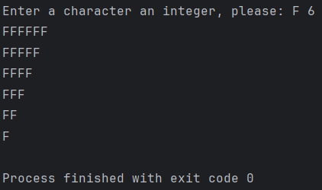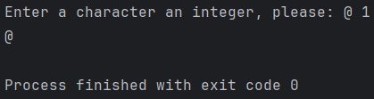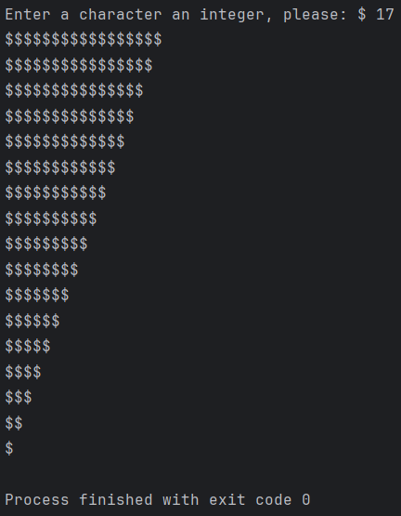

שאלה 4)
#define _CRT_SECURE_NO_WARNINGS
#include <stdio.h>
#include <math.h>
// This program is a calculator.
// It can average, multiply, spot the min/max and power.
int main()
{
// Instructions.
printf("This is a calculator."
"\n. ___________________________________________________________________________ ."
"\n| Please input: 'A\\a' | '*' | 'm\\M' | '^' | 'q\\Q' |"
"\n| Being.......: Average | Multiple | Minimum\\Maximum | Power | Quit |"
"\n. ___________________________________________________________________________ .");
int a, b, i = 1;
char ch;
// Opens a switch that loops so long as 'ch' isn't 'q' or 'Q'
while (i != 0)
{
// Requests and assigns user value to 'ch'
printf("\n\nInput: ");
rewind(stdin);
scanf("%c", &ch);
// This checks if 'ch' is any of the listed below.
if (ch == 'A' || ch == 'a' || ch == '*' || ch == 'm' || ch == 'M' || ch == '^')
{
printf("Input two whole numbers: ");
scanf("%d %d", &a, &b);
}
// Each case handles simple math/logic for every scenario with accompanying text
switch(ch)
{
case 'A': case 'a':
printf("The average of %d and %d is: %g", a, b, (a + b) / 2.0);
break;
case '*':
printf("The multiplication of %d by %d results in: %g", a, b, (float)(a * b));
break;
case 'm':
printf("The minimum between %d and %d is: %d", a, b, (a < b) ? a : b);
break;
case 'M':
printf("The maximum between %d and %d is: %d", a, b, (a > b) ? a : b);
break;
case '^':
printf("The power of %d and %d is: %g", a, b, pow(a, b));
break;
case 'q': case 'Q':
printf("Finish");
i = 0;
break;
default:
printf("Error");
break;
}
}
return 0;
}
