31/03/2025
מעבדה 4:

תוכן עניינים:

מספר מעבדה ותאריך................................................................................................ 1
תוכן עניינים............................................................................................................ 1
משתתפים............................................................................................................... 1
תרגילים.............................................................................................................. 2-6
שאלה 1) ........................................................................................................... 2
שאלה 2) ........................................................................................................ 3-4

משתתפים:
- איתי רוזן - 207931437
- דימה צ'יביסוב - 342744869
שאלה 1)
#define _CRT_SECURE_NO_WARNINGS
#include <stdio.h>
// This function calculates said midpoint.
void Set_Mid(double x1, double y1, double x2, double y2, double *p_mx, double *p_my);
int main()
{
// These request and assign user values for the two endpoints.
double x1, y1, x2, y2, p_mx, p_my;
// Instructions.
printf("This program can find the midpoint of a line given two endpoints.\n"
"Please enter coordinates for (x1, y1) and (x2, y2).\n");
printf("\n(x1, y1): ");
if (scanf("%lf %lf", &x1, &y1) != 2)
{
printf("Invalid input.\n");
return 0;
}
printf("(x2, y2): ");
if (scanf("%lf %lf", &x2, &y2) != 2)
{
printf("Invalid input.\n");
return 0;
}
// Sends said points to "Set_Mid" for calculations and memory allocation.
Set_Mid(x1, y1, x2, y2, &p_mx, &p_my);
printf("\nThe midpoint is: (%g, %g).\n", p_mx, p_my);
return 1;
}
// This function calculates said midpoint.
void Set_Mid(double x1, double y1, double x2, double y2, double *p_mx, double *p_my)
{
// Pointer to p_mx & p_my that change their values.
*p_mx = (x1 + x2) / 2;
*p_my = (y1 + y2) / 2;
}
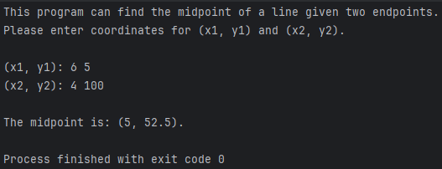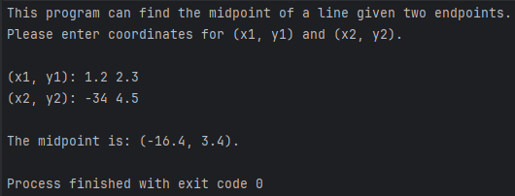

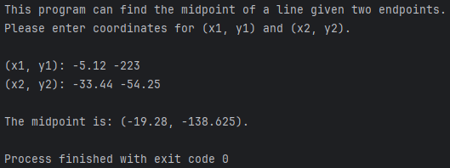
שאלה 2)
#define _CRT_SECURE_NO_WARNINGS
#include <stdio.h>
int InputThree(int *p1, int *p2, int *p3);
void SortTwo(int *p1, int *p2);
void SortThree(int *q1, int *q2, int *q3);
int main()
{
int p1, p2, p3;
// This loop requests and sorts user values until the user fails to provide 3 integers.
while (InputThree(&p1, &p2, &p3) != 0)
{
// Sends said values to "SortThree".
SortThree(&p1, &p2, &p3);
printf("Sorted Values: %d, %d, %d\n", p1, p2, p3);
}
printf("FINISH\n");
return 0;
}
// This function requests three integer inputs and assigns them to '*p1', '*p2', and '*p3'.
int InputThree(int *p1, int *p2, int *p3)
{
int check = 1;
printf("Input three integer values: ");
// Returns 0 if the input is invalid, otherwise returns 1.
if (scanf("%d %d %d", p1, p2, p3) != 3) check = 0;
return check; // 1 == True , 0 == False
}
// This function swaps the values of 'p1' & 'p2' only if 'p1' is greater than 'p2'.
void SortTwo(int *p1, int *p2)
{
int temp;
if (*p1 > *p2)
{
temp = *p1;
*p1 = *p2;
*p2 = temp;
}
}
// This function sorts three integers in ascending order by calling "SortTwo".
void SortThree(int *q1, int *q2, int *q3)
{
SortTwo(q1, q2);
SortTwo(q1, q3);
SortTwo(q2, q3);
}
