08/04/2025
מעבדה 5:

תוכן עניינים:

מספר מעבדה ותאריך................................................................................................ 1
תוכן עניינים............................................................................................................ 1
משתתפים............................................................................................................... 1
תרגילים.............................................................................................................. 2-6
שאלה 1) ........................................................................................................ 2
שאלה 2) ........................................................................................................ 3-4
שאלה 3) ........................................................................................................ 5-6

משתתפים:
- איתי רוזן - 207931437
- דימה צ'יביסוב - 342744869
שאלה 1)
#define _CRT_SECURE_NO_WARNINGS
#include <stdio.h>
#define SIZE 10
float avg(float a[], int size);
int main()
{
// These define various variables used in the script.
float lst[SIZE], average;
int i, best_times = 0;
// This prints instrutions and records user values into 'lst'.
printf("Enter times, please: ");
for (i = 0; i < SIZE;)
{
if (scanf("%f", &lst[i]) != 1)
{
rewind(stdin);
printf("Some of your inputs might've been incorrect..");
return 0;
}
else i++;
}
// Sends 'lst' & 'SIZE' to "avg" for calculations.
average = avg(lst, SIZE);
// This loop figures out how many runner times are below average.
for (i = 0; i < SIZE; i++)
{
if (lst[i] < average) best_times++;
}
// This prints two different messages in relation to 'best_times'.
(best_times == 0) ? printf("\nThere are no runners that ran below the average time! :(")
: printf("\nThe number of runners, running below the average time is %d.\n", best_times);
return 0;
}
// This function calculates the average of it's given values.
float avg(float a[], int size)
{
int i;
float sum = 0;
// Average algoarithm.
for (i = 0; i < size; i++)
sum += a[i];
return sum / size;
}

שאלה 2)
#define _CRT_SECURE_NO_WARNINGS
#include <stdio.h>
#include <stdlib.h>
#include <time.h>
#define N 7
// Function declerations.
void print(int arr[], int size, char name);
int greater(int arr1[], int arr2[], int size);
int main()
{
int arr1[N], arr2[N], i = 0, j = 0, maxValue = 0, index;
// This seeds a random number based on the time.
srand(time(NULL));
// Get all numbers for arr1[]
for (i; i < N;)
{
printf("Enter arr[%d]: ", i);
if (scanf("%d", &arr1[i]) == 0) printf("Wrong Input");
else i++;
}
// Get maxValue
printf("Enter max value greater than 0: ");
while (maxValue <= 0)
{
if (scanf("%d", &maxValue) == 0 || maxValue <= 0) printf("Wrong input");
}
// Get all values for arr2[]
for (j; j < N; j++)
{
// Fills with random numbers
arr2[j] = rand() % (maxValue) + 1;
}
print(arr1, N, '1');
print(arr2, N, '2');
index = greater(arr1, arr2, N);
if (index != -1) printf("\nThe index is %d (number %d and %d)", index, arr1[index], arr2[index]);
else printf("\nNo!!!");
return 1;
}
// This function check if there is a greater number in arr1[] than in arr2[] at the same position
int greater(int arr1[], int arr2[], int size)
{
int i = 0;
for (i; i < size; i++)
{
if (arr1[i] > arr2[i]) return i;
}
return -1; // No number like that
}
// This function will print arrays
void print(int arr[], int size, char name)
{
int i = 0;
printf("Array %c: ", name);
for (i; i < size; i++)
{
printf("%d ", arr[i]);
}
printf("\n");
}

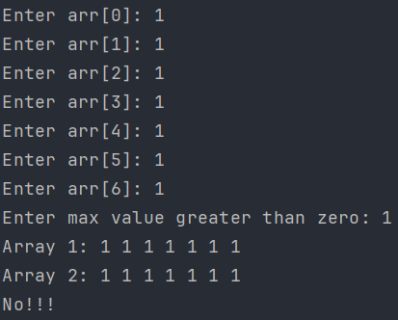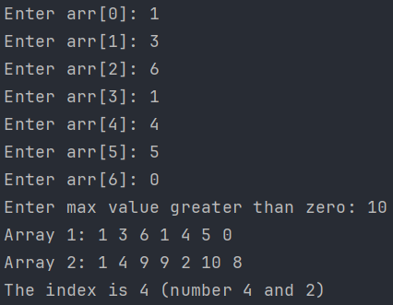

שאלה 3)
#define _CRT_SECURE_NO_WARNINGS
#include <stdio.h>
#include <string.h>
#define N 100
void replaceSubstring(char* str, char* substr);
void replaceEnter(char* str);
int main()
{
char str[N], substr[N];
// Will check if str and substr is not empty
while (1)
{
// Get text
printf("Enter text: ");
fgets(str, N, stdin);
// Replace enter if used to \0
replaceEnter(str);
if (*str == '\0') break;
// Get substring
printf("Enter substring: ");
fgets(substr, N, stdin);
// Replace enter if used to \0
replaceEnter(substr);
if (*substr == '\0') break;
// Call replace func and print result
replaceSubstring(str, substr);
printf("%s\n\n", str);
}
printf("Finish");
return 0;
}
// This function will replace Enter to \0 if enter was used
void replaceEnter(char* str)
{
int len;
// check length of string
len = strlen(str);
// Replace \n to \0
if (str[len - 1] == '\n') str[len - 1] = '\0';
}
// This function will replace each part of the string
// Each part of the string that equal to substring will become upper letters
void replaceSubstring(char* str, char* substr)
{
int i = 0, j = 0, len, sublen;
char* pos;
len = strlen(str);
sublen = strlen(substr);
for (i; i < len-1; i++)
{
pos = strstr(str, substr);
if (pos != NULL)
{
for (j; j < sublen; j++)
{
if (*pos >= 97) *pos -= 32;
pos++;
}
j = 0;
}
}
}

