27/04/2025
מעבדה 6:

תוכן עניינים:

מספר מעבדה ותאריך................................................................................................ 1
תוכן עניינים............................................................................................................ 1
משתתפים............................................................................................................... 1
תרגילים.............................................................................................................. 2-6
שאלה 1) ........................................................................................................2-4
שאלה 2) ........................................................................................................ 5-6
שאלה 3) ........................................................................................................ 7-8
שאלה 4) ........................................................................................................ 9

משתתפים:
- איתי רוזן - 207931437
- דימה צ'יביסוב - 342744869
שאלה 1)
#define _CRT_SECURE_NO_WARNINGS
#define N 5
#define M 4
#define UNDERLINE "\033[4m"
#define RED "\033[38;2;255;0;0m"
#define GREEN "\033[38;2;0;255;0m"
#define LIGHT_BLUE "\033[38;2;150;150;255m"
#define YELLOW "\033[38;2;255;255;0m"
#define R "\033[0m"
#include <stdio.h>
double average(int Matrix[][M], int Rows,int Cols, int r, int c);
int is_legal(int current_i, int current_j, int neighbor_i, int neighbor_j);
int main()
{
int i, j, m[N][M], r, c;
double avg;
printf(UNDERLINE LIGHT_BLUE "Question 1\n\n" R);
printf("This program calculates the " YELLOW "average" R " of the 8 neighboring elements around any given coordinate in a matrix.\n");
// These populate matrix 'm[][]'.
for (i = 0; i < N; i++)
{
printf("Enter " GREEN "%d" R " numbers for row[%d]: ", M, i+1);
for (j = 0; j < M; j++)
{
if (scanf("%d", &m[i][j]) != 1)
{
printf("\nPlease make sure to only enter " UNDERLINE "whole" R " numbers."); return 1;
}
}
}
// This requests and assigns user coordinates into 'r' and 'c'.
printf("\nPlease enter the coordinates of an element you wish to inspect: ");
while (1)
{
if (scanf("%d %d", &r, &c) != 2 || r < 0 || r >= N || c < 0 || c >= M)
{
rewind(stdin);
printf("\n" RED "Invalid coordinates!" R "\nMake sure row is between " UNDERLINE "0-%d" R " and column is between " UNDERLINE "0-%d" R ".\nTry again: ", N - 1, M - 1);
}
else break;
}
// Sends values to "Average" for calculations.
avg = average(m, N, M, r, c);
// These print the matrix and 'average'.
printf("\nThe entered matrix is:\n");
for (i = 0; i < N; i++)
{
for (j = 0; j < M; j++)
{
if (j == 0) printf(GREEN "[%3d" R, m[i][j]);
if (j != 0) printf(GREEN "%3d" R, m[i][j]);
if (j < M - 1) printf(GREEN "," R);
}
printf(GREEN "]\n" R);
}
printf("And the " YELLOW "average" R " of all the elements that surround (%d,%d) is: " GREEN "%.2f" R, r, c, avg);
return 0;
}
double average(int Matrix[][M], int Rows,int Cols, int r, int c)
{
int i, j, sum = 0, count = 0;
for (i = 0; i < Rows; i++)
{
for (j = 0; j < Cols; j++)
{
if (is_legal(r, c, i, j))
{
sum += Matrix[i][j];
count++;
}
}
}
if (count == 0) return 0;
return (double)sum / count;
}
// This function checks if the coordinates (neighbor_i, neighbor_j) are neighbors of (current_i, current_j).
int is_legal(int target_i, int target_j, int i, int j)
{
return ( (i >= target_i -1) && (i <= target_i +1) ) && // 1. Checks if row is within 1 step (above or below).
( (j >= target_j -1) && (j <= target_j +1) ) && // 2. Checks if column is within 1 step (left or right).
( (i != target_i ) || (j != target_j ) ); // 3. Make sure it's not the element itself.
}

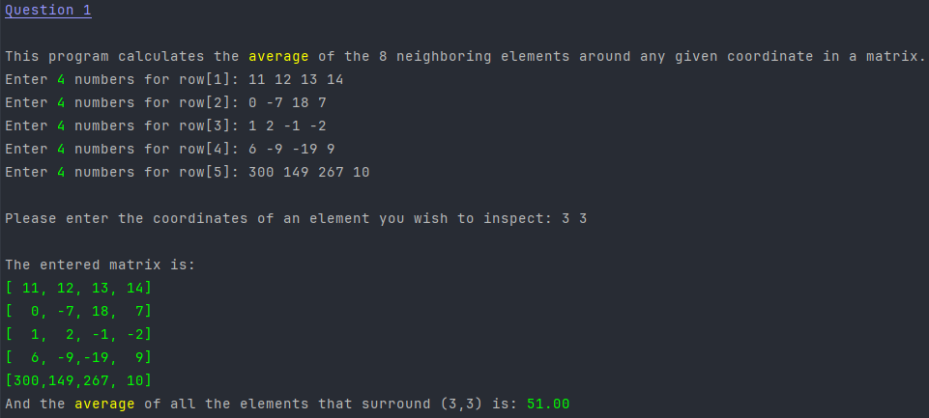

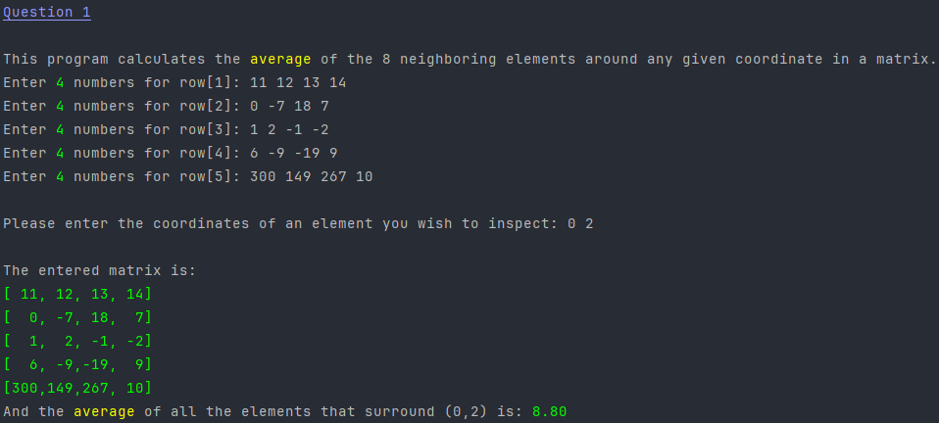

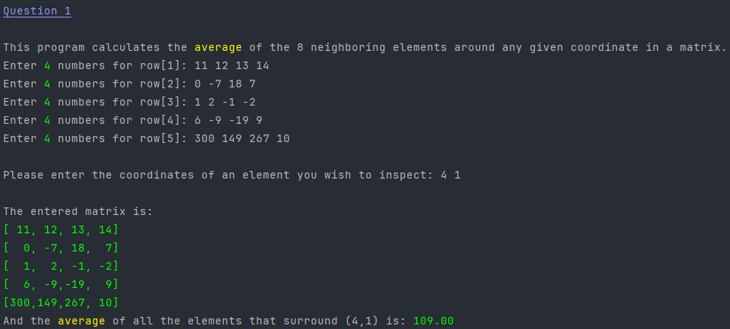

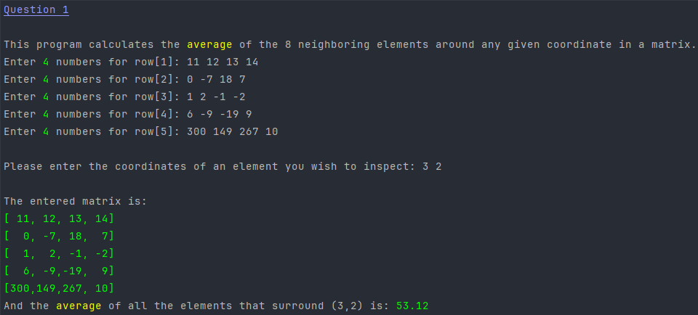

שאלה 2)
#define _CRT_SECURE_NO_WARNINGS
#include <stdio.h>
#include <stdlib.h>
#define UNDERLINE "\033[4m"
#define GREEN "\033[38;2;0;255;0m"
#define LIGHT_BLUE "\033[38;2;150;150;255m"
#define YELLOW "\033[38;2;255;255;0m"
#define R "\033[0m"
double* inputArithmetic(double* a1, double* d, int* n);
double setArithmetic(double a1, double d, double* arr, int n);
int main()
{
int n,i;
double a1, d, sum;
double* arr;
printf(UNDERLINE LIGHT_BLUE "Question 2\n" R);
while(1)
{
arr = inputArithmetic(&a1, &d, &n);
if (arr == NULL)
{
printf("\nThank you for exploring arithmetic sequences and dynamic allocations of arrays."); break;
}
// Gets the sum of all elements in sequence
sum = setArithmetic(a1, d, arr, n);
// Prints all numbers in sequence 5 in each row
for (i = 0;i < n;i++)
{
if (i % 5 == 0) printf("\n");
printf(" %10.6lf", arr[i]);
}
printf("\nThe " YELLOW "sum" R " of the sequence elements is: " GREEN "%9.6f\n" R, sum);
// Free memory of the array
free(arr);
}
return 0;
}
// This function will get starting number, difference between numbers and the number of steps
double* inputArithmetic(double* a1, double* d, int* n)
{
double* arr;
// Gets the first number of the sequence, the size of each step and the amount of numbers in sequence
printf("\nEnter a1, d, and n respectively, please: ");
if (scanf("%lf %lf %d", a1, d, n) != 3)
{
printf("Wrong input");
exit(-1);
}
if (*n <= 0) return NULL;
arr = (double*)malloc((*n) * sizeof(double));
// Check if memory allocated
if (arr == NULL)
{
printf("Error: Not Enough Memory");
free(arr);
exit(1);
}
return arr;
}
// Fill the array with sequence and returns SUM of the array
double setArithmetic(double a1, double d, double* arr, int n)
{
int i;
double sum = 0;
for (i = 0; i < n; i++)
{
arr[i] = a1 + d*i;
sum += arr[i];
}
return sum;
}

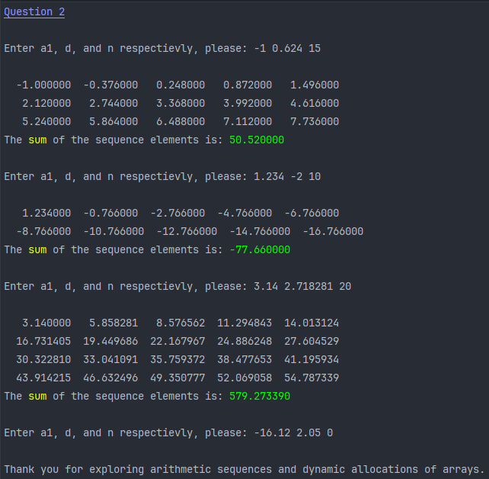

שאלה 3)
#include <stdio.h>
#include <stdlib.h>
#define GREEN "\033[38;2;0;255;0m"
#define LIGHT_BLUE "\033[38;2;150;150;255m"
#define UNDERLINE "\033[4m"
#define R "\033[0m"

void set_2d(float** a, int m, int n);
void print_2d(float** a, int m, int n);
int main()
{
int m, n, i;
float** a;
printf(UNDERLINE LIGHT_BLUE "Question 3\n" R);
printf("\nenter m and n, for m*n array: \n");
if (scanf("%d %d", &m, &n) != 2)
{
printf("\nInvalid input."); return 1;
}
// This dynamically allocates memory for 'm' pointers of size float.
a = (float**)malloc(m * sizeof(float*));
if (a == NULL)
{
printf("\nMemory allocation pointers failed.\n");
exit (1);
}
// This dynamically allocates memory for 'n' columns (of size float) for 'm' rows.
for (i = 0;i < m;i++)
{
a[i] = (float*)malloc(sizeof(float) * n);
// If there is not enough memory
if (a[i] == NULL)
{
printf("\nMemory allocation within the matrix failed.\n");
for (i = 0; i < m;i++)
free(a[i]);
free(a);
exit(2);
}
}
// These send said variables for matrix population and prints the result.
set_2d(a,m,n);
print_2d(a,m,n);
// Memory dumpster.
for (i = 0; i < m; i++)
free(a[i]);
free(a);
return 0;
}
// This function populates matrix 'a' with sequential natural numbers.
void set_2d(float **a, int m, int n)
{
int i, j, k = 1;
for (i = 0; i < m; i++)
for (j = 0; j < n; j++)
a[i][j] = k++;
}
// This function prints said matrix.
void print_2d(float** a, int m, int n)
{
int i, j;
for (i = 0; i < m; i++)
{
for (j = 0; j < n; j++)
printf(GREEN " %5.1f" R, a[i][j]);
printf("\n");
}
}

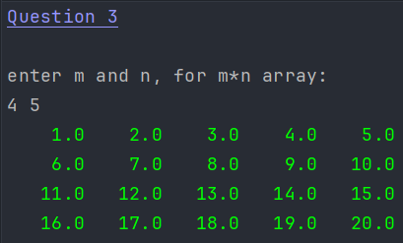

שאלה 4)
#define _CRT_SECURE_NO_WARNINGS
#include <stdio.h>
#include <string.h>
#define NUMELEMS 7
#define R "\033[0m"
#define GREEN "\033[38;2;0;255;0m"
#define LIGHT_BLUE "\033[38;2;150;150;255m"
#define UNDERLINE "\033[4m"
char* findMin(char** arrP, int arrSize);
int main()
{
char* a[] = { "Amos","Nir","Alona","Yosef","alice","Amina","bob" };
int i;
printf(UNDERLINE LIGHT_BLUE "Question 4\n\n" R);
for (i = 0; i < NUMELEMS; i++)
printf("%s\n", a[i]);
printf(GREEN "\n%s\n" R, findMin(a, NUMELEMS));
return 0;
}
// This function finds the lexicographically smallest element in any 'NUMELEMS' sized array.
char* findMin(char** arrP, int arrSize)
{
int i;
char* temp;
// This loop uses "strcmp" to evaluate the current smallest element against the rest of the array.
for (i = 0, temp = *arrP; i < arrSize; i++)
{
if (strcmp(temp, arrP[i]) > 0) temp = arrP[i];
}
return temp;
}

