27/04/2025
מעבדה 6:

תוכן עניינים:

מספר מעבדה ותאריך................................................................................................ 1
תוכן עניינים............................................................................................................ 1
משתתפים............................................................................................................... 1
תרגילים.............................................................................................................. 2-6
שאלה 1) ...........................................................................................................2
שאלה 2) ........................................................................................................ 3-4
שאלה 3) ........................................................................................................... 5

משתתפים:
- איתי רוזן - 207931437
- דימה צ'יביסוב - 342744869
שאלה 1)
#define _CRT_SECURE_NO_WARNINGS
#include <stdio.h>
#include <math.h>
#define UNDERLINE "\033[4m"
#define RED "\033[38;2;255;0;0m"
#define GREEN "\033[38;2;0;255;0m"
#define R "\033[0m"
typedef struct Point { float x, y; }Point;
typedef struct Circle
{
Point c;
float r;
}Circle;
int in_or_out(Point p, Circle c);
int main()
{
printf(UNDERLINE LIGHT_BLUE "Question 1\n\n" R);
Point point;
Circle circle;
// Requests and assigns user values to a point.
printf("Enter the coordinates of your point: ");
while (1)
{
if (scanf("%f%f", &point.x, &point.y) != 2)
{
printf("Please make sure to only input numbers..\n\nTry again: ");
while (getchar() != '\n');
}
else break;
}
// Requests and assigns user values to the center of the circle and its radius.
printf("\nEnter the radius and the center of your circle: ");
while (1)
{
if (scanf("%f%f%f", &circle.r, &circle.c.x, &circle.c.y) != 3)
{
printf("Please make sure to only input numbers..\n\nTry again: ");
while (getchar() != '\n');
}
else break;
}
in_or_out(point, circle) == 1 ? printf("\nThe point " GREEN "is" R " included in the circle")
: printf("\nThe point " RED "is not" R " included in the circle");
return 0;
}
// This function determines whether a given point is within a given circle or not.
int in_or_out(Point p, Circle c)
{ return sqrt(pow(p.x - c.c.x,2) + pow(p.y - c.c.y,2)) < c.r; }

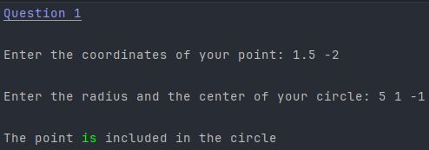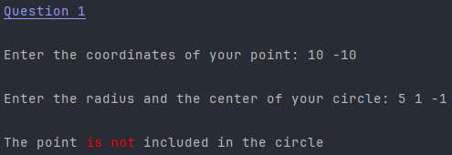

שאלה 2)
#define _CRT_SECURE_NO_WARNINGS
#include <stdio.h>
#include <string.h>
#include <stdlib.h>
#define UNDERLINE "\033[4m"
#define RED "\033[38;2;255;0;0m"
#define GREEN "\033[38;2;0;255;0m"
#define YELLOW "\033[38;2;255;255;0m"
#define LIGHT_BLUE "\033[38;2;150;150;255m"
#define R "\033[0m"
// Declares a structure for keeping track of a student name, 4 grades and the average of said grades.
typedef struct stud
{
char *name;
int marks[4];
float avg;
}student;
student* Create_Class(int size);
void Print_One(student *);
void Avg_Mark(student *);
int main()
{
printf(UNDERLINE LIGHT_BLUE "Question 2\n\n" R);
int size, i;
student *arr;
printf("Enter the number of students: ");
while (1)
{
if (scanf("%d", &size) != 1)
{
printf("Some of your inputs may be " RED "incorrect.." R "\n\nTry again: ");
while (getchar() != '\n');
}
else break;
}
arr = Create_Class(size);
// This prints student information if their average score is above 85.
for (i = 0; i < size; i++)
{
if (arr[i].avg >= 85)
Print_One(&arr[i]);
}
// Memory dumpster.
for (i = 0; i < size; i++)
free(arr[i].name);
free(arr);
return 0;
}
// This function prints the details of a single student, including their name and average marks.
void Print_One(student* s)
{
printf( "\nThe average of " YELLOW "%s" R " is " GREEN "%.1f" R, s->name, s->avg);
}
// This function calculates the average all 4 marks of every student.
void Avg_Mark(student* s)
{
int i;
s->avg = 0;
for (i = 0; i < 4; i++)
s->avg += s->marks[i];
s->avg /= 4;
}
// This function allocates memory for an array of students and populates their details.
student* Create_Class(int size)
{
char str[50];
int i, j;
student *arr = malloc(size * sizeof(student));
if (arr == NULL)
{
printf("Memory allocation for the array failed.\n");
exit(1);
}
for (i = 0; i < size; i++)
{
printf("\nEnter your name: ");
scanf("%s", str);
arr[i].name = (char*)malloc(strlen(str) + 1);
if (arr[i].name == NULL)
{
printf("Not enough memory");
for(j=0; j<i; j++)
free(arr[j].name);
free(arr);
exit(2);
}
strcpy(arr[i].name, str);
// Requests and assigns the marks of the student.
printf("Enter " YELLOW "%s's" R " marks: ",arr[i].name);
for (j = 0; j < 4;)
{
if (scanf("%d", &arr[i].marks[j]) != 1)
{
printf("Input number %d is " RED "incorrect.." R "\n\nTry again: ", j+1);
while (getchar() != '\n');
}
else j++;
}
Avg_Mark(&arr[i]);
}
return arr;
}

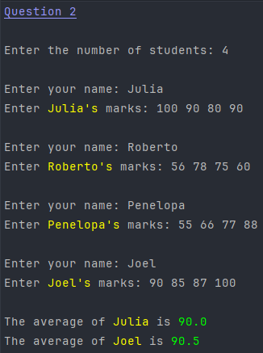

שאלה 3)
#define _CRT_SECURE_NO_WARNINGS
#include <stdio.h>
#include <math.h>
#define UNDERLINE "\033[4m"
#define RED "\033[38;2;255;0;0m"
#define GREEN "\033[38;2;0;255;0m"
#define R "\033[0m"
#define NUM 3
// This defines a Complex structure to store real and imaginary parts of a complex number.
typedef struct Complex { double r, i; } Complex;
double CRadius(Complex c);
Complex *Cmax(Complex a[], int n);
int main()
{
int i;
Complex arr[NUM], *max_complex;
printf(UNDERLINE LIGHT_BLUE "Question 3\n\n" R);
// Requests and assigns user values into a complex number array.
printf("Enter %d " YELLOW "complex" R " numbers:\n",NUM);
for (i = 0; i < NUM; )
{
if (scanf("%lf %lf", &arr[i].r, &arr[i].i) != 2)
{
printf("Some of your inputs may be " RED "incorrect.." R "\n\nTry again: ");
while (getchar() != '\n');
}
else i++;
}
max_complex = Cmax(arr, NUM);
printf("\nThe max " YELLOW "complex" R " number is: " GREEN " %.2f%+.2fi\n" R, max_complex->r, max_complex->i);
printf("The " YELLOW "radius" R " of the max number is: " GREEN " %.2f" R, CRadius(*max_complex));
return 0;
}
// This function calculates the radius of any given complex number.
double CRadius(Complex c)
{
return sqrt(pow(c.r,2) + pow(c.i,2));
}
// This function returns a pointer for the largest complex number based off of its radius.
Complex *Cmax(Complex a[], int n)
{
Complex *max = &a[0];
int i;
for (i = 0; i < n; i++)
{
if (CRadius(a[i]) > CRadius(*max))
max = &a[i];
}
return max;
}

