13/05/2025
מעבדה 8:

תוכן עניינים:

מספר מעבדה ותאריך................................................................................................ 1
תוכן עניינים............................................................................................................ 1
משתתפים............................................................................................................... 1
תרגילים.............................................................................................................. 2-6
שאלה 1) ...........................................................................................................2
שאלה 2) ........................................................................................................ 3-4
שאלה 3) ........................................................................................................ 5-6

משתתפים:
- איתי רוזן - 207931437
- דימה צ'יביסוב - 342744869
שאלה 1)
#define _CRT_SECURE_NO_WARNINGS
#include <stdio.h>
#include <stdlib.h>
#define RED "\033[38;2;255;0;0m"
#define R "\033[0m"
typedef struct Person
{
char ID[10];
char F_name[11];
char L_name[16];
int Age;
char Addr[51];
}Person;
void Error_Msg(char*);
int main()
{
Person temp;
FILE *in,*out;
char* msg = "There was a" RED " problem" R " opening one of the files.";
in = fopen("the_first.txt", "r");
if (in == NULL) {Error_Msg(msg);}
out = fopen("the_second.txt", "w");
if (out == NULL) {Error_Msg(msg);}
// This reads data from the input file.
fscanf(in,"%s %s %s %d %s", temp.ID, temp.F_name, temp.L_name, &temp.Age, temp.Addr);
// These write data to the output file.
fprintf(out,"ID: %s\n", temp.ID);
fprintf(out,"Full name: %s %s\n", temp.F_name, temp.L_name);
fprintf(out,"Age: %d\n", temp.Age);
fprintf(out,"Address: %s", temp.Addr);
// Closes the files.
fclose(in); fclose(out);
return 0;
}
// This function prints an error message and quits the script.
void Error_Msg(char* msg)
{ printf("\n%s",msg); exit(1); }

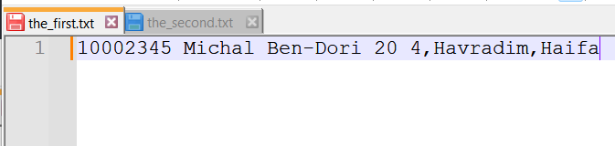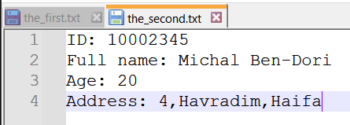

שאלה 2)
#define _CRT_SECURE_NO_WARNINGS
#include <stdio.h>
#include <stdlib.h>
typedef struct
{
char name[20];
int grades[3];
}student;
void Error_Msg(char*);
int InputData(student **, FILE*);
void OutputData(int, student*, FILE*);
int highest_grade(int index, student* arr);
int main()
{
FILE *fp;
student * arr;
int size;
if((fp=fopen("Students.txt","r")) == NULL)
Error_Msg("The input file is wrong");
size = InputData(&arr,fp);
fclose(fp);
if ((fp = fopen("Students.txt", "w")) == NULL)
{
free(arr);
Error_Msg("The output file is wrong");
}
OutputData(size,arr,fp);
fclose(fp);
return 0;
}
// This function populates the 'student' structure dynamically.
int InputData(student ** p_array, FILE * fp)
{
student* arr, *temp;
int i = 1;
// Dynamically creates an array that holds structures of student info.
arr = (student*)malloc(sizeof(student));
// This loop populates the fields in each structure in 'arr', and reallocates more memory to it if needed.
while (fscanf(fp, "%s %d %d %d", arr[i - 1].name, &arr[i - 1].grades[0], &arr[i - 1].grades[1], &arr[i - 1].grades[2]) != EOF)
{
i++;
temp = (student*)realloc(arr, i * sizeof(student));
if (temp == NULL)
{
free(arr);
Error_Msg("Memory reallocation failed.");
}
arr = temp;
}
// Resizes the array to the final size after all data is read.
temp = (student*)realloc(arr, (i - 1) * sizeof(student));
if (temp == NULL)
{
free(arr);
Error_Msg("Memory reallocation failed.");
}
arr = temp;
// Passes 'arr' back to the main and returns the number of students.
*p_array = arr;
return i - 1;
}
// This program rewrites the file with the highest grades.
void OutputData(int arr_size, student *arr, FILE* fp)
{
int i = 0;
int max;
// This loop goes over the size of the array and does as per writen in the function notation.
for (i = 0; i < arr_size; i++)
{
max = highest_grade(i, arr);
if (i == arr_size - 1) fprintf(fp, "%s's highest grade is: %d", arr[i].name, max);
else fprintf(fp, "%s's highest grade is: %d\n", arr[i].name, max);
}
}
// This function prints an error message and quits the script.
void Error_Msg(char* msg)
{ printf("\n%s",msg); exit(420); }
// This function returns the highest grade per student.
int highest_grade(int index, student* arr)
{
int max_grade = arr[index].grades[0], i;
for (i = 1; i < 3; i++)
if (arr[index].grades[i] > max_grade)
max_grade = arr[index].grades[i];
return max_grade;
}

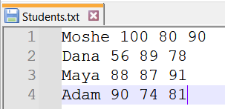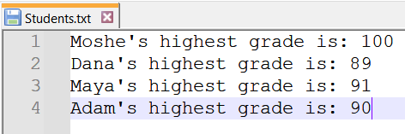

שאלה 3)
#define _CRT_SECURE_NO_WARNINGS
#include <stdio.h>
#include <stdlib.h>
#include <math.h>
#define RED "\033[38;2;255;0;0m"
#define GREEN "\033[38;2;0;255;0m"
#define YELLOW "\033[38;2;255;255;0m"
#define LIGHT_BLUE "\033[38;2;150;150;255m"
#define R "\033[0m"
#define UNDERLINE "\033[4m"
#define N 4
// This defines a Complex structure to store real and imaginary parts of a complex number.
typedef struct Complex
{
double r, i;
}Complex;
double CRadius(Complex c);
void Error_Msg(char* str);
void InputAndWriteToFile(FILE *f);
int CheckFile(FILE *f,float m);
int main()
{
FILE *f;
int res;
printf(UNDERLINE LIGHT_BLUE "Question 3\n\n" R);
f = fopen("complex_number.txt", "w+");
if (f == NULL)
{Error_Msg("There was a " RED "problem" R " opening one of the files."); return 1;}
InputAndWriteToFile(f);
res = CheckFile(f, 4);
res == 1 ? printf("\nThere is " GREEN "%d" R " big number.\n", res)
: printf("\nThere are " GREEN "%d" R " big numbers.\n", res);
return 0;
}
// This function writes the coordinates of a complex number, and it's radius into any given file.
void InputAndWriteToFile(FILE *f)
{
int i = 0;
Complex c;
printf("Enter " YELLOW "%d" R " complex numbers:\n", N);
while (i < N)
{
if (scanf("%lf %lf", &c.r, &c.i) != 2)
{
printf("Coordinate number %d may have been " RED "incorrect.." R "\n\nTry again:\n", i+1);
while (getchar() != '\n');
}
else
{
if (i == N - 1) fprintf(f, "%.1lf %.1lf %.1lf", c.r, c.i, CRadius(c));
else fprintf(f, "%.1lf %.1lf %.1lf\n", c.r, c.i, CRadius(c));
i++;
}
}
}
// This function prints an error message and quits the script.
void Error_Msg(char* str)
{
printf("\n%s",str);
exit(69);
}
// This function calculates the radius of any given complex number.
double CRadius(Complex c)
{ return sqrt(pow(c.r,2) + pow(c.i,2)); }
// This function returns the number of radii that are larger than 'm'.
int CheckFile(FILE *f,float m)
{
int j, count = 0;
double r, i, rad;
rewind(f);
// This loop goes over 'N' rows and checks if the radius is larger than 'm'.
for (j = 0; j < N; j++)
{
if (fscanf(f, "%lf %lf %lf", &r, &i, &rad) == 3)
if (rad > m) count++;
}
return count;
}

