20/05/2025
מעבדה 9:

תוכן עניינים:

מספר מעבדה ותאריך................................................................................................ 1
תוכן עניינים............................................................................................................ 1
משתתפים............................................................................................................... 1
תרגילים.............................................................................................................. 2-6
שאלה 1) ........................................................................................................ 2
שאלה 2) ........................................................................................................ 3-4
שאלה 3) ........................................................................................................ 5
שאלה 4) ........................................................................................................ 6-7

משתתפים:
- איתי רוזן - 207931437
- דימה צ'יביסוב - 342744869
שאלה 1)
#define _CRT_SECURE_NO_WARNINGS
#include <stdio.h>
#include <string.h>
#include <stdlib.h>
#define RED "\033[38;2;255;0;0m"
#define R "\033[0m"
typedef struct Student
{
char name[7];
char department[5];
char grade_1[4];
char grade_2[4];
float f_grade;
}Student;
void Error_Msg(char* str);
void output(FILE *in, FILE *out);
int main()
{
FILE *in,*out;
if((in=fopen("Students.txt","r")) == NULL)
Error_Msg("Something went " RED "wrong" R " with the input file.");
if((out=fopen("Studentsnew.txt","w")) == NULL)
Error_Msg("Something went " RED "wrong" R " with the output file.");
output(in, out);
fclose(in);
fclose(out);
return 0;
}
void Error_Msg(char* str)
{
printf("%s",str);
exit(1);
}
// This function populates an output .txt file.
void output(FILE *in, FILE *out)
{
Student temp;
int flag;
// This loop runs so long as it has text to read, and it updates the output file when the conditions are met.
while (fgets(temp.name, 7, in) != NULL)
{
flag = 0;
if (fgets(temp.department, 5, in) == NULL)
break;
if (strcmp(temp.department, "Comp") == 0)
flag = 1;
if (fgets(temp.grade_1, 4, in) == NULL || fgets(temp.grade_2, 4, in) == NULL)
break;
// Updates the output file if 'flag' is true.
if (flag)
{
temp.f_grade = (atof(temp.grade_1) + atof(temp.grade_2))/2;
fprintf(out, "%s %.2f\n", temp.name, temp.f_grade);
}
}
}
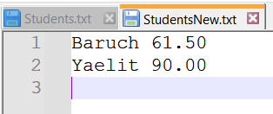

שאלה 2)
#include <stdlib.h>
#include <stdio.h>
#include <string.h>
#define MAX 256
typedef struct
{
char code[10];
char *name;
} Book;
typedef struct
{
char name[MAX];
int size;
Book *shelf;
} Library;
int input_book(Book *B, FILE *in);
void input_library(Library *L, FILE *in);
void output_book(Book *B, FILE *out);
void output_library(Library *L, FILE *out);
void Error_Msg(char *errorMsg);
int main()
{
FILE *in, *out;
Library Libr;
int i;
// Open Files
if ((in = fopen("input.txt", "r")) == NULL)
Error_Msg("The input file is wrong");
if ((out = fopen("output.txt", "w")) == NULL)
Error_Msg("The output file is wrong");
// Copy all info
input_library(&Libr, in);
fclose(in);
// Paste all relevant info
output_library(&Libr, out);
fclose(out);
// Free memory end of program
for (i = 0; i < Libr.size; i++)
free(Libr.shelf[i].name);
free(Libr.shelf);
return 0;
}
// This function will create shelf with books in Library
void input_library(Library *L, FILE *in)
{
int i, j;
// Get Name and amount of library respectievly
if (fscanf(in, "%s %d", L->name, &L->size) != 2)
Error_Msg("Input Error");
// Allocate space for shelf in Library
if ((L->shelf = (Book *)malloc(sizeof(Book) * L->size)) == NULL)
Error_Msg("Memory Error");
// Fill with books
for (i = 0; i < L->size; i++)
{
// If not enough space in memory
if (input_book(&L->shelf[i], in) == 0)
{
// Free memory from books
for (j = 0; j < i; j++)
free(L->shelf[j].name);
// Free memory from shelf blocks
free(L->shelf);
Error_Msg("Memory error");
}
}
}
// This funciton will add a book to a shelf in a library
int input_book(Book *B, FILE *in)
{
char tempName[99];
// Get Code and Name of the book respectievly
if (fscanf(in, "%s %s", B->code, tempName) != 2)
return 0;
// Allocate memmory for name
if ((B->name = (char *)malloc(strlen(tempName) + 1)) == NULL)
return 0;
// Copy name to allocated memory
strcpy(B->name, tempName);
return 1;
}
void output_library(Library *L, FILE *out)
{
int i;
// Print name of Library
fprintf(out,"%s\n", L->name);
// Print books
for(i = 0; i < L->size; i++)
output_book(&L->shelf[i], out);
}
// This function will print the book and the credentials inside the doccument
void output_book(Book *B, FILE *out)
{
// Print Code and Book inside doc
fprintf(out, "%-10s %s\n", B->code, B->name);
}
// This function will write error that you specify
void Error_Msg(char *errorMsg)
{
printf("\n%s\n", errorMsg);
exit(1);
}

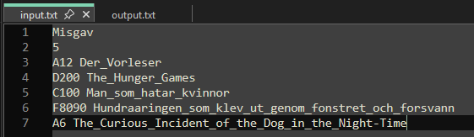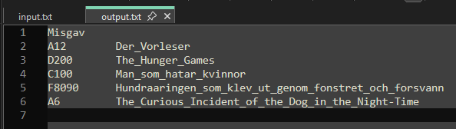

שאלה 3)
#define _CRT_SECURE_NO_WARNINGS
#include <stdio.h>
#define ITALIC "\033[3m"
#define UNDERLINE "\033[4m"
#define GREEN "\033[38;2;0;255;0m"
#define LIGHT_BLUE "\033[38;2;150;150;255m"
#define R "\033[0m"
int Bit_Count(unsigned int x);
void Bin_Print(unsigned int x);
int main()
{
unsigned int x;
printf(UNDERLINE ITALIC LIGHT_BLUE "Question 3\n\n" R);
printf("Enter a number: ");
scanf("%u",&x);
printf("There are " GREEN "%d" R " bits equal to one in %d\n", Bit_Count(x),x);
printf("The binary representation of %d is ",x);
Bin_Print(x);
return 0;
}
// This function counts the number of bits set to 1.
int Bit_Count(unsigned int x)
{
int i, count = 0;
unsigned int mask;
for (i = 31; i >= 0; i--)
{
mask = 1 << i;
if ((x & mask) != 0)
count++;
}
return count;
}
// This function prints the 32-bit binary form of 'x'.
void Bin_Print(unsigned int x)
{
int i;
unsigned int mask;
for (i = 31; i >= 0; i--)
{
mask = 1 << i;
printf(GREEN "%d" R, (x & mask) ? 1 : 0);
}
}

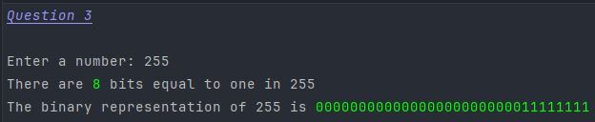

שאלה 4)
#define _CRT_SECURE_NO_WARNINGS
#include <stdio.h>
#define ITALIC "\033[3m"
#define UNDERLINE "\033[4m"
#define GREEN "\033[38;2;0;255;0m"
#define LIGHT_BLUE "\033[38;2;150;150;255m"
#define R "\033[0m"
void BinPrint(unsigned char ch);
unsigned char check_ms(unsigned char ch);
unsigned char change_bit(unsigned char ch, int n);
int main()
{
unsigned char num1 = 102, num2 = 58;
int n;
printf(UNDERLINE ITALIC LIGHT_BLUE "Question 4\n\n" R);
printf(UNDERLINE "The first part:" R);
printf("\nThe number is %d -> ", num1); BinPrint(num1);
num1 = check_ms(num1);
printf ("\nThe " GREEN "new" R " number is: %d -> ", num1);
BinPrint(num1);
printf(UNDERLINE "\n\nThe second part:" R);
printf("\nThe number is %d -> ", num2); BinPrint(num2);
printf ("\nEnter a number of the bit to change(1-8): ");
scanf ("%d",&n);
num2 = change_bit(num2, n);
printf ("\nThe " GREEN "new" R " number is: %d -> ", num2); BinPrint(num2);
return 0;
}
// This function prints the binary form of 'ch'.
void BinPrint(unsigned char ch)
{
int i;
unsigned int mask;
for (i = 7; i >= 0; i--)
{
mask = 1 << i;
printf("%d", (ch & mask) ? 1 : 0);
}
}
// This function flips the MSB if it's unlit.
unsigned char check_ms(unsigned char ch)
{
unsigned int mask = 1 << 7;
if ((ch & mask) == 0)
ch |= mask;
return ch;
}
// This function flips any 'n'th bit it's given.
unsigned char change_bit(unsigned char ch, int n)
{
unsigned int mask = 1 << 8 - n;
ch = ch ^ mask;
return ch;
}
