EDGE COMPUTING ASSIGNMENT

Client-Side Aggregation vs
Direct Data Transmission
Implementation, Evaluation and Comparison Report
Prepared by Daniil Aleksejevich
23 September 2026

1 Assignment Objective
The assignment examines two approaches to collecting employee keyboard activity. In the edge-computing solution, each client counts key presses locally and sends only one aggregate count per 15-minute interval. In the comparison solution, every key event is transmitted directly to the server and aggregated centrally.
Both implementations determine whether a user is working during business hours, absent during business hours, working overtime, or inactive outside business hours. Business hours are inferred when at least 80% of users in a region are active.

2 Supplied Prototype
The supplied prototype contained klientas.py and serveris.py. The client used pynput to monitor key presses, stored every pressed key locally, and periodically sent a count to a Flask server. The server stored a status in SQLite and exposed a report endpoint.
File | Original responsibility
klientas.py | Capture keystrokes, write local raw log and send key_count
serveris.py | Receive aggregates, classify activity and return statistics

3 Problems Identified
Issue | Impact | Improvement
Immediate evaluation after one upload | Incorrect regional 80% calculation | Wait for the configured number of users
10-second demo vs 15-minute logic | Threshold and interval mismatch | Configurable 900-second default window
Raw keys saved locally | Unnecessary privacy exposure | Discard key values in the edge client
Shared global SQLite cursor | Unsafe with concurrent Flask requests | Open a connection per operation
No authentication or validation | Any sender can insert malformed data | API key and input validation
No offline handling | Intervals are lost during outages | Local retry queue

4 Solution A: Edge Aggregation
The improved edge client increments an in-memory counter for each key press but deliberately discards the key value. At the end of the interval, it sends one JSON object containing the user, region, interval timestamps and key count. This follows the principle of data minimisation.
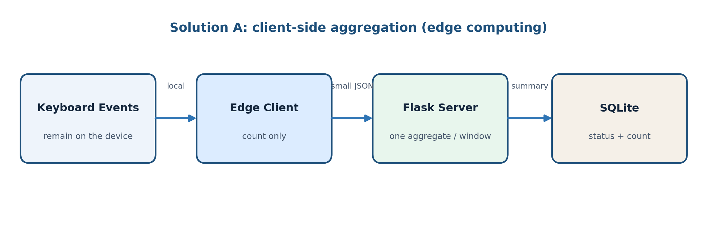
Figure 1 Edge-processing data flow

4.1 Edge payload
{
"user_id": "demo-user",
"region_id": "vilnius",
"interval_start": "2026-09-23T08:00:00+00:00",
"interval_end": "2026-09-23T08:15:00+00:00",
"key_count": 30
}

4.2 Advantages
- The server never receives the characters that were typed.
- Only one small request is sent per interval.
- Temporary connection failures can be handled with a local aggregate queue.
- Server storage and processing requirements are low.

4.3 Limitations
- The server cannot reconstruct detailed event timing within the interval.
- A modified client could report an incorrect count unless device attestation is added.
- The status is delayed until the aggregation interval ends.

5 Solution B: Direct Transmission
The alternative client sends every key event to the server immediately. The server stores raw events, groups them into time windows and then applies the same regional 80% rule. This provides greater event-level detail but creates substantially greater privacy, network and storage costs.
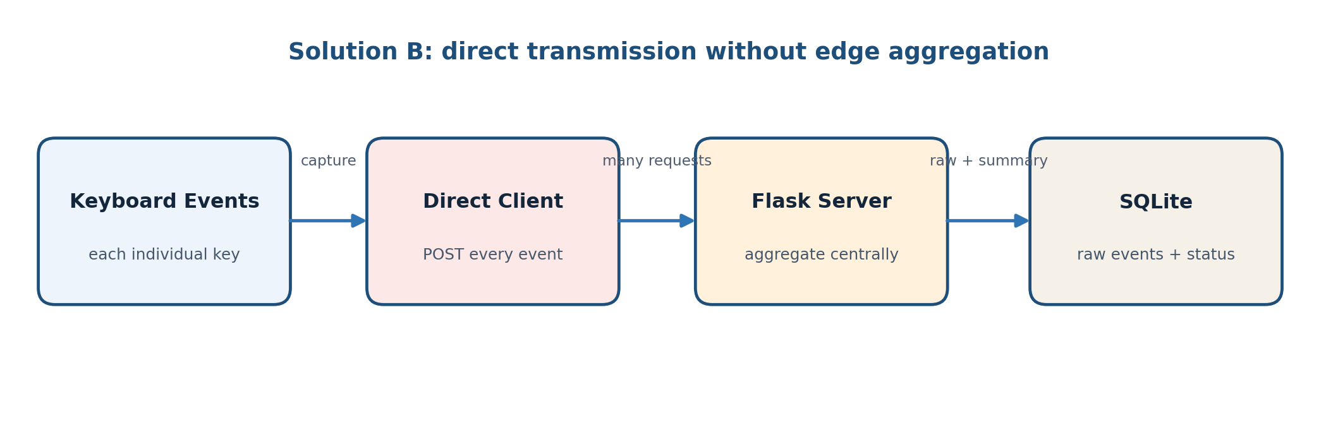
Figure 2 Direct-transmission data flow

5.1 Direct event payload
{
"user_id": "demo-user",
"region_id": "vilnius",
"event_time": "2026-09-23T08:04:12+00:00",
"key": "a"
}

5.2 Advantages
- The server receives precise event timestamps and can change aggregation rules later.
- Central processing simplifies client logic.
- Near-real-time analysis is possible.

5.3 Limitations
- Typed characters and behavioural timing are exposed to the server.
- One request per key press creates high network overhead.
- Raw-event storage increases security impact, database size and compliance burden.
- Connection failures can create a large local backlog and delayed uploads.

6 Running the Solutions
Install the dependencies:
python -m pip install -r requirements.txt

6.1 Edge solution
# Terminal 1
python edge_server.py

# Terminal 2: safe demonstration mode
WINDOW_SECONDS=10 python edge_client.py --user demo-user --simulate 3

6.2 Direct solution
# Terminal 1
python direct_server.py

# Terminal 2: safe demonstration mode
python direct_client.py --user demo-user --simulate 25

6.3 User reports
curl -H "X-API-Key: dev-key" http://localhost:5000/report/demo-user
curl -H "X-API-Key: dev-key" http://localhost:5001/report/demo-user

7 Automated Verification
The verification script creates isolated temporary databases, exercises both Flask applications through their test clients, submits activity data, forces interval evaluation and checks the resulting user summaries.
python test_solutions.py

SUCCESS: edge aggregation and direct transmission solutions passed.
Test | Result
Health endpoints | Passed
Client registration | Passed
Aggregate upload and WORKING classification | Passed
Raw event upload and server-side aggregation | Passed
SQLite report summary | Passed

8 Comparison of the Two Approaches
Criterion | Edge aggregation | Direct transmission
Data privacy | Strong: key values stay on device | Weak: raw keys reach server
Data accuracy | Accurate count, limited event detail | Highest event-level detail
Network load | Very low: one request per interval | High: one request per key
Client data latency | Up to one interval | Near real time
Server storage | Small aggregated records | Large raw-event dataset
Offline resilience | Small aggregate queue | Potentially large event queue
Security impact | Lower if server is compromised | Higher because typed content is stored
Flexibility | Aggregation fixed on client | Server can recalculate from raw data
Recommended use | Preferred for this activity metric | Only when raw detail is justified

9 Recommended Improvements for Production
- Use HTTPS instead of plain HTTP and issue an individual credential to each client.
- Obtain explicit employee consent and complete a GDPR/legal review before deployment.
- Define a short retention period and delete raw or aggregated data automatically.
- Use audit logging and role-based access for reports.
- Replace a fixed threshold with a documented, validated activity model.
- Add monitoring, rate limits, database migrations and central configuration.

10 Conclusion
Both required solutions were implemented and verified. The edge solution performs the first calculation on the user's computer and sends only an interval count. The direct solution sends each key event to the server, where aggregation and classification occur.
For the stated purpose, edge aggregation is the preferable architecture. It provides enough information to calculate the four activity statuses while greatly reducing exposure of typed content, network traffic and server storage. Direct transmission offers lower latency and greater analytical flexibility, but those benefits do not normally justify its privacy and security costs for employee activity monitoring.
The improved implementation also addresses the operational gaps in the supplied prototype through configurable intervals, request validation, API-key authentication, thread-safe database access, offline queues, simulation mode and automated tests.

References
Project repository: github.com/Baldahero/Edge-Computing-Assignment
Flask documentation: flask.palletsprojects.com
Python sqlite3 documentation: docs.python.org/3/library/sqlite3.html
European Commission data-protection guidance: commission.europa.eu/law/law-topic/data-protection

