**FCC-Fractionator Script Documentation**

This document provides information regarding the MATLAB scripts, outputs, debugging etc. The detailed content is described next:

1. How to run simulations …………………………………………………………………………………………… 2
2. Degrees of freedom, set point changes and disturbance disruption ……………………….. 3

2.a Perform set point/disturbance changes …………………………………………………………….. 4

1. Outputs ……………………………………………………………………………………………………………………. 5
2. Numerical errors (debugging) .…………………………………………………………………………………. 8
3. Information of scripts …………..………………………………………………………………………………….. 9

**1. How to run simulations**

The FCC-Fractionator model contains several scripts. The master script (“dynamic.m”) details the data needed (initial conditions, ODE settings, simulation time etc.) to run simulations. This script is commented to provide additional detail. The function needed to start the simulations was thought as a built-in function in MATLAB (in the sense that the outputs and function name have to be stated at the command window to run a simulation). The necessary steps to run a simulation are described next:

1. Copy/paste the “dynamic” function at the command window (note that NO inputs are needed), include the semicolon (optional) and hit enter (or run the function)

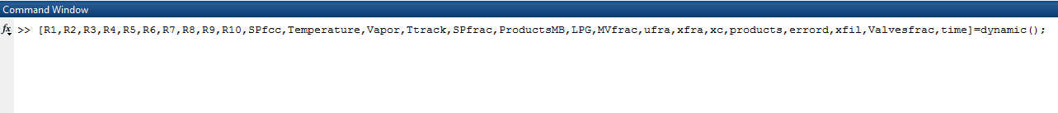

2. The “dynamic” function has several outputs (described in “Outputs” section); however, just the necessary outputs can be selected. The following example details a simulation (case study) in which just the information about the hold up and temperature of the trays of the Fractionator is needed.

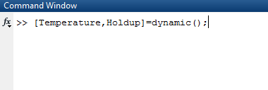

**2. Degrees of freedom, set point changes and disturbance disruptions**

Similar to the previous section, the “dynamic.m” file will be used to perform set point changes or disturbance disruptions. This file defines the degrees of freedom (DoF) of both the FCC and Fractionator, and the potential disturbances.

**FCC DoF**

The DoF of the FCC (vector ufcc) are defined in line 38 (the definition of each component of the vector can be found in “FCC.m” file).



The first two elements of this vector are associated with the flowrate of the VGO (feed) and slurry respectively. The feed flowrate can be modified **smoothly**. The nominal model does not consider (partial) slurry recirculation; however, this can be changed by linking the slurry flowrate with the second component of vector ufcc.

The following seven components of the vector ufcc are DoF that are suggested to be fixed since they are related to the valve positions of the compression system (WGC and CAB). Finally, the last six components of vector ufcc are the set points of the FCC controllers (the order is the following one: temperature of preheater, pressure of fractionator, pressure of regenerator, temperature of regenerator, catalyst inventory of reactor, temperature of reactor riser). These components are the ones that may change with time (e.g. at each time step).

**Fractionator DoF**

The DoF of the fractionator are partitioned into two vectors (“MV” and “SP”). The details of each vector (and its components) can be found in either “Fractionator.m” or “Fractionatori.m”.

The vector “MV” in the “dynamic.m” file is defined in line 46



Vector “MV” contains six elements that are associated with the three pump arounds (with either duty or flowrate). These elements can be modified **smoothly** (particularly the ones associated with the duty of the pump around)**.**

The vector “SP” in the “dynamic.m” file is defined in line 50

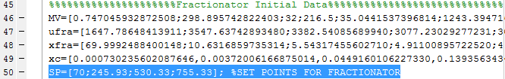

Vector “SP” contains four elements that are associated with the set points of the controllers of the Fractionator (the order is: accumulator level, overhead temperature, 98% temperature cut point HN, 98% temperature cut point LCO). These components are the ones that may change with time (e.g. at each time step).

**Disturbances**

The disturbances (vector dist) of the FCC-Fractionator process are defined in line 40 (the definition of each component of the vector can be found in “FCC.m” file).



Vector “dist” contains four elements that are associated with the different disturbances (the order is the following: ambient temperature, feed quality (API), feed temperature, condenser efficiency). These elements can be modified **smoothly.**

**2.a) Perform set point changes/disturbance changes**

Once all the DoF and disturbances are defined, these can be modified (with respect to time) to run different case studies. The modifications must be carried out at the “dynamic.m” file. These modifications must include the time step-interval at which they are performed and the magnitude. “dynamic.m” already includes the two case studies shown in the manuscript so that they can be replicated (note that they are commented; in order to run any of the two case studies, the corresponding lines should be uncommented).

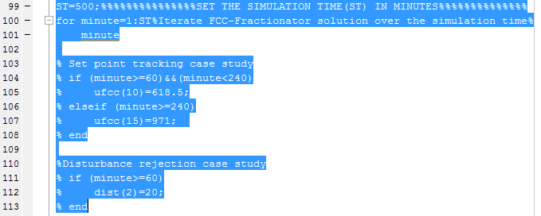

Any of the case studies exemplifies how to make a set point change or disturbance disruption. First, the interval time must be established. Then, the corresponding change and magnitude must be set (select the appropriate component(s) of any DoF vector and set the new value). It is important to note that line 99 sets the simulation time. For the case studies in the manuscript, the simulation time was set to 500 minutes, nevertheless, this can be changed to accommodate user needs.

Another example of set point change & disturbance disruption is shown below. In this case, the pressure of the regenerator (ufcc(12)), the cut point of the HN (SP(3)) and the ambient temperature (dist(1)) are increased after 60 minutes of simulation.

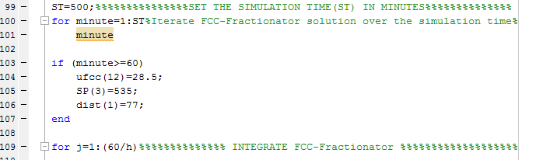

It is important to note that the all set point, disturbance or DoF modifications are performed **before** the integration step (line 109 above in which the for loop for “j” is defined).

Finally, set point changes can be performed at every time step (every minute) for APC purposes etc. However, the maximum magnitude of the change (Δ) should be reduced (particularly for TC2, TC3, PC1, PC2). A "reduction" factor in the range [1/10,1/4] is recommended with respect to magnitude (Δ) stressed in Table 2 in the manuscript. Other DoF and the disturbances can also be modified at each time step, nonetheless, the user have to be careful about potential numerical complexities (see section related to numerical errors)

**3. Outputs**

Running the scripts provides various outputs (command window, figures and workspace matrices). Information of each output is provided next.

**Command window**

At each time step, the command window will display the following information (in form of tables)

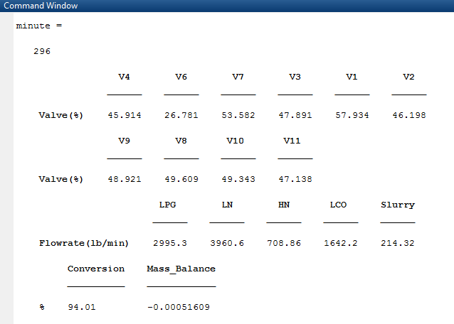

The first table displays information about the valve position of the FCC controllers. The second table displays information about the valve position of the Fractionator controllers. Both tables are useful to double check transient process saturation. The third table shows the products of the Fractionator (useful to see the effect of operating conditions) and finally the last table displays the conversion and the total mass balance (in %). The definition/details of conversion and mass balance can be found “dynamic.m”. It is important to note that these tables can be modified to accommodate user needs.

**Figures**

As soon as the simulation is completed, eight figures (plots) of the most relevant variables are displayed (the variables considered include position of valves, CVs, MVs, amperage of compressors, and production rate). The image below provides an example of the figure related to the CVs of the Fractionator (the dash line represent the desired set point value).

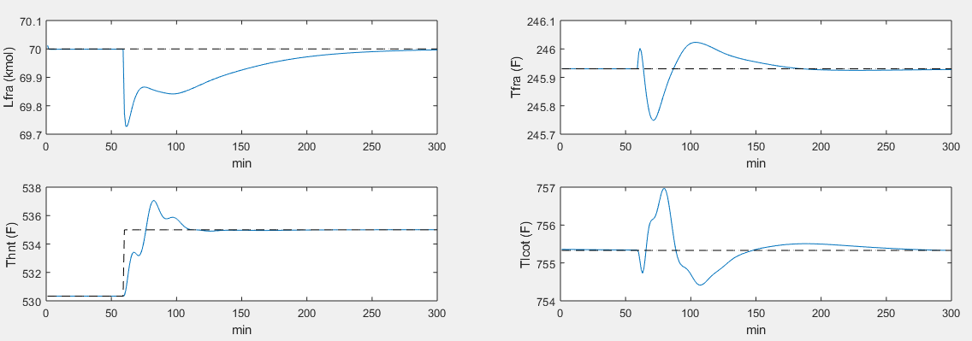

These figures can be modified to accommodate user needs. In addition, if the figures are not required, the “Plotall” statement at the end of the “dynamic.m” file can be commented.

**Workspace**

As soon as the simulation is completed, the outputs of the dynamic function will appear at the workspace window. These outputs consists of matrices (time series). The definition of each matrix can be found in “dynamic.m”. The details of each matrix (elements) can be found in either “FCC.m” or “Fractionator.m/Fractionatori.m”. A sample of the workspace results for a case study is shown next:

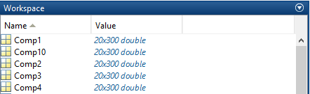

It is important to note that the outputs of the dynamic function can be modified to accommodate user needs. These outputs can be used within MATLAB framework or in another software (e.g. python)

**4. Numerical errors (debugging)**

Extensive simulations have been carried out to test the script robustness, however, in some cases, the model numerical routine might fail (the reason of this situation is that there are operating transitions in which the holdup of some of the fractionator trays is very small (column tray “dry up”) which breaks the MESH equations). This situation can be easily identified by having wrong results (negative hold ups etc.), by important disruptions in the mass balance (indicated at the command window) or by integration errors of the ODE.

Table 2 in the manuscript summarizes the suggested operating region as well as the maximum absolute change (Δ). It is recommended to wait a period of time (e.g. at least 30 minutes of simulation) after consecutive set point changes (especially after applying the absolute maximum set point change for all controllers simultaneously. In this case, the waiting time for another set of set point changes should be more than 30 minutes of simulation). It is important to note that there is possibility that the model may experience numerical complexities while traversing this region.

In case that there exists numerical complexities for a simulation (given set point, DoF or disturbance changes) the following actions are recommended:

1. Reduce the magnitude of the change
2. Increase the settling time of the simulation (the time between consecutive set point, DoF or disturbance changes)
3. Combine the previous actions (i and ii)

These actions reduce the chance of having tray “dry up” problems. In the particular case where the set point, DoF or disturbance have to be performed at each time step, as discussed in section 2, the maximum magnitude of the change should be reduced (the operating region may be contracted too).

**5. Information of scripts**

This last section provides additional details regarding the MATLAB scripts. The master script is the “dynamic.m” file since it runs the simulation and calls the most important subroutines. The next table summarizes the task of each script. **It is very important to note that all scripts include comments providing additional detail.**

|  |  |
| --- | --- |
| **Matlab File** | **Description** |
| dynamic.m | Run the simulation |
| Enthalpy.m | Thermodynamics of all trays other than feed tray |
| EntahlpyB.m | Thermodynamics of feed tray |
| FCC.m | Model of FCC |
| FCND.m | Take FCC function to run the ODE subroutine |
| Filter.m | Filter that connects FCC and Fractionator |
| Fractionator.m | Fractionator model (bottom to top) |
| Fractionatori.m | Fractionator model (top to bottom) |
| PFR.m | Model of riser |
| Plotall.m | Plot relevant results |
| zcyc.m | Regenerator mass and energy calculation |
| zposition.m | Integration of energy and mass balance along z for regenerator |

It is important to mention that any script (or the dynamic FCC-Fractionator model) can be modified (extended) to satisfy the final user requirements.