**EXPERIMENT 3**

**Aim:** Cmd version control commands

**Theory:**

Git Bash comes with a set of commands to perform various operations related to code management and collaboration. Here are some essential Git Bash commands:-

* git init: Initializes the new git repository.

* git clone: “git clone“ command is used to clone the repositories which are already available in the remote repository.

* git add: Files present in the working area will move to the staging area.
* git commit: Files that are available in the staging area will be committed to the local repository.
* git status: This command shows the status of the working tree and the staging area.
* git log: “git log” command will help you to see the logs of all the commits made.
* git branch: Creates a new branch.
* git merge: For merging the changes from one branch to another branch.
* git config: “git config” will help you to configure the username and email id.

* git tag: It will display the all tags.

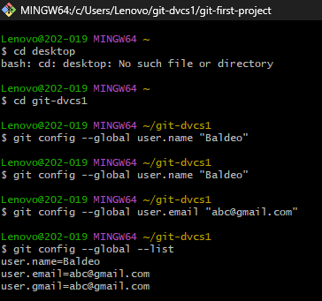

If you want to check your configuration settings, you can use the git config --list command to list all the settings Git can find at that point:

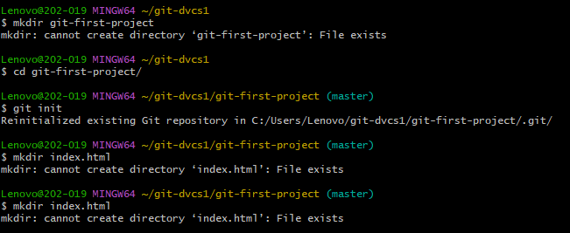

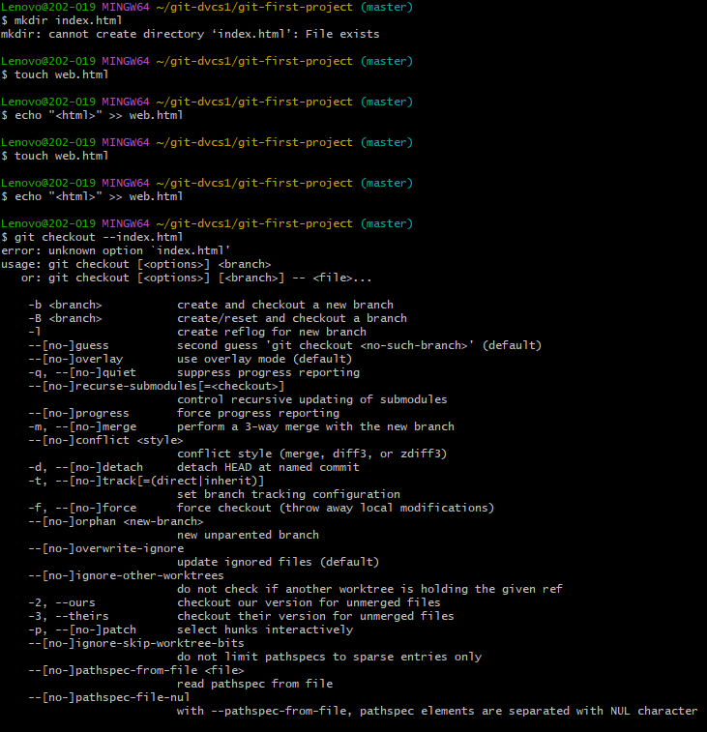

**Conclusion:**  We have learnt different git commands and implemented it.