**EXPERIMENT-04**

**Aim:** To understand Continuous Integration, install and configure Jenkins with Maven/Ant/Gradle to setup a build Job .

**Theory:**

Jenkins is an open source continuous integration/continuous delivery and deployment (CI/CD) automation software DevOps tool written in the Java programming language. It is used to implement CI/CD workflows, called pipelines.

To install Jenkins following software packages are required

1. GIT (git-scm.com)
2. Notepad++ (<https://notepad-plus-plus.org/downloads/>)
3. Latest Java development kit (JDK)
4. Jenkins
5. Apache Maven (Optional)

Step 1-: Install GIT

Step 2 -: Install Notepad++

Step 3 -: Install Java

Step 4 -: Install Jenkins

Step 5 -: Install Maven

Pipelines automate testing and reporting on isolated changes in a larger code base in real time and facilitates the integration of disparate branches of the code into a main branch. They also rapidly detect defects in a code base, build the software, automate testing of their builds, prepare the code base for deployment (delivery), and ultimately deploy code to containers and virtual machines, as well as bare metal and cloud servers. There are several commercial versions of Jenkins. This definition only describes the upstream Open Source project.

**Step-1: Install Git from Browser**

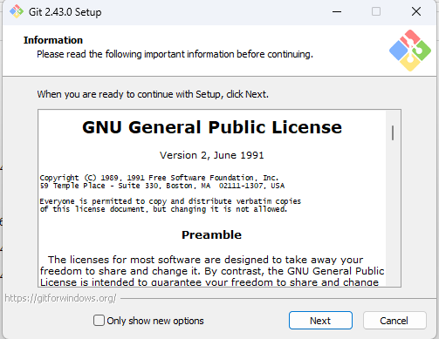

**Step-2: Install Notepad++ from Browser**

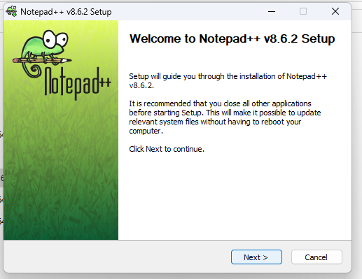

**Step-3: Install Java(JDK 21.0.1) from Browser**

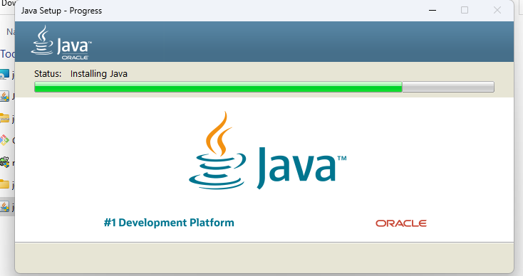

**Step-4: Installation Steps for Jenkins on Windows**

1)-Install Jenkins from Browser

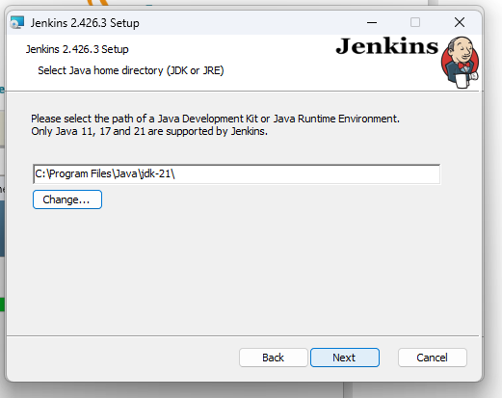

2)-Enter Service Credentials

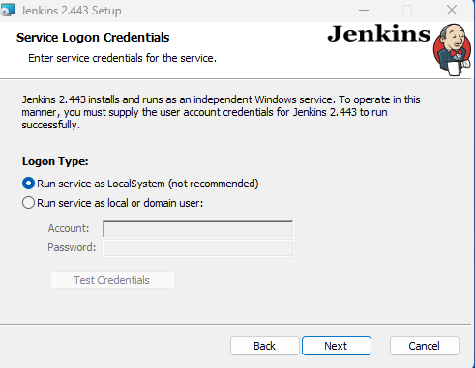

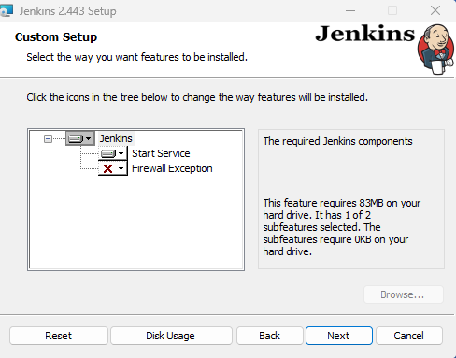

3)-Unlock Jenkins using Administrator password

Once Installation is done, you can test the jenkins on http://localhost:8080 on the browser.First time, when you open jenkins portal it will ask to put admin default password which is stored in /var/lib/jenkins/secrets/initialAdminPassword file.

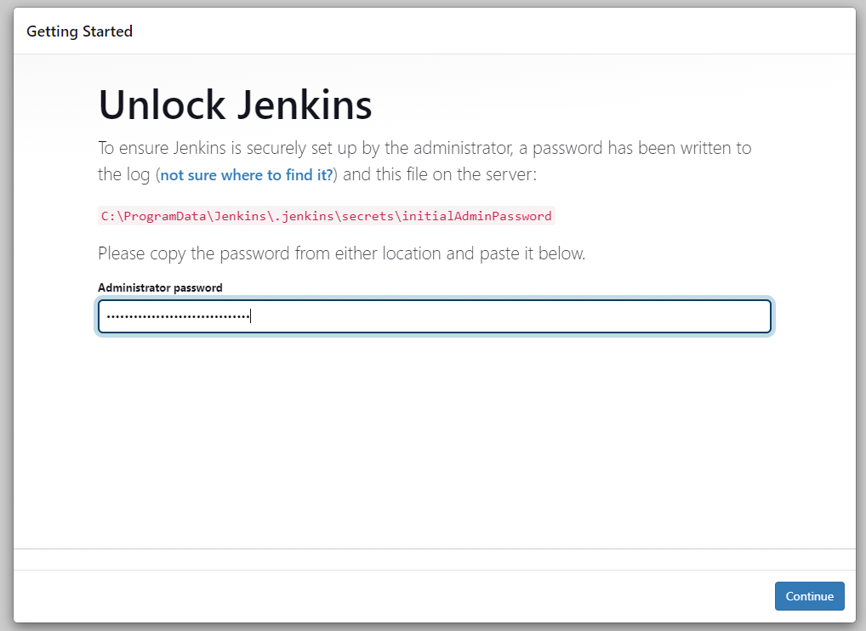

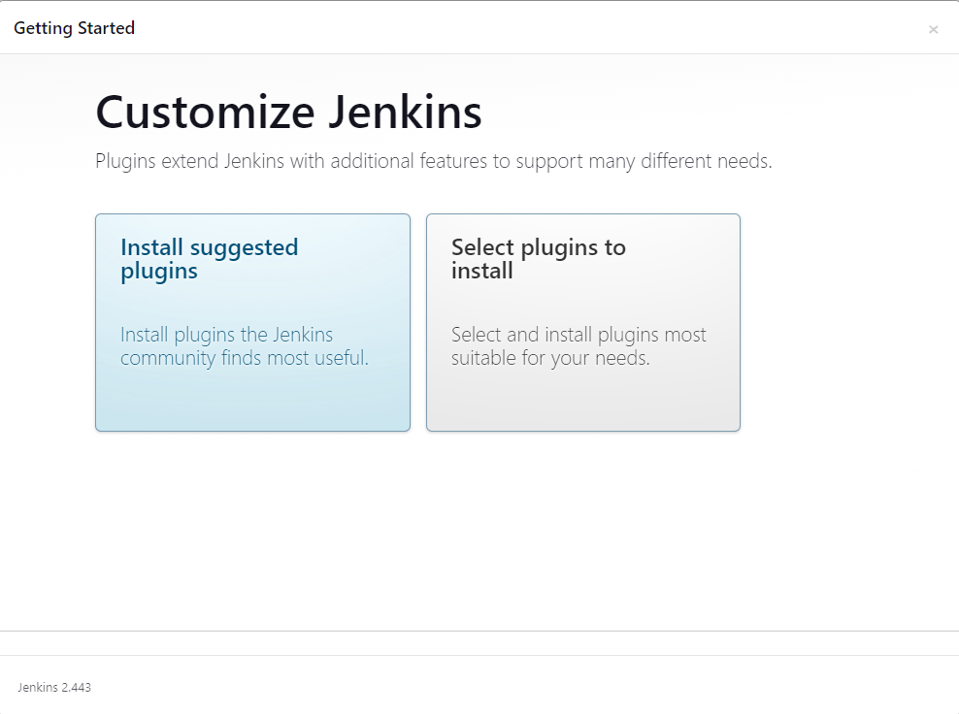

4)-Create Your first admin user

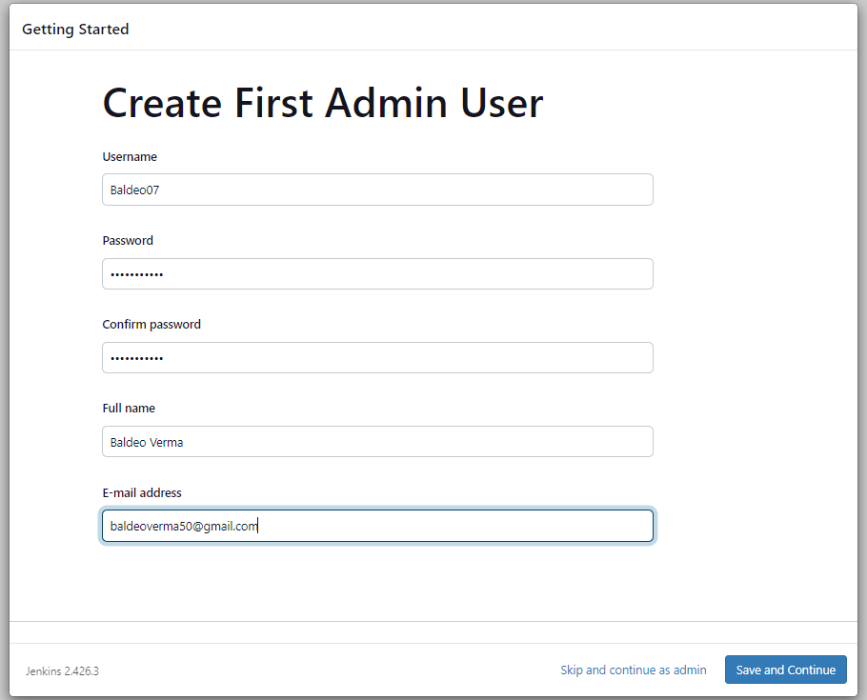

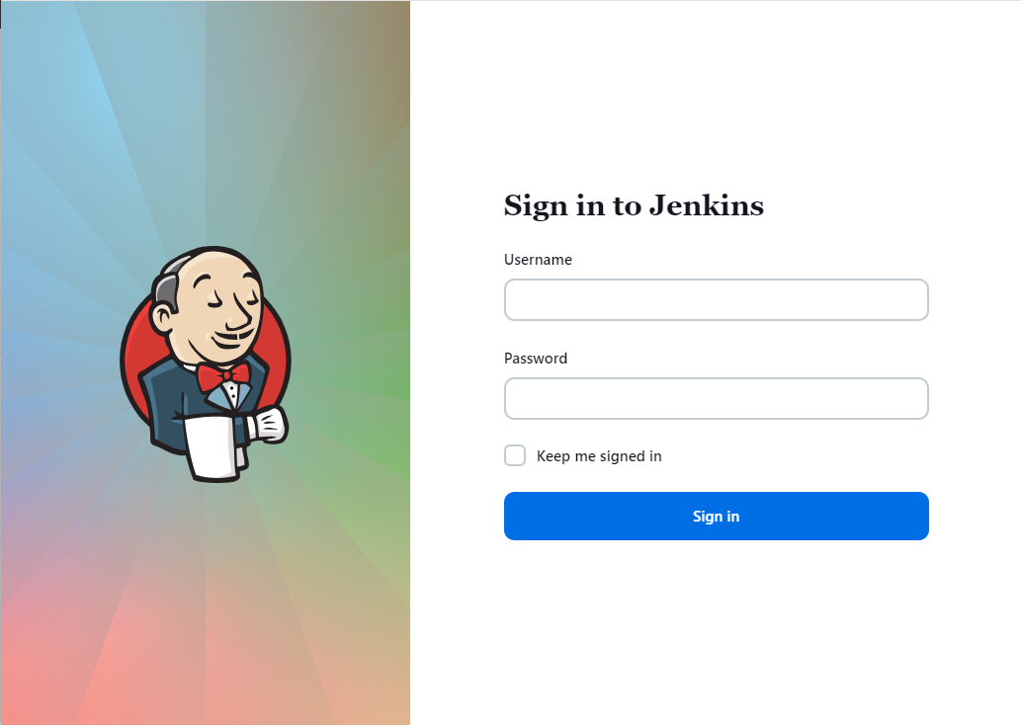

**5)-**Once installation is done, open Jenkins dashboard using <http://localhost:8080> address.

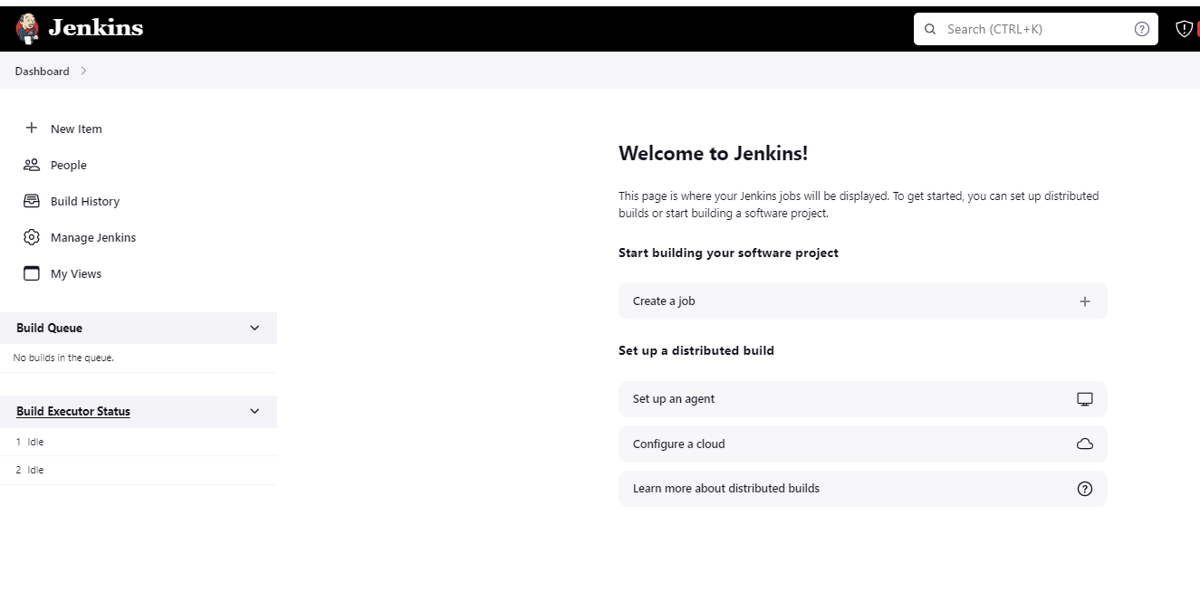

**Conclusion:**We have successfully installed and configured Jenkins with Maven/Ant/Gradle to setup a build Job and learnt about the implementation of Jenkins in open source continuous integration.