Project Name : LabourOnline

***Copy of : Urban Company***

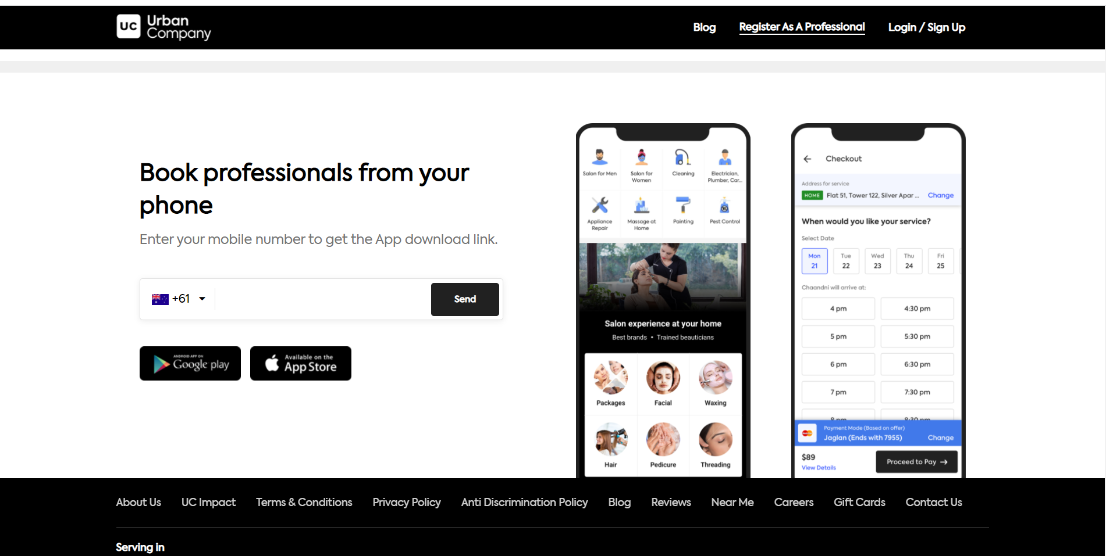

# Overview

Aditi is new to the city of Mumbai. Recently she moved to her new flat, however she faces an issue with her water basin. She couldn‘t find any plumber as she is new to the place and she even didn‘t have any friends. But she called a plumber who fixed the water basin problem by the help of LabourOnline website.

# Goals

1. Login & Sign Up page
2. Signup page
3. Home page
4. Category page
5. Detail Page

## **Technologies used in LabourOnline**

**Front-End:**

1. Html
2. Css
3. Bootstrap
4. Javascript **Dynamic:**
5. Javascript
6. Ci/cd with AWS
7. Login and Logout (oauth and jwt) **Database:**
8. Mongodb
9. Express Js
10. React

**Code compilers:**

1. Visual studio code
2. Git bash
3. Git hub
4. Node js.

**Made By :- Baladev Prakash Ray**