# How to run:

* Windows: run HONVis_NYC_Taxi_Case_Jul_Aug.exe
* Mac and Linux:
  + download the binary executable here (<http://jianxu.net/en/files/Jul_Aug> ) (in the browser save target as file).
  + Then put the binary under code/5_2_HONVis
  + Lastly, navigate to code/5_2_HONVis in Terminal (or your favorite shell)
  + run ./Jul_Aug in Terminal

# Video tutorial of case studies:

Please follow the steps starting from 5th minute in the video at <http://www.higherordernetwork.com/visualization/>

An explanation to HONVis’s control panel from top to bottom:

# Geographic View (upper-left view)

Node Weight: indicates how the nodes in the geographic view should be weighted (#HONodes: the number of corresponding higher-order nodes; Borough: a number based on the corresponding borough).

Prefer Hign Weight: indicates whether the nodes with higher weights or lower weights should be displayed on top of the others. The nodes displayed on top will have the priority to be selected as well. The nodes with lower priority can be selected from the table on the right.

# Dependency View (upper-right view)

Destination Order: indicates how the destinations should be ordered. If "Reduce Occ." (reduce occlusion) is used, the nodes are arrange so that the edges are less likely to occlude each other. If "Node Color" is used, the nodes are ordered according to their colors. For example, if the number of HO-nodes is used to color the nodes, the destination are ordered by their repective number of HO-nodes.

Minimum Probability: filters the edges (and therefore the corresponding nodes) according to their transition probabilities. If the comparison mode is used, the difference between the transition probabilities in the two networks will be used.

Minimum Weight: filters the edges according to the number of transitions in the original data. If the comparison mode is used, the difference between the numbers will be used.

Font Size: changes the font size of the label.

Label Margin: changes the minimum distance between the margins. Smaller value leads to more labels being displayed.

# Subgraph View (lower-left view)

Trace Forward: if checked, this indicates that the tracing will be performed along the edge direction in the network, so that the propagation from a node can be studied; otherwise, we will trace backward to find how to reach the node.

Overlay: if "Overlay" is used, the current nodes being visited will be displayed on top of the HON visualization (the scatter plots); if "Corner" is used, the HON visualization will be moved to corner to reduce occlusion; if "None" is used, the HON visualization will be hidden.

Font Size and Label Margin is the same as the ones in the previous view.

Edge Opacity: adjusts the opacity of edges between the current nodes being visited.

Trace: traces one step forward (or backward) when clicked.

# Aggregation View (lower-right view)

Hide View: indicates whether the aggregation view should be hidden (allowing more space for the dependency view).

Exact Group: if checked, the exact group will be used: for example, red (Brooklyn) to orange (Manhattan) from outer layer to the inner layer contains all HO-nodes from a location in Brooklyn to a location in Manhattan; otherwise, grey color will indicate the previous locations are different from the current location: for example, grey to orange will indicate taxis from outside Manhattan to Manhattan.

Node Group: indicates how the locations should be grouped. In this example, we can only group the locations according to their boroughs.

Node Weight: if "Uniform" is used, every aggregated node will span the same width; if "Number of Nodes" is used, the aggregated nodes will have the width propotional to their respective number of HO-nodes; if "Number of Trips" is used, the width will be determined based on the corresponding taxi trips.

Display In-Group Edges: indicates whether to display edges within the same borough or not. In-group edges are display in blue.

Display Between-Group Edges: indicates whether to display edges between different borough or not. Between-group edges are display in red.

Edge Opacity: adjust the opacity of the edges between the aggregated nodes.

# Demonstrating the basic functions:

Open the new terminal, change directory to the folder containing the software, and run ./Sunday to compare the HONs on all Sundays in 2013.

Select an ordinary day (03-10) in the time slider.

In the aggregation view, we can see that only Manhattan (orange) contains third-order nodes (with three orange layers highlighted in black). This can be more easily observe when the aggregation nodes have uniform weights (right image).

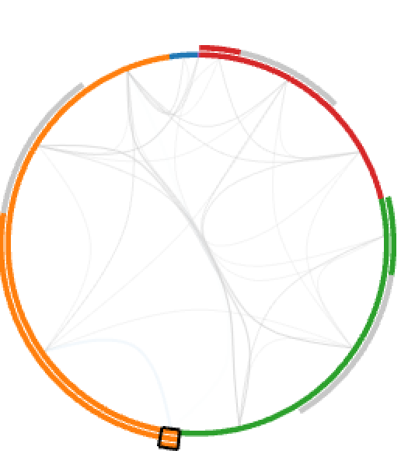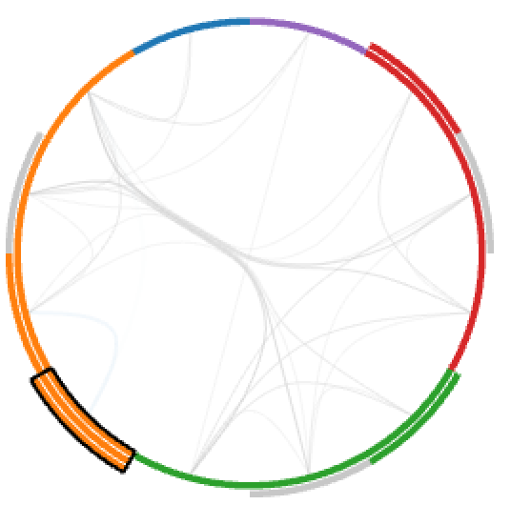

Clicking on the third-order aggregated node in the above images, we can see corresponding nodes in the dependency view.

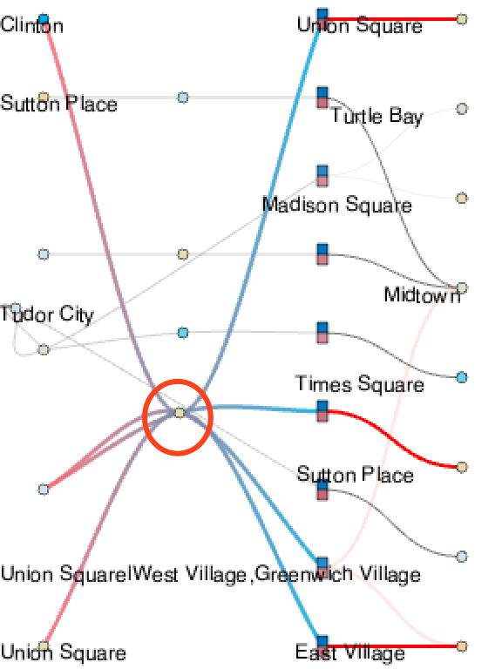

We find that several third-order nodes correspond to the same location (as highlighted in the red circle above). We can click that location to select the corresponding HO-nodes.

Clicking on the “Trace” button three times, we find that it covers most all the locations, and the left part of the HON.

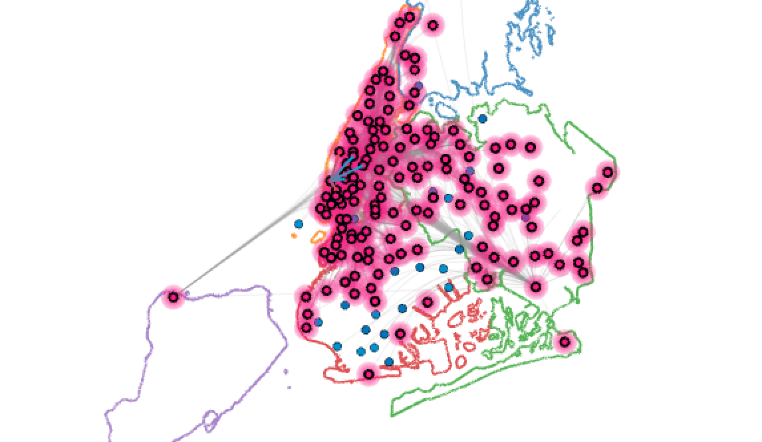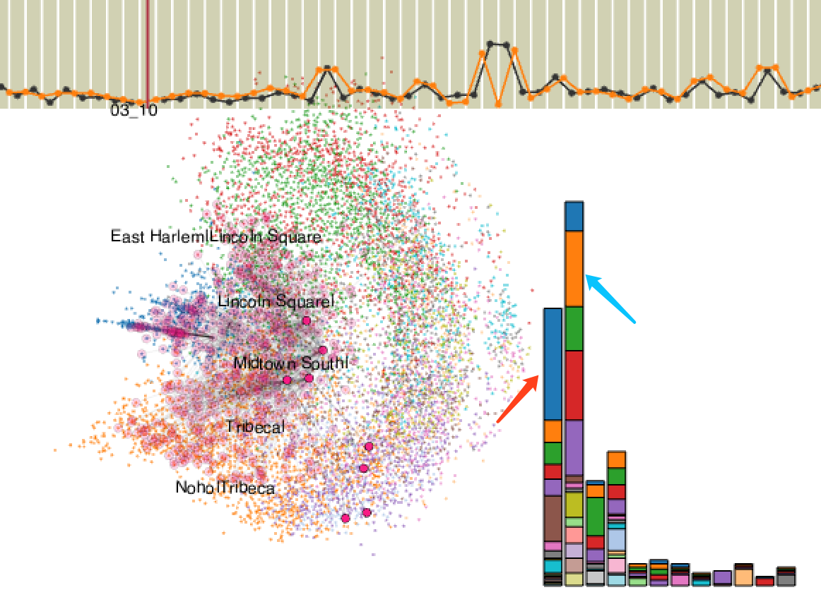

Two communities are largely covered. In the left image below, clicking on the blue bar (pointed by the red arrow) shows that JFK introduce the traffics to the first community, covering most regions in Brookly (red borough) and Queens (green borough). In the right image below, clicking on the orange bar (pointed by the blue arrow) shows that East Village introduce the traffics to the second community, mostly in Brooklyn.