Experiment-5

Ack = nmap – sA -T4 nmap.scanme.nmap.org

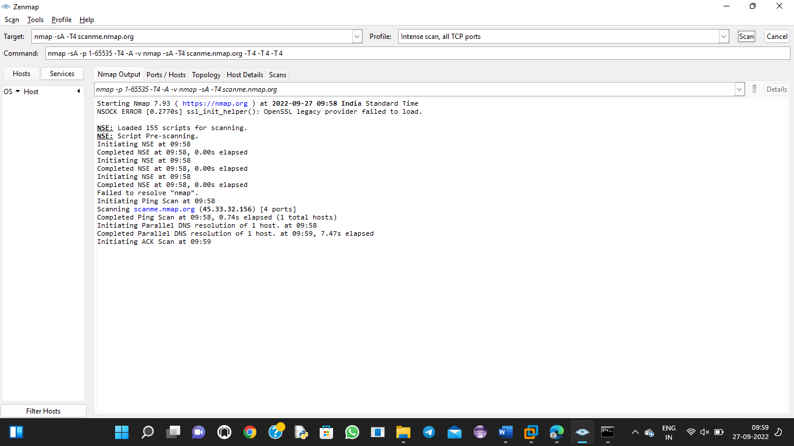

Syn scan= nmap -p22,113,139 scanme.nmap.org

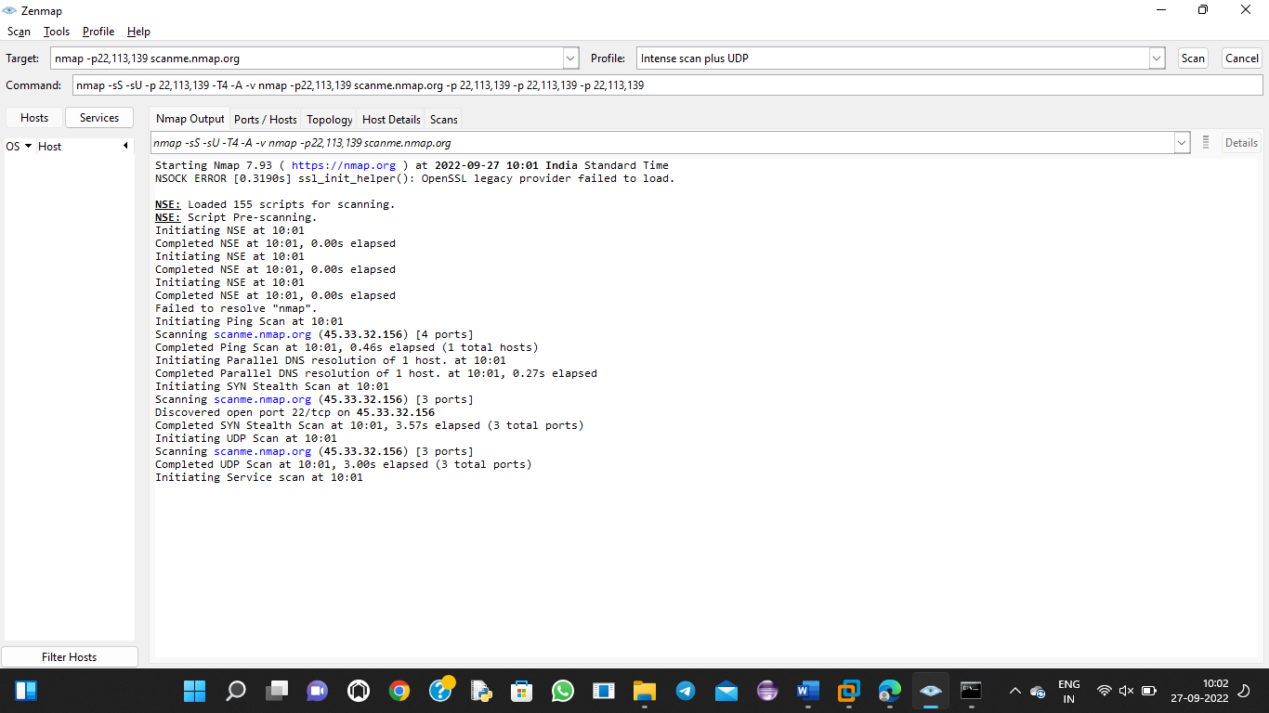

Fin scan -sF = nmap -sF -T4 para

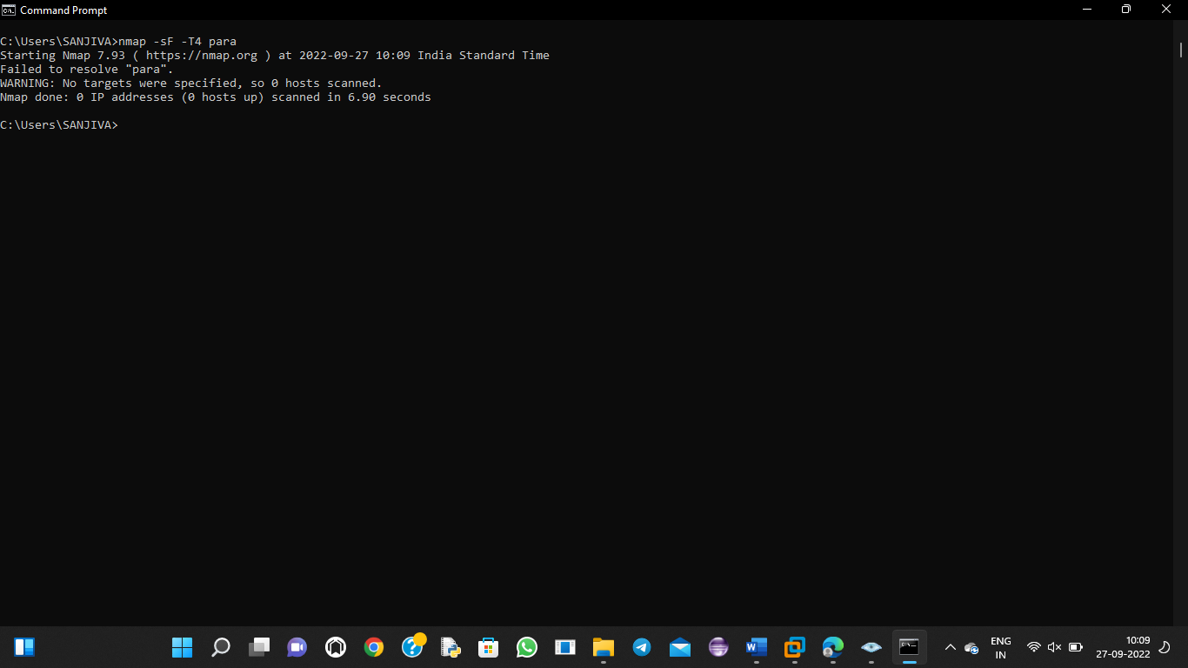

Null scan = nmap -sN -p 22 scanme.org

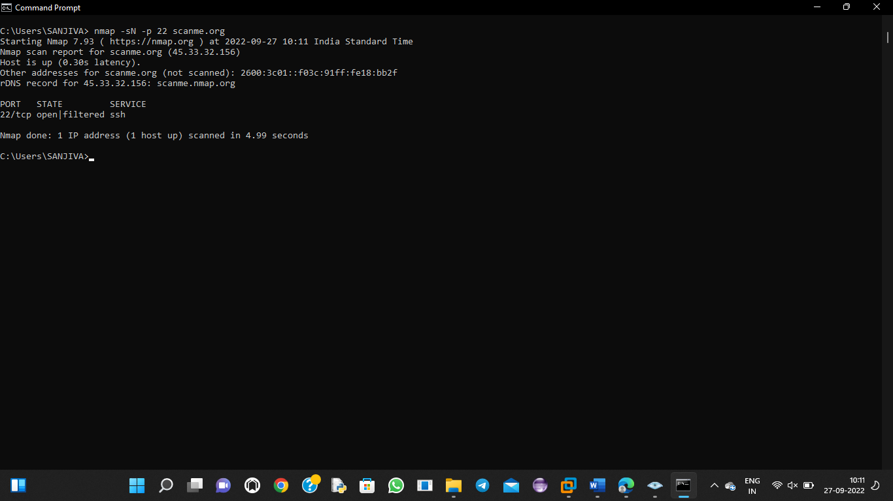

Null scan= nmap -sN -p 22 scanme.nmap.org

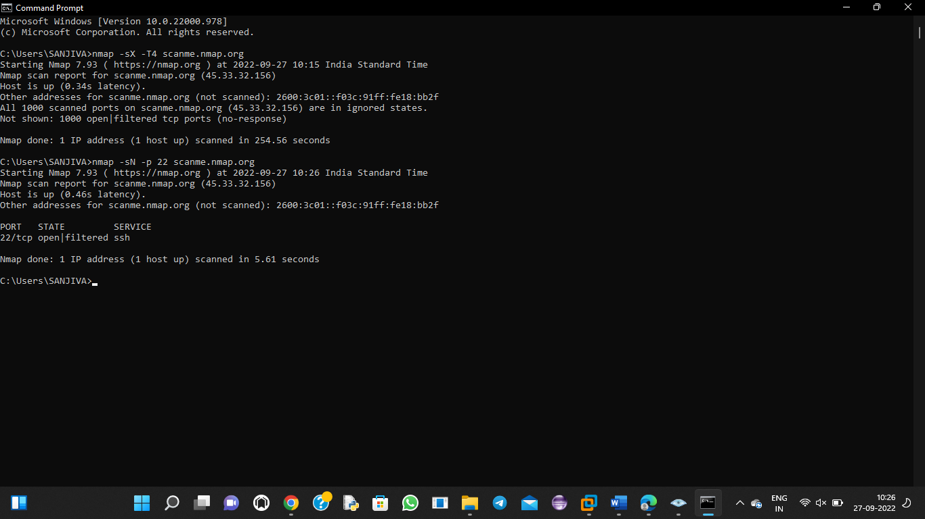

Xmas scan = nmap -sX -T4 scanme.nmap.org

