UniAlert & Found
Campus Safety, Property Recovery & Alert Management System
System Documentation — Features, Roles, Dashboards, Workflows and Requirements

Prepared from the supplied interface designs and design specification.
Version: 1.0 | September 2026

1. System Overview
UniAlert & Found is a university campus safety and property-recovery platform that combines lost-and-found management, student reporting, claim verification, campus alert broadcasting, property custody tracking and operational dashboards in one system.
The supplied design presents the system as an institutional service for students, campus safety teams, property-recovery staff and faculty moderators. Its interface is designed for rapid scanning during normal property-recovery work as well as high-priority campus incidents.
The design specification explicitly describes the product as bridging emergency alert broadcasting with high-volume lost-and-found asset coordination and emphasizes reliability, clarity, verified trust and rapid operational triage.
Source: supplied design specification. fileciteturn0file0L138-L145

2. Purpose and Objectives
- Provide a single university platform for reporting lost and found property.
- Help students search the campus property registry and submit claims.
- Allow found-property reports to be registered, categorized, tagged and placed into custody.
- Support identity and ownership verification before property is handed over.
- Provide moderators and campus safety personnel with operational dashboards.
- Broadcast urgent campus alerts to relevant student and campus audiences.
- Maintain an auditable chain of custody for recovered property.
- Protect sensitive student and item information through controlled disclosure and masked identifiers.
- Provide recovery stations and dispatch points where verified property can be collected.
- Provide statistics and operational indicators for recovery performance, claims and alerts.

3. Users and Roles
Role | Main responsibilities | Main interface / access
Student | Report lost/found items, search the registry, submit claims, view own cases, receive campus alerts, review recovery locations. | Student Dashboard
Faculty Moderator / Property Command | Review reports, verify claims, monitor property custody, manage high-value claims, monitor alerts and broadcast urgent messages. | Admin Console / Moderator Dashboard
Campus Safety / Dispatch | Handle emergency dispatch, recovery operations, custody stations and urgent campus communications. | Admin/operations console; dispatch area
Recovery Station / Custody Staff | Receive, store, verify and hand over recovered property at designated campus hubs. | Recovery/custody workflows
System Administrator (proposed) | Manage users, roles, system configuration, permissions, categories, locations, audit settings and integrations. | System Settings / administrative area

The Student, Faculty Moderator, Campus Safety/Dispatch and Recovery/Custody roles are represented directly or indirectly in the supplied screens. The System Administrator is included as a formal system role because the design contains System Settings and role-based navigation. The supplied screenshots do not show a dedicated System Administrator dashboard, so the administrator dashboard and its management functions are defined here as a required system-management role.

4. Main Dashboards and Interfaces

4.1 Public / Landing Page
- University-branded landing page for the recovery service.
- Primary actions: Report Found Item, Report Lost Item and Find an Item.
- Campus registry search by keywords, category and location.
- High-level service statistics such as total intake, verified match rate, turnaround and data privacy.
- Campus Property Recovery Feed showing recently submitted found items.
- Live Campus Safety Bulletins for active safety and operational notices.
- Explanation of the recovery process: SSO Authentication → Intake & Geo-Tagging → Smart Match Review → Secure Hub Claim.
- Campus Hub Locations and desk hours for property collection.

4.2 Student Dashboard
- Verified student account area with university SSO authentication.
- Student profile information and university identity reference.
- Quick actions: Report Lost Item, Report Found Item and Search Database.
- Summary cards for Lost Items Reported, Found Items Handed In, Active Urgent Alerts and Pending Claims.
- My Active Reports & Claims table showing item, case ID, date and status.
- Campus Bulletins panel showing security, facility and operational notices.
- Recent Campus Found Items feed with Claim Item actions.
- Recovery Stations panel showing available custody/collection points and operating status.
- Property Security Protocol section encouraging registration of device serials and identifiers.

4.3 Faculty Moderator & Property Command Dashboard
- Live telemetry and operational command interface.
- Console navigation for Overview & Triage, Lost Reports, Found Items, Pending Verification and Claim Approvals.
- Campus systems section covering Campus Broadcasts, Faculties & Departments, Recovery Stations, Audit Log & Custody and System Settings.
- Duty Station card showing campus police/dispatch status and SLA information.
- Critical Broadcast panel with delivery count and feed-management actions.
- Operational KPI cards: student registry, total reports, property custody, pending claims, campus advisories and reunification rate.
- Lost-vs-Found volume and recovery trend visualization.
- Intake Hotspot view showing where high volumes of recovery activity are occurring.
- Resolution SLA indicator for average time-to-return.
- High-Value Claim Verification Queue for sensitive/high-tier property.
- Urgent Campus Alert Broadcast workflow with severity selection, message composition, channel selection and authorization.

4.4 Central Registry / Find an Item Interface
- Unified Campus Property Registry & Search.
- Keyword search by item/model/serial/brand.
- Filters for listing status, category, campus zone/facility, date range, sort order and hold location.
- Views for All Records, Found Items and Lost Inquiries.
- Item cards with photo, item category, case/reference ID, time, description, location and action.
- Verification and claim actions for eligible items.
- Privacy indicators such as IMEI encryption and FERPA-redacted student IDs in the supplied design.
- Pagination and missing-item report entry point.
- Privacy and anti-theft protocol explaining verified ownership, legal hold and chain-of-custody concepts.
Backup and data management: coordinate backup, retention, archival and recovery settings where supported.
Reports and system monitoring: access system-wide operational statistics and configuration reports.
System settings: configure global application parameters.
Audit logs: access system-wide administrative and security activity records.
Security settings: manage system access policies and administrative controls.
Notification configuration: manage supported notification channels and delivery settings.
Alert configuration: manage alert types, templates, severity levels, target groups and authorization rules.
Item categories: create and maintain lost/found item categories and classification rules.
Campus locations: manage campus zones, buildings, facilities and recovery stations.
Faculties and departments: maintain university organizational structures used for users, reporting and targeted communication.
Role and permission management: assign and modify Student, Moderator, Safety/Dispatch, Recovery/Custody and administrative permissions.
User and account management: create, activate, deactivate and manage user accounts.
The System Administrator is a formal system-level role responsible for the technical and administrative configuration of UniAlert & Found. This role is separate from the Faculty Moderator role: moderators manage operational cases and claims, while the System Administrator manages users, permissions, configuration and system-wide controls.
4.5 System Administrator Dashboard

5. Core Functional Modules
Module | Description
Authentication & Identity | University SSO, verified student accounts, role-based access, student identity references and controlled access to sensitive records.
Lost Item Reporting | Students submit lost-item information, descriptions, locations, dates and optional identifying characteristics.
Found Item Reporting | Students or staff register found property, upload item information and identify the discovery location.
Property Registry | Central searchable repository of lost, found, claimed, recovered, collected and pending records.
Smart Match / Matching | The interface presents potential matches between reports and found items and allows moderators/students to review them.
Claim Management | Students submit claims while moderators verify ownership before release.
High-Value Claim Verification | Sensitive or high-tier items are routed to a verification queue requiring additional authorization.
Custody & Recovery Stations | Items are assigned to secure desks/hubs and tracked through custody and handover.
Campus Alerts | Authorized personnel create, authorize and distribute urgent, advisory and operational broadcasts.
Campus Bulletins | Students receive current security, facility and operational notices.
Notifications | The design references push notifications, email, hall-display messaging and broadcast feeds.
Audit & Chain of Custody | The system records custody events, verification actions, timestamps and responsible personnel.
Analytics & Reporting | Dashboards show intake, recovery trends, hotspots, claims, SLA and reunification indicators.
Privacy & Data Protection | Sensitive identifiers are masked or redacted in public-facing listings; access is controlled according to role.
Recovery Location Directory | Students can view collection hubs, hours, services and availability.

6. Detailed Feature Catalogue

Student features
- Sign in using university account / SSO.
- Report a lost item.
- Report a found item.
- Search the campus property registry.
- View possible matches.
- Submit or verify a claim.
- View personal reports and claim statuses.
- View recent found items.
- View campus alerts and bulletins.
- Locate recovery stations.
- View property-security guidance and register device identifiers where supported.

Moderator / administrator features
- Review lost and found reports.
- Filter and triage cases.
- Review pending verification.
- Approve/reject claims.
- Manage high-value claim verification.
- Monitor custody and recovery stations.
- View operational trends and intake hotspots.
- Monitor resolution SLA.
- Publish and manage campus broadcasts.
- Authorize urgent broadcasts.
- View audit and custody records.
- Manage system settings and campus structures.

Recovery / custody features
- Receive recovered property.
- Assign custody location.
- Record handover events.
- Verify claimant identity/ownership.
- Maintain item hold information.
- Complete secure release or collection.
- Track custody duration and overdue items.

Alert features
- Create advisory, urgent or lockdown/emergency messages.
- Target campus recipients.
- Select broadcast channels.
- Preview alert content.
- Require authorization before transmission where configured.
- Track delivery counts and active feeds.
- Display persistent alerts during active incidents.

7. Key Business Workflows

7.1 Lost Item Workflow
- Student authenticates using university credentials.
- Student selects Report Lost Item.
- Student enters item details, category, last known location/time and identifying information.
- System creates a lost-item case/reference ID.
- System searches existing found-property records for potential matches.
- Potential matches are shown to the student and/or routed for moderator review.
- If a match is verified, the claim proceeds to ownership verification.
- Approved property is assigned to a recovery station or collection point.
- Student collects the item after required verification.
- System records the final handover and closes/reunifies the case.

7.2 Found Item Workflow
- User selects Report Found Item.
- Item details and discovery location are recorded.
- The item receives a case/reference ID.
- The item is taken to an approved recovery/custody station where applicable.
- Custody information is recorded.
- The system attempts to identify potential lost-item matches.
- Potential claimants are notified or the case is surfaced in the appropriate dashboard.
- Ownership is verified before release.
- The handover is recorded and the item status becomes recovered/collected/reunified.

7.3 Claim Verification Workflow
- Student selects a candidate item and starts a claim.
- System checks the claimant's authenticated student account.
- Moderator reviews ownership evidence and item-specific details.
- High-value or sensitive items enter the High-Value Claim Verification Queue.
- Authorized staff approve or reject the claim.
- Approved claimant receives collection instructions.
- Recovery station verifies identity and custody record.
- Property is handed over and the system records the final custody event.

7.4 Emergency / Campus Alert Workflow
- Authorized staff open the urgent Campus Alert Broadcast module.
- Select severity and predefined or custom template.
- Enter alert headline and message.
- Select target campus population/area.
- Select enabled channels such as push, email, campus display and alert feed.
- Authorized officer reviews and transmits the alert.
- System records authorization and delivery information.
- Active alert remains visible until acknowledged, expired or withdrawn according to configured rules.

8. Suggested Case and Item Status Model
Status | Meaning | Typical next action
Lost | A property-loss report has been submitted. | Search/match against found items.
Found | A property item has been registered as found. | Store, tag and match.
Possible Match | System or moderator has identified a candidate relationship. | Review evidence.
Pending Review | A report or claim requires moderator action. | Verify and decide.
Claim Pending | A student has initiated a claim. | Verify claimant/ownership.
Approved | Claim has passed required verification. | Schedule collection/release.
In Custody | Item is physically held by an approved recovery station. | Maintain custody until release.
Collected | Claimant has physically received the item. | Close custody record.
Recovered / Reunified | The lost property has been successfully returned. | Archive/retain audit record.
Rejected / Disputed | Claim or report was not accepted. | Record reason and allow review where applicable.

9. Core Data Entities
Entity | Important fields / relationships
User / Student | User ID, university email/SSO ID, student number, department/faculty, role, account status.
Lost Report | Case ID, reporter, item, date/time, last-known location, description, status.
Found Item | Reference ID, finder, item details, discovery location, date/time, custody location, status.
Item | Category, brand, model, serial/asset identifier, description, photo(s), security identifiers.
Claim | Claim ID, claimant, item, evidence, verification status, moderator, decision, timestamps.
Custody Record | Item, station, staff member, received time, movement history, handover time, final disposition.
Recovery Station | Station name, location, operating hours, services, current status, responsible staff.
Campus Alert | Alert ID, severity, headline, message, target audience/area, channels, author, authorizer, delivery status, timestamps.
Campus Bulletin | Bulletin ID, category, message, target audience, publication/expiry dates.
Faculty / Department | Faculty/department identifiers used for student organization and targeted communication.
Location / Campus Zone | Campus, building, room/zone, facility type and geographic reference.
Audit Log | Actor, action, entity, timestamp, before/after values where applicable, authorization reference.

10. Security, Privacy and Trust Controls
- University SSO should be the primary authentication method for students.
- Role-based access should restrict administrative, moderation, custody and broadcast actions.
- Sensitive identifiers should not be exposed in public listings.
- The design includes privacy indicators such as IMEI encryption and redacted student IDs.
- High-value claims should require additional verification before physical handover.
- Every custody transfer should create an auditable event with actor and timestamp.
- Broadcast authorization should be separated from ordinary student actions.
- Emergency alert actions should be highly visible and protected from accidental activation.
- Public search results should reveal only information necessary to identify an item while preventing unnecessary disclosure.
- Retention, deletion, legal hold and incident-review policies should be configurable by the university.
The supplied design explicitly labels the interface as FERPA-compliant and includes a privacy/anti-theft protocol. For a real deployment, the university should separately confirm the applicable local legal and institutional privacy requirements rather than treating the UI label as legal certification.

11. Notification and Communication Channels
Channel | Use
In-app notification | Case updates, possible matches, claim decisions and operational messages.
Push notification | Urgent and time-sensitive campus messages.
Email | Campus advisories, claim updates and broadcast delivery.
Campus display / hall display | High-visibility campus emergency or operational notices.
Campus alert feed | Persistent active alerts visible across the portal.
Dispatch / police communication | Operational coordination for safety and recovery response.

12. Reports and Analytics
- Number of lost reports.
- Number of found items.
- Pending verification count.
- Pending and approved claims.
- Items currently in custody.
- Reunification / recovery rate.
- Average time to return / resolution SLA.
- Recovery intake by campus location.
- Lost-versus-found trends by week or other configured period.
- High-value claim queue.
- Active campus alerts and delivery counts.
- Recovery station workload and item volumes.
- Custody aging and overdue items.
- Audit trail of moderation, authorization and handover activity.

13. Non-Functional Requirements
Area | Requirement
Usability | Interfaces should support rapid scanning, clear status badges, obvious primary actions and responsive layouts.
Performance | Search, filtering and case dashboards should respond quickly enough for operational use.
Availability | Alert and recovery services should be highly available, especially during active incidents.
Security | Use authenticated sessions, RBAC, secure password/SSO handling, encrypted transport and secure storage.
Privacy | Minimize public exposure of student identifiers and sensitive item information.
Auditability | Administrative, claim, custody and broadcast actions should be logged.
Scalability | The registry should support growing item, student, alert and custody volumes across campus.
Accessibility | Controls, labels, alerts and status indicators should remain understandable for users with accessibility needs.
Responsiveness | The design specifies desktop, tablet and mobile layouts.
Maintainability | Use modular services/components so reporting, alerts, registry and custody workflows can evolve independently.

14. Interface and Design Standards
The supplied design specification defines a modern corporate / civic utility visual language, with a 12-column responsive layout and strong visual hierarchy for high-stress operational work.
- Primary visual identity: deep academic navy.
- Secondary interaction color: slate blue.
- Success/recovery state: emerald teal.
- Urgent/broadcast states: crimson and amber/coral.
- Typography: Inter.
- Desktop: fixed role-based sidebar with a fluid 12-column stage.
- Tablet: collapsible icon rail or administrative app bar.
- Mobile: single-column layout with bottom navigation.
- Cards use rounded containers, low-contrast borders and subtle shadows.
- Status indicators use pill-shaped badges with semantic colors.
- Emergency broadcasts use a strong red visual treatment and prominent acknowledgement/action controls.
The design specification provides the detailed color, typography, spacing, elevation and component rules. fileciteturn0file0L147-L219

15. Proposed System Navigation
Navigation item | Who uses it | Purpose
Landing / Home | All users | Service overview, search and key campus information.
Find an Item | Students, staff | Search property registry.
Report Lost | Students | Create a lost-property case.
Report Found | Students, staff | Register found property.
Campus Alerts | All users | Read active and archived campus notices.
Student Dashboard | Students | Manage personal reports, claims and alerts.
Admin Console | Moderators / administrators | Manage cases, claims, custody and alerts.
Recovery Stations | Students, custody staff | Locate and manage collection hubs.
Audit & Custody | Authorized staff | Review custody history and audit events.
System Settings | Administrators | Manage configuration, roles and system parameters.

The System Administrator should have a dedicated system-management navigation area in addition to the operational Admin Console.

16. Suggested Technical Architecture
The screenshots and design file define the interface and workflows but do not specify a final software stack. The following is therefore an implementation recommendation, not a source-stated requirement.
- Frontend: responsive web application for student and administrative interfaces.
- Backend API: REST or equivalent service layer for users, items, reports, claims, custody, alerts and analytics.
- Database: relational database for users, cases, items, claims, custody and audit records.
- Authentication: university SSO / OAuth2 or SAML integration.
- File storage: secure object storage for item photographs and approved attachments.
- Notification service: email, push and campus-display integrations.
- Search: indexed database search; optionally add a dedicated search engine as volume increases.
- Audit service: append-only or protected audit records for sensitive actions.
- Analytics: reporting queries/materialized views for dashboard KPIs.
- Deployment: university-managed server or approved cloud environment with backups, monitoring and disaster recovery.

17. Role-Permission Matrix
Function | Student | Moderator | Safety/Dispatch | Custody Staff | System Admin
Search registry | ✓ | ✓ | ✓ | ✓ | ✓
Report lost/found | ✓ | ✓ | ✓ | ✓ | ✓
View own reports | ✓ | — | — | — | ✓
Review all reports | — | ✓ | ✓ | ✓ | ✓
Approve claims | — | ✓ | ✓* | ✓* | ✓
Manage custody | — | ✓ | ✓ | ✓ | ✓
Send emergency broadcast | — | ✓* | ✓ | — | ✓
Authorize broadcast | — | ✓* | ✓ | — | ✓
View audit logs | Limited | ✓ | ✓ | Relevant | ✓
Manage system settings | — | Limited | — | — | ✓

*Exact authority should be configurable by university policy. The supplied interface shows authorization controls for urgent broadcasts and moderator oversight of high-value claims.
For high-impact actions such as emergency broadcasting, the system should support configurable authorization so that the person who prepares an alert is not necessarily the only person who can authorize its transmission.
Student: manages only their own reports, claims and personal interactions with the recovery service.
Recovery/Custody Staff: manages physical intake, custody, station storage and handover.
Campus Safety/Dispatch: manages safety incidents, dispatch operations and authorized emergency broadcasts.
Faculty Moderator: manages reports, matching, claim verification, high-value claim queues and property-recovery operations.
System Administrator: manages configuration, accounts, roles, permissions, categories, locations, stations, system security and audit access.
The System Administrator has system-wide authority but should not automatically receive authority over every operational decision. The implementation should use least-privilege permissions so that technical administration, claim verification, custody operations and emergency dispatch can be separated.
18. System Administrator Responsibilities and Boundaries

18. High-Level Acceptance Criteria
- A verified student can sign in and access the student dashboard.
- A student can submit a lost or found item report and receive a case/reference ID.
- A user can search and filter the central property registry.
- Potential item matches can be surfaced for review.
- A moderator can approve/reject claims and the decision is auditable.
- Recovered items can be assigned to a custody/recovery station.
- A custody handover can be recorded with time and responsible actor.
- Authorized staff can publish campus alerts with severity, target and delivery channels.
- Active alerts are clearly visible across relevant interfaces.
- Administrative dashboards show operational counts and trends.
- Sensitive identifiers are masked or restricted according to role.
- The system maintains an audit trail for sensitive administrative, claim and custody actions.

19. Recommended Future Enhancements
- Barcode/QR code labels for recovery-station intake and handover.
- Mobile camera workflow for rapid item registration.
- Advanced similarity matching using image and text features, with human review before final decisions.
- SMS integration for users who have limited access to app notifications.
- Multi-campus support with campus-specific administrators.
- Configurable escalation rules for unclaimed high-value property.
- Automated reminder notifications for pending claims and expiring holds.
- Detailed role and permission management.
- Data export for university reporting and audit.
- Offline-friendly intake mode for recovery stations with unreliable connectivity.
- Integration with campus police/dispatch systems and university student information systems.

20. Scope Notes and Assumptions
- This final documentation is based on the supplied UniAlert & Found interface designs and DESIGN.md specification. It incorporates the System Administrator as a formal role and separates technical system administration from operational moderation and campus safety duties.
- The screenshots demonstrate the intended experience but do not expose the complete backend data model or implementation.
- Where a role or technical component is marked 'proposed', it is a recommended implementation detail rather than something explicitly shown in the supplied design.
- The displayed statistics in the screenshots should be treated as sample/demo data unless connected to a live database.
- Regulatory/compliance labels shown in the design should be validated against the university's actual legal and institutional requirements before production deployment.

21. Summary
UniAlert & Found is structured as two closely connected systems: (1) a campus property-recovery platform for lost/found reports, matching, claims, custody and reunification; and (2) a campus-safety communication layer for bulletins and urgent broadcasts. The student dashboard focuses on reporting, searching, claims and alerts, while the moderator/property-command dashboard focuses on triage, verification, custody, analytics and broadcast control. The central registry connects these workflows by providing a searchable record of campus property.
The strongest implementation principle visible throughout the supplied design is controlled trust: authenticate the user, minimize sensitive disclosure, verify ownership, record custody events, and require appropriate authorization for high-impact actions.

Appendix A — Supplied Interface Screens
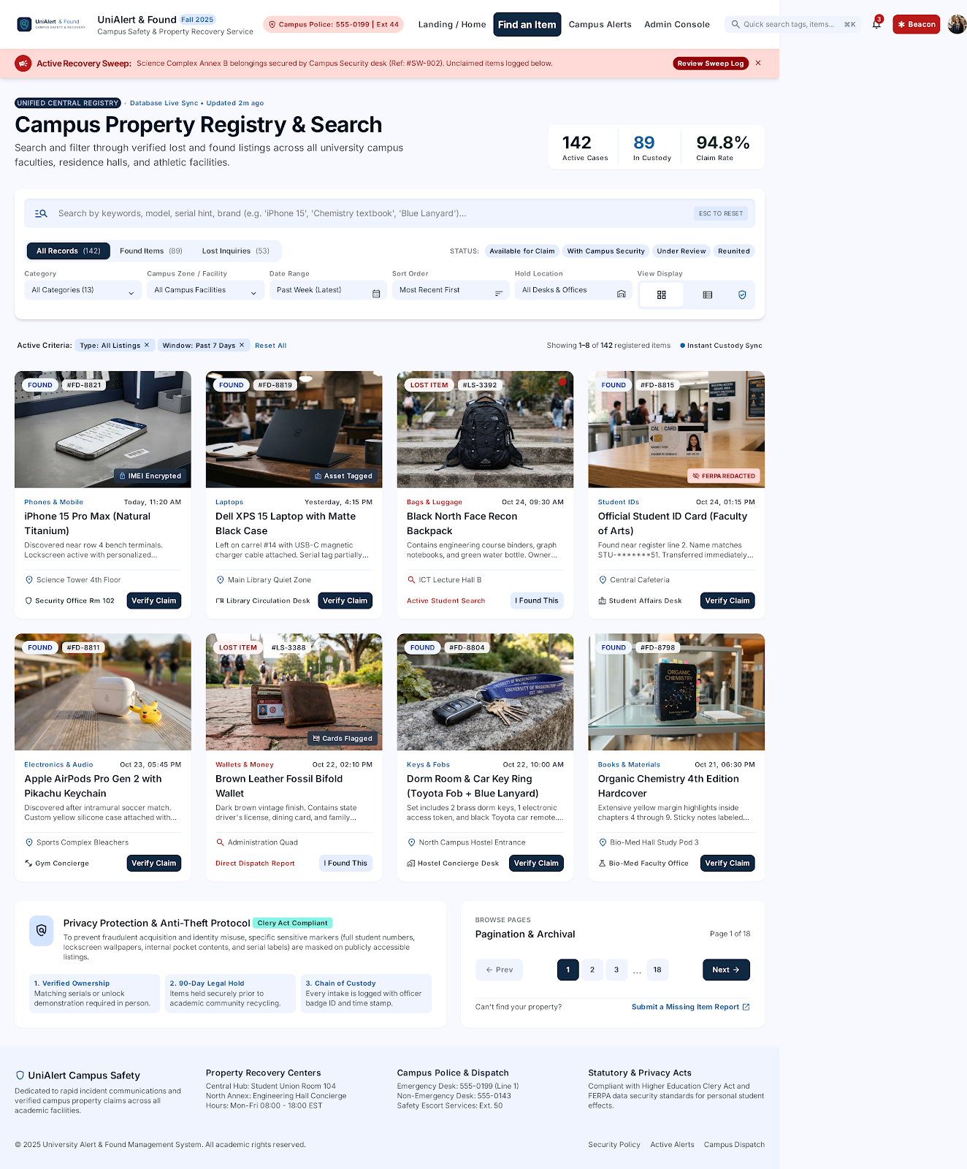
Central Campus Property Registry & Search
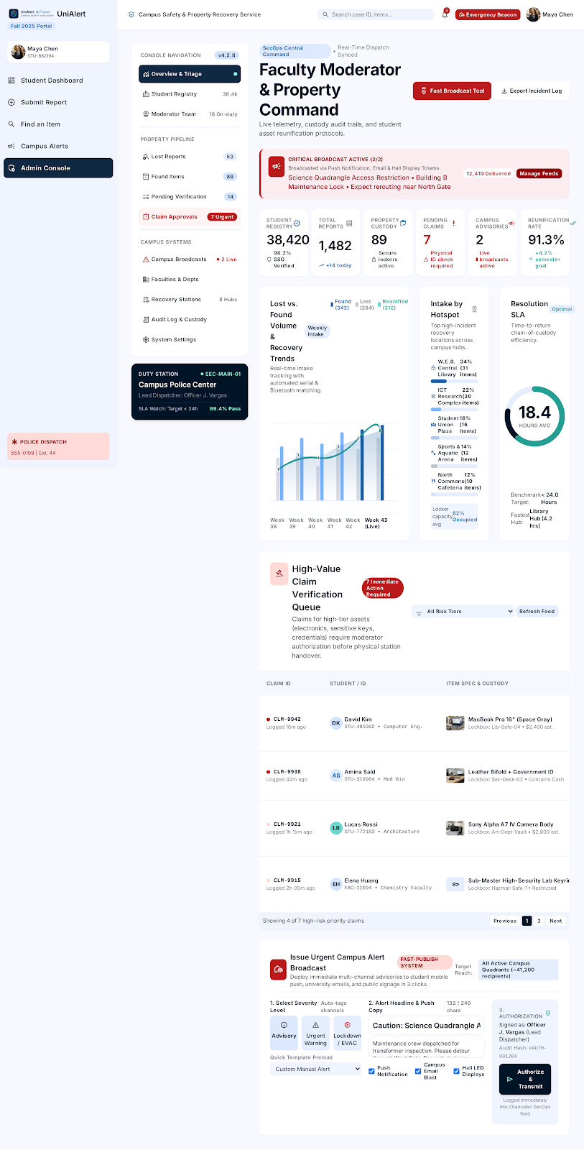
Faculty Moderator & Property Command Dashboard
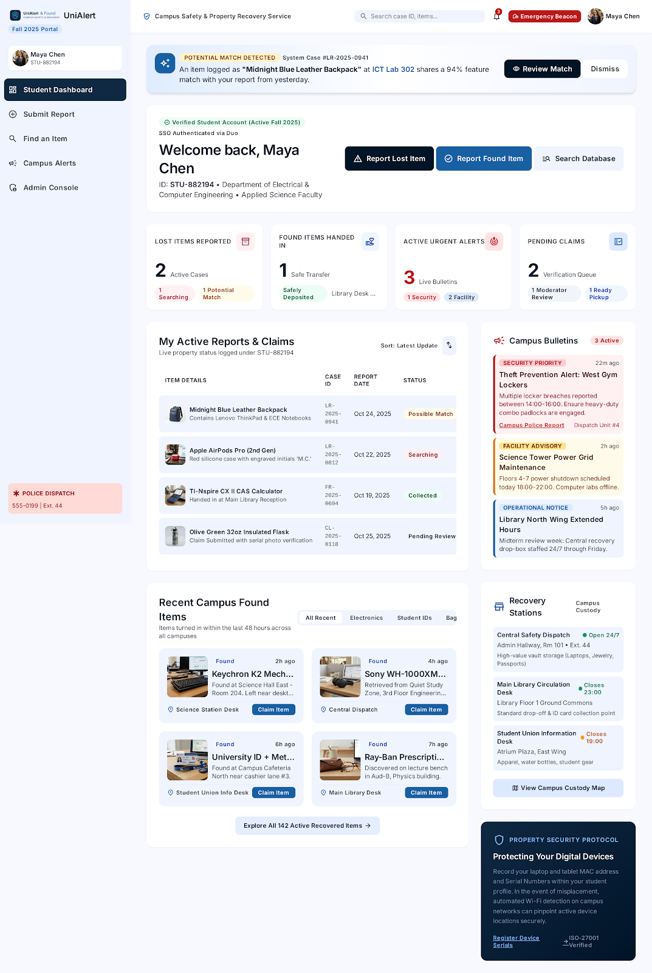
Student Dashboard
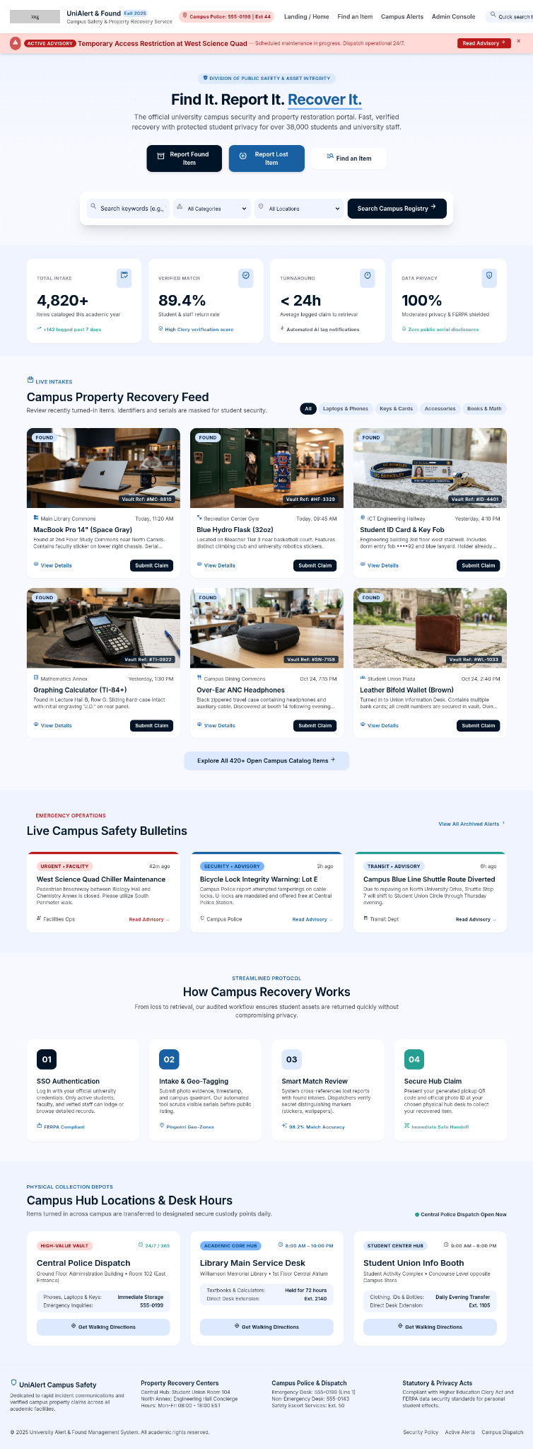
UniAlert Public / Landing Page

Appendix B — Final Role Structure
Role | Primary responsibility | Dashboard / interface
Student | Report/search property, submit claims and receive alerts. | Student Dashboard
Faculty Moderator | Review reports, verify matches and claims, and monitor recovery operations. | Faculty Moderator & Property Command
Campus Safety / Dispatch | Manage emergency operations, dispatch and authorized safety broadcasts. | Property Command / Dispatch
Recovery / Custody Staff | Receive, store, verify and hand over recovered property. | Recovery / Custody workflows
System Administrator | Manage users, roles, permissions, configuration, locations, categories, security and audit settings. | System Administration Dashboard
Final role-design principle: operational users manage campus cases and safety activities, while the System Administrator manages the platform itself. Permissions should follow least privilege and all sensitive administrative actions should be auditable.

