**ARTIFICIAL INTELLIGENCE**



**School of Computer science engineering**

**Subject code**- INT- 404

**Project name** – Wishlist Price Comparision

**Submitted to** -Ishatpreet Kaur

Submitted by

|  |  |  |  |
| --- | --- | --- | --- |
| **Reg.no** | **Roll no.** | **Name** | **Marks** |
| 11808862 | K18FRB65 | SWAYAMBHOO CHAUHAN |  |
| 11814266 | K18FRB66 | VEEKENDRA PATEL |  |
| 11805490 | K18FRB67 | VIKAS ARJA |  |
| 11805974 | K18FRB68 | BALJEET CHAUDHARY |  |

INTRODUCTION: -

Price comparison websites are becoming more popular since Ecommerce revolution. The data and values provide by the price comparison sites helps consumers to save money while shopping online. The ability to check the price of products brings convenience and saves a lot of time. Price comparison is done when the price of the same product is compared in different outlets. There are many online shopping sites which are being used to shop various products online. A particular product has different prices on every different shopping site. We need to check manually the price of the product on every site, which causes inconvenience and consumes a lot of time. There are many price comparison sites which provide products comparison, but there is no site which compares the price of wish list products. Hence, we have proposed a project named Wish list Products Price comparison website which compares the prices of only interested products which user intents to buy. This price comparison website for wish list products will help to compare the price from various e-commerce websites. This system has an advance feature of sending notification when the price changes of a particular product which has been added in the wish list. This Price comparison site is extremely helpful for frequent online shoppers to check prices on different online stores in one place. This system will show you the product prices from different retailers to show you where to buy the product at affordable price. Whenever the price of the product changes it sends notification to the user.

**OBJECTIVES: -**

The data and values provide by the price comparison sites helps consumers to save money while shopping online .

The ability to check the price of products brings convenience and saves a lot of time .

Price comparision is done when the price of the same product is compared in different outlets.

This price comparison website for wish list products will help to compare the price from various e-commerce websites.

**PRICE COMPARISION TOOL**

Price comparison tool help us to track the price of product across different sources thus helping you to keep informed how’s your competitor is doing. It can help a business to know when the price of certain product goes up or down than your own target price.

**DEVELOPMENT OF PRICE COMPARISON TOOL**

The tool is written in python and we are going to use JSON library to parse JSON and further processing the tool will be printing the product name and price of the site providing the most lucrative offer

**Code(Snippet)**

import requests

import json

import csv

import matplotlib.pyplot as plt

import pandas

from bs4 import BeautifulSoup

URLlist = [‘https://www.priceme.com.my/Samsung-Galaxy-S10-SM-G973F-8GB-128GB/p-903473115.aspx’, ‘https://www.priceme.com.my/iPhone-11-Pro-64GB/p-904566323.aspx’, ‘https://www.priceme.com.my/Huawei-P30-Pro-256GB/p-903485037.aspx’]

#get the total number of URL

lenURL = len(URLlist)

#create an array with size of total number of URL to store the title

Title = [‘’]*lenURL

#open exel file with writing mode

file_result = open(‘Price Comparison.csv’, ‘w’ , encoding= ‘UTF-8’ )

# get data in targeted website (title ,store ,price)

for i in range (lenURL):

resp= requests.get(URLlist[i])

soup = BeautifulSoup(resp.content, ‘lxml’)

table_title = soup.find(‘div’,{‘class’ : ‘pHead’})

title = table _title.find(‘h1’).text.strip()

table_info = soup.find(‘div’,{‘class’ : ‘rpContent’})

#title store here for future purpose

Print(title)

titles[i] = title

For data in table_info.findA11(‘div’,{‘class’ : ‘pricesDiv’}):

price = data.find(‘span’,{‘class’ : ‘priceSpan’}).text.strip()

store =data.find(‘amp-img’, {‘width’ : ‘90’})

file_result.write(title + ‘,’ + store[“alt”] + ‘,’ + price.replace (‘,’ ‘’) + ‘\n’)

file_result.close()

#plot bar graph

column = [‘title’, ‘store’, ‘price’]

dataset = pandas.read_csv(‘Price Comparison.csv’,names=column)

length = len(dataset.title.unique())

color=iter([‘orange’ , ‘blue’ , ‘purple’])

for i in range (length):

arr = dataset.loc[dataset.title == dataset.title.unique()[i]]

print (‘Item title :’ + arr.title.unique())

print(‘Lowest price :’ + str(min(arr.price)) + ‘at :’ + arr.loc[arr.price==arr.price.min()].store.values)

print()

plt.figure(figsize=(12,5))

plt.barh(arr.store, arr.price, color = next(colors))

plt.xlim(xmin = arr.price.min()-arr.price.min()%1000-1000)

plt.suptitle(dataset.title.unique()[i])

plt.show()

**APPLICATIONS:**

* + **User Login**: User can login in using credentials.
  + **Search Product**: User can search for the respective product for comparison. It will also auto correct the spelling mistake.
  + **Price Compared**: User will get the price fetch from different e-com websites for comparison.
  + **Add Wish list**: User can add products to wish list.
  + **View/ Notify Changes**: User can see the price changes in products added in wish list, and also user will get SMS and Email notification.
  + This system can be used by the multiple peoples to get the counselling sessions online.

**Test Cases**

1-:Verify that user is able to navigate through all the products across different categories

2-: Verify that the company logo is clearly visible

3-:verify that all the text product, category name,price and product description are clearly visible

4-:verify that correct count of total product are listed on the category pages

**Flow chart**

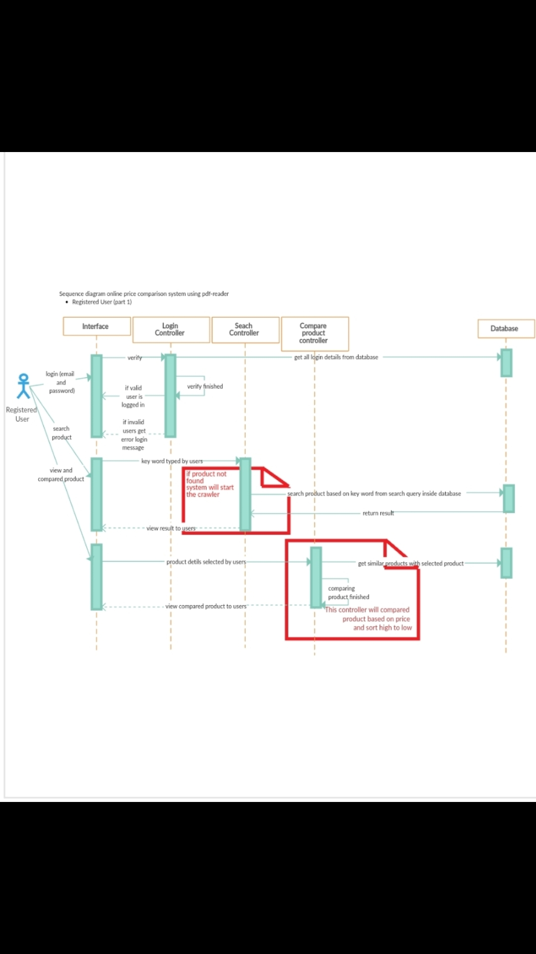

**WORK DIVISION: -**

The implementation of this AI project is in python and work division is as: -

Roll.no -65: - Functional requirement and Methodology will be done by SWAYAMBHOO CHAUHAN

Roll.no -66: - Project Report generation and Project management will be done by VEEKENDRA PATEL

Roll.no-68: - Code implementation will be done by BALJEET CHAUDHARY in python.

Roll.no-67: - Testing and test cases will be done by VIKAS ARJA

**GENTT CHART WITH MILESTONES: -**

**Gentt-Chart:-**

**Milestone-Chart:-**

In this milestone chart the colour are as follows:-

Blue colour indicates that task is completed. The orange colour indicates that task is pending.

**THANK YOU**