SVN(SubVersion) VisualSVN Server Setup installation in Windows

Installation of VisualSVN Server on Windows

Step1: Now We are downloading VisualSVN server 5.1.1(64 bits) After download Run the installer File and Click Next. <https://www.visualsvn.com/server/download/>

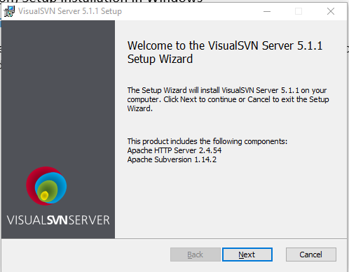

Step 2: After Select License Now Select Component. We select VisualSVN Server and Administration Tools and click Next

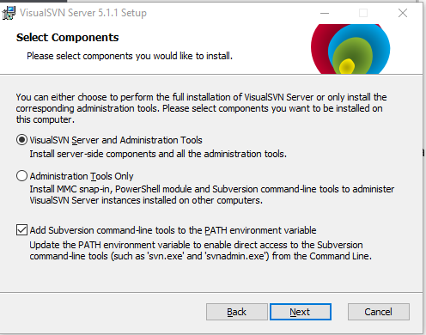

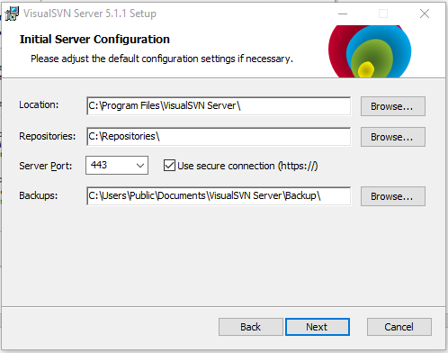

Step 3: Now Select the Use of Subversion Authentication and click next

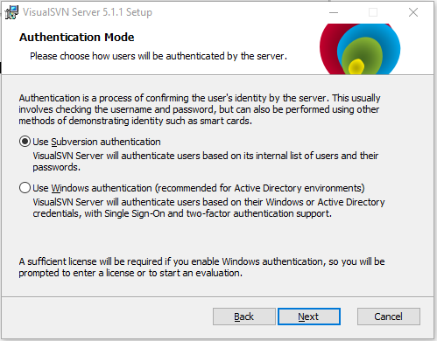

Step 4: See the VisualSVN Server 5.1.1 for Windows

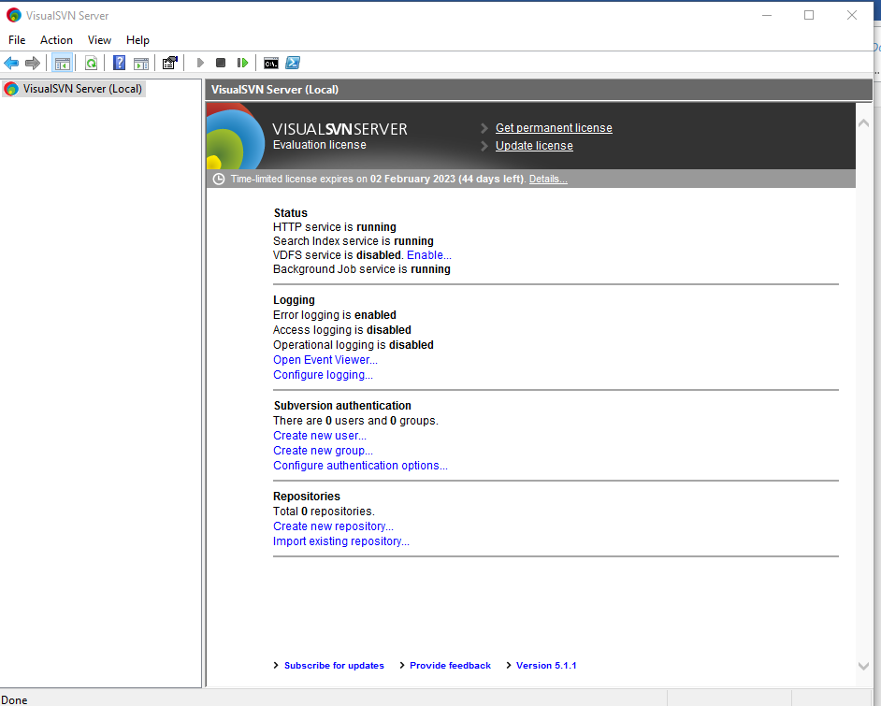

SVN(SubVersion) TortoiseSVN(SVN Client) Setup installation in Windows

Tortoise SVN is popular SVN Client used to communicate SVN Server.

There three Control Software for Windows <https://tortoisesvn.net/downloads.html>

* revision Control
* version Control
* source Control

Now Start Client SVN installation Process

Step1: Install TortoiseSVN 1.14.5 and Click Next

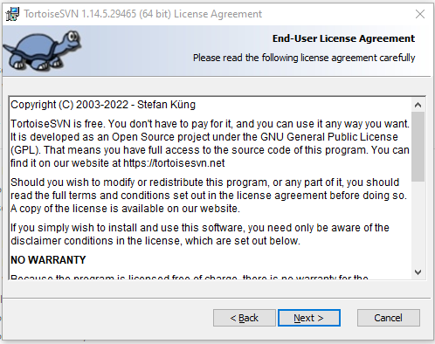

step 2: Next Step to Pick and Installation the Location and features. Pick Location and Select Feature You want to install. and then click Next

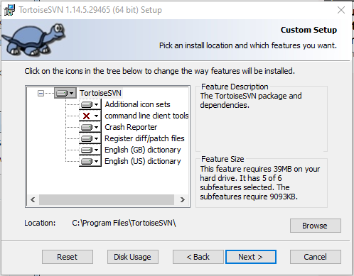

Step 3: The Tortoise setup is Complete Now click finish.

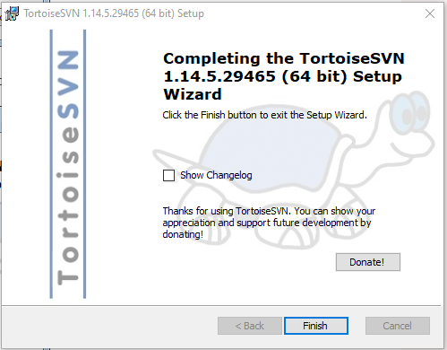

**VisualSVN Users and Access Permission**

* It Allow You to set access to Selected Users.
* We can create Users Whom We want to give access to SVN Server.
* We can set Accessibility for every User.

Now Start to create User

Step 1: Right-Click on **User** option and After that **Create user**.

Provide Username and Password to make New Users

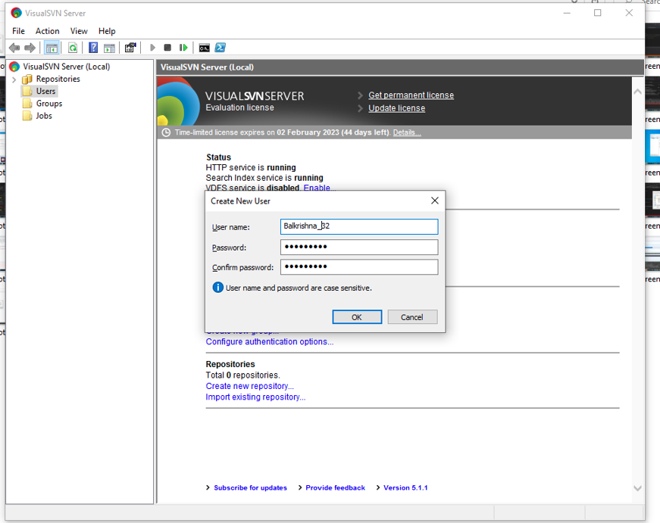

**Access Permission in VisualSVN**

Access Permission is needed to set for Private Repositories. If we want to share Private Repository, We have to grant access to Particular User.

Provide Access to particular User

**SVN Repository**

It is a collection of files and directories.These files and Directory are bundled together in a Particular Database.

**Create a Repository using VisualSVN Server**

Step1: Right-Click on Repositories and Select **Create New Repository and Select File System type**

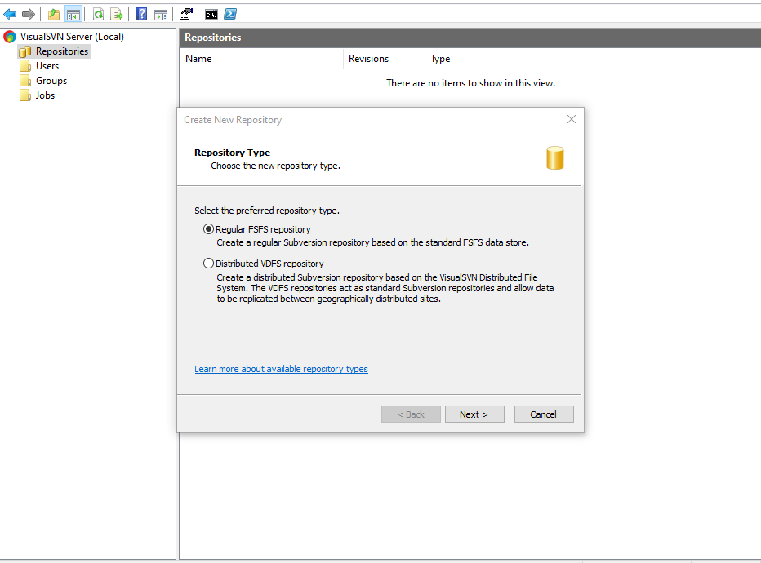

Step 2: After click Next Now Provide the Repository Name.

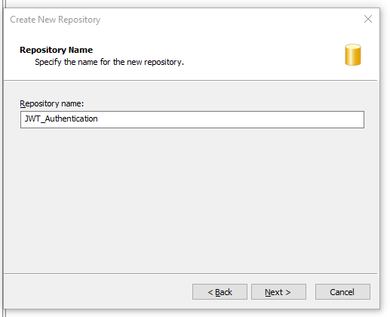

Step 3: After click Next Select Repository Type Empty , Single-Project Repository(with Top level ‘trunk’ ,’branches’ and ‘tag’ Folders)

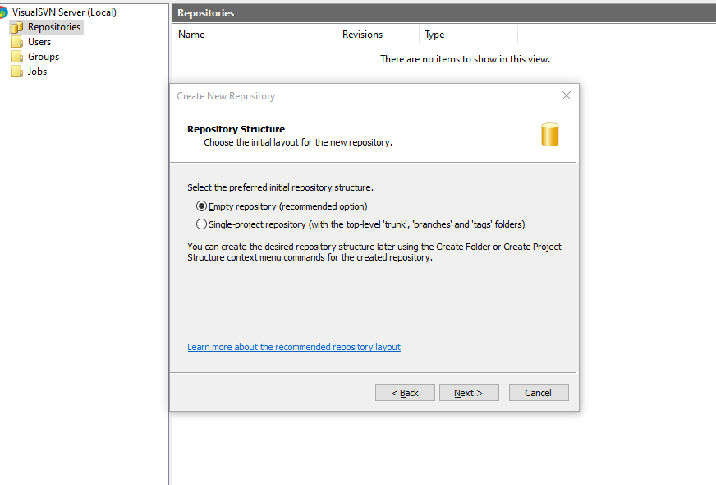

Step 4: After Select Repositories Kindly Choose Your Desired Access Permission.

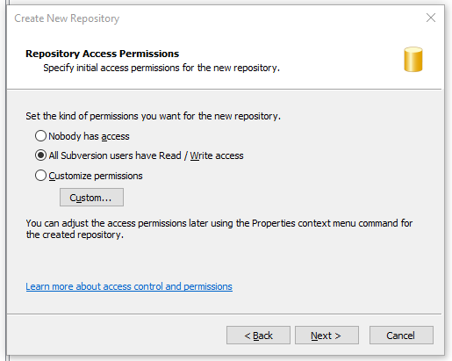

Step 5: Now see Successfully our Repository using VisualSVN

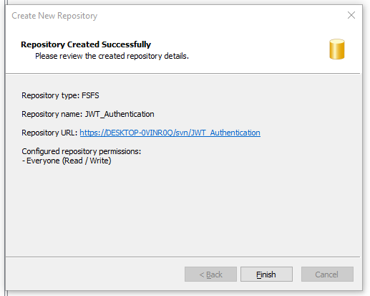

**Import a Project by TortoiseSVN**

If We want to import a project in existing Repository,

Now select the root directory of the project in the windows explorer and **right-click**on it. It will open the context menu, choose **TortoiseSVN → Import**to import the project

Step 1: After Importing the Url Then Provide Repository Url then click Ok

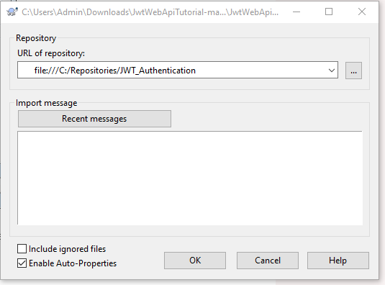

Step 2: After that all files are Imported and Path are shown



Step 3: Browse the Project Check Project Successfully Imported or not.

3.1 Right Click of any folder and Select TortoiseSVN -> Repo-browser then click ok

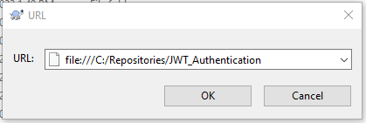

Step 4: It will Open Tortoise Repo-browser.

