**3.1 Proposed Work**

The proposed irrigation monitoring and controller system using IoT (Internet of Thing) consists of the Arduino Uno, water pump, and Soil-moisture Sensor and Wi-fi Modules. Smartphones module is used for communication. In the proposed work, crops or plants are considered along with their water requirement at different stages. The crops or plants are irrigated with respect to the water requirements at different stages of their growth.

Fig 1 shows the architectural design of the project. The smartphone is connected to Arduino Uno through wi-fi modules. The motor is controlled by the smartphone by the values moisture level of soil which is turn ON and OFF.

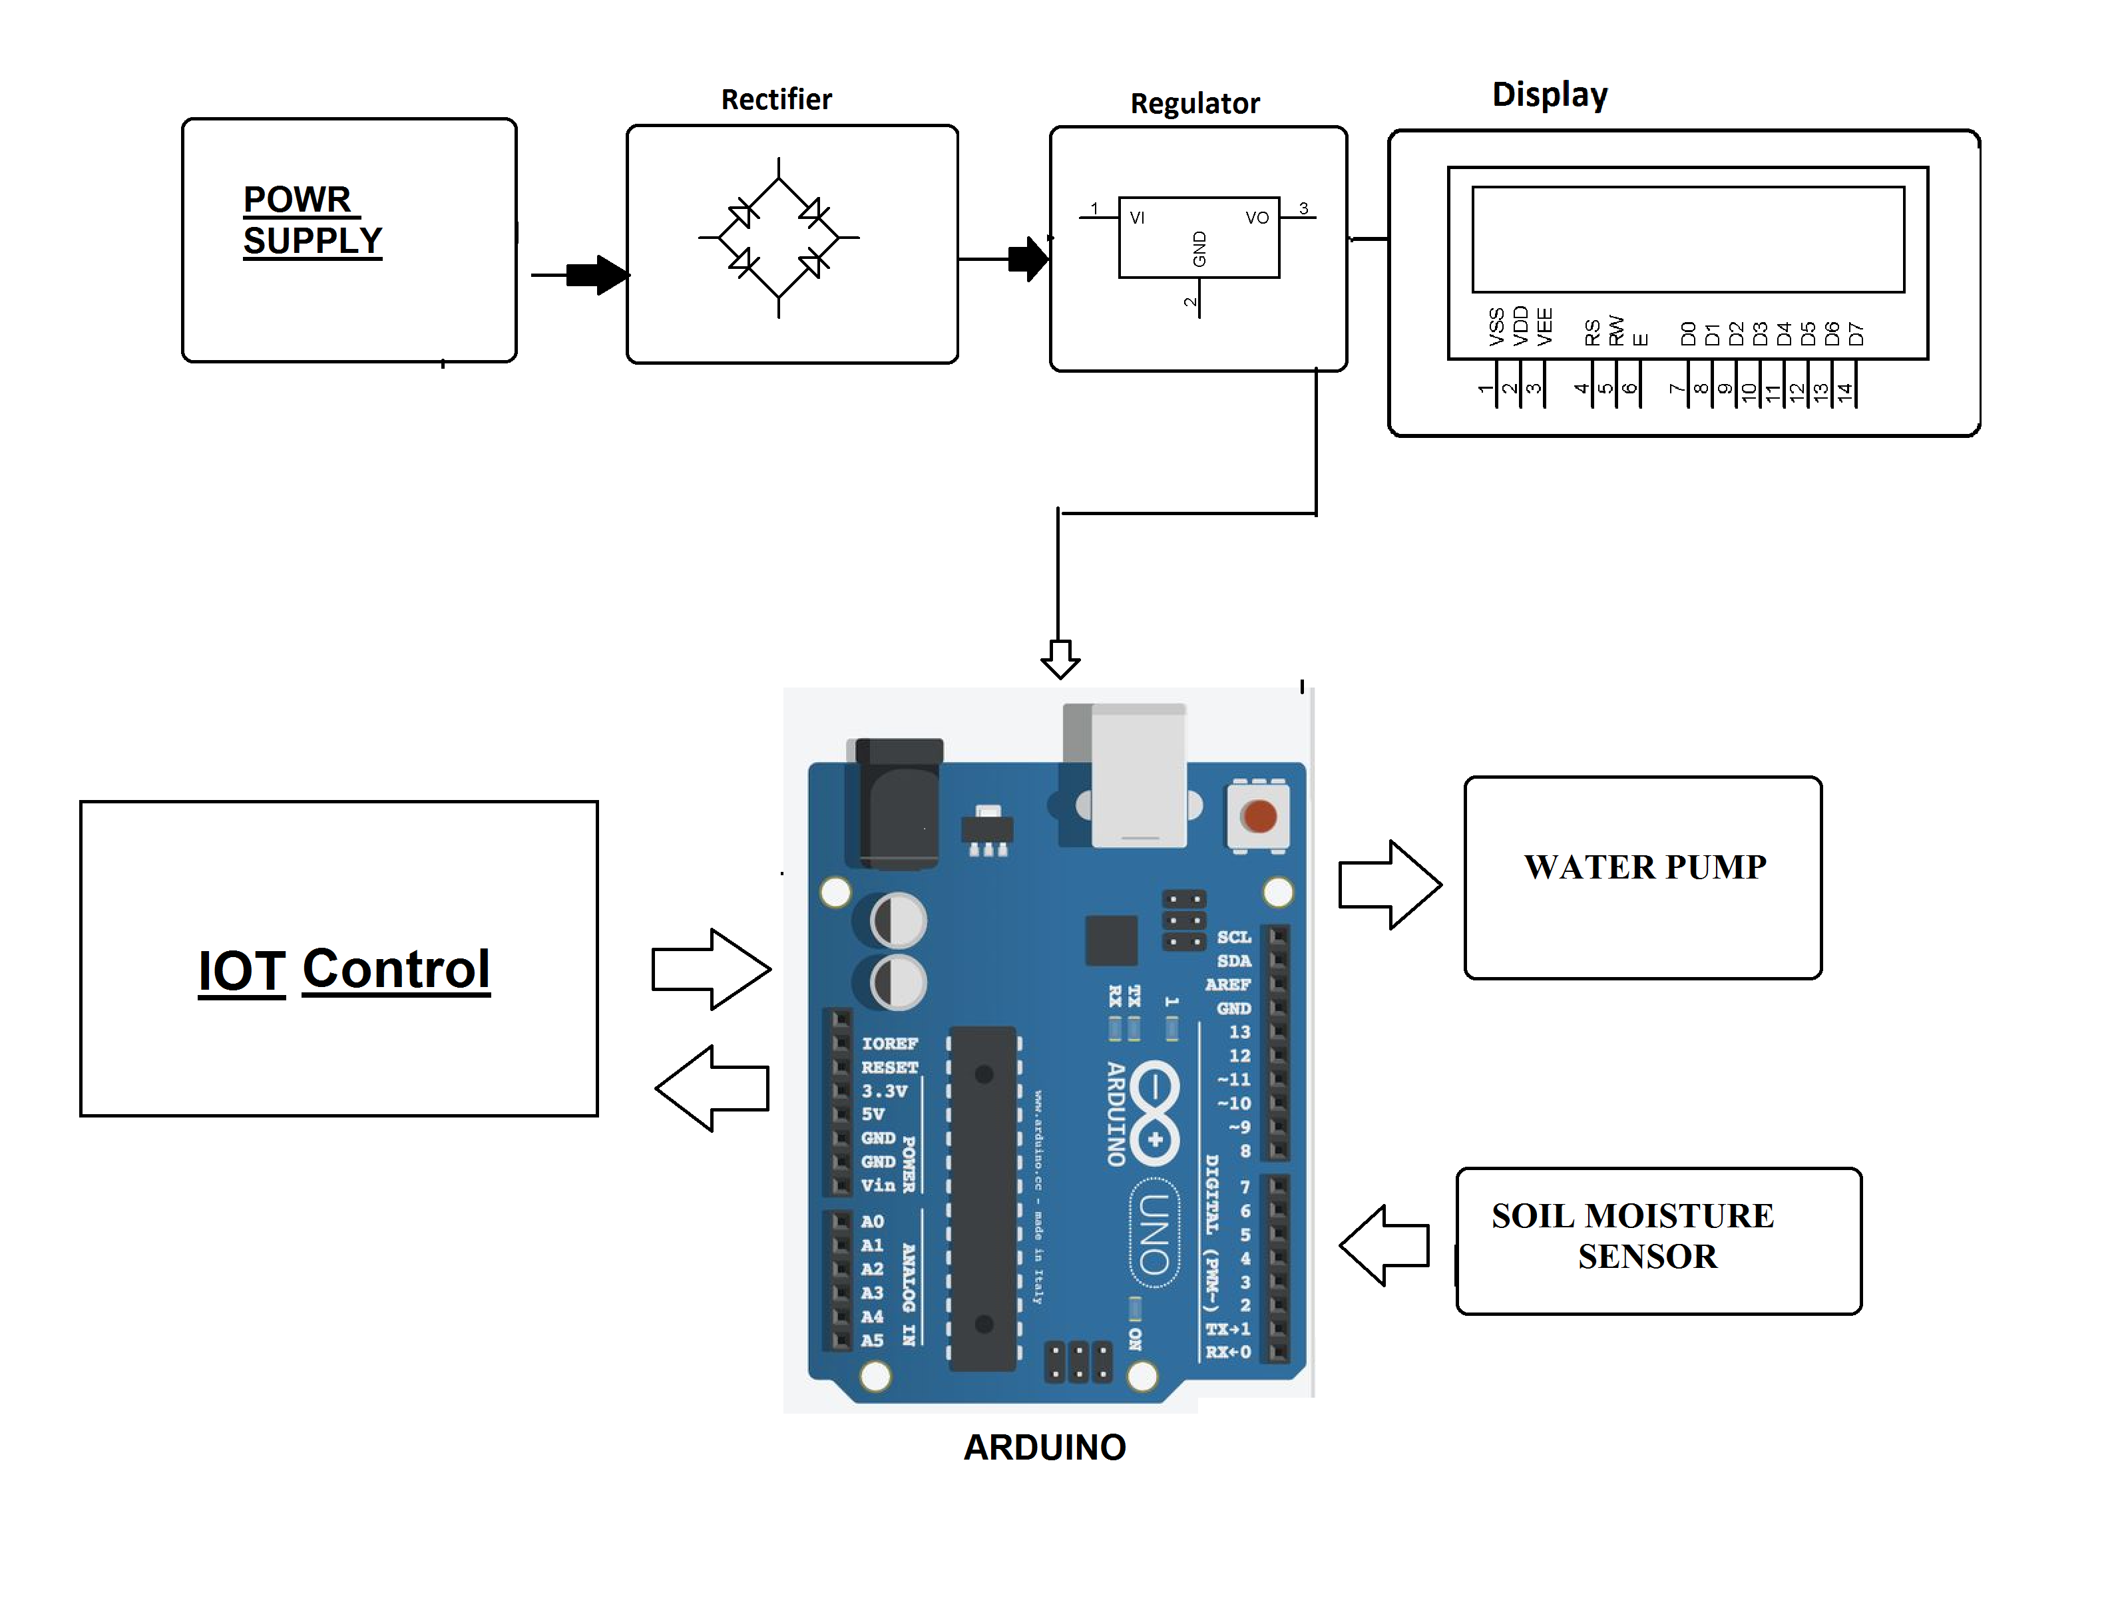

Fig.1 Proposed System Design

They continuously monitor the field and send it to the web server using NRF24LO1 transmitter and receiver and Ethernet connection at receiver ends. The sensor data are stored in database. The web application is designed in such a way to analyze the data received and to check with the threshold values of moisture. The decision making is done at server to automate irrigation. If soil moisture is less than the threshold value the motor is switched ON and if the soil moisture exceeds the threshold value the motor is switched Off.