**5.1 Arduino**

Arduino is an open source physical computing platform based on simple input/output board and a development environment that implements the Processing language (www.processing.org). Arduino can be used to develop standalone interactive objects or can be connected to software on your computer. The boards can be assembled by hand or purchased preassembled; the open source IDE (Integrated Development Environment) can be downloaded for free from [www.arduino.cc](http://www.arduino.cc).

**Arduino** is an [open-source hardware](https://en.wikipedia.org/wiki/Open-source_hardware) and [software](https://en.wikipedia.org/wiki/Open-source_software) company, project and user community that designs and manufactures [single-board microcontrollers](https://en.wikipedia.org/wiki/Single-board_microcontroller) and [microcontroller](https://en.wikipedia.org/wiki/Microcontroller) kits for building digital devices and interactive objects that can sense and control both physically and digitally. Its products are licensed under the [GNU Lesser General Public License](https://en.wikipedia.org/wiki/GNU_Lesser_General_Public_License) (LGPL) or the [GNU General Public License](https://en.wikipedia.org/wiki/GNU_General_Public_License)(GPL), permitting the manufacture of Arduino boards and software distribution by anyone. Arduino boards are available commercially in preassembled form or as [do-it-yourself](https://en.wikipedia.org/wiki/Do-it-yourself) (DIY) kits.

**5.1.1 Introduction to Arduino Boards**

Arduino is an architecture that combines Atmel microcontroller family with standard hardware into a board with inbuilt bootloader for plug and play embedded programming. Arduino Software comes with an IDE that helps writing, debugging and burning program into Arduino. The IDE also comes with a Serial Communication window through which can easily get the serial data from the board.

**5.1.2 Arduino UNO**

The Arduino Uno is a microcontroller board developed by Arduino.cc and based on the ATmega328P. Microcontrollers are widely used in embedded systems and make devices work according to our needs and requirements. Arduino Uno is a very valuable addition in the electronics that consists of USB interface, 14 digital I/O pins, 6 analogue pins, and Atmega328 microcontroller. It also supports serial communication using Tx and Rx pins. Each of the 14 digital pins can be used as an input or output, using pinMode(), digitalWrite(), and digitalRead() functions. They operate at 5 volts. The Arduino Uno is a small single board computer which is been used to teach computer science. The Arduino Uno is been used as a computer where external memory can be used and it has four ports where any input devices can be connected. This project uses Arduino Uno for easy process and installation.

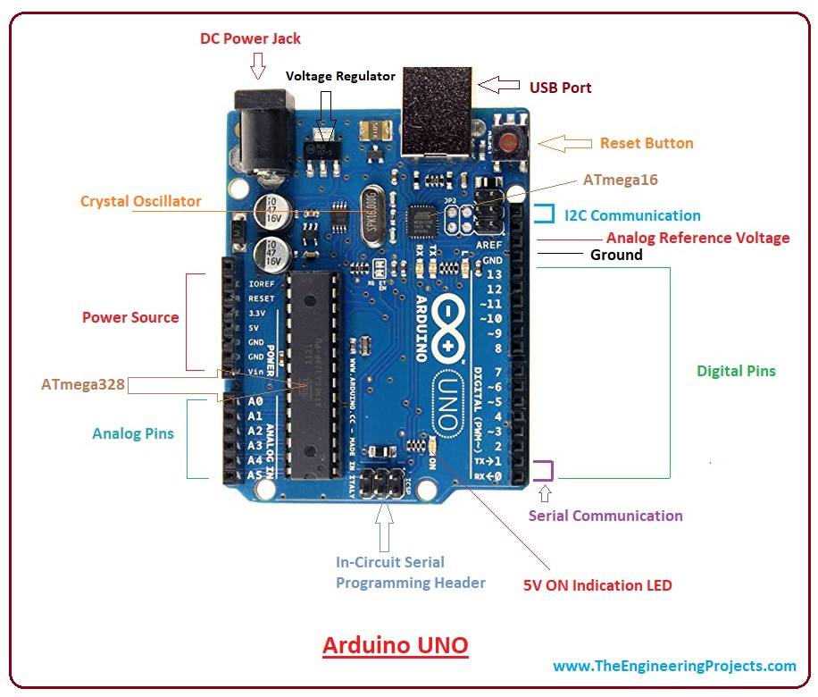

Fig 5.1 Arduino Uno

They operate at 5 volts. Each pin can provide or receive 20 mA as recommended operating condition and has an internal pull-up resistor (disconnected by default) of 20-50k ohm. A maximum of 40mA is the value that must not be exceeded on any I/O pin to avoid permanent damage to the microcontroller.

In addition, some pins have specialized functions:

* Serial: 0 (RX) and 1 (TX). Used to receive (RX) and transmit (TX) TTL serial data.
* External Interrupts: 2 and 3. These pins can be configured to trigger an interrupt on a low value, a rising or falling edge, or a change in value.
* PWM: 3, 5, 6, 9, 10, and 11. Provide 8-bit PWM output with the analogWrite() function.
* SPI: 10 (SS), 11 (MOSI), 12 (MISO), 13 (SCK). These pins support SPI communication using the SPI library.
* LED: 13. There is a built-in LED driven by digital pin 13
* TWI: A4 or SDA pin and A5 or SCL pin. Support TWI communication using the Wire library.

The Uno has 6 analog inputs, labeled A0 through A5, each of which provide 10 bits of resolution (i.e. 1024 different values). By default they measure from ground to 5 volts, though is it possible to change the upper end of their range using the AREF pin and the

analogReference () function.

There are a couple of other pins on the board,

* AREF Reference voltage for the analog inputs. Used with analogReference ().
* Reset. Bring this line LOW to reset the microcontroller. Typically used to add a reset button to shields which block the one on the board.

**5.1.3 Arduino UNO Technical Specifications**

|  |  |
| --- | --- |
| Microcontroller | ATmega 328P |
| Operating Voltage | 5V |
| Input Voltage (recommended) | 7-12V |
| Input Voltage (limit) | 6-20V |
| Digital I/O Pins | 14 (of which 6 provide PWM output) |
| PWM Digital I/O Pins | 6 |
| Analog Input Pins | 6 |
| DC Current per I/O Pin | 20 mA |
| DC Current for 3.3V Pin | 50 mA |
| Flash Memory | 32 KB (ATmega328P)  of which 0.5 KB used by bootloader |
| SRAM | 2 KB (ATmega328P) |
| EEPROM | 1 KB (ATmega328P) |
| Clock Speed | 16 MHz |
| Length | 68.6 mm |
| Width | 53.4 mm |
| Weight | 25 g |

Table 5.1 Technical Specification

**5.2 ESP8266**

**5.2.1 Introduction to ESP8266**

The ESP8266 Arduino compatible module is a low-cost Wi-Fi chip with full TCP/IP capability, and the amazing thing is that this little board has an MCU (Micro Controller Unit) integrated which gives the possibility to control I/O digital pins via simple and almost pseudo-code like a programming language. ESP8266 is a complete and self-contained Wi-Fi network solution that can support and move (someone or something) from one place to another software applications, or through another application, processor uninstalls all Wi-Fi networking capabilities. Built-in cache memory will help improve system performance of software application and reduce memory requirements. Another situation is when wireless Internet access assumes the task of the Wi-Fi adapter, you can add it to any microcontroller-based design, and the connection is simple.

Another situation is when wireless Internet access assume the task of Wi-Fi adapter, you can add it to any microcontroller-based design, and the connection is simple, just by SPI / SDIO interface or central processor AHB bridge interface. Processing and storage capacity on ESP8266 powerful piece, it can be integrated via GPIO ports sensors and other applications specific equipment to achieve the lowest early in the development and operation of at least occupy system resources. The ESP8266 highly integrated chip, including antenna switch balun, power management converter, so with minimal external circuitry, and includes front-end module, including the entire solution designed to minimize the space occupied by PCB. The system is equipped with ESP8266 manifested leading features are: energy saving VoIP quickly switch between the sleep / wake patterns, with low-power operation adaptive radio bias, front-end signal processing functions, troubleshooting and radio systems coexist characteristics eliminate cellular / Bluetooth / DDR / LVDS / LCD interference.

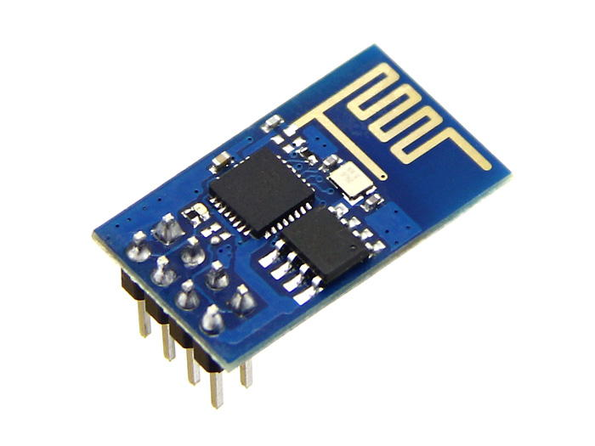

*Fig. 5.2 wi-fi modules*

**5.2.2 Block Diagram of ESP8266**



**5.2.3 Characteristics of ESP8266**

* 802.11 b / g / n
* Wi-Fi Direct (P2P), soft-AP
* Built-in TCP / IP protocol stack
* Built-in TR switch, balun, LNA, power amplifier and matching network
* Built-in PLL, voltage regulator and power management components
* 802.11b mode + 19.5dBm output power
* Built-in temperature sensor
* Support antenna diversity
* off leakage current is less than 10uA
* Built-in low-power 32-bit CPU: can double as an application processor
* SDIO 2.0, SPI, UART
* STBC, 1x1 MIMO, 2x1 MIMO
* A-MPDU, A-MSDU aggregation and the 0.4 Within wake
* 2ms, connect and transfer data packets
* standby power consumption of less than 1.0mW (DTIM3)

**5.2.4 Schematic Diagram of ESP8266-EX**



**5.2.5 ESP Modules**

The ESP8266 is a low-cost Wi-Fi chip with full TCP/IP stack and microcontroller capability produced by Shanghai-based Chinese manufacturer, **Espressif**. These were the first series of modules made by third-party manufacturer, **AI-Thinker** with the ESP8266 and remain the most widely available.

**Board ID Pins Pitch LEDs Antenna Dimensions mm**

ESP-01 8 .1“ Yes Etched-on PCB 14.3 x 24.8

ESP-02 8 .1” No None 14.2 x 14.2

ESP-03 14 2mm No Ceramic 17.3 x 12.1

ESP-04 14 2mm No None 14.7 x 12.1

ESP-05 5 .1“ No None 14.2 x 14.2

ESP-06 12+GND misc No None ?

ESP-07 16 2mm Yes Ceramic 20.0 x 16.0

ESP-08 14 2mm No None 17.0 x 16.0

ESP-09 12+GND misc No None 10.0 x 10.0

ESP-10 5 2mmm? No None 14.2 x 10.0

ESP-11 8 1.27mm No Ceramic 17.3 x 12.1

ESP-12 16 2mm Yes Etched-on PCB 24.0 x 16.0

ESP-12-E 22 2mm Yes Etched-on PCB 24.0 x 16.0

ESP-13 18 1.5mm - Etched-on PCB -

ESP-14 22 2mm 1 Etched-on PCB 24.3 x 16.2

WROOM-02 18 1.5mm No Etched on PCB 20.0 x 18.0

WT8266-S1 18 1.5mm 1 Etched on PCB 15.0 x 18.6

**5.2.6 ESP8266 Applications**

* Smart Power Plug
* Home Automation
* Industrial wireless control
* Baby Monitor
* Network Camera
* Wireless location-aware devices and positioning system signals

**5.2.7 Explore ESP8266 Wi-Fi Module**

The ESP8266 ESP12E Wi-Fi Module is more user friendly with the Explore ESP8266 Wi-Fi Module. It fits on a breadboard with all pins taken out. The module goes into programming mode with a single reset switch.

Features:

* Fits on a breadboard.
* Single button 'Reset' switch for programming. Uses MOSFET's to put the module in
* programming mode.
* All pins of ESP12E taken out.
* Separate serial pins breakout compatible with FTDI cable layout.
* On-board LM1117-3.3V regulator.
* Works with Arduino IDE for ESP8266.
* Programs can easily dump using USB to TTL converter.
* ESP8266 ESP12E features.

**5.2.8 Schematic Diagram of Explore ESP8266 Wi-Fi Module**



Figure 5.5 Schematic Diagram of Explore ESP8266 Wi-Fi Module.

**5.2.9 AT Commands**

ESP8266, in its default configuration, boots up into the serial modem mode. In this mode you can communicate with it using a set of **AT commands**. AT commands are based on the Hayes Command Set.

**Basic Wi-Fi layer TCPIP Layer**

AT AT+CWMODE AT+CIPSTATUS

AT+RST AT+CWJAP AT+CIPSTART

AT+GMR AT+CWLAP AT+CIPSEND

AT+GSLP AT+CWQAP AT+CIPCLOSE

ATE AT+CWSAP AT+CIFSR

AT+CWLIF AT+CIPMUX

AT+CWDHCP AT+CIPSERVER

AT+CIPSTAMAC AT+CIPMODE

AT+CIPAPMAC AT+CIPSTO

AT+CIPSTA AT+CIUPDATE

AT+CIPAP +IPD

**5.3 Soil Moisture Sensor**

The sensors are the device which converts the physical parameter into the electric signal. The system consists of soil moisture sensor Fig 3. The output of the sensor is analogue signal; the signal is converted into the digital signal and then fed to the processor. The soil moisture sensor is a flow sensor technology, but ideal for monitoring an urban garden or your pet plant's water level and must-have tool for a connected garden. This sensor uses the two physically explore to pass current through the soil, and then it reads that resistance to get the moisture level of the soil. In soil moisture sensor, Copper electrodes are used to sense the moisture content of the soil.

**

Fig. 5.6 Soil Moisture Sensor

**5.4 Submersible Motor Pump**

A submersible pump (or sub pump, electric submersible pump) (figure3.8) is a device which has a hermetically sealed motor close-coupled to the pump body. The whole assembly is submerged in the fluid to be pumped. The main advantage of this type of pump is that it prevents pump cavitation’s, a problem associated with a high elevation difference between pump and the fluid surface. Small DC Submersible water pumps push fluid to the surface as opposed to jet pumps having to pull fluids. Submersibles are more efficient than jet pumps. It is usually operated between 3v to 12v.



Figure 3.8 Submersible Water Pump.

**Specifications:**

* Voltage : 2.5-10V
* Maximum lift : 40-110cm / 15.75"-43.4"
* Flow rate : 80-120L/H
* Outside diameter : 7.5mm / 0.3"
* Inside diameter : 5mm / 0.2"
* Diameter : Approx. 24mm / 0.95"
* Length : Approx. 45mm / 1.8"
* Height : Approx. 30mm / 1.2"
* Material : Engineering plastic
* Driving mode : DC design, magnetic driving
* Continuous working life for 500 hours

**5.5 Relay Switch**

Relay is an electromagnetic device which is used to isolate two circuits electrically and connect them magnetically. They are very useful devices and allow one circuit to switch another one while they are completely separate. They are often used to interface an electronic circuit (working at a low voltage) to an electrical circuit which works at very high voltage. For example, a relay can make a 5V DC battery circuit to switch a 230V AC mains circuit. Thus, a small sensor circuit can drive, say, a fan or an electric bulb. A relay switch can be divided into two parts: input and output. The input section has a

coil which generates magnetic field when a small voltage from an electronic circuit is applied to it. This voltage is called the operating voltage. Commonly used relays are available in different configuration of operating voltages like 6V, 9V, 12V, 24V etc. The output section consists of contactors which connect or disconnect mechanically. In a basic relay there are three contactors: normally open (NO), normally closed (NC) and common (COM). At no input state, the COM is connected to NC. When the operating voltage is applied the relay coil gets energized and the COM changes contact to NO.



Figure 5.7 Relay switch