A

PROJECT REPORT

**ON**

**“Irrigation Monitoring With Control System using IoT”**

**Submitted in partial fulfilment of the requirement for the**

VIII semester of

BACHELOR OF TECHNOLOGY

IN

INFORMATION TECHNOLOGY

Submitted By:

Balkaran Kumar (15107010)

Vivek Bharati (15107030)

Under the supervision of:

Anand Prakash Rawal

(Assistant Professor)

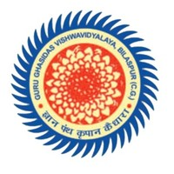

TO

DEPARTMENT OF INFORMATION TECHNOLOGY

SCHOOL OF STUDIES IN ENGINEERING & TECHNOLOGY

GURU GHASIDAS VISHWAVIDYALAYA BILASPUR, INDIA

(CENTRAL UNIVERSITY)

SESSION: 2018-2019