

**Amrit Campus**

Tribhuvan University

Faculty of Institute of Science and Technology

**‘B.Sc. CSIT’**

Sixth Semester

A Project Report on

**“Online Pothole Reporting System”**

*Submitted in partial fulfillment of the requirements for the course*

|  |  |
| --- | --- |
| **Name: Balkrishna Gautam** Roll Number: 113  Symbol Number: 28164/078 | **Mr. Satya Bahadur Maharjan**  Department of Computer Science and Information Technology  Amrit Campus |

**E-Governance (CSC 366)**

**Student Details:**  **Submitted to:**

# Acknowledgments

The successful completion of this project, titled **"Online Pothole Reporting System"**, would not have been possible without the guidance, support, and resources provided by various individuals and institutions.

The completion of this work is attributed to the academic environment and support system provided by **Amrit Campus**, which facilitated a conducive setting for learning, development, and innovation.

Gratitude is extended to the **Department of Computer Science and Information Technology** **(CSIT)** for providing the necessary academic framework, technical knowledge, and resources essential for the design and implementation of the system.

Acknowledgement is also due to all faculty members who contributed their expertise, directly or indirectly, through lectures, guidance, or feedback during the course of study, which formed the foundation of this work.

Finally, the contribution of open-source communities and publicly available documentation is recognized for their valuable role in the development and integration of technologies used in this project.

**Balkrishna Gautam**

# Abstract

Road infrastructure plays a critical role in ensuring public safety and efficient transportation. One of the persistent challenges in urban and rural road maintenance is the timely identification and repair of potholes. The traditional methods of reporting such issues are often inefficient, delayed, or inaccessible to the general public. To address this problem, the **Online Pothole Reporting System** has been developed as a web-based solution that enables users to report potholes in real time through an intuitive interface.

This system allows users to submit pothole reports by filling out a form and pinpointing the location. Users may also upload images of the pothole to assist authorities in assessing its severity. The system stores these reports in a centralized database using MongoDB, ensuring efficient data management and retrieval. An administrative dashboard is included to enable authorized personnel to review, categorize, and update the status of reported potholes, thereby streamlining the maintenance process.

Developed using modern web technologies such as React.js for the frontend and Node.js with Express for the backend and Mongoose and MongoDB for database, the system emphasizes scalability, usability, and responsiveness. The platform is built using modern web development technologies and offers a user-friendly interface to ensure ease of use for both the general public and administrators. By digitizing the pothole reporting process, this system improves the efficiency, traceability, and responsiveness of road maintenance efforts.

The proposed system enhances civic engagement, improves response times for road maintenance, and supports municipalities in managing road infrastructure more efficiently. It serves as a step toward the digitization of public infrastructure monitoring and contributes to the development of smarter, more responsive urban management systems.

**Keywords:** Pothole Reporting, Web Application, Geolocation, MongoDB, Road Maintenance, React, Node.js, Feedback System, Digital Reporting

**Contents**

Acknowledgments II

Abstract III

1. Introduction 1

1.1 Background 1

1.2 Objective 1

1.3 Scope 1

1.4 Relevance to E-Governance 2

2. System Overview 2

2.1 User Interface (Frontend) 2

2.2 Backend System (Server & Database) 3

2.3 Admin Dashboard 3

2.4 Flow Summary 3

3. Features 6

3.1 Submit Pothole Report via Form 6

3.2 Upload Images 7

3.3 Admin Dashboard for Viewing Reports 7

4. Usage 7

4.1 How to Report a Pothole 7

4.2 Accessing the Admin Dashboard 9

4.3 Viewing Submitted Reports 9

5. Code Structure 9

5.1 Folder Structure 10

5.2 Key Components/Modules 10

5.2.1 Backend Components 10

5.2.2 Frontend Components 11

5.3 Code Flow Overview 12

6. Database Schema 12

6.1 MongoDB Collections 12

6.1.1 reports Collection 13

6.2 Mongoose Models 13

6.3 Data Relationships 13

6.4 Diagram 14

7. API Documentation 14

7.1 Endpoints Overview 15

7.1.1 POST /auth - User Login 15

7.1.2 GET /report - Fetch All Reports 15

7.1.3 POST /report - Submit a New Pothole Report 15

7.1.4 DELETE /report/:id - Delete a Pothole Report 15

7.2 Request/Response Format 15

7.3 Authentication 15

8. Challenges and Solutions 15

8.1 Challenge: Handling Incomplete or Invalid User Inputs 16

8.2 Challenge: Handling Multiple Image Uploads 16

8.3 Challenge: Ensuring Smooth User Experience with Report Submission 16

9. Future Improvements 17

9.1 Integration of Map-Based Reporting 17

9.2 GPS-Based Location Tracking 17

9.3 User Authentication and Role-Based Access Control 18

9.4 Report Status Notifications and Alerts 18

9.5 Pothole Resolution Tracking 19

9.6 Mobile Application Development 19

9.7 Data Analytics and Reporting for Administrators 19

9.8 Integration with Local Government Systems 20

10. Conclusion 20

Final Thoughts 20

Impact and Value of the System 21

11. Screenshots 22

# Introduction

## Background

In many regions, road damage caused by potholes is a recurring issue that affects daily transportation, road safety, and public satisfaction. Traditional methods of addressing these problems—such as verbal complaints or manual reporting—are often inefficient, unstructured, and slow to reach the appropriate authorities.

With the rise of digital governance initiatives, there is a growing emphasis on using technology to streamline public service delivery and encourage active citizen participation. The implementation of online reporting systems for civic issues is one such approach that aligns with the broader goals of e-Governance.

## Objective

The primary objective of this project is to develop a centralized and user-friendly platform for reporting potholes, which can be used by both citizens and local authorities. The system is designed to:

* Enable the public to submit pothole complaints digitally.
* Collect structured data including location details, images, and reporter information.
* Assist municipal bodies in managing and prioritizing maintenance tasks efficiently.
* Promote transparency and responsiveness in civic issue handling.

## Scope

This project focuses on the development of a web-based application that facilitates pothole reporting through a digital form. The form collects key details such as:

* Reporter’s name, email, and phone number
* Location of the pothole and nearest landmark
* Approximate size of the pothole
* Images for visual reference

While the current scope covers reporting and record-keeping functionalities, the system is designed to be extendable in the future. Potential enhancements may include integration with mapping services, automated status tracking, and analytics dashboards for administrators.

## Relevance to E-Governance

The Online Pothole Reporting System embodies the principles of e-Governance by:

* Digitizing citizen-government interaction for infrastructure maintenance
* Enabling faster and traceable service delivery
* Encouraging civic engagement and participation
* Supporting data-driven decision-making for public works departments

By providing a structured, transparent, and efficient reporting mechanism, the system contributes to the modernization of local governance and serves as a practical model for other digital public service platforms.

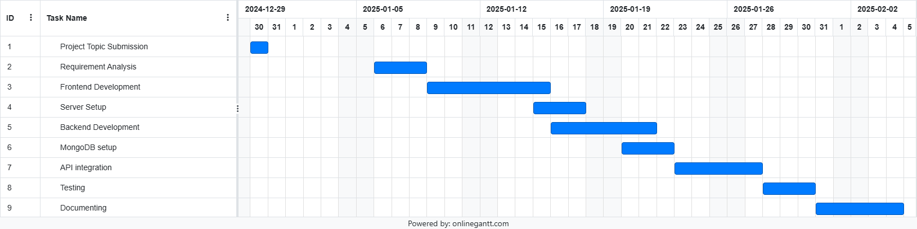

Fig : Gantt Chart for Online pothole reporting syste Development Schedule

# System Overview

The **Online Pothole Reporting System** is a web-based platform designed to simplify and digitize the process of reporting potholes. The system is built to serve as a bridge between the public and local municipal authorities, offering a centralized and efficient mechanism to report road damage and monitor it through structured digital records.

The system comprises two main components:

## 2.1 User Interface (Frontend)

The frontend provides a simple and accessible platform for users to submit pothole reports. Key functionalities include:

* **Form Submission:** Users fill in a form with required details such as:
  + Full Name
  + Email Address
  + Phone Number
  + Pothole Location (typed address or description)
  + Nearest Landmark
  + Approximate Size (small, medium, large, etc.)
  + Image Upload (optional but encouraged)
* **Validation:** Input fields are validated to ensure completeness and correctness before submission.
* **Responsive Design:** The interface is accessible across different devices including desktops, tablets, and mobile phones.

## 2.2 Backend System (Server & Database)

The backend handles form processing, data storage, and administrative access. It consists of:

* **Server-Side Logic:** Built using Node.js and Express, it manages:
  + Routing for form submissions
  + Image upload handling
  + Communication with the database
  + Authentication and admin access
* **Database:** MongoDB is used to store report data. Each submission is saved as a document containing:
  + Reporter’s contact details
  + Description of the pothole
  + Uploaded images

## Admin Dashboard

A restricted-access dashboard is available for authorized personnel to:

* View submitted pothole reports
* User friendly tabulated structure
* View details of reporter and report
* Delete report manually

This component helps local authorities prioritize and respond to reported issues more effectively.

## 2.4 Flow Summary

1. **User fills out the report form** on the frontend.
2. **Form data and image are submitted** to the backend server.
3. **Backend processes and validates** the data, storing it in the MongoDB database.
4. **Admin panel retrieves and displays** the stored reports for review and action.

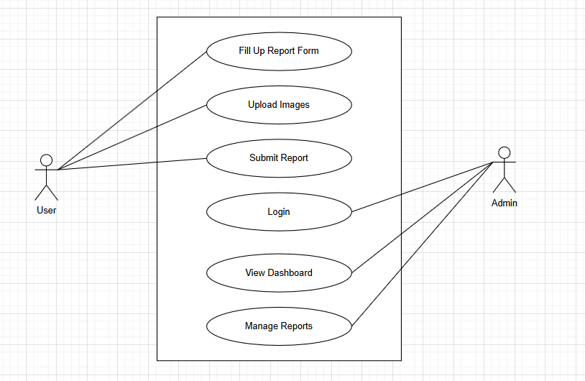

Fig: Use-case diagram for online pothole reporting system

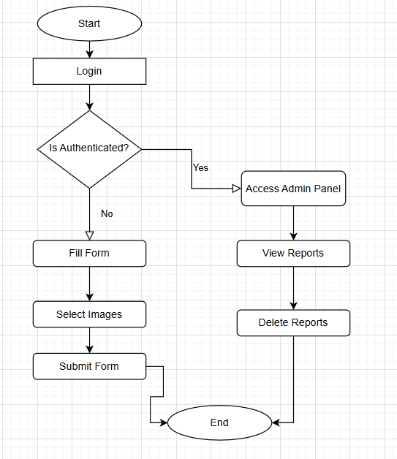

Fig: flowchart for online pothole reporting system

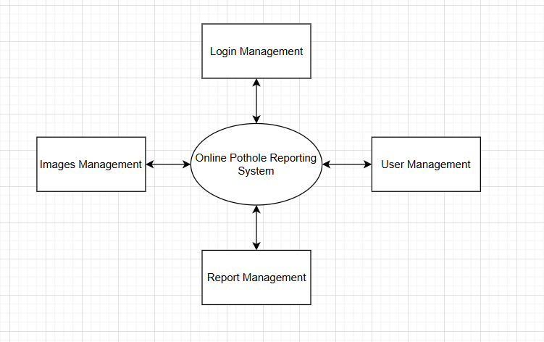

Fig: Level-0 Data flow diagram (DFD) of online pothole reporting system

# 3. Features

The **Online Pothole Reporting System** is equipped with several essential features that facilitate a smooth user experience for citizens and provide useful tools for administrative personnel. These features are designed to align with the goals of e-Governance, such as transparency, accessibility, and responsiveness in public service management.

## 3.1 Submit Pothole Report via Form

Users can report potholes by filling out a structured online form. The form is designed to capture all necessary details for authorities to assess the issue effectively. Required inputs include:

* Full Name
* Email Address
* Phone Number
* Pothole Location (entered manually)
* Nearest Landmark (to help identify exact location)
* Approximate Size (e.g., small, medium, large)

The intuitive interface ensures that even users with minimal technical skills can report issues without difficulty.

## 3.2 Upload Images

To provide visual evidence of the reported issue, users can upload one or more images of the pothole. This feature assists authorities in:

* Verifying the report’s authenticity
* Assessing the severity of the damage
* Prioritizing repair tasks based on visual input

The system accepts common image formats and ensures that uploaded files are securely handled and stored.

## 3.3 Admin Dashboard for Viewing Reports

A dedicated administrative interface is available for authorized personnel to manage and monitor submitted reports. The dashboard includes:

* A list view of all pothole reports
* Sorting and filtering based on date, location, or size
* Access to uploaded images
* Contact information of the reporter (for follow-up if needed)

This dashboard simplifies the process of reviewing complaints, allows for easy data tracking, and enhances coordination among municipal departments.

# 4. Usage

The **Online Pothole Reporting System** is designed to be user-friendly and easy to navigate. The following step-by-step guide will walk you through the process of submitting a pothole report:

## 4.1 How to Report a Pothole

#### Step 1: Access the Reporting Page

1. Open a web browser and go to the **Online Pothole Reporting System**.
2. On the homepage, you will see an option to **Report a Pothole**. Click this button to navigate to the report submission page.

#### Step 2: Fill in the Reporter Information

You will be prompted to provide your personal details to ensure authorities can contact you if necessary:

* **Full Name:** Enter your first and last name.
* **Email Address:** Provide a valid email address for follow-up communication.
* **Phone Number:** Include your phone number for contact purposes.

These details are important for verifying the authenticity of the report and reaching out to you if needed.

#### Step 3: Enter the Pothole Location

Provide the following details about the location of the pothole:

* **Pothole Location (Address or Description):** Manually type the address or a clear description of where the pothole is located. If the pothole is near a known landmark, you can include that information to help local authorities locate it more easily.
* **Nearest Landmark:** You can mention any nearby landmarks (e.g., intersections, well-known buildings, or street names) to assist authorities in pinpointing the pothole location.

**Note:** While the system does not currently have an interactive map or GPS auto-fetch feature, this information will help municipal workers find the pothole based on your input.

#### Step 4: Specify the Pothole Size

Indicate the approximate size of the pothole in inches:

* **length**
* **breadth**

This information helps prioritize repairs, as larger potholes may require immediate attention.

#### Step 5: Upload Pothole Image

You can upload images to provide a visual representation of the pothole. This step is highly encouraged. To upload an image:

1. Click the **Choose File** button.
2. Select a clear photo of the pothole from your device.
3. Wait for the image to upload successfully.

#### Step 6: Review and Submit the Report

Once you have filled in all the necessary fields:

1. Review the information to ensure all fields are correctly completed.
2. If everything looks good, click the **Submit Report** button to send your pothole report to the local authorities.

You will see a confirmation message once your report is successfully submitted.

## 4.2 Accessing the Admin Dashboard

Once logged in, the admin gains access to the **Admin Dashboard**, which acts as the main interface for managing pothole reports. It's like a digital filing cabinet where every pothole report submitted by the public is neatly organized and easily accessible.

* The **Dashboard** displays a list of all pothole reports submitted by users. It’s similar to an inbox in an email application, where new reports appear at the top for easy viewing.

## 4.3 Viewing Submitted Reports

Each report contains essential details such as:

* **Reporter’s Name and Contact Information**
* **Pothole Location and Description**
* **Pothole Size**
* **Uploaded Images**

Admins can click on a report to open a detailed view, like unfolding a piece of paper to examine the full content. This allows the admin to assess the severity of the pothole, view the uploaded images, and gather all necessary information to act upon the report.

# 5. Code Structure

The **Online Pothole Reporting System** is organized into distinct directories and modules to separate concerns and make the codebase maintainable and easy to understand. Below is an overview of the folder structure and the key components within each.

## 5.1 Folder Structure

The project follows a standard structure for a **full-stack web application** with both **backend** and **frontend** components. The directory structure is as follows:

pothole-reporting-system/

│

├── backend/ # Backend server (API and database logic)

│ ├── config/ # Configuration files (database, environment variables)

│ ├── controllers/ # Logic for handling requests and responses

│ ├── models/ # Mongoose models (schema definitions for MongoDB)

│ ├── routes/ # Express routes to handle different HTTP requests

│ ├── middleware/ # Middlewares (authentication, error handling)

│ ├── utils/ # Utility functions (helpers for validation, etc.)

│ ├── .env # Environment variables for backend

│ ├── server.js # Entry point for the backend server

│ └── package.json # Backend dependencies and scripts

│

├── frontend/ # Frontend client (React app)

│ ├── src/ # Source code of the React application

│ │ ├── assets/ # Static assets like images, icons, etc.

│ │ ├── components/ # Reusable UI components (forms, buttons, etc.)

│ │ ├── pages/ # Main application views or pages (ReportPage, DashboardPage, etc.)

│ │ ├── services/ # API service calls (axios, fetch)

│ │ ├── App.js # Main React component

│ │ ├── index.js # Entry point for the React app

│ │ └── package.json # Frontend dependencies and scripts

│

└── README.md # Project documentation and instructions

## 5.2 Key Components/Modules

### 5.2.1 Backend Components

The backend of the application is built using **Node.js** with the **Express** framework. Below is a breakdown of the key components:

1. **server.js**
   * The entry point for the backend server. It initializes the Express app, sets up middleware, and defines the server’s routes. This is where the server starts running.
2. **config/**
   * Contains configuration files for connecting to the MongoDB database and reading environment variables. It may also include configurations for external services, such as an email or notification service.
3. **controllers/**
   * This directory contains files that define the logic for handling incoming requests. For example, a reportController.js file might handle submitting a new pothole report, validating the data, and saving it to the database.
4. **models/**
   * Contains Mongoose models (schemas) that define how data is structured in the database. For example, the Report.js file might define the schema for pothole reports, including fields such as the reporter's name, location, size, etc.
5. **routes/**
   * This folder contains the route definitions for the backend. Each route handles a specific HTTP request (GET, POST, PUT, DELETE) and connects the request to a corresponding controller function. For example, reportRoutes.js might define a POST route to submit a new pothole report.
6. **middleware/**
   * Contains functions that can be executed before or after requests are processed. For example, a middleware function might validate the incoming request body, check if the user is authenticated, or handle errors.
7. **utils/**
   * Utility functions or helper methods that are used across various components of the backend. For example, functions to validate email addresses or parse uploaded images could be placed here.

### 5.2.2 Frontend Components

The frontend of the application is built using **React**. Below are the main directories and files in the frontend:

1. **App.js**
   * This is the root component of the React application, where routing, global context, and core logic are set up.
2. **components/**
   * This directory holds reusable components that make up the UI of the application. Examples include:
     + ReportForm.js – The form used to submit pothole reports.
     + ImageUpload.js – A component for handling image uploads.
     + Navbar.js – A navigation bar for the application.
3. **pages/**
   * This directory contains the different "pages" or views of the application. Each page corresponds to a route in the frontend. For example:
     + ReportPage.js – The page where users can fill out and submit pothole reports.
     + DashboardPage.js – The page where admins can view and manage submitted reports.
4. **services/**
   * Contains files for managing API requests. For example:
     + api.js – Handles HTTP requests to the backend API, such as fetching or submitting pothole reports. This module uses **Axios** or **Fetch** to communicate with the backend.
5. **assets/**
   * This folder holds static assets such as images, icons, and fonts used in the frontend.
6. **index.js**
   * The entry point for the React application. This file renders the root App component into the DOM.

## 5.3 Code Flow Overview

Here’s a simplified flow of how the application works:

1. **Frontend:** The user fills out the pothole report form and submits it.
   * The frontend sends an HTTP POST request to the backend API with the report data and any uploaded images.
2. **Backend:** The backend receives the data via an Express route.
   * The server processes the request, validates the input, and stores the report in the MongoDB database using Mongoose.
3. **Admin:** The admin can access the report through the **Admin Dashboard**, view the details, and update the report status as needed.

This modular approach makes it easy to maintain and expand the system in the future.

# 6. Database Schema

The **Online Pothole Reporting System** utilizes **MongoDB**, a NoSQL database, for storing the reports submitted by users. MongoDB's flexible schema allows for efficient storage and retrieval of data related to pothole incidents. The core data is stored in a **single collection**, which simplifies the structure and provides a clear view of the system’s functionality. Below is an overview of the **database schema** and the key collections used in the system.

## 6.1 MongoDB Collections

In MongoDB, data is organized into collections, which are analogous to tables in relational databases. Each collection stores documents, which are similar to rows in relational databases. The **Online Pothole Reporting System** uses the following collection:

### 6.1.1 reports Collection

The **reports** collection stores the pothole reports submitted by users. Each document in this collection represents an individual pothole report and includes several fields that provide details about the pothole’s location, size, and status, along with the reporter’s contact information and any images submitted with the report.

The **fields** stored in each document within the **reports** collection are as follows:

* **Reporter Information**: Includes fields such as name, email, and phone, which store the personal details of the user reporting the pothole.
* **Pothole Location**: This includes the location (description of where the pothole is located, e.g., street name) and the landmark (the nearest landmark to the pothole, if available).
* **Pothole Details**: The size field categorizes the pothole into one of three sizes.
* **Images**: The imageUrl field stores the URLs of images uploaded by the reporter, which provide visual evidence of the pothole.

## 6.2 Mongoose Models

In the backend, **Mongoose** is used to define the **Report model**, which provides an interface to interact with the **reports** collection in MongoDB. Mongoose schemas ensure that the data is validated before being saved into the database. The model facilitates operations such as creating, retrieving, updating, and deleting pothole reports.

The **Mongoose model** for the reports collection enforces the structure of each report, specifying the required fields and their data types, such as:

* **String** for text fields like name, email, location, and landmark.
* **Enum** for the size and status fields, restricting values to predefined categories.
* **Array of Strings** for storing multiple image URLs associated with each pothole report.

## 6.3 Data Relationships

At present, the system uses a **single collection** (reports), with each document representing a single pothole report. The current data model is relatively simple, but it is designed to be scalable for future enhancements. For example, if needed, additional collections could be added in the future, such as:

* **users**: To store information about users (if implementing authentication).

In its current form, the system does not yet require complex relationships between collections, as all necessary data resides in the **reports** collection.

## 6.4 Diagram

The accompanying diagram provides a visual representation of the **reports** collection structure and its key fields. This diagram will help clarify the relationships between the data elements and how they are stored in the database.

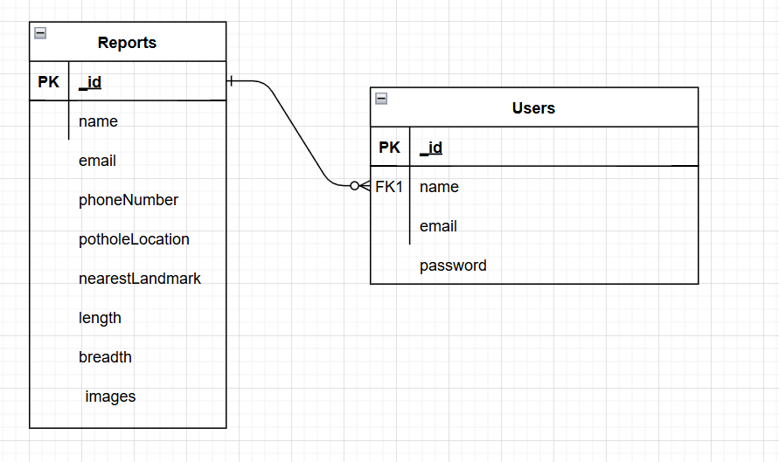

Fig: ER diagram for online pothole reporting system

# 7. API Documentation

This section outlines the **API endpoints** available in the Online Pothole Reporting System, including the request/response formats and authentication details.

## 7.1 Endpoints Overview

### 7.1.1 POST /auth **- User Login**

The **POST /auth** endpoint allows users to log in to the system. It accepts login credentials (username and password) and returns a success **response** if the login is successful.

### 7.1.2 GET /report **- Fetch All Reports**

The **GET /report** endpoint allows users to retrieve a list of all pothole reports stored in the system. This endpoint is typically used by admins to view all submitted reports.

### 7.1.3 POST /report **- Submit a New Pothole Report**

The **POST /report** endpoint allows users to submit a new pothole report. The request should include the reporter's information, pothole details, and any images associated with the report.

### 7.1.4 DELETE /report/:id **- Delete a Pothole Report**

The **DELETE /report/:id** endpoint allows an admin to delete a specific pothole report by its ID.

## 7.2 Request/Response Format

The request and response formats for all the endpoints are **JSON-based**, which ensures consistency across the system. The body of the requests and responses follows a standard structure, as outlined in the examples for each endpoint.

## 7.3 Authentication

The **Online Pothole Reporting System** includes a simple authentication mechanism to ensure that only authorized users can access certain features of the system. Users must submit a **valid email and password** via the POST /auth endpoint to authenticate. This step ensures that users can access the system and submit pothole reports.

# 8. Challenges and Solutions

Throughout the development of the **Online Pothole Reporting System**, several challenges emerged. Some were related to technical aspects of the project, while others were more focused on design and user experience. Below are the key challenges faced during development and the solutions implemented to address them.

## 8.1 Challenge: Handling Incomplete or Invalid User Inputs

**Problem**: One of the primary challenges was ensuring that users could submit reports with valid and complete information. Since the system collects multiple fields (name, email, phone, location, images, etc.), it was difficult to ensure that users entered all the necessary data correctly, especially without proper validation.

**Solution**: To solve this, I implemented **form validation** both on the client-side (using JavaScript) and server-side (using Mongoose validation) to ensure that all required fields were properly filled out before the data was submitted. For example:

* **Client-side validation**: I added checks to make sure that fields such as **name**, **email**, and **location** were not left empty.
* **Server-side validation**: I ensured that the data sent from the client adhered to the expected structure using Mongoose’s schema validation.

## 8.2 Challenge: Handling Multiple Image Uploads

**Problem**: Another challenge was managing **multiple image uploads** for each pothole report. Users could upload multiple images, but handling the upload and storing the images securely (while ensuring they were properly associated with the corresponding report) posed a challenge.

**Solution**: I solved this by using ‘multer’ library and disk storage on the server for image uploads. Each image is uploaded to the disk storage, and the resulting paths are stored in the database. This approach allowed for efficient storage and retrieval of images, without taking up too much time. The paths were then associated with each pothole report in the database, ensuring that images were easily accessible.

## 8.3 Challenge: Ensuring Smooth User Experience with Report Submission

**Problem**: The submission process of pothole reports involved a lot of fields (e.g., location, size, and image uploads). Ensuring that the process was straightforward and that users did not get confused by the multiple steps or make mistakes during report submission was a challenge.

**Solution**: To address this, I focused on **simplifying the user interface (UI)**:

* **Clear Labels and Instructions**: I ensured that all fields were clearly labeled, and added placeholder text or tooltips where necessary.
* **Step-by-Step Guidance**: The submission form was structured in a way that guided users through the process, allowing them to fill out only the necessary fields at each stage.
* **Error Messages**: In case of any invalid or missing information, the system displays clear error messages, guiding the user to correct their input before proceeding.

# 9. Future Improvements

While the **Online Pothole Reporting System** provides basic functionality for submitting and managing pothole reports, there are several opportunities for improvement in the future. These enhancements can enhance both the user experience and the system's overall performance. Below are some potential features and improvements that could be added in future versions:

## 9.1 Integration of Map-Based Reporting

**Feature**: Allow users to report potholes by selecting a location on an interactive map rather than manually entering location data.

**Description**: In the current version, users are required to provide the nearest landmark and other location details. However, integrating a map interface (such as Google Maps) would allow users to drop a pin on the exact location of the pothole. This would reduce the chance of errors in reporting and provide more accurate location data for the pothole reports.

**Benefits**:

* More accurate pothole location identification.
* Better user experience with a more intuitive interface.
* Easier navigation for users in unfamiliar areas.

## 9.2 GPS-Based Location Tracking

**Feature**: Use the browser's **GPS capabilities** to automatically fetch the user's location when submitting a pothole report.

**Description**: Currently, the system does not automatically fetch the user's location. Implementing GPS-based location tracking would allow users to submit reports with their current location by default. This feature can be especially helpful in areas with no clear landmarks or when users are on the move.

**Benefits**:

* Streamlined process for users to report potholes without needing to enter location manually.
* Improved accuracy of pothole location data.
* Convenient for users to quickly report a pothole while traveling.

## 9.3 User Authentication and Role-Based Access Control

**Feature**: Implement a more robust user authentication system with **role-based access control (RBAC)**.

**Description**: Currently, the system has a simple authentication process. However, in the future, adding role-based access control (RBAC) would allow for different levels of user access:

* **Admin**: Full access to all reports and the ability to update their status.
* **User**: Can submit reports but cannot modify or delete existing reports.
* **Guest/Visitor**: Limited access to view public reports without the ability to submit new ones.

**Benefits**:

* Enhanced security for user data and system operations.
* Ability to assign different permissions based on user roles.
* Better management and tracking of user activity within the system.

## 9.4 Report Status Notifications and Alerts

**Feature**: Implement a **notification system** to alert users when the status of their report changes.

**Description**: Once a report is submitted, users are currently unaware of any updates or changes to the status of their reports. Implementing a notification system (via email or in-app alerts) would keep users informed about their report's progress (e.g., when the pothole is being addressed or resolved).

**Benefits**:

* Improved user engagement and trust in the system.
* Increased transparency for users regarding the status of their reports.
* Encourages users to stay involved and follow up on their reports.

## 9.5 Pothole Resolution Tracking

**Feature**: Add the ability to **track pothole resolution** over time, including the **date of resolution** and **actions taken**.

**Description**: In the current version, pothole reports can be submitted and marked as "resolved," but there is no detailed tracking of actions taken to fix the pothole. A more comprehensive tracking system could include:

* **Resolution details** (e.g., type of repair).
* **Estimated repair date** and **actual repair date**.
* **Assigned repair personnel** or **contractors**.

**Benefits**:

* Provides a clear history of actions taken to resolve each pothole.
* Increases accountability for municipal authorities or road maintenance teams.
* Allows users to see if and when their report is being addressed.

## 9.6 Mobile Application Development

**Feature**: Develop a **mobile application** for easier reporting and management of potholes.

**Description**: While the current system is web-based, creating a dedicated mobile app would provide a more seamless experience for users on the go. The app could integrate the same features as the web version, such as location-based reporting, image uploads, and report status tracking, with the added benefit of push notifications for real-time updates.

**Benefits**:

* Increased accessibility for users on smartphones.
* More convenient for users to report potholes while traveling.
* Ability to access the system offline with limited functionality (e.g., store reports for later submission).

## 9.7 Data Analytics and Reporting for Administrators

**Feature**: Implement **data analytics** tools for the admin dashboard, allowing administrators to view detailed reports and trends related to pothole reports.

**Description**: Currently, the system allows admins to view reports and update their statuses, but adding data analytics features would allow for the visualization of trends, such as:

* Heat maps showing pothole hotspots.
* Reports of pothole types and sizes over time.
* Statistics on how long it takes to resolve each pothole.

**Benefits**:

* Provides valuable insights for municipal authorities to prioritize road repairs.
* Helps in identifying areas with the highest frequency of potholes.
* Improves decision-making for road maintenance and urban planning.

## 9.8 Integration with Local Government Systems

**Feature**: Integrate the pothole reporting system with local government **road maintenance management systems**.

**Description**: Future versions could include an API integration with local government systems to automatically pass pothole data to the relevant departments for quicker action. This could include automating the process of scheduling repairs and updating the status of reported issues.

**Benefits**:

* Streamlines communication between citizens and government departments.
* Reduces delays in pothole repair requests.
* Provides a more efficient system for handling road maintenance issues.

# 10. Conclusion

### Final Thoughts

The **Online Pothole Reporting System** has successfully addressed a key issue in urban infrastructure management—ensuring the timely identification and reporting of potholes. With its simple yet effective design, the system empowers citizens to report potholes, making it easier for road maintenance teams and local authorities to track and address these issues efficiently. The system's current version provides a practical, user-friendly solution that contributes to road safety and quality.

While the project is still in its early stages, it serves as a crucial first step toward enhancing **e-governance** in urban areas. The use of an online platform for pothole reporting reduces the reliance on manual processes and increases transparency in how road maintenance requests are handled. As the system evolves, additional features like **GPS-based reporting**, **mobile apps**, and **data analytics** will further streamline the process, benefiting both citizens and municipal authorities.

### Impact and Value of the System

The impact of the **Online Pothole Reporting System** is significant for both the general public and government agencies. By providing a platform for citizens to easily report potholes, it fosters greater civic participation and community involvement in the maintenance of public infrastructure. Some key impacts include:

1. **Improved Road Safety**: Timely identification and reporting of potholes help prevent accidents and vehicle damage, contributing to safer roads for all users.
2. **Increased Efficiency for Authorities**: The system allows local authorities to track pothole reports, prioritize repairs, and streamline their maintenance workflows. This leads to quicker response times and more effective resource allocation.
3. **Enhanced Transparency**: Citizens can track the status of their reports, ensuring that there is accountability in the resolution process. This transparency builds trust between the public and government authorities.
4. **Cost-Effective Maintenance**: With a centralized system for pothole reporting, authorities can better assess and address problem areas, potentially reducing the long-term cost of road repairs through proactive maintenance.
5. **Scalability for Future Integration**: The system can easily be scaled to include more advanced features, such as integration with local government road management systems, advanced data analytics, and mobile access, providing even greater value in the future.

Overall, the **Online Pothole Reporting System** is a step forward in the digital transformation of public services. It aligns with the goals of **e-governance**, providing an accessible, efficient, and transparent way for citizens to contribute to the betterment of their communities. As the system continues to evolve, it has the potential to drive further improvements in urban infrastructure management and public service delivery.

# 11. Screenshots

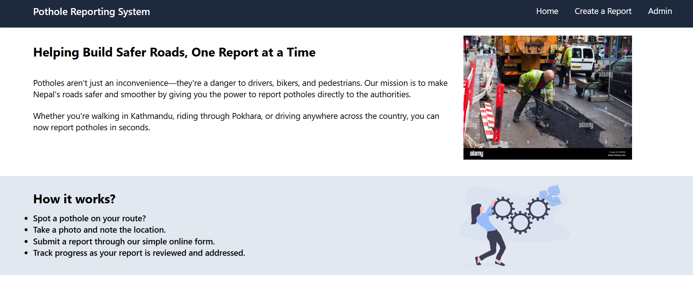

Fig: Landing Page

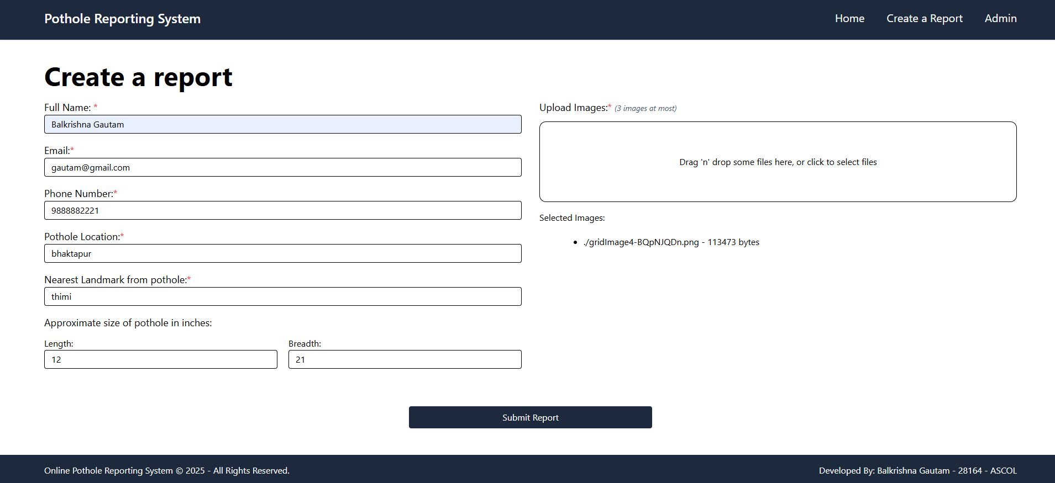

Fig: Create report Form

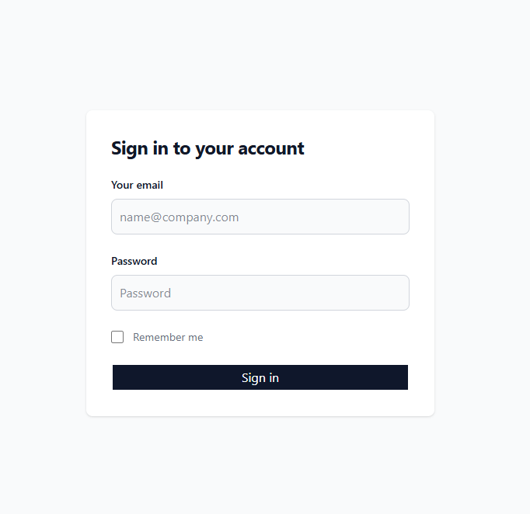

Fig: Login form

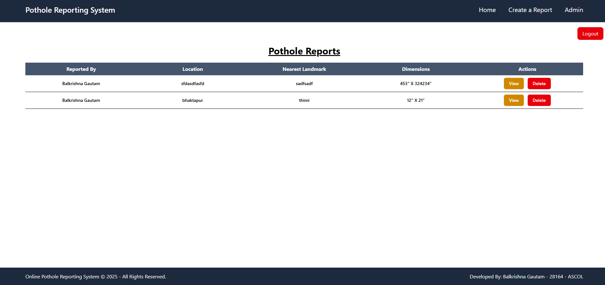

Fig: admin page

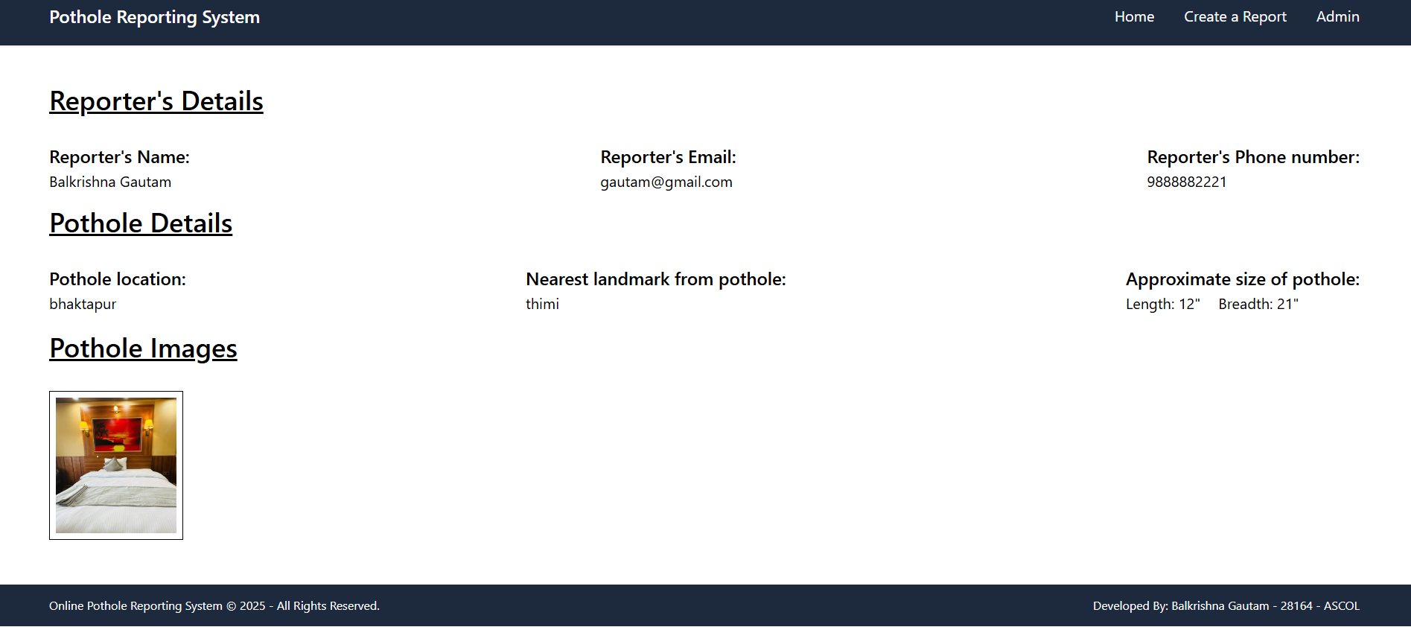

Fig: Report details page