AIR QUALITY PREDICTION USING MACHINE LEARNING IN R
A Time-Aware Comparative Study of Regression Models
Course: Predictive Analytics (CSE574)
Language/IDE: R / RStudio
Student Name: ______________________________
Roll Number: ________________________________
Institution: _________________________________
Faculty: ____________________________________
Submission Date: _____________________________

Abstract
This project develops a reproducible R workflow to estimate hourly carbon monoxide concentration (CO(GT), mg/m³) from air-quality sensor responses, meteorological variables and calendar features. The UCI Air Quality dataset is cleaned by removing fully blank records, interpreting -200 as a missing-value code, parsing timestamps, and retaining observations with a valid target. Five regression families are compared: Multiple Linear Regression, K-Nearest Neighbors (KNN), Support Vector Regression (SVR), Random Forest and Gradient Boosting. A chronological train/validation/test split is used to reflect evaluation on later observations. Hyperparameters are selected on the validation period; the test period is reserved for final evaluation using MAE, RMSE and R². A further contribution is a high-pollution error audit. This is a same-hour estimation study, not a forecast of future pollution.

1. Introduction
Air-quality data contain nonlinear relationships among sensor responses, pollutant levels and meteorological conditions. Predictive analytics can quantify how well these relationships support estimates of a target pollutant. The goal here is not to claim a deployed monitoring system, but to construct a transparent, reproducible academic comparison of regression algorithms.

2. Problem Statement
Given historical hourly air-quality sensor responses and weather variables, estimate the same-hour reference CO concentration (CO(GT), mg/m³). Compare five regression models using a time-aware evaluation protocol and determine which model performs best on a held-out later period.

3. Objectives
- Import and validate the UCI Air Quality dataset in R.
- Clean blank records and translate the documented -200 missing-value code to NA.
- Explore target distribution and time patterns.
- Train and compare five regression algorithms.
- Use chronological train/validation/test partitions and training-only preprocessing.
- Report MAE, RMSE and R² and examine errors in higher-CO observations.
- Document limitations, reproducibility and future work.

4. Dataset and Variables
The dataset is from the UCI Machine Learning Repository and records hourly air-quality observations in an Italian city during 2004–2005. The supplied file contains semicolon-separated fields and decimal commas, along with trailing empty columns/records. The cleaning script removes fully blank records and trailing empty columns.
Variable group | Examples | Use
Target | CO(GT) | Continuous response, mg/m³
Sensor response | PT08.S1(CO), PT08.S2(NMHC), PT08.S3(NOx), PT08.S4(NO2), PT08.S5(O3) | Predictors
Weather | T, RH, AH | Predictors
Calendar | Hour, Month, DayOfWeek | Derived predictors
Excluded | NMHC(GT), C6H6(GT), NOx(GT), NO2(GT) | NMHC has extreme missingness; other reference-analyzer values excluded to emphasize sensor/weather estimation
Rows with missing CO target values cannot be used for supervised training and are excluded. Missing predictor values are median-imputed using statistics calculated on the training partition only.

5. Novelty and Scope
The project’s novelty is a practical experimental-design contribution rather than a claim of a new algorithm: (1) a sensor-and-weather-only feature set that avoids depending on other reference-analyzer pollutant readings, (2) chronological validation rather than a random split, (3) comparison of five algorithm families, and (4) an error audit for higher-CO observations. The task estimates CO for the same hour. It does not claim to forecast the next hour or the next day.

6. Methodology

6.1 Data preparation
Read the semicolon-delimited CSV using a comma decimal mark; remove trailing empty columns and fully blank rows; replace -200 with NA for measurement variables; parse Date and Time into Timestamp; sort chronologically; keep valid CO target observations.

6.2 Features
Five PT08 sensor response variables, temperature (T), relative humidity (RH), absolute humidity (AH), hour, month and day of week. NMHC(GT) is omitted because it is missing for most observations. Other reference-analyzer pollutant measurements are omitted to keep the estimation scenario sensor/weather-oriented.

6.3 Data partition
The first 70% of target-valid observations form training, the next 15% validation, and the final 15% test. This preserves time order.

6.4 Preprocessing
Median imputation is fitted on training data and applied to validation/test data. Standardization is used for KNN and SVR, with means and standard deviations learned from training data.

6.5 Algorithms
Multiple Linear Regression provides a baseline; KNN predicts from nearby scaled observations; linear-kernel SVR uses an epsilon-insensitive loss; Random Forest averages randomized trees; Gradient Boosting builds trees sequentially.

6.6 Model selection
Hyperparameters are compared on validation RMSE. After selection, each model is refitted on training plus validation data and evaluated once on the untouched test period.

7. Evaluation Metrics
MAE = mean absolute error, in mg/m³. RMSE = square root of mean squared error, also in mg/m³ and more sensitive to large misses. R² compares squared prediction error with variation around the observed test mean; higher is generally better, but it can be negative. No classification accuracy is reported because the target is continuous.

8. Exploratory Analysis
The figures below are exploratory/reference figures created from the supplied dataset. The R script regenerates the corresponding figures from its own cleaned data.
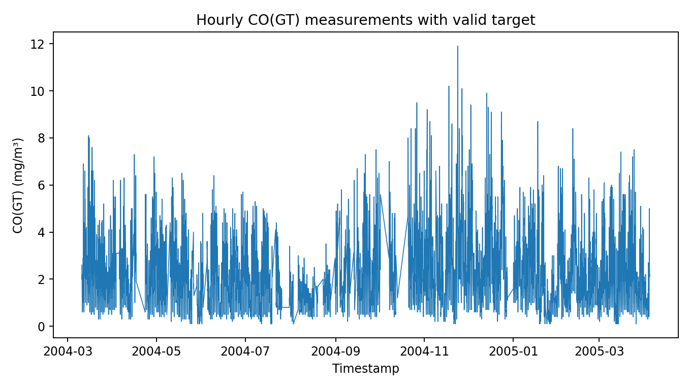
Figure 1. Valid hourly CO measurements over time.
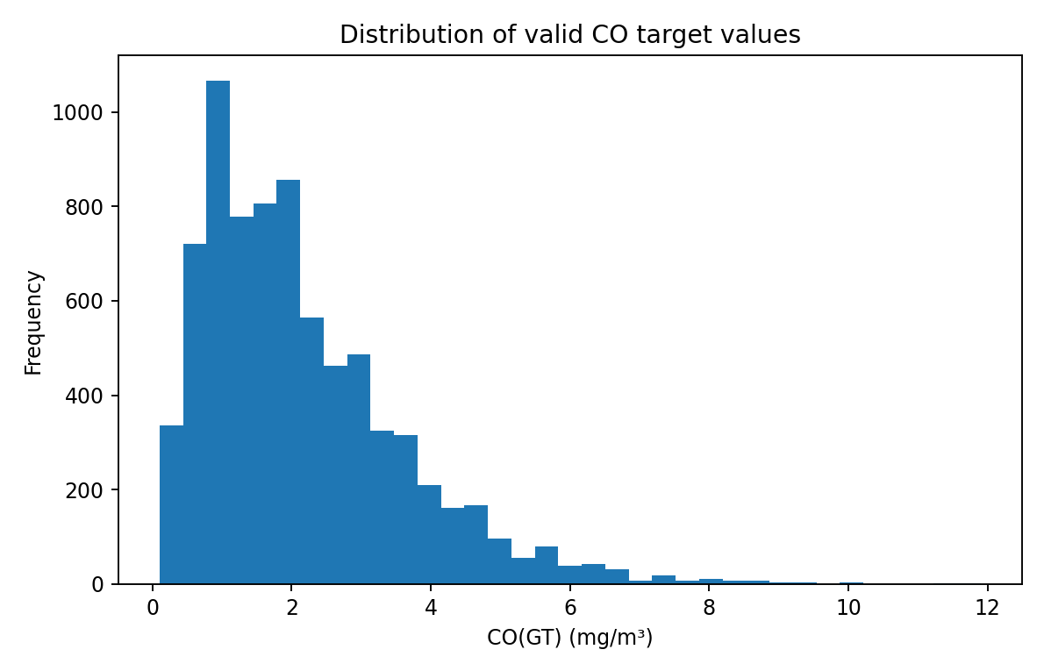
Figure 2. Distribution of valid CO target values.

9. Preliminary Model Comparison
The table below is a reference benchmark produced with analogous Python implementations because an R runtime was not available when this package was assembled. It is included to provide a sanity check and illustrate reporting format. It is NOT a substitute for running the included R pipeline: package implementations and tuning can produce different results. Before submission, replace this table with outputs/test_metrics.csv generated by RStudio.
Model | MAE (mg/m³) | RMSE (mg/m³) | R²
Random Forest Regression | 0.318 | 0.480 | 0.858
Gradient Boosting Regression | 0.321 | 0.481 | 0.858
Support Vector Regression (linear kernel) | 0.336 | 0.495 | 0.849
Multiple Linear Regression | 0.372 | 0.515 | 0.837
KNN Regression | 0.390 | 0.550 | 0.814
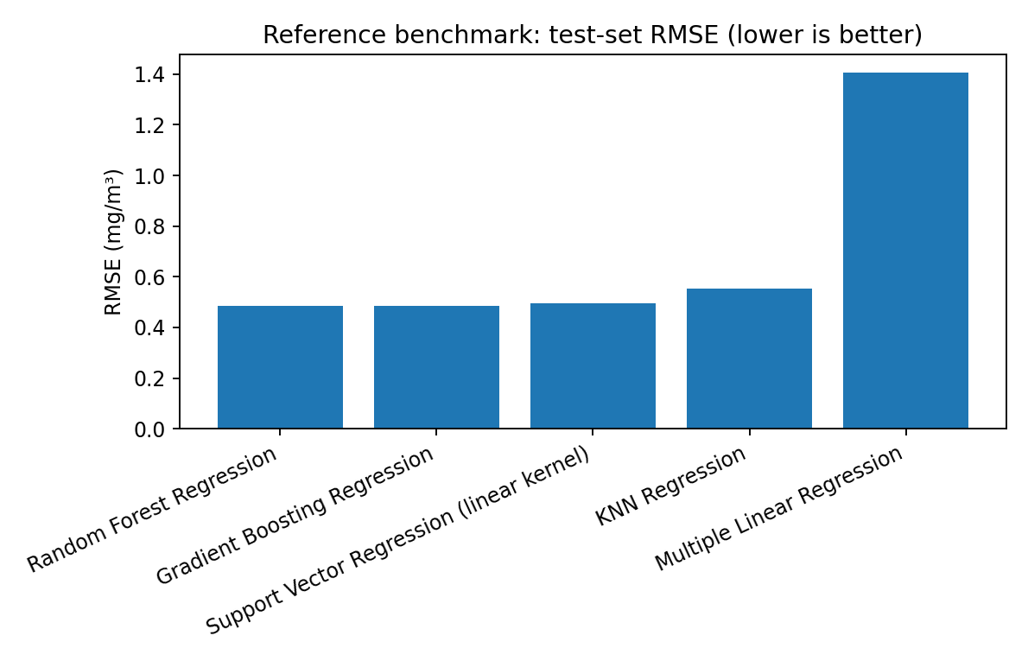
Figure 3. Reference benchmark test RMSE. Lower values indicate smaller average squared-error magnitude.
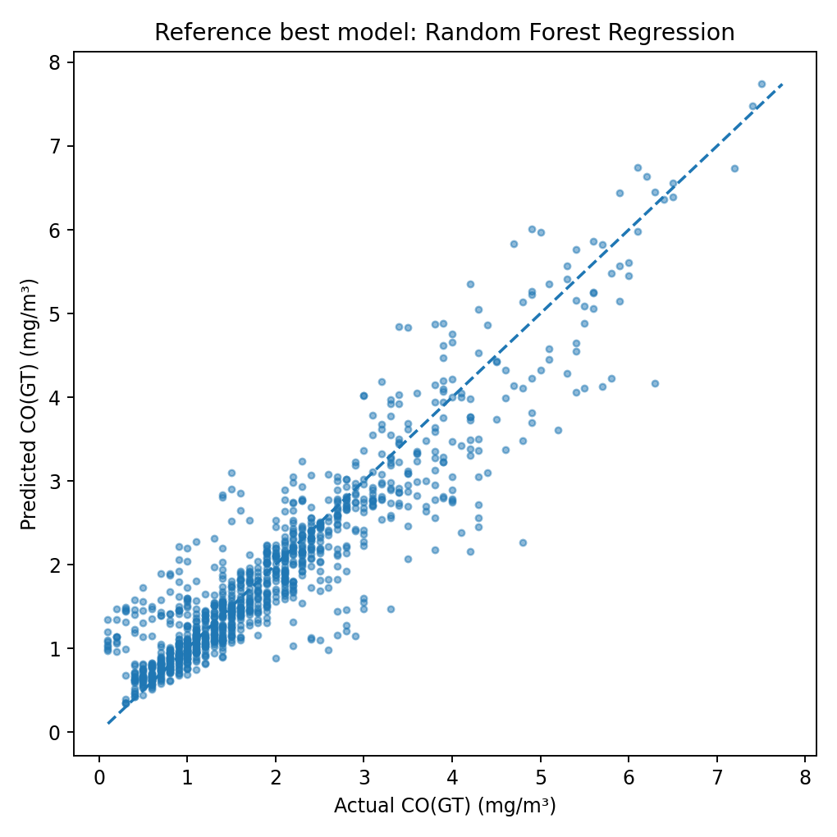
Figure 4. Actual-versus-predicted reference plot for Random Forest Regression. The diagonal indicates perfect predictions.

10. Error Audit and Interpretation
The R script creates outputs/high_pollution_error_audit.csv, which compares overall test error with error for observations at or above the 75th percentile of CO in the training-plus-validation period. This matters because an overall metric can hide poorer performance during higher-pollution periods. Review this output after running the R pipeline and discuss whether the higher-CO subset has larger errors.

11. Limitations
- The data represent one location and an older period (2004–2005), so results may not generalize to current sensors or other cities.
- Sensor drift, calibration and data collection conditions may affect results.
- Target observations with missing CO are excluded; predictor missingness is imputed.
- This is same-hour estimation, not future forecasting.
- The linear SVR is selected for practical runtime; nonlinear SVR can be explored as an extension if computing time permits.
- Reference benchmark scores in this report are not the authoritative R run; regenerate results using the provided script.

12. Conclusion and Future Work
The project provides an end-to-end, reproducible comparison of five regression methods for same-hour CO estimation. Its main strength is a defensible time-aware evaluation design, careful treatment of missing codes, and a separate high-pollution error audit. The final conclusion about the best model must be based on the R-generated held-out test metrics. Future work can develop a true one-hour-ahead forecast using lagged predictors, evaluate a nonlinear SVR, conduct rolling-origin validation, or test generalization on a second location/dataset.

References
Vito, S. (2008). Air Quality. UCI Machine Learning Repository. https://doi.org/10.24432/C59K5F
R Core Team. R: A Language and Environment for Statistical Computing. https://www.r-project.org/
Package documentation: readr, dplyr, ggplot2, e1071, randomForest, gbm and FNN (CRAN).

Appendix A — Reproducibility
Open the supplied RStudio project and run source('scripts/run_project.R') from the project root. The script writes test_metrics.csv, test_predictions.csv, high_pollution_error_audit.csv and figures under outputs/. Include the final R-generated files in the submission and replace reference values in this report.

