PRESENTATION ON INDIAN BANKING



***BY:- 1) SAMARTH DUDHAGUNDI***

***2) NIKHIL PAWAR***



# TYPES OF BANKING SECTOR

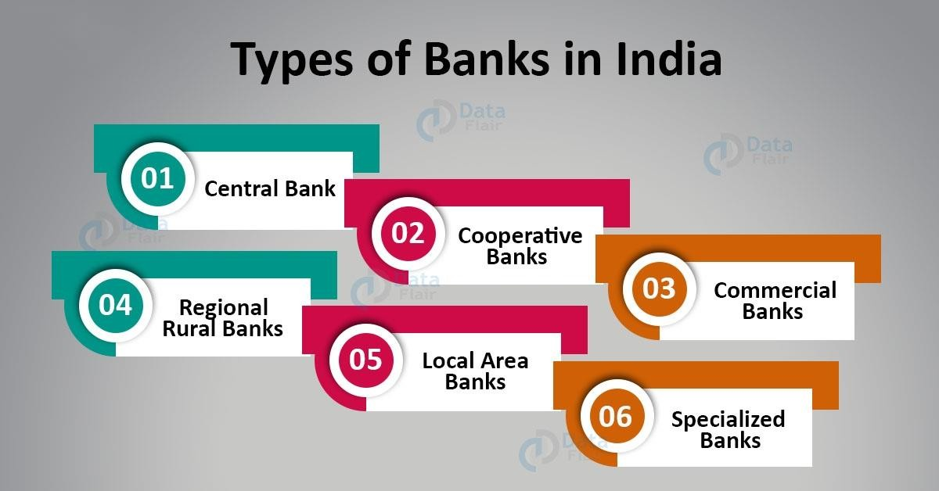



**BANKING SYSTEM IN INDIA**

* The banking system of India consists of the central bank (Reserve Bank of India – RBI), commercial banks, cooperative banks and development banks (development finance institutions).These institutions, which provide a meeting ground for the savers and the investors, form the core of India’s financial sector.



**STRUCTURE OF INDIA BANKING**

**SECTOR**

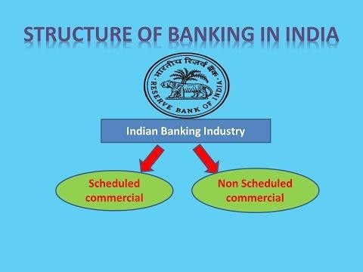

**ALL STRUCTURES**



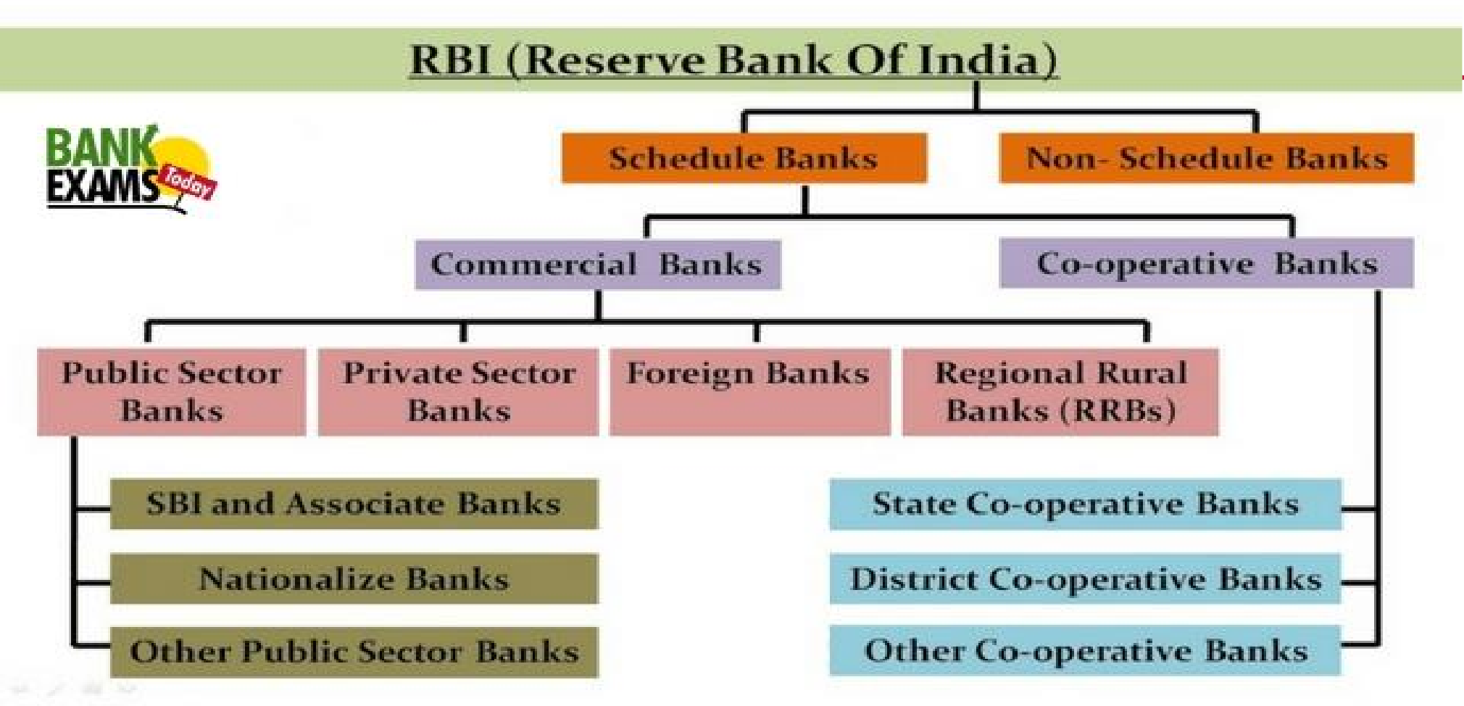



**TYPES OF BANK ACCOUNTS**

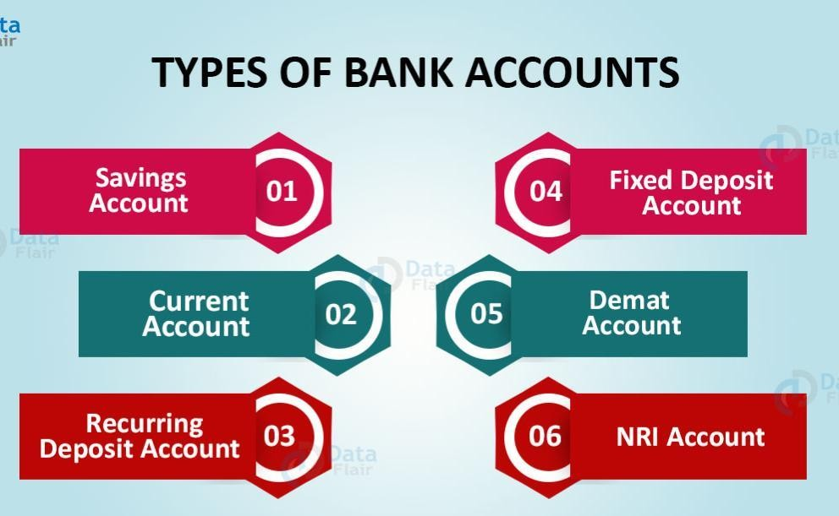



# OBJECTIVE OF BANK

