| **Group No:** XX  **Group Member:**   1. Name Surname 2. Name Surname 3. Name Surname 4. Name Surname 5. Name Surname |
| --- |

# **Part 0: Preparation**

● Go to<https://www.tinkercad.com/>. This website helps us design 3D models and simulate circuits. For this activity, we will create some basic circuits here.

● Log in with your account. If you don’t have an account yet, you need to register first (By clicking the “Sign Up” button on the upper right corner and then click “Create a personal account”) or you may log in via Facebook / Google Account / etc.)

● After successfully creating an account / logging in, you should be redirected to<https://www.tinkercad.com/dashboard>. This is where you can view/manage your created projects.

Next, we will begin the activity by clicking on the “+” under the Circuits – Create your first circuit design. 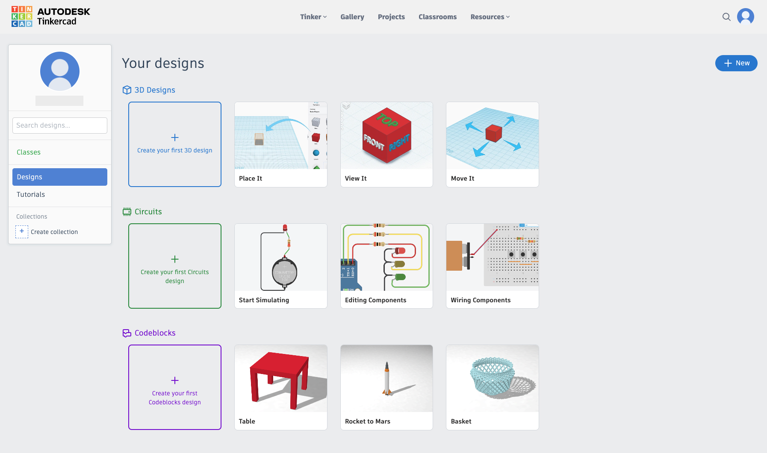

You will be redirected to the workspace, this is the place where you are able to design your own circuit, code some programs in the programmable components and simulate them.

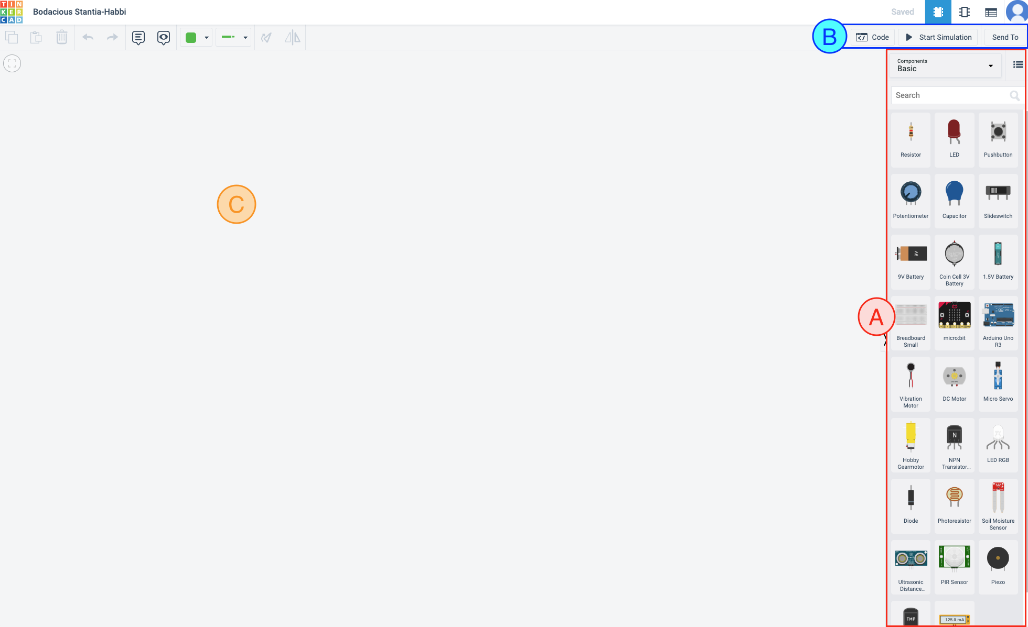

On this page, you will find

- (A) you can get the components that you need for your circuit here. For example, resistors, capacitors, LEDs and more.

- (B) you can add your code to some programmable components (Code) and control your circuit simulation here. You can also click “Send To” > “Invite People” to get the link where you can share to your group members and live-editing with your group.

- (C) your work area where you can create your circuit.

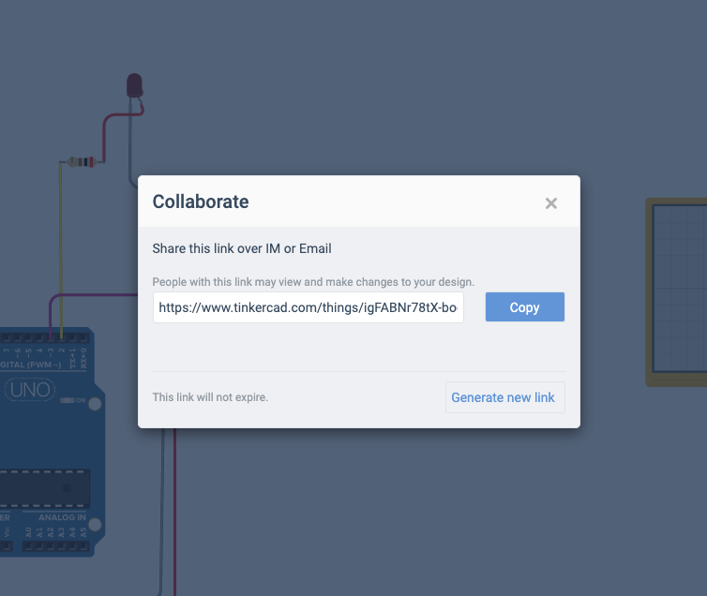

Next, drag and drop the following components from (A) to your work area. You should use the search bar to find your desired components more quickly.  
 - 1 Breadboard

- 1 Arduino UNO

- 2 resistors

- 1 LED

- 1 push button

- 1 oscilloscope

Tips You can press CTRL and scroll your mouse at the work area in order to zoom in/out.

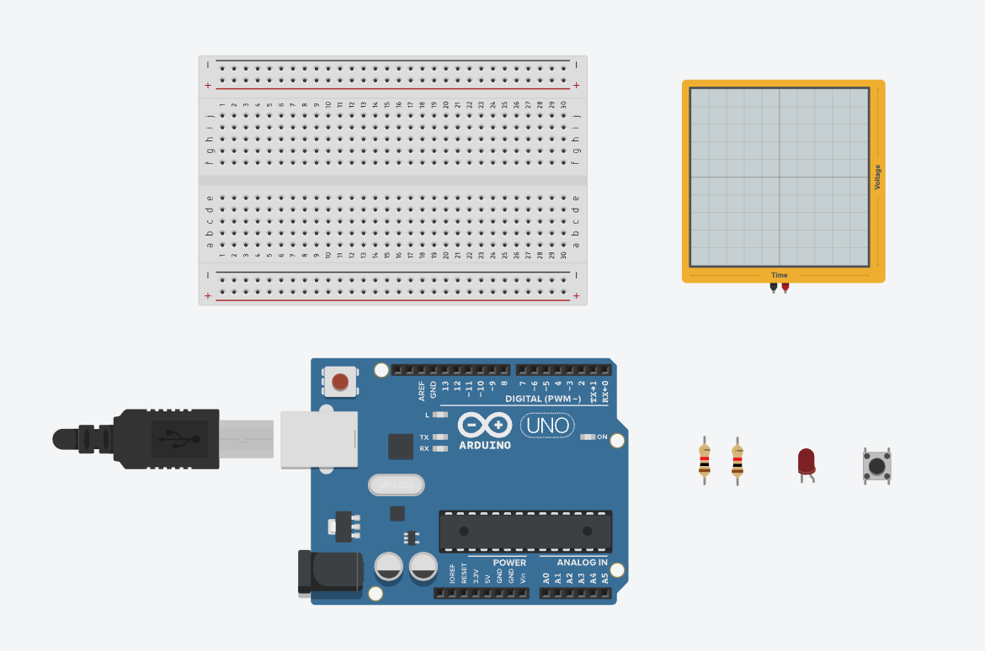

Congratulations, once you reach here, it means that you have finished the Preparation Part. For the rest of the parts, answer the questions in the box given and submit this file (.pdf format) to myCourseVille.

*— THIS IS THE END OF PART 0 —*

**Part 1 : Basic circuit and basic Arduino**

Connect the circuit to the breadboard as shown in the figure. You can wire by clicking and dragging between the devices you want to connect.

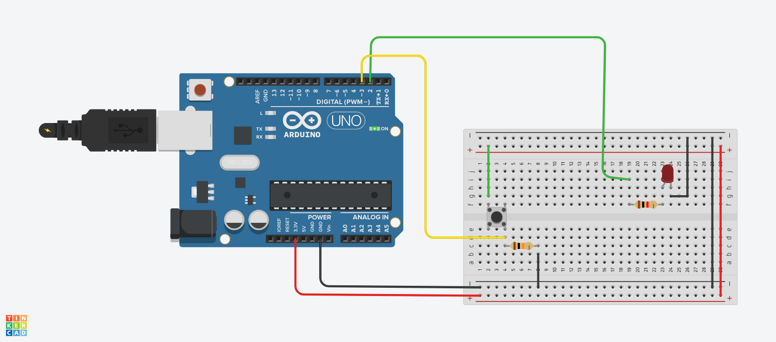

Draw the electrical circuit, by using the electronics devices notation such as 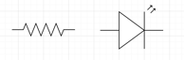. You may use draw.io on google drive or use your tablet to draw the circuit.

Tips For those who aren't familiar with the breadboard connections, you may find this link useful. <https://www.sciencebuddies.org/science-fair-projects/references/how-to-use-a-breadboard> or try [this tutorial](https://www.tinkercad.com/learn/overview/OPRHCXXL20FZS3N?collectionId=undefined&type=circuits)

|  |
| --- |

Try this code to see if your circuit is correct. You can copy-and-paste the code below.

| int LED_PIN = 2;  int BUTTON_PIN = 3;  int buttonState = 0;  void setup()  {  pinMode(LED_PIN, OUTPUT);  pinMode(BUTTON_PIN, INPUT);  }  void loop()  {  buttonState = digitalRead(BUTTON_PIN);  *if*(buttonState == 1){  digitalWrite(LED_PIN, HIGH);  }  *if*(buttonState == 0){  digitalWrite(LED_PIN, LOW);  }  } |
| --- |

Explain what the code above does?

|  |
| --- |

Write Arduino code to do the following task. Toggle the LED light when the push button is pushed, i.e. if the LED is on, turn it off but if the LED is off, turn it on. It should not toggle again until the pushbutton is released and re-pressed again (this means, if you keep the button pressed constantly, the LED should not be constantly toggling)

|  |
| --- |

Once you finish, students must inform an instructor or a TA for inspection.

*— THIS IS THE END OF PART 1 —*