| Group No: XX  Group Member:   1. Name Surname 2. Name Surname 3. Name Surname 4. Name Surname 5. Name Surname |
| --- |

**Part 2.1 : Serial ports**

What is the meaning of “Baud Rate”? What is the unit of the “Baud Rate”?

|  |
| --- |

Use the following code to control the LED via the serial input port. Sending ‘1’ turns on the LED, Sending ‘0’ turns off the LED.

| const int LED_PIN = 2;  const int BUTTON_PIN = 3;  int ledState = LOW;  void setup() {  pinMode(LED_PIN, OUTPUT);  pinMode(BUTTON_PIN, INPUT);  Serial.begin(115200);  Serial.println("\n\nHello world!!!");  }  void loop() {  *if*(Serial.available() > 0) {  char inChar = Serial.read();  *if*(inChar == '0') {  ledState = LOW;  Serial.println("Turn Off");  } *else* *if*(inChar == '1') {  ledState = HIGH;  Serial.println("Turn On");  }  }  digitalWrite(LED_PIN, ledState);  } |
| --- |

Serial Monitor (Box A & B) provides an interface to Arduino via serial port. You can observe the serial output in Box A at the bottom of the Code pane and you can enter input in Box (B).

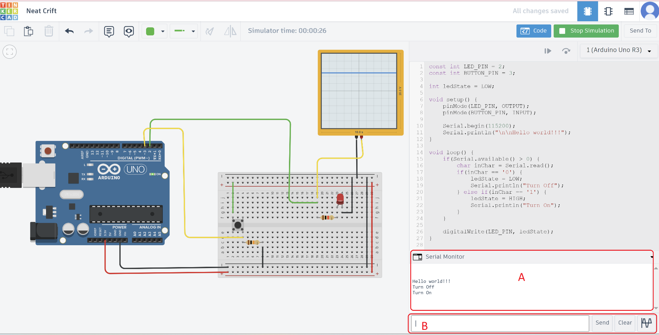

**Part 2.2 : PWM**

What does “PWM” stand for?

|  |
| --- |

Use the following code to implement PWM with the built-in analogWrite(). You can monitor the PWM graph via the oscilloscope. (The range of PWM is between 0 and 255. If the PWM is at 0 that mean the system is running at 0% and If the PWM is at 255 this mean that the system is running at 100%)

const int LED_PIN = 3;

int dutyCycle = 0;

void setup() {

pinMode(LED_PIN, OUTPUT);

Serial.begin(115200);

Serial.println("\n\nHello world!!!");

}

void loop() {

analogWrite(LED_PIN,dutyCycle);

dutyCycle++;

delay(30);

}

Explain the output of the code above.

|  |
| --- |

Create PWM manually, write code to accept an input from ‘0’ to ‘9’ through the serial port. The value should control the LED intensity such that ‘0’ corresponds to 0% and ‘9’ corresponds to 90%. This must be performed using only digitalWrite() instead of analogWrite(); i.e. bit banging PWM method.

Example Video Clip: <https://youtu.be/oLsSGaJd38o>

|  |
| --- |

Once you finish, students must inform an instructor or a TA for inspection.

*— THIS IS THE END OF PART 2 —*