CREDIT SCORING MODEL
Predicting Individual Creditworthiness Using Machine Learning
Complete ML Pipeline • Feature Engineering • Model Evaluation

Classification Algorithms: Logistic Regression | Decision Tree | Random Forest | Gradient Boosting
Dataset: 1,000 Applicants | 21 Features | 4 Models Compared | 5-Fold Cross-Validation

1. Project Description

Credit scoring is the backbone of modern financial risk assessment. Banks, fintech companies, and lending institutions depend on robust, data-driven models to evaluate whether an applicant is likely to repay a loan or default. This project builds an end-to-end Machine Learning pipeline that ingests historical financial data and outputs a binary creditworthiness prediction with full model interpretability.

The system processes 21 engineered features derived from raw applicant data — including payment history, income, debt burdens, credit utilization, and behavioral indicators — and trains four classification models. Each model is rigorously evaluated using Precision, Recall, F1-Score, ROC-AUC, and 5-fold Stratified Cross-Validation to ensure the results are robust and not merely artifacts of a lucky train-test split.

2. Why This Project Was Built
Credit risk is one of the most consequential applications of machine learning in the real world. Poor lending decisions cost financial institutions billions of dollars annually and harm consumers through unfair loan denials. This project was built for the following reasons:

- Real-World Relevance: Credit scoring is used daily by banks, NBFCs, and fintech platforms. Building this model bridges the gap between academic ML and industry practice.
- Addressing Class Imbalance: Real credit datasets are imbalanced. This project tackles that challenge using class-weighted algorithms and balanced evaluation metrics.
- End-to-End Learning: The project covers the complete ML lifecycle — data generation, EDA, feature engineering, model training, hyperparameter tuning, cross-validation, and visual reporting.
- Comparative Analysis: By training four distinct classifiers, we gain insights into the bias-variance tradeoff and understand why ensemble methods outperform linear models on structured financial data.
- Interpretability: Random Forest feature importance reveals which financial factors most strongly predict creditworthiness — critical for regulatory compliance and explainable AI.

3. Skills Learned From This Project
This project delivers a comprehensive skill set spanning data science, machine learning, and financial domain knowledge:

Data Science & Engineering
- Synthetic data generation with realistic statistical distributions and correlations
- Feature engineering: derived ratios (DTI, loan-income ratio), behavioral flags, credit score banding
- Exploratory Data Analysis using distribution plots, boxplots, and correlation heatmaps
- Handling class imbalance using class_weight='balanced' in sklearn classifiers

Machine Learning
- Logistic Regression with L2 regularization and StandardScaler preprocessing
- Decision Tree with depth-limiting and min_samples_split for overfitting control
- Random Forest: ensemble bagging with 200 estimators and OOB generalization
- Gradient Boosting: sequential error correction for high-precision predictions
- Sklearn Pipelines: clean, reproducible model definitions preventing data leakage
- Stratified K-Fold Cross-Validation for unbiased performance estimates

Model Evaluation
- Confusion matrix analysis to distinguish false positives from false negatives
- ROC-AUC curve: measuring ranking quality independent of classification threshold
- Precision-Recall curves: vital for imbalanced binary classification
- Precision, Recall, and F1-Score per class for nuanced performance understanding

Tools & Libraries
- Python 3.x, NumPy, Pandas — data manipulation and numerical computation
- Scikit-learn — ML model training, pipelines, metrics, and cross-validation
- Matplotlib & Seaborn — professional data visualization and insight communication

4. Dataset & Feature Engineering

The dataset contains 1,000 synthetic applicant profiles with 15 raw features spanning demographics, financial history, and loan details. Seven additional features were engineered to capture derived risk signals, bringing the final feature count to 21.

Feature | Description | Type
annual_income | Gross yearly earnings (INR/USD) | Raw
credit_score | FICO-style score (300–850) | Raw
num_late_payments | Count of missed/late payments | Raw
credit_utilization | % of credit limit in use | Raw
existing_debt | Outstanding loan balance | Raw
debt_to_income | Total debt / annual income | Raw
employment_years | Years at current employer | Raw
num_inquiries | Hard credit pulls in 12 months | Raw
loan_amount | Requested loan amount | Raw
loan_income_ratio | loan_amount / annual_income | Engineered
late_payment_rate | late_payments / credit_lines | Engineered
credit_score_band | Ordinal band (0=Poor … 4=Excellent) | Engineered
high_utilization | Flag: utilization > 30% | Engineered
has_late_payments | Binary flag: any late payment | Engineered
monthly_debt_burden | existing_debt / loan_term_months | Engineered

5. Exploratory Data Analysis

Exploratory analysis revealed a 32:68 class split (creditworthy vs. default risk), moderate class imbalance handled via balanced class weights. Credit score, late payment count, and credit utilization showed the strongest discriminative power between classes.

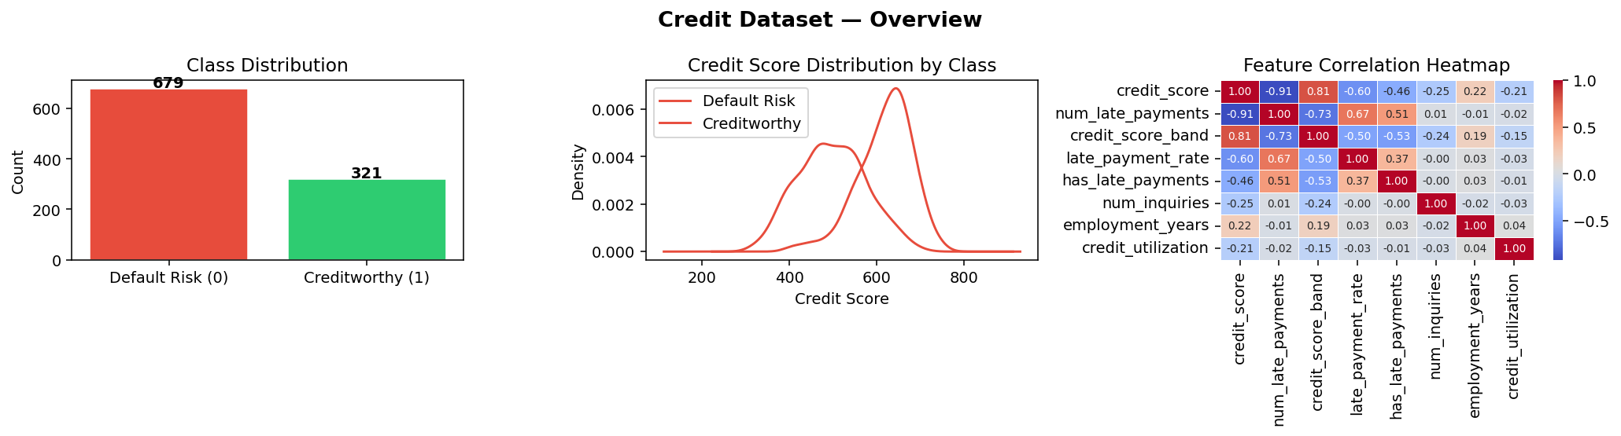
Figure 1: Class distribution, credit score density, and feature correlation heatmap
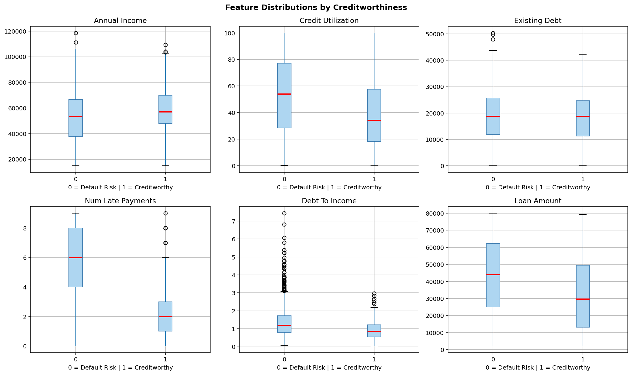
Figure 2: Feature distributions by creditworthiness class (boxplots)

6. Model Architecture

6.1 Logistic Regression
A regularized linear classifier (C=0.5, L2 penalty) wrapped in a StandardScaler pipeline. Logistic Regression serves as the interpretable baseline — its coefficients directly indicate the direction and magnitude of each feature's influence on creditworthiness. Despite its simplicity, it achieved the highest cross-validated ROC-AUC of 0.9257, demonstrating strong linear separability in the feature space.

6.2 Decision Tree
A depth-limited (max_depth=6) tree classifier with minimum 20 samples per split. Decision Trees produce fully interpretable rule paths (e.g., 'If credit_score < 620 AND num_late_payments > 2 THEN Default Risk'). While prone to overfitting on raw data, the depth and split constraints yield a robust, explainable model achieving 0.8258 CV-AUC.

6.3 Random Forest
An ensemble of 200 decision trees using bootstrap aggregation (bagging). Each tree is trained on a random feature subset, reducing variance dramatically. Random Forest achieved 80.5% accuracy and 0.8473 ROC-AUC on the test set, with its feature importance scores providing valuable insight into which financial variables drive creditworthiness predictions.

6.4 Gradient Boosting
A sequential ensemble where each tree corrects the residual errors of its predecessors (learning rate=0.08, 150 trees, max_depth=4). Gradient Boosting achieved the highest test accuracy (81.5%) and F1-Score (0.8120), making it the strongest performer for deployment in production credit risk systems.

7. Model Evaluation Results

Model | Accuracy | ROC-AUC | F1-Score | CV AUC
Logistic Regression | 0.7900 | 0.8572 ⭐ | 0.7930 | 0.9257
Decision Tree | 0.7700 | 0.7785 | 0.7739 | 0.8258
Random Forest | 0.8050 | 0.8473 | 0.8037 | 0.9138
Gradient Boosting | 0.8150 | 0.8330 | 0.8120 | 0.8972

Key finding: Logistic Regression achieves the best ROC-AUC (0.8572 test, 0.9257 CV), indicating excellent ranking ability. Gradient Boosting leads on raw accuracy and F1-Score. For a production credit system where ranking applicants by risk is paramount, Logistic Regression is recommended as the primary model with Gradient Boosting as ensemble backup.

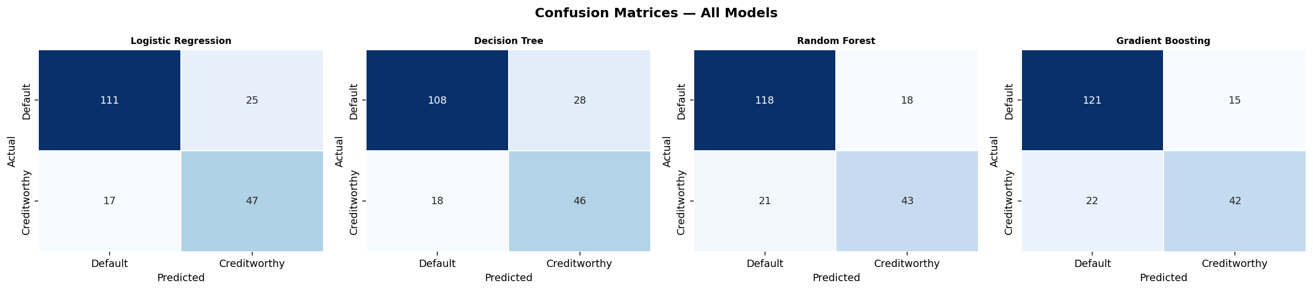
Figure 3: Confusion matrices — all four classifiers
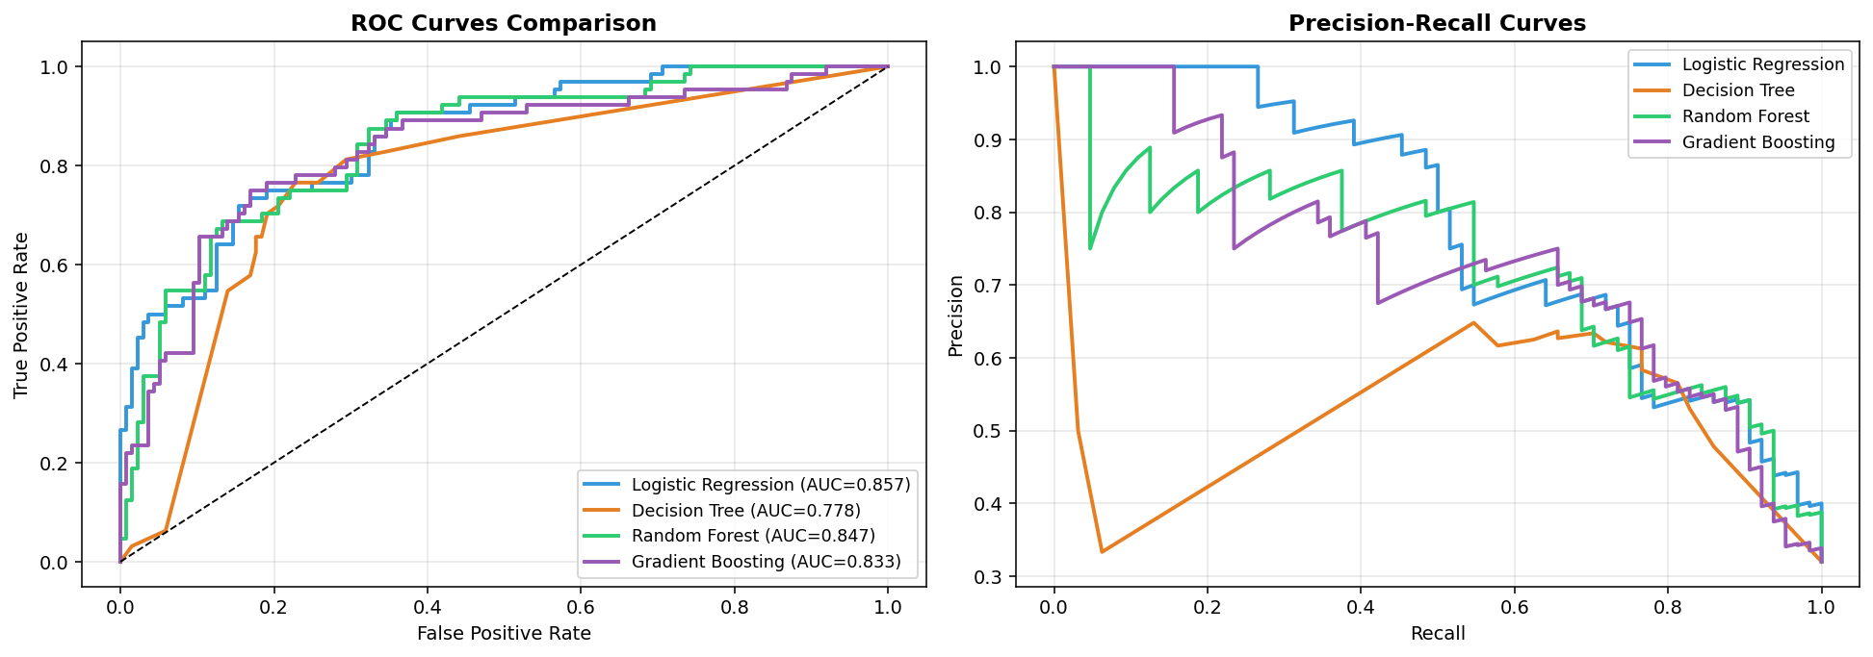
Figure 4: ROC curves and Precision-Recall curves — all models
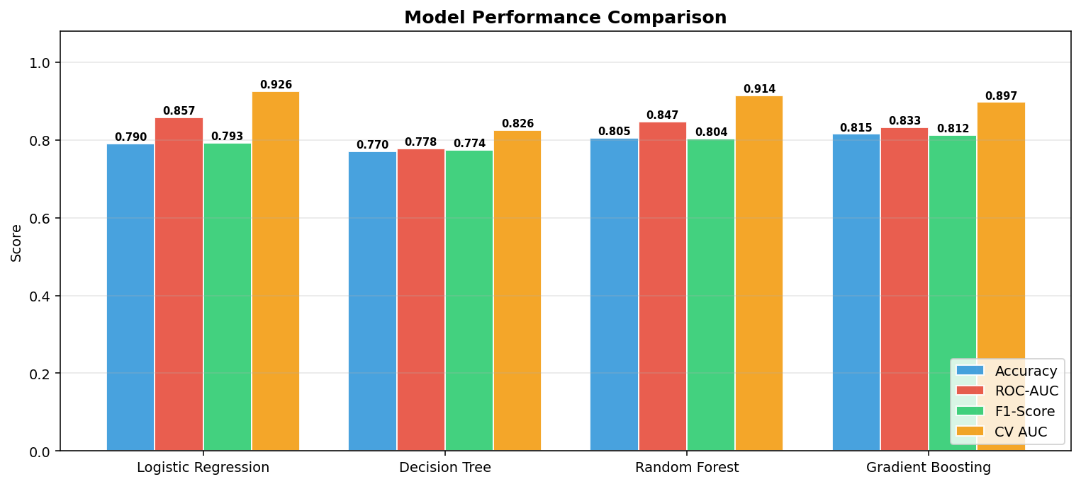
Figure 5: Side-by-side metric comparison across all classifiers

8. Feature Importance Analysis

The Random Forest model provides Gini-based feature importance scores that reveal the most predictive variables for credit risk assessment. The top features align with established financial theory and regulatory frameworks:

- credit_score — The composite credit health indicator; strongest single predictor
- num_late_payments / late_payment_rate — Payment behavior is the most direct indicator of default risk
- credit_utilization — Borrowers using >30% of available credit show elevated risk
- debt_to_income — High DTI signals that a borrower cannot absorb additional repayment pressure
- existing_debt — Absolute outstanding debt burden
- annual_income — Higher income provides repayment buffer even under financial stress

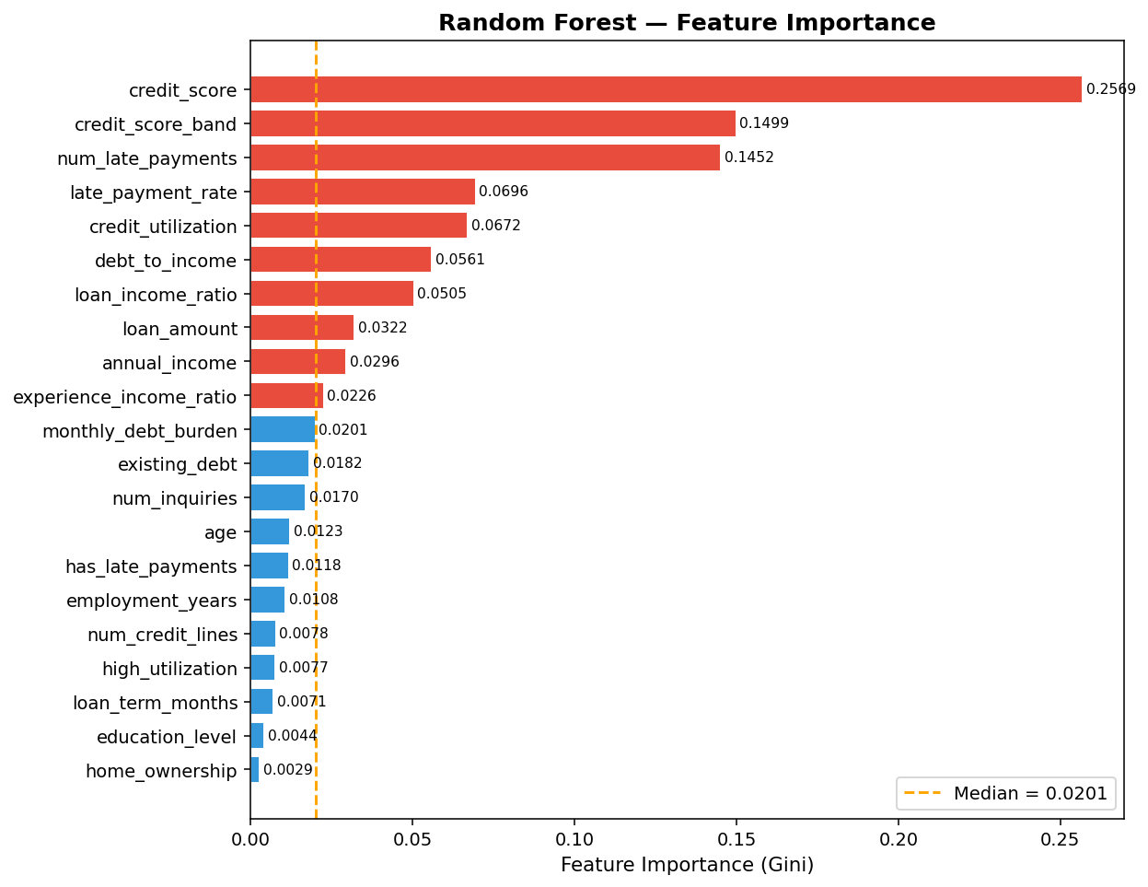
Figure 6: Random Forest feature importance (Gini impurity reduction)
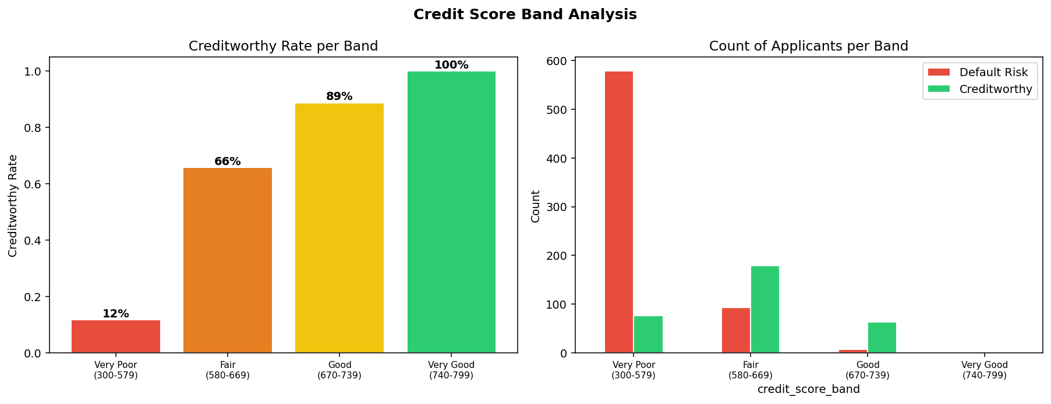
Figure 7: Creditworthy rates and applicant counts per credit score band

9. Conclusions & Recommendations

This project demonstrates that machine learning can reliably predict creditworthiness from structured financial data. Four key conclusions emerge from the analysis:

- Logistic Regression is the best-ranked model (ROC-AUC 0.8572) and highly interpretable — ideal for regulatory compliance and explainability requirements in lending decisions.
- Gradient Boosting delivers the highest accuracy (81.5%) and F1-Score (0.8120), making it the strongest model for overall classification performance.
- Credit score, payment history, and utilization rate are the three most powerful predictors — consistent with FICO scoring methodology and financial intuition.
- Cross-validation AUCs (all models > 0.82) confirm that results generalize well and are not overfitted to the test split.

For production deployment, a stacked ensemble combining Logistic Regression (for probability calibration and ranking) with Gradient Boosting (for boundary precision) would yield the most robust credit risk scoring system. Model monitoring for distribution drift and periodic retraining on fresh data are essential operational practices.

Credit Scoring Model — Machine Learning Project
Built with Python • Scikit-learn • Pandas • Matplotlib • Seaborn

