MENU

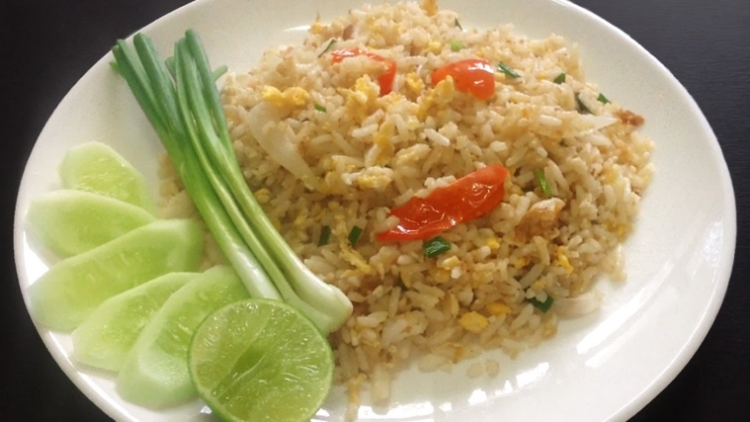

ข้าวผัด fried rice 炒飯

|  |  |  |
| --- | --- | --- |
|  |  |  |
| 35 THB | 35 THB | 40 THB |

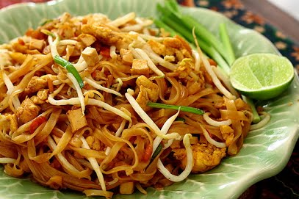

ผัดไท Pad thai

|  |  |  |
| --- | --- | --- |
|  |  |  |
| 35 THB | 35 THB | 40 THB |

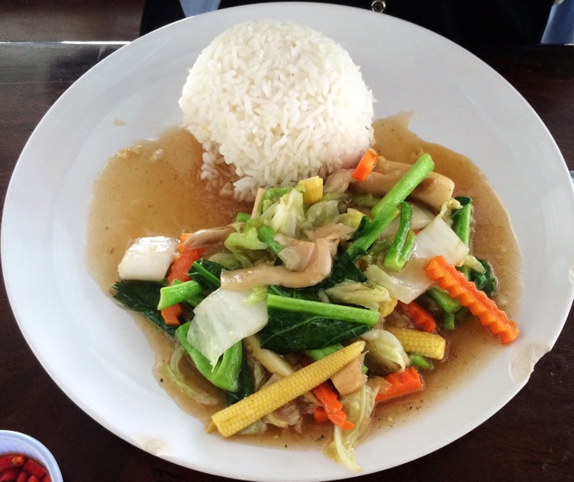

ผัดผักรวมมิตร stir fried vegetable

|  |  |  |
| --- | --- | --- |
|  |  |  |
| 35 THB | 35 THB | 40 THB |

MENU

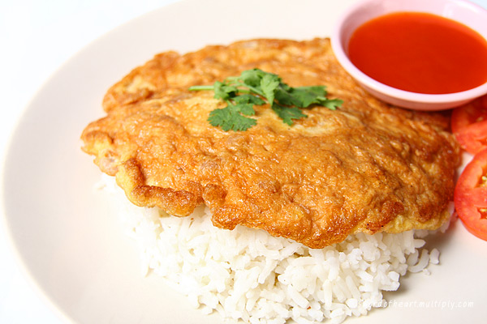

ไข่เจียว Omelet

|  |  |  |
| --- | --- | --- |
|  |  |  |
|  | 35 THB |  |

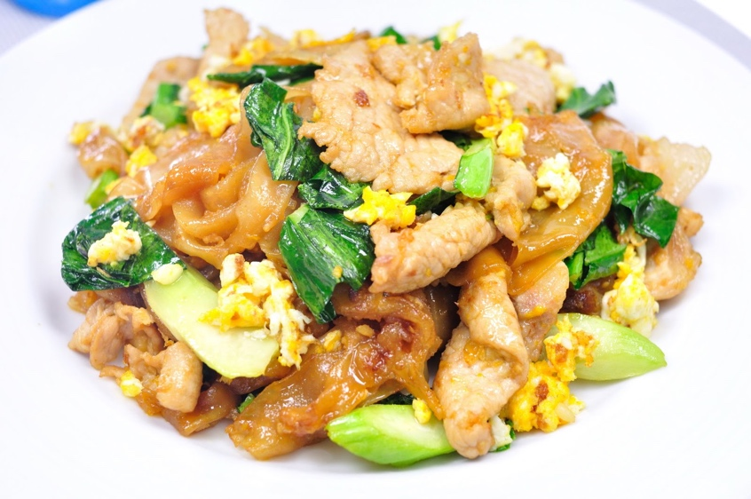

ผัดซีอิ้ว stir fried noodle

|  |  |  |
| --- | --- | --- |
|  |  |  |
| 35 THB | 35 THB | 40 THB |

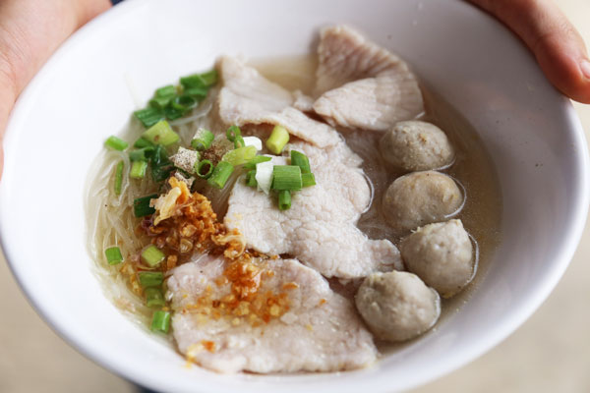

ก๋วยเตี๋ยว noodle

|  |  |  |
| --- | --- | --- |
|  |  |  |
|  | 30 THB |  |

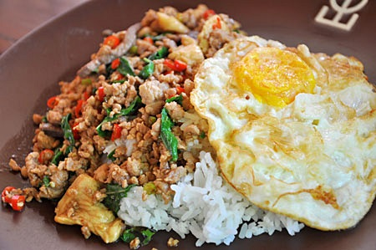

ผัดกระเพรา stir fired basil and chili

|  |  |  |
| --- | --- | --- |
|  |  |  |
| 35 THB | 35 THB | 45 THB |

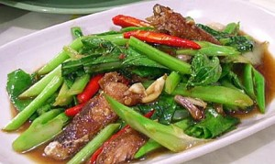

ผัดคะน้า Kale fried in oyster sauce

|  |  |  |
| --- | --- | --- |
|  |  |  |
| 35 THB | 35 THB | 40 THB |

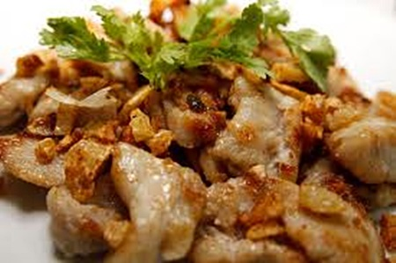

ทอดกระเทียม พริกไทย Fried with garlic and pepper

|  |  |  |
| --- | --- | --- |
|  |  |  |
| 35 THB | 35 THB | 50 THB |

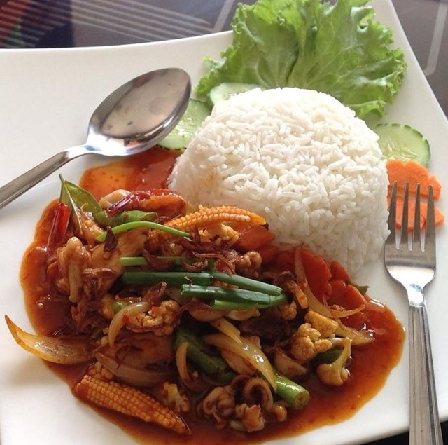

ผัดพริกเผา fried with chili paste

|  |  |  |
| --- | --- | --- |
|  |  |  |
| 35 THB | 35 THB | 45 THB |
|  |  |  |

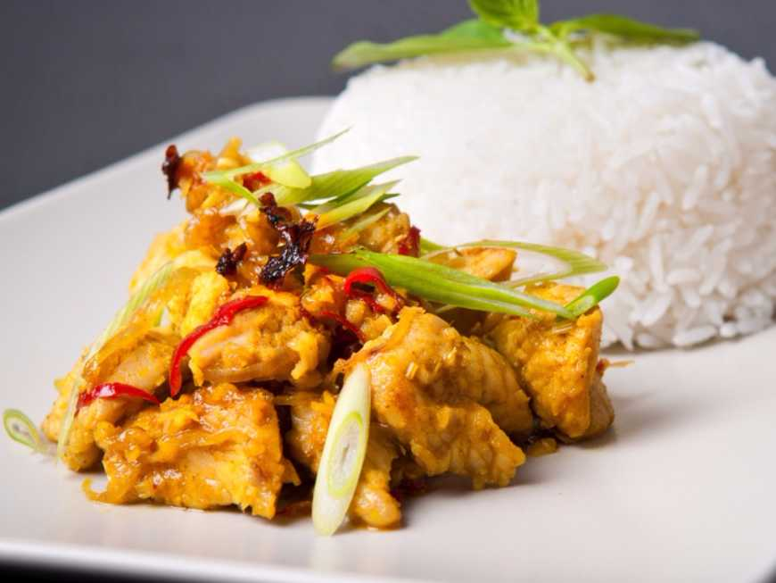

ผัดผงกระหรี่ stir fried with Curry Powder

|  |  |  |
| --- | --- | --- |
|  |  |  |
| 40 THB | 40 THB | 45 THB |
|  |  |  |

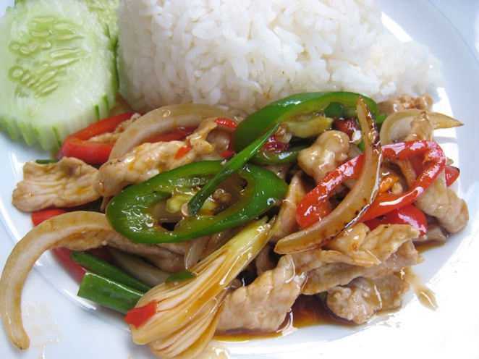

ผัดพริกสด stir fried with chili and onion

|  |  |  |
| --- | --- | --- |
|  |  |  |
| 35 THB | 35 THB | 45 THB |
|  |  |  |