uSER’S MANUAL

Ballenger Operating System (BOS)

Table of Contents

Overview of the OS 2

Summary of Commands 3

Commands 4

Version 4

Date 4

Directory 5

History 5

Alias 6

Exit 6

Help 7

Execute 8

# Overview of the OS

The Ballenger Operating System (BOS) offers simple commands to access information from your computer. Offering 8 total commands, ranging from simple information providing commands to running files and executing basic instructions. The following information shows simple examples of each command as well as the possible errors that occur.

# Commands

The following details all valid commands for BOS. Each section includes the syntax for the command, the use for the command, examples of the command in use, and any possible errors.

## Version

**Syntax:** ver

**Use:** This command will print out the software version number for your BOS shell.

**Example:**

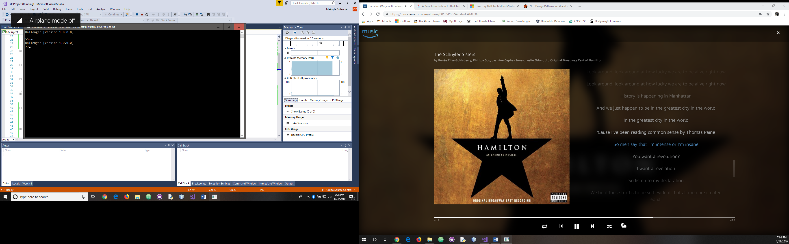

**Possible Errors with Error Message:**

Not applicable.

## Date

**Syntax:** date**,** first three letters of the day mm/dd/yyyy

**Use:** This command will print out the current date. It will also provide the option to change this date using the format in the syntax section.

**Example:**

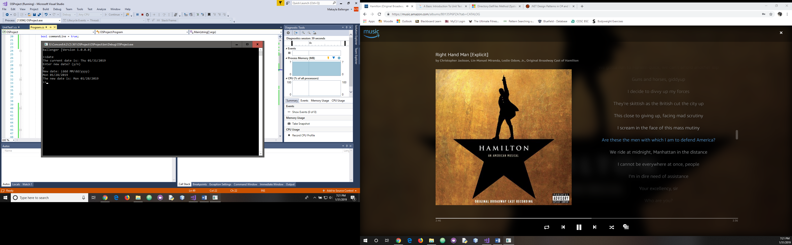

**Possible Errors with Error Message:**

Not applicable.

## Directory

**Syntax:** dir

**Use:** This command will print out all of the folders/files within a directory.

**Example:**

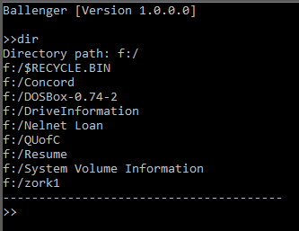

**Possible Errors with Error Message:**

Non-existent path name

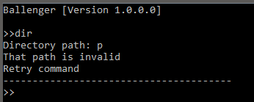

## History

**Syntax:** hist

**Use:** This command will print out all of the commands previously used while this instance of the shell was running.

**Example:**

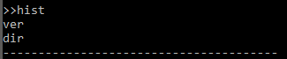

**Possible Errors with Error Message:**

Not applicable.

## Alias

**Syntax:** alias

**Use:** This command will rename a standard command to a name of the user’s choice. The standard command will also still be available. The user can have several different names for a command.

**Example:**

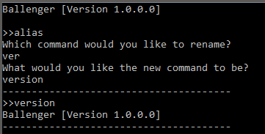

**Possible Errors with Error Message:**

Invalid command to rename

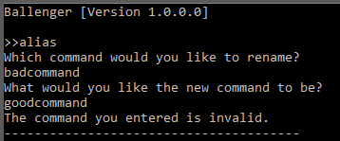

## Exit

**Syntax:** exit

**Use:** This command will exit the user out of the shell.

**Example:**

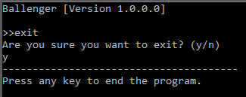

**Possible Errors with Error Message:**

Invalid syntax when confirming the exit

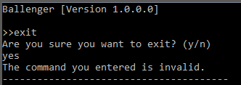

## Help

**Syntax:** help

**Use:** This command will provide the necessary information for each command.

**Example:**

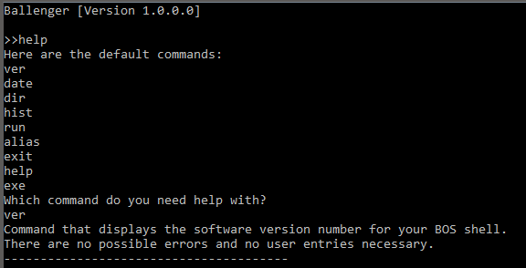

**Possible Errors with Error Message:**

Invalid command to receive help with

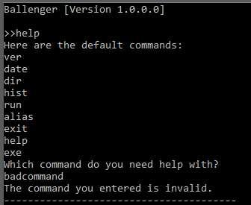

## Execute

**Syntax:** exe

**Use:** This command will execute user provided files and show the result of each command.

**Example:**

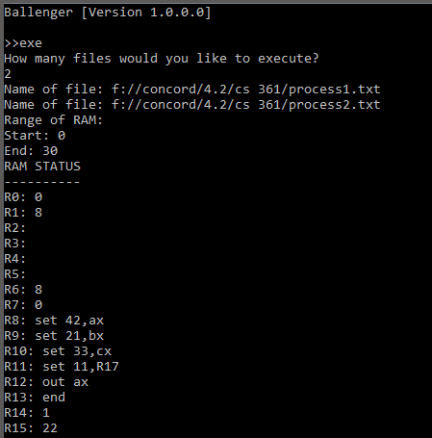

**Possible Errors with Error Message:**

Non-existent file location/name

