Design Description:

Fault Tolerant Fuel Control System

Disclaimer: This design description document is not complete and it is used for illustration of typical set of design description, The document is to be for feature demonstration purposes only.

Date: October 7, 2009

Version: 1.0

Table of Contents

Design Description: 1

Fault Tolerant Fuel Control System 1

*1.* Interface Definition 3

1.1. Input Signals 3

1.2. Output Signals 4

*2.* Subsystems 4

2.1. Mass airflow estimation 4

2.2. Determination of pumping efficiency 4

2.3. Adjustment of estimated airflow 4

2.4. Failure Control Vector 4

2.5. Fueling Modes 4

*3.* Failure Management Subsystem 5

3.1. Oxygen sensor disabled during warmup 5

3.2. Enriched mixture usage 5

3.3. Manifold pressure failure mode 5

3.4. Speed sensor failure detection 5

3.5. Disable fuel system due to sensor failure 5

3.6. Disable fuel system due to engine speed 5

## Interface Definition

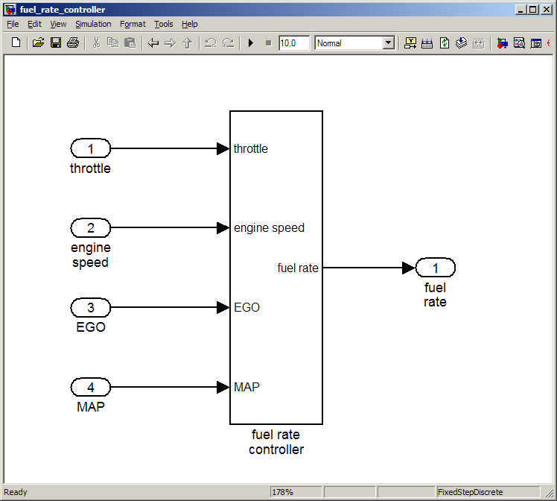  
*Image 1: High level block diagram of the System*

### Input Signals

#### Throttle Sensor

**Description:** The throttle position sensor shall have a normal and a failed control mode within a state diagram used to design the failure detection logic.

**Data Type:** double

**Nominal Ranges:**

#### Manifold Absolute Pressure Sensor

**Description:** The manifold absolute pressure (MAP) sensor shall have a normal and a failed control mode within a state diagram used to design the failure detection logic.

**Data Type:** double

**Nominal Ranges:**

#### Oxygen Sensor

**Description:**

**Data Type:** double

**Nominal Ranges:**

#### Speed Sensor

**Description:**

**Data Type:** uint8

**Nominal Ranges:**

### Output Signals

#### Fuel Rate

**Description:**

**Data Type:** double

**Nominal Ranges:**

## Subsystems

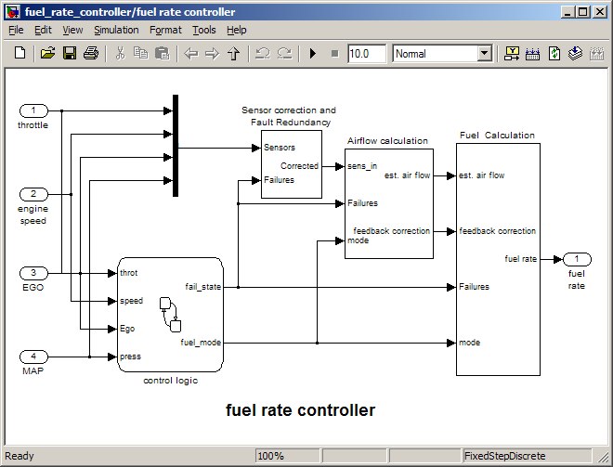

### Mass airflow estimation

Model Element: fuelsys/fuel rate controller/Airflow calculation

Details: The controller will use engine speed, throttle position and manifold pressure to estimate the mass airflow through the engine. This was very important change.

### Determination of pumping efficiency

Model Element: fuelsys/fuel rate controller/Airflow calculation/Pumping Constant

Details: The airflow calculation will use a calibratible table to determine the pumping efficiency of the engine based on engine speed and manifold pressure.

### Adjustment of estimated airflow

Model Element: fuelsys/fuel rate controller/Airflow calculation/Integrator

Details: The fuel system will use an exhaust gas oxygen sensor to adjust the estimated airflow.

### Failure Control Vector

The controller shall provide access to the internal vector of failure flags that indicate what sensors are in a failure condition.

### Fueling Modes

The controller shall provide access to the fueling mode indicator that will identify when the controller is using operating in a stoichiometric mode, a programmed enrichment mode, or the fuel disabled mode.

## Failure Management Subsystem

### Oxygen sensor disabled during warmup

Model Element: State: Oxygen_Sensor_mode.O2_warmup

Trans: [t > o2_t_thresh]

Details: During a calibratible warm up period the oxygen sensor correction will be disabled.

### Enriched mixture usage

Model Element: State: Fueling_Mode.Running.Rich_Mixture

Details: The fuel system will use an enriched mixture whenever a sensor has failed.

### Manifold pressure failure mode

Model Element: fuelsys/fuel rate controller/Sensor correction and Fault Redundancy/MAP Estimate

Details: When the manifold pressure sensor is in a failure mode, manifold pressure will be estimated from a lookup table based on engine speed and manifold pressure.

### Speed sensor failure detection

Model Element: Trans: [speed==0 & press < zero_thresh] / Sens_Failure_Counter.INC

Details: The fuel system will detect failures in speed sensor when speed is measured as 0 and manifold pressure is below a calibratible threshold.

### Disable fuel system due to sensor failure

Model Element: State: Fueling_Mode.Fuel_Disabled.shutdown

Details: The fuel system will disable fuel when two or more sensors have failed to prevent the possibility of fire.

### Disable fuel system due to engine speed

Model Element: State: Fueling_Mode.Fuel_Disabled.overspeed

Details: The fuel system will disable fuel whenever the engine speed exceeds a calibratible threshold.

This link is intentionally broken by removing slvnvdemo_fuelsys_officereq_copy.mdl from MATLAB path: