**Tasks 1: Database Design:**

1. Create the database named "SISDB":

CREATE DATABASE SISDB;

USE SISDB;

1. Define the schema for the Students, Courses, Enrollments, Teacher, and Payments tables based on the provided schema. Write SQL scripts to create the mentioned tables with appropriate data types, constraints, and relationships. a. Students b. Courses c. Enrollments d. Teacher e. Payment.

 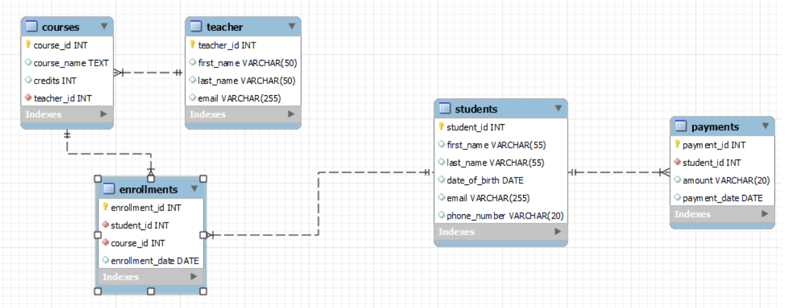

1. Create an ERD (Entity Relationship Diagram) for the database.

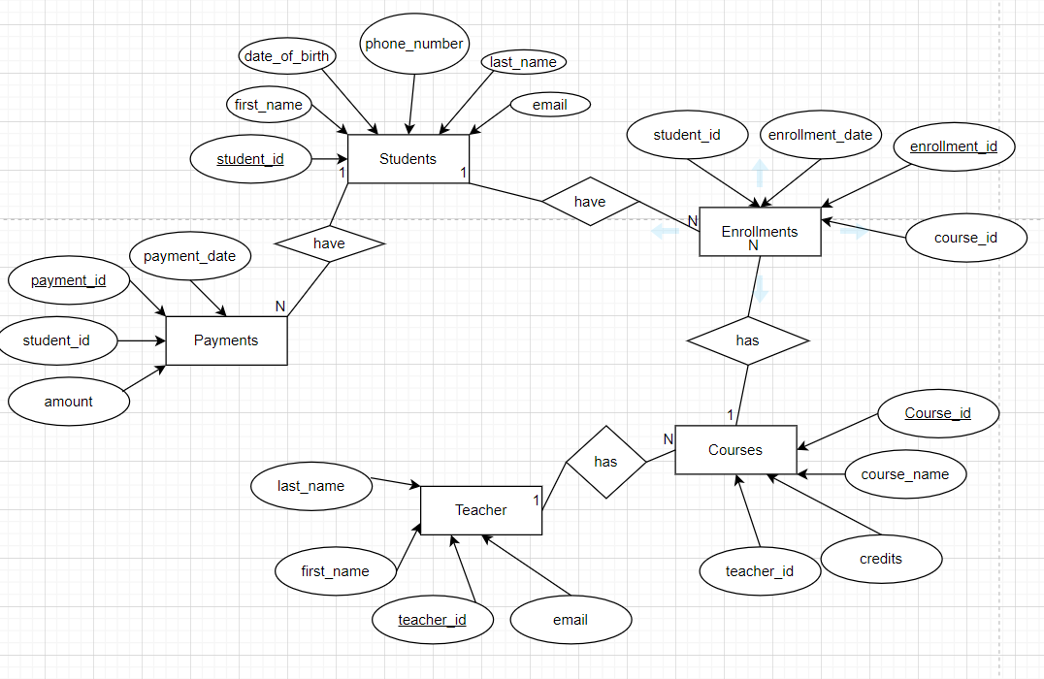

1. Create appropriate Primary Key and Foreign Key constraints for referential integrity:

Students Table:

student_id INT PRIMARY KEY

Teacher Table:

teacher_id INT PRIMARY KEY

Courses Table:

course_id INT Primary Key and

FOREIGN KEY(teacher_id) REFERENCES Teacher(teacher_id) ON DELETE CASCADE

Enrollments Table:

enrollment_id INT Primary Key and

FOREIGN KEY(course_id) REFERENCES Courses(course_id) ON DELETE CASCADE

Payments Table:

payment_id INT PRIMARY KEY and

FOREIGN KEY(student_id) REFERENCES Students(student_id) ON DELETE CASCADE

1. Write SQL scripts to create the mentioned tables with appropriate data types, constraints, and relationships.

* Students:

CREATE TABLE Students (

student_id INT PRIMARY KEY,

first_name VARCHAR(55),

last_name VARCHAR(55),

date_of_birth DATE,

email VARCHAR(255),

phone_number VARCHAR(20));

* Teacher:

CREATE TABLE Teacher(

teacher_id INT PRIMARY KEY,

first_name VARCHAR(50),

last_name VARCHAR(50),

email VARCHAR(255)

);

* Courses:

CREATE TABLE Courses(

course_id INT Primary Key,

course_name TEXT,

credits INT,

teacher_id INT NOT NULL,

FOREIGN KEY(teacher_id) REFERENCES Teacher(teacher_id)

);

* Enrollments:

CREATE TABLE Enrollments(

enrollment_id INT Primary Key,

student_id INT NOT NULL,

FOREIGN KEY(student_id) REFERENCES Students(student_id) ON DELETE CASCADE,

course_id INT NOT NULL,

FOREIGN KEY(course_id) REFERENCES Courses(course_id) ON DELETE CASCADE,

enrollment_date DATE

);

* Payments:

CREATE TABLE Payments(

payment_id INT PRIMARY KEY,

student_id INT NOT NULL,

FOREIGN KEY(student_id) REFERENCES Students(student_id) ON DELETE CASCADE,

amount VARCHAR(20),

payment_date DATE

);

1. **Insert at least 10 sample records into each of the following tables:**

* Students:

INSERT INTO Students values

(1,'Avinash','Kumar','2001-02-10','avi.kr131000@gmail.com', 8210642402),

(2,'Ashish','Kumar','2001-06-26','ashish@gmail.com',8210642401),

(3,'Deepanshu','Patel','2000-02-10','deepanshu@gmail.com',8210642403),

(4,'Shashwat','Shivam','2000-05-28','shashwat@gmail.com',8210642404),

(5,'Prashant','Mahato','2001-02-12','prashant@gmail.com',8210642405),

(6,'Ayush','Pandey','2001-01-15','ayush@gmail.com',8210642406),

(7,'Pragyan','Pandey','2000-12-15','pragyan@gmail.com',8210642474),

(8,'Vibhor','Mishra','1999-05-12','vibhor@gmail.com',8210642407),

(9,'Pranav','Gandhi','1999-06-02','pranav@gmail.com',8210642408),

(10,'Mayank','Agarwal','2000-04-06','mayank@gmail.com',8210642409)

;

* Teacher:

INSERT INTO Teacher values

(1,'Suman','Das','Suman@gmail.com'),

(2,'Lakshay','Kaushik','Lakshay@gmail.com'),

(3,'Arnav','Pandey','arnav@gmail.com'),

(4,'Priyansh','Agarwal','priyansh@gmail.com'),

(5,'Rohit','Sharma','rohit@gmail.com'),

(6,'Virat','Kohli','virat@gmail.com'),

(7,'Steph','Curry','curry@gmail.com'),

(8,'Lebron','James','James@gmail.com'),

(9,'Stuart','Broad','Broad@gmail.com'),

(10,'Jimmy','Anderson','jimmy@gmail.com')

;

* Courses:

INSERT INTO Courses (course_id, course_name, credits, teacher_id)

VALUES

(1, 'Maths', 3,1),

(2, 'Computer Science', 4,2),

(3, 'database', 2,3),

(4, 'Circuits', 4,4),

(5, 'English', 3,5),

(6, 'History', 3,6),

(7, 'Civics', 4,8),

(8, 'Geography', 1,7),

(9, 'Maths', 4,9),

(10, 'Computer Science', 4,10)

;

* Enrollments:

INSERT INTO Enrollments (enrollment_id, student_id, course_id, enrollment_date)

VALUES

(1, 2, 1, '2023-12-01'),

(2, 3, 2, '2023-12-02'),

(3, 5, 3, '2023-12-03'),

(4, 1, 4, '2023-12-04'),

(5, 4, 5, '2023-12-05'),

(6, 10, 6, '2023-12-01'),

(7, 9, 7, '2023-11-06'),

(8, 8, 8, '2023-11-03'),

(9, 7, 9, '2023-11-04'),

(10, 6, 10, '2023-11-05')

;

* Payments:

INSERT INTO Payments (payment_id, student_id, amount, payment_date)

VALUES

(1, 2, '1000', '2023-12-06'),

(2, 3, '1500', '2023-02-06'),

(3, 4, '2000', '2023-02-06'),

(4, 1, '2500', '2023-02-05'),

(5, 5, '3000', '2023-02-06'),

(6, 6, '1000', '2023-12-06'),

(7, 7, '1500', '2023-02-06'),

(8, 8, '2000', '2023-02-06'),

(9, 9, '2500', '2023-02-05'),

(10, 10, '3000', '2023-02-06')

;

**Tasks 2: Select, Where, Between, AND, LIKE:**

1. **Write SQL queries for the following tasks:**
2. Write an SQL query to insert a new student into the "Students" table with the following details:

a. First Name: John

b. Last Name: Doe

c. Date of Birth: 1995-08-15

d. Email: [john.doe@example.com](mailto:john.doe@example.com)

e. Phone Number: 1234567890 :

INSERT INTO Students (student_id,first_name, last_name, date_of_birth, email, phone_number)

VALUES ('11','John', 'Doe', '1995-08-15', 'john.doe@example.com', '1234567890')

;

1. Write an SQL query to enroll a student in a course. Choose an existing student and course and insert a record into the "Enrollments" table with the enrollment date.

INSERT INTO Enrollments (enrollment_id,student_id, course_id, enrollment_date)

VALUES ('11','1', '3', '2023-12-07');

1. Update the email address of a specific teacher in the "Teacher" table. Choose any teacher and modify their email address.

UPDATE Teacher

SET email= 'kohli@gmail.com' WHERE teacher_id='6';

1. Write an SQL query to delete a specific enrollment record from the "Enrollments" table. Select an enrollment record based on the student and course:

DELETE FROM Enrollments WHERE student_id = '2' AND course_id = '1'AND enrollment_date = '2023-12-01' ;

1. Update the "Courses" table to assign a specific teacher to a course. Choose any course and teacher from the respective tables:

UPDATE Courses SET teacher_id = '5' WHERE course_id = '2;

1. Delete a specific student from the "Students" table and remove all their enrollment records from the "Enrollments" table. Be sure to maintain referential integrity.

DELETE FROM Payments WHERE student_id = '8';

DELETE FROM Enrollments WHERE student_id = '8';

DELETE FROM Students WHERE student_id = '8'

1. Update the payment amount for a specific payment record in the "Payments" table. Choose any payment record and modify the payment amount.

UPDATE Payments SET amount = '5000' WHERE payment_id = 1;

**Tasks 3: Aggregate functions, Having, Order By, GroupBy and Joins:**

1. Write an SQL query to calculate the total payments made by a specific student. You will need to join the "Payments" table with the "Students" table based on the student's ID.

SELECT s.student_id, CONCAT(s.first_name,' ',s.last_name) AS FULL_NAME, SUM(p.amount) AS total_payments FROM Students s

JOIN Payments p ON s.student_id = p.student_id

WHERE s.student_id = 2

GROUP BY s.student_id;

1. Write an SQL query to retrieve a list of courses along with the count of students enrolled in each course. Use a JOIN operation between the "Courses" table and the "Enrollments" table:

SELECT c.course_id, c.course_name,

COUNT(e.student_id) AS student_count FROM Courses c

LEFT JOIN Enrollments e ON c.course_id = e.course_id

GROUP BY c.course_id, c.course_name;

1. Write an SQL query to find the names of students who have not enrolled in any course. Use a LEFT JOIN between the "Students" table and the "Enrollments" table to identify students without enrollments.

SELECT s.first_name, s.last_name FROM Students s

LEFT JOIN Enrollments e ON s.student_id = e.student_id

WHERE e.student_id IS NULL;

1. Write an SQL query to retrieve the first name, last name of students, and the names of the courses they are enrolled in. Use JOIN operations between the "Students" table and the "Enrollments" and "Courses" tables.

SELECT s.first_name, s.last_name, c.course_name FROM Students s

JOIN Enrollments e ON s.student_id = e.student_id

JOIN Courses c ON e.course_id = c.course_id;

1. Create a query to list the names of teachers and the courses they are assigned to. Join the "Teacher" table with the "Courses" table

SELECT

t.first_name AS Teacher_FirstName,

t.last_name AS Teacher_LastName,

c.course_name AS Course_Assigned

FROM Teacher t, Courses c WHERE t.teacher_id = c.teacher_id;

1. Retrieve a list of students and their enrollment dates for a specific course. You'll need to join the "Students" table with the "Enrollments" and "Courses" tables.

SELECT s.first_name AS Student_FirstName, s.last_name AS Student_LastName, e.enrollment_date AS Enrollment_Date FROM Students s

JOIN Enrollments e ON s.student_id = e.student_id

JOIN Courses c ON e.course_id = c.course_id

WHERE c.course_name = 'English';

1. Find the names of students who have not made any payments. Use a LEFT JOIN between the "Students" table and the "Payments" table and filter for students with NULL payment records.

SELECT s.first_name AS Student_FirstName, s.last_name AS Student_LastName

FROM Students s

LEFT JOIN Payments p ON s.student_id = p.student_id WHERE p.payment_id IS NULL;

1. Write a query to identify courses that have no enrollments. You'll need to use a LEFT JOIN between the "Courses" table and the "Enrollments" table and filter for courses with NULL enrollment records:

SELECT c.course_id, c.course_name FROM Courses c

LEFT JOIN Enrollments e ON c.course_id = e.course_id WHERE e.enrollment_id IS NULL;

1. Identify students who are enrolled in more than one course. Use a self-join on the "Enrollments" table to find students with multiple enrollment record:

SELECT s.student_id, s.first_name, s.last_name,

COUNT(e.enrollment_id) AS num_enrollments FROM Students s

JOIN Enrollments e ON s.student_id = e.student_id

GROUP BY s.student_id, s.first_name, s.last_name

HAVING num_enrollments > 1;

1. Find teachers who are not assigned to any courses. Use a LEFT JOIN between the "Teacher" table and the "Courses" table and filter for teachers with NULL course assignments:

SELECT t.teacher_id, t.first_name, t.last_name FROM Teacher t

LEFT JOIN Courses c ON t.teacher_id = c.teacher_id WHERE c.course_id IS NULL;

**Tasks 4: Subquery and its type:**

1. Write an SQL query to calculate the average number of students enrolled in each course. Use aggregate functions and subqueries to achieve this.

SELECT c.course_id, c.course_name,

AVG(enrollment_count) AS average_students_enrolled

FROM Courses c LEFT JOIN ( SELECT course_id,COUNT(DISTINCT student_id) AS enrollment_count

FROM Enrollments GROUP BY course_id) e ON c.course_id = e.course_id

GROUP BY c.course_id, c.course_name;

1. Identify the student(s) who made the highest payment. Use a subquery to find the maximum payment amount and then retrieve the student(s) associated with that amount.

SELECT CONCAT(s.first_name,s.last_name) AS Full_Name, a.amt FROM students s JOIN (

SELECT student_id,sum(amount) amt FROM Payments

GROUP BY student_id

ORDER BY amt DESC LIMIT 1) a ON s.student_id=a.student_id ;

1. Retrieve a list of courses with the highest number of enrollments. Use subqueries to find the course(s) with the maximum enrollment count.

SELECT c.course_id, c.course_name, count(e.enrollment_id) AS enrolled_count

FROM Courses c LEFT JOIN Enrollments e ON c.course_id = e.course_id GROUP BY c.course_id, c.course_name

HAVING enrolled_count = (SELECT max(enrolled_count) FROM (SELECT count(enrollment_id) AS enrolled_count FROM Enrollments

GROUP BY course_id) AS maximum_enrolls);

1. Calculate the total payments made to courses taught by each teacher. Use subqueries to sum payments for each teacher's courses.

SELECT t.teacher_id,c.course_id,c.course_name,CONCAT(t.first_name ,' ',t.last_name )AS NAME_OF_TEACHER ,SUM(p.amount) AS total_payments_IN$

FROM Teacher t LEFT JOIN Courses c ON t.teacher_id = c.teacher_id

LEFT JOIN Enrollments e ON c.course_id = e.course_id LEFT JOIN Payments p ON e.student_id = p.student_id

GROUP BY c.course_id,t.teacher_id;

1. Identify students who are enrolled in all available courses. Use subqueries to compare a student's enrollments with the total number of courses.

SELECT

s.student_id,

s.first_name,

s.last_name

FROM Students s

WHERE NOT EXISTS (SELECT c.course_id FROM Courses c WHERE NOT EXISTS ( SELECT e.course_id FROM Enrollments e WHERE e.student_id = s.student_id AND e.course_id = c.course_id)

);

1. Retrieve the names of teachers who have not been assigned to any courses. Use subqueries to find teachers with no course assignments.

SELECT t.teacher_id, t.first_name, t.last_name

FROM Teacher t WHERE NOT EXISTS (SELECT 1 FROM Courses c WHERE c.teacher_id = t.teacher_id);

1. Calculate the average age of all students. Use subqueries to calculate the age of each student based on their date of birth.

SELECT AVG(student_age) AS average_age

FROM (SELECT student_id, TIMESTAMPDIFF(YEAR, date_of_birth, CURDATE()) AS student_age FROM Students) AS student_ages;

1. Identify courses with no enrollments. Use subqueries to find courses without enrollment records.

SELECT course_id, course_name

FROM Courses WHERE course_id NOT IN ( SELECT DISTINCT course_id FROM Enrollments);

1. Calculate the total payments made by each student for each course they are enrolled in. Use subqueries and aggregate functions to sum payments.

SELECT e.student_id,concat(s.first_name,' ',s.last_name) AS FULL_NAME ,e.course_id,(SELECT sum(amount) FROM payments p

WHERE p.student_id = e.student_id) AS total_payments

FROM enrollments e

JOIN Students s on s.student_id=e.student_id

GROUP BY e.student_id,e.course_id;

1. Identify students who have made more than one payment. Use subqueries and aggregate functions to count payments per student and filter for those with counts greater than one.

SELECT s.student_id, s.first_name, s.last_name

FROM Students s

JOIN (SELECT student_id, COUNT(*) AS payment_count

FROM Payments

GROUP BY student_id HAVING payment_count > 1) p_counts ON s.student_id = p_counts.student_id;

1. Write an SQL query to calculate the total payments made by each student. Join the "Students" table with the "Payments" table and use GROUP BY to calculate the sum of payments for each student.

SELECT s.student_id, s.first_name, s.last_name,

IFNULL(SUM(p.amount), 0) AS total_payments

FROM Students s

LEFT JOIN Payments p ON s.student_id = p.student_id

GROUP BY s.student_id, s.first_name, s.last_name;

1. Retrieve a list of course names along with the count of students enrolled in each course. Use JOIN operations between the "Courses" table and the "Enrollments" table and GROUP BY to count enrollments.

SELECT c.course_name, COUNT(e.student_id) AS enrollment_count

FROM Courses c

LEFT JOIN Enrollments e ON c.course_id = e.course_id

GROUP BY c.course_id, c.course_name;

1. Calculate the average payment amount made by students. Use JOIN operations between the "Students" table and the "Payments" table and GROUP BY to calculate the average.

SELECT s.student_id, CONCAT(s.first_name, ' ',s.last_name) AS FULL_NAME, AVG(p.amount) AS average_payment_amount from Students s

JOIN Payments p ON s.student_id = p.student_id GROUP BY s.student_id;