Home Security System with Arduino

Software Requirements Specification

Version 1.0

Chris Mack

Chance Williams

Aaron Rodriguez

Blayne Naufel

[Note: The following template is provided for use with the Rational Unified Process. Text enclosed in square brackets and displayed in blue italics (style=InfoBlue) is included to provide guidance to the author and should be deleted before publishing the document. A paragraph entered following this style will automatically be set to normal (style=Body Text).]
[To customize automatic fields (which display a gray background when selected), select File>Properties and replace the Title, Subject and Company fields with the appropriate information for this document. After closing the dialog, automatic fields may be updated throughout the document by selecting Edit>Select All (or Ctrl-A) and pressing F9, or simply click on the field and press F9. This must be done separately for Headers and Footers. Alt-F9 will toggle between displaying the field names and the field contents. See Word help for more information on working with fields.]
[Note: The Software Requirements Specification (SRS) captures the complete software requirements for the system, or a portion of the system. Following is a typical SRS outline for a project using use-case modeling. This artifact consists of a package containing use cases of the use-case model and applicable Supplementary Specifications and other supporting information. For a template of an SRS not using use-case modeling, which captures all requirements in a single document, with applicable sections inserted from the Supplementary Specifications (which would no longer be needed), see rup_srs.dot.]
Many different arrangements of an SRS are possible. Refer to [IEEE93] for further elaboration of these explanations, as well as other options for SRS organization.]

Revision History
Date | Version | Description | Author
<dd/mmm/yy> | <x.x> | <details> | <name>

Table of Contents
1. Introduction 4
1.1 Purpose 4
1.2 Scope 4
1.3 Definitions, Acronyms and Abbreviations 4
1.4 References 4
1.5 Overview 4
2. Overall Description 4
2.1 Use-Case Model Survey 4
2.2 Assumptions and Dependencies 4
3. Specific Requirements 4
4. Supporting Information 5

Software Requirements Specification

Introduction

Purpose
This document provides the reader an in depth look of the software requirements for the “Home Security System with Arduino” system that will be used throughout its development. The purpose of this document is to describe all necessary software requirements and external behavior of the system giving the reader a complete and comprehensive description of the requirements needed. Included in this document are definitions, acronyms and abbreviations that will be used throughout the document, along with use-cases, UML documents and specific requirements.

Scope
The system that will be implemented is a home security, through the use of motion sensors, a camera, speaker, pin pad, and a web application hosted on a Raspberry Pi. Each of these components will rely on the use of the Arduino micro controller. The goal for this system is to alert the user of unsuspected intrusions in his or her residence. Users will have the ability to set up an account using the web application, allowing customizable pass codes to be set up. They may also use the web application to monitor the system’s log files to view the timestamp of triggered motion sensors along with pictures of the invader.

Definitions, Acronyms and Abbreviations
Arduino - an open-source microcontroller based on easy-to-use hardware and software
PIR – Passive Infrared, a technology used in order to detect motion in the presence of humans in the vicinity of the sensor
Raspberry Pi – A compact low power applications processor with built in I/O devices such as Ethernet and USB

References
[This subsection should provide a complete list of all documents referenced elsewhere in the SRS. Each document should be identified by title, report number (if applicable), date, and publishing organization. Specify the sources from which the references can be obtained. This information may be provided by reference to an appendix or to another document.]

Overview
The remaining sections of this Software Requirements Specification document contains a brief overall description of the system. Use-cases that model various features of the system, which include descriptions of each use-case and its actors, as well as assumptions and dependencies needed. UML diagrams are used when necessary to show relationships between use-cases or actors. The Specific Requirements section which contains details for all software requirements that provide designers and testers with the information needed to design and test the system to make sure it satisfies the requirements.

Overall Description
[This section of the SRS should describe the general factors that affect the product and its requirements. This section does not state specific requirements. Instead, it provides a background for those requirements, which are defined in detail in section 3, and makes them easier to understand. Include such items as product perspective, product functions, user characteristics, constraints, assumptions and dependencies, and requirements subsets.]

Use-Case Model Survey
[If using use-case modeling, this section contains an overview of the use-case model or the subset of the use-case model that is applicable for this subsystem or feature. This includes a list of names and brief descriptions of all use cases and actors, along with applicable diagrams and relationships. Refer to the use-case model survey report, which may be used as an enclosure at this point.]
[ Define your actors (users of the system).
Define your use-cases as scenarios of usage of the systems by the actors.
Draw use-case diagram(s) (follow UML notation).
Use the table format below to document all use-cases.
One table per use-case and maintain the table format.
The blue text inside the table is just for guidance; remove it from the final document.]

Insert your Use-Case Diagram before the description tables. The diagram should reflect all relationships among the use-cases as indicated in the ”Relationships:” cell of the table.
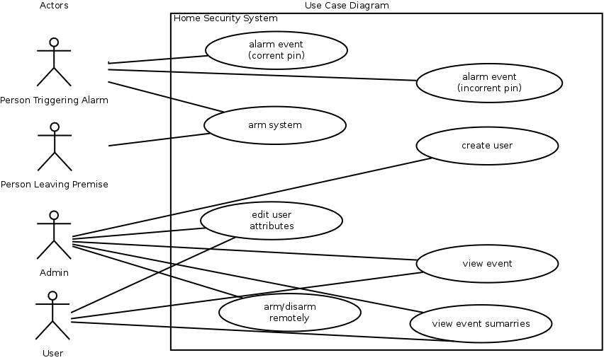

(This table is adopted from “Systems Analysis and Design”, by Whitten, Bentley, and Dittman)

Use case name:  Alarm Event (Correct Pin) |  | ID:  AE-01
Primary actor:  Person that triggers alarm | Source:  Security Device | Use case type:  Technical Requirement
Interested Stakeholders:
Any residence of the household
Brief description:
A user will trigger a motion sensor and proceed to enter a valid pin
Precondition:
The security device is in an armed state.
Trigger:
Some form of motion happens in front of one of the sensors, which sets the device in an alarming state.
Relationships: None
Typical flow of events:
- Some user triggers the alarm
- Device is in alarming state waiting for PIN
- User presses “D” on the pad
- User inputs valid pin code
- Event is logged to server with timestamp and user info
- Device is set to unarmed state
Assumptions:
- Device did not already detect motion
- All components of the system are working

Use case name:  Alarm Event (Incorrect Pin) |  | ID:  AE-02
Primary actor:  Person that triggers alarm | Source:  Security Device | Use case type:  Technical Requirement
Interested Stakeholders:
Any residence of the household
Brief description:
An intruder will trigger a motion sensor and proceed to enter invalid pin
Precondition:
The security device is in an armed state.
Trigger:
Some form of motion happens in front of one of the sensors, which sets the device in an alarming state.
Relationships: None
Typical flow of events:
- Some user triggers the alarm
- Device is in alarming state waiting for PIN
- User presses “D” on the pad
- User inputs invalid pin code or no pin code is entered
- Device takes pictures
- Event is logged to server with timestamp, images, failed pin number
- Device continues with alarming state
Assumptions:
- Device did not already detect motion
- All components of the system are working

Use case name:  Arm the System |  | ID:  AS-01
Primary actor:  User that is interacting with the Security System | Source:  Security Device PIN Pad | Use case type:  Technical Requirement
Interested Stakeholders:
Any residence of the household
Brief description:
When a user intends to secure the house, they will activate the system
Precondition:
The security device is in an unarmed state.
Trigger:
User enters correct PIN
Relationships: None
Typical flow of events:
- User presses “A” on the PIN pad
- User inputs valid pin code
- System waits some period of time giving user time to vacate
- Speaker beeps increase frequency
- System state is set to armed
- Event is logged to server with timestamp and user info
Assumptions:
- User knows the correct PIN.
- All components of the system are working

Use case name:  Admin Create User (Admin Application) |  | ID:  AA-CU01
Primary actor:  Admin User | Source:  Web Application | Use case type:  Technical Requirement
Interested Stakeholders:
Owner/Admin of the Security System
Brief description:
The admin user will create other users to interact with the security system
Precondition:
Admin user account exists and user has access to application located on a webserver.
Trigger:
Admin user commits changes using the admin application.
Relationships: None
Typical flow of events:
- Admin user logs into the web application
- Admin clicks link admin panel
- Admin selects ‘Add User’
- Admin provides information about the new user (i.e. Name, Password, Permission Level)
- Admin confirms new user that has been entered
- New user is created and added to the database.
Assumptions:
- The webserver is running
- User account exists

Use case name:  Admin Edit other User Profile |  | ID:  AA-CU01
Primary actor:  Admin User | Source:  Web Application | Use case type:  Technical Requirement
Interested Stakeholders:
Owner/Admin of the Security System
Brief description:
The admin user will edit other users that interact with the security system
Precondition:
Admin user account exists
Trigger:
Admin user commits changes using the admin application.
Relationships: None
Typical flow of events:
- Admin user logs into the web application
- Admin clicks link admin panel
- Admin selects ‘Add User’
- Admin provides information about the new user (i.e. Name, Password, Permission Level)
- Admin confirms new user that has been entered
- New user is created and added to the database.
Assumptions:
- The webserver is running
- User account exists

Use case name:  User Edit Own Attributes |  | ID:  UA-01
Primary actor:  User accessing the web panel | Source:  Web Application | Use case type:  Technical Requirement
Interested Stakeholders:
User of the security system
Brief description:
The user intends to edit their profile information
Precondition:
User account exists
Trigger:
User commits changes from the account panel
Relationships:
Depends on: Create User (Admin Application)
Typical flow of events:
- User logs into website
- User clicks link to profile panel
- User selects ‘edit user profile’
- User enters the edited information about the user (name, password)
Assumptions:
- The webserver is running
- User account exists

Use case name:  View Event |  | ID:  VE-01
Primary actor:  User accessing the web panel | Source:  Web Application | Use case type:  Technical Requirement
Interested Stakeholders:
User of the security system
Brief description:
The User intends to view events log in the security system
Precondition:
User account exists
Trigger:
User logs into account
Relationships:
Depends on: Create User (Admin Application)
Typical flow of events:
- User logs into website
- User clicks link to event in the event panel
- User views event details and picture
Assumptions:
- The webserver is running
- User account exists
- Event has occurred

Use case name:  View event summaries (with filters & graphs) |  | ID:  VE-02
Primary actor:  User accessing the web panel | Source:  Web Application | Use case type:  Technical Requirement
Interested Stakeholders:
User of the security system
Brief description:
The User intends to view events log in the security system by filtered results
Precondition:
User account exists
Trigger:
User log into account and selects filters
Relationships:
Include: View Event
Extend: Create User (Admin Application), View Event
Depends on: Create User (Admin Application), View Event
Typical flow of events:
- User logs into website
- User select which filters to order events
- User views event details
Assumptions:
- The webserver is running
- User account exists
- Event has occurred
Assumptions:
- The webserver is running
- User account exists
- Event has occurred

Use case name:  Arm/Disarm System Remotely |  | ID:  AS-02
Primary actor:  User accessing the web panel | Source:  Web Application | Use case type:  Technical Requirement
Interested Stakeholders:
User of the security system
Brief description:
The User intends to view events log in the security system by filtered results
Precondition:
User account exists and system hardware is running
Trigger:
User log into account and selects “Arm System”
Relationships:
Depends on: Admin Create User (Admin Application)
Typical flow of events:
- User logs into the website
- User changes alarm state
  - User clicks arm button
  - User clicks disarm button
Assumptions:
- The webserver is running
- User account exists
- System is in undesired state

Assumptions and Dependencies
[This section describes any key technical feasibility, subsystem or component availability, or other project related assumptions on which the viability of the software described by this SRS may be based.] [Here, include any limitations, constraints, restrictions identified for the application]

Specific Requirements
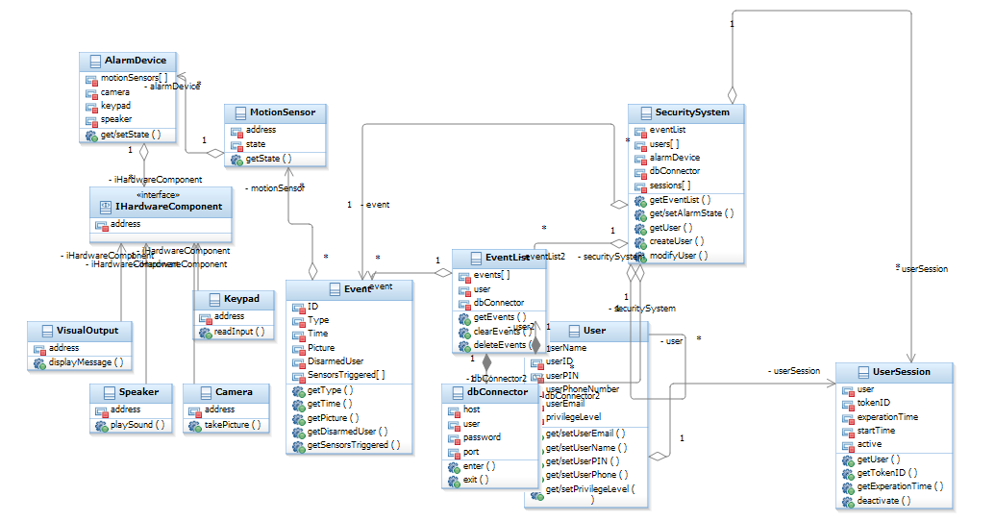

Class name: User
Brief description: Has information of a user
Attributes (fields) | Attribute Description
UserName | Contains user name
UserID | Contains user ID
UserPin | Contains user pin number for security system
UserPhoneNumber | Contains user phone number for use with automated text message
UserEmail | Contains user email for use with automated email message
PrivilegeLevel | Contains user privilege level
Methods (operations) | Method Description
GetSetEmail | Gets and sets user email value for DB
GetSetUserName | Gets and sets user name value for DB
GetSetUserPin | Gets and sets user PIN value for DB
GetSetUserPhone | Gets and sets user phone value for DB
GetSetPrivilegeLevel | Get and set user privilege level

Class name: Event
Brief description: Has information of a single Event
Attributes (fields) | Attribute Description
ID | ID of the event
Type | Type of event
Time | Contains the date and time of the given event
Picture | Picture for the event
Disarmed User | Contains user of the
Sensors Triggered [] | Contains a list of all sensors that were triggered during this event
Methods (operations) | Method Description
GetType | Gets type of event
GetTime | Gets date and time the event occurred
GetPicture | Gets a picture depending if one was taken during this event
GetDisarmedUser | Gets the user that disarmed the event
GetSensorsTriggered | Gets a list of all sensors that were triggered during an event.

Class name: AlarmDevice
Brief description: The alarm device object that holds information of all hardware devices that make up the device.
Attributes (fields) | Attribute Description
MotionSensors[] | A list of motion sensors that are attached to the alarm device
Camera | Contains information of the camera that is attached to the alarm device
Keypad | Contains information of the keypad that is attached to the alarm device
Speaker | Contains information of the speaker that is attached to the alarm device
Methods (operations) | Method Description
GetSetState(State) | Get or Set the alarm device state depending on the parameter passed

Class name: MotionSensor
Brief description: Used by the alarm device that will sense motion and change its state based on movement
Attributes (fields) | Attribute Description
Address | Contains the address for the motion sensor
State | Holds the state of the motion sensor device
Methods (operations) | Method Description
GetState() | Gets the state of the motion sensor based on sensing any motion.

Class name: Security System
Brief description: Provides access to the event list, users, alarm device, and current sessions.
Attributes (fields) | Attribute Description
EventList | Contains an event list object which provides all events of the security system.
Users [] | A list of all users that have access to the security system
Alarm Device | An alarm device object that has all the devices that are connected to the alarm
DB Connector | A connection object that is used to connect to the database
Sessions[] | A list of all current user sessions
Methods (operations) | Method Description
GetEventList(args) | Is passed an argument that behaves like a filter and returns an event list that meets the specified criteria.
GetSetAlarmState | Get and Set the current alarm state of the security system.
GetUser() | Get a specified user
CreateUser() | Creates a user object
ModifyUser() | Modifies user attributes

Class name: Camera
Brief description: Camera object that
Attributes (fields) | Attribute Description
Address | Contains information of the camera’s address
Methods (operations) | Method Description
TakePicture() | Will return a picture when called during an event

Class name: Keypad
Brief description: Will take user input and send it to the security system for validation.
Attributes (fields) | Attribute Description
Address | Contains information of the keypad’s address
Methods (operations) | Method Description
ReadInput() | Reads input provided from the user and send it for validation

Class name: Speaker
Brief description: Used to receive message from the system depending on event it will have the physical speaker produce sound
Attributes (fields) | Attribute Description
Address | Contains information of the speakers address
Methods (operations) | Method Description
PlaySound(args) | Will play a specific sound depending on the event message received

Class name: VisualOutput
Brief description: Will provide the user with information of the current state of the system.
Attributes (fields) | Attribute Description
Address | Contains information of the visual outputs address
Methods (operations) | Method Description
DisplayMessage(message) | Will display the message that was passed to the visual output

Class name: DBConnector
Brief description: The connection object that will provide the creation of a connection to communicate with the data base
Attributes (fields) | Attribute Description
Host | Contains the address to the host/hostname
User | Information of the user wishing to establish the connection
Password | Information of the user’s password
Port | The port to which the host is listening on
Methods (operations) | Method Description
Enter | Creates connection returns a cursor object
Exit | Closes connection and destroys cursor object

Class name: EventList
Brief description: Used to view the events in the database
Attributes (fields) | Attribute Description
Events[] | A list of events
User | Contains info of the user of the event list
DBConnector | Creates a db connector object
Methods (operations) | Method Description
GetEvents(args) | Gets a set of Events based on the filter arguments passed in
ClearEvents() | Clear all Events in the list
DeleteEvent() | Remove Event from the list

Class name: User Session
Brief description: Will provide information of an individual user session after the user has successfully established a connection
Attributes (fields) | Attribute Description
User | Contains information of a user object
TokenID | Unique token for the session
ExperationTime | Holds the time at which a session will expire for the user depending on the user session start time
StartTime | Contains information of when the user session initially started
Active | Provides the current state of a user session
Methods (operations) | Method Description
GetUser | Returns information of the user that initiated the session.
GetTokenID | Returns the unique token for the specified session
GetExperationTime | Returns the expiration time at which the session will be terminated
Deactivate | Terminates the current session based of the expiration time or logging out of the session

Class name: HardwareComponent
Brief description: Interface for the hardware component
Attributes (fields) | Attribute Description
Address | Contains address for a hardware component.
Methods (operations) | Method Description

  - Sequence Diagrams
Draw a UML sequence diagram for each use-case. Multiple diagrams may be drawn for a use-case.

  - Object Collaboration Diagrams
Draw UML object relationship (collaboration) diagram(s).
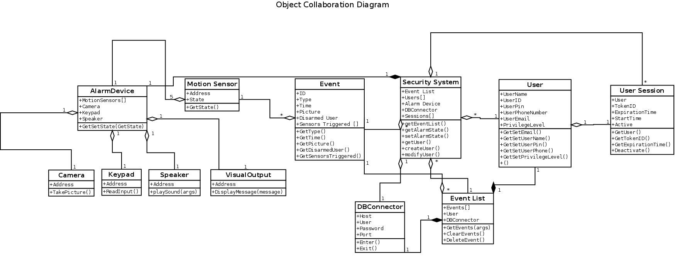

  - Object Behavior Diagrams
Draw UML state (state chart) diagrams for the system.

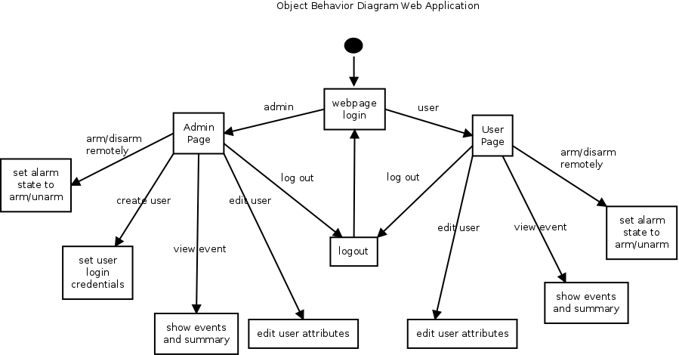

Supporting Information
[The supporting information makes the SRS easier to use. It includes: a) Table of contents, b) Index, c) Appendices. These may include use-case storyboard, user-interface prototypes, and/ or CRC Cards. When appendices are included, the SRS should explicitly state whether or not the appendices are to be considered part of the requirements.]

