Home Security System with Arduino
Final Report

Version 1.0

Chris Mack – cmack3@students.kennesaw.edu
Chance Williams – cwill316@students.kennesaw.edu
Aaron Rodriguez – arodri31@students.kennesaw.edu
Blayne Naufel – cnaufel@students.kennesaw.edu

Revision History
Date | Version | Description | Author
12/4/2014 | 1.0 | Added primary content | Blayne Naufel

Table of Contents

1. Software Development Plan 4
1.1 Introduction 4
1.2 Project Overview 4
1.3 Project Organization 4
1.4 Management Process
1.5 Supporting Process Plans 4
2. Software Requirements Specifications 4
2.1 Introduction 4
2.2 Overall Description 4
2.3 Specific Requirements 4
2.4 Supporting Information 4
3. Software Design Document 5
3.1 Introduction 5
3.2 Design Overview 5
3.3 System Object Model
3.4 Object Descriptions
3.5 Object Collaboration
3.6 Dynamic Model
3.7 Data Design
3.8 Non-functional Requirements
3.9 Supplementary Documentation 5
4. Updates 5
4.1 Documentation 5
4.2 Code 6
4.3 Future Functions of the System 6

5. Supporting Information
5.1 Index

Software Development Plan

Introduction

Purpose
This Software Development Plan establishes the plan to be used during the development process of the Home Security System with Arduino. The purpose of this document is to gather all of the necessary information to develop and deliver a final product in a timely, efficient manner. This document is for use by the project members to outline project requirements, create and track a project schedule, and develop a deeper understanding of the project as a whole.

Scope
This Software Development Plan outlines the steps by which the development of the Home Security System with Arduino will be executed and the management approach to the software and hardware development. Please refer to the Scope Statement document for a further elaboration of the scope of the project, some of this information is included in section 2 of this document.

Overview
This Software Development Plan contains the following:
- Project Overview - objectives of the product to be developed along with organizational structure of the development process
- Project Organization - entails organization and authorities of project team members
- Management Process - outlines major phases and milestones and describes how the project will be monitored
- Supporting Process Plan - includes other documents that are to be generated during the development cycle of this project
- References - appropriate references will be appended to this document as needed (see References for more details)

Definitions, Acronyms and Abbreviations
Arduino - an open-source microcontroller based on easy-to-use hardware and software
PIR – Passive Infrared, a technology used in order to detect motion in the presence of humans in the vicinity of the sensor
Rasberry Pi – A compact low power applications processor with built in I/O devices such as ethernet and USB

Project Overview

Project purpose, scope and objectives
The project will be to implement a home security system by use of motion sensors, cameras, speakers, a pin pad, and a web application that will rely heavily on the micro controller, Arduino. The objective of this product is to alert the user of unsuspected intrusion in his or her home. The user will have the ability to set up an account via the web application that will allow customizable pass codes to be set up as well as monitoring of the system’s log files to view times of the triggers as well as pictures of the invader.

Assumptions and constraints
Assumptions
- User will be computer-literate enough to set up account and equipment in home
- User primarily speaks English as we do not plan to release the product in any other language
- User has Internet access where the product will be set up
- The allotted time will be enough to deliver a complete and finalized version of the project
- The team budget will be sufficient to obtain all required components
Constraints
- 10 weeks of time for development of final product
- A maximum budget of $60 for all components and project requirements
- Use of programming languages which will suit the application best
- Project testing cannot be executed individually by team members unless Arduino is present
- Reliability of network connection

Project deliverables

Project Scope Statement | September 1, 2014
Software Development Plan | September 8, 2014
Software Requirements Document | September 29, 2014
Software Design Document | October 13, 2014
Finalized Project Report | December 15, 2014

Project Organization

Organizational Structure
Christopher Mack | Software Developer
Blayne Naufel | Software Developer
Aaron Rodriguez | Project Lead, Git Project Maintainer, Software Developer
Chance Williams | Software Developer, Primary Document Editor

External Interfaces
The database and webhost can optionally be hosted on an external 3rd party hosting service. The scope of this particular project does not include reporting security intrusions to government authorities (e.g. Law Enforcement, Emergency Services), however intrusions may be reported to the users via e-mail, in which case, these events must interface with a mailserver (optionally hosted on the same server as the webhost and the database)

Social and Ethical Issues
The database will be storing sensitive information including the users’ passcodes and information related to the intrusion events in the users’ home. Given the nature of the data stored on this sever, encryption is required at least for the passcodes, and optionally for all data stored in the database. Additionally, pictures of these events will be stored on the server, which poses a privacy issue with the possibility of unknowingly photographing people within frame of the camera.

Management Process

Project Plan

Phase Plan
In the Gannt chart below we have broken up the each of our milestones and assignments to reflect the time needed to complete each task. This will help provide us with a good timeline of where we should be during the life cycle of our project.

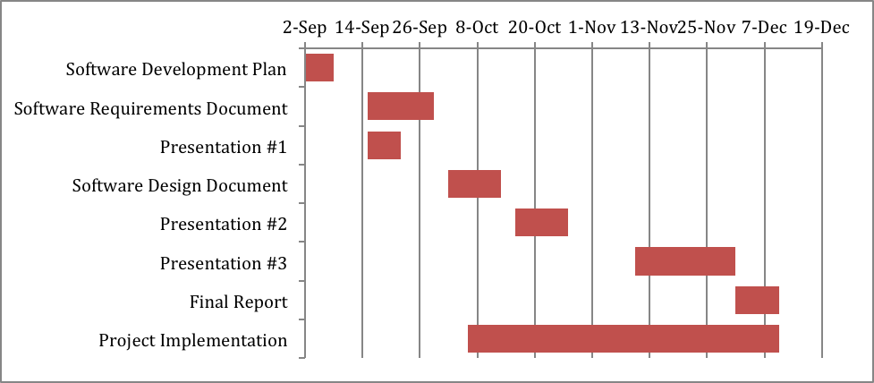

Project Monitoring and control

Schedule control plan
In order to make sure our group is on track for completing each milestone and assignment by the desired end date, our group will participate in SCRUM meetings on Tuesdays and Thursdays of each week. We will use this time to discuss the progress of the weekly assigned tasks and any road blocks they may foresee happening during the week. The Monday of each week will be used to discuss our accomplishments from the previous week along with the future tasks. These meetings will help ensure that our current goals will be reached by the end date for each of our tasks. By having these meetings it allows us to catch any major issues that may cause a delay in any deliverables, allowing us to re-allocate any available resources to help keep us on track for success.

Reporting Plan
Throughout the project we will be providing weekly reports to the instructor and our group members these reports will provide information of current tasks for the week and tasks that were accomplished in the previous week. Our group members will also participate in SCRUM meets on Tuesdays and Thursdays of each week to discuss the progress of their assigned tasks or any road blocks they foresee happening during the week. The Monday of each will be used to discuss our accomplishments from the previous week and confirm we are still on track.

Supporting process plans

Documentation plan
- Presentation #1 – Sept 22, 2014
- Software Requirements Specification – Sept 29, 2014
- Software Design Document – Oct 13, 2014
- Presentation #2 – Oct 27, 2014
- Presentation #3 – Dec 1, 2014
- Final Report – Dec 10, 2014

References
Scope Statement – CS4850_Aaron_Rodriguez_Week2.docx

Software Requirements Specification

Introduction

Purpose
This document provides the reader an in depth look of the software requirements for the “Home Security System with Arduino” system that will be used throughout its development. The purpose of this document is to describe all necessary software requirements and external behavior of the system giving the reader a complete and comprehensive description of the requirements needed. Included in this document are definitions, acronyms and abbreviations that will be used throughout the document, along with use-cases, UML documents and specific requirements.

Scope
The system that will be implemented is a home security, through the use of motion sensors, a camera, speaker, pin pad, and a web application hosted on a Raspberry Pi. Each of these components will rely on the use of the Arduino micro controller. The goal for this system is to alert the user of unsuspected intrusions in his or her residence. Users will have the ability to set up an account using the web application, allowing customizable pass codes to be set up. They may also use the web application to monitor the system’s log files to view the timestamp of triggered motion sensors along with pictures of the invader.

Definitions, Acronyms and Abbreviations
Arduino - an open-source microcontroller based on easy-to-use hardware and software
PIR – Passive Infrared, a technology used in order to detect motion in the presence of humans in the vicinity of the sensor
Raspberry Pi – A compact low power applications processor with built in I/O devices such as Ethernet and USB

References
Scope Statement
S Software Development Plan

Overview
The remaining sections of this Software Requirements Specification document contains a brief overall description of the system. Use-cases that model various features of the system, which include descriptions of each use-case and its actors, as well as assumptions and dependencies needed. UML diagrams are used when necessary to show relationships between use-cases or actors. The Specific Requirements section which contains details for all software requirements that provide designers and testers with the information needed to design and test the system to make sure it satisfies the requirements.

Overall Description

Use-Case Model Survey
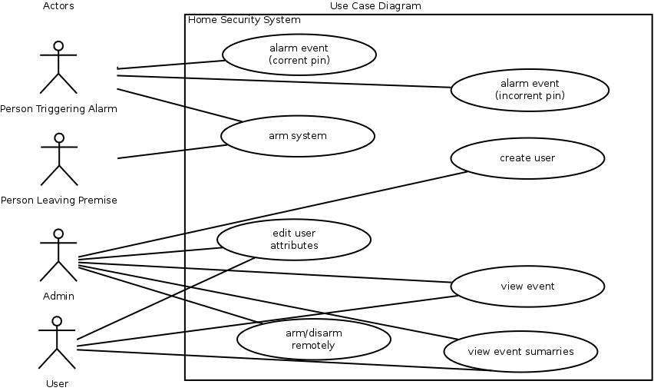

(This table is adopted from “Systems Analysis and Design”, by Whitten, Bentley, and Dittman)

Use case name:  Alarm Event (Correct Pin) |  | ID:  AE-01
Primary actor:  Person that triggers alarm | Source:  Security Device | Use case type:  Technical Requirement
Interested Stakeholders:
Any residence of the household
Brief description:
A user will trigger a motion sensor and proceed to enter a valid pin
Precondition:
The security device is in an armed state.
Trigger:
Some form of motion happens in front of one of the sensors, which sets the device in an alarming state.
Relationships: None
Typical flow of events:
- Some user triggers the alarm
- Device is in alarming state waiting for PIN
- User presses “D” on the pad
- User inputs valid pin code
- Event is logged to server with timestamp and user info
- Device is set to unarmed state
Assumptions:
Device did not already detect motion
All components of the system are working

Use case name:  Alarm Event (Incorrect Pin) |  | ID:  AE-02
Primary actor:  Person that triggers alarm | Source:  Security Device | Use case type:  Technical Requirement
Interested Stakeholders:
Any residence of the household
Brief description:
An intruder will trigger a motion sensor and proceed to enter invalid pin
Precondition:
The security device is in an armed state.
Trigger:
Some form of motion happens in front of one of the sensors, which sets the device in an alarming state.
Relationships: None
Typical flow of events:
- Some user triggers the alarm
- Device is in alarming state waiting for PIN
- User presses “D” on the pad
- User inputs invalid pin code or no pin code is entered
- Device takes pictures
- Event is logged to server with timestamp, images, failed pin number
- Device continues with alarming state
Assumptions:
Device did not already detect motion
All components of the system are working

Use case name:  Arm the System |  | ID:  AS-01
Primary actor:  User that is interacting with the Security System | Source:  Security Device PIN Pad | Use case type:  Technical Requirement
Interested Stakeholders:
Any residence of the household
Brief description:
When a user intends to secure the house, they will activate the system
Precondition:
The security device is in an unarmed state.
Trigger:
User enters correct PIN
Relationships: None
Typical flow of events:
- User presses “A” on the PIN pad
- User inputs valid pin code
- System waits some period of time giving user time to vacate
- Speaker beeps increase frequency
- System state is set to armed
- Event is logged to server with timestamp and user info
Assumptions:
User knows the correct PIN.
All components of the system are working

Use case name:  Admin Create User (Admin Application) |  | ID:  AA-CU01
Primary actor:  Admin User | Source:  Web Application | Use case type:  Technical Requirement
Interested Stakeholders:
Owner/Admin of the Security System
Brief description:
The admin user will create other users to interact with the security system
Precondition:
Admin user account exists and user has access to application located on a webserver.
Trigger:
Admin user commits changes using the admin application.
Relationships: None
Typical flow of events:
- Admin user logs into the web application
- Admin clicks link admin panel
- Admin selects ‘Add User’
- Admin provides information about the new user (i.e. Name, Password, Permission Level)
- Admin confirms new user that has been entered
- New user is created and added to the database.
Assumptions:
The webserver is running
User account exists

Use case name:  Admin Edit other User Profile |  | ID:  AA-CU01
Primary actor:  Admin User | Source:  Web Application | Use case type:  Technical Requirement
Interested Stakeholders:
Owner/Admin of the Security System
Brief description:
The admin user will edit other users that interact with the security system
Precondition:
Admin user account exists
Trigger:
Admin user commits changes using the admin application.
Relationships: None
Typical flow of events:
- Admin user logs into the web application
- Admin clicks link admin panel
- Admin selects ‘Add User’
- Admin provides information about the new user (i.e. Name, Password, Permission Level)
- Admin confirms new user that has been entered
- New user is created and added to the database.
Assumptions:
The webserver is running
User account exists

Use case name:  User Edit Own Attributes |  | ID:  UA-01
Primary actor:  User accessing the web panel | Source:  Web Application | Use case type:  Technical Requirement
Interested Stakeholders:
User of the security system
Brief description:
The user intends to edit their profile information
Precondition:
User account exists
Trigger:
User commits changes from the account panel
Relationships:
Depends on: Create User (Admin Application)
Typical flow of events:
- User logs into website
- User clicks link to profile panel
- User selects ‘edit user profile’
- User enters the edited information about the user (name, password)
Assumptions:
The webserver is running
User account exists

Use case name:  View Event |  | ID:  VE-01
Primary actor:  User accessing the web panel | Source:  Web Application | Use case type:  Technical Requirement
Interested Stakeholders:
User of the security system
Brief description:
The User intends to view events log in the security system
Precondition:
User account exists
Trigger:
User logs into account
Relationships:
Depends on: Create User (Admin Application)
Typical flow of events:
- User logs into website
- User clicks link to event in the event panel
- User views event details and picture
Assumptions:
The webserver is running
User account exists
Event has occurred

Use case name:  View event summaries (with filters & graphs) |  | ID:  VE-02
Primary actor:  User accessing the web panel | Source:  Web Application | Use case type:  Technical Requirement
Interested Stakeholders:
User of the security system
Brief description:
The User intends to view events log in the security system by filtered results
Precondition:
User account exists
Trigger:
User log into account and selects filters
Relationships:
Include: View Event
Extend: Create User (Admin Application), View Event
Depends on: Create User (Admin Application), View Event
Typical flow of events:
- User logs into website
- User select which filters to order events
- User views event details
Assumptions:
The webserver is running
User account exists
Event has occurred
Assumptions:
The webserver is running
User account exists
Event has occurred

Use case name:  Arm/Disarm System Remotely |  | ID:  AS-02
Primary actor:  User accessing the web panel | Source:  Web Application | Use case type:  Technical Requirement
Interested Stakeholders:
User of the security system
Brief description:
The User intends to view events log in the security system by filtered results
Precondition:
User account exists and system hardware is running
Trigger:
User log into account and selects “Arm System”
Relationships:
Depends on: Admin Create User (Admin Application)
Typical flow of events:
User logs into the website
User changes alarm state
  - User clicks arm button
  - User clicks disarm button
Assumptions:
The webserver is running
User account exists
System is in undesired state

Assumptions and Dependencies

We are assuming that the product will be set up in an environment that has access to Internet. Without internet, the product would not be able to function properly.

Specific Requirements
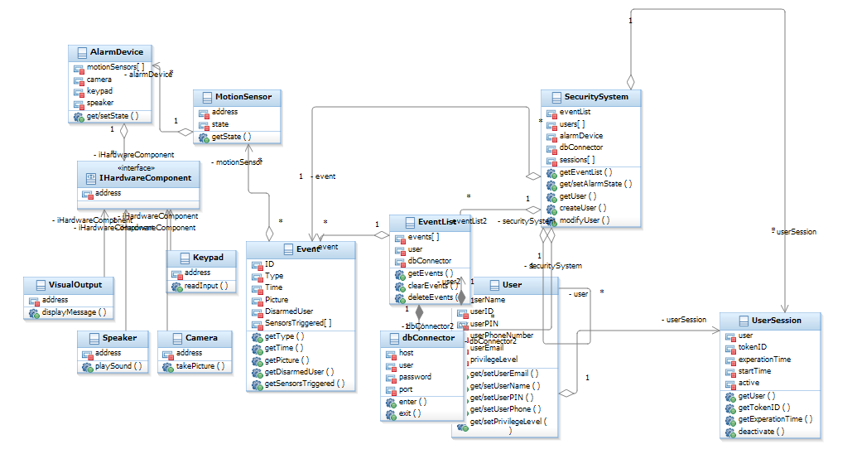

Class name: User
Brief description: Has information of a user
Attributes (fields) | Attribute Description
UserName | Contains user name
UserID | Contains user ID
UserPin | Contains user pin number for security system
UserPhoneNumber | Contains user phone number for use with automated text message
UserEmail | Contains user email for use with automated email message
PrivilegeLevel | Contains user privilege level
Methods (operations) | Method Description
GetSetEmail | Gets and sets user email value for DB
GetSetUserName | Gets and sets user name value for DB
GetSetUserPin | Gets and sets user PIN value for DB
GetSetUserPhone | Gets and sets user phone value for DB
GetSetPrivilegeLevel | Get and set user privilege level

Class name: Event
Brief description: Has information of a single Event
Attributes (fields) | Attribute Description
ID | ID of the event
Type | Type of event
Time | Contains the date and time of the given event
Picture | Picture for the event
Disarmed User | Contains user of the
Sensors Triggered [] | Contains a list of all sensors that were triggered during this event
Methods (operations) | Method Description
GetType | Gets type of event
GetTime | Gets date and time the event occurred
GetPicture | Gets a picture depending if one was taken during this event
GetDisarmedUser | Gets the user that disarmed the event
GetSensorsTriggered | Gets a list of all sensors that were triggered during an event.

Class name: AlarmDevice
Brief description: The alarm device object that holds information of all hardware devices that make up the device.
Attributes (fields) | Attribute Description
MotionSensors[] | A list of motion sensors that are attached to the alarm device
Camera | Contains information of the camera that is attached to the alarm device
Keypad | Contains information of the keypad that is attached to the alarm device
Speaker | Contains information of the speaker that is attached to the alarm device
Methods (operations) | Method Description
GetSetState(State) | Get or Set the alarm device state depending on the parameter passed

Class name: MotionSensor
Brief description: Used by the alarm device that will sense motion and change its state based on movement
Attributes (fields) | Attribute Description
Address | Contains the address for the motion sensor
State | Holds the state of the motion sensor device
Methods (operations) | Method Description
GetState() | Gets the state of the motion sensor based on sensing any motion.

Class name: Security System
Brief description: Provides access to the event list, users, alarm device, and current sessions.
Attributes (fields) | Attribute Description
EventList | Contains an event list object which provides all events of the security system.
Users [] | A list of all users that have access to the security system
Alarm Device | An alarm device object that has all the devices that are connected to the alarm
DB Connector | A connection object that is used to connect to the database
Sessions[] | A list of all current user sessions
Methods (operations) | Method Description
GetEventList(args) | Is passed an argument that behaves like a filter and returns an event list that meets the specified criteria.
GetSetAlarmState | Get and Set the current alarm state of the security system.
GetUser() | Get a specified user
CreateUser() | Creates a user object
ModifyUser() | Modifies user attributes

Class name: Camera
Brief description: Camera object that
Attributes (fields) | Attribute Description
Address | Contains information of the camera’s address
Methods (operations) | Method Description
TakePicture() | Will return a picture when called during an event

Class name: Keypad
Brief description: Will take user input and send it to the security system for validation.
Attributes (fields) | Attribute Description
Address | Contains information of the keypad’s address
Methods (operations) | Method Description
ReadInput() | Reads input provided from the user and send it for validation

Class name: Speaker
Brief description: Used to receive message from the system depending on event it will have the physical speaker produce sound
Attributes (fields) | Attribute Description
Address | Contains information of the speakers address
Methods (operations) | Method Description
PlaySound(args) | Will play a specific sound depending on the event message received

Class name: VisualOutput
Brief description: Will provide the user with information of the current state of the system.
Attributes (fields) | Attribute Description
Address | Contains information of the visual outputs address
Methods (operations) | Method Description
DisplayMessage(message) | Will display the message that was passed to the visual output

Class name: DBConnector
Brief description: The connection object that will provide the creation of a connection to communicate with the data base
Attributes (fields) | Attribute Description
Host | Contains the address to the host/hostname
User | Information of the user wishing to establish the connection
Password | Information of the user’s password
Port | The port to which the host is listening on
Methods (operations) | Method Description
Enter | Creates connection returns a cursor object
Exit | Closes connection and destroys cursor object

Class name: EventList
Brief description: Used to view the events in the database
Attributes (fields) | Attribute Description
Events[] | A list of events
User | Contains info of the user of the event list
DBConnector | Creates a db connector object
Methods (operations) | Method Description
GetEvents(args) | Gets a set of Events based on the filter arguments passed in
ClearEvents() | Clear all Events in the list
DeleteEvent() | Remove Event from the list

Class name: User Session
Brief description: Will provide information of an individual user session after the user has successfully established a connection
Attributes (fields) | Attribute Description
User | Contains information of a user object
TokenID | Unique token for the session
ExperationTime | Holds the time at which a session will expire for the user depending on the user session start time
StartTime | Contains information of when the user session initially started
Active | Provides the current state of a user session
Methods (operations) | Method Description
GetUser | Returns information of the user that initiated the session.
GetTokenID | Returns the unique token for the specified session
GetExperationTime | Returns the expiration time at which the session will be terminated
Deactivate | Terminates the current session based of the expiration time or logging out of the session

Class name: HardwareComponent
Brief description: Interface for the hardware component
Attributes (fields) | Attribute Description
Address | Contains address for a hardware component.
Methods (operations) | Method Description

  - Sequence Diagrams

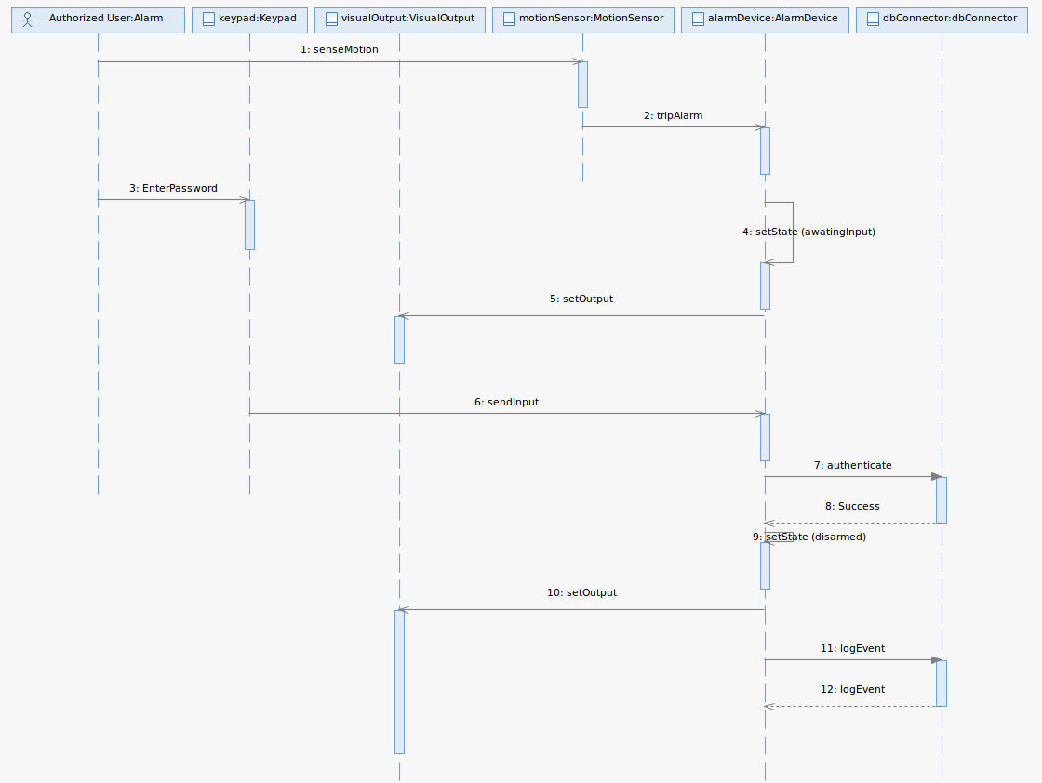

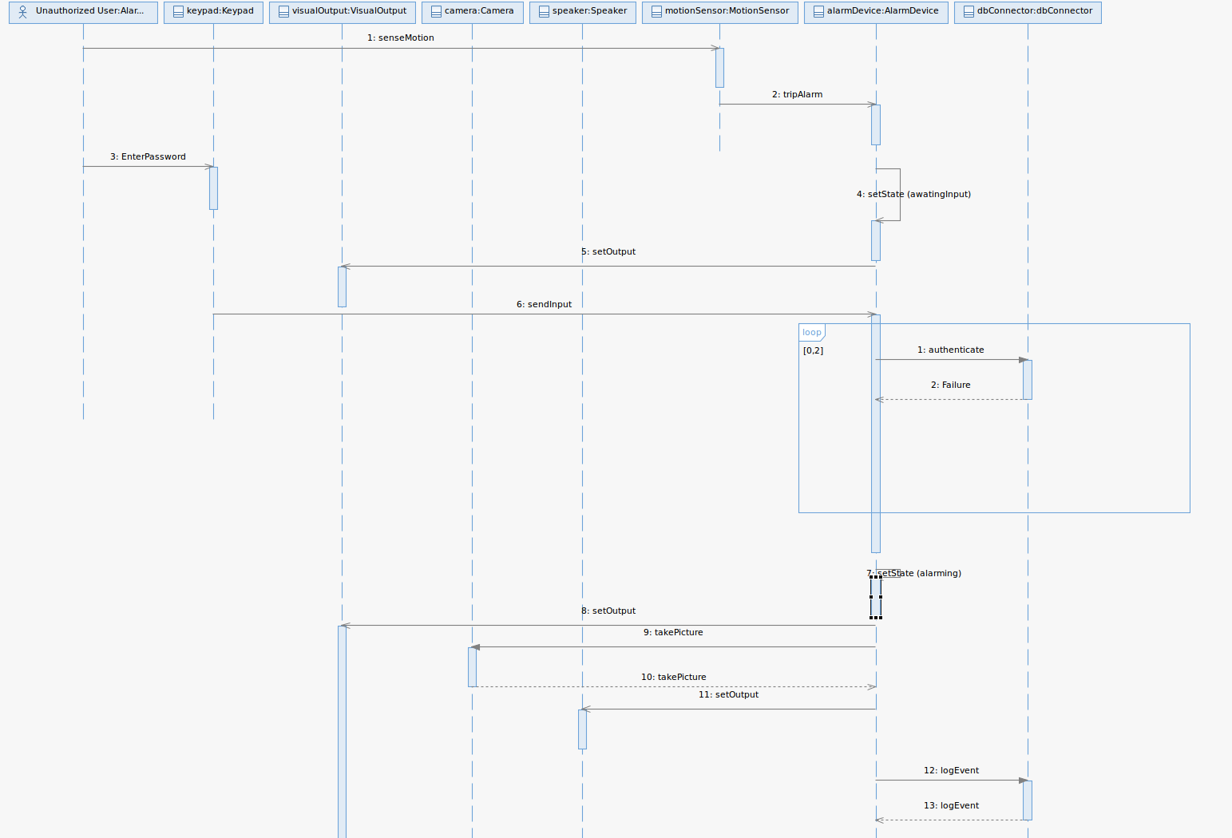

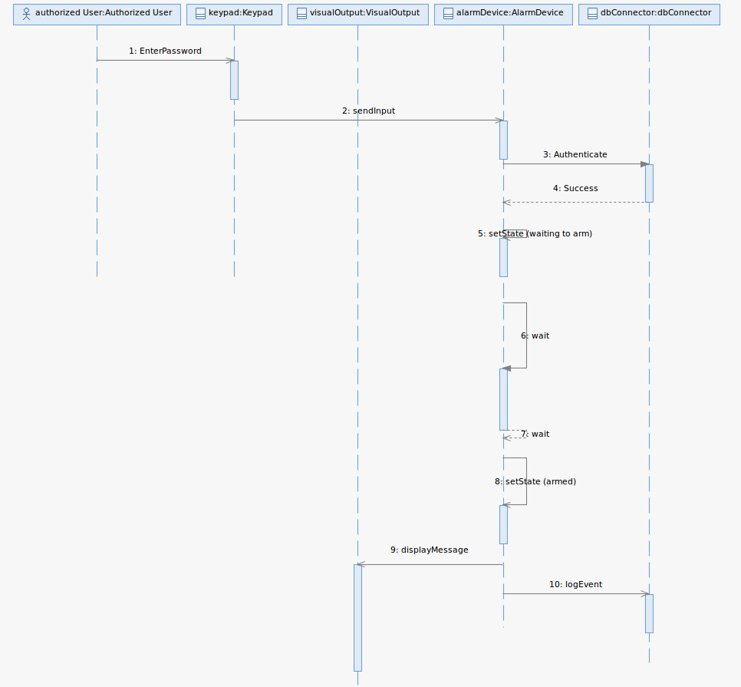

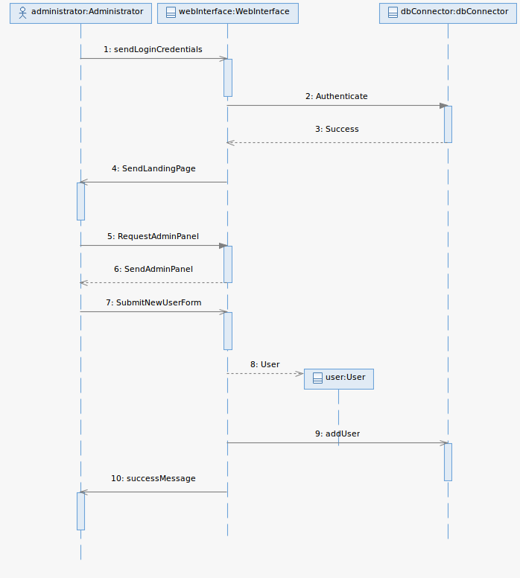

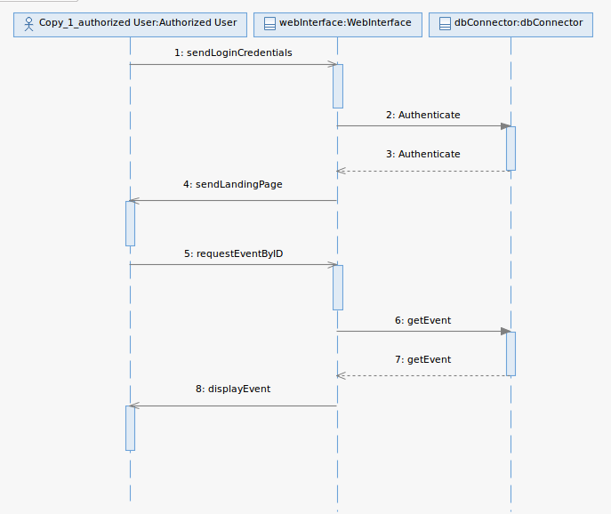

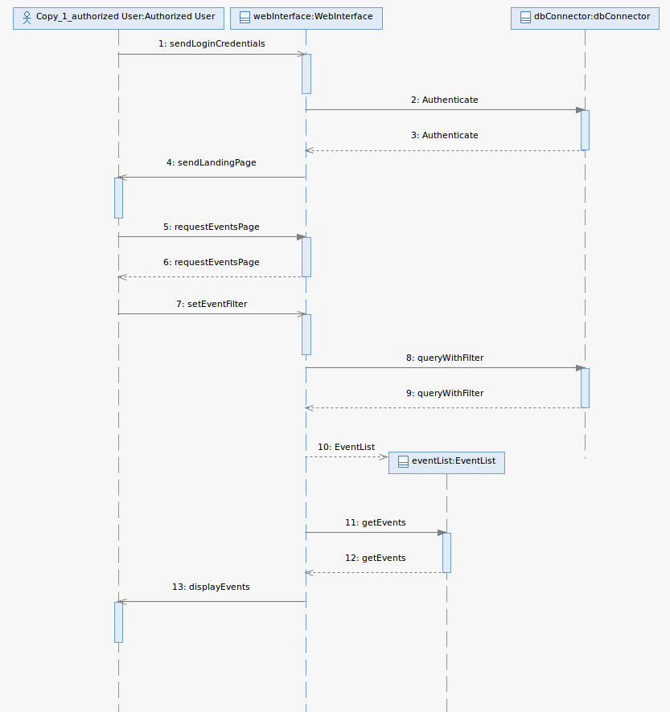

View Event
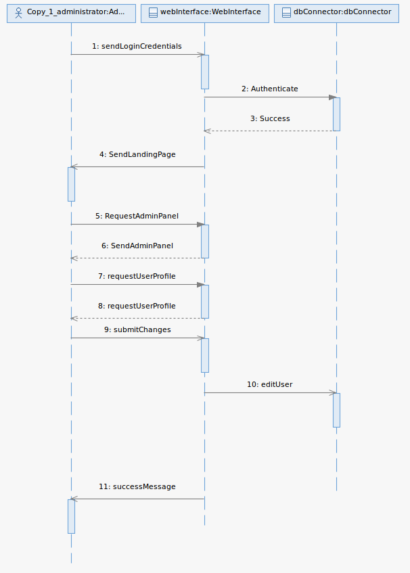

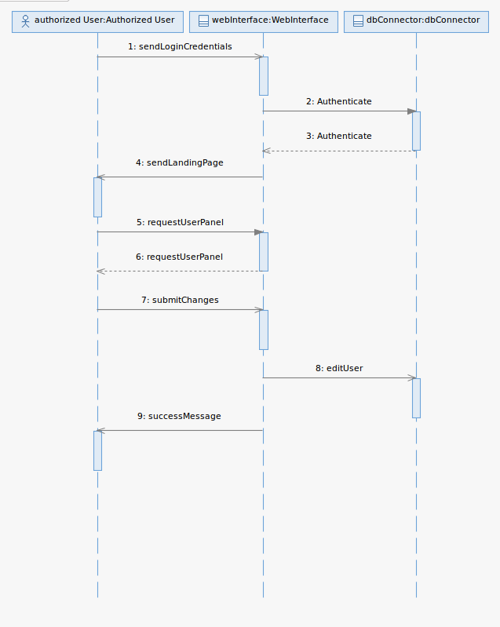

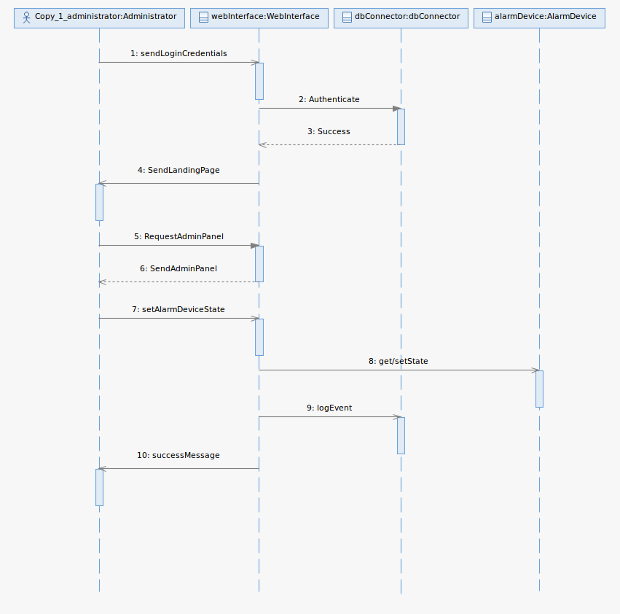

  - Object Collaboration Diagrams
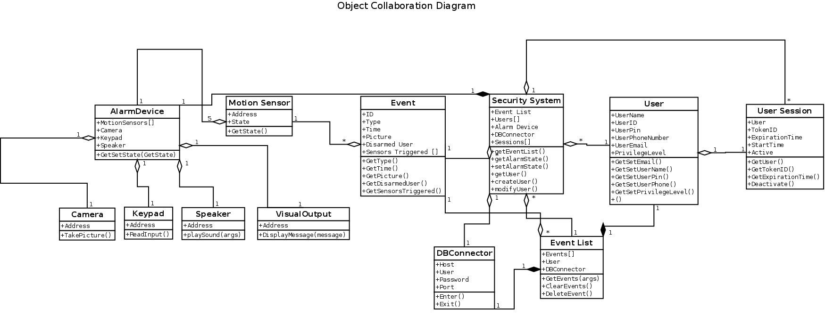

  - Object Behavior Diagrams

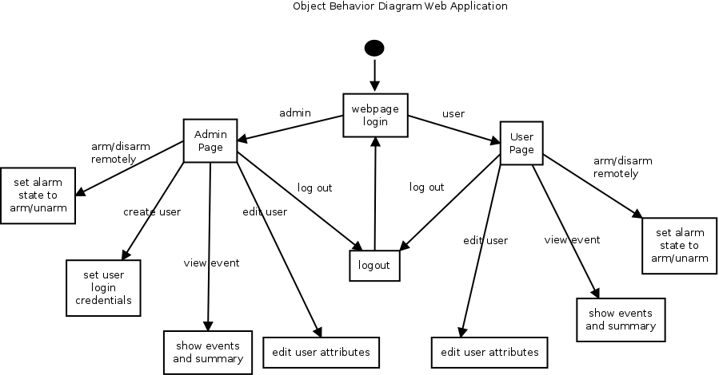

Software Design Document

Introduction

Purpose

The purpose of this SDD is to provide a low-level description of the Home Security System with Arduino and the web application used to manage it. This document will also provide insight into the structure and design of each component. The different sections include Design Overview, System Object Model, Object Descriptions, Object Collaboration, Dynamic Model, Data Design, and Non-Functional Requirements.

Scope

The Home Security System with Arduino is composed of multiple components: an Arduino device, motion sensors, key pad, and Raspberry Pi. A user will be able to access the web application which will be composed of an Administration implementation that allows the admin to add and remove users, view all security events, edit descriptions of motion sensors, and remotely disarm and arm the security system. There is a basic user implementation that will allow a user to filter through a set of security events. The system features are divided into core features that are essential to the function of the application and additional features which contain extra functionality.

Definitions, Acronyms and Abbreviations
HTTP Hyper Text Transfer Protocol
SOCKET One endpoint of a two-way communication link between two programs running on a network
HTML Language used to write web pages
JavaScript A dynamic programming language most commonly used as part of web browsers, allowing client-side scripts to interact with the user.
CSS Cascading Style Sheets Used for describing the look and formatting of a document written in a markup language.

References
SRS

Design Overview

Introduction

The Home Security System is a physically present intrusion detection system for home use. The system is comprised of two discrete subsystems that are interdependent. The first subsystem, the mounted unit, is the physically present component of the system that detects intrusions by the use of a PIR motion sensor, and also contains a pin pad for users to interact with in order to arm or disarm the system. The second subsystem, the back-end server, is not required to be physically present in the user's home, and is used for storing and delivering information about users and events to authorized users.

System Architecture

The mounted unit:

Functionality of the mounted unit is fully dependent on the back-end server's availability. Without a response from the back-end server, the unit does not serve any function and will not raise alarms, nor can it be armed or disarmed. The unit itself is comprised of the following components: the microcontroller, the Ethernet shield, the motion sensors, the pin pad, indicator LEDs, the camera, and a speaker. All components are connected to the microcontroller by its pins. All of these components use 5 volt and 3.3 volt logic, and all except for the speaker and LEDs are digital in their signaling mechanisms. This subsystem is designed for device interaction, and may be referred to as such later in this document.

The back-end server:

Functionality of the back-end server is not dependent on the wall mounted unit in order to function. Administration tasks may still be carried out on the server even when the unit is disconnected. However, all information that populates the database held on this server originates from the wall mounted unit. This machine runs a version of Debian Linux that is designed for ARM based processors like the Raspberry Pi. The machine contains a few server applications such as an Apache web server, a PosgreSQL database, and a server-side application written in Python that listens for events as they come on the wire, and then logs these events into the database. From the webserver, users will be able to view events and modify information about sensors and users of the system. This subsystem is designed for system administration, and may be referred to as such later in this document.

System Interfaces

There are two ways in which the system interfaces with outside users. One being physically in person. The mounted unit is accessed this way. The other method of interfacing with the system is remotely through the web console. Events are triggered and created from the mounted unit, and the system's state may also be changed this way. The back-end server may also change the state of the system remotely through the web console.

Constraints and Assumptions

Interaction with the mounted unit assumes that all components are properly connected and not physically damaged, and is not designed to detect such damage. Results are unexpected if such damage were to occur.

Interaction with the back-end server assumes that the same users that trigger events and interact with the mounted unit also interact with the server. Compromises within the network and man in the middle attacks are still possible, and are currently unaccounted for.

System Object Model

Introduction

This section represents the Home Security System in terms of objects. Each object is implemented to satisfy all system requirements. The Home Security System object is composed of two subsystems. The two subsystems are Device Interaction and System Administration.

Subsystems

The Device Interaction subsystem interacts with all components of the system that involve the security hardware functionality. The System Administration involves all the components which determine the characteristics and settings of users and components of the system.

Subsystem Interfaces

The Device Interaction interfaces are all the Arduino components. Such components include motion detectors, camera, keypad, visual display, and microphone. The System Administration is the web application that is run by a server and database in the raspberry pi.

Object Descriptions

Objects in Security Device
Use case name:  Alarm Event (Correct Pin) |  | ID:  AE-01
Primary actor:  Person that triggers alarm | Source:  Security Device | Use case type:  Technical Requirement
Interested Stakeholders:
Any residence of the household
Brief description:
A user will trigger a motion sensor and proceed to enter a valid pin
Precondition:
The security device is in an armed state.
Trigger:
Some form of motion happens in front of one of the sensors, which sets the device in an alarming state.
Relationships: None
Typical flow of events:
- Some user triggers the alarm
- Device is in alarming state waiting for PIN
- User presses “D” on the pad
- User inputs valid pin code
- Event is logged to server with timestamp and user info
- Device is set to unarmed state
Assumptions:
- Device did not already detect motion
- All components of the system are working

Use case name:  Alarm Event (Incorrect Pin) |  | ID:  AE-02
Primary actor:  Person that triggers alarm | Source:  Security Device | Use case type:  Technical Requirement
Interested Stakeholders:
Any residence of the household
Brief description:
An intruder will trigger a motion sensor and proceed to enter invalid pin
Precondition:
The security device is in an armed state.
Trigger:
Some form of motion happens in front of one of the sensors, which sets the device in an alarming state.
Relationships: None
Typical flow of events:
- Some user triggers the alarm
- Device is in alarming state waiting for PIN
- User presses “D” on the pad
- User inputs invalid pin code or no pin code is entered
- Device takes pictures
- Event is logged to server with timestamp, images, failed pin number
- Device continues with alarming state
Assumptions:
- Device did not already detect motion
- All components of the system are working

Use case name:  Arm the System |  | ID:  AS-01
Primary actor:  User that is interacting with the Security System | Source:  Security Device PIN Pad | Use case type:  Technical Requirement
Interested Stakeholders:
Any residence of the household
Brief description:
When a user intends to secure the house, they will activate the system
Precondition:
The security device is in an unarmed state.
Trigger:
User enters correct PIN
Relationships: None
Typical flow of events:
- User presses “A” on the PIN pad
- User inputs valid pin code
- System waits some period of time giving user time to vacate
- Speaker beeps increase frequency
- System state is set to armed
- Event is logged to server with timestamp and user info
Assumptions:
- User knows the correct PIN.
- All components of the system are working

Objects in System Administration
Use case name:  Admin Create User (Admin Application) |  | ID:  AA-CU01
Primary actor:  Admin User | Source:  Web Application | Use case type:  Technical Requirement
Interested Stakeholders:
Owner/Admin of the Security System
Brief description:
The admin user will create other users to interact with the security system
Precondition:
Admin user account exists and user has access to application located on a webserver.
Trigger:
Admin user commits changes using the admin application.
Relationships: None
Typical flow of events:
- Admin user logs into the web application
- Admin clicks link admin panel
- Admin selects ‘Add User’
- Admin provides information about the new user (i.e. Name, Password, Permission Level)
- Admin confirms new user that has been entered
- New user is created and added to the database.
Assumptions:
- The webserver is running
- User account exists

Use case name:  Admin Edit other User Profile |  | ID:  AA-CU01
Primary actor:  Admin User | Source:  Web Application | Use case type:  Technical Requirement
Interested Stakeholders:
Owner/Admin of the Security System
Brief description:
The admin user will edit other users that interact with the security system
Precondition:
Admin user account exists
Trigger:
Admin user commits changes using the admin application.
Relationships: None
Typical flow of events:
- Admin user logs into the web application
- Admin clicks link admin panel
- Admin selects ‘Add User’
- Admin provides information about the new user (i.e. Name, Password, Permission Level)
- Admin confirms new user that has been entered
- New user is created and added to the database.
Assumptions:
- The webserver is running
- User account exists

Use case name:  User Edit Own Attributes |  | ID:  UA-01
Primary actor:  User accessing the web panel | Source:  Web Application | Use case type:  Technical Requirement
Interested Stakeholders:
User of the security system
Brief description:
The user intends to edit their profile information
Precondition:
User account exists
Trigger:
User commits changes from the account panel
Relationships:
Depends on: Create User (Admin Application)
Typical flow of events:
- User logs into website
- User clicks link to profile panel
- User selects ‘edit user profile’
- User enters the edited information about the user (name, password)
Assumptions:
- The webserver is running
- User account exists

Use case name:  View Event |  | ID:  VE-01
Primary actor:  User accessing the web panel | Source:  Web Application | Use case type:  Technical Requirement
Interested Stakeholders:
User of the security system
Brief description:
The User intends to view events log in the security system
Precondition:
User account exists
Trigger:
User logs into account
Relationships:
Depends on: Create User (Admin Application)
Typical flow of events:
- User logs into website
- User clicks link to event in the event panel
- User views event details and picture
Assumptions:
- The webserver is running
- User account exists
- Event has occurred

Use case name:  View event summaries (with filters & graphs) |  | ID:  VE-02
Primary actor:  User accessing the web panel | Source:  Web Application | Use case type:  Technical Requirement
Interested Stakeholders:
User of the security system
Brief description:
The User intends to view events log in the security system by filtered results
Precondition:
User account exists
Trigger:
User log into account and selects filters
Relationships:
Include: View Event
Extend: Create User (Admin Application), View Event
Depends on: Create User (Admin Application), View Event
Typical flow of events:
- User logs into website
- User select which filters to order events
- User views event details
Assumptions:
- The webserver is running
- User account exists
- Event has occurred
Assumptions:
- The webserver is running
- User account exists
- Event has occurred

Use case name:  Arm/Disarm System Remotely |  | ID:  AS-02
Primary actor:  User accessing the web panel | Source:  Web Application | Use case type:  Technical Requirement
Interested Stakeholders:
User of the security system
Brief description:
The User intends to view events log in the security system by filtered results
Precondition:
User account exists and system hardware is running
Trigger:
User log into account and selects “Arm System”
Relationships:
Depends on: Admin Create User (Admin Application)
Typical flow of events:
- User logs into the website
- User changes alarm state
  - User clicks arm button
  - User clicks disarm button
Assumptions:
- The webserver is running
- User account exists
- System is in undesired state

Object Collaboration

Objects in Subsystem 1
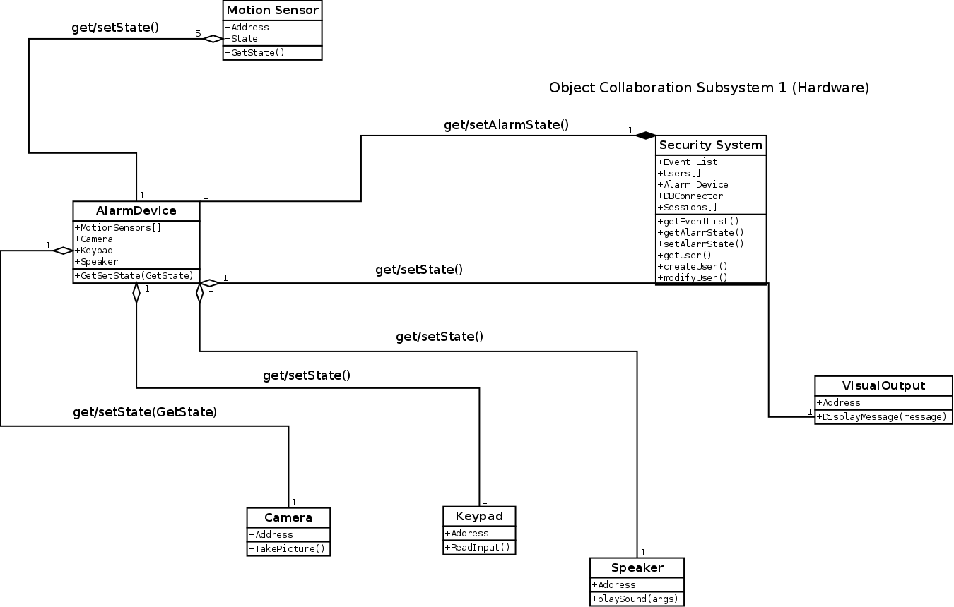

Objects in Subsystem 2

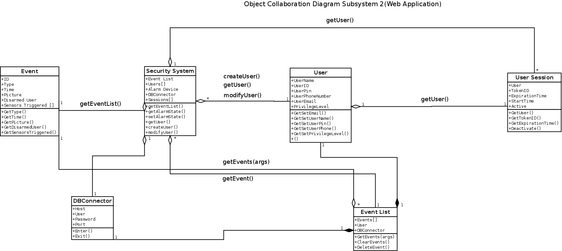

Dynamic Model
3.1 External interface requirements
3.1.1 User interfaces
The main requirement for the user interface is that it must be easy to use and simplistic.
3.1.2 Hardware interfaces
The hardware interface will allow a physical way for users to interact with the security system as a whole. This is where the pin pad, LCD screen, and other hardware will come in.
    - Software interfaces
The software interface will allow users to interact with the security system as a whole. This is where the web application will come in to play. The software interface must have a way for users to create, edit and update accounts, view logs, and remotely arm/disarm.
    - Communication interfaces
The communication interface must allow communication between the server and database as well as communication among other hardware components.

3.2 Analysis Classes

Class name: User
Brief description: Has information of a user
Attributes (fields) | Attribute Description
UserName | Contains user name
UserID | Contains user ID
UserPin | Contains user pin number for security system
UserPhoneNumber | Contains user phone number for use with automated text message
UserEmail | Contains user email for use with automated email message
PrivilegeLevel | Contains user privilege level
Methods (operations) | Method Description
GetSetEmail | Gets and sets user email value for DB
GetSetUserName | Gets and sets user name value for DB
GetSetUserPin | Gets and sets user PIN value for DB
GetSetUserPhone | Gets and sets user phone value for DB
GetSetPrivilegeLevel | Get and set user privilege level

Class name: Event
Brief description: Has information of a single Event
Attributes (fields) | Attribute Description
ID | ID of the event
Type | Type of event
Time | Contains the date and time of the given event
Picture | Picture for the event
Disarmed User | Contains user of the
Sensors Triggered [] | Contains a list of all sensors that were triggered during this event
Methods (operations) | Method Description
GetType | Gets type of event
GetTime | Gets date and time the event occurred
GetPicture | Gets a picture depending if one was taken during this event
GetDisarmedUser | Gets the user that disarmed the event
GetSensorsTriggered | Gets a list of all sensors that were triggered during an event.

Class name: AlarmDevice
Brief description: The alarm device object that holds information of all hardware devices that make up the device.
Attributes (fields) | Attribute Description
MotionSensors[] | A list of motion sensors that are attached to the alarm device
Camera | Contains information of the camera that is attached to the alarm device
Keypad | Contains information of the keypad that is attached to the alarm device
Speaker | Contains information of the speaker that is attached to the alarm device
Methods (operations) | Method Description
GetSetState(State) | Get or Set the alarm device state depending on the parameter passed

Class name: MotionSensor
Brief description: Used by the alarm device that will sense motion and change its state based on movement
Attributes (fields) | Attribute Description
Address | Contains the address for the motion sensor
State | Holds the state of the motion sensor device
Methods (operations) | Method Description
GetState() | Gets the state of the motion sensor based on sensing any motion.

Class name: Security System
Brief description: Provides access to the event list, users, alarm device, and current sessions.
Attributes (fields) | Attribute Description
EventList | Contains an event list object which provides all events of the security system.
Users [] | A list of all users that have access to the security system
Alarm Device | An alarm device object that has all the devices that are connected to the alarm
DB Connector | A connection object that is used to connect to the database
Sessions[] | A list of all current user sessions
Methods (operations) | Method Description
GetEventList(args) | Is passed an argument that behaves like a filter and returns an event list that meets the specified criteria.
GetSetAlarmState | Get and Set the current alarm state of the security system.
GetUser() | Get a specified user
CreateUser() | Creates a user object
ModifyUser() | Modifies user attributes

Class name: Camera
Brief description: Camera object that
Attributes (fields) | Attribute Description
Address | Contains information of the camera’s address
Methods (operations) | Method Description
TakePicture() | Will return a picture when called during an event

Class name: Keypad
Brief description: Will take user input and send it to the security system for validation.
Attributes (fields) | Attribute Description
Address | Contains information of the keypad’s address
Methods (operations) | Method Description
ReadInput() | Reads input provided from the user and send it for validation

Class name: Speaker
Brief description: Used to receive message from the system depending on event it will have the physical speaker produce sound
Attributes (fields) | Attribute Description
Address | Contains information of the speakers address
Methods (operations) | Method Description
PlaySound(args) | Will play a specific sound depending on the event message received

Class name: VisualOutput
Brief description: Will provide the user with information of the current state of the system.
Attributes (fields) | Attribute Description
Address | Contains information of the visual outputs address
Methods (operations) | Method Description
DisplayMessage(message) | Will display the message that was passed to the visual output

Class name: DBConnector
Brief description: The connection object that will provide the creation of a connection to communicate with the data base
Attributes (fields) | Attribute Description
Host | Contains the address to the host/hostname
User | Information of the user wishing to establish the connection
Password | Information of the user’s password
Port | The port to which the host is listening on
Methods (operations) | Method Description
Enter | Creates connection returns a cursor object
Exit | Closes connection and destroys cursor object

Class name: EventList
Brief description: Used to view the events in the database
Attributes (fields) | Attribute Description
Events[] | A list of events
User | Contains info of the user of the event list
DBConnector | Creates a db connector object
Methods (operations) | Method Description
GetEvents(args) | Gets a set of Events based on the filter arguments passed in
ClearEvents() | Clear all Events in the list
DeleteEvent() | Remove Event from the list

Class name: User Session
Brief description: Will provide information of an individual user session after the user has successfully established a connection
Attributes (fields) | Attribute Description
User | Contains information of a user object
TokenID | Unique token for the session
ExperationTime | Holds the time at which a session will expire for the user depending on the user session start time
StartTime | Contains information of when the user session initially started
Active | Provides the current state of a user session
Methods (operations) | Method Description
GetUser | Returns information of the user that initiated the session.
GetTokenID | Returns the unique token for the specified session
GetExperationTime | Returns the expiration time at which the session will be terminated
Deactivate | Terminates the current session based of the expiration time or logging out of the session

Class name: HardwareComponent
Brief description: Interface for the hardware component
Attributes (fields) | Attribute Description
Address | Contains address for a hardware component.
Methods (operations) | Method Description

  - Sequence Diagrams

  - Object Collaboration Diagrams

  - Object Behavior Diagrams

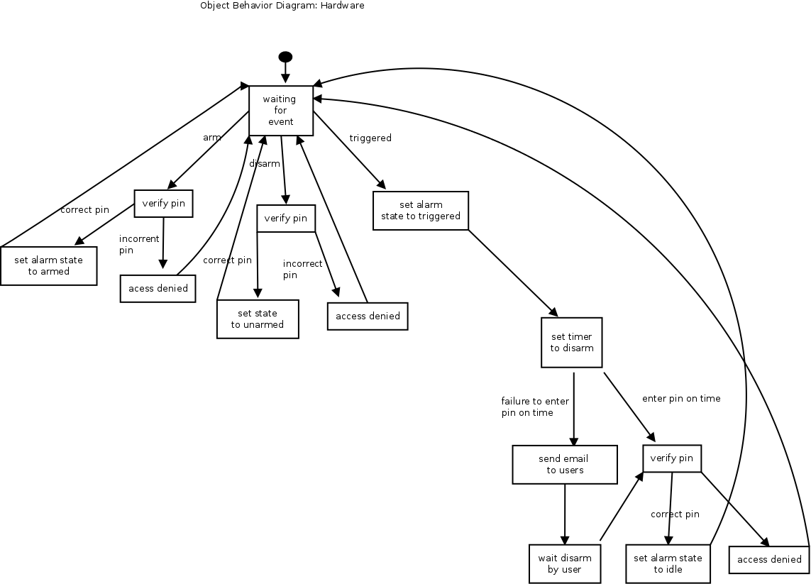

Data Design

Data Description
The below table contains the PostgreSQL tables that will be used in the database that is installed locally on the server.

Table | Field | Type | NULL | Default
users | UID | char(10) | NO
 | UserName | char(15) | NO
 | FirstName | char(75) | NO
 | LastName | char(75) | NO
 | Email | char(75) | NO
 | PhoneNumber | char(15) | NO
 | PrivilegeLevel | Enum(‘admin’, ‘basic’) | NO | basic
 | Password | char(20) | NO | password
 | PIN | char(4) | NO | 1234
events | UID | char(10) | NO
 | EventType | Enum(‘alarming’, ‘alarm’, ‘disarm’) | NO
 | UserID | char(10) | YES | NA
 | DateCreated | Timestamp | NO | CURRENT_TIMESTAMP
 | SensorTriggered | char(10) | YES | NA
 | Picture | bytea | YES | NULL
Sensors | UID | char(10) | NO
 | SensorName | char(10) | NO
 | Description | char(10) | YES | NULL

Non-functional Requirements

- All information in the database should be up to date, meaning that the most recently generated event from the hardware device is always the most recent event in the database.
- The web console needs to be able to access all events and users, reflecting the most recent changes at all times.
- Data contained within the back-end server should be private from actors outside of the system's users. All events are readable by basic users, and all events are modifiable by admin users. Non-users should have no access.
- The mounted unit must be operable by any physically present user, and can have it's state changed by admin users remotely.
- Both the mounted unit and the back-end server are portable, in that they can be relocated at any time without any needed configuration changes.
- The system must be able to be disabled and re-endabled spontaneously at any time by an admin user only.
- Since the back-end server is only a software component, it should be compatible on a wide array of platforms, and may be ported to other platforms without data loss.

Updates

Documentation

Software Development Plan
Section | Changes Updated

Software Requirement Specifications
Section | Changes Updated

Software Design Document
Section | Changes Updated

  - Coding
Please refer to the following URL to view the source code for this project: https://github.com/BallisticBuddha/HomeSecurityProject
  - Future Functions of the System
In the future we would like to add in the following features:
- camera as a motion sensor
- sound detection
- remote arming and disarming through web interface
- phone notification to alert user of arming events

